4 The Walled Garden, Farnham, Surrey, GU10 1FA
Tele: 01252 758960 email: david@cyberpictures.net
Mobile: 07836 547472 Voipfone: 30204177*204

INVOICE #9375

Monday, 13 August 2018
JD Motors
1 Rowan Industrial Park
Mill Lane, Alton
Hampshire
GU34 2QG

Reclaim of expenses made to Voipfone

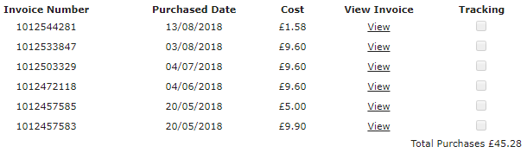

With Compliments
David Bradley

Payment by BACS acceptable to:
Sort Code: 40-47-86
Account Number: 64418050
Account Name: D C Bradley
Payment reference: 9375

