Notes on your telephone service
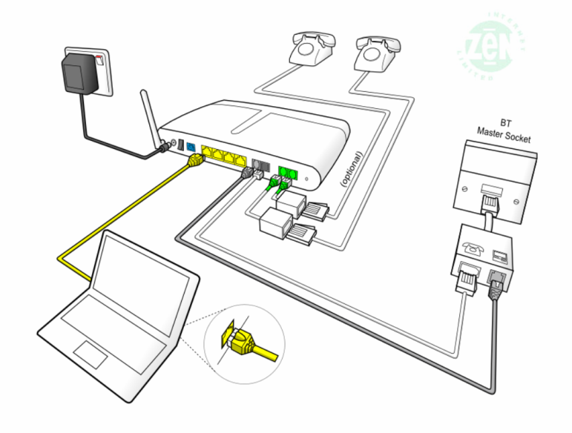
Your phone service is provided from three sources with the Draytek router knitted everything together. As installed, there will be no phone service if power to the home is lost but this can be overcome by purchasing a basic phone available from numerous sources for less than £10. You are able to make and receive phone calls via three different services use the Zen phone line, Zen Broadband Voice and Draytel VoIP; details of each are given below.
Phone Line
A basic requirement giving a voice service and the ability to have a broadband service. You have chosen to have your service provided by Zen so if there is a fault on the line you report it to them on 01706 902000.
The telephone number for this line is 01730 816315 and all calls made on this number will be a Zen’s standard call rates which shown below. Calls can be routed through this service by dialling #0 and waiting for a different dialling tone at which point you can dial the number required.
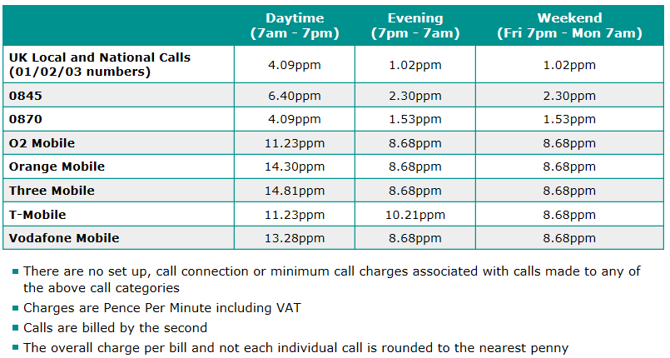
Zen VoIP Service
This service, at £5.10 a month [inc VAT] includes 1,000 inclusive minutes to UK landlines (01/02/03/0870 numbers) and reasonable call rates to international and mobile telephone numbers. The DrayTek router has been configured to make this your default phone service as soon as 0 is dialled. The telephone number for this line is 01730
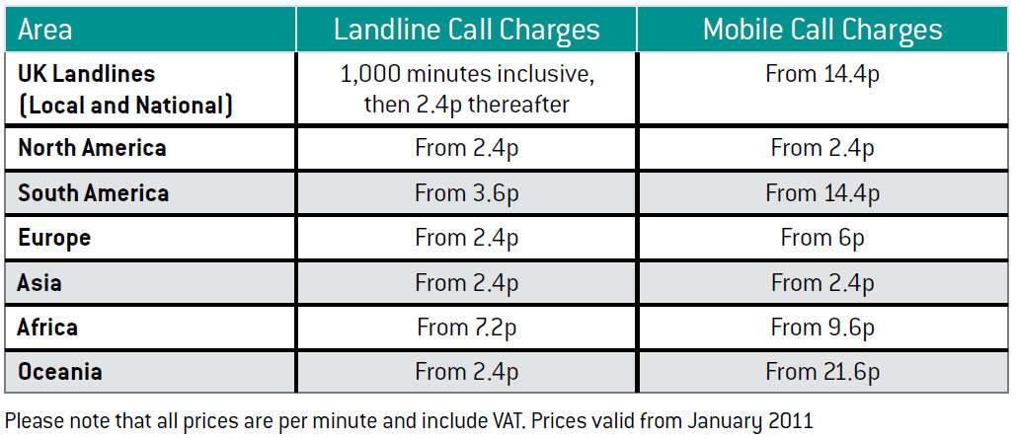
A full list of call charges at http://www.zen.co.uk/business/voice/voip.aspx?page=10157
01/02/03/0870 numbers - 1,000 minutes included, then 2.4ppm
0845 - 4.7ppm (Peak); 1.175ppm (Off Peak)
0844 - 5.88ppm
0871 - 11.75ppm
Test number: 7130 [Just responds with 01252706933]
Support: 777
DrayTEL VoIP Service
No rental charges but useful for free calls to other DrayTEL subscribers. The telephone number for this line is 0845 557 8295.
Dial Plan
Entry | Service | Displayed | Called | Called Party | Cost
123 | Draytel | 8488593 | 8234842 | David Bradley | Free
49 | Draytel | 8488593 | 8237300 | MIDENG Workshop | Free
2 | Zen VoIP |  | 01730 812162 | MIDENG Switchboard | Inclusive Minutes then 2.4ppm
3 | Zen VoIP |  | 01730 858062 | Rosemary Courtyard | Inclusive Minutes then 2.4ppm
0 [Area Code][Number] | Zen VoIP |  | As dialled | Any POTS Subscriber | Inclusive Minutes then 2.4ppm
7 [Area Code][Number] | Landline | anonymous | As dialled | Any POTS Subscriber | As phone line table
#0 [Area Code][Number] | Landline | 01730 816315 | As dialled | Any POTS Subscriber | As phone line table
47 | Draytel | 8488593 | 8485796 | Mike Morgan [W] | Free
8xxxxxx | Draytel | 8488593 | As dialled | Any Draytel Subscriber | Free
42 | Draytel | 8488593 | 8453255 | JDs – Ian Madden | Free
777 | Zen VoIP |  | 777 | Zen Help Desk | Free
999 | Landline | 01730 816315 | Emergency Services | As requested | Free
7130 | Zen VoIP |  | 7130 | Zen VoIP System Check | Free

