Essential Information Work Sheet
Rented rooms from TCP Richings
POTS Tele: 01268 572320 VoIP: 01268 856409 Identity: 200920393 VMB:
Jackie
email: kirstey.foot@tcprichings.co.uk
Cancel BT Service
A/C Number: TH15264837
Telephone Number: 01252 7038001
Outgoing calls need to be prefixed with 9

Cancel Broadband Service from TalkTalk Business
Account Number: 1303909
Service on 01252 703001
TalkTalk: 0800 083 3003 Password: trolleybus
ADSL Login: alfa2@gotadsl.co.uk Password: vhig1kej

Virgin Broadband Service
Account number 643392501
PPP Username: bb006v8445@cable.vmbusiness.net PPP Password: 8nalvg2l
Fixed IP [WAN]: 213.105.153.84
Access: http://213.107.197.87:8080/
Help Desk: 0800 052 0800
Router URL [LAN]: 192.168.60.1
Router Userid: admin Password: elstead
Start IP Range: 192.168.60.50 to 109
SSID: Wise-Wingate Password: route654
SSID: WW-Guest Password: ww170115
Time Server: time.nist.gov DNS: 8.8.8.8 and 8.8.4.4
wickford.router@bakerlegal.co.uk Password: 3yx4yze38982

Network Printer at Wickford
Supplied by Copy Care Services
Tele: 07973 677358
DHCP: 192.168.60.51 MAC: 00:80:91:6d:07:80
wickford.printer@bakerlegal.co.uk Password:46mmy4u5vr89
Scans go into a folder named file_share

VoIP Phones
Ext VoIP User Location MAC ID PW Code
10 200920393 TCP Richings Wickford 00-04-13-2C-CE-B1 start finish 4040
11 200820217 [3] Jill Wickford [BL] 00-04-13-29-33-BD pencil rubber 1879
12 200923663 [3] Rebecca Winchester 00-04-13-29-CB-FA sunrise sunset 2022
13 200920427 Tony [H] Ingatestone 00-04-13-29-41-8E Nothing set
14 200820216 [3] Tony [O] Wickford [BL] 00-04-13-29-56-D9 Apple route46 4020
15 200923779 Hot Desk [1] Wickford [BL] 00-04-13-34-A6-0A Nothing set
16 200923782 Not Allocated - 00-04-13-29-CF-86 woodland elstead 7644
17 200920410 Hot Desk [2] Wickford [BL] - ** Service via Router **
18 200920428 Paddie Tunbridge Wells 00-04-13-29-43-37 admin elstead 2014
123 200920255 David Elstead
8500 Voice Mail

MAC Address Identity User CLI DDI VMB VMB email
00-04-13-2C-CE-B1 200920393 TCP 01428 687717 01268 856409 8715 tony@bakerlegal.co.uk
TCP 01428 687717 604

00-04-13-29-33-BD 200820217 Tony 01428 687717 01428 788250 8710 tony@bakerlegal.co.uk
200920244 Tony 01428 788211 01428 788211 614
200820242 Tony 01428 788232 01428 788232 613

00-04-13-29-56-D9 200820216 Jill 01428 687717 01428 788253 8709 jill@bakerlegal.co.uk
200920243 Jill 01428 788211 01428 788211 614
200920245 Jill 01428 788232 01428 788232 613

00-04-13-34-A6-0A 200923779 HD** 01428 687717 01892 882899 9048
Server
IP MAC Host ID Login Password
192.168.60.5 FC-AA-14-37-70-7D Phoenix StoreRoom files231114

Port Usage on Virgin Router
- Server
- Ethernet over Power plug
- Tony’s Phone >>> Laptop
- Printer

Network in Room 1 - Jill
Ethernet cable from the router’s port to service snom217. Laptop connected to the phone’s hub.

Network in Room 2 - Tony
Ethernet over Power plug used to service snom216. Laptop connected to the phone’s hub.

Connection into TCP Richings Office
Ethernet over Power plug used to service snom393. Unable to get a service from TCP Richings LAN.

Wired Devices
MAC Address IP Address Device Name User
e8:03:9a:1d:94:99 192.168.60.50 Baker3 Tony
00:80:91:6d:07:80 192.168.60.51 Printer Everyone
00:04:13:29:33:bd 192.168.60.54 snom217 Jill
00:04:13:29:56:d9 192.168.60.55 snom216 Tony
00:04:13:2c:ce:b1 192.168.60.56 snom393 TCP Richings
e8:03:9a:2b:c8:c0 192.168.60.68 Baker5 Jill

Night Service at Wickford
Functionality requires testing. It is set up on Jill’s snom as a toggle on Function Button 6.

Rebecca - EE
VoIP Phone LAN 192.168.1.135:443
Tele: 01243 819014
Paddie - Virgin
VoIP Phone LAN 192.168.0.19:443 incorrectly shows DDI number 788254
Voice Mail Boxes
8715 tony
604 general
8710 debbie@bakerlegak.co.uk
614 none
613 NONE
8709 tracey@bakerlegal.co.uk >>>
9048 patricia.marshall
8717 NOT LISTED
8716 hd and tony
8718 patrica.marshall
8719 rebecca
9618 julie

Notes for David Bradley
The Port Forwarding area allows you to make local devices/services/servers available from the Internet (for example, FTP uses TCP ports 20 and 21, HTTP uses TCP port 80).
You can set up to 20 different rules for services, applications or games.
When setting up a rule you'll need the IP address of the device along with the ports that need to be made available.

Port Forwarding Rules Table
The table displays a list of ports that are currently being forwarded. Incoming traffic on the ports listed will be forwarded to the associated IP address. You can enable, disable and delete individual rules using the check boxes.

Choose a predefined rule
For each predefined rule you'd like to add:
- Choose a service rule from the pull-down menu.
- Enter the IP address for the computer using the service.
- Click 'Add Rule'
- Click 'Apply'.

To add a new rule
If the service you would like to add is not available from the pull-down menu, you can add it manually:
- Enter a name for the service rule.
- Enter the start and end port for the service.
- Select the protocol for the service, either TCP, UDP or Both.
- Enter the IP address for the device using the service.
- Click 'Add Rule'.
- Click 'Apply'.

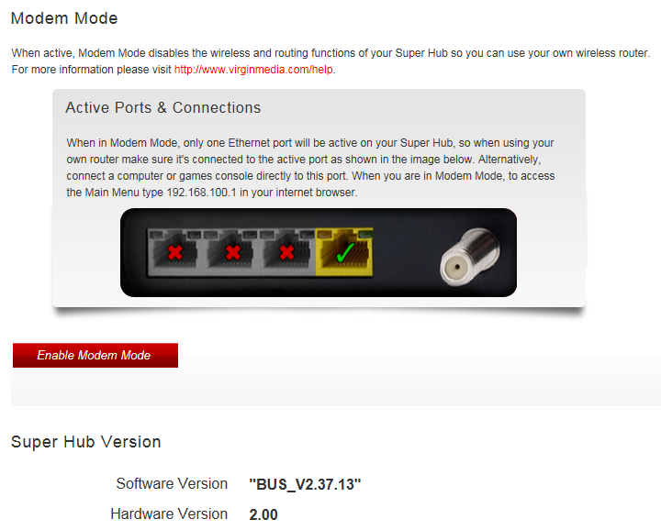

http://www.virginmedia.com/help

