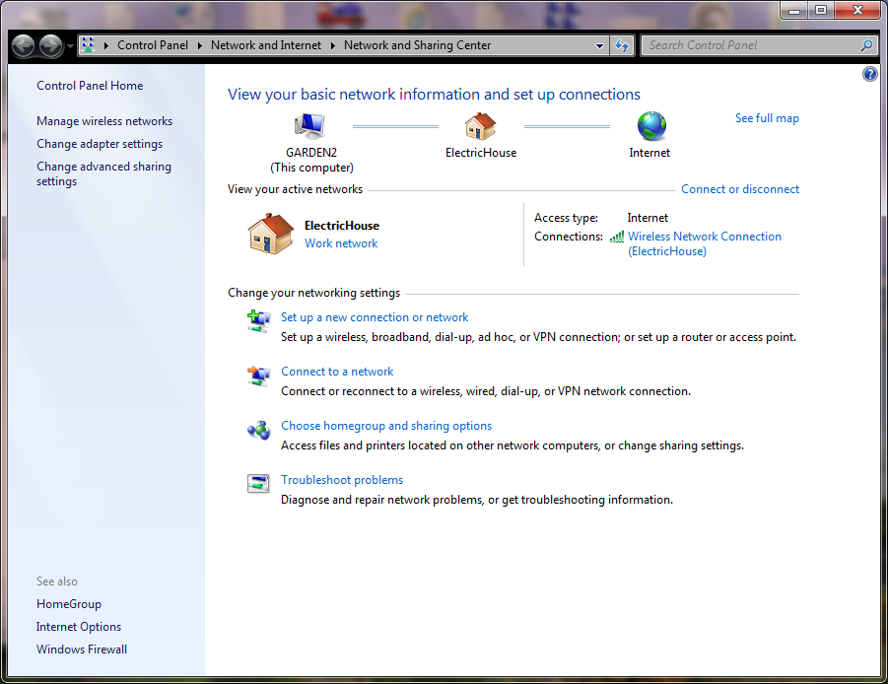
Start by going to the Network and Sharing Center and use Setup a new connection.
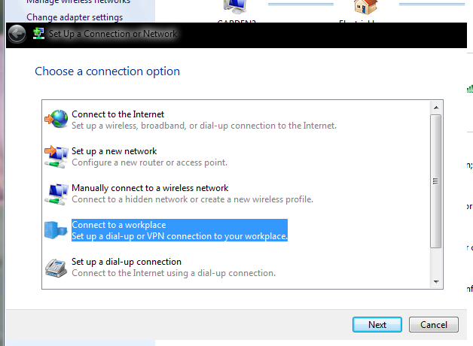
Select Connect to a workplace
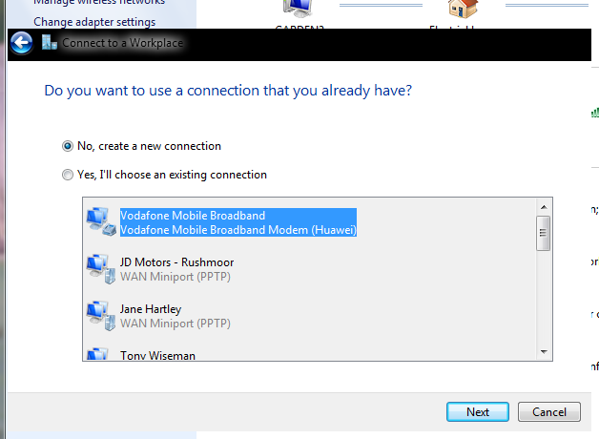
Select No
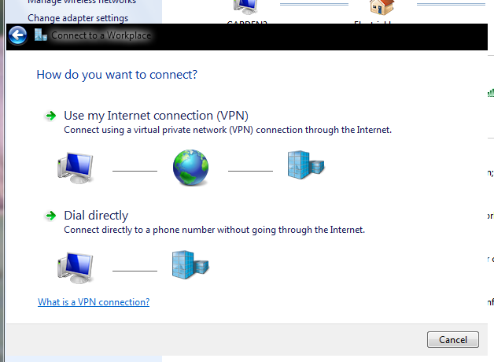
Select Use my Internet connection
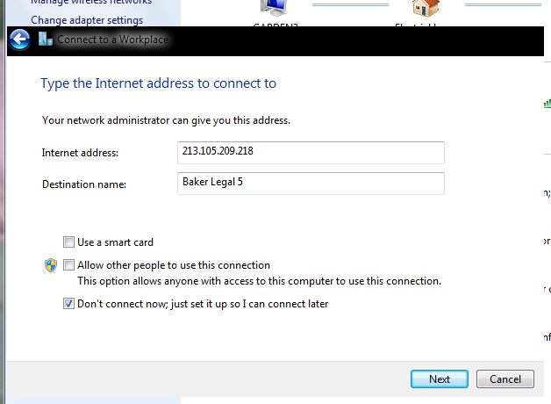
Enter values shown and select Don’t connect now
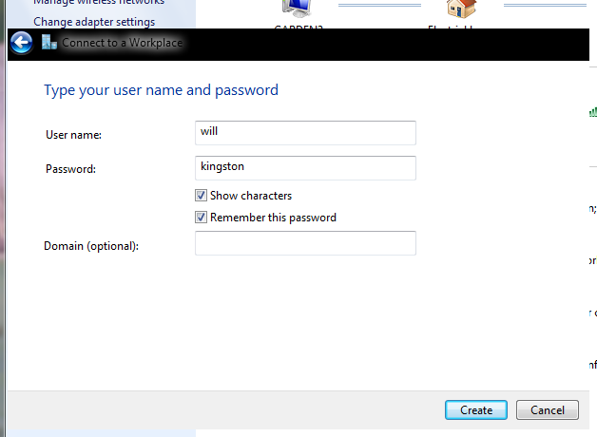
Enter values shown and tick the boxes
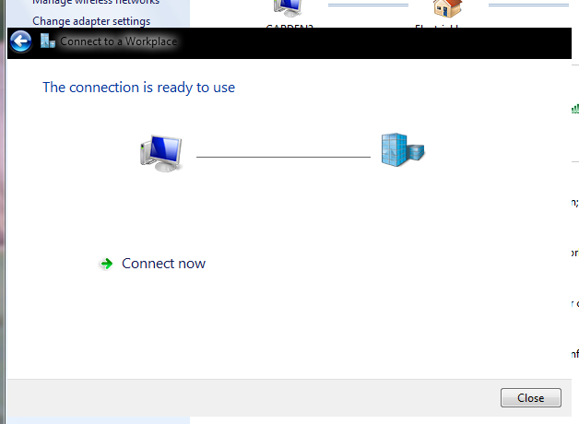
At this stage just click on Close

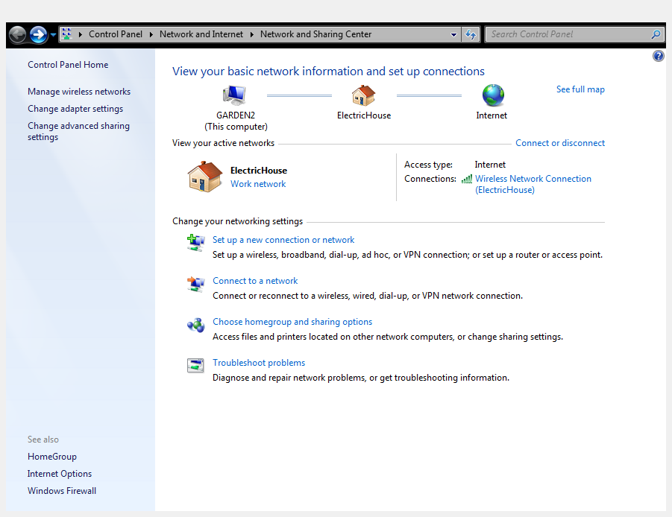
Bring up the Network and Sharing Centre again and select Change adapter settings
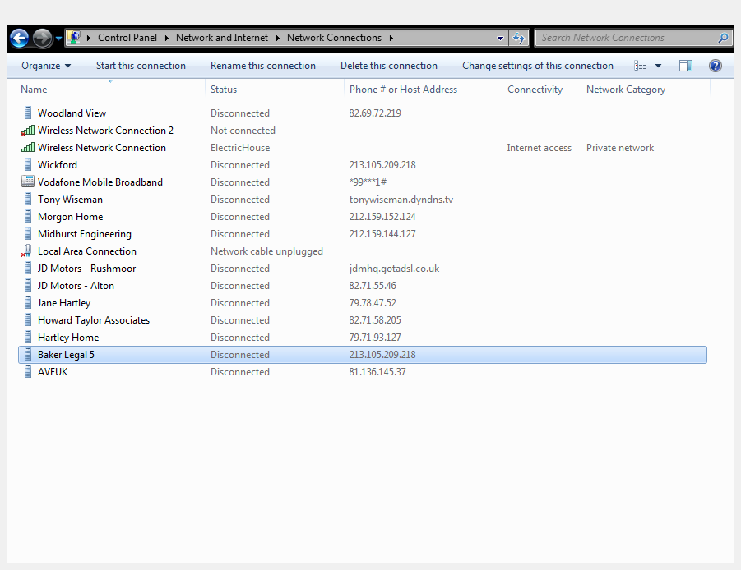
Your entries will be vastly different to that shown but you should have an entry Baker Legal 5
Click on this

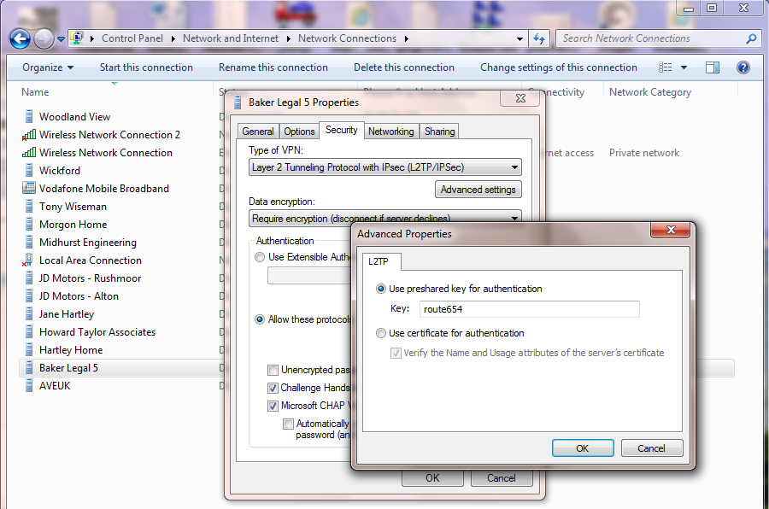
Navigate to Advanced properties and enter the Key as shown. OK >> OK and click on Baker Legal 5
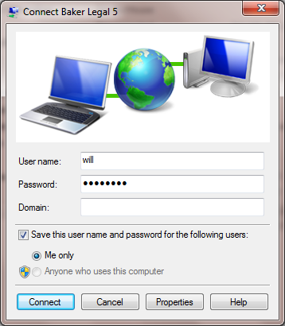
Enter username and password [kingston], tick the save option if you want to.
Click Connect
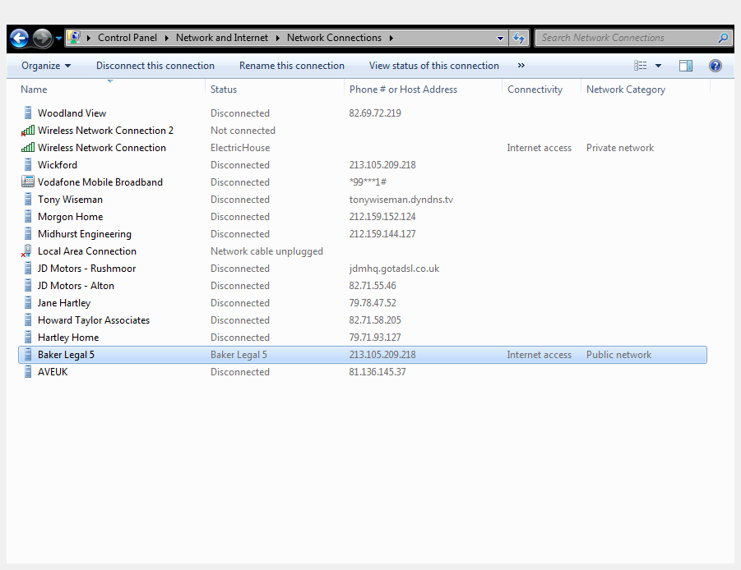
You will see confirmation that you are connected to the Baker Legal 5 network.
Create a shortcut for Baker Legal 5 on the desktop to make it easier to connect or disconnect in the future. Being on the Local Area Network it is possible to map a drive to the document store, use RDC, HTTP or HTTPS for access to Pro Computers, the DrayTek unit, snom phones, the document store and the printer. Mapping drives makes the transfer of files easier.

