Computer Installation and Telephone Services Fact Sheet
Company: Baker Legal Last Update: Monday, 29 May 2017

Business Address: Home Address:
Basilica House 18 Park Drive
334 Southend Road Ingatestone
Wickford Essex
Essex CM4 9DT
SS11 8QS

Business: 01428 687717
Wickford Virgin: 01268 459604
Other Fax: 020 7788 1298
Business Fax: 01428 788469

Wickford Office Broadband Service from Zen
Sharing offices with TCP Richings
Help Desk:
Provisioned Service Speed:
PPP Username: zen299936@zen
PPP Password:
Fixed IP: 88.98.92.243
Host Name: 88-98-92-243.dsl.in-addr.zen.co.uk

Former Virgin Service details
Broadband Service from Virgin Media Business [Account Number: 643392501]
Help Desk: 0800 052 0800
Provisioned Service: 50/5
PPP Username: bb006v8445@cable.vmbusiness.net
PPP Password: 8nalvg2l
Fixed IP: 213.105.209.218
Name Address: 218.209-105-213.static.virginmediabusiness.co.uk
Virgin Landline Number: 01268 459604

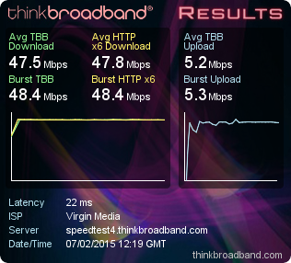

Night Service Facility
Provided on Function Key P6
Identity: 200920393 with DDI 01268 856409
Answered either by Jackie or Kirstey
email: kirstey.foot@tcprichings.co.uk
Telephone: 01268 572320

Workgroup: PLANET

DrayTek Router
Access: 192.168.60.1:8088
Userid: admin Password: elstead2008
Start IP Range: 192.168.60.50 to 109
SSID: Wise-Wingate Password: route654
SSID: WW-Guest Password: ww170115
Time Server: time.nist.gov
DNS: 194.168.4.123 and 194.168.8.123
Email: wickford.router@bakerlegal.co.uk Password: 3yx4yze38982

Connected Devices
IP Address MAC Address HOST ID User User Account Password
192.168.60.5 FC-AA-14-37-70-7D PHOENIX - StoreRoom files231114
192.168.60.15 00-80-91-AE-BA-90 Network Printer - Admin 123456
192.168.60.17 00-04-13-29-33-BD snom217 Rev 6 Jill pencil rubber
192.168.60.50 E8-03-9A-1D-94-99 Baker3
192.168.60.51 00-04-13-29-41-8E snom216 Tony none set
192.168.60.55 00-04-13-2C-CE-B1 snom393 TCP start finish
192.168.60.56 E8-03-9A-2B-C8-C0 Baker5
192.168.60.57 00-04-13-29-CB-FA Rebecca
192.168.60.58 A0-2B-B8-6C-79-53 HP5D15FB Tony
192.168.60.59 DC-A9-71-AC-33-3E Baker1
192.168.60.60 2C-60-0C-44-64-65 Baker12 Jill Jill 50lights
192.168.60.61 FC-DB-B3-2C-36-A4 android-ad4856859e3aabdb
192.168.60.62 C4-54-44-EE-06-9D Baker9 Anna Anna
192.168.60.63 88-25-2C-B1-9C-DD Stardust
192.168.60.64 F0-27-65-68-C7-51 android-51255e6d9fcb6a
192.168.60.65 C4-54-44-EE-06-9D Baker9 Anna Anna
192.168.60.66 2C-60-0C-44-64-94 baker7 Tony Tony 50lights

Sage
Instant Accounts S/N: E679318 Key: QFZNENG
Ebanking S/N E681020 Key: UDPSCLR [Does not appear to be used]

IVR Fax to email Service
01428 788469 >> fax@bakerlegal.co.uk
There is no email account for this email address; instead forwarding is used.


Network Connected Printer
Userid: Admin
Password: 123456
Supplied by Copy Care Services - Tele: 07973 677358
Fixed IP: 192.168.60.15
MAC: 00-80-91-AE-BA-90
Name: MFP11451024
Copier Model: TOSHIBA e-STUDIO2555C
Serial Number: C7DE53946
Scans go into a folder named file_share

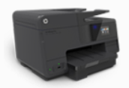
Network Connected Printer
Name HP Officejet Pro 8610
Model Number A7F64A
Userid: Admin Password: [not set]
Serial Number CN471CW1DR
Service ID 24284
Firmware Version FDP1CN1411AR
Wireless Fixed IP: 192.168.60.58
SSID: Wise-Wingate
MAC: A0-2B-B8-6C-79-53
Name: HP5D15FB

Wired (802.3)
Status: Not connected
Host Name: HP5D15FB
IP Address:
MAC: A0-2B-B8-5D-15-FB

HP Wireless Direct
Status: On
HP Wireless Direct Name: HP-Print-53-Officejet Pro 8610
HP Wireless Direct Channel: 6

VoIP Phones
Ext VoIP User Location MAC ID PW Code
10 200920393 TCP Richings Wickford 00-04-13-2C-CE-B1 start finish 4040
11 200820217 [3] Jill Wickford [BL] 00-04-13-29-33-BD pencil rubber 1879
12 200923663 [3] Rebecca Winchester 00-04-13-29-CB-FA sunrise sunset 2022
13 200920427 Tony [H] Ingatestone not on line
14 200820216 [3] Tony [O] Wickford [BL] 00-04-13-29-41-8E Nothing set
15 200923779 Hot Desk [1] Wickford [BL] 00-04-13-34-A6-0A Nothing set
16 200923782 DCB - 00-04-13-29-CF-86 woodland elstead 7644
17 200920410 Hot Desk [2] Wickford [BL] - ** Service via Router **
18 200920428 Paddie Tunbridge Wells 00-04-13-29-43-37 admin elstead 2014
8500 Voice Mail

Tony’s broken phone 00-04-13-29-56-D9 Apple route46 4020

MAC Address Identity User CLI DDI VMB VMB email
00-04-13-2C-CE-B1 200920393 TCP 01428 687717 01268 856409 8715 divert@bakerlegal.co.uk
Currently not a need for voice mail box 604 but please retain in reserve for future use

00-04-13-29-41-8E 200820216 Tony 01428 687717 01428 788250 8709 tony@bakerlegal.co.uk
200920243 Tony 01428 788211 01428 788211 614 general@bakerlegal.co.uk
200820245 Tony 01428 788232 01428 788232 613 general@bakerlegal.co.uk

00-04-13-29-33-BD 200820217 Jill 01428 687717 01428 788253 8710 jill@bakerlegal.co.uk
200920244 Jill 01428 788211 01428 788211 614 general@bakerlegal.co.uk
200920242 Jill 01428 788232 01428 788232 613 general@bakerlegal.co.uk

00-04-13-34-A6-0A 200923779 HD 01428 687717 01892 882899 9048 general@bakerlegal.co.uk

200920427 Tony [H] 8717

Check List
192.168.60.17 00-04-13-29-33-BD snom217 Jill OK
192.168.60.55 00-04-13-2C-CE-B1 snom393 TCP OK
192.168.60.51 00-04-13-29-41-8E snom216 Tony OK
192.168.60.57 00-04-13-29-CB-FA snom663 Rebecca Instrument not on site

SIP Password is either esoteric31415 or baker31415 and for 200923782 is elstead31415

Quick Overview of VoIP
Ext VoIP User Location MAC ID PW Code VMB
10 200920393 Ana Wickford [BL] 00-04-13-2C-CE-B1 4040 8715
11 200820217 Jill Wickford [BL] 00-04-13-29-33-BD 1879 8710
12 200923663 Rebecca Winchester 00-04-13-29-CB-FA sunrise sunset 2022 8719
13 200920427 Tony Ingatestone Nothing set 8717
14 200820216 Tony Wickford [BL] 00-04-13-29-41-8E 8709
15 200923779 -- Wickford [BL] 00-04-13-34-A6-0A Nothing set
18 200920428 -- Tunbridge Wells 00-04-13-29-43-37 admin elstead
17 200920410 Hot Desk Wickford - ** Service via Router ** 8716
16 200923782 David Walled Garden 00-04-13-34-A6-97 woodland route654 7644 9058

Provisioning URL: http://snom.provu.co.uk/snom360.php?mac={mac}
** SIP Password is either esoteric31415 or baker31415 and for 200923782 is elstead31415
Apple route46 4020
Time Server: pool.ntp.org

Used in Wickford Router Used in spare DCB snom
Identity: 200920410 200923782
Password: bk31415 elstead31415
POTS: 020 3627 3974 01202 912871
Voice Box: 8716 9058
Original setup
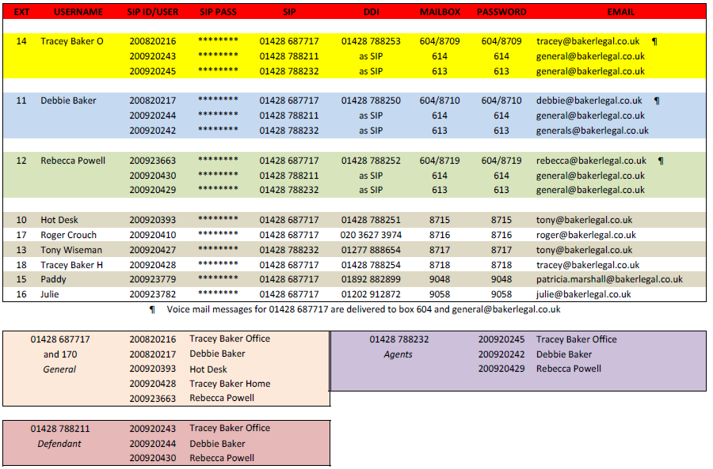
Notes:
Incoming calls to 01428 788232 rings …….
Incoming calls to 01428 788211 rings …….

The short code 170 and 01428 687717 should ring:
200920393 [Hot Desk], 200820217 [Debbie], 200820216 [Tracey], 200920428 [Tracey H] and 200923663 [Rebecca]

Control Panel
www.bakerlegal.co.uk:2082 or https://ns10.sovdns.com:2083/
Username: whitley
Password: P349dfmmgm
Changed to 2QWvtK*[K,(W Wednesday, 2 November 2016
Changed to 2v6tJtD&{fK] Monday, 29 May 2017

Microsoft Office [Debbie Purchase]
XJJ6C-WPWY3-HWFHQ-37TBC-HQ4PT

ESET Smart Security Business Edition
Number of computers: 7 - Expiry date: 08/08/2015
Username: EAV-50056975 Password: hemx25dnhe

Seagate NAS
Help Desk: 00800 4732 4283
Check that the serial number is NA6102LR
Access within the office: http://BA-390B31:8082/ or http://192.168.60.64:8082/
Administration Userid: admin Password: route654

Manual - http://www.seagate.com/files/www-content/about/newsroom/media-kits/_shared/images/BlackArmorNAS110UserGuide.pdf

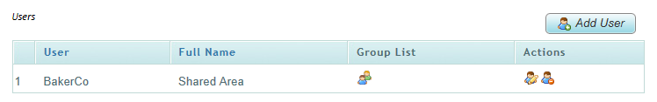

To access files and folders remotely use Seagate Global Access: https://seagate.tappin.com/login
User email password
BakerCo documents@bakerlegal.co.uk route654

Tony Wiseman
Email: tony@bakerlegal.co.uk

Broadband Service from BT
Draytek 2820: [192.168.1.1]
Userid: admin Password: elstead2008
BT Help Desk: 0800 111 4567

Private: 01892 549692? 01277 356271 Mobile: 07932 418664 Fax: 01245 330044
Email: tony.wiseman18@btinternet.com
VoIP: 200920427
Computers: E8-03-9A-1D-94-99 Baker3 00-13-77-AE-FA-E7 Applegarth

Last known WAN address: 31.51.180.16
SSID: WiseHome Password: route630

VPN:
Account: tony Password: legalfour

Patricia Farley
20 Princes Street, Tunbridge Wells, TN2 4SL
Email: patricia.marshall@bakerlegal.co.uk

30Mb Broadband Service from Virgin
Using Virgin Media Super Hub which has no DDNS
Info: http://www.expertreviews.co.uk/wireless-routers/1282879/virgin-media-super-hub
Router: http://82.40.187.147:8080/ Userid: admin Password: england08
snom300: https://82.40.187.147:443/ Userid: admin Password elstead2008

79.77.135.37

Private: 01892 549692 Mobile: 07751592943 Email: johnmashall@hotmail.com
VoIP: 200923779 Last connected as 192.168.0.5 on Monday, 20 August 2012
Computer: 88-25-2C-B6-C4-A6 Garrett - Black Toshiba

VPN
Account: paddie Password: paddie

Email Service

Email account passwords [where known]
accounts@bakerlegal.co.uk 20b7bzuyiihp
anna@bakerlegal.co.uk 7hig7163rkbx
debbie@bakerlegal.co.uk
general@bakerlegal.co.uk 4vq8ccg247o5
jill@bakerlegal.co.uk 2t6ysugcodxp
patricia.marshall@bakerlegal.co.uk elstead2008
phillip@bakerlegal.co.uk 44nrzfo9wtfu
rebecca@bakerlegal.co.uk 9xd9usahhxrf
reception@bakerlegal.co.uk 5a7c3knzh5na
support@bakerlegal.co.uk nkmsrpnc21d4
sysadmin@bakerlegal.co.uk 49lgy700wp7v
tony@bakerlegal.co.uk dgum0s4z6fu5
wickford.printer@bakerlegal.co.uk
wickford.router@bakerlegal.co.uk

Forwarding
fax@bakerlegal.co.uk >>> jill@bakerlegal.co.uk
fax@bakerlegal.co.uk >>> rebecca@bakerlegal.co.uk
fax@bakerlegal.co.uk >>> tony@bakerlegal.co.uk
messages@bakerlegal.co.uk >>> jill@bakerlegal.co.uk
messages@bakerlegal.co.uk >>> rebecca@bakerlegal.co.uk
messages@bakerlegal.co.uk >>> tony@bakerlegal.co.uk
paddy@bakerlegal.co.uk >>> patricia.marshall@bakerlegal.co.uk
patricia@bakerlegal.co.uk >>> patricia.marshall@bakerlegal.co.uk
tracey@bakerlegal.co.uk >>> rebecca@bakerlegal.co.uk
webmaster@bakerlegal.co.uk >>> david@cyberpictures.net
debbie@bakerlegal.co.uk >>> rebecca@bakerlegal.co.uk

Wiseman Wingate Solicitors
sysadmin@wwslegal.co.uk 7q00wekwvfaz
tony@wwslegal.uk f9mnop7r9cz2
rebecca@wwslegal.uk f4fo90whf6t8
jill@wwslegal.uk wg79n6zf7qn6
patricia@wwslegal.uk fph7496ag887
general@wwslegal.uk 94vit4dal2q8

Incoming POP3: 995 with SSL
Outgoing: SMTP: 465 with SSL
POP3 and SMTP Server: ns34.sovdns.com

Configured with smtp-auth.gotadsl.co.uk authentication
Username: alfa2@gotadsl.co.uk
Password: vhig1kej

URL: http://ns34.sovdns.com/cpanel
Username: davi3252
Password: DtgL1ug5eh
Callmaster
Identity: 200920410
Password: bk31415
POTS: 020 3627 3974
Voice Box: 8716
Email advice: hd@bakerlegal.co.uk
Call Return Code: *69

Draytel
Administration: sysadmin@bakerlegal.co.uk Password: route654

Domain name:
bakerlegal.co.uk
Registrant:
Tracey Baker
Registrant type:
UK Sole Trader
Registrant's address:
4 Bannister Close
Whitley
United Kingdom
GU8 5RR
United Kingdom
Data validation:
Registrant contact details validated by Nominet on 10-Dec-2012
Registrar:
Compila Limited [Tag = COMPILA]
URL: http://www.compila.com
Relevant dates:
Registered on: 24-Jan-2008
Expiry date: 24-Jan-2018
Last updated: 09-Sep-2014
Registration status:
Registered until expiry date.
Name servers:
ns10.sovdns.com
ns10sec.sovdns.com
Server – Desktop – Document Store
Windows 8.1 Pro
Product Part No.: [Blue]X18
Product ID: 00259-40846-86988-AAOEM match to CD Key data
CD Key: XYRX9-TKNWK-2F3CM-3JC8W-J8D2Q
Computer Name: PHOENIX
Registered Owner: StoreRoom [Previously User]
Registered Organization:

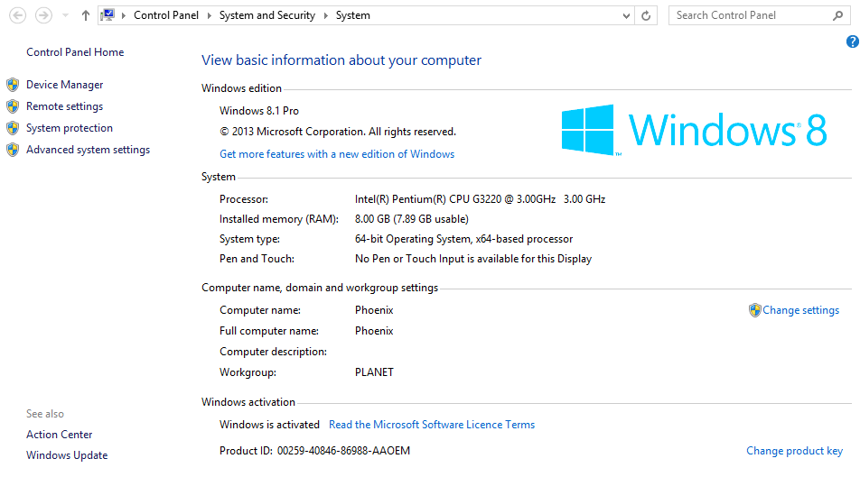

Appendix

Cancel BT Service
A/C Number: TH15264837
Telephone Number: 01252 7038001
Outgoing calls need to be prefixed with 9

Cancel Broadband Service from TalkTalk Business
Account Number: 1303909
Service on 01252 703001
TalkTalk: 0800 083 3003 Password: trolleybus
ADSL Login: alfa2@gotadsl.co.uk Password: vhig1kej

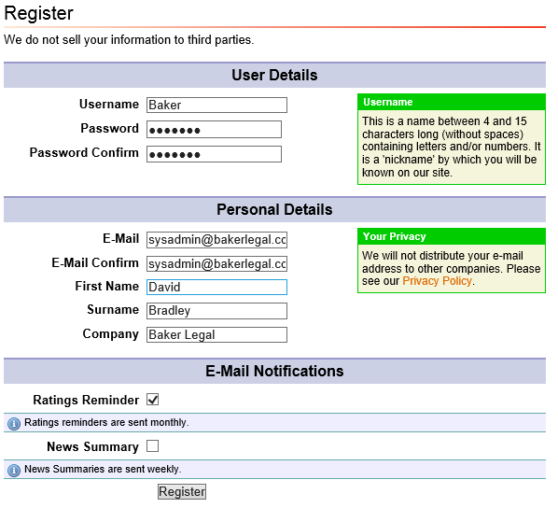
Note Username is: BakerLegal

From: >Essentials [mailto:essentials@virginmedia.co.uk]
Sent: 02 February 2015 14:24
To: tony@bakerlegal.co.uk
Cc: david@cyberpictures.net
Subject: Account : 643392501 BAKER & CO 5 ips

Hello,

Thank you for your recent contact regarding your Ips.

Following our conversation, you have opted to set up a subnet on the account.

A Subnet consists of 5ips and will enable you to use the wireless capabilities of a 3rd party router, set up voips, vpns, it gives a gateway IP and Subnet IP and allows you to do other things.

Before you are able to take full advantage of the features above, we require you to complete the configuration sheet attached, doing so will allow you to connect to the internet.

Please be aware, we can only offer support on the physical connection and not setting the ips to pieces of equipment etc.

If you require further assistance regarding this or any other matter, please contact us on the number below between 9am and 5pm Monday to Friday, or respond to this email.

Thank you.

Kind regards,

David Oldershaw
Business Essentials Customer Care Representative
Virgin Media Business
1 Chippingham Street
Sheffield
S9 3SE
T: 08000520800
F: 08009533800
Email - essentials@virginmedia.co.uk



Your Super Hub Mac is: 2C:B0:5D:05:24:5C

Your IP Range is: 213.105.209.216 - 213.105.209.223

Below are your IP addresses and which parts are usable.

Start Address: 213.105.209.216<<<<<<<<< NETWORK IP
213.105.209.217<<<<<<<<< GATEWAY IP
213.105.209.218<<<<<<<<< AVAILABLE FOR CUSTOMER USE
213.105.209.219<<<<<<<<< AVAILABLE FOR CUSTOMER USE
213.105.209.220<<<<<<<<< AVAILABLE FOR CUSTOMER USE
213.105.209.221<<<<<<<<< AVAILABLE FOR CUSTOMER USE
213.105.209.222<<<<<<<<< AVAILABLE FOR CUSTOMER USE
End Address: 213.105.209.223<<<<<<<<<<<<<<<<<< BROADCAST IP

Subnet Mask is 255.255.255.248 for 5 static IPs and 255.255.255.240 for 13 static IPs

PPP Username: bb006v8445@cable.vmbusiness.net
PPP Password: 8nalvg2l

Follow these steps:

Once these details have been saved and the superhub has fully rebooted, you will then be able to break out to the internet from your device!

Please note this hub will no longer have the wireless feature and you will need to configure your own device (e.g. router) to break out if you are using more than 1 device.

Set a fixed IP up on the Network card of your device
[Network settings on laptop or desktop]

The IP should be 192.168.0.2 - subnet mask should be 255.255.255.0 - Gateway 192.168.0.1 No need to alter the DNS settings. This is on the assumption that the LAN settings were never changed!!

Open web browser
Type 192.168.0.1 and press enter

Enter the username: admin
Enter the password: changeme (this is default so maybe different if you have changed it)

You will then be presented with the below. Please click on advanced settings.

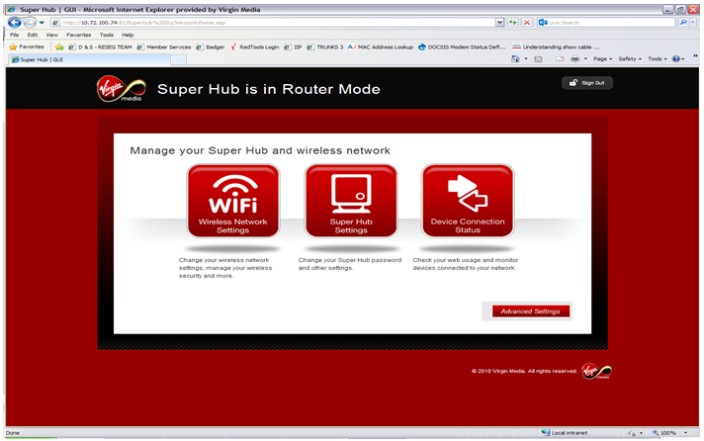

Scroll Down to Business settings and select Static IP subnet Setup
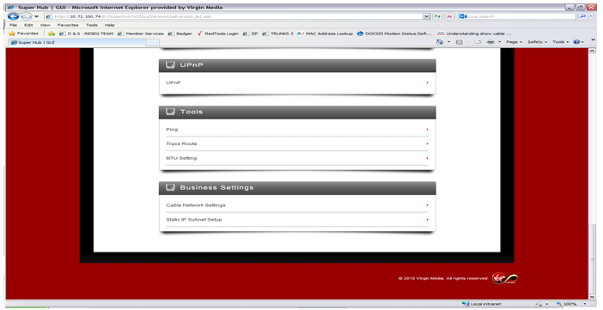

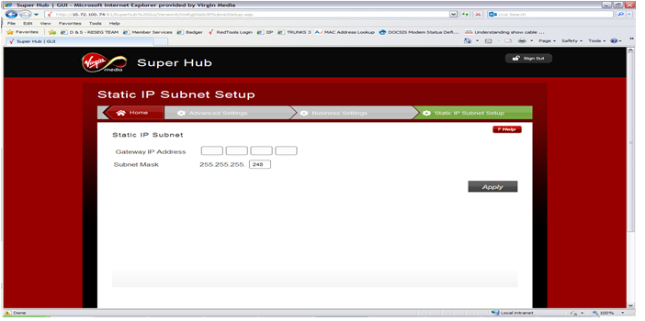
Enter the Gateway IP address as noted above and the subnet mask, then click apply.

Once this has been completed, you will then need to change the IP address on your network card to one of the available IP addresses that have been assigned to you.

This should be configured as below:

IP address: 213.105.209.218
Subnet Mask: 255.255.255.248 (This should be 240 if you have 13 static IPs)
Gateway IP: 213.105.209.217

DNS Servers: Primary: 194.168.4.123 and Secondary: 194.168.8.123

