Computer Installation Notes
Last Update: Monday, 07 May 2012

Full Name:
Barbara Newell

Home Address:
112 Abbey Road
Basingstoke
Hampshire
RG24 9EB

Home: 01256 843765
Email: newell.barbara@hotmail.com
Email2: barbara.newell@virginmedia.com – casualday1

Broadband Service from Virgin Media [Account Number: 0000]
Router: 192.168.112.1 Start IP: 192.168.112.112 Pool Count: 20
Userid: admin Password: elstead2008
Time Server: time.nist.gov

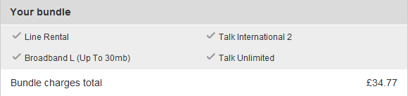

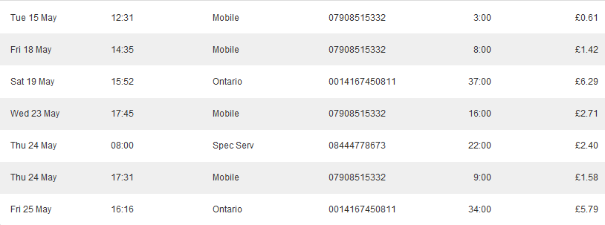

Computer[s]:
Name: Dulux
Workgroup: BEE

Wireless: [WPA-SPK Security]
SSID: Honey Password: route654

ESET Smart Security Home Edition
Number of computers: 1
Expiry date: 18 September 2012
Username: EAV-34930870
Password: c7e7rvc2sm
Help Desk: 0845 838 0832

Virgin Security
What’s my pet’s name: Priddy
Reference number: 752684703

