Computer Installation – Bradley’s Home
Last Update: Sunday, 10 January 2021

Home Address:
5 Raglan Close
Frimley
Camberley
Surrey
GU16 8YL

Telephone:

Username: steve@bradleyshome.co.uk
Password: 5beudb7xcny3qiwz
Incoming Server: sxb1plzcpnl437829.prod.sxb1.secureserver.net
IMAP Port: 993
Outgoing Server: sxb1plzcpnl437829.prod.sxb1.secureserver.net
SMTP Port: 465

IMAP and SMTP require authentication.

Broadband Service: Virgin Cable Speed: 80/5
Last know WAN address: 82.14.243.119

LAN IP: 192.168.0.1 Start: 2 End: 254 Lease Time: 1 Day
Remote Management: ON Only Allowed: Blank Port No.: 8080

Router on LAN: 192.168.0.1 Remote Access: http://82.14.243.119:8080/
Password: elstead2008 Use Firefox to connect

Router on LAN: 192.168.0.11 Remote Access: http://82.14.243.119:8081/
Username: admin Password: elstead2008 Use Firefox to connect

Wireless
Living Room SSID: virginmedia0766292 Channel: Auto Password: gzsgavns

Games Room SSID: 00:14:6c:5a:86:da 192.168.0.8
Family Room SSID: ParkRoad Channel: 11 Password: route654

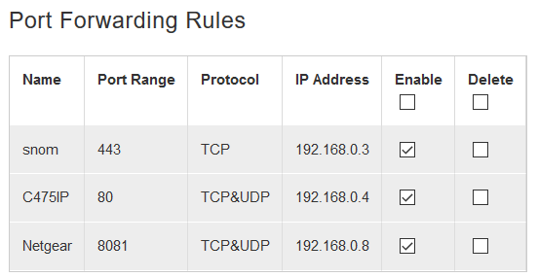
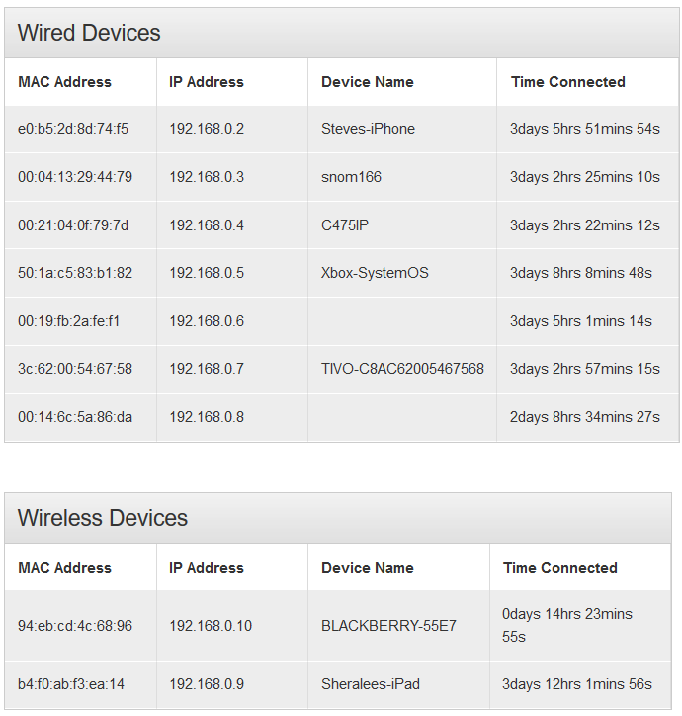

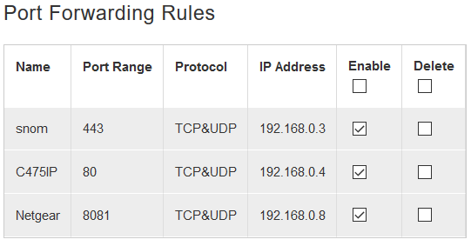

Login URL: https://sxb1plzcpnl437829.prod.sxb1.secureserver.net:2083/
Login Username: egs3dj5wzey2
Login Password: 66kkx4CFkA!

Secure SSL/TLS Settings (Recommended)
Username: steve@bradleyshome.co.uk
Password: sb7kobf0bk2d
Incoming Server: sxb1plzcpnl437829.prod.sxb1.secureserver.net
IMAP Port: 993

Outgoing Server: sxb1plzcpnl437829.prod.sxb1.secureserver.net
SMTP Port: 465

IMAP and SMTP require authentication.

Webmail
https://sxb1plzcpnl437829.prod.sxb1.secureserver.net:2096
Username: steve@bradleyshome.co.uk
Password: sb7kobf0bk2d

Email Accounts
steve@bradleyshome.co.uk sb7kobf0bk2d
sysadmin@bradleyshome.co.uk

Snom identity 200921166 Logon Userid to GUI: trolleybus Password: route654
Rings on 01252 733200 and DDI 01252 739166 No voicemail facilities except on 200
HT Office
733200
SF
733200
SRB
Jane
Spares
Katherine
HT Home
Alex
ARB Work
James

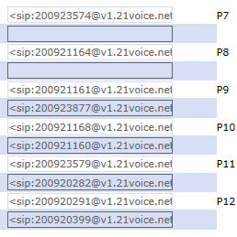

P7 200923574 HT Office
P1 733200 Line
P8 200921168 SF
P2 733200 Line
P9 200921161 SRB
P3 200923877 Jane
P10 200921164 SPARES
P4 200921160 Katie
P11 200923579 HT Home
P5 200920282 Alex
P12 200920291 ARB Work
P6 200921165 James

Access to Gigaset: http://82.14.243.119 – Password: 2010. Using port 80 [no option to change]
DrayTEL Numbers: [Domain: draytel.org]
8304582 Password: Got2lq=X Registration ID not known
8234859 * Password: 41870110 steve.bradley@aveuk.net cr1cket
* No idea where this number is installed.

Gigaset C475IP Identities:
#1 Callmaster: 200921169 Password: RnkF3x3S
#2 DrayTEL: 8304582 Password: Got2lq=X
#9 Gigaset: 213894604002
Computer Inventory

Pepsi – Laptop – Ben
Userid: Ben
Password: flyby10
MAC: C4-46-19-11-88-C5
Windows 7 Home Premium Service Pack 1
Product Part No.: X15-37379
Product ID: 00359-OEM-8992687-00006 match to CD Key data
CD Key: VQB3X-Q3KP8-WJ2H8-R6B6D-7QJB7
Computer Name: PEPSI
Registered Owner: Ben
Registered Organization:

Microsoft Office Home and Student 2007
Product ID: 81602-908-4085605-68934
CD Key: C9YGJ-XW92H-KGYH9-TRKFR-37RFY

Command and Conquer: Generals
Key: 4515472413968607141958

Command and Conquer: Generals Zero Hour
Key: 7TRZXLVFGTHS87HKF7NJ
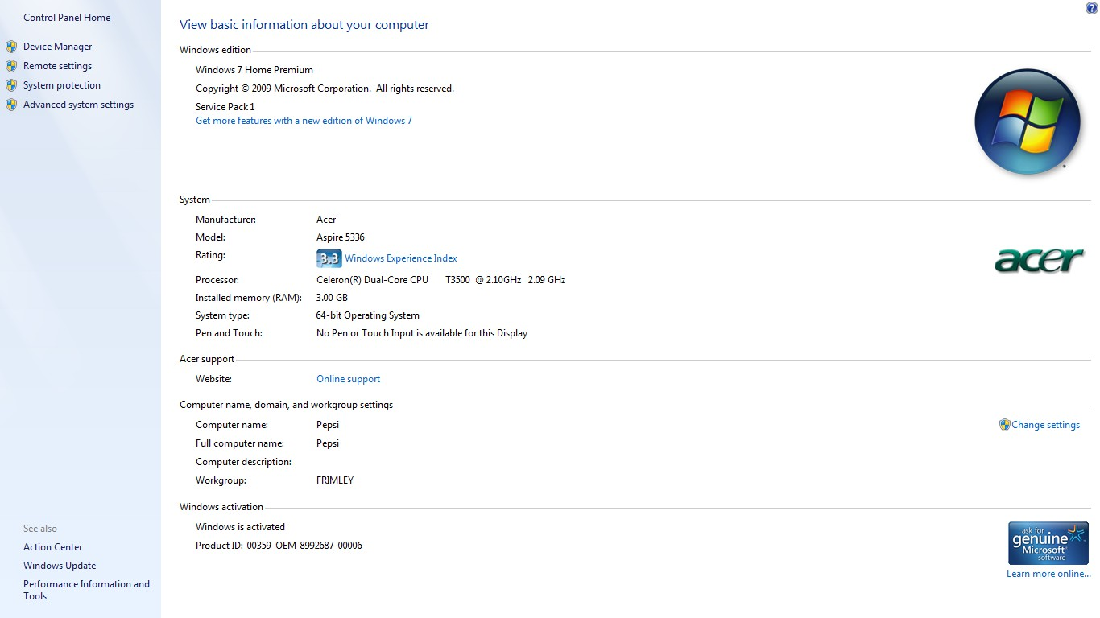

Domain Control Panel:
https://ns39.sovdns.com:2083/
Login: raglan Password: ID>m5ly%z4nH

Domain name:
bradleyshome.co.uk
Registrant:
Steven Bradley
Registrant type:
Unknown
Registrant's address:
5 Ragland Close,
Frimley
Surrey
GU16 8YL
United Kingdom
Data validation:
Nominet was able to match the registrant's name and address against a 3rd party data
source on 10-Dec-2012
Registrar:
Paragon Internet Group Ltd t/a Vidahost [Tag = THERMAL]
URL: http://vidahost.co.uk
Relevant dates:
Registered on: 05-Jan-2004
Expiry date: 05-Jan-2017
Last updated: 05-Aug-2015
Registration status:
Registered until expiry date.
Name servers:
ns10.sovdns.com
ns10sec.sovdns.com
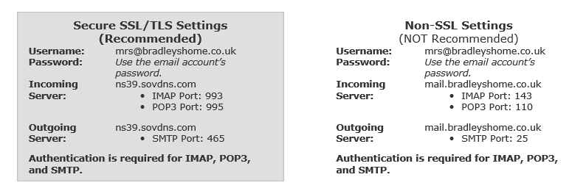
Domain name:
machinerysolutions.co.uk
Registrant:
Steven Bradley
Registrant type:
UK Sole Trader
Registrant’s address:
5 Raglan Close
Frimley
Camberley
Surrey
GU8 6HQ

Registrar:
GX Networks Ltd t/a 123-Reg.co.uk [Tag = 123-REG]
Relevant dates:
Registered on: 21-Sep-2009
Renewal date: 21-Sep-2011
Last updated: 21-Sep-2009

Name servers:
ns10.sovdns.com
ns10sec.sovdns.com

Machinery Solutions
www.machinerysolutions.co.uk:2082
davi0919
7QQvsEnFUZ

Email Accounts:
steve.bradley@machinerysolutions.co.uk cr1cket
sales@machinerysolutions.co.uk &%E?6!KW
accounts@machinerysolutions.co.uk 27sus8dexgp7
james.crighton@machinerysolutions.co.uk z66zlb7t42g7
alec.simister@machinerysolutions.co.uk 40y8ot072zin

Setup
Incoming Server: ns28.sovdns.com IMAP Port: 993
Outgoing Server: ns28.sovdns.com SMTP Port: 465
Authentication is required with SSL.

http://www.pspreforms.com/cpanel
Username: davi6749
Password: jIdTwijTZS

