Computer Installation Notes
Version: Wednesday, 23 August 2023

Full Name: Colin Lock

Home Address:
50 Weyhill
Haslemere
Hampshire
GU27 1BX

Home: 01428 652357
Email: colin@ingleoak.co.uk

Username: colin@ingleoak.co.uk
Password: 45yf5hf83qgrmz2q
Incoming Server: sxb1plzcpnl489859.prod.sxb1.secureserver.net
IMAP Port: 993
Outgoing Server: sxb1plzcpnl489859.prod.sxb1.secureserver.net
SMTP Port: 465

IMAP and SMTP require authentication.

ESET
Public ID: 33C-9PH-KRB
Username: EAV-33460272
Device name: SOUP
Seat name: Soup
Product name: ESET Internet Security
Product version: 19.0.14.0
Operating system: Windows 11 Pro(64-bit)Version 10.0 (Build 26100)
Machine: Intel(R) Core(TM) i5-2410M CPU @ 2.30GHz, 8064 MB RAM
Password: mtcpvpxspv
9EC9-X79B-CJCD-J8TN-H3JC

DELL Computer: Soup
Test
Matey40

Google
colinlock722@gmail.com
Matey400

TSOHOST
davi9284
83zjcwjcygkz

Sky Broadband Support:
help@skycustomersupport.com
08442 410515 - Lines are open 24 hours a day.

ESET
01202 405 405 Mon – Fri 08:30 - 17:30
Product: ESET Smart Security Home Edition
Number of computers: 2
Number of years: 2
Expiry date: 04/08/2014
Username: EAV-33460272
Password: mtcpvpxspv
9EC9-X79B-CJCD-J8TN-H3JC
Home Account Password: WestCroydon630

https://www.eset.com/uk/home/internet-security/loyalty-reward-download
GBAH-W344-AC5T-TFKG-THFA
GBAH-W344-AFNH-HJNU-BMKG
GBAH-W344-AAEF-FMSN-U3AU
Each license needs to be activated on or before 29th February 2024.

Router
Userid: admin
Password: sky

POP / SMTP email information
Incoming mail server (POP3): pop.tools.sky.com – Use port 995 with SSL
[Alternative setting pop.gmail.com]
Outgoing mail server (SMTP): smtp.tools.sky.com – Use port 465 with SSL
[Alternative setting smtp.gmail.com]
Outgoing server requires authentication [Same]

Wireless
SSID: Normandy
Password: route654

Router
Userid: admin
Password: sky

Steps to Add Yahoo Mail to Outlook (Classic & New):
Generate an App Password (Necessary if 2FA is on):
Sign into your Yahoo account in a web browser.
Go to Account Info > Security > Generate App Password.
Select "Outlook" from the dropdown and click Generate.
Copy the password provided.
spiqxxiebyzlngxs
Add Account in Outlook:
Open Outlook and select File > Add Account.
Enter your full Yahoo email address and click Connect.
When prompted for a password, enter the app password you generated.
Click Finish to complete setup.

The logon password to the account is now:
FairGreen612^2026
------------------------------------

Sign in to your Sky account online.
Navigate to the "Sky Yahoo Mail" section to generate an app password, as regular passwords often fail due to security settings.
Generated app password; result:
zzsolatblhxftlpz
Add Account in Outlook:
Open Outlook, click File > Add Account.
Enter your full @sky.com email address and click Connect.
When prompted for a password, paste the App Password generated above.
If using manual setup, use the following IMAP/SMTP settings:
Incoming Mail (IMAP) Server: imap.tools.sky.com
Incoming Port: 993 (Requires SSL)
Outgoing Mail (SMTP) Server: smtp.tools.sky.com
Outgoing Port: 465 or 587 (Requires SSL)

Username: susan@ingleoak.co.uk
Password: a33tr9o708y5wuov
Incoming Server: sxb1plzcpnl489859.prod.sxb1.secureserver.net
IMAP Port: 993
Outgoing Server: sxb1plzcpnl489859.prod.sxb1.secureserver.net
SMTP Port: 465

IMAP and SMTP require authentication
Webmail: ingleoak.co.uk:2096

-------------------------------------

ESET
URL: login.esit.com/login
Password: Colsus2026^
Public ID: 33C-9PH-KRB
Username: EAV-33460272
Device name: KUKANA1953
Seat name: kukana1953
Product name: ESET Internet Security
Product version: 19.0.14.0
Operating system: Windows 11 Home(64-bit)Version 10.0 (Build 26200)
Machine: Intel(R) Core(TM) Ultra 7 258V, 32385 MB RAM
Password: mtcpvpxspv
9EC9-X79B-CJCD-J8TN-H3JC

---------------------------------------

Microsoft Account: lock-susan@sky.com
Computer KUKANA1953 Login Pin: 654630 Warranty until: 6 JAN 2027
Google Account: lock-susan@sky.com
HP Account: lock-susan@sky.com Peperharrow2026$
DOB: 12 APR 1953
Mobile: 07838381818 07952910238
Email: goosey53@outlook.com kukana294@gmail.com

The settings were applied like this:
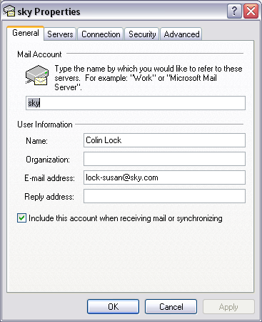

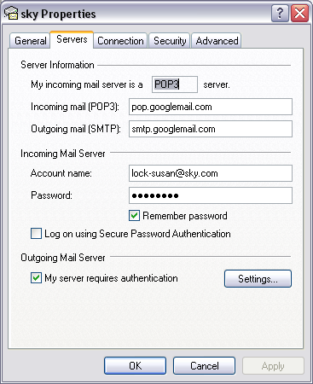

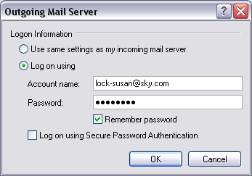

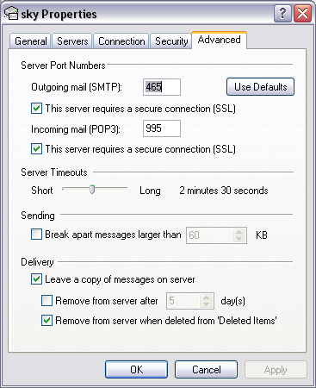

User Name: lock-susan@sky.com
Password: saints10

Access to www.sky.com/mysky/
Username: lock-susan
Password: bond

Log onto mail.tools.sky.com and changed the settings in the mailbox settings tab to enable POP access
The steps for doing it are:-
- Log onto mail.tools.sky.com
- Click on ‘Check Emails’ or ‘Go To Inbox’
- Click on the ‘Mail Settings Tab’
- On the settings page, click on ‘forwarding and pop’
- Place the dot next to ‘Enable POP for all mail’
- Click on ‘save changes’

After enabling POP, you may find Outlook constantly asking for a password, if this is the case, please follow the steps below:
- Close your email client application
- From the computer on which the POP logins are failing, go to www.sky.com/unlock Enter your Username and Password, and the letters in the distorted picture.
- Once you have successfully logged in, restart your mail Client application and try to download your mail.

Registration Information
Domain name:
ingleoak.co.uk

Registrant:
Colin Lock

Registrant type:
Unknown

Registrant's address:
50 Weyhill
Haslemere
Surrey
GU27 1BX
United Kingdom

Registrar:
Compila Limited [Tag = COMPILA]
URL: http://www.compila.com

Relevant dates:
Registered on: 04-Aug-2010
Expiry date: 04-Aug-2013
Last updated: 30-Jul-2012

Registration status:
Registered until expiry date.

Name servers:
ns15.sovdns.com
ns15sec.sovdns.com

Windows 10
License: 8RN7Y-3C78M-6Y72Q-GGBTX-P38GG
​https://www.microsoft.com/en-us/software-download/windows10

