Computer Home Installation and Telephone Services Fact Sheet
2 Shipley Close, Alton, GU34 2RW

Version: Sunday, 1 December 2013

David Drew Limited t/a JD Motors, Registered in England & Wales Registration Number: 08229200
Registered Office: Unit 31, Base Point Business Centre, Winnall Valley Road, Winchester, Hampshire, SO23 0LD

Home: 01420 83250
JD Line: 01420 83609
Garage: 01420 544644
Mobile: 07887 524472

E-mail: dave.drew@jd-motors.co.uk
E-mail 2: EDREW275@aol.com
Web Page: http://www.jd-motors.co.uk

Draytek Router Model Name: Vigor2820Vn Title: Shipley
Firmware Version: 3.3.7.3_232201 Build Date/Time: Sep 13 2012 19:09:39
ADSL Firmware Version : 232201_A Hardware: Annex A
Router: http://192.168.202.1 Userid: admin Password: elstead2008
LAN Start IP Address: 192.168.202.202 Pool Size: 30

Broadband Service from Zen Connected to: 01420 83609
Zen Order No: 969002 - Date order placed: 22-Nov-2013 Scheduled Installation date: 2-Dec-2013 PM
Help Desk: 01706 902000 Customer Portal: http://portal.zen.co.uk/
8am - 8pm, Monday to Friday Username: david@jd-motors.co.uk
9am - 5pm on Saturdays and Sundays Password: route654

WAN address to router: http://82.71.12.19:8080/ access via VPN is ok
Zen username: zen255123@zen
Connection password: mMmL9ML9
Static IP Address: 82.71.12.19 [Subnet mask 255.255.255.255]
Primary IP Address: 212.23.3.100
Secondary IP Address: 212.23.6.100
Wireless SSID: Lewis Password: route654 Security: WPA/PSK2 Channel: Auto

Default email username: zen255123@zen.co.uk
Default email password: 4bAb6GA3
Default web space username: zen255123
Default web space password: 4bAb6GA3

Former Broadband Service from TalkTalk Connected to: 01420 83609
Help Desk: 0800 083 3003

WAN address to router: http://84.12.100.64:8080/
Login: jdmdd@gotadsl.co.uk
Password: klet9pex
Static IP Address: 84.12.100.64
Primary IP Address: 212.139.132.43
Secondary IP Address: 212.139.132.44
Wireless SSID: Lewis Password: route654 Security: WPA/PSK2 Channel: Auto

All Devices [Mclaren is bound to MAC]
IP Address MAC Address Device Name Operating System User Password
192.168.202.1 00-50-7F-26-3B-5A ROUTER 3.3.7.3_232201 admin elstead2008
192.168.202.202 94-44-44-07-F6-B6 TV
192.168.202.204 88-25-2C-B6-85-41 Mclaren Windows7 Pro J D Motors route654
192.168.202.205 64-20-0C-D6-C6-89 iPad
192.168.202.206 E0-C9-7A-D5-12-7A Lewis-iPhone
192.168.202.207 00-88-65-A5-41-DE Emmas-phone
192.168.202.209 1C-AB-A7-58-F8-48 iPad
192.168.202.210 88-30-8A-36-C5-ED android-3385ea1611f03f31
192.168.202.211 3C-E0-72-C4-79-96 Sherries-iPad
192.168.202.213 04-F7-E4-F3-57-F8 iPhone

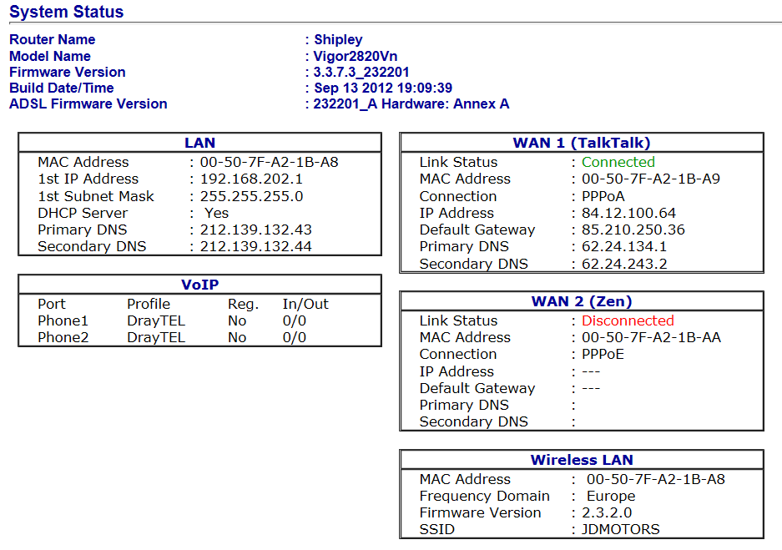

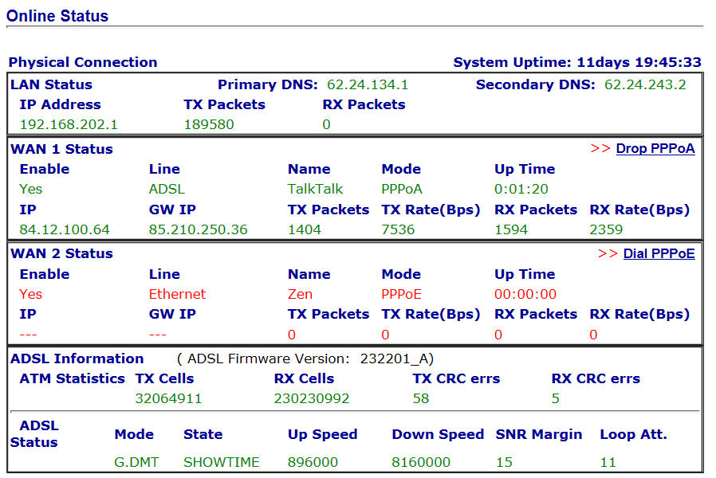

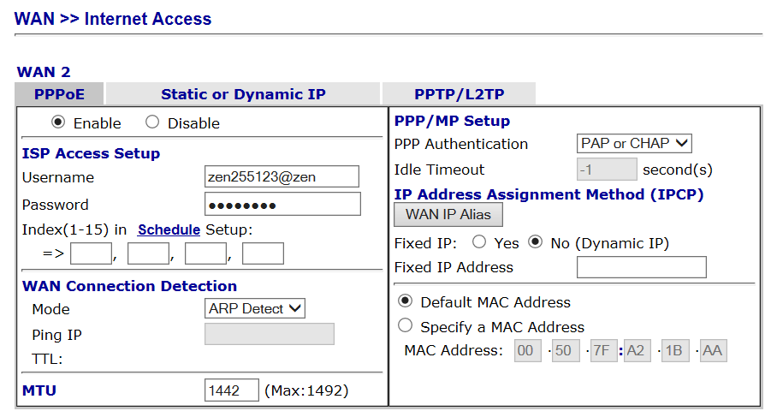
ISP Password: mMmL9ML9
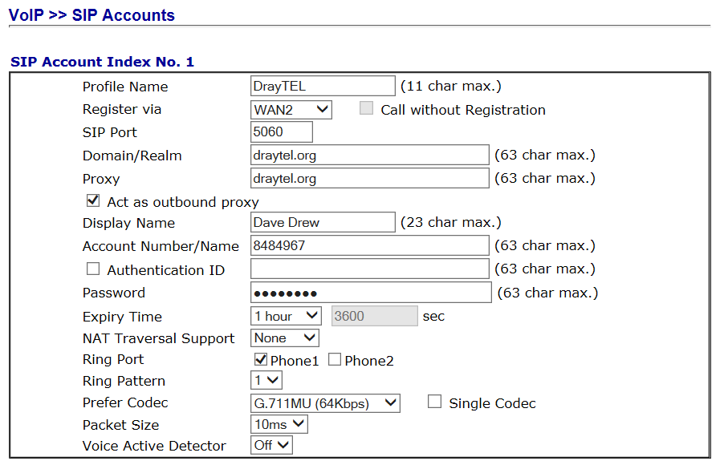

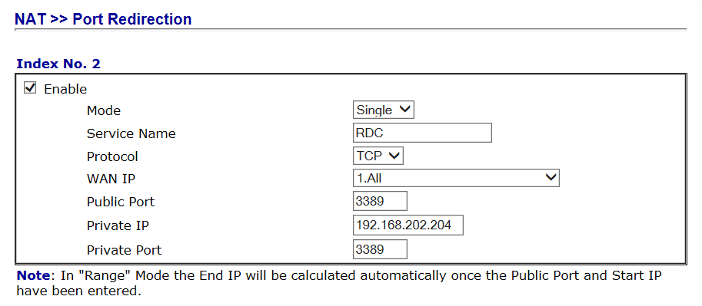

Compila Control Panel
http://www.jd-motors.co.uk/cpanel
Login: davi1819 Password: kte4rew3bNhg

ESET - Endpoint Security
Telephone Number: 0845 838 0832
Registered by Licence No Password Expiry Date No of PCs
david@jd-motors.co.uk EAV-55959751 dxenbpu8s3 24/08/2013 16

Telecommunication Facilities
- 01420 83250 Domestic Number
Supports 2*Sky. Issues with internal wiring suggest best not to use a broadband service on this line
- 01420 83609 Night Service Line
Supports broadband service
- 8484967 >7DZ(mtt david@jd-motors.co.uk route654

Upgrade to FTTC

Telephone Number 0142083609 on Exchange ALTON is served by Cabinet 4
Featured Products | Downstream Line Rate(Mbps) |  | Upstream Line Rate(Mbps) |  | Downstream Range(Mbps) | Availability Date
 | High | Low | High | Low
FTTC Range A (Clean) | 80 | 78.1 | 20 | 20 | -- | Available
FTTC Range B (Impacted) | 80 | 67.2 | 20 | 19 | -- | Available
WBC ADSL 2+ | Up to 17 |  | -- |  | 10 to 19.5 | Available

For FTTC Ranges A and B, the term "Clean" relates to a line which is free from any wiring issues (e.g. Bridge Taps) and/or Copper line conditions, and the term "Impacted" relates to a line which may have wiring issues (e.g. Bridge Taps) and/or Copper line conditions.

VPN
david elstead

