Computer Installation at David Bradley Online
Last Updated: Saturday, 30 May 2026

david.bradley@mideng.co.uk
WestCroydon630^

From: Atera <noreply@atera.com>
Sent: 14 February 2025 08:29
To: david@mideng.co.uk
Subject: Welcome to Atera


Dear David,
We received a request from kieran to set you up as a technician in Atera.

Your username is: david@mideng.co.uk

Please click the button below to set your password:

Set My Password

This link is good until today at midnight and can only be used once.

Thanks,
Atera Product Team

Password: WestCroydon630!

Midhurst VoIP Router: 36eq3b3qmkxo^&^D

identity.comparethemarket.com: 36eq3b4qmkxo^&^E

26/6/2024
Username: david@cyberpictures.net
Password: zx8wscswiu972t3r
Incoming Server: sxb1plzcpnl453518.prod.sxb1.secureserver.net
IMAP Port: 993
Outgoing Server: sxb1plzcpnl453518.prod.sxb1.secureserver.net
SMTP Port: 465

IMAP, POP3, and SMTP require authentication.

Webmail: https://sxb1plzcpnl453518.prod.sxb1.secureserver.net:2096

Username: david2@cyberpictures.net
Password: hxcm02obp6i80njs
Incoming Server: sxb1plzcpnl453518.prod.sxb1.secureserver.net
IMAP Port: 993
Outgoing Server: sxb1plzcpnl453518.prod.sxb1.secureserver.net
SMTP Port: 465

IMAP, POP3, and SMTP require authentication.

Added 26/6/2024
Username: david@wg4.uk
Password: xnf64h08dy02s6od
Incoming Server: sxb1plzcpnl453518.prod.sxb1.secureserver.net
IMAP Port: 993 POP3 Port: 995
Outgoing Server: sxb1plzcpnl453518.prod.sxb1.secureserver.net
SMTP Port: 465

IMAP, POP3, and SMTP require authentication.

Webmail: https://sxb1plzcpnl453518.prod.sxb1.secureserver.net:2096

ewhGpmkEeqe2W37 elstead2008
https://www.discountvoip.co.uk/login/
Requires STUN to be used

Added 2JAN2024
xyq15rrwbf8l
BEghTV#tgR4R

david@cyberpictures.net
2vsb7idccw8iw7zn

Username: resistance@cyberpictures.net
Password: qx4uz4zep272md88
Outgoing Server: sxb1plzcpnl453518.prod.sxb1.secureserver.net
SMTP Port: 465
IMAP and SMTP require authentication.

https://banking.suitsmecard.com/auth/login
100617591478
Route6542023*
06/10/1939
7644
Quick access code on mobile phone 76440

Account Number 01961444
Sort Code 23 03 63

Uktv play
david@mphem.net
Trolleybus654*

Omnia Technologies Group
+39 0423 677444
https://dellatoffolahelpdesk.freshservice.com/support/home
WestCroydon630^

OVO
A/C #20059589

TEMU
customer service
k9sqstdntv@privaterelay.appleid.com
WestCroydon530^

Your purchase of Microsoft 365 Basic has been processed
Thanks for subscribing to Microsoft 365 Basic. We’re happy you’re here.
We've charged GBP 1.99 to Visa **1366. For a complete breakdown of charges, see your order details.
Starting Friday, April 17, 2026, your payment of GBP 1.99 including taxes will be charged to Visa **1366 automatically every 1 month.

Manage subscription >

Subscription Information
Subscription: Microsoft 365 Basic
Order Number: 7484675958
Plan Price: GBP 1.99 including taxes/1 month
Renewal Date: April 17, 2026

Additional details on refunds for Microsoft subscription services
When you made your subscription purchase above, we provided you with immediate access to your subscription service. You may exercise your right to cancel for this purchase by managing your subscription or contacting support to receive a refund under the following conditions:
- You will receive a refund of your most recent recurring billing charge if you cancel your subscription and request a refund within 30 days after being charged. This refund right is limited to one time per Microsoft Account, per subscription product.
Note: for customers in Europe, the Microsoft contracting entity is Microsoft Ireland Operations Limited, One Microsoft Place, South County Business Park, Leopardstown, Dublin 18, D18 P521, Ireland.

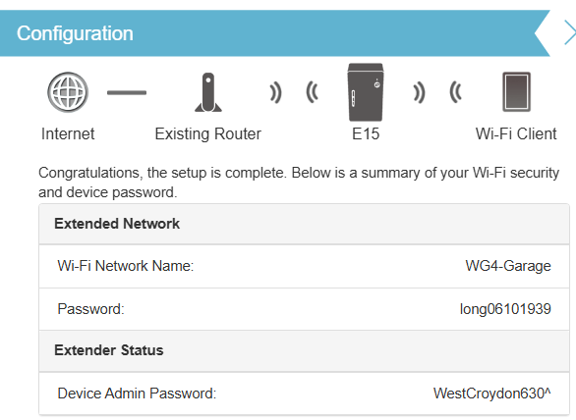No longer in use
SKY
Ordered 25/10/2024:
- Sky Stream puck
- Sky Essential TV
- Netflix Standard with Ads
- £18 perv moth rolling contract
- Setup fee: £20

SKY ID: DAVID1119
Password: WestCroydon630
A/c #: 625246651370
Recovery Code: e96516b
PIN: 7472

As part of your Sky Essential TV subscription, you now get discovery+ Entertainment at no extra cost.
To set up discovery+ and start watching, simply follow one of these steps:

- Say "Get discovery+" while pressing the voice button on your Sky remote
- Go to My Sky on your Streaming TV device, select Sky Shop, then select the discovery+ tile in Sky Marketplace
- Go to Apps and inputs on your Streaming TV device and select the discovery+
- Then follow the on-screen instructions to set up your discovery+ Entertainment account.
- Once done, you'll be able to log in and watch great entertainment from all your devices.

For more support with setting up your access, see our guide on how to use discovery+ with Sky.
https://www.sky.com/help/articles/discovery-plus

Netfix
Userid: david@cyberpictures.net
Password: cry630
Home Address:
4 The Walled Garden
Farnham
Surrey
GU10 1FA

E-mail: david@cyberpictures.net
Web Page: http://www.trolleybus.net

Voipfone
Userid: david@cyberpictures.net
Password: Route6542020*
Memorable Word: trolleybus

Virtual Number Account Number Password Control email
01252 702791 30204177*200} Group 432962
01252 702791 30204177*201} 988691
01252 758121 30204177*202 993939
None 30204755 488202 jane@hartleyhome.net

Microsoft
david@cyberpictures.net Password: dcb19392025* or 764400
david@mideng.co.uk Password: Route612^

Cloudscape
Control Panel
registrar@trolleybus.net
broadband.cloudscapeconnect.com
Username: dbol
Password: Route6542021*

Inbound Server (POP3):
Server: mail.cldmail.co.uk
Port: 995 (use SSL)
Username: david@cldmail.co.uk
Password: Route6542020*

Outbound Server (SMTP):
The outbound mail server requires authentication.
Server: smtp.cldmail.co.uk
Port: 465 (use SSL or SSL/TLS)
Username: david@cldmail.co.uk
Password: Route6542020*

Netgear
192.168.254.48
admin
CrystalPalace2024^

SSID: Trolleybus
Password: Route6542024^
System Wide Short Codes on the Voipfone Platform

112 Emergency Services
999 Emergency Services
101 Police Non-Emergency Number
111 NHS Mon-Emergency Number
105 Power Cut Information Line
116 000 Missing children helpline
116 111 NSPCC ChildLine
116 123 Samaritans
119 COVID-19 Help Line
159 Not yet supported
888 Not yet supported

123 Gives Day, Date and Time

141 Withhold your number
1470 Un-withhold your number

150 Customer Services (Account number and password required)
152 Echo test. Shows how good your connection to Voipfone is.
154 A recording of call credit left to use before top-up is necessary.
155 Confirms that you have set up your phone correctly
166 Anti-Sales call tool (Subject to an extra monthly fee)

1471 Plays back the last number (Call barring service available at extra cost)
1571 Voicemail for the extension you are using.
1572 Voicemail for the Master Account
1573 Voicemail for Group messages

118 707 Connects to BT's Directory Enquiry services (Very expensive to use)

Applies if you have more than three extension numbers

**1571ext - Direct Voicemail - Connect to the Voicemail of an Extension without having to call the extension and wait for it to ring out. Useful if you answer a call, and would like to transfer the caller directly to another user’s voicemail service, so you don't have to take a message and pass it on.
e.g., **1571205 would connect to Extension 205 Voicemail Directly to leave a message.
In-Call Feature Codes

## Used to transfer a call if your telephone does not have a transfer button
#0 Starts and stops call recording (charged at 2.5p pm)
#1 Places call on hold. Use # to cancel
**ext Picks up the ringing extension from another phone
e.g., **201 would pick up 201 if it was ringing
Liberti
3CX is a unified communications solution that will help you work more effectively. Besides using your office extension from your deskphone, you can take calls from anywhere using the softphones for iOS, Android, Mac and Windows.
3CX also includes web conferencing which will allows you to easily make face to face meetings. You can even integrate 3CX with your CRM system or send customers your personal Click2Meet URL and arrange ad-hoc web meetings
Read the user manual at http://www.3cx.com/user-manual/.
Your 3CX extension
- Your extension number is "170"
- Your voice mail PIN is "6068"
- You can retrieve your voice mail by dialing "666"
- Your personal Click2Meet URL is: https://sip11-liberty-izone-com.3cx.net/join/david

- bradley
Using the 3CX webclient
With 3CX webclient you don’t need to install any software. To access it
- Go to https://93.190.116.120:5001/webclient if in the office or
https://sip11.liberty-izone.com:5001/webclient when out of the office
- Login using 170
- With password t2dmaud
Using the Chrome Plugin you can call numbers directly from any webpage or CRM.
Installing the 3CX Client / Softphone
With the 3CX client you can make and receive calls, view the presence of your colleagues,
divert & transfer calls with a mouse click and setup call conferences.
To install it click on the relative link:
- Windows
- Mac
- Android
- iOS
After installation, open the attachment in this email on your device. This will automatically configure your client.
Money Saving Expert
https://clubs.moneysavingexpert.com/creditclub/login

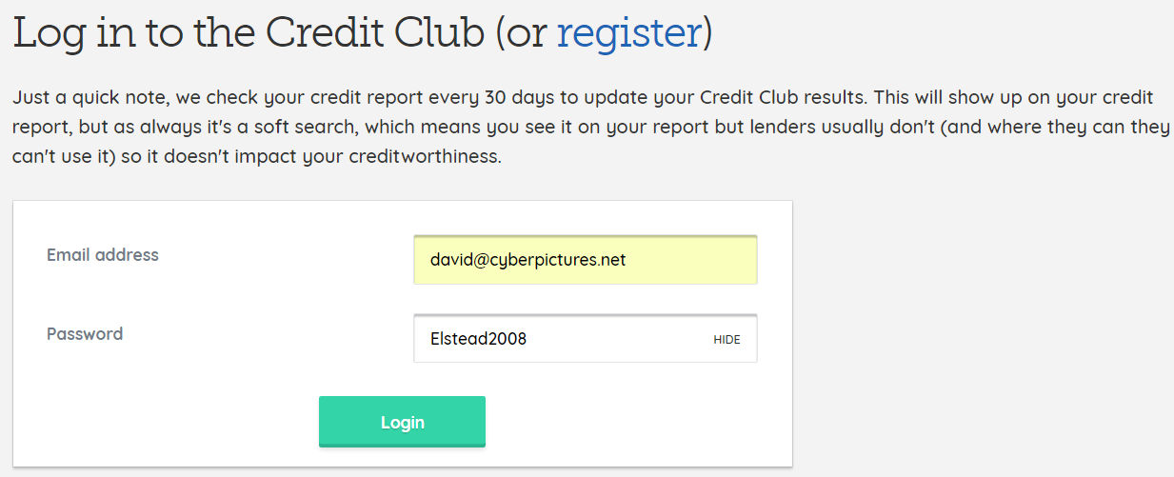

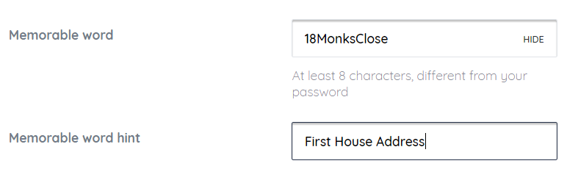

18Monksclose
1 2 3 4 5 6 7 8 9 10 11 12
Devices connected to the Network
IP Address MAC Address HOST ID USERID PASSWORD
192.168.254.20 00-04-13-29-8A-71 snom255 trolleybus route654 7644
192,168.254.22 00-04-13-27-D4-7B 200920329
192.168.254.51 00-0E-58-D7-5F-54 SonosZP
192.168.254.52 90-E7-C4-C7-CE-A6 android-98cbfe1dafc0ae41
192.168.254.53 00-0E-58-D7-69-D2 SonosZP
192.168.254.54 00-0E-58-D7-69-DE SonosZP
192.168.254.55 00-01-E3-FD-A1-50 C470IP ---- 1111
192.168.254.56 00-26-AB-6C-11-3C EPSON6C113C [Printer]
192.168.254.57 50-E5-49-56-C2-00 Woodland4
192.168.254.58 E0-41-36-78-AA-18
192.168.254.59 10-DA-43-0E-8B-09 WN3000RPv3
192.168.254.60 20-C6-EB-CA-1B-46 COM-MID1
192.168.254.64 30-52-CB-ED-B3-AC Jenson
192.168.254.65 28-BE-03-37-85-C3 android-966bed14348aade0

192.168.254.xx 28-C2-DD-56-EA-4D Woodland5
192.168.254.xx D0-4F-7E-39-9E-D5 Eileens-iPad
192.168.254.xx 6C-AD-F8-84-E9-A2 Chromecast
192.168.254.xx 78-84-3C-C0-8C-69 Bedroom TV [Manhatten]
192.168.254.xx 00-04-13-29-43-37 snom monkey business
192.168.254.xx B0-A7-37-AB-05-7B NP-1ML49N060061 [NowTV]
192.168.254.xx 00-04-13-29-CF-86 snom768 woodland route654
192.168.254.xx 00-06-F4-35-EE-E0 Lounge TV
192.168.254.xx D0-DF-9A-14-91-C4 Garden2
192.168.254.xx 00-1D-92-F6-8C-C5 Woodland3

192.168.254.23 00-04-13-91-07-C4 FIXED snom 2 P1
192.168.254.40 84-69-93-39-5A-0F BIND HP OfficeJet Pro 8020 series P2
192.168.254.41 0E-3C-60-EB-E2-92 8:18:39 My Mobile via EH5G
192.168.254.42 D8-0D-17-56-21-B0 23:58:54 TL-WPA4220 P5
192.168.254.43 C8-9E-43-A1-5F-F4 18:23:00 GS724TPv2 P1
192.168.254.44 EC-71-DB-99-F4-25 18:23:15 WalledGardenCarPark P1
192.168.254.45 00-04-13-91-2C-AA FIXED snom main P1
192.168.254.46 00-04-13-99-00-E8 FIXED snom D385 P1
192.168.254.47 90-91-64-3F-54-79 22:38:29 WR18 P1
192.168.254.48 8C-8C-AA-46-A2-E0 22:38:25 Batman P1
192.168.254.49 FC-B3-BC-E4-36-35 22:38:23 Batman P1
192.168.254.50 92-CA-1B-34-EA-5E 20:06:52 My Mobile via Garage P1
192.168.254.52 B4-2E-99-41-4E-0D 23:40:42 Woodland6 P4
192.168.254.53 20-C6-EB-CA-1B-46 20:12:17 COM-MID1 P1
192.168.254.54 FE-EE-02-DA-C1-52 11:49:48 My Mobile via WWT
192.168.254.55 7C-2F-80-E4-CB-D9 FIXED N510 IP PRO P1
192.168.254.60 08-62-66-C3-F5-04 23:48:05 Woodland5 P3

Callmaster VoIP - Snom360
IP address MAC Userid Password Administrator
192.168.254.20 00-04-13-29-8A-71 trolleybus route654 7644
192.168.254.21 awaited apple fiveaday 1618
192.168.254.22 went to mideng tramway route42 1618
192.168.254.59 00-04-13-29-CF-86 woodland route654 7644
192.168.254.54 00-04-13-29-43-37 monkey business 1001

Nominet 4060554
registrar@trolleybus.net
route654

Thinkbroadband
Userid: trolleybus
Password: route654

Zen Contact Information
Switchboard: 01706 902 000 Fax: 01706 902 005
Support help line via VoIP: 777 Support POTS number: 01706 902 009
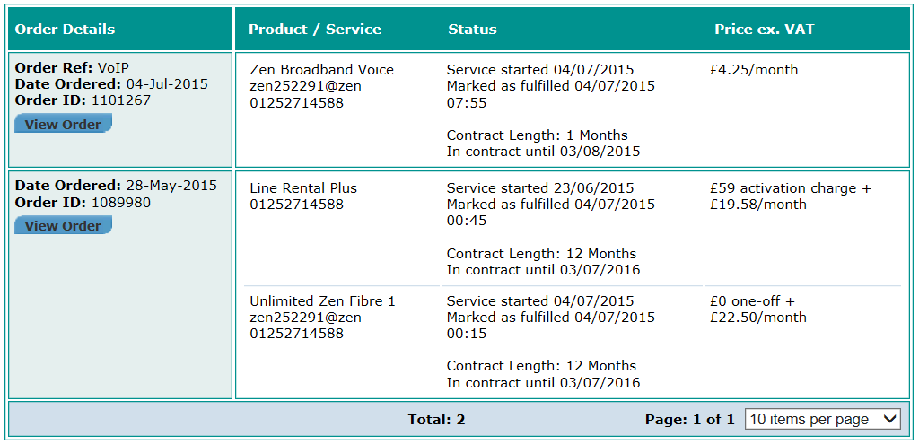

Line Rental Plus - monthly service charge | £19.58
Unlimited Zen Fibre 1 - monthly charge | £15.00
Zen Broadband Voice | £4.25
Sum | £38.83
With VAT | £46.60

Apple ID = Route422025%
https://www.apple.com/uk/shop/buy-iphone/iphone-17-pro/6.9-inch-display-256gb-silver
Unlimited ZEN Fibre 1 Broadband
Monthly charge: £27 including VAT Care Level: Standard Current Line technology: WBMC
Customer Portal: http://portal.zen.co.uk/
Username: david@cyberpictures.net
Password: route654
Help guides: http://www.zen.co.uk/support/broadband/fibre-setup.aspx
Connection type: PPPoE
Authentication type: CHAP [Listed as "PAP or CHAP"]
Logon: zen252291@zen
Password: qjrMyhim
Static IP: 82.69.72.219
Name Address: 82-69-72-219.dsl.in-addr.zen.co.uk
Subnet mask: 255.255.255.255
Primary DNS: 212.23.3.100 Secondary DNS: 212.23.6.100
The router forces the use of Google’s DNS Servers of 8.8.8.8 and 4.2.2.5 [Setting can be removed]

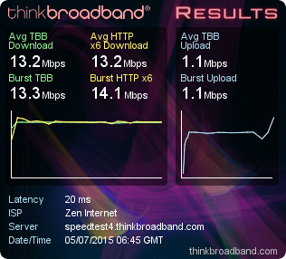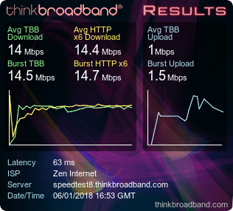

Zen VoIP
Monthly charge: £5.10 including VAT [Rolling one month contract period]
Username: 01252714588
Password: 5DmdJHeM
Registrar Address: voip.zen.co.uk
Proxy Address: voip.zen.co.uk
Test number: 7130 [Just responds with 01252714588]
Support number and for all Zen departments: 777
The IP address of voip.zen.co.uk is 212.23.7.228

Call charges: http://www.zen.co.uk/business/voice/voip.aspx?page=10157
01/02/03/0870 numbers - 1,000 minutes included, then 2.35ppm
0845 - 4.7ppm (Peak); 1.175ppm (Off Peak)
0844 - 5.88ppm 0871 - 11.75ppm Mobiles from 14.1ppm

Zen Email
http://support.zen.co.uk/kb/KnowledgebaseArticle.aspx?articleid=10866
SMTP Server: mailhost.zen.co.uk POP3 Server: mailhost.zen.co.uk
Email Accounts:
Default: zen252291@zen.co.uk Password: 2fPFyhnE
A/c 1: transpo@dbol.myzen.co.uk Password: route654
When using a laptop or other portable device, use authenticated SMTP for sending email, using the same username as for incoming e-mail.

Zen Web Space
Web space username: zen252291 Web space password: 2fPFyhnE
FTP Server: ftp.zen.co.uk Web Site Address: http://www.zen252291.zen.co.uk

CLOUDSCAPE CONFIGURATION SETTINGS
Service started on: Tuesday, 19 April 2022
-----------------------------------------------------
Broadband Username: VFC3614308@cloudscape.uk
Broadband Password: gu101fa
Connection Type: PPPoE
VLAN ID: 101
WAN IP: 92.62.0.111

Zoopla
davidbradleyonline@gmail.com
david@cyberpictures.net
Route6542020*

Hampers.com
david@cyberpictures.net
Route6122022*

Garage Installation
IP Address: 192.168.254.51:8080
Login ID: admin
Password: elstead2008
SSID: WG4Garage
Key: [SimpleOne]2024^
Mode: WPA2/PSK
Channel: 4
Email Accounts and Passwords
messages@cyberpictures.net 7kqt7ycv5cb3
sysadmin@796.org.uk 6340aoqezx7u
chiefengineer@trolleybus.net *JXQp6TPnFLW
dzb@trolleybus.net 4iv4czpxfacg
eileen.bradley@trolleybus.net garden1943
ezb@trolleybus.net
gary.stevenson@trolleybus.net cqwrxoypdz27
htex@trolleybus.net 0v=z%%Eh13z@
isleworthdepot@trolleybus.net PnTN08rYorBF
it@cyberpictures.net y3a0vvgkmssp
hillside@cyberpictures.net csQMsoYY[7]X
kate@trolleybus.net
keith.farrow@trolleybus.net
madeleine@cyberpictures.net 62si9mcrqsqv
overbrook@cyberpictures.net 2vych379ca6h
paul@cyberpictures.net
david@trolleybus.net
richard@cyberpictures.net
robin.hood@cyberpictures.net
roger@trolleybus.net
registrar@trolleybus.net o9(P@wdWKUp*
david@cyberpictures.net 2tgrepke2ojo7uhq

dummy@cyberpictures.net kg3x8az6k5yqtx30
router@cyberpictures.net vltsh0a2nqxnse6z

Username: david@cyberpictures.net
Password: APay@%fgQt#(
Incoming Server: sxb1plzcpnl453518.prod.sxb1.secureserver.net
IMAP Port: 993
Outgoing Server: sxb1plzcpnl453518.prod.sxb1.secureserver.net
SMTP Port: 465

IMAP, POP3, and SMTP require authentication.

Gmail - Help Centre: https://support.google.com/accounts/
Thank you for adding Gmail to your Google Account.
Your Gmail address and primary username is: davidbradleyonline@gmail.com
You may continue to sign in with your old email address if you prefer: david@cyberpictures.net
Added david@wg4.uk 1JUL2024
Password: WoodlandView2016^

Universal Lighting
Username: david.bradley.
View orders, change password, and more at: https://www.universal-lighting.co.uk/account/
Vidahost
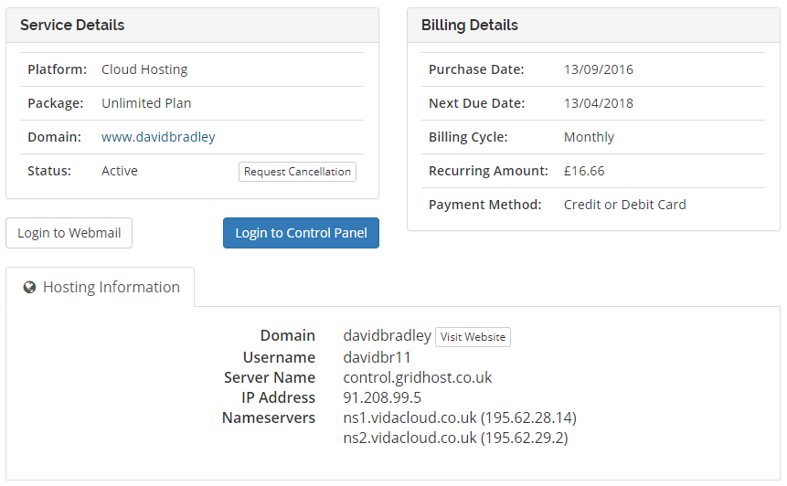

Control Panel for cyberpictures.net and trolleybus.net [cpanel]
Registered with TSOHOST: http://www.cyberpictures.net:2082/frontend/rvblue/index.html
User name: davi3277
Password: t7m0c2hsd28t >>> kdQ8TXVJ_Qr*p>Ec >>> nnH@aaLAr%,"5}(!

New Hosting
URL: 92.205.13.208
Userid: xyq15rrwbf8l
Password: 88u.kE}kH3 Created 1JUL2022

ftp accounts
URL: 31.170.123.89
jayengland@488.cyberpictures.net mCd-4{B&TN48
david@cyberpictures.net h6xdv4ripq35pcv8

The domain trolleybus.net is registered with www.enom.com
Logon: davidbradley
Password: elstead2008

ESET Internet Security on 3 computers until 26 August 2020
Product Platform: ESET Smart Security (Home Edition)
Username: EAV-04826105 Password: 7ps64n7rra
Licence Key: BU3T-XK7K-FCH2-45P7-PC9K
URL: my.eset.com
Portal password changed to Elstead2021* 23JUN2021

Partner Portal
https://portal.eset.co.uk/s/login/?language=en_US
david@cyberpictures.net
WestCroydon630*

Reon Siyaya
ESET Account Manager
reon.siyaya@eset.com

https://portal.eset.co.uk/
https://portal.eset.co.uk/s/account/0david010Y00000WbhwMQAR/david-bradley-online
Password: Elstead2021*
020 3587 7784

Gigaset Phone [C475IP]
Gigaset.net number: 213 275 197 002#9
Gigaset.net name: Trolleybus Password: 1111
MAC Address: 00:01:E3:FD:A1:50 (0001E3FDA150-43B2)
Gigaset help-desk: 020 3695 3111. Not UK based but open 09:00 through to 20:00

Southern Electric Online Account
http://sse.co.uk
Logon: david@cyberpictures.net Password: route654

Scottish & southern Electricity Networks Priority Services
08002943259

SSID
Electric House Route604*****

wifispark.net
rowtonhall
SPARK Management Portal

If you are trying to access the Internet through WiFi SPARK, please check you are connected to the correct wireless network.

If you require any assistance using the WiFi service, please make a note of the IP address below then get in touch.

IP address : 92.62.0.170
WiFi Helpdesk : 0344 848 9555

Vision Express
https://www.visionexpress.com/my-account/profile
david@cyberpictures.net
StuartRoad2021

EBay
Username: xngc1998 Password: Route612

Just Cloud
http://my.justcloud.com Account: david@cyberpictures.net Password: route654
Tele: 0333 370 6520
email: billing@Justcloud.com
Web: www.justcloud-cc.com
Unlimited Plan 1 Year 06/13/2013 - 06/13/2014 £99.40 less 30% + VAT = £76.34
Renewal £99.40 + VAT = £119.28
07/06/2014 000011 WWW.JUSTCLOUD-CC.COM 0844-445-7768 GB 119.28

Facebook
I have two accounts; use the ‘cyberpictures’ account most of the time.

Login email: david@cyberpictures.net Password: WestCroydon630
http://www.facebook.com/tram42 - Joined: 19 January 2008

Login email: chiefengineer@trolleybus.net Password: Elstead2008 Route612^
https://www.facebook.com/david.bradley.3705157 - Joined: 22 July 2008

One of these accounts was changed to: Farnham6122021*

Twitter
No idea how it came about that I have a twitter account
Contact email address: chiefengineer@trolleybus.net
Account: cyberpictures Password: Elstead2008 Changed 13/3/18
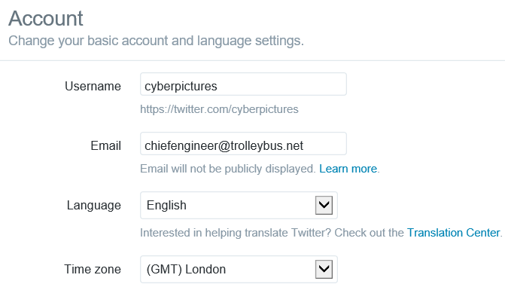

Yahoo
Username: xngc Password: Route654
Password changed Thursday, 15 December 2016 to [TRAM42]
7664walled

OneDrive
WestCroydon630

Pixio
Route6542021*

Saga Car Insurance
Username: david@cyberpictures.net
Password: Route6122023*
saga.co.uk/mypolicy or call us on 0800 092 3117
Domain Tools
Email: david@cyberpictures.net Password *elstead2008*

Cisco
david bradley,
Your user ID is: Trolleybus2 Password: route654
Now you can log in with your user ID and password.
• Visit Cisco Account Profile to add certifications, request permission to download software, or select your preferred language.
• Become a customer by associating your user ID with a contract number or bill-to ID.
If you do not have a contract number, order services directly through our global network of certified partners.
• Become a partner by associating your user ID with a partner company or register your company as a partner.
Need help? Contact web-help@cisco.com

Vodafone – Updated 23 SEP 2025
www.vodafone.co.uk
Userid: mideng DAVID@CYBERPICTURES.NET
Password: recovery1 WestCroydon630^
PIN: 7644
Memberable Word Pauline

Tesco Bank
www.tescobank.com
Username: DAVID@CYBERPICTURES.NET
Security Number: 764400
Password: WestCroydon630^
PIN: 7644
Passcode: 65442
Pippip

Tesco Car Insurance
www.tescoinsurance.com
david@cldmail.co.uk
Password: CrystalPalace654
Policy Number: 8895033H
Phone Number: 03456 730 000 [Open: M-F 8-8, W/E 9-2]

M&S
Email: david@cyberpictures.net Password: route654
www.marksandspencer.com/sparks
URL: bank.marksandspencer.com
Username: TROLLEYBUS2
Password: Route6542021
Pet: pippip
Vehicle: 693CJJ
Company: balfourbeatty

Woodland3 User Accounts:
Eileen StuartRoad*

Skype
dbol123
Route612

myipswitch
Username: david@cyberpictures.net
Password: 9g4D0BVO or KRF8z4VV
Login: www.myipswitch.com
Serial Number: 0YR4WUBGM7T2D2I Perpetual
https://ipswitchft.secure.force.com/cp/
Username: david@cyberpictures.net
Password: MMonp91lA change to route654 on 17/3/2016

iCloud
eileen.bradley@trolleybus.net
*Garden43*

DrayTek 2860 Router
Login: admin Password: route654 >>> @TGVr}G?5h[&+(7x >>> YpyUbUQH?Pmfp4JW
For some reason it became elstead2008

Draytek 2865 Router
admin
vq8q!GqqxbgekRd

Highways Customer Panel
Thank you for joining [14/11/2015] the Highways Customer Panel.
We will be in touch with you shortly.
Contact: 0300 200 1003 or email highways.customerpanel@surreycc.gov.uk

Patient Access
https://patient.emisaccess.co.uk/
Userid: 6837002039
Password: route654
Memorable Word: route630

Waitrose
https://www.johnlewis.com/myjohnlewis
Userid: david@cyberpictures.net
Password: Route6542021

https://www.google.com/webmasters/tools/googlebot-fetch
Account: david@cyberpictures.net changed on 8 APRIL 2022
Password: Route6542020* maybe born061039^
For: David Bradley Online / aveuk.net / thornden.net

Account: registrar@trolleybus.net Password: route612
For: Forty Winks / Mitchell and Partners

Vodafone
www.vodafone.co.uk
Userid: mideng
Password: recovery1
7644

National Grid
URL: https://www.nationalgridpensions.com/182
Username: trolleybus
Password: Bradley1

Draytel
897558 elstead registrar@trolleybus.net route654 05601042165
8234842 26883613 david@cyberpictures.net route654
8485517 K76Gt,y8 david@cyberpictures.net route654
8485594
8486036 %lI6}F^P david@cyberpictures.net route654

Santander Share View Portfolio - Equiniti
Reference number: 3198228
Access account: https://portfolio.shareview.co.uk/7/Portfolio/santanderportfolio/en/inactive/Pages/RegistrationCompleted.aspx
Username: trolleybus Password: Route654
Activation Code: 61460617
UK Helpline: 0371 384 2000 Opening hours: Mon to Fri 8.30am to 5.30pm.
Calls are free from BT landlines but other network providers may charge.

Amazon Prime Renewal Date: 4 March
https://www.amazon.co.uk/gp/primecentral?ie=UTF8&ref_=ya_manage_prime&
Login: david@cyberpictures.net Password: elstead2008 was route654 on 13/4/17
The £79 per year service includes free one-day delivery and the Amazon Prime Instant Video TV and film streaming service that rivals Netflix. Amazon allows you to share that membership with up to four of family members, meaning you can share out the cost to make it just £16 per year.

I can only share the Amazon Prime delivery benefits.
Prime Instant Video and Kindle Owners' Lending Library is not included.

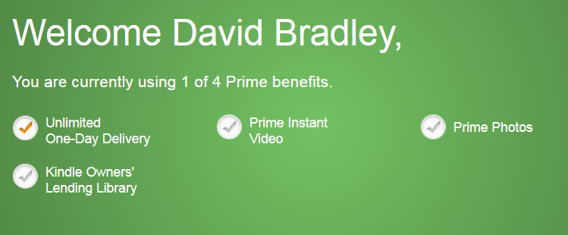

MBNA
https://www.mbna.co.uk/online-card-services/
username: TROLLEYBUS
password: 19stuartroad
Memorable information: route612

Janelow1
03456062062
Compare the Market
david@cyberpictures.net
Route6542020

Freestat Device
Support: 0870 247 8800 [Mon-Fri 8:30-21:00]
Email: uksupport@humax-digital.co.uk
Web: www.humax-digital.co.uk
No idea what this is for
PW: d4jzwG97

Team Viewer
531 498 992
david@cyberpictures.net
Route6122021* Password changed 24/JUNE/2021
Call us Monday to Friday from 07:00 to 17:00 (BST) 020 8099 7265

To ensure there is no gap or interruption of service, your TeamViewer subscription will continue to automatically renew on 23-Jul-2019, unless according to our terms and conditions you contact us 28 days before the renewal date by submitting a ticket.
Please get in touch if your contact and/or payment information has changed.
We look forward to serving you for another 365 days, and wish you luck and success in the year ahead.
Best regards,
Your TeamViewer Team

123 REG
https://account.123-reg.co.uk/
Customer #637705884
chiefengineer@trolleybus.net
nnH@aaLAr%,"5}(!

registrar@trolleybus.net
WestCroydon630^

Account: trolleybus1
Password: [Route654]2020 Correct on Thursday, 20 February 2020
Tele: 0330 221 1007
Registered email address: registrar@trolleybus.net

Instagram
URL: https://www.instagram.com/
Account: davidbradley231
Password: Route612-2020

Flickr
URL: https://www.flickr.com/people/11168446@N07/
Login: chiefengineer@trolleybus.net
Password: elstead2008-2020
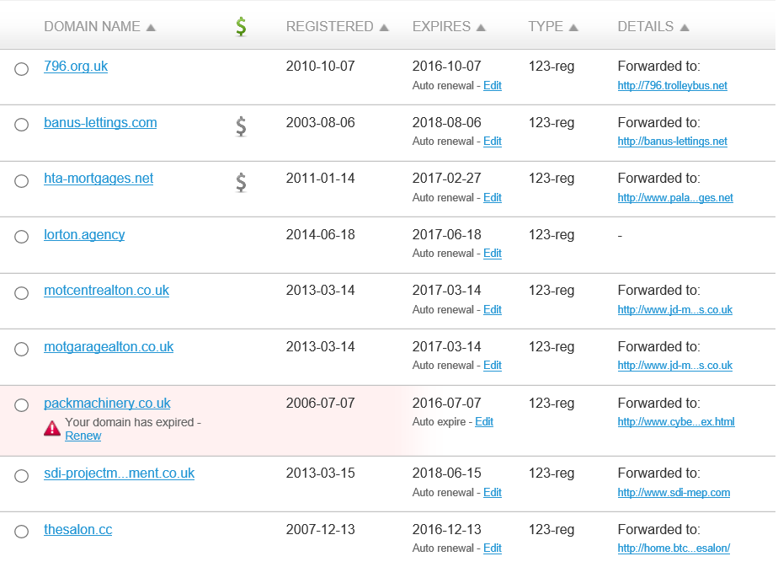

Each new or reset password will have to meet the following criteria:
- Eight or more characters
- A mix of lower and upper case English letters
- At least one number (0-9)
- At least one special character from: ! $ % ^ & * > ( ) – _ = + } { # @ ‘ : ; . , < / | ? “
- At least four unique characters
- No more than two repeated characters together (eg. hhh)
- No number sequences (e.g. 5678)

To ensure that all accounts adhere to the new policy we will be enforcing an update to all current passwords on 1/9/16. We will not email you a reset link without you requesting it first.

Vidahost
Password: Croydon
Support PIN: 721 848
Credit Card: 4043
MyVidahost: chiefengineer@trolleybus.net
Password: uAGJyIwzoEJZ – doesn’t seem to be correct

Milk&More
URL: https://www.milkandmore.co.uk/OA_HTML/xxdcibeNationWideLoginPage.jsp?a=b
Customer Services: 0345 606 3606.
Account Number: 1213966
Userid: david@cyberpictures.net
Password: Elstead2008

EHIC [European Health Insurance Card]
https://www.ehic.org.uk/Internet/login.do
Login: david@cyberpictures.net
Password: Route654#
Queries: nhsbsa.ehicenquiries@nhsbsa.nhs.uk
Provide: full name, date of birth and address, including postcode.
Enquiry line: 0300 330 1350
Card Number: 80826 00001 01 4690 2917
Expiry date: 23/07/2022

Nectar Card
www.nectar.com
Tele: 0344 811 0811
david@cyberpictures.net
Card Number: 98263000 53420336 013
Password: Tram422024^

PayPal
Password: Route6542021
Email: david@cyberpictures.net

NHS NUMBER
410 451 0122
WestCroydon2016^

Electronic Payslips from AVEUK
https://login.xero.com
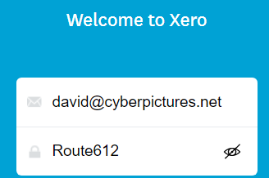

NETFLIX
0800 096 8879
Account Information: david@cyberpictures.net
Service Provider: Netflix International B.V.‬ ‬‬‬‬‬‬‬‬‬‬‬‬‬‬‬‬‬‬‬‬‬‬‬‬‬‬‬‬‬‬‬‬‬‬‬‬‬‬‬‬‬‬‬‬‬‬‬‬‬‬‬‬‬‬‬‬‬‬‬‬‬‬‬‬‬‬‬‬‬‬‬‬‬‬‬‬‬‬‬‬‬‬‬‬‬‬‬‬‬‬‬‬‬‬‬‬‬‬‬‬‬‬‬‬‬‬‬‬‬‬‬‬‬‬‬‬‬‬‬‬‬‬‬‬‬‬‬‬‬‬‬‬‬‬‬‬‬‬‬‬‬‬‬‬‬‬‬‬‬‬‬‬‬‬‬‬‬‬‬‬‬‬‬‬‬‬‬‬‬‬‬‬‬‬‬‬‬‬‬‬‬‬‬‬‬‬‬‬‬‬‬‬‬‬‬‬‬‬‬‬‬‬‬‬‬‬‬‬‬‬‬‬‬‬‬‬‬‬‬‬‬‬‬‬‬‬‬‬‬‬‬‬‬‬‬‬‬‬‬‬‬‬‬‬‬‬‬‬‬‬‬‬‬‬‬‬‬‬
Plan: 4 screens at a time
Plan Price: £8.99/month
Subscription: Free Trial (ends on Tuesday, 19th September 2017)
Payment Method: •••• •••• •••• 7524
Help Centre: https://help.netflix.com/en/node/412?g=C4B5FF7319321B68F4BA3AB15343F71664530B90&lkid=URL_HELP&lnktrk=EMP
Contact details:
https://help.netflix.com/contactus?lnktrk=EMP&g=C4B5FF7319321B68F4BA3AB15343F71664530B90&lkid=URL_CONTACT

The cost of Netflix membership increased to £9.99 on Monday, 20th November 2017.
So cancelled the membership as I didn’t use the facility frequently enough to warrant spending £10 a month.

Commission from Cloudscape
You can access your account details, invoices, make payments, see the services you use and renew and manage your domain names through the My Account section of our secure website.

To access the secure website visit: https://www.cloudscapeconnect.com/myaccount
Username: DBradley8378 Password: Postcard791Yellow

We also recommend registering your mobile phone number as this will aid our support team in the event of any problems. If you have any questions, queries or problems with your account or services then you can contact us using the following methods:
During Office Hours (9am - 7pm Monday to Friday) Phone: 0116 274 7360
Experian
david@cyberpictures.net
Route612

Turnkey Point
https://turnkeypoint.com/my-account/
david@cyberpictures.net

david.bradley-6847
xZDh9y9!fpxPGXU
Mazda Mapping – SD Card in car – Insert into computer to update using Mazda Toolbox
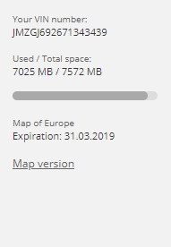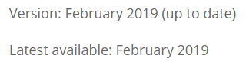

Logon: david@cyberpictures.net Password: *Elstead2008*
Freephone customer service center: 00800 4263 7383

First Direct
User: trolleybus
Password: WestCroydon630*
Logon security code from app

TP Link
URL: http://192.168.254.42/
Host ID: TL-WPA4220
Userid: Admin
Password:
Correct as at 12th January 2024

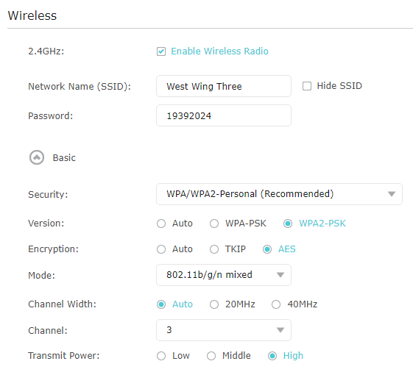

Instant Ink
david@cyberpictures.net
Route42%
HP OfficeJet Pro 8020 series Printer
LAN: 192.168.245.41
PIN: 42441698
Make sure 912 cartridges are installed

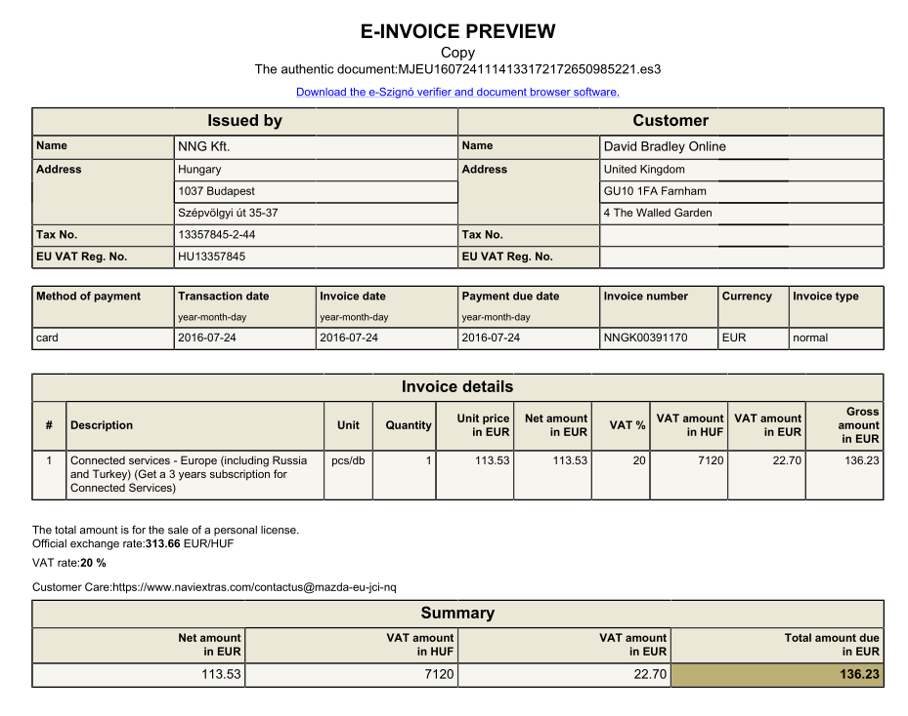

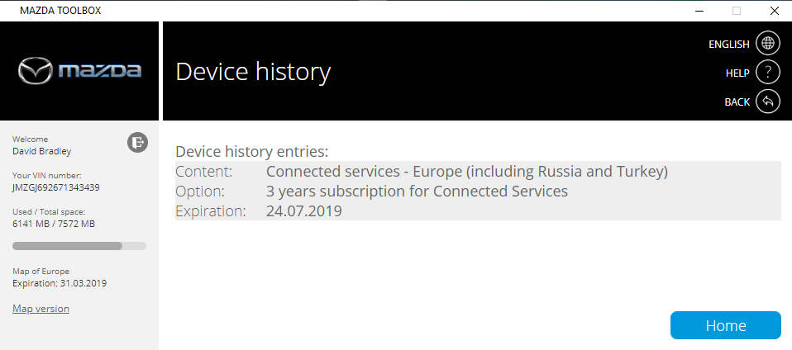

NOWTV – Cancelled Saturday, 18 June 2016
Order Reference: 451M13720260
Order Date: 11-Dec-2014
Payment: GBP 19.99
https://watch.nowtv.com/account
Userid: tram42
Password: Route654
Pin: 6540 was OK but might have changed it to 7644 on 5JUL15
Parental Control Pin: 6300 Feature removed

Driving License

Government Gateway User ID: 9952 3003 6732
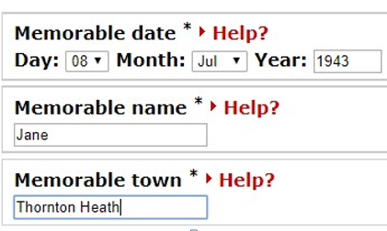

Viking
Username: david@mideng.co.uk
Customer number : 7136848

Username: david@mphem.net
Password: feocbsozzxqg5re8
Incoming Server: sxb1plzcpnl489868.prod.sxb1.secureserver.net
IMAP Port: 993
Outgoing Server: sxb1plzcpnl489868.prod.sxb1.secureserver.net
SMTP Port: 465

Username: chiefengineer@trolleybus.net
Password: 2w4mgd2zg6yafegg
Incoming Server: sxb1plzcpnl453518.prod.sxb1.secureserver.net
IMAP Port: 993
Outgoing Server: sxb1plzcpnl453518.prod.sxb1.secureserver.net
SMTP Port: 465

Username: registrar@trolleybus.net
Password: zba3fc65dh9044j9
Incoming Server: sxb1plzcpnl453518.prod.sxb1.secureserver.net
IMAP Port: 993
Outgoing Server: sxb1plzcpnl453518.prod.sxb1.secureserver.net
SMTP Port: 465

david.bradley@mideng.co.uk
WestCroydon630^

Can’t add this account
Username: david@mideng.co.uk
Password: hed7w48nkaijw6bg
Incoming Server: mail.mideng.co.uk
IMAP Port: 993
Outgoing Server: mail.mideng.co.uk
SMTP Port: 465

Username: quarantine@rushmoormotor.co.uk
Password: 9xke5dtec7omxc58
Incoming Server: sxb1plzcpnl504421.prod.sxb1.secureserver.net
IMAP Port: 993
Outgoing Server: sxb1plzcpnl504421.prod.sxb1.secureserver.net
SMTP Port: 465

Historical Information

BT Telephone Service Terminated 23 October 2013
Account Number: TH1308 4584
Unlimited Weekend Plus at £46.35 = £15.45 a month
Paid in advance 7 Sep – 6 Dec
Refund of £22.43 made

Broadband from TalkTalk – Terminated
Logon: dcb@gotadsl.co.uk
Password: kleq9zed
Static IP Address: 82.133.118.158
Email address: dcb@gotadsl.co.uk
Opal account number: 1281762
Subscription reference: 489604

ADSL Login and e-mail Login: dcb@gotadsl.co.uk
Dialup Login: dcb
Password: kleq9zed

Client Information

Site | URL | Userid | Password
London Trolleybus 796 | 796.trolleybus.net
Auto Panels | www.autopanels.net | davi1082 | OCcidi9SBL
AVE UK | www.aveuk.net | bottling | yk588bznyo89
Baker Legal | www.bakerlegal.co.uk | whitley | 0p05mioydudg
Banus Lettings | www.banus-lettings.net | davi1208 | VbuJYA3bef
Bottling Machinery | www.bottlingmachinery.net | davi5572 | cznFeuWEu8
Bradleyshome | www.bradleyshome.co.uk | raglan | ID>m5ly%z4nH
Chuter Hills | www.chuterhills.co.uk | coach | kNNH8Ku8
Cyberpictures | www.cyberpictures.net | davi3277 | t7m0c2hsd28t
E & L Services | www.eandlservices.co.uk | alnus | C(ZNE)7!,xa5
Hartley Home | www.hartleyhome.net | davi9752 | gA23u9edhS
JD Motors | www.jd-motors.co.uk | davi1819 | nhg66tr4ERw3
Keiths Private Hire | www.keithsprivatehire.co.uk | davi5442 | Xplpc2NA4B
Margret Kelly | www.kellyshome.net | davi1700 | 0ijIaQGH5w
Lanfranchi.co.uk | www.lanfranchi.co.uk | davi8221 | WiI7F9lYBq
Lanfranchi UK | www.lanfranchiuk.net | alex9594 | oxf2n49swd
Lesley Lettings | www.lesleylettings.co.uk | wickett | 283Kdmf546
Lorage | www.lorage.co.uk | davi9994 | jwcjQEmulp
Machinery Solutions | www.machinerysolutions.co.uk | davi0919 | 7QQvsEnFUZ
M & M Technical | www.mandmtechnical.com | davi8632 | wQ84KLwHF6
Midhurst Engineering | www.mideng.co.uk | davi7174 | MK98yt6We
Mitchell and Partners | www.mitchellandpartners.com | davi5831 | KEnxHqRV4O
Pack Machinery | www.packmachinery.co.uk | boxed | route612
Palace Mortgages | www.palacemortgages.net | davi6839 | pRriknHalj
PS Preforms | www.pspreforms.com | davi6749 | jIdTwijTZS
Robanes | www.robanes.com | davi1960 | 4dtzX3hBBD
Rushmoor Mototor | www.rushmoormotor.co.uk | davi6629 | szEoU8FIif
Sdi | www.sdi-mep.com | davi7231 | gl56Hi3VsM
Terry Russell Trams | www.terryrusselltrams.co.uk | davi8326 | 3uud46ua879k
Trolleybuses for West London | www.tfwl.org.uk | davi2976 | iIcCo9wrKT
David Bradley Online | www.trolleybus.net | david42 | 2BXp/z|/@@gz
HTA Mortgages | www.htamortgages.net | htamortgages | 9sbc4w8uky55
Thornden | http://ns31.sovdns.com/cpanel | davi5881 | AYiUaFSVyy

snom phone label
Computer
702791
279411
702791
Terry
758960
Jane
758960
938013
888196
Home
Active

The password for all these accounts has been changed by a third party. Replacement passwords are as shown below.

david@cyberpictures.net
[Route654]2020

chiefengineer@trolleybus.net
nnH@aaLAr%,"5}(!

registrar@trolleybus.net
[Route654]2020
elstead2008

david@wg4.uk
xnf64h08dy02s6od

