Computer Installation at Eceau Ltd
Updated: Tuesday, 9 August 2016 Contact: Barnaby Foster

Business Address:
Greenhills Estate
Tilford Road
Tilford
Farnham
Surrey
GU10 2DZ

Telephone: 01252 758933
Web: http://eceaultd.co.uk
email: barnabyf@eceaultd.co.uk

Router No.1
Model Name: Vigor2860Vac
Firmware Version: 3.8.2.3_BT
Build Date/Time: Apr 22 2016 19:28:07
Access: http://192.168.1.1
Userid: admin Password: darwin31415
Broadband Service from BT
Username: D458423@hg70.btclick.com Password: welcome1
Phone Number: 01252 793804
Fixed IP: 81.136.214.64
LAN: IP range start: 192.168.1.10 Pool Count: 150
DHCP: ON

Router No.2
Model Name: Vigor2830n
Firmware Version: 3.6.8.4_sb_232201
Build Date/Time: 2016/01/19 18:28:17
Access: http://192.168.1.254
Userid: admin Password: darwin31415
Broadband Service from BT
Username: D246794@hg52.btclick.com Password: bravo987
Phone Number: 01252 790468
Dynamic Allocation – Current Address: 31.54.142.234 [Wednesday, 25 May 2016]
DHCP: OFF

Sure Signal Device
Help Desk: 03333 040191 Ask for Sure Signal Tech Help
Serial Number: 42151520733
MAC: B0-46-FC-80-8C-9B
Bind MAC to IP: 192.168.1.11
Controlling Mobile: 07825 290427
www.vodafone.co.uk
Userid:
Password:

Netgear Switch
JGS516PE - 16-Port Gigabit ProSAFE Plus Switch with POE [Unmanaged]
DHCP from Router No1: 192.168.1.14 [As at Tuesday, 26 July 2016]
Access: http://192.168.1.14
Password: password [Default in place]
MAC: B0-7F-B9-41-B0-44

2860 Settings as at Tuesday, 26 July 2016

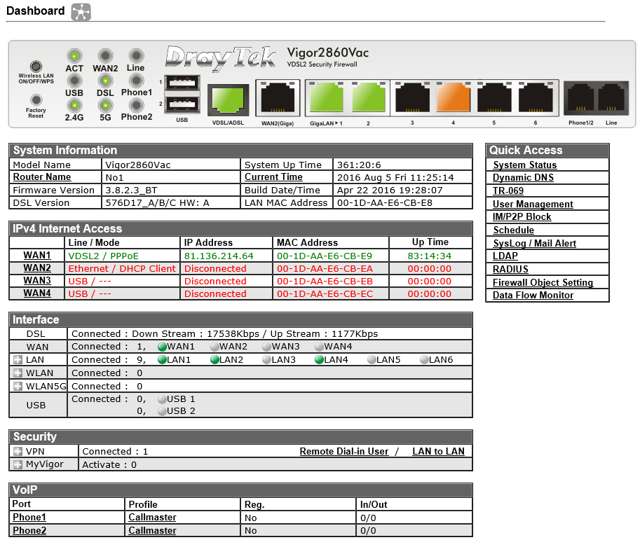

The router is connected directly to the telephone line.
Port 1: Netgear Switch
Port 2: Link to Router No.2
Port 4: Service to Sure Signal Device
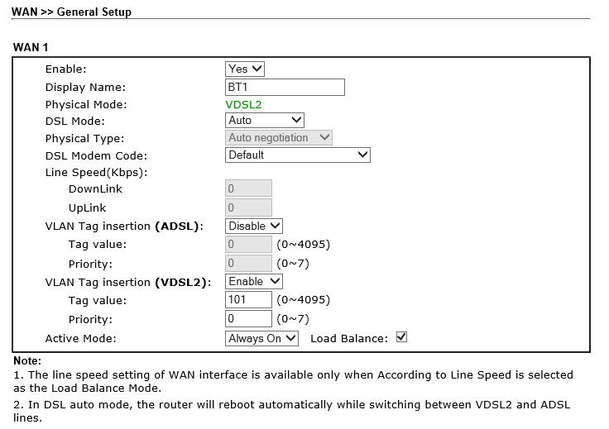

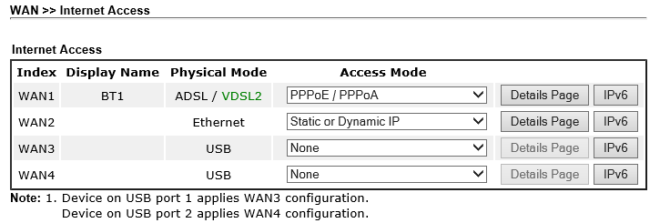
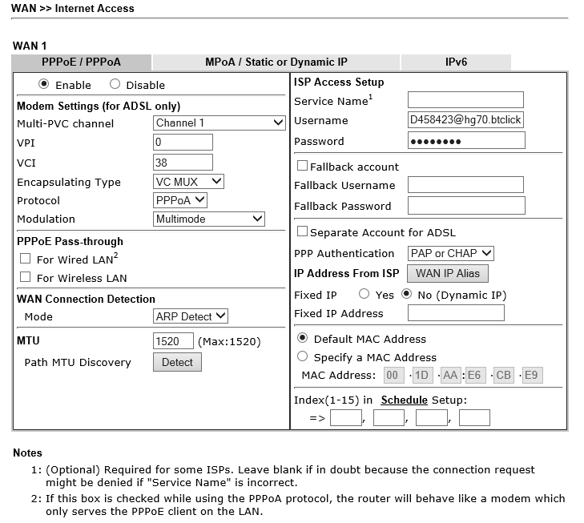

UPnP

Said to be necessary to enable UPnP for the Sure Signal Device to work. However it has not been enabled, which is good from a security view point, as the SSD works without this setting.

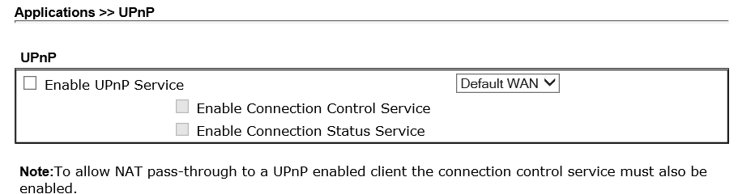

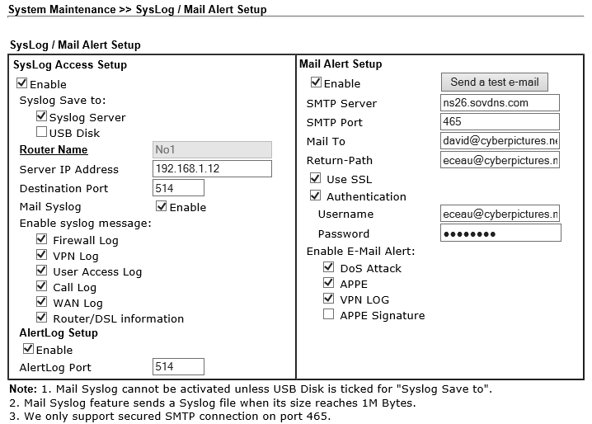

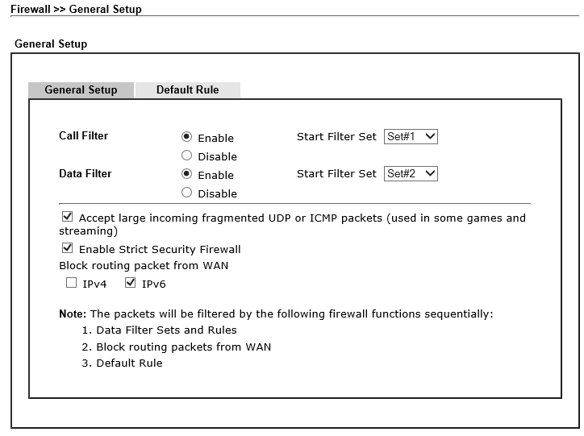

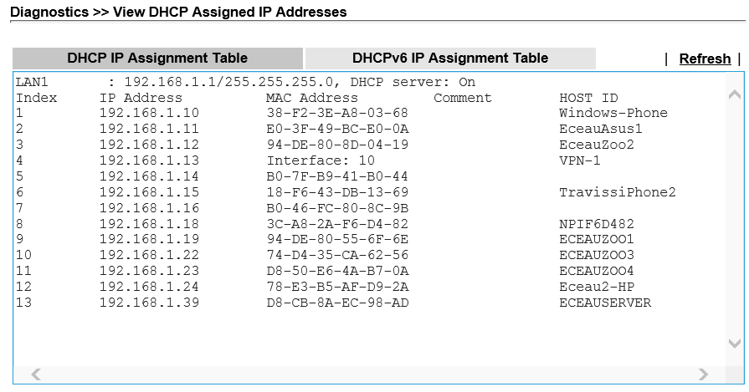
Item 5 is the Netgear Switch
Item 6 is the Sure Signal Device
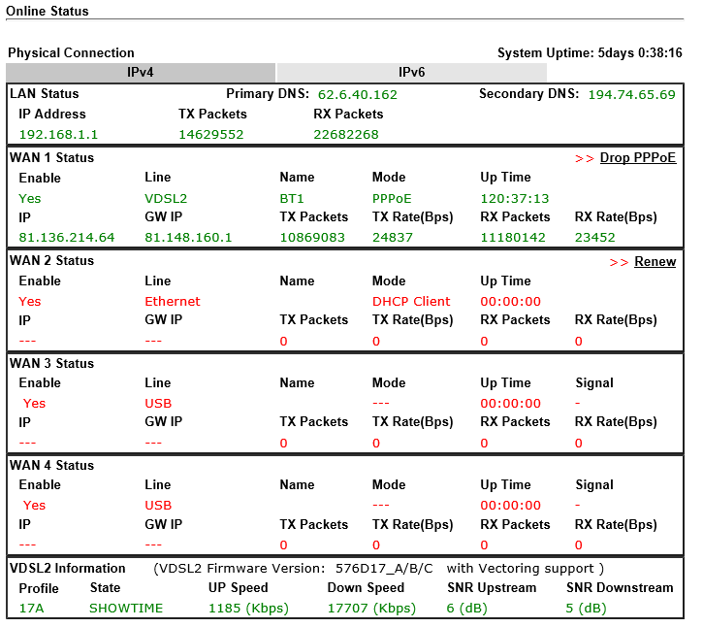
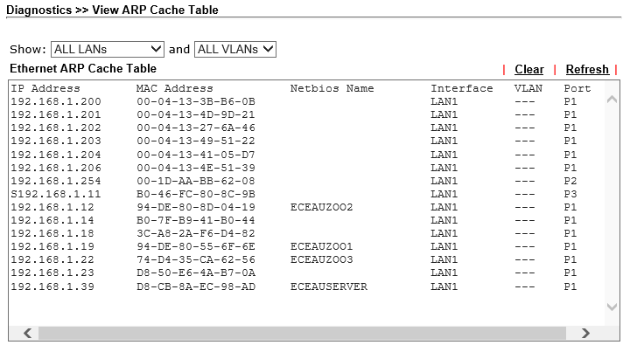

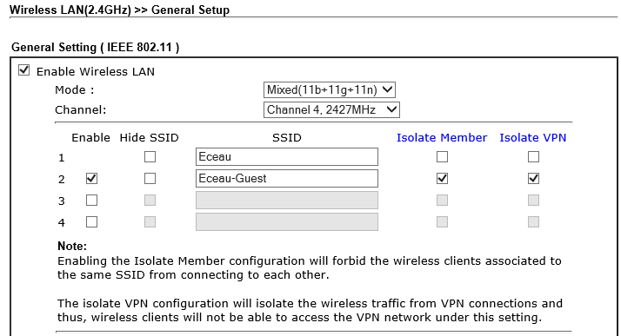

Passwords:
Route654
Route630
Route612
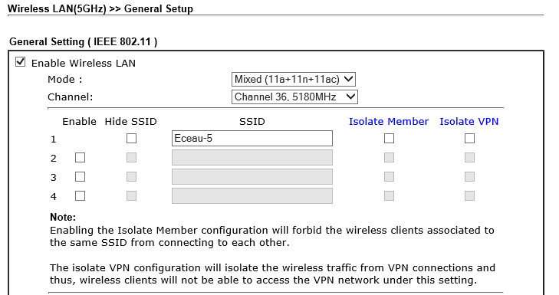
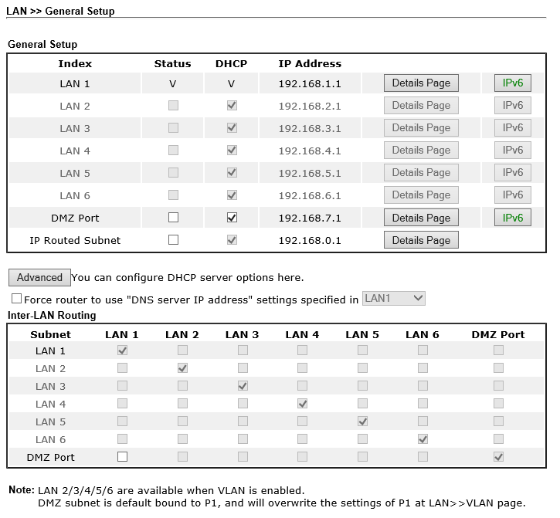

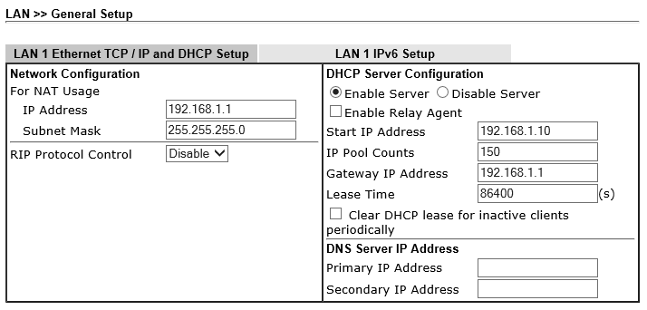

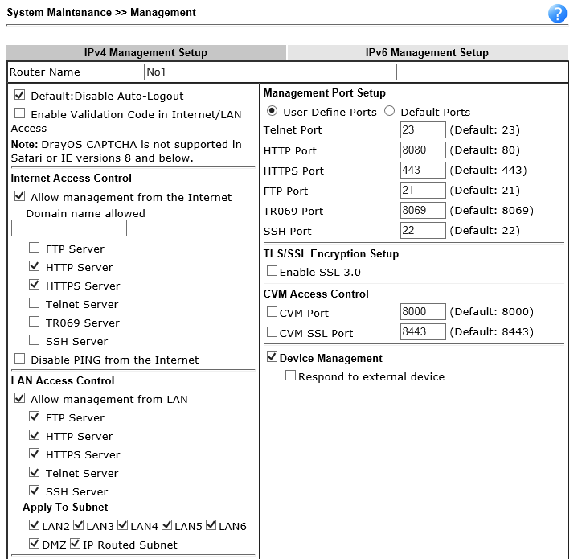
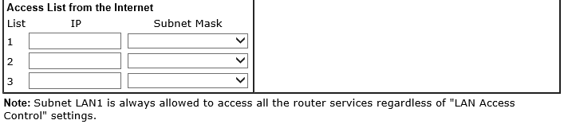
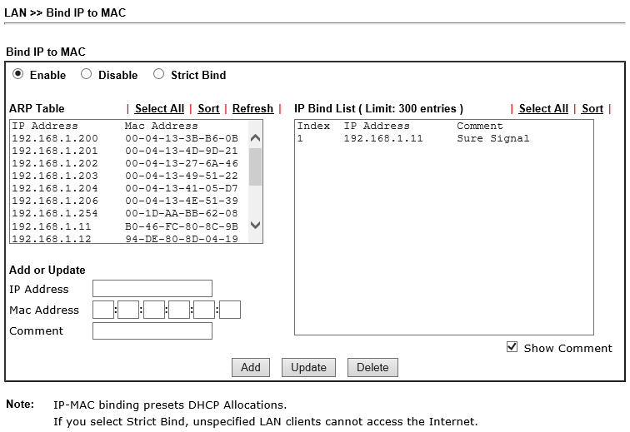

Office VoIP Phones - All are fixed IPs with Gateway 192.168.1.254 except 200923736
192.168.1.200 201123561 Warehouse
192.168.1.201 200920387 Lisa
192.168.1.202 200923736 Sarah O
192.168.1.203 201123312 Barnaby F
192.168.1.204 201123590 Nick S
192.168.1.208 201123591 Alice
192.168.1.209 201123273 Ian C

Speed Dial:
10: Warehouse 00-04-13-3B-B6-0B 201123561
11: Alice 00-04-13-4D-9D-20 201123591
12: Sarah O 00-04-13-27-6A-46 200923736
13: Carrieann O 00-04-13-36-13-4D 201123675 01252750701 8936
14: Barnaby F 00-04-13-49-51-22 201123312
15: Nick S 00-04-13-41-05-D7 201123590
16: Ian C 00-04-13-4E-51-39 201123273
17: Lisa 00-04-13-4D-9D-21 200920387
18: Walkabout . . 01252790468

Directory
Name: | Number: | Contact Type: | Outgoing Identity: | Edit | Delete
10 Warehouse | 201123561 | None | 200920387@v1.21voice.net
11 Alice | 201123591 | None | 200920387@v1.21voice.net
12 Sarah O | 200923736 | None | 200920387@v1.21voice.net
13 Carrieann O | 201123675 | None | 200920387@v1.21voice.net
14 Barnaby F | 201123312 | None | 200920387@v1.21voice.net
15 Nick S | 201123590 | None | 200920387@v1.21voice.net
16 Ian C | 201123273 | None | 200920387@v1.21voice.net
17 Lisa | 200920387 | None | 200920387@v1.21voice.net
18 Walkabout | 01252793804 | None | 200920387@v1.21voice.net
20 Nick Simpson Mobile | 07825290427 | None | 200920387@v1.21voice.net
21 Barnaby Mobile | 07899123321 | None | 200920387@v1.21voice.net
22 Ian C Mobile | 07342880655 | None | 200920387@v1.21voice.net
23 Carrieann O’Connell | 07714788039 | None | 200920387@v1.21voice.net
30 Nick Home | 01252261565

snom Phone Setup

Within the advanced settings of each VoIP phone on the Network tab, DHCP is turned off and a fixed LAN IP address is given but maintaining the first three octaves as 192.168.1. By setting the IP Gateway as 192.168.1.254, VoIP traffic is forced to use Router No.2 thus using the alternative internet connection. A better internet connection with an up speed greater than 2Mbps would make this arrangement unnecessary.

Typical setup shown below:

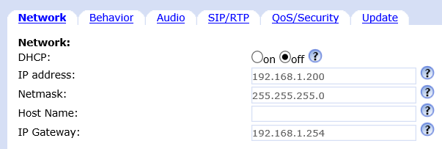

Workgroup
Workgroup

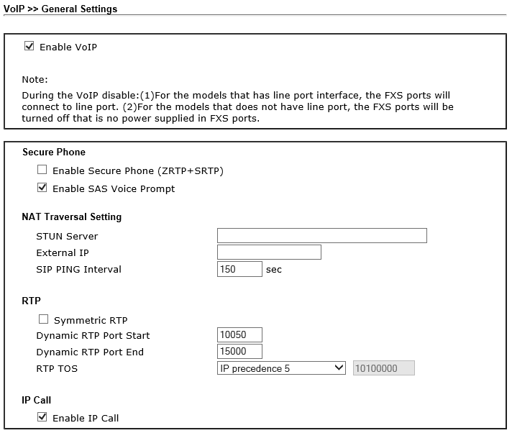

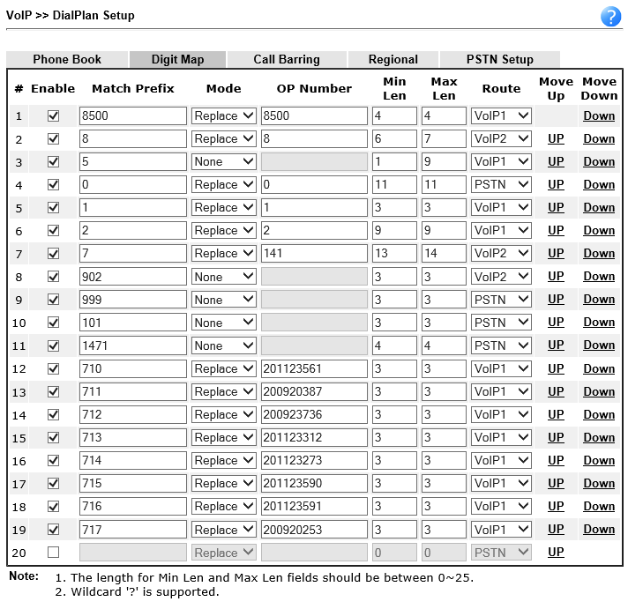

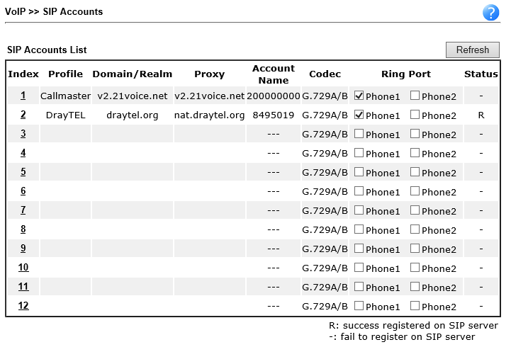
Callmaster Configuration [Dummy details shown]

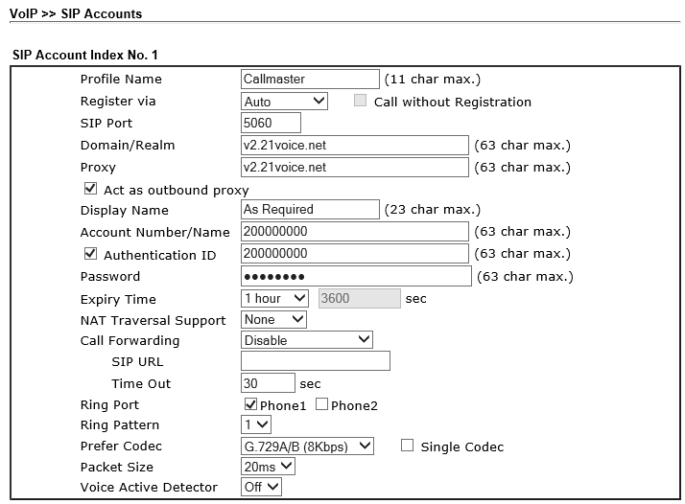
DrayTEL Configuration [Active but with no credit added for PAYG]

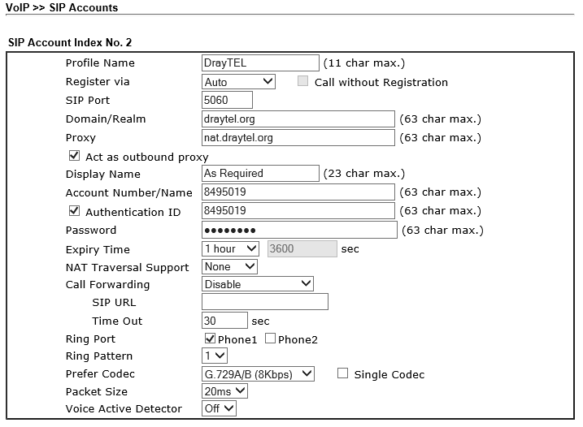

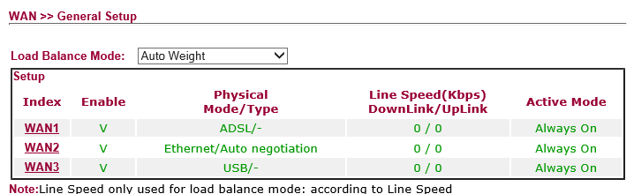

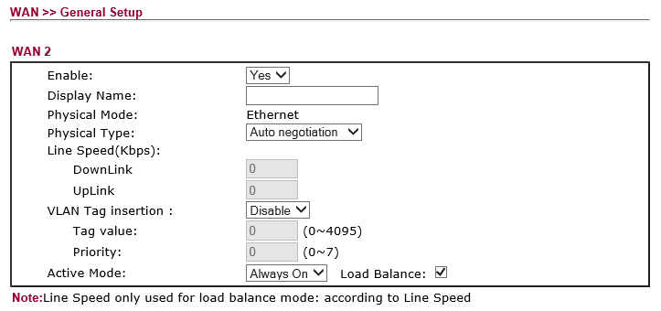
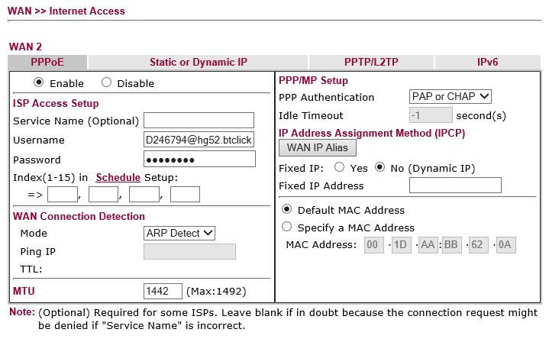
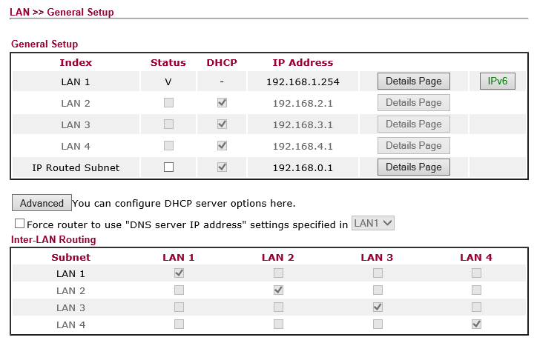

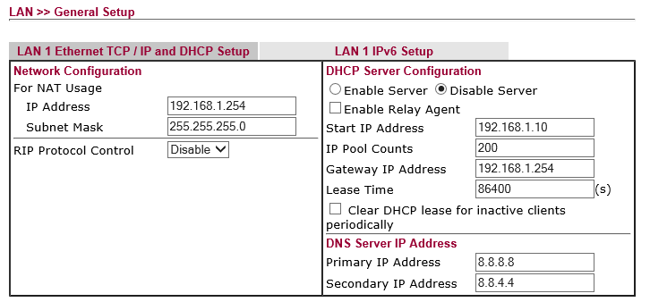
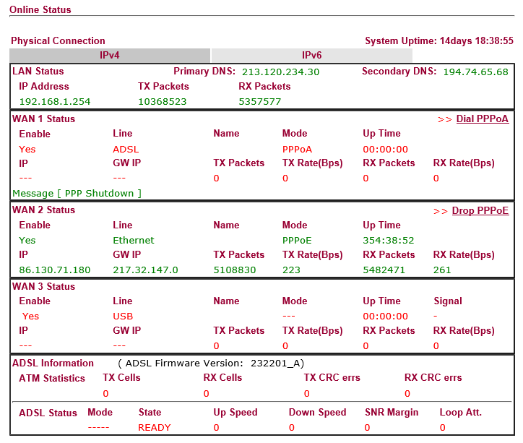
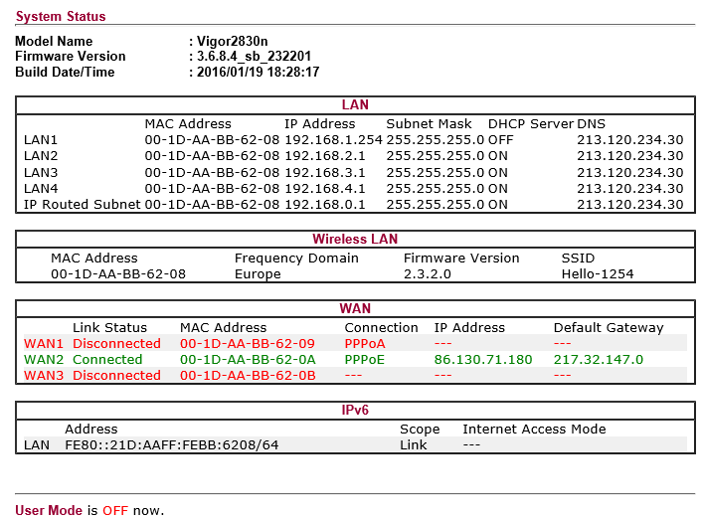



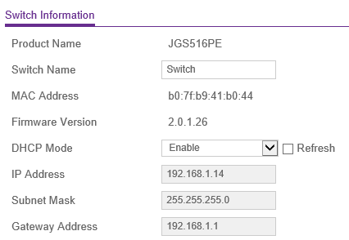

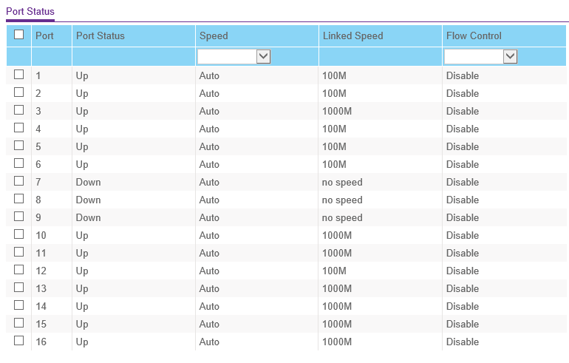

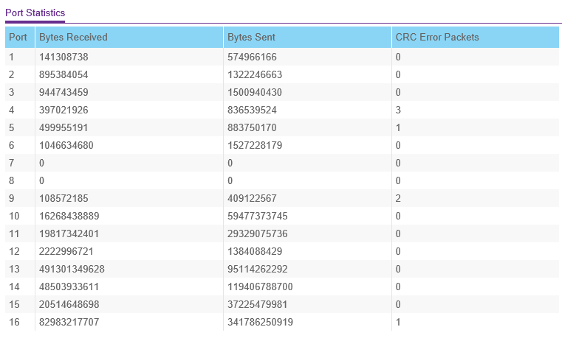

3 192.168.1.12 94-DE-80-8D-04-19 15:17:21 EceauZoo2
5 192.168.1.14 B0-7F-B9-41-B0-44 22:24:28
6 192.168.1.15 E0-3F-49-BC-E0-0A 13:37:13 EceauAsus1
7 192.168.1.16 B4-E1-C4-E3-BE-D0 22:44:22 Windows-Phone
8 192.168.1.18 3C-A8-2A-F6-D4-82 13:18:51 NPIF6D482
9 192.168.1.19 94-DE-80-55-6F-6E 23:23:36 ECEAUZOO1
10 192.168.1.22 74-D4-35-CA-62-56 12:24:37 ECEAUZOO3
11 192.168.1.23 D8-50-E6-4A-B7-0A 23:20:01 ECEAUZOO4
12 192.168.1.39 D8-CB-8A-EC-98-AD 14:43:58 ECEAUSERVER
BT Business Hub; How to convert to modem mode
http://btbusiness.custhelp.com/app/answers/detail/a_id/35226/~/how-do-i-enable-bridge-mode-on-my-bt-business-hub-5%3F

How do I enable bridge mode on my BT Business Hub 5?
To enable bridging mode on the BT Business Hub 5:
- On a PC or laptop connected to your hub, enter http://btbusinesshub.home or 192.168.1.254
- Click on Advanced Settings
- Enter your Admin password if prompted (can be found on the base of your Hub) and click Ok
- Click Continue to Advanced Settings
- Choose the Broadband tab, then click on the Routing tab
- Scroll down to the bottom of the page to Bridging
- Tick Yes next to Enabled
- If you're sure click Yes on the next screen
Your BT Business Hub should now be in bridge mode. You will need to change the settings on your other Router to use connection type PPPoE. Depending on the Hub you are bridging to, you may need to enter your broadband connection details.

