Computer Installation Fact Sheet for SDi Limited
Update: Tuesday, 29 January 2019 Contact: Graham Travis

Business Address:
SDi Limited
The Studio
50 Herons Way
Bolton
BL2 1EX

Home: 01204 527011
Business: 01204 894518
Fax: 01204 897330
Mobile: 07939 056421
Sky: 01204 783766
Stuart Travis: 07943 333858

email: g.travis@sdi-projectmanagement.co.uk

Router
WAN: 82.28.103.20 Dynamic address
Virgin Super Hub: 192.168.0.1 Password: virgin1894

VoIP Info – Using snom360
SIP: 201123161 Password: sdi31415 now gtrav085429
Voice Mail: 9805 External 9806 Internal Password: matches box number

snom interface: https://82.28.103.20:1939 [Router requires configuring because of router upgrading]
[NB: Note the port number used for the GUI]

Domain name: sdi-mep.com

Control Panel:
http://www.sdi-mep.com/cpanel
Username: davi7231
Password: gl56Hi3VsM
Hosting Package: Commerce

Email Accounts:
enquiries@sdi-mep.com v991vwgrdadk
g.travis@sdi-mep.com rmrav3no4hbo
m.windsor@sdi-mep.com puff88c4p729
sysadmin@sdi-mep.com apple
neal.travis@sdi-mep.com qyzy8gbrh58x

Forwarding accounts
none >>>> none

Name: graham travis
User ID: g.travis@meplex.onmicrosoft.com

Typical SDI-MEP Set Up
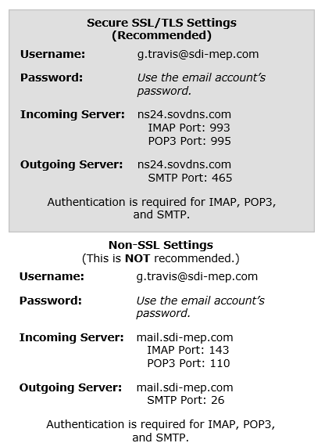

Setup information for lorage

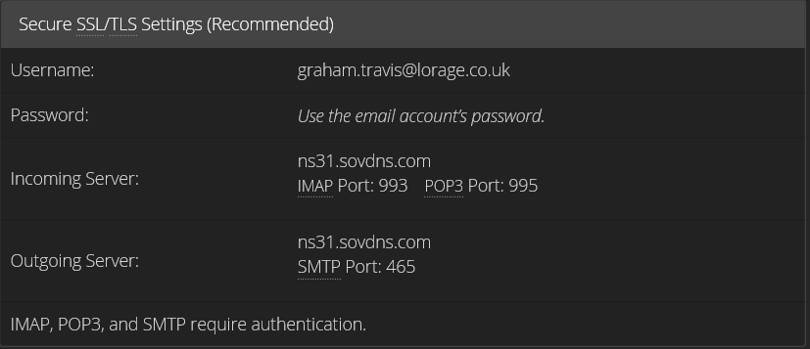

Password is u5taqaisspsa
Broadband Services in the area

Address 50 HERONS WAY, BOLTON, BL2 1EX on Exchange BOLTON is served by Cabinet 120
Featured Products | Downstream Line Rate(Mbps) |  | Upstream Line Rate(Mbps) |  | Downstream Range(Mbps) | Availability Date
 | High | Low | High | Low
FTTC Range A (Clean) | 80 | 74 | 20 | 20 | -- | Available
FTTC Range B (Impacted) | 80 | 61.9 | 20 | 12.2 | -- | Available
WBC ADSL 2+ | Up to 12 |  | -- |  | 7 to 17 | Available
WBC ADSL 2+ Annex M | Up to 12 |  | Up to 1 |  | 7 to 17 | Available
ADSL Max | Up to 6.5 |  | -- |  | 5.5 to 8 | Available
WBC Fixed Rate | 2 |  | -- |  | -- | Available
Fixed Rate | 2 |  | -- |  | -- | Available
Other Offerings
FTTP on Demand | 330 |  | 30 |  | -- | Available
Fibre Multicast | -- |  | -- |  | -- | Available
Copper Multicast | -- |  | -- |  | -- | Available



Domain name: sdi-mep.co.uk
Registrant:
SDi Limited
Registrant type:
Unknown
Registrant's address:
The Studio, 50 Herons Way
Bolton
Lancs
BL2 1EX
United Kingdom
Registrar:
Compila Limited [Tag = COMPILA]
URL: http://www.compila.com
Relevant dates:
Registered on: 01-Feb-2013
Expiry date: 01-Feb-2015
Last updated: 01-Feb-2013
Registration status:
Registered until expiry date.
Name servers:
ns.compila.com
ns2.sovdns.com

http://www.compila.com/domain-name-registration/domain-name-forwarding.html
Use Firefox and logon with sdipm and route654


Domain name: sdi-projectmanagement.co.uk
Managed by 123-REG Account Trolleybus1
Web forwarding to sdi-mep.com and Catch All emails to g.travis@sdi-mep.com

Registrant:
Services Design & Installations Ltd

Registrant type:
Unknown

Registrant's address:
50 Herons Way
Bolton
Lancashire
BL2 1EX
United Kingdom

Registrar:
Webfusion Ltd t/a 123-reg [Tag = 123-REG]
URL: http://www.123-reg.co.uk

Relevant dates:
Registered on: 15-Jun-2010
Expiry date: 15-Jun-2014
Last updated: 26-Feb-2013

Registration status:
Registered until expiry date.

Name servers:
ns.123-reg.co.uk
ns2.123-reg.co.uk

