Computer Installation – Hartley Home
Last Update: Monday, 22 September 2014

Home Address:
The Chestnuts
Gorselands Close
Headley Down
Hampshire
GU35 8HL

Business Address:
Salisbury House
Weyside Park
Catteshall Lane
Godalming
Surrey
GU7 1XE

Business: 01483 410216
Home: 01428 712787
Home 2: 01252 758538
Mobile - Jane: 07979 725544
Mobile – Steve: 07918 888102
VoIP: 200923877

E-mail: jane@hartleyhome.net
E-mail 2: jane.hartley@scotts.com

Web Page: http://www.hartleyhome.net

Logon on passwords to Fire
Steve poontang
Jane flower123*
Ellouise *expertuser*

Broadband Service from TalkTalk Business
WAN: 212.159.138.90 [Dynamic]
LAN Network: 192.168.40.50 to 59
Router IP: 192.168.40.1
ADSL login: 01428712787@talktalkbusiness.net Password: L2A4M5R5W5
Retrieve username and password by calling the automated service on 0870 087 5562
You'll need to call from your home landline number so we recognise your account
VPI: 0 VCI: 38 MTU: 1432
DNS settings: Set as automatic
Encapsulation: PPP over ATM (PPPoA) using VC-MUX Modulation Type: Auto

Help Desk: 0800 083 3003

“MyAccount” information:
Access: https://myaccount.talktalkbusiness.co.uk/Login/
Login email:
Password:
FTTC Availability
Using http://www.hampshiresuperfastbroadband.com/ the following information comes up:
4 GORSELANDS CLOSE, HEADLEY DOWN, BORDON, GU35 8HL: Coming soon
Congratulations, your area is part of the Hampshire Superfast Broadband Programme. New equipment will be installed in your area between July and December 2014. Please register your interest below and we will let you know when the service is available.
More info at: http://www.hampshiresuperfastbroadband.com/#sthash.3U6T9ZDr.dpuf

This map comes from http://www.coolwebhome.co.uk/headley-down-map/ [After you zoom in]

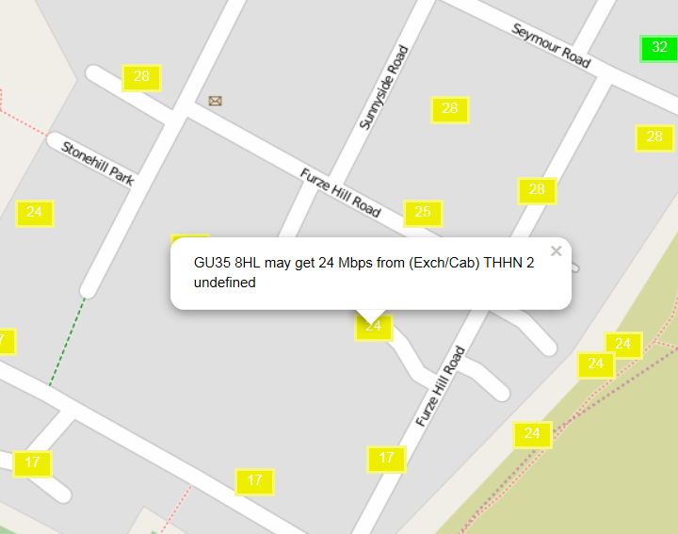

From the BT Availability Checker
Address 4 GORSELANDS CLOSE, HEADLEY DOWN, BORDON, GU35 8HL on Exchange HEADLEY DOWN is served by Cabinet 2
Featured Products | Downstream Line Rate(Mbps) | Upstream Line Rate(Mbps) | Downstream Range(Mbps) | Availability Date
WBC ADSL 2+ | Up to 6 | -- | 4 to 8 | Available
Router reports:
Syncing at: 7.36 Mbps down 0.585Mbps up SNR: 12.85 [Very Good]

Zen Pricing
ADSL Fibre 40/10
500g £35.74 Unlimited £27.00
5000mins £17.35 Unlimited £22.05
Total £53.09 Total £49.05**

** Connection fee £35
From: http://www.samknows.com/broadband/exchange/THHN
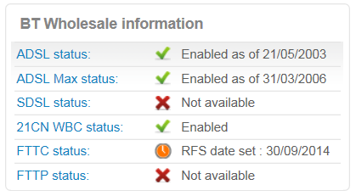

Cabinet No.2 is located at the top of Stonehill Road. The cabinet now has a FTTC twin so indeed it is highly feasible that orders will be accepted at the beginning of October.

Draytek2820Vn Old Draytek 2600 Router
User Name: admin User Name: admin
Password: elstead Password: elstead
Wireless SSID: hartwoods Channel: 6 Wireless SSID: hartwoods Channel: 6
Password: 76677 Password: 76677
Security format: WEP only Security format: WEP only
VPN: david Password: route654 VPN: david Password: route654

Gigaset phone
DrayTEL
Registered under jane.hartley@hartleyhome.net
Password: route654
Enter the following details into your SIP client:
Username: 8462805
Password: ]:L_tJ5Q
Domain: draytel.org
NAT Proxy (if required): nat.draytel.org

Callmaster
Identity: 200923877
Password: route630
POTS: 01252 758538
Mailbox: 9214

Gigaset
username: 213894531002#9
password: rtY8qrED

ESET Smart Security Home Edition
Number of computers: 3
Expiry date: 26/08/2015

Username: EAV-04826105
Password: 7ps64n7rra

Workgroup
GORSELAND
Hosting by Compila
www.hartleyhome.net/cpanel
Username: davi9752 Password: gA23u9edhS

Mailboxes:
sgh@gotadsl.co.uk pickle1
Use: https://netmail.pipex.net/apm/horde/imp/mailbox.php

ellouise@hartleyhome.net 6d6mhvwzdki2
jane@hartleyhome.net 26051969
steve@hartleyhome.net floods2014
sysadmin@hartleyhome.net

Email Forwarding
anastasia@hartleyhome.net >>> ellouise@hartleyhome.net
eah@hartleyhome.net >>> ellouise@hartleyhome.net
jane.hartley@hartleyhome.net >>> jane@hartleyhome.net
stephen.hartley@hartleyhome.net >>> steve@hartleyhome.net

Mail Settings
Using: ns12.sovdns.com
Incoming POP3: 995
Outgoing: SMTP: 465

Web Site
None, currently advertising Compila
Computer Inventory

Computer Name: Fire – Desktop
Windows 8.1 Pro
Product Part No.: [Blue]X18
Product ID: 00259-40847-09800-AAOEM
CD Key: N7D3F-R74QR-M3P8V-KJGFQ-GF26D
Computer Name: FIRE
Registered Owner: Steve
Registered Organization:

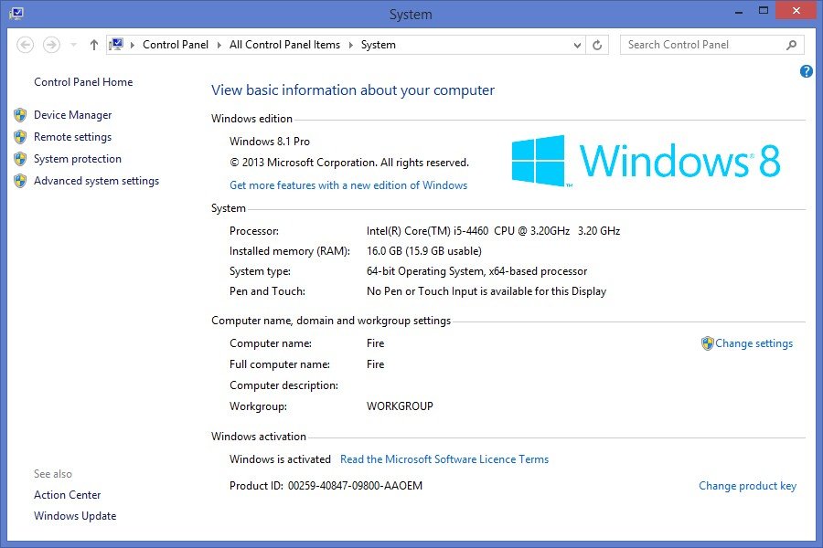

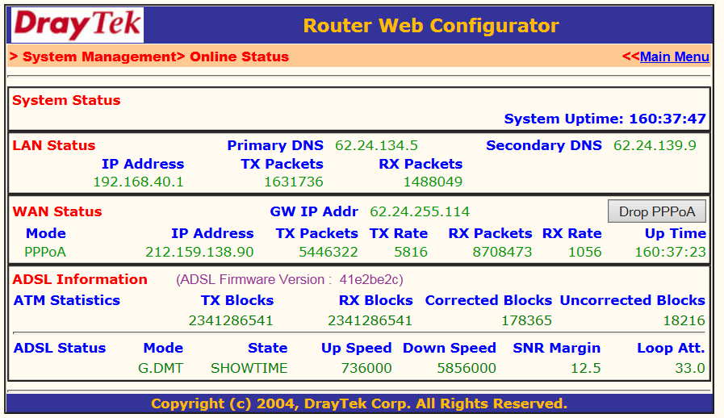

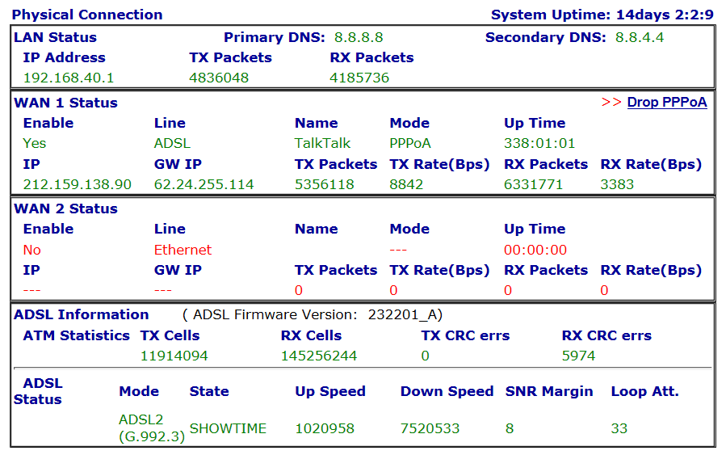

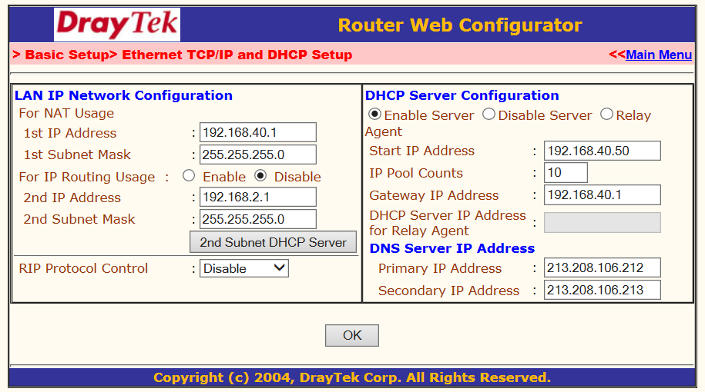

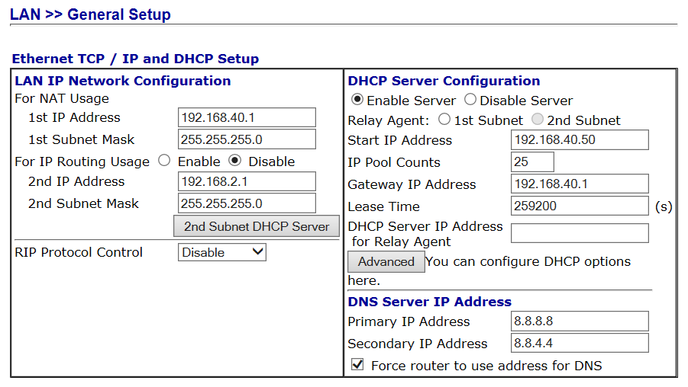

Thank you for your application for a van and trailer permit. Your submitted details are below. If they are incorrect please telephone our Contact Centre on 03456 009 009
Mr David Bradley
WOODLAND VIEW LOWER HAM LANE ELSTEAD
GODALMING
GU8 6HQ
david@cyberpictures.net
01252758960
mk62zjx Trailer
Your Permit Number is 6445412
Print this email and keep in your vehicle for future reference.
You will need to produce your permit number when you visit the site if you have a second vehicle, a hire vehicle or if our system is experiencing technical problems.

