Computer Installation Fact Sheet for Holistic Dental Centre
Company: Holistic Dental Centre Contact: Sharon Saunders
Last Updated: Monday, 30 May 2016

Business Address:
5 Hart House
The Hart
Farnham
Surrey
GU9 7HJ

Business: 01252 820004

E-mail: info@holisticdentalcentre.co.uk
E-mail 2: sharonj25@hotmail.com

Web Page: http://www.holisticdentalcentre.co.uk/

Broadband Service: From BT on 01252 820003 [Order No. BTMYR6131-2]
Help Desk: xxxxxxx Account number: VP30391370
Userid: B349344@hg7.btclick.com Password: CApup170914
Fixed IP address: 81.137.89.225 Range: 81.137.89.225 to 81.137.89.229
Telephone Number 01252 820003 is served by Cabinet 55 – Fifty metres away!
Provisioned Service: 80/20

VPN Access Accounts [PPTP via Wan1]:
giant
homeaccess
will
david
emma

DrayTek Router Information
LAN Access: http://10.0.0.10:8080/
DrayTek Username: admin Password: 5harttoothbrush
Model Name: Vigor2860n
Firmware Version: 3.8.2_VT1
Build Date/Time: Oct 29 2015 16:08:34

Configured Pages:

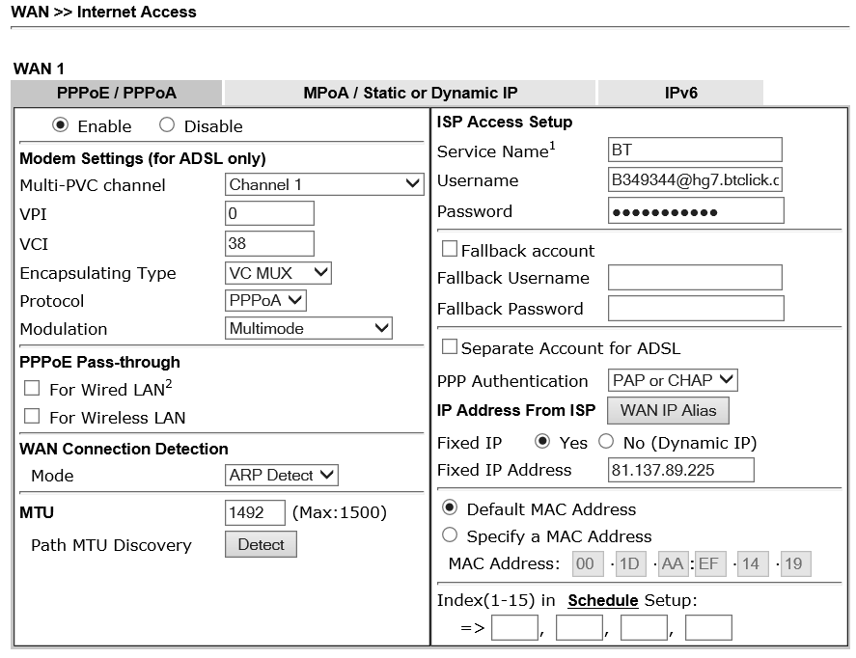

Networked Devices on Monday, 30 May 2016
IP Address MAC Address HOST ID USER Password Comment
10.0.0.1 EC-A8-6B-DB-AA-FE SERVER
10.0.0.2 EC-A8-6B-DB-AA-4F SURGERY1
10.0.0.3 EC-A8-6B-DB-A9-E0 SURGERY2
10.0.0.4 00-19-99-4B-B5-F0 XRAY
10.0.0.10 00-1D-AA-EF-14-19 DrayTek Router
10.0.0.101 00-04-13-38-78-7C snom 200923867
10.0.0.108 00-04-13-4D-9E-08 snom 200923763
10.0.0.203 00-04-13-3B-06-A0 snom 200923764
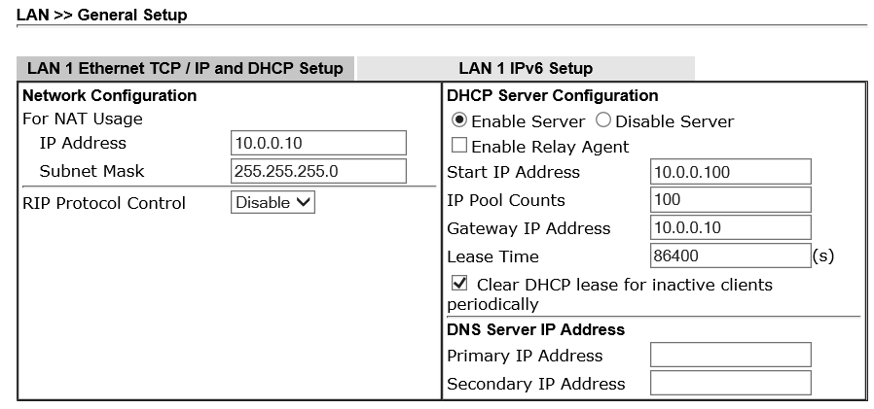

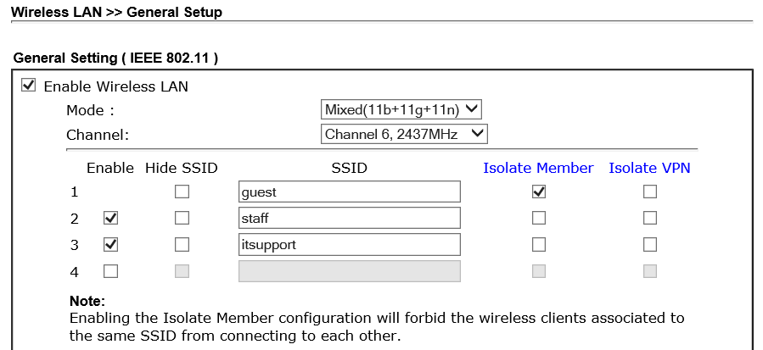

SSID Isolate Mode Password
guest YES WPA2/PSK holisticdental
staff NO WPA/PSK mercury5
itsupport NO WPA2/PSK route654

VoIP Phones

200923867 – downstairs phone
Status: | 200923867@84.45.58.116: OK
Version: 7
DHCP ON
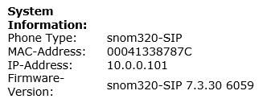

200923763 – Reception
Status: | 200923763@84.45.58.116: OK
Version: 8
DHCP ON

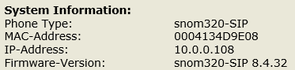

200923764 – Upstairs Phone
Status: 200923764@v1.21voice.net: OK
Version 7
DHCP ON
