Computer Installation at Howard Taylor Associates
Version: Tuesday, 3 February 2026

Business Address:
50 Poyle Road
Tongham
Farnham
GU10 1DU

Howard Mobile: 07932 156045
Office Tele: 01252 669936 Call Group 1
Home Tele: 01252 640261 Call Group 2
Door Bell Unit: 056 0386 4716 Call Group 2
Failover numbers: 07932 156045

Call groups as at 3 FEB 2026:
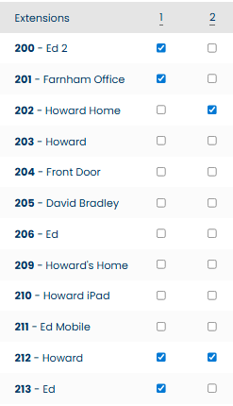
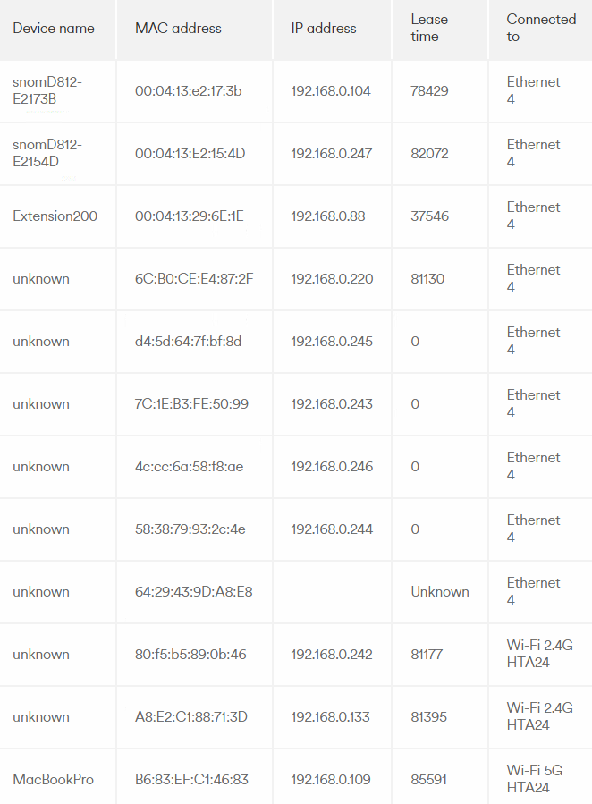

Voipfone
URL: https://my.voipfone.co.uk/#!/dashboard+auth
Logon: howard.taylor@htamortgages.uk
Password: Route6122024^

Broadband Service from Virgin
WAN: 86.15.124.1
Access to the router is through the web page 192.168.0.1
Password: pryi4xE7ttvS
Hub 5 Model F3896L G-VMB
07542318839 – Mary Virgin installation engineer

SSID from Virgin Router
Name Password
HTA Palace@2008

Howard’s phone:

Username: trolleybus Password: route654

Ed’s phone:

Username: trolleybus Password: route654

The Door Entry System:
https://192.168.79.23:5555/
Username: Admin
Password: Elstead2008

Gigaset N300IP:

Pin: 2222
Use Configuration Assistant
Prefix: 30205019
To configure personal info services (e.g. Weather, News, etc.) go to www.gigaset.net/myaccount
For manual authentication in Gigaset.net:
Username: 229389760024#9
Password: ENmLbf2F

Configured these accounts in the Gigaset N300IP:

01252 893575 – CLID 01252 640261

01252 640261 – CLID 01252 640261

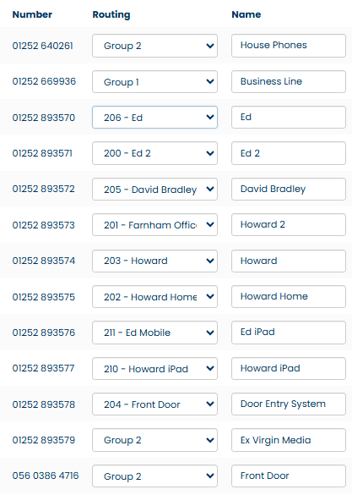

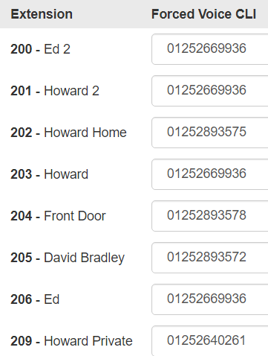
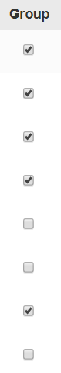
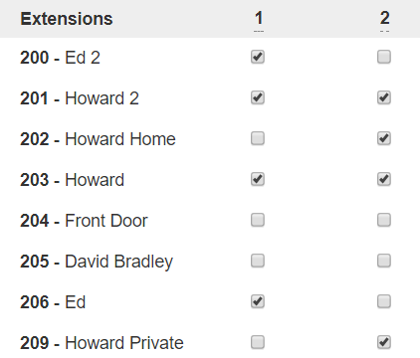

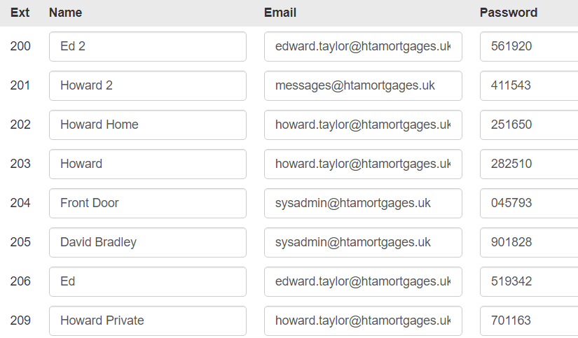

Multi-Function Printer
Printer Details:
Fixed IP:
Userid: ? Password: ?

ESET Licence Information - 01202 548 888
Contact: Howard Taylor
Company: Howard Taylor Associates
Username: EAV-01665106
Password: sfu2v24m5v
Licence Key: CEJF-XPT4-A3MJ-7WSA-5UE7
Product: ESET Endpoint Security
Quantity: 6 computers
Expiry: 14/03

ESET Licence Administrator - https://ela.eset.com/LicenseOwner
Licence Key: CEJF-XPT4-A3MJ-7WSA-5UE7
Password: c7JpAHhd8R

Users of PCs
Bolton
Palace

Halifax
IT Help Line: 01422 394620
Account: 9764510000
User: Palace1
Birthplace: palace

Sage - S/COV Instant Accounting
Account Number: 60583639
Tele: 0845 111 6666
Help Desk: 0845 111 55 55 - support@sage.com
Customer Reference U570466
Sage Cover Extra until 30th July 2013
Password: Palace01 is used somewhere but not sure where!
Software Login: MANAGER Password: 60583639
Activation Key: TBEKXZDY
Frustratingly no link email address known.

VoIP Installation Information
01252 893575 200923575 01252 893575 2222 Poyle Road gigaset Howard 3575
Password: hta31415 for all identities
Userid: dusty Password: springfield

DrayTEL
Username: 8462918
Password: f<2eOlJ>
Domain: draytel.org
NAT Proxy (if required): nat.draytel.org
Registered under david.bradley@htamortgages.net
Password: route654

Thank you for registering your company:
Howard Taylor Associates
79 Victoria Road
Farnborough
Hampshire
GU14 7DB
England

You have also registered yourself as a supervisor user for your company:
Mr Howard Taylor
FSA No: 138206
Email Address: howard.taylor@htamortgages.net
Please make a note of your User ID and Password for future reference.
Supervisor User ID: Howard-Taylor-71304
Supervisor Password: 0am6

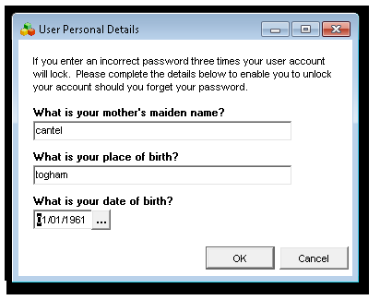

Domains held

https://mybill.virginmediabusiness.co.uk/web/guest
Username: dbradley Password: woodside1993 Only works with IE8

Registration Procedure
Destroy MAC association at https://autoreg.autoregister.net/cgi/acorn
https://memberservices.ntlbusiness.com
Serial Number: ntl-ac3-ac328 USER ID: Admin.HowaG1L0B186 Password b078866494
SABS ID 8174016 MAC number of cable modem: 00 22 CE 7F 09 66

The Virgin broadband service used was this one: http://www.virginmediabusiness.co.uk/products__solutions/broadband__internet_services/business_broadband__phone.aspx#overview.
It cost £39 plus an extra £10 for the fixed IP which was necessary to run the email service out of the server and to provide remote connectivity. [£49 + VAT = £58.80].

The package included a land line on 01252 501318 that was used for the fax machine. It provided unlimited calls to UK destinations; together with international landlines in many countries for the first 60 minutes [redial after 59 minutes]. Calls to numbers starting with 0845 and 0870 are also included. Mobile calls were charged separately.

Door Entry System Settings
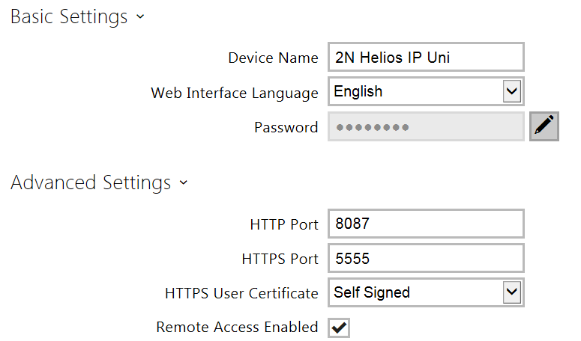
Userid = Admin Password = Elstead2008 [Case sensitive]
Remote: https:// :5555/ Local: http://192.168.0.243:8087/

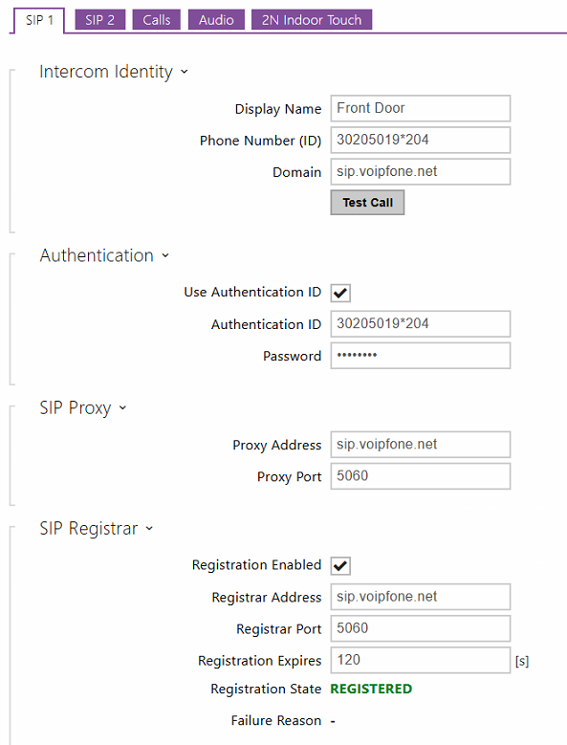
Password =
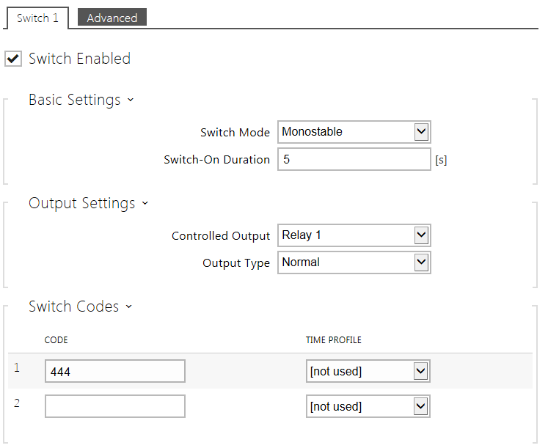

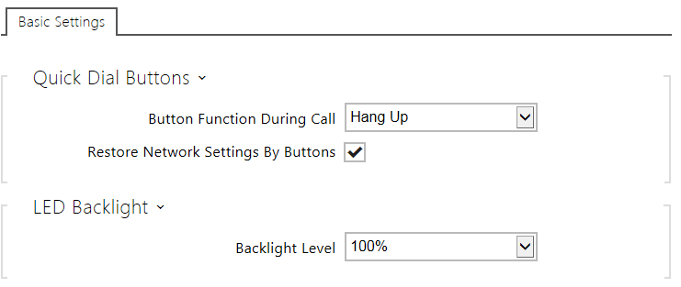

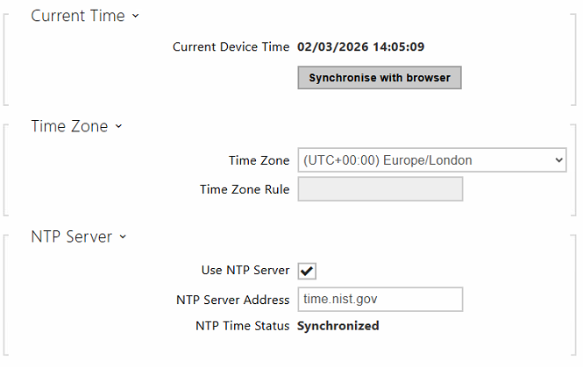

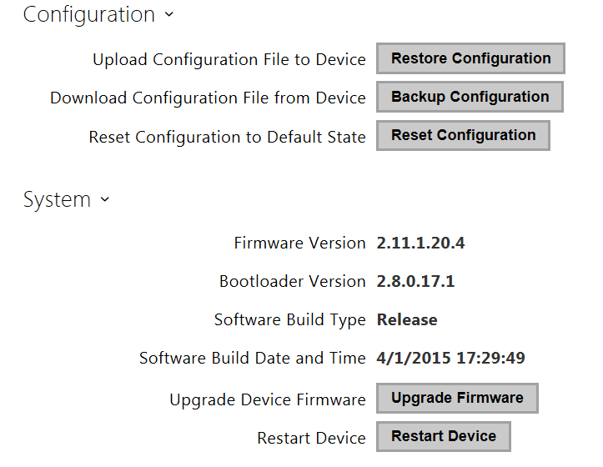

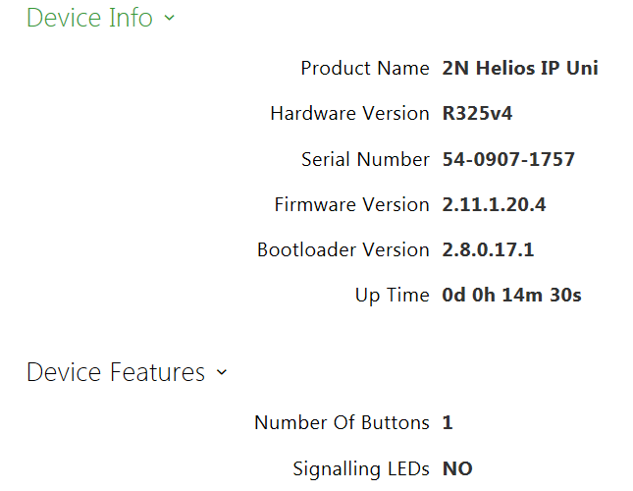

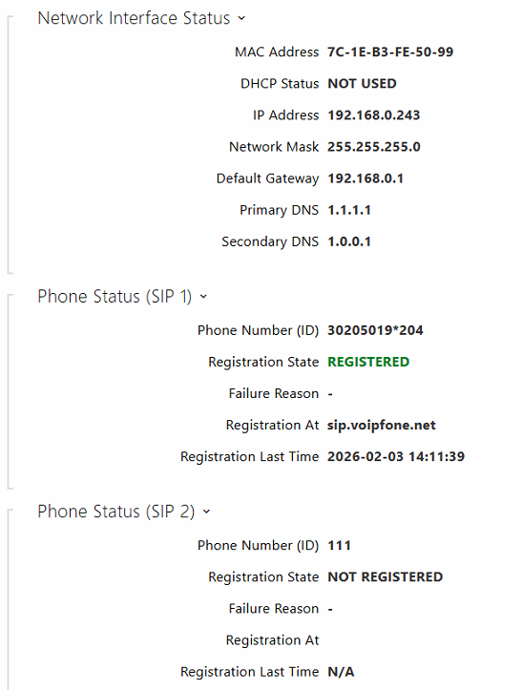

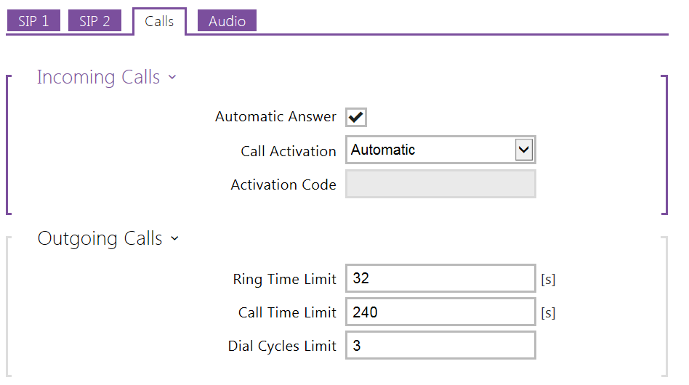

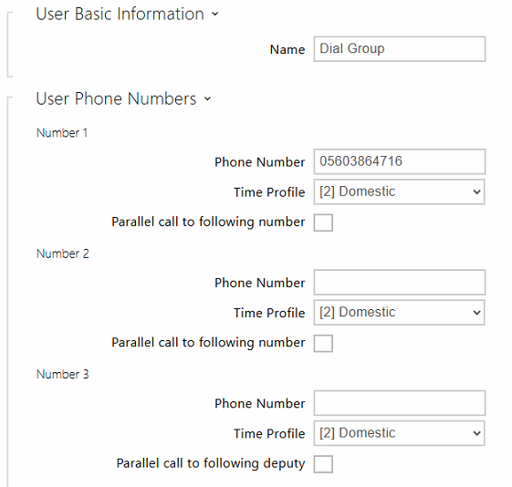

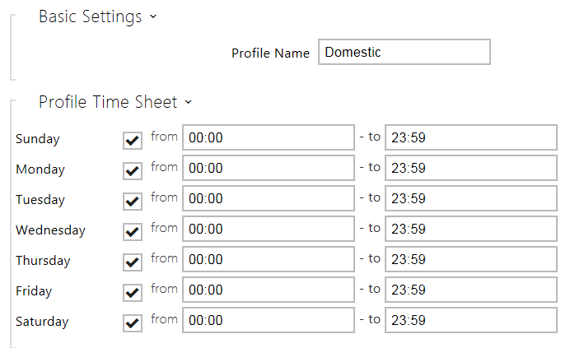

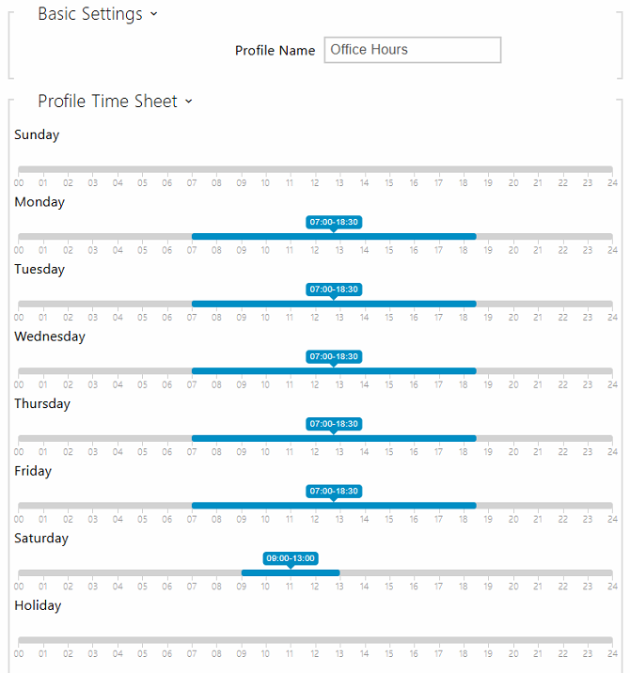

http://www.2n.cz/en/downloads/p=helios-ip-uni%7Ccategory=firmware

