Computer Installation at Howard Taylor Associates
Version: Wednesday, 18 December 2013

Business Address:
79 Victoria Road
Farnborough
Hampshire
GU14 7PL

Home Address:
50 Poyle Road
GU10 1DU

Victoria Road: 01252 669936 [VoIP Number with Callmaster]
Poyle Road: 01252 893574 [VoIP Number with Callmaster]
Mobile: 07932 156045
Virtual Fax: 01252 669937 [VoIP Number with Callmaster]
Converted to TIFF and sent to info@htamortgages.net
Physical Fax: 01252 501318 [Virgin Media Land Line]
2nd Line: 01252 511053 [Was 01252 519098 until April 2012]
Zen Order Number: 973534 Order Date: 03-Dec-2013
Monthly Charge: 13.49 ex. VAT Contract Term: 30 days
VoIP fall over number: 07841 866934

Virgin 10Mb Broadband and Telephone Service [Unlimited calls to 01/02/03 numbers]
Speed Test: 9.3/0.7 [Monthly Fee: £58.80 inc VAT]
Help Desk: 0800 052 0800
Account number: 100755802
Telephone Number: 01252 501318
Fixed IP: 86.7.208.62
DNS: 194.168.4.123 and 194.168.8.123
SMTP: smtp.virginmediabusiness.co.uk



https://mybill.virginmediabusiness.co.uk/web/guest
Only works with IE8
Username: dbradley
Password: route654

Registration Procedure
Destroy MAC association at https://autoreg.autoregister.net/cgi/acorn
https://memberservices.ntlbusiness.com
Serial Number: ntl-ac3-ac328
USER ID: Admin.HowaG1L0B186
Password b078866494
SABS ID 8174016

The Virgin broadband service selected is shown here: http://www.virginmediabusiness.co.uk/products__solutions/broadband__internet_services/business_broadband__phone.aspx#overview.
It cost £39 plus an extra £10 for the fixed IP which is necessary to run the email service out of the server and to provide remote connectivity.

The package includes a telephone line that is needed for the fax machine. This telephoned line has the number 01252 501318 and is quite independent from the broadband service.

It has uunlimited calls to UK destinations; together with international landlines in many countries for the first 60 minutes (just redial after 59 minutes). Calls to numbers starting with 0845 and 0870 are also included. Please note that mobile calls are charged separately.

An upgrade is available to 50/2 but FTTC via Zen considered a better choice.

Notes on Virgin Service

The Virgin plan signed up for is this one: http://www.virginmediabusiness.co.uk/products__solutions/broadband__internet_services/business_broadband__phone.aspx#overview. It cost £39 plus an extra £10 for the fixed IP which is necessary to run the email service out of your server and to provide remote connectivity.
£49 + VAT = £58.80

The package includes a telephone line that is needed for the fax machine. This telephoned line has the number 01252 501318 and is quite independent from the broadband service.

The 10Mb packages includes unlimited calls to UK destinations; together with international landlines in many countries for the first 60 minutes (just redial after 59 minutes). Calls to numbers starting with 0845 and 0870 are also included. [Mobile calls are chargeable].

Possible to upgrade to 50/2 service but FTTC via Zen considered a better deal.

Broadband Service using FTTC from Zen
Telephone Number 01252511053 on Exchange FARNBOROUGH is served by Cabinet 67
Featured Products | Downstream Line Rate(Mbps) |  | Upstream Line Rate(Mbps) |  | Downstream Range(Mbps) | Availability Date
 | High | Low | High | Low
FTTC Range A (Clean) | 80 | 79.9 | 20 | 20 | -- | Available

Zen Business Plus telephone Line rental with 5000 minutes per month of anytime UK landline calls
Line Rental £13.49 ex. VAT [£16.19] Contract term: 30 days
01, 02, 03, 845 & 0870 Line restarted 6/12/13 – one off charge of £9.99 ex. VAT [£11.99]

Zen Broadband Details
Monthly charge: £25 including VAT Care Level: Standard
Switchboard: 01706 902 000 Fax: 01706 902 005
Support help line via VoIP: 777 Support POTS number: 01706 902 009
Help guides: http://www.zen.co.uk/support/broadband/fibre-setup.aspx

- Totally unlimited uploads and downloads
- One static IP included.
- Download speed up to 76Mbps
- Upload speed up to 19Mbps
- 12 month contract

Customer Portal: http://portal.zen.co.uk/
Username: howard.taylor@htamortgages.net
Password: route654

Connection type: PPPoE
Authentication type: CHAP [Listed as "PAP or CHAP"]
Zen username: zen256185@zen
Connection Password: idGATqbG
Static IP: 82.71.58.205
Subnet mask: 255.255.255.255
Primary DNS: 212.23.3.100 Secondary DNS: 212.23.6.100
Name Address: 82-71-58-205.dsl.in-addr.zen.co.uk

Zen Order No: 975134 Date order placed: 10-Dec-2013
Installation Date: 19/12/2013 Time: 08:00 - 13:00

Default email username: zen256185@zen.co.uk
Default email password: rpuYXfqf

Default web space username: zen256185
Default web space password: rpuYXfqf

On 7th December 2013, all inbound emails were diverted to hosting facilities provided by Compila. To achieve this all advanced DNS settings were deleted and new Nameservers recorded.

DELETED:
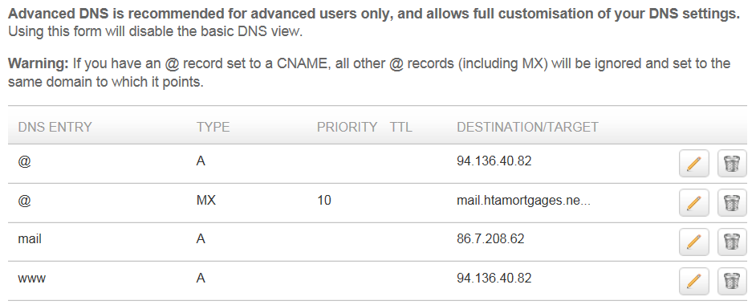

IP address 86.7.208.62 is the fixed IP provided by Virgin
IP address 94.136.40.82 is 123REG [Necessary to use for framed web forwarding]
The web site contents removed as instructed by Howard.

Records were set up so that emails are handled by the server [Manchester] and Framed Web Forwarding for the web site went to www.palacemortgages.net

CREATED:
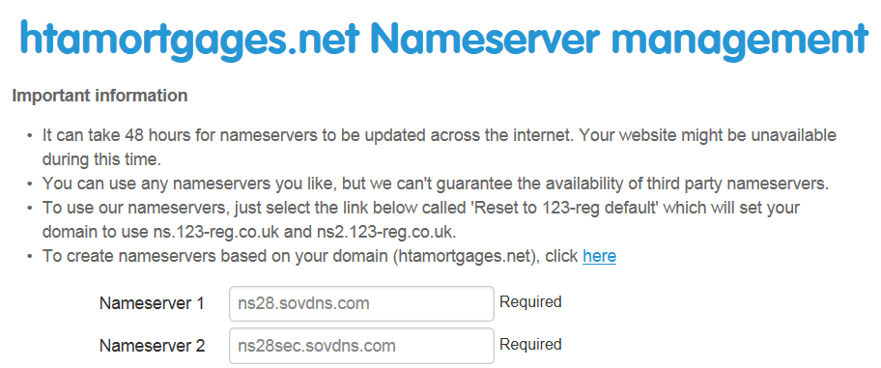
RESULTANT WHOIS RECORD:

Domain Name: HTAMORTGAGES.NET
Registry Domain ID:
Registrar WHOIS Server: whois.tucows.com
Registrar URL: http://tucowsdomains.com
Updated Date: 2013-12-07 10:24:17
Creation Date: 2008-05-09 15:24:13
Registrar Registration Expiration Date: 2015-05-09 15:24:13
Registrar: TUCOWS, INC.
Registrar IANA ID: 69
Registrar Abuse Contact Email:
Registrar Abuse Contact Phone:
Reseller: 123-reg.co.uk
Reseller:
Reseller: 0845 450 2310
Reseller: http://www.123-reg.co.uk
Domain Status: clientTransferProhibited
Domain Status: clientUpdateProhibited
Registry Registrant ID:
Registrant Name: Howard Taylor
Registrant Organization: Howard Taylor Associates
Registrant Street: 79 Victoria Road
Registrant City: Farnborough
Registrant State/Province: United Kingdom
Registrant Postal Code: GU14 7PL
Registrant Country: GB
Registrant Phone: +44.1252669936
Registrant Phone Ext:
Registrant Fax: +44.1252669937
Registrant Fax Ext:
Registrant Email:
Registry Admin ID:
Admin Name: David Bradley
Admin Organization: David Bradley Online
Admin Street: Woodland View, Lower Ham Lane Elstead
Admin City: Godalming
Admin State/Province: United Kingdom
Admin Postal Code: GU8 6HQ
Admin Country: GB
Admin Phone: +44.1252758960
Admin Phone Ext:
Admin Fax:
Admin Fax Ext:
Admin Email:
Registry Tech ID:
Tech Name: David Bradley
Tech Organization: David Bradley Online
Tech Street: Woodland View, Lower Ham Lane Elstead
Tech City: Godalming
Tech State/Province: United Kingdom
Tech Postal Code: GU8 6HQ
Tech Country: GB
Tech Phone: +44.1252758960
Tech Phone Ext:
Tech Fax:
Tech Fax Ext:
Tech Email:
Name Server: NS28.SOVDNS.COM
Name Server: NS28SEC.SOVDNS.COM
DNSSEC:
URL of the ICANN WHOIS Data Problem Reporting System: http://wdprs.internic.net/

Registration Service Provider:
123-reg.co.uk,
0845 450 2310
08709126612 (fax)
http://www.123-reg.co.uk
This company may be contacted for domain login/passwords,
DNS/Nameserver changes, and general domain support questions.
ESET - 0845 838 0832
Licence Information
Contact: Howard Taylor
Company Howard Taylor Associates
UserName EAV-01665106
Password sfu2v24m5v
Product ESET Endpoint Security
Size 8 computers
Expiry Date 14/03/2014

Multi-Function Printer
Ricoh Printer Aficio 2022:
Fixed IP: http://192.168.79.5
Userid: admin Password: password
Fax Facility: 01252 501318

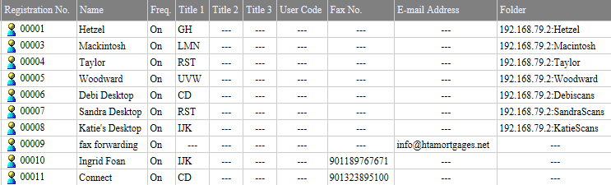

Draytek Unit:
Access: 192.168.79.1:8080
Userid: admin Password: elstead2008
LAN: 192.168.79.xx
DHCP: Assigned by the Manchester Server

Remote Access to Manchester:
Create a VPN connection first then issue the RUN command: mstsc /admin

Usually Attached Devices on the Network
IP Address MAC Address Netbios Name Interface
192.168.79.2 00-0C-29-EE-F4-F0 MANCHESTER LAN1
192.168.79.5 00-00-74-8D-85-70 RNP8D8570 LAN1
192.168.79.9 00-50-8D-CB-E7-DE PORTSMOUTH LAN1
192.168.79.74 00-07-E9-62-F3-42 ARSENAL – info – Xp LAN1
192.168.79.76 90-2B-34-25-86-62 PALACE – Sandra – Windows7 LAN1
192.168.79.57 90-2B-34-17-4D-26 BOLTON – Debi – Windows7 LAN1
192.168.79.58 00-04-13-29-6E-33 snom3570 - Debi LAN1
192.168.79.59 00-04-13-29-6E-20 snom3574 – Howard LAN1
192.168.79.61 E0-C9-7A-7D-E9-38 LAN1
192.168.79.63 00-E0-4D-57-07-08 LEEDS – Debi – Xp LAN1
192.168.79.65 00-04-13-29-7E-1D snom3573 – Reception LAN1
192.168.79.66 00-04-13-29-6E-1E snom3571 – Sandra LAN1
192.168.79.71 6C-F0-49-E7-63-AA ALDERSHOT – Howard – Windows7 LAN1
86.7.208.1 00-0F-F8-B6-00-01

Users of PCs
Portsmouth Server Password: banus2008()
Manchester Server Password: banus2008() [Virtual PC under Portsmouth]
Aldershot Howard Taylor – Windows7 PC
Bolton Debi Hetzel – Windows7 PC
Palace Sandra Mackintosh – Windows7 PC
Arsenal To be decommissioned Xp **
Leeds To be decommissioned Xp **
Southampton To be decommissioned Xp **

INVU Contact Information
Contact: issmith@IKON.com
See also http://www.uk.ikon.com/support/
Tele: 08705 20 20 40
Serial number for machine: J8654201712
Care program in place

Ash Kent 07710745380
anthony.barnes@ricoh.co.uk
020 8261 4203 also 020 8261 4348
Mobile: 07970499461

Halifax
IT Help Line: 01422 394620
Account: 9764510000
User: Palace1
Birthplace: palace

Sage - S/COV Instant Accounting
Account Number: 60583639
Tele: 0845 111 6666
Help Desk: 0845 111 55 55 - support@sage.com
Customer Reference U570466
Sage Cover Extra until 30th July 2013
Password: Palace01 is used somewhere but not sure where!
Software Login: MANAGER Password: 60583639

Microsoft Office 2010 Home and Business - 1 Install (Download Delivery)
From: info@coastalsoftware.co.uk Date: 2013-12-10 15:22
Order#: 9847210 Code: O2K10HBRPKC
Microsoft Office 2010 Home and Business - 1 Install (Download Delivery)
Product Key: 6JP8Y-2CQ3P-T9Y6K-KYMW6-9WBX9
Follow the link to access the download for one computer:
http://tinyurl.com/msoffice2010msi

Purchased from: http://www.coastalsoftware.co.uk/O2K10HBRPKC.html
Check in case of fraud:
Domain name: coastalsoftware.co.uk
Registrant: Coastal Software ltd. UK Limited Company, (Company number: 7215111)
Registrant's address: 32 crofts path, hemel Hempstead, Hertfordshire, hp38hd, United Kingdom
Registrar: Register.com Inc [Tag = REGISTER-DOT-COM] URL: http://www.register.com
Registered on: 14-Jan-2010 Expiry date: 14-Jan-2016 Last updated: 30-Nov-2013
VoIP Installation Information
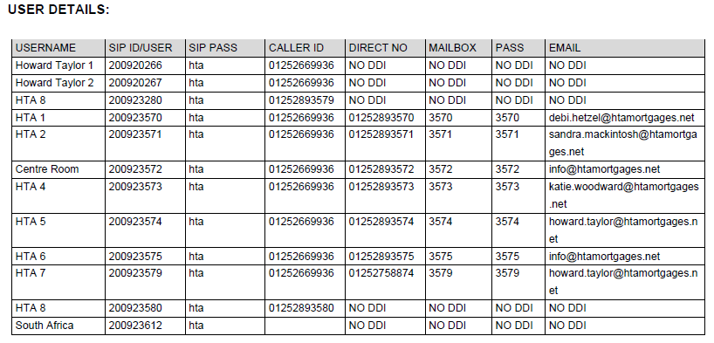
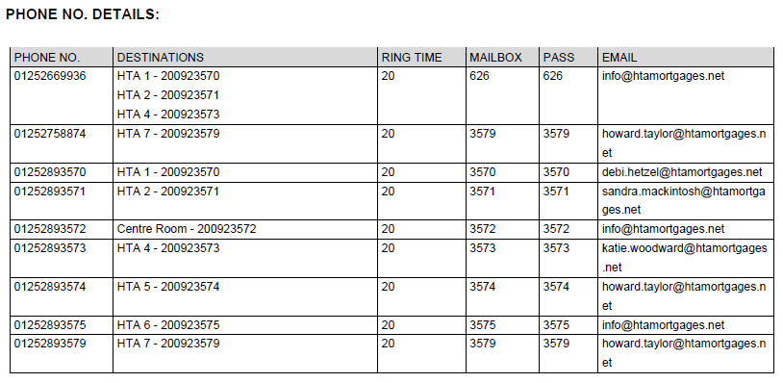

Callmaster Basics
01252 893570 - 200923570 - Debi Hetzel
01252 893571 - 200923571 - Sandra Mackintosh
01252 893573 - 200923573 - Reception
01252 893574 - 200923574 - Howard Taylor GUID: Trolleybus Password: route630

01252 669936 - 200923579 - Poyle Road
01252 758874 - 200923580 - Poyle Road

DrayTEL
Username: 8462918
Password: f<2eOlJ>
Domain: draytel.org
NAT Proxy (if required): nat.draytel.org
Registered under david.bradley@htamortgages.net
Password: route654

debi.hetzel@htamortgages.net 67ro9ndsk3zq
sandra.mackintosh@htamortgages.net 8xhs1gvibo59
david@htamortgages.net 6ougcp4dei9q
howard.taylor@htamortgages.net drc44t5o9eux

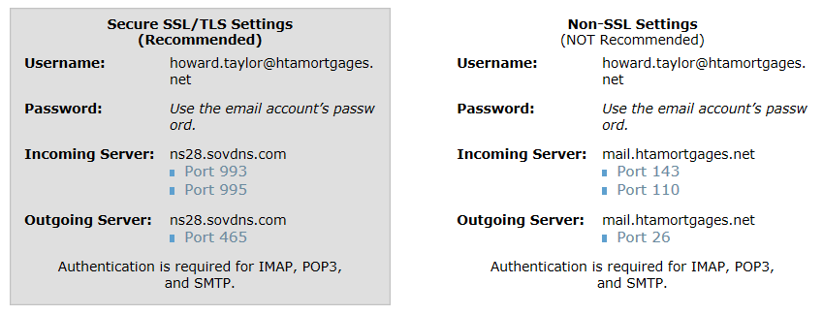

Emergency email accounts are available at www.palacemortgages.net/webmail
Access to the Control Panel:
www.palacemortgages.net Userid: davi6839 Password: pRriknHalj
 |  | davi6839 | pRriknHalj
debi@palacemortgages.net
sandra@palacemortgages.net
howard@palacemortgages.net
info@palacemortgages.net

All have the password of elstead2008

Thank you for registering your company:
Howard Taylor Associates
79 Victoria Road
Farnborough
Hampshire
GU14 7DB
England

You have also registered yourself as a supervisor user for your company:
Mr Howard Taylor
FSA No: 138206
Email Address: howard.taylor@htamortgages.net
Please make a note of your User ID and Password for future reference.
Supervisor User ID: Howard-Taylor-71304
Supervisor Password: 0am6

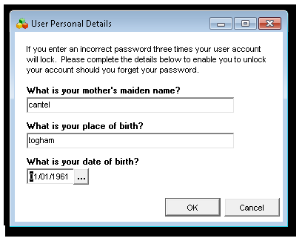

Record of Settings in the Router

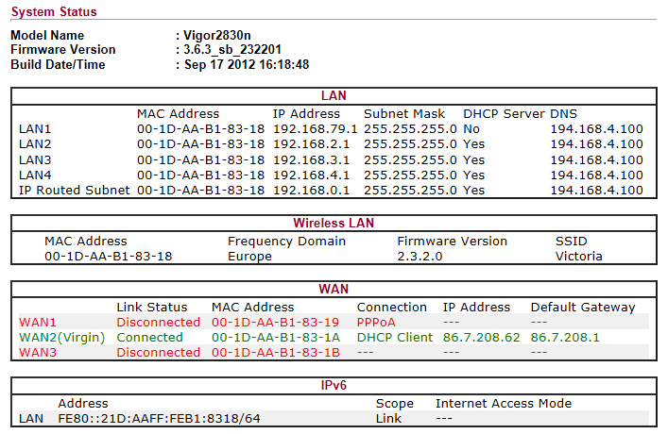

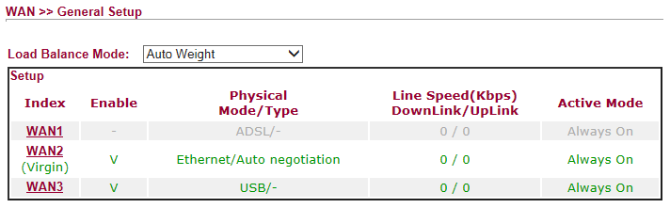

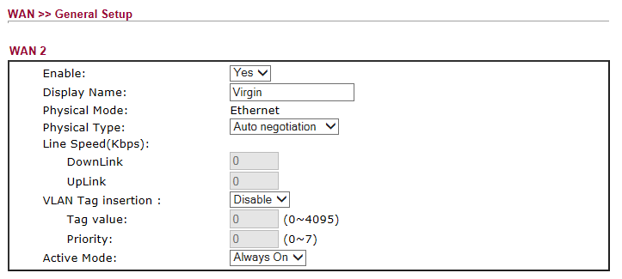
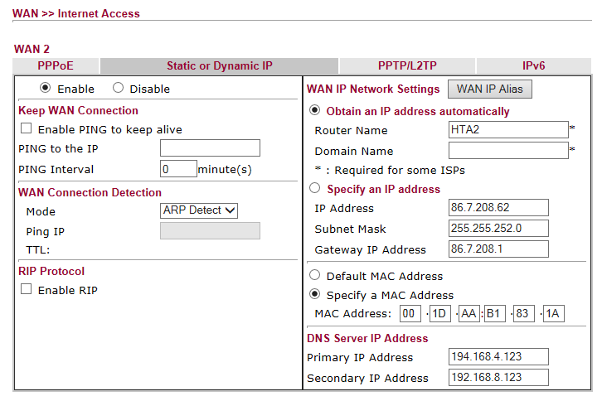
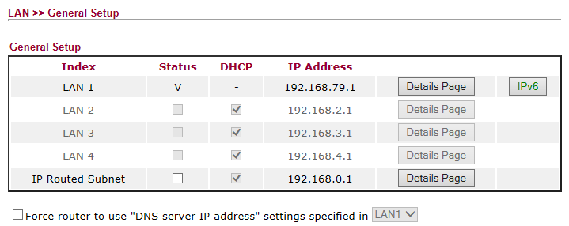
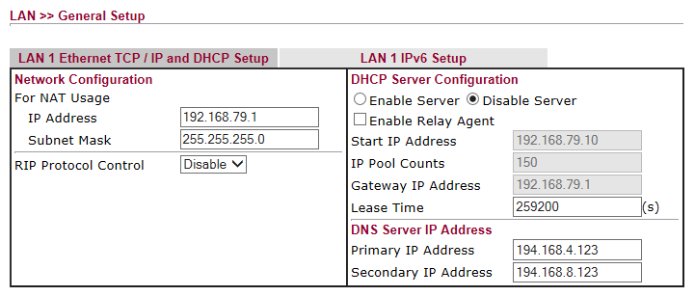
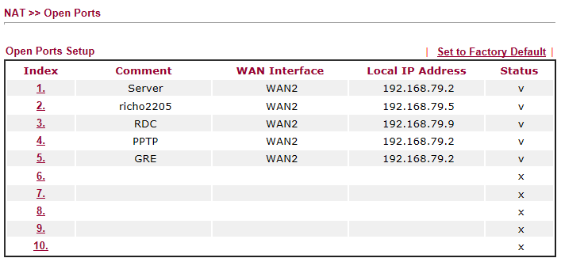

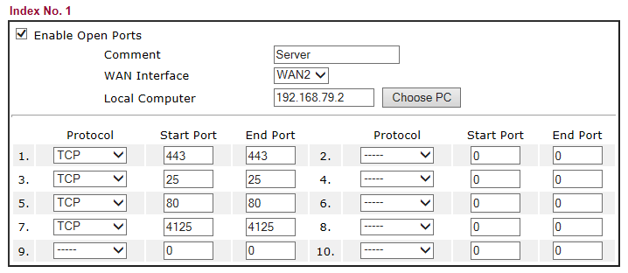
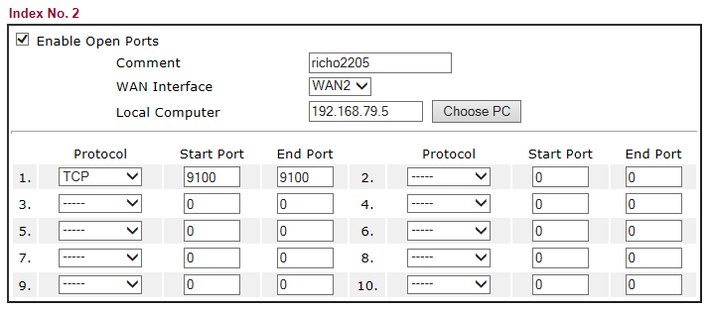
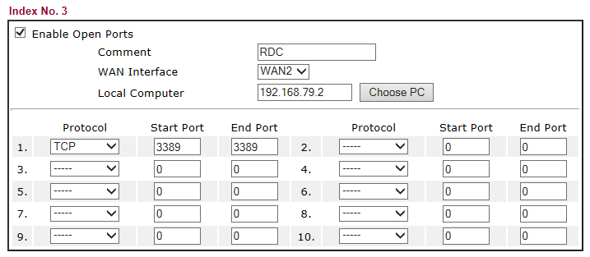
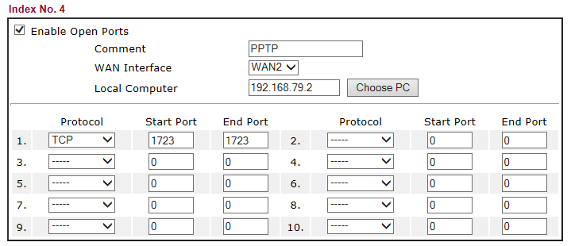
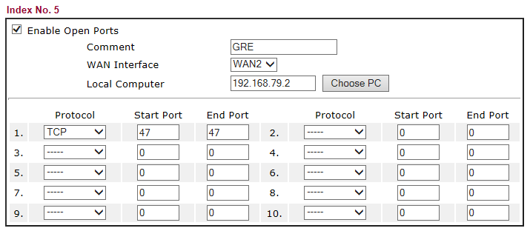
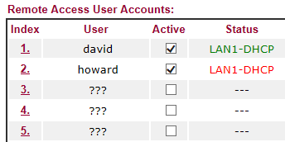

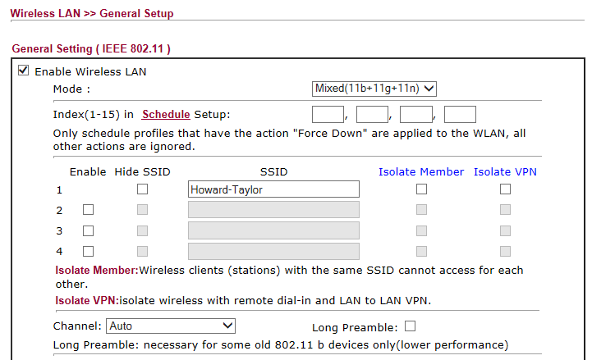

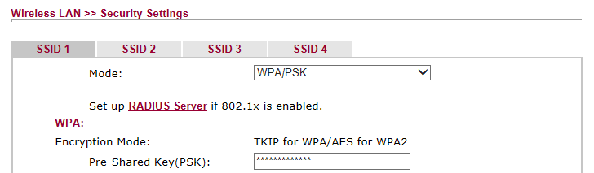

Password: route654
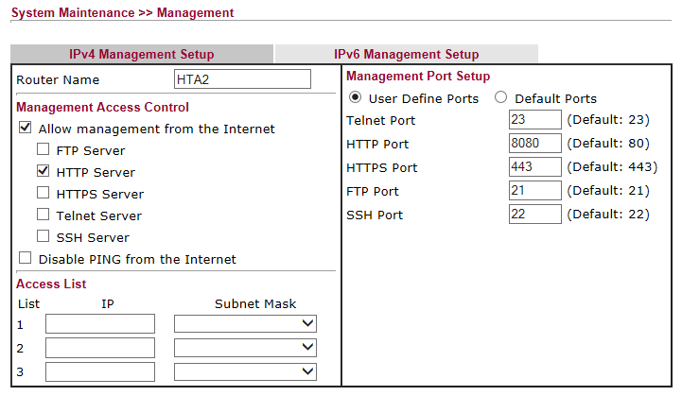

Sandra’s PC
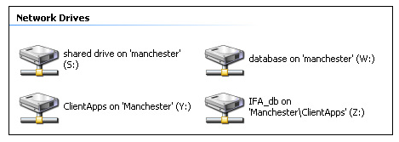

Debi’s PC


Domains held [Current and previously]

howardtaylorassociates.co.uk
howardtaylorassociates.com

Have been allowed to expire

banus-lettings.com – Expiry date: 6 Aug 2018.
This is a virtual domain registered with 123 REG which is redirected to banus-lettings.net

banus-lettings.net – Expiry date: 6 August 2016
Registered and Hosted by Compila. Expiry date: 6 August 2016
Username:davi1208
Password: VbuJYA3bef

Web site and email facilities

palacemortgages.net
Registered and Hosted by Compila. Expiry date: 6 February 2015
Username: davi6839
Password: pRriknHalj

Historically used when there was a company of that name but now used for emergency email purposes and to host the
Web site which had to be taken down as it was substantively out of date.

All unrouted mail for palacemortgages.net diverted to howard.taylor@htamortgages.net

hta-mortgages.net
Registered with 123-REG. Expiry date: 27 February 2016
No hosting facilities

This was the original domain name but a few emails still come into the old address and are therefore redirected to the equivalent email address on htamortgages.net

Computer Inventory

ALDERSHOT – Desktop – Howard’s Office

Windows 7 Professional Service Pack 1
Product Part No.: X15-37362
Installed from 'OEM' media.
Product ID: 00371-OEM-9044155-32869
CD Key: 88BPK-3Q43P-PJHQR-WB9XW-J3GC9
Computer Name: ALDERSHOT
Registered Owner: User [Howard's PC]
Registered Organization: Owner

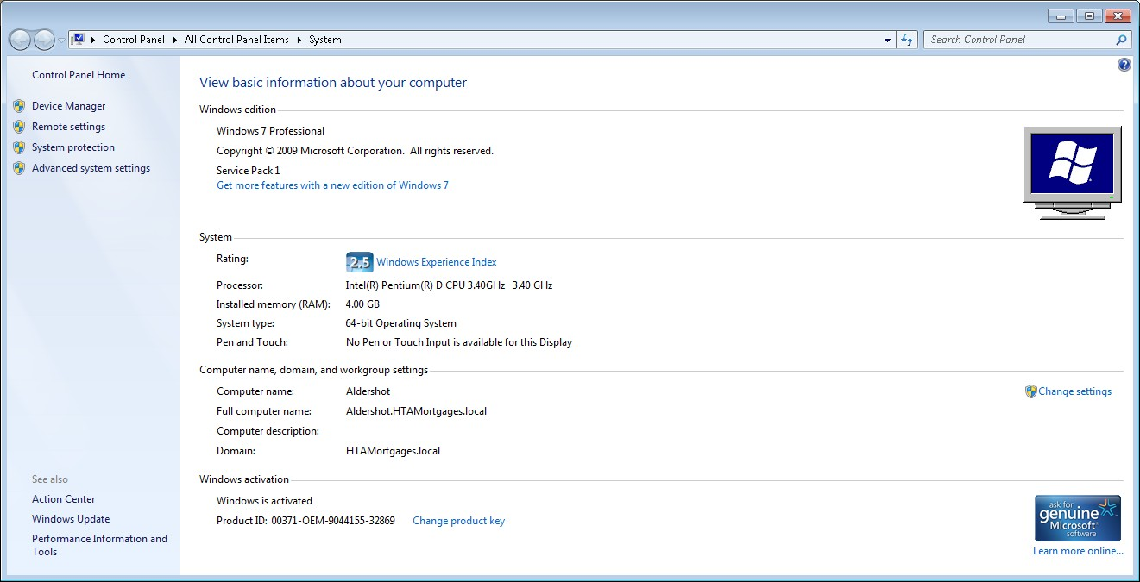

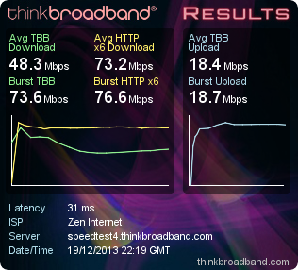
Home Installation
Using Virgin Media Cable
NETGEAR WGR614v9 Wireless Router
http://62.255.198.21:8080/start.htm
Userid: virgin Password: elstead2008
Remote Management of router restricted to IP address 82.133.118.158
LAN Range is 70 to 90

Wireless Information:
SSID: Clifton2
Using WEP Key1: A28D7B15C7

DDI number for the snom phone at Poyle Road is 01252 893579
The command https://62.255.198.21/ continues to give remote access to the phone although I have now added logon credentials which are david and elstead2008

Attached Devices
# | IP Address | Device Name | MAC Address
1 | 192.168.150.74 | IPAD | 1C:AB:A7:3F:A8:E7
2 | 192.168.150.76 | GRANDSTAND | 00:30:05:E2:9C:48
3 | 192.168.150.78 | snom | 00:04:13:29:6E:19

Port Forwarding
 | # | Service Name | Start Port | End Port | Server IP Address
 | 1 | rdc | 3389 | 3389 | 192.168.150.70
 | 2 | snom | 443 | 443 | 192.168.150.78

ESET [Registered under howard.taylor@htamortgages.net]
2 copies of Smart Security (Home Edition) – Expires 19 April 2014
User Name: EAV-44392893
Password: 5nvt8e657u

