Computer Installation at Hugh Taylor
Updated: Monday, 31 March 2025

Home Address:
20 Hillside Drive
Edgware
Middlesex
HA8 7PG

Telephone: 020 8958 5906
DrayTEL: 8494598

E-mail: isleworthdepot@trolleybus.net

Broadband Service: From Zen
Switchboard: 01706 902000 Help Desk: 01706 902009
Username: zen299844@zen Password: zfWgf5dG
IP Address: 82.69.45.121
Primary DNS: 8.8.8.8
Secondary DNS: 8.8.4.4
Zen Order No: 1165141 Date order placed: 11-Apr-2016
Activation date: 27/04/2016

Broadband Username: VFP2752128@cloudscape.uk
Broadband Password: ha87pg
Connection Type: PPPoE
You will be assigned an IP of: 92.62.1.182 (This is dynamically assigned when you connect)

Broadband Service: From Cloudscape
Help Desk: 0345 688 7227
Support Website: http://support.cloudscapeconnect.com
Username: CTaylor8684 Password: 8684CT4868
Broadband Username: 02089585906@cloudscape.uk Password: ha87pg
IP Address: 92.62.8.232
Primary DNS: 8.8.8.8
Secondary DNS: 8.8.4.4
Date order placed: 17 December 2018 12:37
Activation date: 4/01/2019

FTTH Service
Router login details below.
Username = VFP2790640@cloudscape.uk
Password = ha87pg

Router:
Router Name: 2820vn
Model Name: Vigor2820Vn
Firmware Version: 3.3.7.3_232201
Build Date/Time : Sep 13 2012 19:09:39
ADSL Firmware Version : 232201_A Hardware: Annex A
Access: http://192.168.220.1:8080
Userid: admin Password: elstead2008
LAN: IP range start: 192.168.220.220 - Pool Count = 20
SSID: TrolleybusDepot Password: route654

Attached Devices
IP Address MAC Address HOST ID USER Password
192.168.220.220 A8-A1-59-78-48-E8 Parsons Hugh Taylor daisy

Workgroup
Edgware

Microsoft Office
2K7FN-GK8JH-P96R8-VG9GJ-9TJ9D

Voipfone
Registered email address: isleworthdepot@trolleybus.net
Password: Daisy2025^ (Changed 31May2025)
Voipfone Account Number: 30207548
Voipfone password: 477640
Memorable Word: trolleybus
CLID for extn 203: 056 0386 8182
CLID for extn 200: 020 8958 5906

The email account zyxel@cldmail.co.uk has been created.
URL: https://webmail.cldmail.co.uk

Inbound Server (POP3):
Server: mail.cldmail.co.uk
Port: 995 (use SSL)
Username: zyxel@cldmail.co.uk
Password: WestCroydon630*
Outbound Server (SMTP):
The outbound mail server requires authentication.
Server: smtp.cldmail.co.uk
Port: 465 (use SSL or SSL/TLS)
Username: zyxel@cldmail.co.uk
Password: WestCroydon630*

DrayTEL
Registered email address: htex@trolleybus.net Password: route654
Username: 8494598 Password: ]S7jP34T
Registrar: draytel.org Outbound Proxy: nat.draytel.org:5065 [if required]

Voice Mail menu:
Dial 9200 from the DrayTEL phone or 0845 004 9207 from a POTS phone
Voice mail pin: 2008 Any Messages left will go to
1 - New Messages Playback. While listening you can select:
  - 3 - Advanced Options
    - 1 - Reply to user (if it's another DrayTEL user)
    - 3 - Read 'Envelope' (time, date, caller ID)
    - * - Return to previous menu
  - 5 - Repeat the current message
  - 6 - Move to next message
  - 7 - Delete the current message
  - 8 - Forward the current message (to another DrayTEL user)
  - 9 - Save the current message
  - # - Exit back to the previous menu
2 - Folder Selection - Switch between New and Old (listened to) messages:
  - 0 - Old Messages
  - 1 - New Messages
0 -Voicemail Options:
  - 1 - Record your own message for when Unavailable (when you don't answer)
  - 2 - Record your own message for when Busy (you're engaged)
  - 5 - Change your Voicemail password
* - Repeat the Options menu
# - Exit the Voicemail System (or just hang up!)

Instructions to add credit to the account

Go to www.draytel.org - On that page use this box:
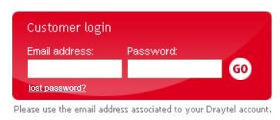
The Registered email address is htex@trolleybus.net with the password of route654. Once entered these credentials are saved.

You then arrive here:
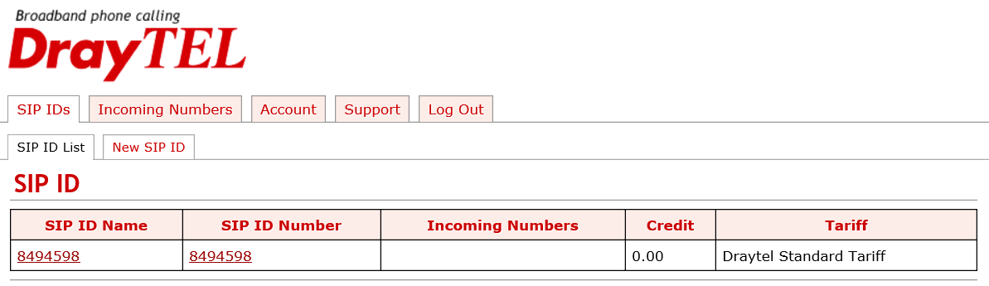

Click on SIP ID Name to get here:
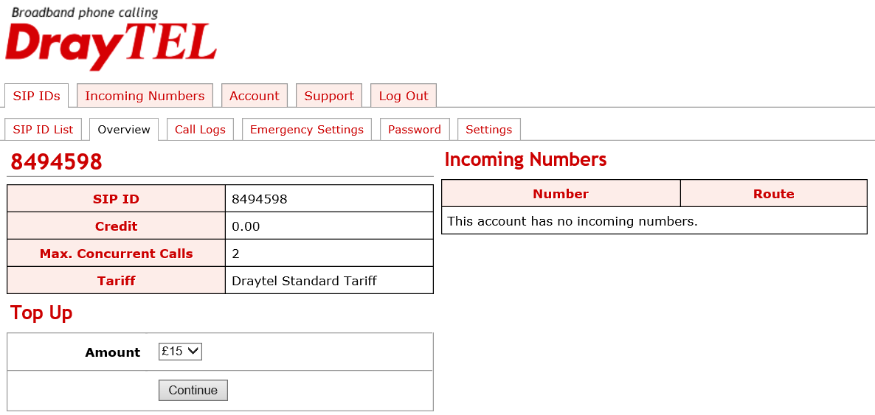
Use the Top Up feature to add funds choosing the amount you wish to pay. Whatever it is VAT will be added to the amount payable. Whatever credit is added, there is no time limit to expend on calls. Don’t forget to logout afterwards.

Abbreviated Dialing Codes from the VoIP phone usually setup

Called Party | Code to use
David Bradley Office | 123
David Bradley Mobile | 127
David Bradley Home | 124
TalkTalk Help Desk | 777
JD Motors Rushmoor | 133
JD Motors Alton | 175
Access to Draytel Voice Mail *** | 9200
Callmaster Voice Mail Service | 8500
Will Handcock [Callmaster] | 121
Draytel service test | 902
Last Call Return [Miss] | *69
Last Call Return [In] | *12
Last Call Return [Out] | *14

*** Voice mailbox number is: 8494598 Voice mail pin:

Email Accounts
hillside@cyberpictures.net cbvti90rcsof
htex@trolleybus.net IRSNkCy1}K[Q
isleworthdepot@trolleybus.net
kate@trolleybus.net

Outlook Settings
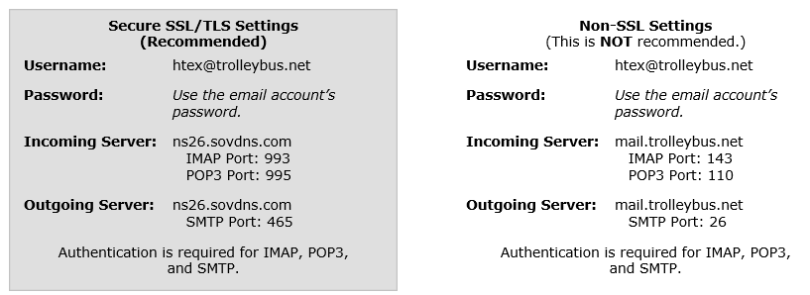

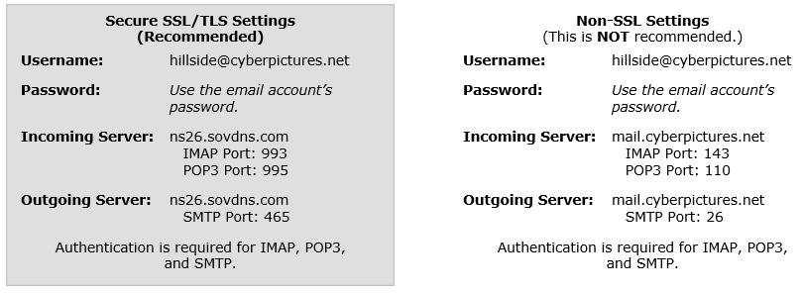

CANON iMAGE GATEWAY http://www.cig.canon-europe.com
Support: http://www.cig.canon-europe.com/ce/en_GB/support.html

Username : htex@trolleybus.net
Password : (Character string that you set by you)
Registered Name: Hugh Taylor
Option to receive updates about us
Yes Option to receive emails in HTML: Yes

Model Name: PIXMA MG6150
Serial Number: ABXP18081
Date of Purchase: 28/03/2011

2* ESET Smart Security Expiry date: 25/03/2022
Username: EAV-43158737
Password: vrjppx76dk

User Name: isleworthdepot@trolleybus.net
Email Address: isleworthdepot@trolleybus.net
Password: Route6542021*

The email account printer@cldmail.co.uk has been created. Pin
https://webmail.cldmail.co.uk
Configuration Information:
Inbound Server (POP3):
Server: mail.cldmail.co.uk
Port: 995 (use SSL)
Username: printer@cldmail.co.uk
Password: Route6542020
Outbound Server (SMTP):
The outbound mail server requires authentication.
Server: smtp.cldmail.co.uk
Port: 465 (use SSL or SSL/TLS)
Username: printer@cldmail.co.uk
Password: Route6542020
This email account created for the printer so that reports can be sent to Hugh

PIN = 44254816

