David Drew Limited t/a JD Recovery, Registered in England & Wales
Registration Number: 08229200
Registered Office: Tremain House, 8 Maple Drive, Kings Worthy, Winchester, Hampshire, SO23 7NG
Headquarters: 1 Rowan Industrial Estate, Mill Lane, Alton, Hampshire, GU34 2NQ

Contact: lewis@jdrecovery.team Tele: 01483 666 247 Mobile: 07738 648 722

cPanel - old
URL:
Userid: jdrecove
Password: pFQTXA3Y4Aa8XWf8

Username: tyrone@jdrecovery.team
Password: D0jo[aB{5z#Z
Incoming Server: sxb1plzcpnl473185.prod.sxb1.secureserver.net
IMAP Port: 993
Outgoing Server: sxb1plzcpnl473185.prod.sxb1.secureserver.net
SMTP Port: 465

IMAP, POP3, and SMTP require authentication.

email Accounts
email Password
bmwinbox@jdrecovery.team d[zgE)fV%tL8
chris.hughes@jdrecovery.team z7zlzs5cxcm2
dave@jdrecovery.team w~!+i12]6fug bzc8n8engzjz
emma@jdrecovery.team 1miga$F$quBi i5r52yyn37uz
internal@jdrecovery.team as0jfjfrex6rmshg
info@jdrecovery.team r3L$gSekQ.lW twmcxzcxrj3t
jasmine@jdrecovery.team 5bCE,42=.[Gt
jon.parslow@jdrecovery.team p4hw3nnr6ass
john.drew@jdrecovery.team agje8rr3fi2g
lee.barrett@jdrecovery.team en8f6bphzo53
lewis@jdrecovery.team ?P.UUlgq0A~I
mark@jdrecovery.team x7rg0ro38z7g9hff
matt.pusey@jdrecovery.team wre7uisk2szo
michelle@jdrecovery.team %}J(x46GNCRn 2cr3282murvm
mike@jdrecovery.team rxmyz32dh4oc
neil.morton@jdrecovery.team c5ko8v5hovjy
neil.topliss@jdrecovery.team fe6a0c3u5vqp
police@jdrecovery.team N%T,HtjF45!T q0n9o40xyahf7kvp
reg.chittenden@jdrecovery.team 8ocxkyq40ayh
sean.woodward@jdrecovery.team fkrhtf0643tn
sherrie@jdrecovery.team Z3~TCsHdP&+1
sue@jdrecovery.team 8RSlWNYjqV?~ 7vqdbnc3ev0h
sysadmin@jdrecovery.team htdyrd3e0r7c
tyrone@jdrecovery.team D0jo[aB{5z#Z

email Forwards
email Address Forward To
accounts@jdrecovery.team emma@jdrecovery.team
accounts@jdrecovery.team lewis@jdrecovery.team
accounts@jdrecovery.team sue@jdrecovery.team
covidteam@jdrecovery.team 1reg1988@gmail.com
covidteam@jdrecovery.team hughes9746@hotmail.co.uk
covidteam@jdrecovery.team marklinegar19@gmail.com
covidteam@jdrecovery.team neil.morton04@gmail.com
covidteam@jdrecovery.team seanyw69@hotmail.co.uk
drivers@jdrecovery.team 1reg1988@gmail.com
drivers@jdrecovery.team bruvjon@aol.com

New Server

cPanel - old
URL: https://sxb1plzcpnl434629.prod.sxb1.secureserver.net:2083/
Userid: bj1yzoe729ub
Password: *;5&q@K[_L2ZM

cPanel - new
URL: 92.205.14.36 https://sxb1plzcpnl473185.prod.sxb1.secureserver.net:2083/
Userid: xmo5voydzge4
Password: Pv_N^,T1

email Accounts
dave@jdrecovery.team BZZ!I9lHSIxS
emma@jdrecovery.team l5,DkN+xN}C1
info@jdrecovery.team 0BPyJ1HCycJb
internal@jdrecovery.team nZQSp49&P0D-
jasmine@jdrecovery.team I6GMOZSiAuIl
lewis@jdrecovery.team
michelle@jdrecovery.team kY35pJcO3OKJ
police@jdrecovery.team ZnhpzUk9LCWD
sherrie@jdrecovery.team ai3NyB7EApa5
steve.scott@jdrecovery.team hJR5112D7YUT
sue@jdrecovery.team oppsIcVzVqUb
sysadmin@jdrecovery.team j9bkeaz72sato7o8

Typical Outlook Client information
Username:
Password: Use the email account’s password.
Incoming Server: sxb1plzcpnl473185.prod.sxb1.secureserver.net
IMAP Port: 993
Outgoing Server: sxb1plzcpnl473185.prod.sxb1.secureserver.net
SMTP Port: 465

IMAP and SMTP requires authentication

Forward
accounts@jdrecovery.team emma@jdrecovery.team
accounts@jdrecovery.team lewis@jdrecovery.team
accounts@jdrecovery.team sue@jdrecovery.team
cbod@jdrecovery.team dave@jdrecovery.team
cbod@jdrecovery.team gericke.roy@gmail.com
cbod@jdrecovery.team ian@businessnavigationservices.com
cbod@jdrecovery.team lewis@jdrecovery.team
cbod@jdrecovery.team paul@businessnavigationservices.com
compound@jdrecovery.team daniel.tomiczek@sky.com
compound@jdrecovery.team michelle@jdrecovery.team
daniel.tomiczek@jdrecovery.team daniel.tomiczek@sky.com
management@jdrecovery.team dave@jdrecovery.team
management@jdrecovery.team emma@jdrecovery.team
management@jdrecovery.team lewis@jdrecovery.team
management@jdrecovery.team steve.scott@jdrecovery.team
recovery.drivers@jdrecovery.team 1reg1988@gmail.com
recovery.drivers@jdrecovery.team danny.basham22@yahoo.co.uk
recovery.drivers@jdrecovery.team marklinegar19@gmail.com
recovery.drivers@jdrecovery.team neil.morton04@gmail.com
staff@jdrecovery.team 1reg1988@gmail.com
staff@jdrecovery.team daniel.tomiczek@sky.com
staff@jdrecovery.team dave@jdrecovery.team
staff@jdrecovery.team emma@jdrecovery.team
staff@jdrecovery.team jasmine@jdrecovery.team
staff@jdrecovery.team lewis@jdrecovery.team
staff@jdrecovery.team marklinegar19@gmail.com
staff@jdrecovery.team matthew10911@gmail.com
staff@jdrecovery.team michelle@jdrecovery.team
staff@jdrecovery.team neil.morton04@gmail.com
staff@jdrecovery.team seanyw69@hotmail.co.uk
staff@jdrecovery.team sherrie@jdrecovery.team
staff@jdrecovery.team steve.scott@jdrecovery.team
staff@jdrecovery.team sue@jdrecovery.team
transport.drivers@jdrecovery.team matthew10911@gmail.com
transport.drivers@jdrecovery.team seanyw69@hotmail.co.uk
transport@jdrecovery.team jasmine@jdrecovery.team
transport@jdrecovery.team lewis@jdrecovery.team
transport@jdrecovery.team steve.scott@jdrecovery.team

Changeover Instructions
From: Georgi Valchev - Tsohost Support <support@tsohost.com>
[TSL-931-46382] Further to our conversation regarding DNS Records, emails, new hosting package

As promised, I'm sending short instructions about domain pointing and cancellation of the previous package.

When you are ready with the mailboxes and backups, you'll need to point the domain to the new hosting package.

In order to do this, please follow this path:
Client Area >> Domains >> My Domains >> Green ACtive button next to the domain >> Nameservers >> Change them to ns1.tsodns.com and ns2.tsodns.com.
I've filled all of the necessary records already, but if you want to check them you can do that from the Custom DNS menu on the left hand side.

Regarding the cancellation of the previous product, when you are ready with the email migration, you can request cancellation by following this path:
Client Area >> Services >> My Services >> Green ACtive button next to the hosting package >> Request cancellation >> Immediate When you request the cancellation, you can contact us in order to apply an account credit for the rest of the period of the package.

With TSOHOST
Registered Domain Names
Domain Registered Expires Cost Ex VAT
jdrecovery.team 27/10/2019 27/10/2020 £24.95 Every Year
jd-motors.co.uk 15/03/2015 15/03/2021 £6.95 Every Year
jd-motors.com 15/03/2014 13/03/2022 £21.90 Every 2 Years
jd-recovery.co.uk 25/05/2014 25/05/2022 £13.90 Every 2 Years
jd-recovery.com 30/10/2019 30/10/2020 £10.95 Every Year
Total sum spent each year is: £60.75 (£72.90 inc VAT)

Services
Name Domain Expires Payment Ex VAT
Business cPanel Hosting jd-motors.co.uk 13/03/2021 £87.90 Annually
Startup cPanel Hosting jdrecovery.team 27/10/2020 £37.90 Annually
Total sum spent each year is: £125.80 (£150.96 inc VAT)

Forward All Emails for a Domain
Entries made within the cPanel of jdrecovery.team and jd-motors.co.uk
Domain Forward To
jd-recovery.co.uk jdrecovery.team
jd-recovery.com jdrecovery.team
jd-motors.com jdrecovery.team

If there is no matching address it will end up in the default account of jdrecovery.team although all such emails are usually spam. However, these senders are thought to be genuine and should be advised to use the appropriate email address:
davidmead@pmawin.com
louise@smartbodyshop.co.uk
subscription.notifications@post.xero.com
te-maos@email-aql.com

Zone Editor in jd-motors.co.uk diverts web requests to:
https://www.theworkshop-auto.co.uk/ 91.109.118.22
Business Devices – Detected Wednesday, 22 July 2020
IP Address MAC Address HOST ID USER Logon Password
192.168.1.1 00-1D-AA-54-04-39 Router --- admin farnham2020
192.168.1.10 54-E1-40-1C-74-4F 82170961 [Credit Card Machine]
192.168.1.11 1C-1B-0D-E6-4B-99 Ford Dave Dave Drew buster1
192.168.1.17 40-EC-99-A8-77-53 Zenos Michelle Michelle Ingram route654
192.168.1.20 40-EC-99-95-E1-29 Hawk Emma Emma Drew route654
192.168.1.25 18-68-CB-8A-10-EA HIKVISION CCTV Required Required
192.168.1.27 CC-2F-71-02-BA-11 Invicta Lewis
192.168.1.28 40-EC-99-8D-F6-3A TVR Lewis Lewis Drew route654
192.168.1.29 B0-68-E6-63-55-6F Tesla
192.168.1.30 AC-9E-17-A8-F9-A9 Daimler Michelle Michelle route654
192.168.1.31 B8-D7-AF-2A-CF-3B
192.168.1.32 B0-C0-90-63-87-A9 Audi Sue Sue lucy
192.168.1.33 A0-C5-89-EB-14-EB Daf
192.168.1.35 50-E5-49-5B-C1-2D Bugatti Emma Emma buster1
192.168.1.38 5C-96-56-A3-B1-BB
192.168.1.39 C0-B6-F9-C8-F4-C9 Humber Jasmine Jasmine recovery1
192.168.1.42 40-EC-99-95-23-15 BMW Dave Dave Drew route654
192.168.1.43 AC-9E-17-A8-F9-A9 Daimler Michelle Michelle route654
192.168.1.99 00-80-91-B1-06-1D MFP11601437 --- admin 123456
192.168.1.xx 74-D4-35-9B-9A-19 Wolseley

Mobile Devices – Detected Wednesday, 22 July 2020
IP Address MAC Address HOST ID
192.168.1.13 D0-E1-40-AF-E4-F0 iPad
192.168.1.13 D0-E1-40-AF-E4-F0 iPad
192.168.1.14 F8-2D-7C-56-EE-78 MichelliPhoneXR
192.168.1.15 84-B8-B8-1F-02-F2 android-ec913495a3fb0fc5
192.168.1.16 8C-B8-4A-50-E5-0E Galaxy-Note10
192.168.1.17 C0-A6-00-24-97-3F iPhone
192.168.1.18 E8-50-8B-A8-88-5E Galaxy-S6-edge
192.168.1.19 D4-11-A3-C4-C1-DF Samsung-Galaxy-XCover-4
192.168.1.21 D6-BD-AD-88-65-57 Galaxy-S10
192.168.1.26 A8-DB-03-15-9C-D5 Galaxy-S10
192.168.1.27 C0-A6-00-24-97-3F iPhone
192.168.1.41 FC-DE-90-FD-E3-B5 Galaxy-XCover-4s
192.168.1.44 DC-72-9B-45-A1-B2 HUAWEIP20Pro-dbee8602d
192.168.1.45 40-9C-28-A1-45-BC Emmas-phone-2
192.168.1.48 28-16-AD-63-1C-EE LSUK682219
192.168.1.xx F4-0E-01-9F-F3-C3 Kes-AppleWatch
192.168.1.xx 4C-0B-BE-0C-BF-28 iPhone
192.168.1.xx 58-B1-0F-F3-74-BE EmmasiPodtouch
192.168.1.xx 64-89-F1-94-5C-49 Galaxy-XCover-4s
192.168.1.xx 74-42-8B-A6-6D-8A
192.168.1.xx D8-4C-90-A6-E6-21 iPhone
192.168.1.xx E4-2B-34-18-C5-36 Galaxy-J5
192.168.1.xx FC-D8-48-5A-18-B9 Matts-11-Pro

VoIP Phones – Detected Wednesday, 22 July 2020
IP Address MAC Address HOST ID
192.168.1.12 D4-AD-BD-2B-F5-E9 SEPD4ADBD2BF5E9
192.168.1.22 D4-AD-BD-CA-07-C6 SEPD4ADBDCA07C6
192.168.1.23 D4-AD-BD-2B-F8-04 SEPD4ADBD2BF804
192.168.1.24 D4-AD-BD-2B-F5-EC SEPD4ADBD2BF5EC
192.168.1.34 D4-AD-BD-2B-FA-43 SEPD4ADBD2BFA43
192.168.1.36 D4-AD-BD-2B-FA-53 SEPD4ADBD2BFA53
192.168.1.37 D4-AD-BD-2B-F5-F5 SEPD4ADBD2BF5F5
192.168.1.40 D4-AD-BD-CA-07-59 SEPD4ADBDCA0759

Computer Devices Status as at Sunday, 26 July 2020

Key
Not in use
In use now but will be out of use when new laptops come
In use
In build
Future unknown

Computer Names in Use
Ford Dave Drew
Invicta Lewis Drew
Bugatti Emma Drew
Audi Sue Summers
Humber Jasmine Kilby [Future use as spare laptop]
Daimler Michelle Ingram
Invicta Lewis Drew >>> Sherrie Drew
Tesla
Wolseley
DAF Dave Drew

New Laptops
BMW Dave Drew
TVR Lewis Drew
Toyota Jasmine Kilby
Zenos Michelle Ingram
Caterham Sue Summers
Hawk Emma Drew

Previously Seen on the Network
Cooper
Porsche
Lexus2
Landrover
Ferrari
AUSTIN
Bedford
Viva
Polo
monkey
Lancia
Maserati
Supplier of Telephone Number 01483 666 247
Budget Numbers
James Goddard
Managing Director
t: 03333 222 123
e: james@budgetnumbers.co.uk
w: www.budgetnumbers.co.uk

Tosh Network Printer at Alton
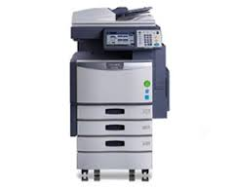
Userid: admin
Password: 123456
Name: MFP07365668
Copier Model: TOSHIBA e-STUDIO2040C
Serial Number: CJI119236
MAC Address: 00:80:91:70:64:24
Static IP Address: 192.168.1.99
Driver: Available in ‘Add a Printer’
Service Phone Number: 08450 500400 [Probably]
Stored Scanned Documents: file_share

ESET - Endpoint Security
Telephone Number: 01202 405 405
Administrator Licence No Password Expiry Date No.
david@jd-motors.co.uk EAV-55959751 dxenbpu8s3 24/08/20? 21
3RUK-XPFH-3NEP-EJWE-HH9M

ELVIS
Hants Help desk: 02380 674766 [John or Peter] email: frs@hampshire.pnn.police.uk
Registered IP address: 195.89.243.170
Hants = https://www.hantselvis.co.uk/main/start.asp?
Surrey = https://elvisvr.theaa.com/enquiries/viewenq.asp?EID=141931

Information on the Draytek Router to be added

Typical Footer Layout

David Bradley
Technology Advisor

Tel: 01483 666 247
DDI: 01252 758 960
Web: www.jdrecovery.team

This email [and any attachments] is intended solely for the individual[s] to whom addressed. It may contain confidential and/or legally privileged information. Any statement or opinions therein are not necessarily those of JD Recovery Limited unless specifically stated. Any unauthorised use, disclosure or copying is prohibited. If you have received this email in error, please notify the sender and delete it from your system. Security and reliability of emails and attachments are not guaranteed. You must take full responsibility for virus checking.
David Drew Limited t/a JD Recovery, Registered in England & Wales
Registration Number: 08229200
Registered Office: Tremain House, 8 Maple Drive, Kings Worthy, Winchester, Hampshire, SO23 7NG
Headquarters: 1 Rowan Industrial Estate, Mill Lane, Alton, Hampshire, GU34 2NQ

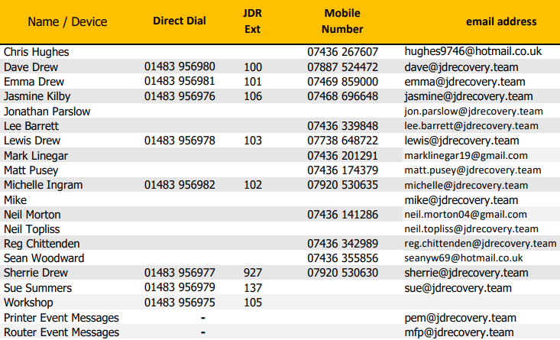
Communications Overview

Hunt Groups
Accounts 01483 956973 (003)
Breakdown & Recovery 01483 956971 (001)
General Enquires 01483 956974 (004)
Storage 01483 956972 (002)


VoIP Supplier
Services no longer required and to be discontinued

Voipfone
Registered email address: david@jd-motors.co.uk
Voipfone Account Number: 30204994
Voipfone password: 251843
Telephone number: 05603 864691
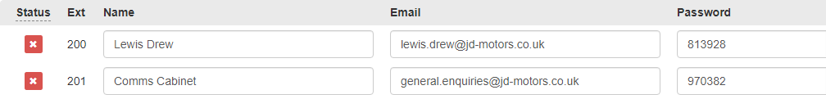
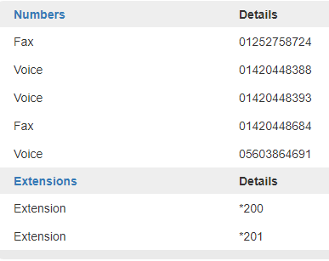
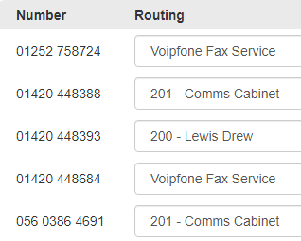

DrayTEL
Dave Drew 8453255 SE#=w1<i david@jd-motors.co.uk

