Overview of Zen Broadband Services
Each service retains the existing telephone voice provider
Zen Customer Portal: http://portal.zen.co.uk/
Username: david@jd-motors.co.uk Password: route654
Shipley Close – FTTC 80/20 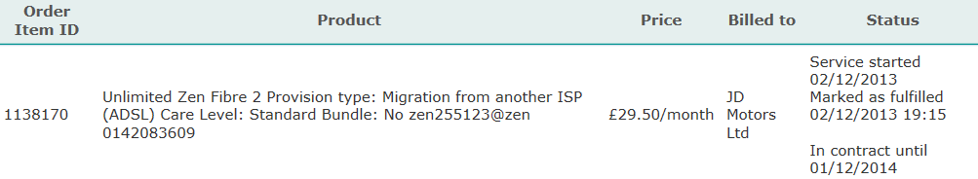
Alton Garage – ADSL Service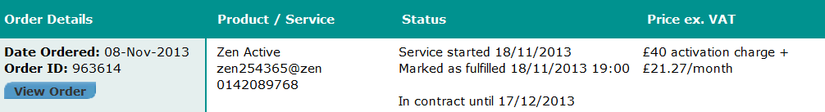
Rushmoor Garage – FTTC 40/10 – Order in progress
Sent: 19 September 2014 12:54 To: david@jd-motors.co.uk
TalkTalk Business account 01286418
Telephone number 01252792103
Your MAC code is: LATH4176973/MJ19M
Product Ordered from Zen is Fibre 1 without line rental so £4.25 surcharge payable. Ex-VAT.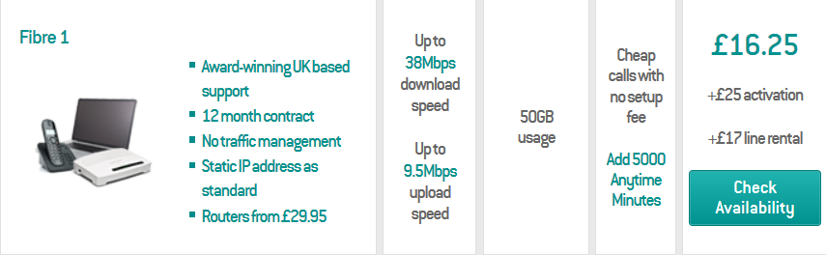
Predictive speed: Down 12.6Mbps Up 0.8Mbps
Zen Username: zen270161@zen
1st bill for installation at £25 + first payment for ongoing monthly payment of £16.25 + £4.25 excluding VAT
