Computer Installation for Karen Tyler
Version: Friday, 7 February 2014

Full Name: Karen Tyler

Home Address:
Overbrook
Pitch Place
Thursley
GODALMING
GU8 6QW

Home: 01252 702164
Mobile: 07798 634904

E-mail: mandktyler@hotmail.co.uk

Desktop Setup:
Computer Name: Smoke
Vaio Registration ID: 27525351-5003958
Users: Karen, Alice, Giles, Malcolm

Local Area Network [LAN] Information
Workgroup: Mirror

ESET Smart Security on 1 computer [£71.93]
Expiry: 12 August 2014
Username: EAV-51809383 Password: mmvaard27t
Help Desk: 0845 838 0832

MS Student Package:
http://e5.onthehub.com/d.ashx?s=4iy3zjku8j
H83GM-73J4F-HMYMM-KRJDD-6PMDF

Broadband Availability – BT Predictive Speeds
Address: OVERBROOK, PITCH PLACE, THURSLEY, GODALMING, GU8 6QW is served by Cabinet 4
from Elstead exchange

Featured Products | Downstream Line Rate(Mbps) |  | Upstream Line Rate(Mbps) |  | Downstream Range(Mbps) | Availability Date
 | High | Low | High | Low
FTTC Range A (Clean) | 68.1 | 50.7 | 20 | 14 | -- | Available
For FTTC Ranges A and B, the term "Clean" relates to a line which is free from any wiring issues (e.g. Bridge Taps) and/or Copper line conditions, and the term "Impacted" relates to a line which may have wiring issues (e.g. Bridge Taps) and/or Copper line conditions.
Throughput/download speeds will be less than line rates and can be affected by a number of factors within and external to BT's network, Communication Providers' networks and within customer premises.
Up to 300m from the cabinet makes economic sense for the 80/20 service otherwise opt for the cheaper 40/10 service.
Cabinet 4 is at the junction of Dyehouse Road with Thursley Road, some 500m from your home so surprising to see predictions of speed for you being given that are close to the maximum achievable.

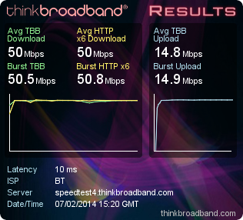

Wireless Information:
SSID 1: Overbrook Security Mode: WPA-PSK Channel: Auto Password: th10916383
SSID 2: Guest Security Mode: WPA-PSK Channel: Auto Password: friends2014
SSID 3:
SSID 4:

VPN Access
User Name Password
david elstead

DrayTEL Numbers https://admin.draytel.org/login
Domain: draytel.org NAT Proxy (if required): nat.draytel.org
Number POTS Password Registered by Password
8489483 0845 5570145 >6([1ZqC karen@cyberpictures.net route654

Email Information:
Control Panel: http://www2.btbroadbandoffice.com/
Login: ? Password: ?
POP3: pop3.btconnect.com
SMTP: mail.btconnect.com

BT Information
BT Support Line: 0845 600 7020
Primary email address:
Package:

How additional email accounts are set up
* Logon to https://www2.btbroadbandoffice.com/
* On the "Your Account" tab select "Add a New User"
* Re-enter logon password
* Fill in the form and go through the steps requested
* Test Account (?@btconnect.com) was setup with password of ?
* Use Webmail to check account
* Set security question and answer [is that setup ?]

DrayTek Router 2830Vn [http://192.168.57.1:8080]
Serial Number 13B002265752
Firmware Version: 3.6.6.1_sb_232201 Build Date/Time : Nov 1 2013 18:47:14
DHCP Pool Start: 57 Pool Size: 50 [Range: 57-106]

Connected Devices Entries shown in blue are bound to MAC address
IP Address MAC Address HOST ID User ID Password
192.168.57.1 00-1D-AA-B2-9A-C2 Overbrook admin elstead2008
192.168.57.58 80-57-19-09-94-15 android-150a3126f5ef8ea5
192.168.57.59 54-42-49-ED-04-2F Smoke
192.168.57.61 00-24-A5-62-CA-B6
192.168.57.62 88-53-2E-DE-65-89 Giles-PC
192.168.57.64 50-46-5D-16-C4-89 android-ca957ad442f6d1c3
192.168.57.65 08-60-6E-A5-B7-67 android-5873d9044b194f7e

Configuration Screens

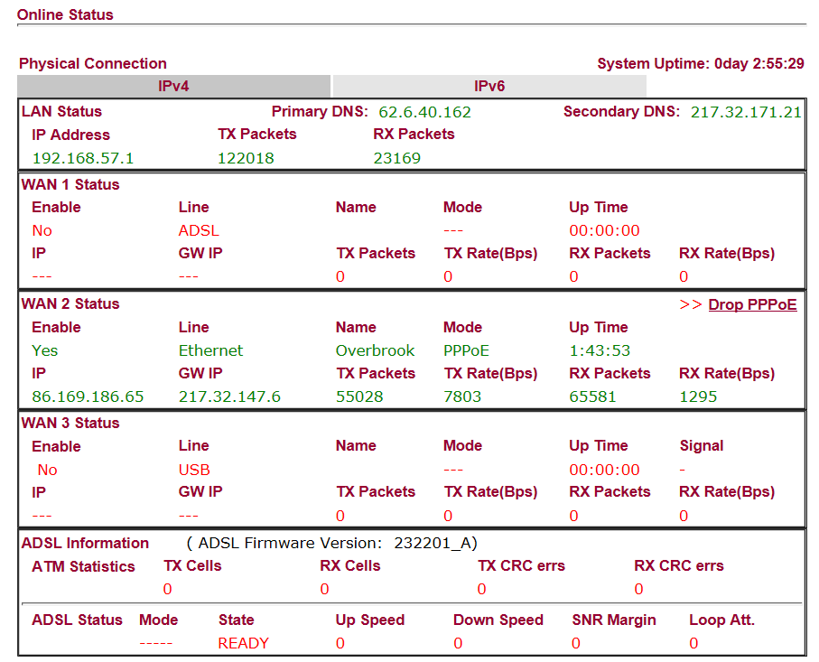

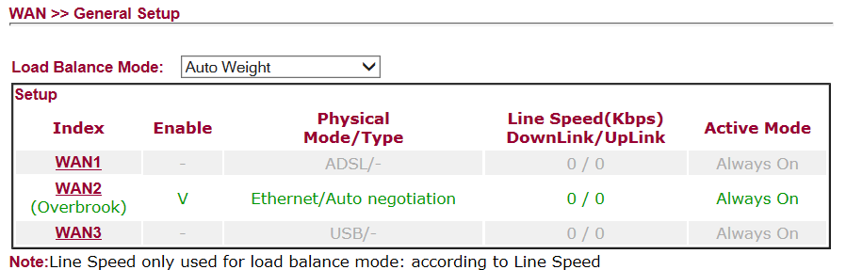

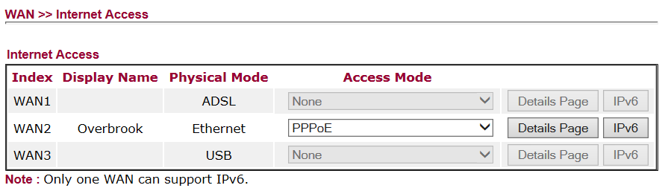

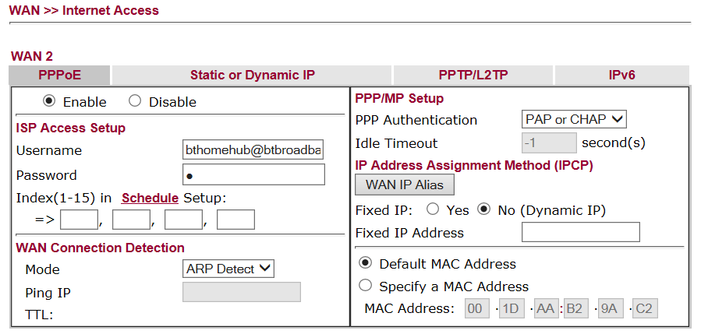
BT Infinity domestic service does not require a password but the DrayTek router does, so a space is used

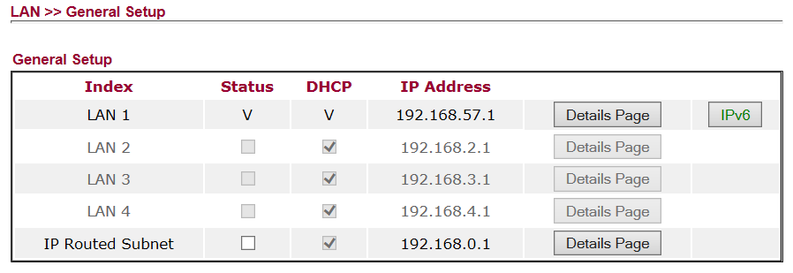

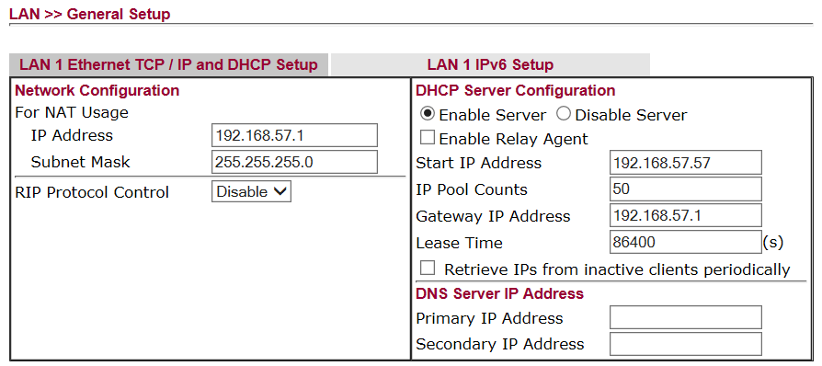

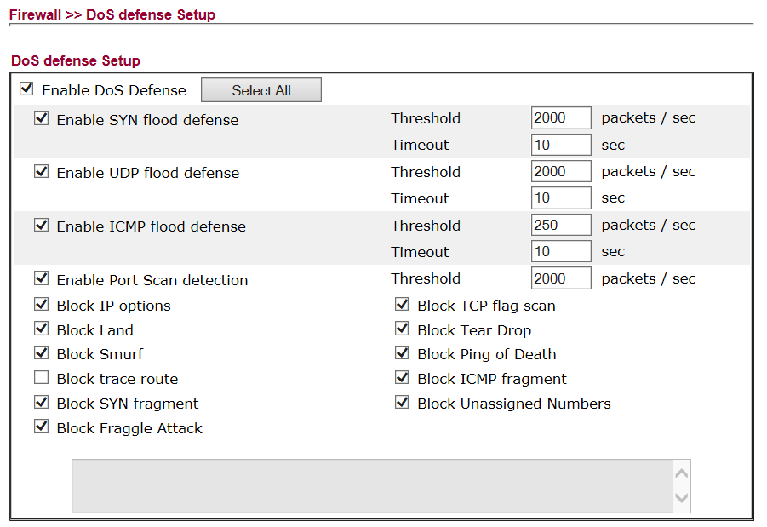

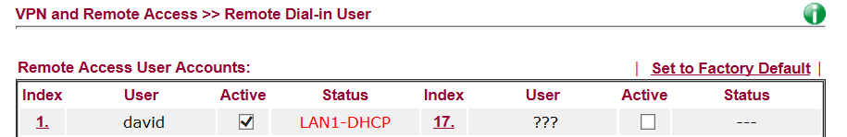

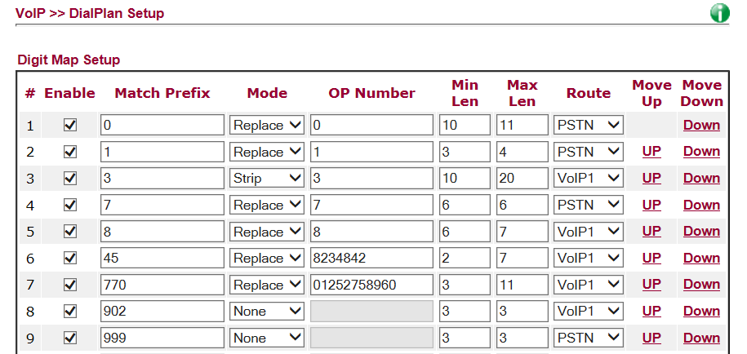

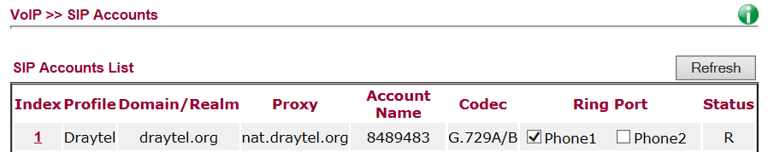

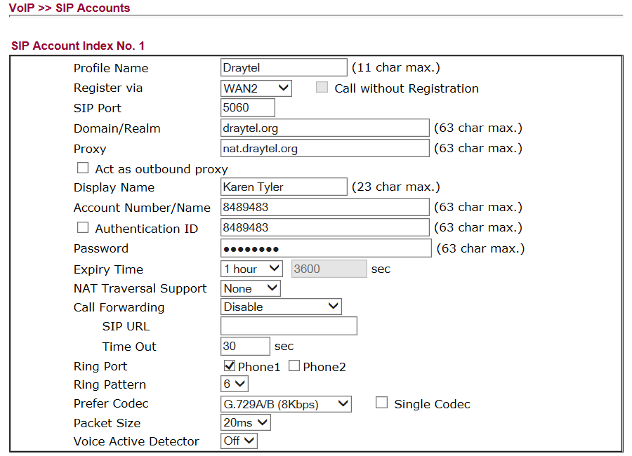

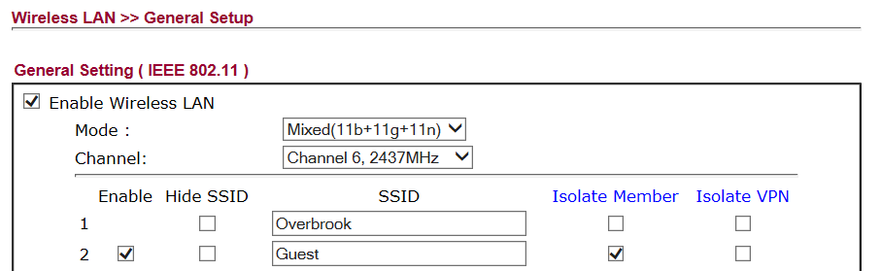

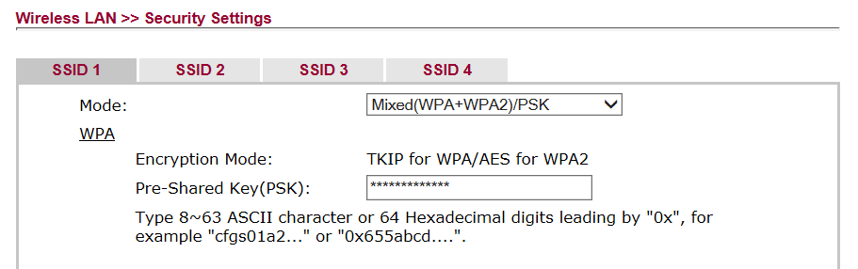

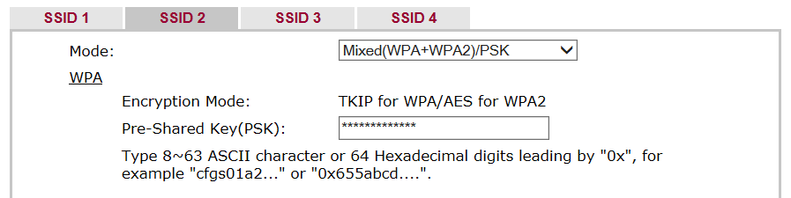

FreeDNS.afraid.org
http://freedns.afraid.org/subdomain/
+----------------------------------+
Your signup credentials are:
+----------------------------------+
Name: Karen Tyler
Username: overbrook
Password: route654
Signup IP: 82.69.72.219
Signup Date: 2014-02-06 09:36:26
+----------------------------------+
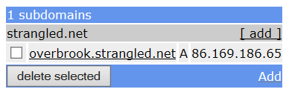

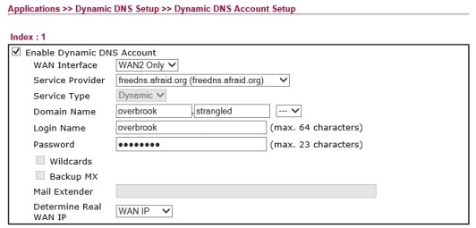

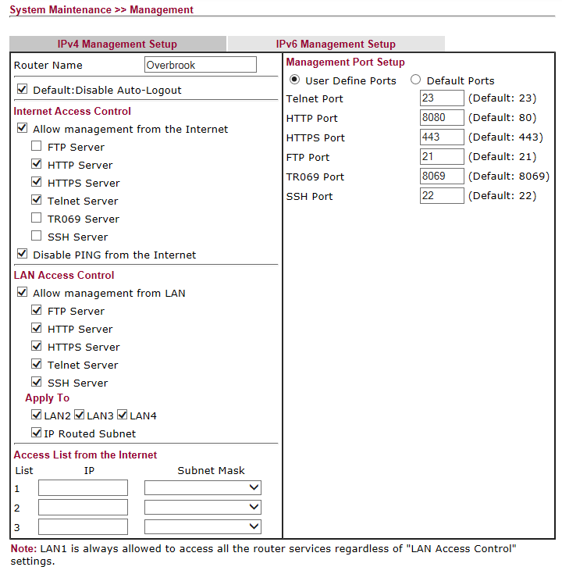

Vodafone Sure Signal

MIGHT have to disable the DrayTek’s own IPSEC VPN feature, and allow IPsec passthru before the sure signal will work. Not many routers do IPSEC VPN but the Sure Signal makes an IPSEC VPN connection to Vodafone.

IPSec passthrough is disabled by default on the Vigor2820. The reason for this is because IPSec passthrough is not compatible with the new NAT-T support of the routers internal VPN server. The Vigor2820 NAT-T support allows remote VPN clients that are behind a NAT router to more easily connect via VPN.

There is a telnet command to enable IPSEC passthrough. The command is srv nat ipsecpass on."

Background: http://www.draytek.co.uk/support/kb_vigor_telnet.html#wintelnet
On Windows7 there is no hyperterminal, so download PuTTYtel
Possible that there may be some issues with the router’s built in VPN features.
Computer Inventory

Smoke – Desktop
Userid Password
?
?

ESET Anti-Theft Email
?

Historical Information

BT Router – Configuration Access
Network: 192.168.1.254
Logon: admin
Password: route654

