Lorraine Chapman’s Computer Installation
Updated: Monday, 8 June 2020

Home Address:
144 Ardingley Drive
Goring-by-Sea
BN12 4TP

Mobile: 07870 211491
Home:

Broadband Service from Virgin Media

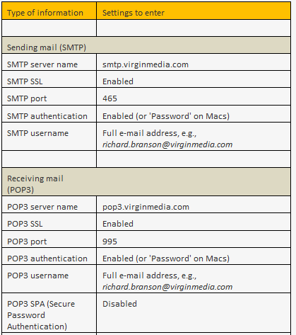

Email accounts
lortin144@virginmedia.com mooncat08
lorraine.chapman@lorage.co.uk sdzqhsx9c5se
lorraine.chapman@lorage.uk yZM6EDKWuf

Typical Setup for GMAIL in Outlook 2010
Refer to these instructions:
http://www.lytebyte.com/2009/08/11/guide-to-setup-gmail-imap-in-outlook-2010/
http://www.lytebyte.com/2008/06/08/how-to-solve-when-two-copies-of-sent-mail-are-saved-while-using-gmail-and-outlook/

VoIP
Registered email address: sysadmin@eservicesestimating.uk [registrar@trolleybus.net]
Voipfone Account Number: 30210751
Voipfone password: 640325
Free telephone number: 056 0387 1422
Subscriber Number: 020 8191 9830

Lorton VoIP extensions:
