The Selham Portakabin Project
Location: W L West & Sons Ltd, Area 14, Selham, GU28 0PJ

Document last updated: Friday, 7 August 2015 at 2:43 PM

Generally Overview
Additional engineering facility using a redundant structure on the W L West & Sons site at Selham with a new Portakabin positioned at one end to house on site staff. Contains all the required user amenities.

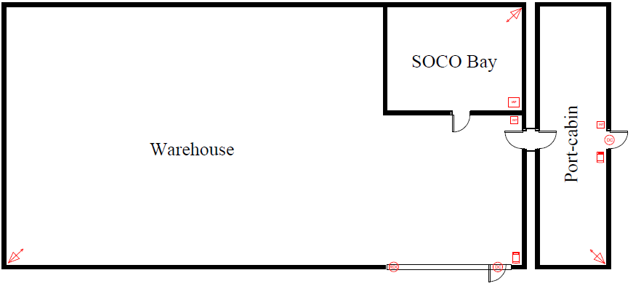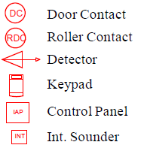
Figure 1 – Accommodation Planned

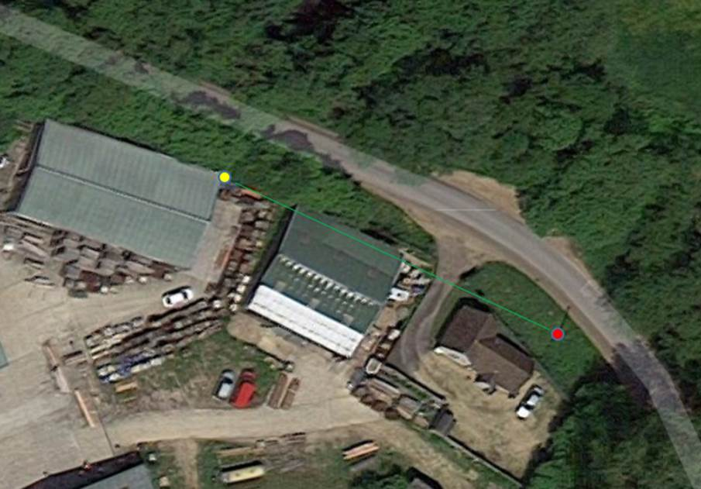
Figure 2 - Site Plan
Red dot indicates BT network pole supplying service to the site; Yellow dot indicates suggested position of new pole.

Comment from Dave West [07803 037529]: As long as there is height to fly a cable over an existing shed, it should not be necessary to pay BT for a pole to be installed. On site expertise could have a scaffolding pole fixed to the shed which should suffice. There may indeed be issues installing a BT pole as its location is on the higher side of a bank,

Enquiries for a Broadband and telephone service
Using the telephone number of the broadband service used by W L West, the Broadband Availability Checker indicates that predictive speeds at this location are low and insufficient to meet the requirements of Midhurst Engineering. Indeed this is also true for W L West & Sons who have found it necessary to use a bonded service.

Telephone Number 01798861358 on Exchange LODSWORTH is served by Cabinet 2
Featured Products | Downstream Line Rate(Mbps) | Upstream Line Rate(Mbps) | Downstream Range(Mbps) | Availability Date
ADSL Max | Up to 2.5 | -- | 1.5 to 5 | Available
Fixed Rate | 2 | -- | -- | Available

Telecommunication services for this site are therefore connected to roadside cabinet #2 which is approximately 1.5km away, so even when FTTC becomes available, no significant uplift in speed can be expected.

FTTC will probably become available by the end of the year [2015], making a boding solution unnecessary but the timescale for its arrival is unhelpful to MIDENGs plans.

Another alternative would be to use Kijoma wireless which covers the area giving a download speed of 20Mbps. Sadly the provisioning of that service could take months for a connection to be made. Again this is unhelpful to MIDENGs plans.

Midhurst Engineering therefore has no option than to adopt broadband bonding using the available ADSL Max to get a half-decent service which may not even support remote CCTV. Bonding significantly increases installation and running costs but is way cheaper than a leased line solution.

When FTTC becomes available, an upgrade from ADSL Max to FTTC can be made but bonding will still be required since no significant uplift in speed can be expected as the roadside cabinet #2 is at least 1.5km away.

We have been informed by jo.furber@westsussex.gov.uk that there is “The Better Connected Scheme” [to give a ‘superfast’ solution of more than 24Mbps where current speeds are sub 2Mbps] with postcode GU28 0PJ eligible for funding. What this means in practice for a location covered by Kijoma Wireless, who can’t meet the 24Mbps threshold as seen by their coverage maps, is very vague. With no response from Kijoma Wireless to our enquiries MIDENG seems to be in a stalemate situation with that one. If there survey indicated that their service was available to that site, then it is the one to run with providing installation charges are affordable. Ongoing monthly rentals are very reasonable.

Background Information on Kijoma

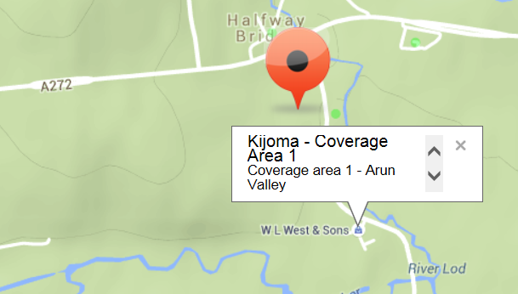
Figure 3 – Engineering wise a goer but administration wise uncontactable.

Kijoma is a wireless [not WiFi] broadband provider, who specialise in providing high speed broadband services overlaid with VoIP if required. They are not restricted by the ancient infrastructure of phone lines and their limitations. Kijoma is backed by 20 years+ of professional Radio network and system design, not many if any Wireless ISP's have this level of background in military and commercial solution provision and this is what makes them unique.

The downside to Kijoma is that it is a small company who do not have teams of call centre hens there to answer queries with generic responses. They receive a lot of enquiries from all over the country every day; as a result do have to sort them into a priority list. A response to any enquiry may take days or weeks and some may not get a response for months!

To answer all the enquiries received by Kijoma would require obviously require additional staff whose cost apparently impinges on their ability to maintain investment in the goal of them being the fastest Wireless ISP in the country and to also support their existing customer base on a priority basis.

So while MIDENG would love to use their service, the timetable of provisioning is outside the goal of getting the Selham facility up and running as quickly as possible. So an inferior traditional landline connection has to be ordered to ensure that telecommunication services would be available in a reasonable timeframe.

If it was available here and now, then there would be substantial savings against a bonded ADSL service since only the normal Draytek router would be required for a connection.

The Zen Response
Our preferred supplier is Zen but unfortunately they identified a number of issues in supplying telecommunication services to this site with their pricing confirmed in this email.

From: Michelle Buckley [mailto:michelle.buckley@zeninternet.co.uk]
Sent: 07 July 2015 09:51
Subject: New phone and Broadband Service for MIDENG GU28 0PJ

I have spoken with my manager regarding supplying a new telephone line to a Portakabin on this site. Irrespective of how long the cabin will be on the site, Openreach treat this as a specialist installation, and the cost of the new line install would be £518.58 + VAT. Installation of broadband would be £40 + VAT.

With respect to the broadband, there is no date currently provided for Fibre, in fact the checker that I have used says it is not yet planned. As we both know, these estimations can change day by day. I would suggest placing an order for broadband and upgrading to Fibre as soon as it becomes available. Broadband speeds are estimated at 4 Mbps download.

Monthly Service Charges:
· Business Line Rental Premium - £17.49 + VAT
· Broadband Lite HCA 50 GB Usage - £11.50 + VAT

Putting this into a standard format for budgetary and comparison purposes:
Name of Product/Service Minimum Period Quantity Total
Business Broadband Lite HCA 50 GB Usage [£11.50] 12 Months 2 £23.00
Business Line Rental Premium [£17.49] 12 Months 2 £34.98
=====
Ongoing Monthly Rental with Zen £57.98

Line Installation: £518.58 * 2 £1037.16
Broadband Installation: £40.00 * 2 £80.00
Estimated Pole Cost: £300.00
=======
One-off Fees £1417.16

Business Line Rental Plus which has 5000 inclusive anytime minutes to 01, 02, 03, 0845 and 0870 numbers, normally £23.50, was not offered.

Using Zen would have cost in the first year [£57.98 * 12] £695.76 plus £1417.16 = £2112.92 plus the cost of any calls which cannot be estimated at this stage. However it would have been just a 12 month contract.

Zen provides a free IP address but wouldn’t have been needed anyway because aggregation is being used.

From: Michelle Buckley [mailto:michelle.buckley@zeninternet.co.uk]
Sent: 17 July 2015 09:27
Subject: FW: New telephone and broadband service required

I see you are going with BT to provide the service as they are offering a cheaper installation charge. I am sorry that we were unable to be more competitive on this occasion, but hope that you will think about using Zen at any other sites that require Broadband.

BTs Response
Help Desk: 0800 800 152. Open Monday to Friday 8am to 6pm [excluding Bank Holidays]

Name of Product/Service Minimum Period Quantity Total
Business Broadband Unlimited [£17] [17/1Mbps* ] 24 Months 2 £34
Business Value PSTN phone line [£18] 24 Months 2 £36
Business Call Essentials Plan & Call Package [£10] 24 Months 2 £20
===
Ongoing Rental with BT £90

Line Installation: £115 * 2 £230
Broadband Installation: £0
Estimated Pole Cost: £300
===
One-off Fees £530

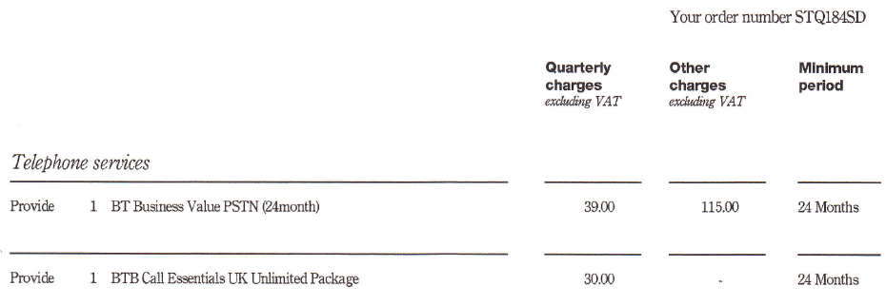
http://business.bt.com/voice/phone-lines-and-numbers/
This web page shows the current prices, ex VAT, as of August 2015. Prices increase on 20th September 2015.
The tariff is known as “Value phone line with basic fault fix” which is 2 working days.

A free router * 2 is provided by BT which is not required. However there is a £8 * 2 delivery charge. These have been rejected but are already are enroute to W L West. A refund of delivery charges has been promised.
Parcel received at WLS on 4 AUG but only one router supplied.

* Predictive speed by BT of an un-bonded ADSL service is different than that estimated by Zen being only in the range of 1-3Mbps, rather worrying that.

BT would have charged for an IP address, free with Zen, however the aggregation service supplies this.

Using BT will cost in the first year [£90 * 12] £1080 plus £530 = £1610 with no call charges and no cap on internet usage. However it is a 24 month contract and there is a known price rise which will come into effect on 20th September 2015. Actual figure unknown but thought to be £2.50 adding £30 to first year costs. All prices exclude VAT. Even so this is around a £500 saving against using Zen but with all the frustrations that is always present with BT.

On reaching the end of your Minimum Period:
- BT will continue to provide the benefits of BT Business Call Essentials with the exception of the Inclusive minutes, which will no longer apply. [Consider migrating to Zen then]
- There’s no new Minimum Period.
If a further 24 month contract is entered into, then inclusive minutes would be reinstated.

Modem Configuration Details

Order number B0S 000000015903403 01798 861829 11 AUG
Network Login Username: D839115@hg70.btclick.com
Password: welcome1

Order number B0S 000000015903405 01798 861602 7 AUG
Network Login Username: D839116@hg57.btclick.com
Password: welcome1

Password information taken from email:
From: BT Business Total Broadband [mailto:remedy@fuswrk.fusion.bt.com]
Sent: 03 August 2015 18:04

BT Business Account and BT Wi-fi username
Account: midhursteng1@btconnect.com Password: welcome1
Account: midhursteng2@btconnect.com Password: welcome1

Web address: https://www.bt.com/business/youraccount
Password: recovery1 [The temporary password was nje0717164516]
Full access to the system is not yet possible because an account number is required from the first bill.

Entering the system may require a response to this security question:
Mother’s maiden name: midhurst

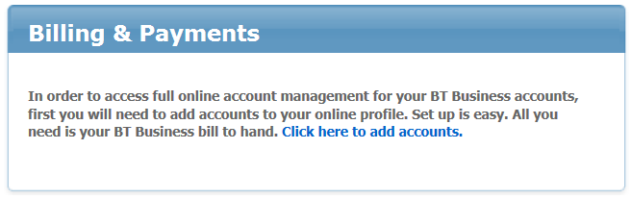

WiFi Hotspots
As part of BTs broadband service, MIDENG has unlimited wi-fi access to over five million BT WiFi hotspots
To get started, log onto www.bt.com/business/btwifi using either username and password shown above.

There are no nearby WiFi hotspots at Selham.

Mobile Reception
There is frequently no signal from any mobile provider on this site. It may be prudent to have a Sure Signal Device installed.

Planned computing facilities
Initially using a laptop previously used by Matt. It will have the email account of selham@mideng.co.uk.

A local wireless or LAN printer needs to acquired and installed.
The Aggregated Service
http://uk.store.sharedband.com/index.php?package=Professional&refer=&packageID=39&stage=2
MIDENG are free to use any other supplier for the bonded broadband service but Sharedband looks fine. This adds to the connection costs and there is a monthly fee payable as well.

This innovative service allows multiple ADSL connections to be bonded. As these can be from any ISP, the service is essentially available to any broadband user. With Sharedband’s Professional package, two lines can be bonded for a total monthly subscription of £20 + VAT. It seems the Professional option meets MIDENGs requirements.
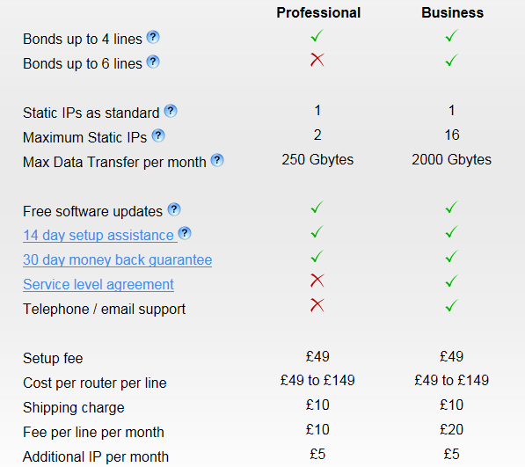

Research indicates it all goes together like this:
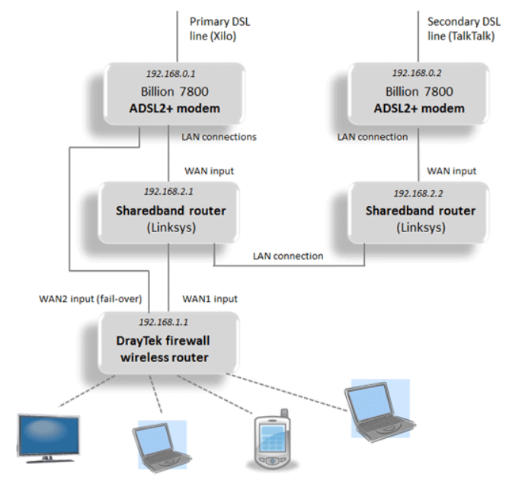

So apart from the aggregation monthly fee, there are additional hardware costs of two Billion ADSL2 modems and two Sharedband routers on top of the required Draytek router. This is an ongoing exercise to determine hardware costs but it could be like this, Ex VAT pricing:
2 * ADSL modems @ £45 each £90
2 * Sharedband routers @ £150 each £300
1 * Draytek 2830vN router @ £250 £250
====
£640

Plus ongoing monthly rental 2 * £10 £20

Bibliography on Sharedband ADSL bonding
http://www.increasebroadbandspeed.co.uk/review-sharedband-ADSL-bonding

Check out the videos starting at: https://www.youtube.com/watch?v=pYyCgcpn4zU
In particular: https://www.youtube.com/watch?v=OPAzo8j9Dns

Very useful technical guide: http://www.increasebroadbandspeed.co.uk/review-sharedband-page-3
Also read: http://www.increasebroadbandspeed.co.uk/follow-up-sharedband-review

CCTV

Supplier: CCTVTEK
T: 0161 820 1933
E: Support@cctvtek.co.uk
W: www.cctvtek.co.uk

Please see the link below, it is for their Analog DVR. however features wise it is more or less the same setup.
https://vimeo.com/113516854 Password is: securicam2468

MIDENG System
Default Userid: admin
Default Password: <blank> Check with Paddy for actual password.
The fixed LAN address for this unit is to be set to 192.168.14.8
.

INTRUDER ALARM SYSTEM
Ben Cooper
Security System Designer
DDI: 023 9224 2413
Mob: 077 6812 3663
Tel: 023 9226 5111
Fax: 023 9226 5112
www.ciaalarms.co.uk
Ben Cooper [mailto:benc@ciaalarms.co.uk]

It is not known why the SOCO bay was chosen to house the intruder alarm control panel however MIDENG will arrange for an extension from the master socket located in the portakabin to a temporary IDC coupler junction box located at the proposed intruder alarm control panel position in the SOCO bay. While this termination will be in place during the week commencing 10th August 2015, it is not currently known when the telephone service will actually commence.
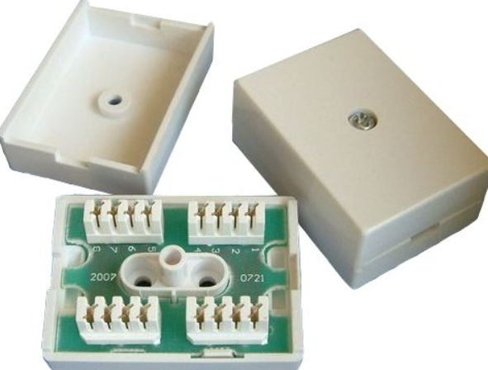
It is assumed that CIAALARMS will replace this item with something more suitable.

It is noted that a routine call may be initiated once a day using a non-geographical telephone number to ensure the telephone line is operational. This implies that an exclusive exchange line for this system is required. The use of a non-geographical number is depreciated as this will probably incur unwelcomed call charges which could be significant. MIDENG has selected a call package that provides unlimited calls to UK landlines and would therefore wish to see a landline number used. A line health check just once a day seems somewhat inadequate.

It would seem more logical to position the intruder alarm control panel near to the communications cabinet in the portakabin. Local to this cabinet are the telephone master sockets.

A LAN interface can easily be provided but has not be specified in any detail to ensure it meets the needs of the intruder alarm system.

The remote location of the site brings into question the viability of any external audible device other than identifying the actual building which has received unwelcomed attention to emergency responders.

Communications cabinet in the Portakabin

This is a picture of a similar cabinet that will be used at Selham. The monitor above it is for the CCTV system.

Picture of installed cabinet will be available soon.

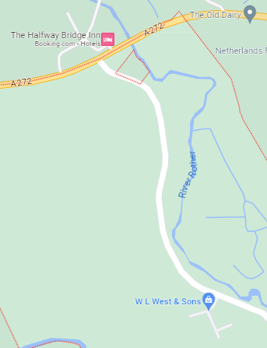

Site Map

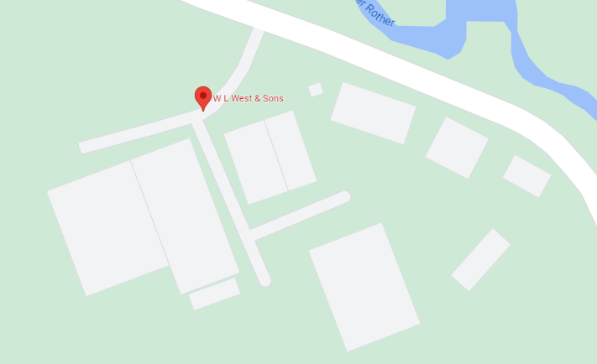

General Information
Postcode | GU28 0PJ
Post Town | Petworth
Nearest station | Pulborough (11 km)
Bus stops | Halfway Bridge (E)
Geography
Latitude | 50.987591
Longitude | -0.672762
Easting | 493254
Northing | 121748
Grid reference | SU932217
UTM reference | 30U 663335 5651023
what3words | argue.swatting.identify
Plus code | 9C2XX8QG+2V

