Installation at Rushmoor Motor Company
Updated: Saturday, 22 February 2025 Contact Name: Peter Harrison

Business Address:
Rushmoor Motor Company
Tilford Road
Rushmoor
Farnham
Surrey
GU10 2EP

Home Address:
Weyside Cottage
Red Lion Lane
Farnham
Surrey
GU9 7QM

Business (Line 1): 01252 794643
Business (Line 2): 01252 790900

Home: 01252 722327
Mobile: 07768 333031

Username: quarantine@rushmoormotor.co.uk
Password: r56aiea7wey3ngj9
Incoming Server: sxb1plzcpnl504421.prod.sxb1.secureserver.net
IMAP Port: 993
Outgoing Server: sxb1plzcpnl504421.prod.sxb1.secureserver.net
SMTP Port: 465

IMAP, POP3, and SMTP require authentication and SSL/TLS

DrayTEL: POTS: 01252 299067 VoIP: 8364103
VoIP credentials User Account: 8364103 Password: _0DSqVbe
URL: https://www.draytel.org/pbx/
Logon id: sales@rushmoormotor.co.uk Password: route654

Voicemail access: Dial 9200# from your DrayTEL phone
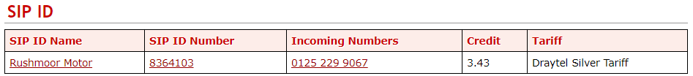
Voice mail pin: 2008
As at Wednesday, 25 November 2020 there was a credit of £3.43

E-mail: sales@rushmoormotor.co.uk
Web Page: http://www.rushmoormotor.co.uk

Not sure what this is about:
email account: facebook@rushmoormotor.co.uk
Password

mail.rushmoormotor.co.uk:2083
b6s8k56292hv
RJ8U%5KMh@k8

Username: sales@rushmoormotor.co.uk
Password: ty3ye3icnepxjzb2
Incoming Server: sxb1plzcpnl504421.prod.sxb1.secureserver.net
IMAP Port: 993
Outgoing Server: sxb1plzcpnl504421.prod.sxb1.secureserver.net
SMTP Port: 465

IMAP, POP3, and SMTP require authentication.

peters email myak2aqyvh4pfdiq

Showroom Installation:

Cloudscape using 01252 795461 Installation date: 5 February 2018
Upgraded date: 12 July 2019
Help Desk: 0345 688 7227 Account Number: 00008379
DSL username: 01252795461@cloudscape.uk DSL Password: gu102ep
WAN Address: 92.62.10.111
SMTP Server: smtp3.uk4dsl.co.uk

Cloudscape “My Account”
URL: https://www.cloudscapeconnect.com/myaccount/default.asp
Userid: Rushmoormotorco
Password: Rushm00r

01252795461 Phone Line Rental £10.42
01252795461 Enhanced Care Level 2 £1.50
01252795461 Fibre 80:20 £20.83
Typical Call Usage £0.00 Because calls go via VoIP
£32.75
VAT @ 20% £6.55
Total £39.30

VoIP Installation for Showrooms (Monthly Payment):

Item Quantity Cost Total
Cloud Call Recording 1 £10.00 £10.00
UK Geographic Number 01252279901 1 £3.00 £3.00
UK Geographic Number 01252279902 1 £3.00 £3.00
UK Geographic Number 01252279903 1 £3.00 £3.00
UK Geographic Number 01252790900 1 £3.00 £3.00
UK Geographic Number 01252794643 1 £3.00 £3.00
Virtual PBX Call Group 3 £1.00 £3.00
Virtual PBX Extensions 12 £1.50 £18.00
Storage Fee For 2552 Minutes 1 £1.35 £1.35 Typical Amount
VAT @ 20% £9.47
Total £56.82

Router
Name: RMC
URL: 192.168.82.1:8080
Userid: admin
Password: WestCroydon2025^
CLS: 01252795461
Minimum Guaranteed Speed: 48/11

Wireless 2.4 GHz
RMCKEYS WPA3/SAE Welcome2RMCtoday
RushmoorGarage WPA2/PSK Route6302021*
RG-Customer WPA2/PSK 4*4Specialist

Wireless 5 GHz
RMC5 WPA2 + WPA3/SAE Welcome2RMCtoday

Remote Access
URL: 92.62.10.111
Userid: david
Password: elstead2008
PIN: 764400
Secret: WeysideCottage
HEX: 57657973696465436F7474616765

Cloudscape
Help Desk: 0345 688 7227 Account Number: 00008379
DSL username: 01252790754@cloudscape.uk DSL Password: gu102ep
WAN Address: 92.62.10.111

USB
Workgroup Name: WORKGROUP
Host Name: STOREROOM
Username: dcb
Password: Elstead
Home Folder: /
Access Rule: Everything
File Explorer: /sr/

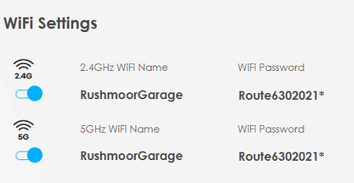
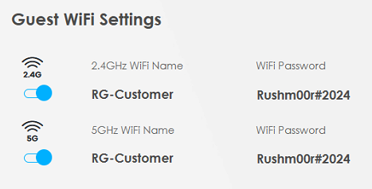
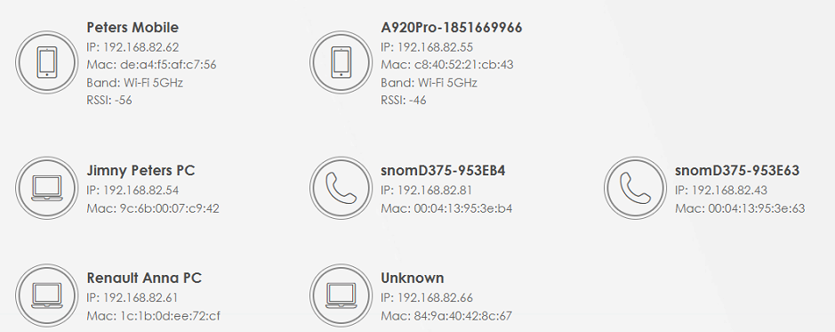

Username: rmc@rushmoormotor.co.uk
Password: t0wtxe6o8p62yk4yoa
Outgoing Server: sxb1plzcpnl504421.prod.sxb1.secureserver.net
SMTP Port: 465

SMTP require authentication.
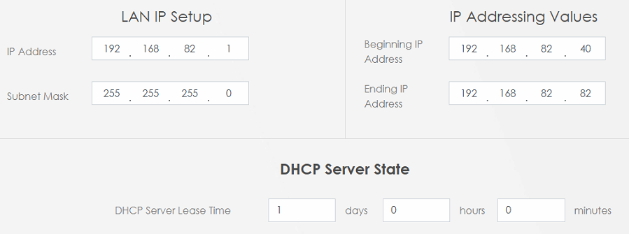
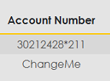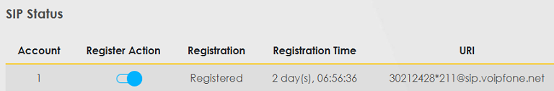
01252790754@cloudscape.uk
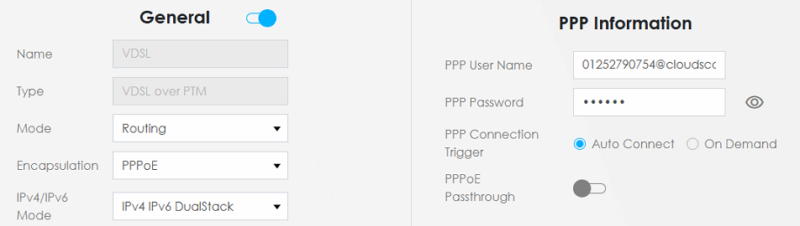

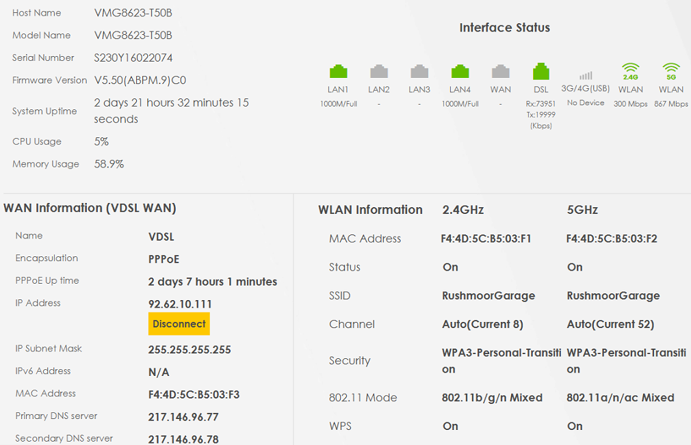

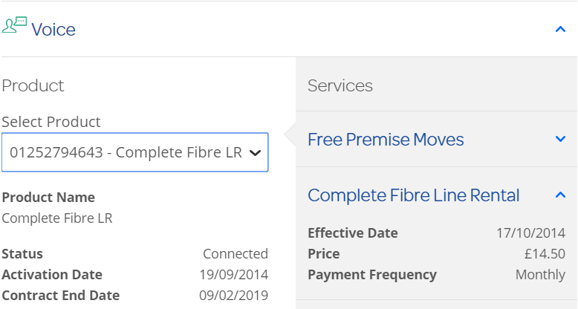

Fixed IP Addresses – CCTV
IP Address MAC Address Host ID Port
192.168.82.36 4C-11-BF-D3-2C-AA
192.168.82.37 4C-11-BF-D3-2C-51
192.168.82.38 4C-11-BF-D3-2A-BF
192.168.82.39 4C-CC-6A-03-64-15 ALNET-PC 1

DHCP Table on Monday, 05 April 2021
IP Address MAC Address HOST ID Userid Account Password
192.168.82.82 B4-00-16-45-35-D4 12:20:27 81892487
192.168.82.83 84-AA-9C-3C-E6-EF 21:43:55 Sure Signal
192.168.82.88 84-9A-40-42-8C-67 17:24:59 Switch?
192.168.82.95 40-8D-5C-06-A0-A3 18:58:32 Landrover
192.168.82.96 1C-1B-0D-EE-72-CF 18:58:29 Renault
192.168.82.99 74-40-BB-C9-75-C8 23:59:00 BRW7440BBC975C8 initpass

ARP Cache Table on Monday, 05 April 2021
IP Address MAC Address HOST ID Interface VLAN Port
192.168.82.82 B4-00-16-45-35-D4 81892487 LAN1 VLAN0 P1
192.168.82.83 84-AA-9C-3C-E6-EF Sure Signal LAN1 VLAN0 P1
192.168.82.85 00-04-13-95-3E-63 snom LAN1 VLAN0 P1
192.168.82.87 00-04-13-95-3E-B4 snom LAN1 VLAN0 P1
192.168.82.88 84-9A-40-42-8C-67 Switch? LAN1 VLAN0 P1
192.168.82.95 40-8D-5C-06-A0-A3 Landrover LAN1 VLAN0 P2
192.168.82.96 1C-1B-0D-EE-72-CF Renault LAN1 VLAN0 P3

Website Information
Contact: Abbie Harvey - Client Services Executive
Email: abbie.harvey@theAAcars.com
Phone: 01920 877750
Website: www.theAAcars.com

Re-direct via cPanel of rushmoormotor.co.uk to:
http://rushmoormotorcompany.dweb.vcarsdna.com/

Advanced DNS Zone Editor entries:
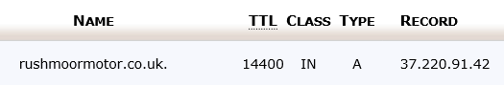

cPanel from TSOHOST
Access: https://sxb1plzcpnl504421.prod.sxb1.secureserver.net:2083/
Username: b6s8k56292hv Password: t0wtxe6o8p62yk4yoa

Email Accounts
sales@rushmoormotor.co.uk rkgfubypjpyqjftq
helen@rushmoormotor.co.uk 3e8dz1b52yga
sysadmin@rushmoormotor.co.uk 7fr4cbx9nff8
toby@rushmoormotor.co.uk 83kzcu0no9cc
chloe@rushmoormotor.co.uk 5ft4usx4gle2
enquiry@rushmoormotor.co.uk fbbw4qdy0k5u
peter@rushmoormotor.co.uk zwu7nag9yzmt
steve@rushmoormotor.co.uk ra6krr988zc7
info@rushmoormotor.co.uk v84oiqr4dzob
facebook@rushmoormotor.co.uk hrua4s440hdsh347
bodyshop@rushmoormotor.co.uk nhc5asiboim6
weyside.router@rushmoormotor.co.uk E}3n@wf$mG+Q
exp@rushmoormotor.co.uk Route612*

Email Forwarding

autonerd@rushmoormotor.co.uk >>> 4outof10@gmail.com
autonerdbodyshop@rushmoormotor.co.uk >>> 4outof10@gmail.com
autonerdbodyshop@rushmoormotor.co.uk >>> haitch.england@gmail.com
autonerdbodyshop@rushmoormotor.co.uk >>> info@rushmoorbodyshop.co.uk
autonerdsales@rushmoormotor.co.uk >>> 4outof10@gmail.com
autonerdsales@rushmoormotor.co.uk >>> haitch.england@gmail.com
autonerdsales@rushmoormotor.co.uk >>> sales@rushmoormotor.co.uk
sales@rushmoormotor.co.uk >>> enquiry@rushmoormotor.co.uk

Email Settings
nebula.servers.prgn.misp.co.uk
IMAP: 993
SMTP: 465
SSL: On
Authentication required for both IMAP and SMTP

Webmail / Box Trapper
URL:
Userid: sales@rushmoormotor.co.uk
Password: rkgfubypjpyqjftq
Footer Design for Bodyshop

With regards
Peter Harrison
Director

Tele: 01252 794 700
DDI: 01252 279 904
Web: www.rushmoorbodyshop.co.uk
Check our website for opening hours

This email [and any attachments] is intended solely for the individual[s] to whom addressed. It may contain confidential and/or legally privileged information. Any statement or opinions therein are not necessarily those of Rushmoor Bodyshop Ltd unless specifically stated. Any unauthorised use, disclosure or copying is prohibited. If you have received this email in error, please notify the sender and delete it from your system. Security and reliability of the e-mail and attachments are not guaranteed. You must take full responsibility for virus checking.
Rushmoor Bodyshop Ltd registered in England & Wales
Registered Office: Rushmoor Garage, Tilford Road, Rushmoor, Farnham, Surrey, GU10 2EP
Registration Number: 12240968

- From the Start Menu, select Control Panel.
- Click User Accounts.
- Search for Mail if you don't see it on the page. Click Mail.
- Click Show Profiles.
- Click Add.
- Enter a name for the profile.
- Select Always use this profile to set the new profile as the default. (If you have more than one profile, you can set Outlook to prompt for a profile.)
- In the drop-down list, select the new profile name.
- Click OK.
- On the Auto Account Setup page, enter the following:
Field | What to enter...
Your Name | Enter your first and last name.
E-mail Address | Enter your email address.
Password and Retype Password | Enter your password
- Click Next.
- Once Outlook is done configuring your account, click Finish
- Send yourself a test email from your Outlook for Web (OWA) and respond to it from Outlook 2013. This is the quickest way to confirm your email address is ready to go
MS Office Home & Business 2013
376991-706134-588220-345954-890772-932580-638156-782096

Workgroup WEYSIDE

CAP 4206 cam4206

KMC
Username: Rushmoor Password: larson1
Tele: 01925 730175
Email: sales@kmccredit.co.uk

Credit Card Machine from World Pay – Model ICT 250
Account: 96659463 Access ID: 0000
Help Desk: 08457 616263

Voipfone Customer Services
https://www.voipfone.co.uk/login.php
iNet Telecoms Ltd (Voipfone)
Sovereign House
227 Marsh Wall
London
E14 9SD

Tel: 020 7043 5555
Help Desk: 150
Fax: 020 7043 5556

Web: https://www.voipfone.co.uk
Blog: http://www.voipfoneblog.co.uk
Forum: https://www.voipfoneuserforum.co.uk
Twitter: http://www.twitter.com/voipfone

Registered Number: 05168033
VAT Registration Number: 858850966

URL: https://my.voipfone.co.uk/
Registered email address: sysadmin@rushmoormotor.co.uk
Phone Account: 30212428
Phone Password: 598579
Logon Password: Weyside2022*
Memorable Word: larson
Free tele no.: 05603873109

ESET
Username: EAV-24792347
Password: ajcavcb8m5 Harri50n#241160
B7RB-XUJK-RJSB-WC25-KWXA
Expiry date: 25/11/201? [2 Computers]

Bankline.Administrator@natwest.com
Customer Id : 78052
User Id : larson1
Activation Code: 1404256245
MFC-9330CDW 192.168.82.43 74-40-BB-C9-75-C8 BRW7440BBC975C8
Login Password: initpass
Model Name: Brother MFC-9330CDW
Serial no.: E71817G8J956270
Main Firmware Version: ZA
Sub1 Firmware Version: 1.10
Sub2 Firmware Version: Q1811192000
Memory Size: 192MB

Network Status Monday, September 9, 2019

Wired
Ethernet 10/100BASE-TX
(Inactive)
Node Type
NC-8500h
Node Name
BRN3C2AF467E977
MAC address
3c-2a-f4-67-e9-77

Wireless
IEEE 802.11b/g/n
(Active)
Node Type
NC-8100w
Node Name
BRW7440BBC975C8
MAC address
74-40-bb-c9-75-c8
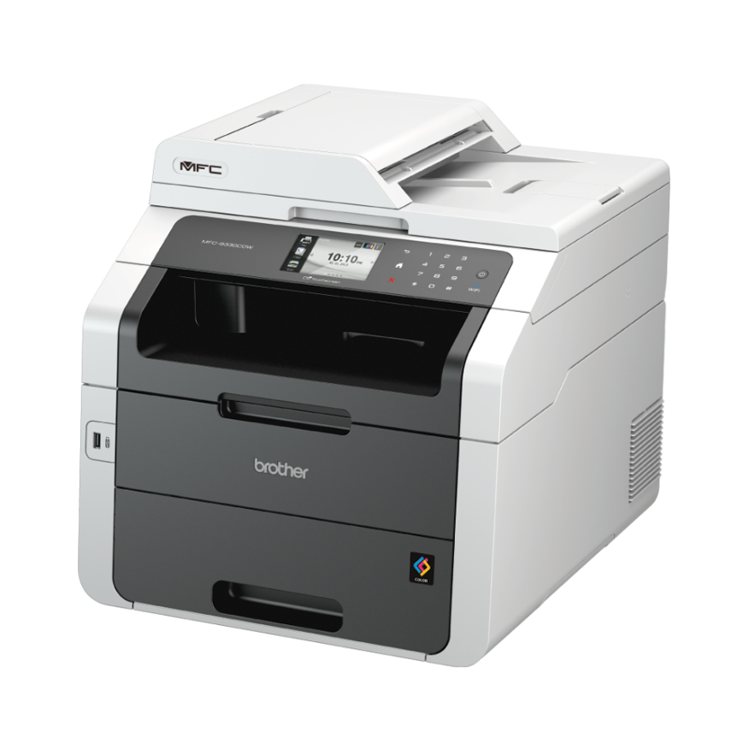

DrayTEL
Registered email address: sales@rushmoormotor.co.uk Password: route654
Username: 8364103 Password: _0DSqVbe Telephone number: 01252 299067
Registrar: draytel.org Outbound Proxy: nat.draytel.org:5065 [if required]

Voice Mail menu:
Dial 9200 from the DrayTEL phone or 0845 004 9207 from a POTS phone
Voice mail pin: 2008 Any Messages left will go to sales@rushmoormotor.co.uk
How to add credit to the account
Go to www.draytel.org - On that page use this box:
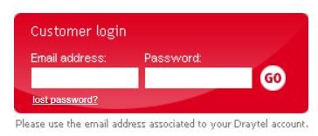
The Registered email address is sales@rushmoormotor.co.uk with the password of route654. Once entered these credentials are saved.

You then arrive here:
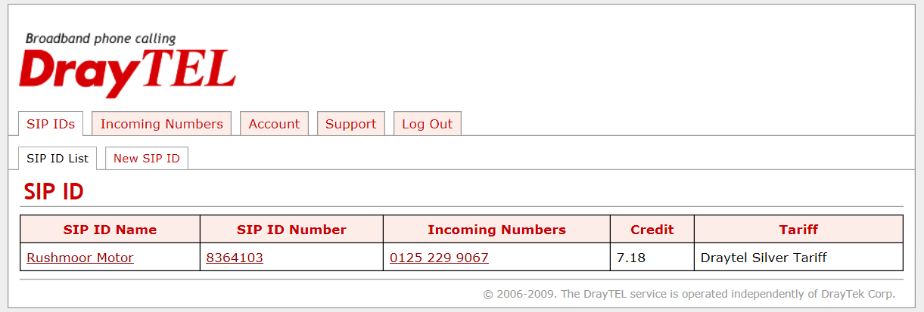

Click on Rushmoor Motor to get here:
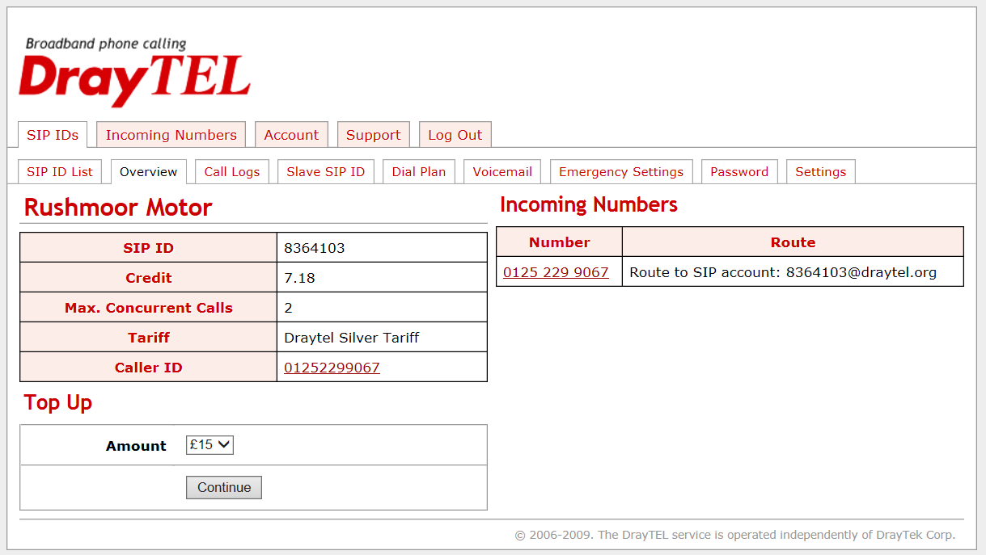
Use the Top Up feature to add funds choosing the amount you wish to pay. Whatever it is VAT will be added to the amount payable. Whatever credit is added, there is no time limit to expend on calls. Don’t forget to logout afterwards.

SecurityMetrics
Technical Support: 0330 808 0832
Email: support@securitymetrics.com
Web: www.securitymetrics.com
Userid: sales@rushmoormotor.co.uk
Password: r U S H M 0 0 R [no spaces]

SecurityMetrics has determined that RUSHMOOR MOTOR COMPANY is COMPLIANT with the PCI scan validation requirement for this target. Rescan required 23 December 2017.

Domain name:
rushmoormotor.co.uk
Registrant:
Rushmoor Motor Company
Registrant type:
Unknown
Registrant's address:
Tilford Road
Rushmoor
Nr. Farnham
Surrey
GU10 2EP
United Kingdom
Data validation:
Nominet was able to match the registrant's name and address against a 3rd party data
source on 10-Dec-2012
Registrar:
Paragon Internet Group Ltd t/a Vidahost [Tag = THERMAL]
URL: http://vidahost.co.uk
Relevant dates:
Registered on: 14-May-2001
Expiry date: 14-May-2017
Last updated: 05-Aug-2015
Registration status:
Registered until expiry date.
Name servers:
ns24.sovdns.com
ns24sec.sovdns.com
Domain name:
rushmoormotor-cars.co.uk
Registrant:
Rushmoor Motor Company
Registrant type:
Unknown
Registrant's address:
Tilford Road
Rushmoor
Nr Farnham
GU10 2EP
United Kingdom
Data validation:
Nominet was able to match the registrant's name and address against a 3rd party data
source on 12-Apr-2016
Registrar:
Ascio Technologies Inc. Denmark ? filial af Ascio Technologies Inc. USA t/a Ascio
Technologies inc [Tag = ASCIO]
URL: http://www.ascio.com
Relevant dates:
Registered on: 16-Apr-2013
Expiry date: 16-Apr-2017
Last updated: 12-Apr-2016
Registration status:
Registered until expiry date.
Name servers:
razsorns1.autotrader.co.uk 193.243.130.151
razsorns2.autotrader.co.uk 193.243.131.151

Historical Information

Settings used in the ATA
Settings for ATA - Cisco SPA112 VoIP/SIP ATA/Telephone Adapter w/ 2-FXS Ports
Firmware version as of Friday, 28 August 2015: 1.4.0 (001) May 27 2015
Default dial plan: (*xx|[3469]11|0|00|[2-9]xxxxxx|1xxx[2-9]xxxxxxS0|xxxxxxxxxxxx.)
Custom dial plan in use: (xxxxxxxxxxxx.|8xxxxxxS0|902S0|9200#S0|0[45689]x.|*xx|8500S0|999S0)
- Registrar: draytel.org
- SIP port: 5060
- Username: 8364103 (the numeric part of your DrayTEL account, before the @draytel.org)
- Password: _0DSqVbe
- Outgoing Proxy: nat.draytel.org:5065 - Note: This should not be used unless the VoIP device is behind another firewall - only use it if that is the case and try without first. The Port number and outgoing proxy name might be entered separately.

Need to delete this sometime:
http://homepages.nildram.co.uk/~rmc
ftp: homepages.nildram.co.uk
Userid: rmc
Password: thot5car

Callmaster VoIP
Service cancelled by email by Peter, September 2014
POTS number is unknown. SIP: 200920330 Password: db Voicemail: 9472

Siemens Gigaset C475IP purchased from DST 22/02/10
[Used in First Floor Flat – Not in use]
www.gigaset.net/myaccount
username: 223380270024#9
password: 1ZuBWQ2E
Help desk: 0845 3670812
Last known IP address:
Password: 1111

First Floor Flat Service Started 30/9/10 Since Discontinued
01252 757866 - 200923750 - 9002 - route654

VigorAP 700 in first floor flat
Mode: Universal Repeater
Band: 2.4GHz (B+G+N)
SSID: FlatConnect Channel: 11 Root SSID: RushmoorMotor
Encryption: WPA-shared key
WPA Mode: WPA2 (AES) Key: route654
Instructions: www.draytek.co.uk/support/kb_wlan_AP700_UniversalRepeater.html
Domain Registration Details

Domain name:
rushmoormotor.co.uk

Registrant:
Rushmoor Motor Company

Registrant type:
Unknown

Registrant's address:
Tilford Road
Rushmoor
Nr. Farnham
Surrey
GU10 2EP
United Kingdom

Registrar:
Compila Limited [Tag = COMPILA]
URL: http://www.compila.com

Relevant dates:
Registered on: 14-May-2001
Expiry date: 14-May-2015
Last updated: 05-Apr-2013

Registration status:
Registered until expiry date.

Name servers:
ns24.sovdns.com
ns24sec.sovdns.com

Home Installation

Router Vigor2865Vac
URL: 192.168.55.1:8080
UserID: admin
Password: Route6542021

VoIP
Account: 30212428*213
Password: 631521
Socket: Phone1

SSID
1: WC2
Password: WhiteDiamond2021

2: BT-36A2RR
Password: N7VeCnqRU6UQM6

VDSL
Logon: bthomehub@btbroadband.com
Password: BT

VPN
URL: weyside.ddns.net
User: Martin
Password: gu97qm

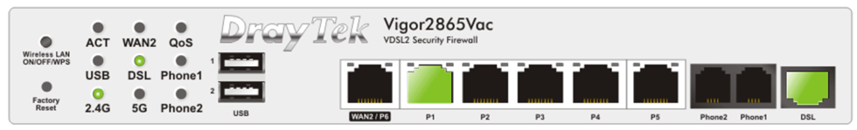

K9 Web Protection
License: K9A6A73722
Password: ?????

Mailboxes for account 01252722327.uwclub.net
[Using 2 of your 10 available mailboxes]
Username: 01252722327.uwclub.net
Password: 3E0DBE5
email: 01252722327@uwclub.net
Username: harrifamily.uwclub.net
Password: LARSON
email: harrifamily@uwclub.net

Outgoing Mail Server
Account Type: SMTP
Username: Your email address is your username
Server hostname: mail.uwclub.net
Server port: 587
Authentication: Password
SSL/TLS: Yes

Incoming Mail Server
Account Type: IMAP
Username: Your email address is your username
Server hostname: mail.uwclub.net
Server port: 993
Authentication: Password
SSL/TLS: Yes

Local Area Network [LAN] Information

Control Panel:
https://members.uwclub.net
Username: 01252722327
Password: 3E0DBE5
Connection settings
Default access number: 1840 01625401199
0845 access number: 08452231199
DNS Settings
195.184.228.6
195.184.228.7
News settings
News server: newsgroups.go-plus.net
Web space settings
ftp hostname: webspace.go-plus.net
ftp username: 01252722327.go-plus.net
Your web site can be found at www.select.go-plus.net
Software4Students
User Name: harrifamily@uwclub.net
Password: V?1|yYdysnL3Yj
MS suite of programs key: KF8FY-THJD2-B8MFX-P7X36-8DHY8

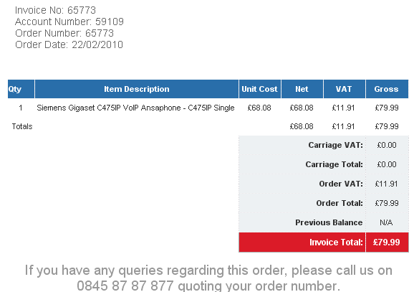

Printer XP-2100
Helen Norris
Tel: 01252 721029 Mobile: 07799113573
38 Lodge Hl Rd, Lower Bourne, Farnham, GU10 3RF
Born: 19 February 1970
Email: bournevalley@outlook.com Password: Mallory49
Access: http://login.live.com

Work on Vio Laptop as at 4 June 2013

Office 365 [2013 Version] is loaded but it costs £80 a year and therefore not configured.
A copy of Microsoft Outlook 2007 has been loaded and configured with a newly created email account of: helen.norris@outlook.com – Password: route654
Settings used:
Incoming Mail Server (POP3): pop3.live.com – Port 995 with SSL
Outgoing Mail Server (SMTP): smtp.live.com – Port 465 with TLS
Using “Test Account Settings” failure

Tried to use IMAP with these settings but without success:
POP: pop3.live.com - Port 995 with SSL
SMTP: smtp.live.com, Port 587 with TLS

The breakthrough was using this: http://office.microsoft.com/en-us/outlook/microsoft-office-outlook-hotmail-connector-overview-HA010222518.aspx - All fine now.

helen@rushmoormotor.co.uk 24zghqqmo09v

"C:\Program Files\Intel Security\True Key\application\truekey.exe" --open-source=dtopicon

C:\CapWin\CAP94.exe

https://www.motonovofinance.com/dealer-site/mymotonovo/

http://www.autotrade-mail.com/

https://trade.autotrader.co.uk/articles/autotrade-mail/

ANA’s Label
790900
Peter [M]
790900
B&S [W]
Peter
B&S [T]
Peter
David
Peter
794643

