Sure Signal Troubleshooting Guide
See http://forum.vodafone.co.uk/t5/Vodafone-Sure-Signal/Version-2-Sure-Signal-Troubleshooting/td-p/679129
And more particularly: http://forum.vodafone.co.uk/t5/Vodafone-Sure-Signal/Steady-power-light-only/td-p/679063
Worryingly is this: http://forum.vodafone.co.uk/t5/Vodafone-Sure-Signal/Vodafone-Sure-Signal-Is-It-Compatible-With-PPPoE-Connections/td-p/464447/page/4

Then we have this: http://forum.vodafone.co.uk/vodafoneuk/attachments/vodafone/70/21763/1/DrayTek%202820%20setup.pdf but as it is WAN1 it would be PPoA and therefore may not be a solution.
Configuration of the Router that has been carried out
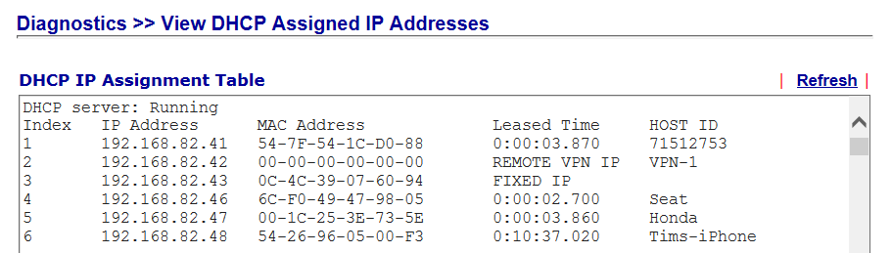
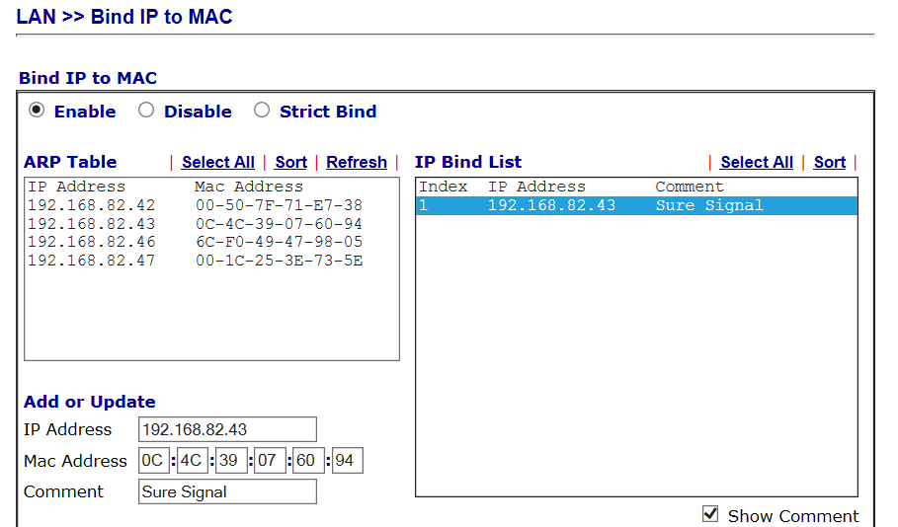

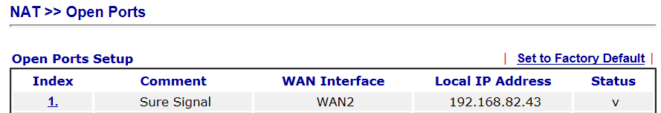
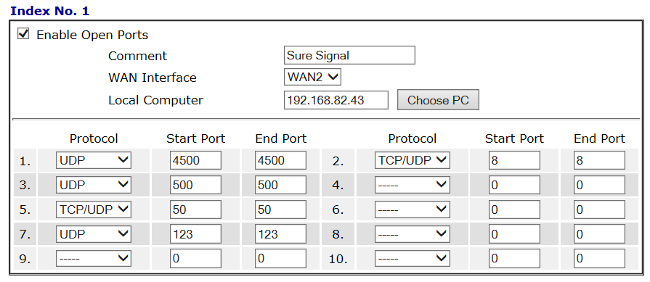
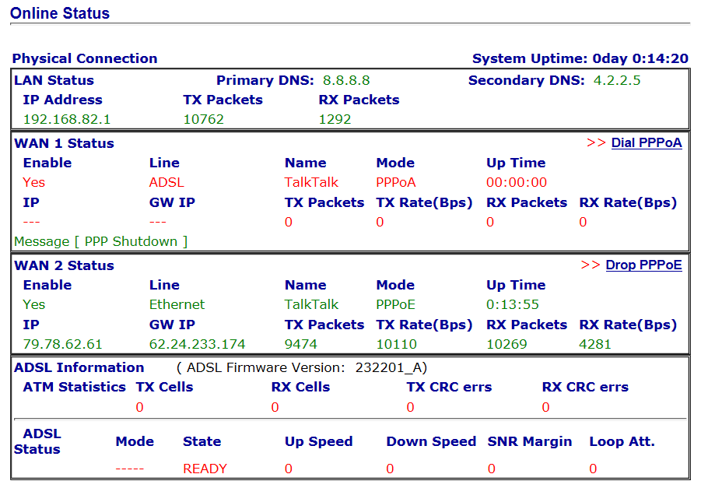

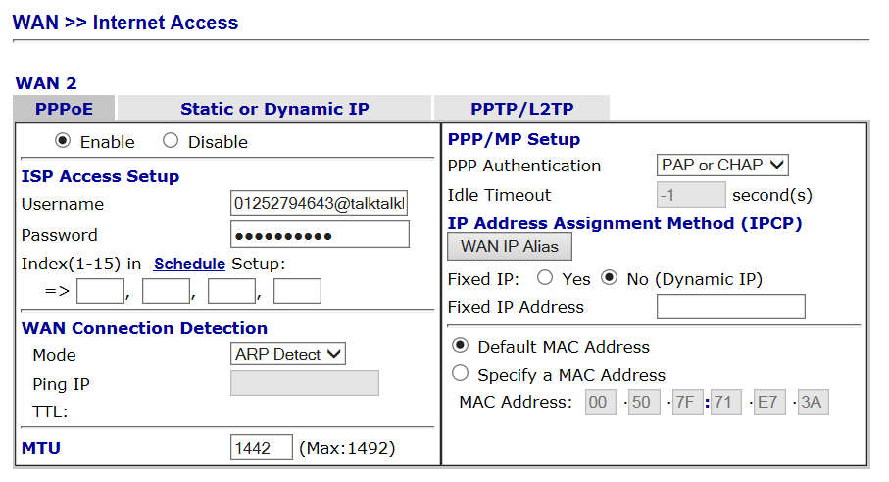
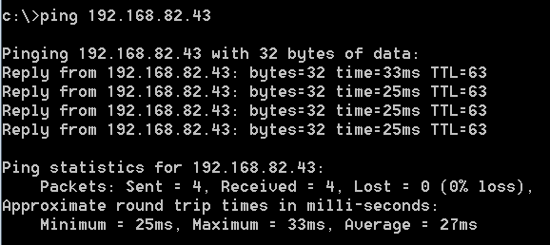
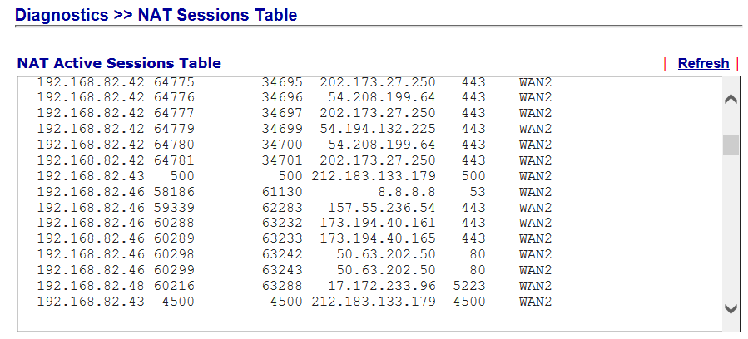Well, it’s connecting on ports 500 and 4500.
Time now 15/10/2014 17:34:33 – I wonder if this applies? Wait 24 hours.
It can sometimes take up to 24 hours for the Sure Signal to fully register with the server. Before attempting any of the steps below, please wait 24 hours.
Do we need to tweak My Account in any way?
Check that our Sure Signal has registered successfully.
Before your Sure Signal can connect to our network, you need to register it with us.
You’ll receive a text or email to let you know when the registration is complete and your Sure Signal won’t work until you’ve received this message.
To check your Sure Signal is registered, login to My Account and click on the 'My Sure Signal' tab. Our Sure Signal details should be listed, along with the status 'Registered'.
Need to find out how to do this:
Please see the following for a list of IP addresses and port numbers that need to be forwarded to your Sure Signal's internal IP address. For instructions on how to do this, we recommend you contact your ISP or Router Manufacturer, or refer to the default guide for your particular make and model, over at http://portforward.com.
Destination IP Addresses:
212.183.133.177
212.183.133.178
212.183.133.179
212.183.133.181
212.183.133.182
212.183.131.128/26
Need the serial number of the sure signal device

Model Name: Vigor2820Vn
Firmware Version: 3.3.7.3_232201
Build Date/Time: Sep 13 2012 19:09:39

Disable WAN1 and WAN3(4) (the ADSL and USB(s))
WAN2 (Ethernet) should then be configured for PPPoE, and set up with your ISP login details.
The Max MTU on PPPoE is 1492, so use that, as it shouldn't let you enter higher.

In the VPN section, there is a setting for VPN passthrough... Enable all passthroughs.

Check that you can get onto the internet ok using your computer.
Reset the suresignal...

That is exactly the same setup as I have, apart from I am using a 2860, which has replaced the openreach modem too.
I've not changed any port forwarding, or set static IPs, or played with UPnP, so leave all them as standard.

