Purge IMAP items marked for deletion
Show All

When you mark an item on an IMAP e-mail server for deletion, the item is displayed in strikethrough text in the header list. However, the item is not removed from the IMAP mail server until a purge command is used.
Note You can change the view of an IMAP folder so that items marked for deletion do not appear. On the View menu, point to Current View, and then click Hide Messages Marked for Deletion. If you are using the Reading Pane, you must turn it back on after using this command. On the View menu, point to Reading Pane, and then click Right or Bottom.
If you do not purge the deleted items periodically, you might reach and exceed the allotted disk space on your e-mail server. If you exceed your allotted disk space, you might not receive any new messages, or you might incur additional charges from your Internet service provider (ISP).

Manually purge deleted items
To permanently delete the items marked for deletion, do the following:
- Click a folder in your IMAP e-mail account.
- On the Edit menu, point to Purge Deleted Messages.
- Do one of the following:
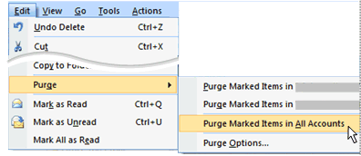
- Click Purge Marked Items in "folder".
Only items marked for deletion in the folder that you are in are purged from the IMAP mail server.
- Click Purge Marked Items in "e-mail account".
All items marked for deletion in any folder for this IMAP e-mail account are purged from the IMAP mail server.
- Click Purge Marked Items in All Accounts.
All items marked for deletion in any folder for any IMAP e-mail account are purged from the IMAP mail server.
Note You must be working online with the mail server for this feature to work.
Tip Add the Purge command to a toolbar. On the Tools menu, click Customize. On the Commands tab, under Categories, click Edit. Under Commands, drag the Purge command to a toolbar.

Automatically purge the deleted items
You can configure Microsoft Outlook so that when you switch between folders, any items you have marked for deletion are purged from the IMAP mail server.
- Click a folder in your IMAP e-mail account.
- On the Edit menu, point to Purge Deleted Messages.
- Click Purge Options.
The Internet E-mail Settings dialog box opens.
- On the General tab, under Purge Options, select the Purge items when switching folders while online check box.
Note You must be working online with the mail server for this feature to work.

