Voice and Data Service Information Sheet

The Internet service is in-contract until 15th July 2021 from TalkTalk Business.
Details are:

Help Desk: 0800 083 3003 Account number: 88201446103
DSL Username: 01252447030@talktalkbusiness.net – DSL Password: H6R4V4Q6G3
WAN address: 92.27.221.10
Voice Line: 01252 447030

Line Rental £14.50
Typical Call Usage £0.00 Because calls normally routed via VoIP
Complete Fibre Business BB £15.05 GMS 40.48Mps
Discount (No idea why) -£6.00
£23.55
VAT @ 20% £4.71
Total £26.26

A TalkTalk Business router has been deployed with defaults changed as follows (Ignore the information label on the router):

Router IP: 192.168.30.1
Admin Login: admin
Password: elstead2008
SSID: bodyshop2
Password: route654
LAN IP range start: 192.168.30.30 Pool Count = 20

The advertised number of the business is 01252 794700. This is a virtual number from Voipfone. The account details are shown below. This is a rolling one-month contract. Call charges are paid against a call deposit which is auto topped up when down to £2. The top up amount is currently set at £50.

Registered email address: sysadmin@rushmoorbodyshop.co.uk
Account Numbers: 30213872
Password: 079847
Generic Number: 05603 874 561

Rental Charges per Month

Service | Qty | Fee | Total
Cloud Call Recording | 1 | £10.00 | £10.00
UK Geographic Number 01252279750 | 1 | £2.00 | £2.00
UK Geographic Number 01252794700 | 1 | £2.00 | £2.00
Virtual PBX Call Group | 2 | £1.00 | £2.00
Virtual PBX Extension Number(s) | 5 | £1.00 | £5.00
Typical Storage Fee | 1 | £0.27 | £0.27
Sum |  |  | £21.27
VAT @ 20% |  |  | £4.25
Total |  |  | £25.52

Present Basic Setup
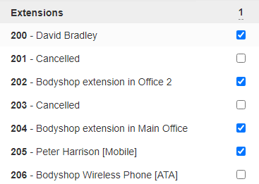
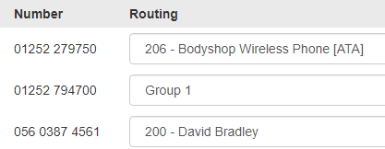
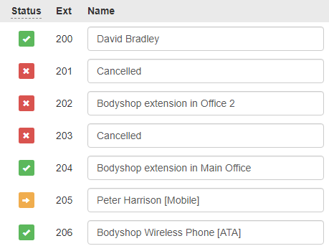

Any changes to the VoIP system can be made almost immediately. In the event of power failure incoming calls are automatically diverted to 01252 447030 but there is currently no phone connected to the phone socket. A basic corded phone is all that is required and costs £10.

Incoming calls to 01252 794700 are filtered by a business hours schedule.
This is currently setup as follows:
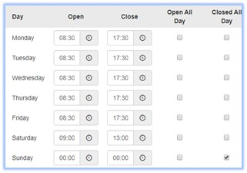
The DDI number 01252 279750 is not affected by the business hours filter.
To call the Car Showrooms use extension 204. The

The entire VoIP service could be swept away but in the process 01252 794700 would be lost.

Outgoing calls must use the area code, exceptions being system calls such as 1471 and 1571 etc.
TalkTalk ‘MyAccount’
Credentials correct on Thursday, July 11, 2019
URL: https://myaccount.talktalkbusiness.co.uk/
Logon email address: sysadmin@rushmoormotor.co.uk
Security password: Elstead2008 [Case sensitive]
File contact numbers: 01252 758960 and 07836547472
Subscription: 1037486 [No idea what this is for]
Other Information: Larson1
Security Question: Where were you born? Answer: Croydon
88201446103
Rushmoorbodyshop ltd
Rusmoormotorcompy
Tilford road
Surrey
GU10 2ep

Change in business ownership
If there is to be a change in ownership of your business then we will need to know about it, especially if the new owner intends to retain some or all of the TalkTalk Business services.

We will need the following information

- New contact name Allan J MacDonald
- New contact number No Change
- New Business name (if changing) MacDonald Ryan Ltd
- Confirmation if some or all services are being retained Everything
- Date of change ASAP

Logon email address: sysadmin@rushmoorbodyshop.co.uk
Please contact us with the above information in order for us to process your request.
Small Business: 0800 840 6787
21089372

MacDonald Ryan Ltd
45 The Street
Wrecclesham
GU10 4QS

IP Address: 92.204.68.8
Domain: rushmoorbodyshop.co.uk
Logon: jzcenrwqptes
Password:

Custom DNS
Was: 67.225.147.60
Changed to: 64.91.224.25 8JUL22

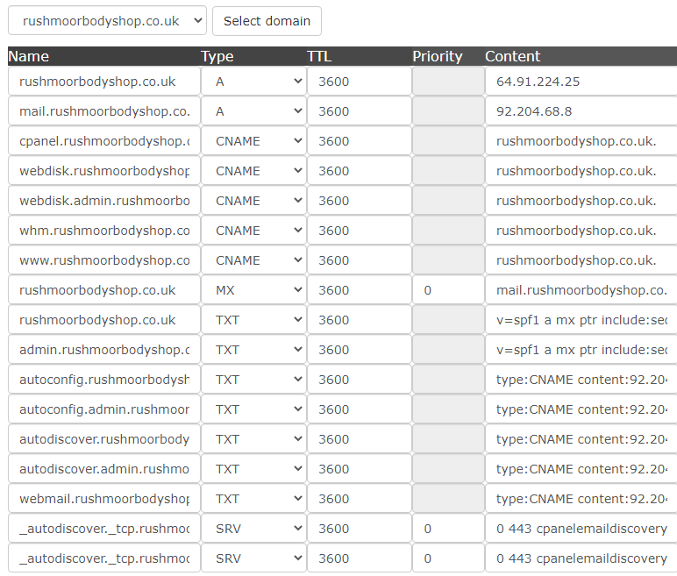

New email account: webmaster@rushmoorbodyshop.co.uk
Password: dgoks2m38orj

