Computer Installation for Terry Russell
Updated: Saturday, 4 August 2018

Address:
23 Thornden
Cowfold
Horsham
RH13 8AG

Home: 01403 865435
Mobile: 07840 957090
VoIP: Draytel: 8477989
Gigaset: 226011894024

email: terry@terryrusselltrams.co.uk
Web Page: http://www.terryrusselltrams.co.uk

Workgroup: COWFOLD

Broadband Service from EE - Connected to: 01403 865435
Account number: 214143477
Help Desk telephone number: 150 (from EE phone) or 0330 123 1105
Primary web page: ee.co.uk/myee

To logon to the router use: http://192.168.1.1 [Network was 33]
Router Login: admin Password: hh9pj4
Broadband User Name: chaceside.wanadoo.co.uk@fs
Broadband Password: Phoebe
ISP email address: joanrussell@chaceside.wanadoo.co.uk Password: Phoebe
Last known WAN address: 96.147.54.93
DNS: 193.36.79.101 and 193.36.79.100

Wireless Setup
New: Wireless SSID: EE-BrightBox-39pfnq Password: jar-bend-fatal

Connecting addition wireless devices to the router
- Search for SSID

Security type: ?

ESET
Username: EAV-46096206
Password: hpfv6rjeub
License name: ESET Internet Security
Expiration date: 06/01/?
Public license ID: 333-XSW-SND
License Key: BM76-XP5D-PH58-6HNB-XF39
Portal Password: Tramcar2000*
Mail Client Setup for Terry Russell Trams
www.terryrusselltrams.co.uk
smtp.orangehome.co.uk
No authentication require - Standard ports used

Email accounts on Terry Russell Trams
terry@terryrusselltrams.co.uk Password:
sysadmin@terryrusselltrams.co.uk Password: route654

Email Forwarding
david@terryrusselltrams.co.uk to david@cyberpictures.net

VoIP Services using Gigaset N300A IP – Connected as 192.168.1.240
From the handset press the right arrow on the central button and select the ”settings” menu,
Then scroll down and select “Base”, then scroll down and select “Local Network”.
This will present you with the IP address of the base unit.

IP Services set up
#1 – Voipfone
#2 – Draytel 8477989
#9 – Gigaset 226011894024
#0 – Home Line 01403865435

From Voipfone
Registered email address: sysadmin@terryrusselltrams.co.uk
Account Number: 30208019
Voipfone password: 843976
Telephone Number: 05603 868662

From DrayTEL
Web Site: www.draytel.org
Registered: sysadmin@terryrusselltrams.co.uk
Password: route654
Setup Info: nat.draytel.org – 5065 - 5060

Line1 Username: 8477989
Password: +tb[Dzc1
Installed in Gigaset as #1

Line2 Username: 8485594
Password: P1>AnK#2
For DCB use

From Gigaset
To find the number dial 1188#9 - Then select options followed by own number
Number is: 226011894024
Personal info services configuration page: gigaset.net/myaccount
Username: 226011894024
Password:?

zvf6kso4h5vr
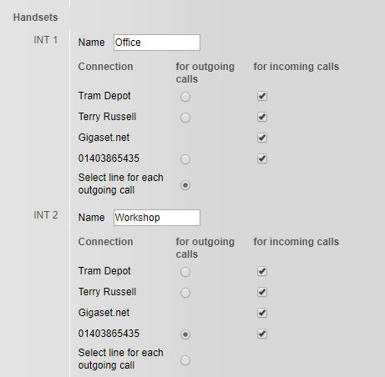

Domain Access – Hosted by Tsohost
Control Panel: terryrusselltrams.co.uk:2082
Login: davi8326 Password: GHhdNUxR39t9

No idea how all this came about:
You can see your entry here: http://www.cylex-uk.co.uk/company/terry-russell-trams-17521855.html
Your customer number is: 17521855
Your password is: route654
To make further modifications, please visit our homepage http://www.cylex-uk.co.uk

Joan’s Laptop

Mail Client Setup for Orange
POP3: pop.wanadoo.co.uk
SMTP: www.thornden.net With authentication
Email: joanrussell@chaceside.wanadoo.co.uk Password: Phoebe

Mail Client Setup for Thornden
POP3: www.thornden.net
SMTP: www.thornden.net No authentication required >>>> ns31.sovdns.com
Email: joanrussell@thornden.net Password: dragon73

Fundamentals
Windows 8.1
Product Part No.: [8]X18-15
Product ID: 00179-60868-80086-AAOEM
CD Key: WRR36-NG7PW-BCMQP-Q8KQM-DPBQ6
Computer Name: ACER
Registered Owner: Joan
Registered Organization:
Logon ID: Joan
Password: gloworm1

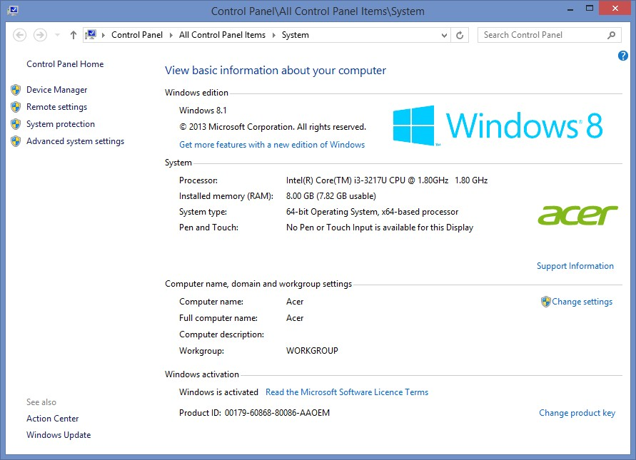

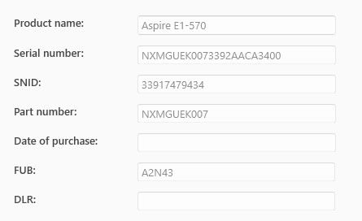
Date Purchased: 25th January 2014 Currys PO11607752

Domain Access – Hosted by Compila
Control Panel: https://nebula.servers.prgn.misp.co.uk:2083
Login: davi5881 Password: AYiUaFSVyy

Domain Name: THORNDEN.NET
Registrar: BB ONLINE UK LTD
Whois Server: whois.nominate.net
Referral URL: http://www.nominate.net
Name Server: NS31.SOVDNS.COM
Name Server: NS31SEC.SOVDNS.COM
Status: clientTransferProhibited
Updated Date: 28-nov-2013
Creation Date: 28-nov-2013
Expiration Date: 28-nov-2015

Skype
Name: thornden23
Password: polly2014
Security: 18.10.40

ESET Anti-Theft
Locates and retrieves your missing device. Should you part with your device, ESET Anti-Theft helps to track and locate it. See its position on the map, monitor foreign activity, and increase the chance of getting it back.

Web: https://my.eset.com
Account: terry@terryrusselltrams.co.uk
Password: trolleybus654
Register Device[s]: ACER

