Computer Installation at Trotton Gate Garage
Updated: Thursday, 11 June 2020 Contact Name: Barry Stevens

Business Address:
Main Rd
Midhurst
West Sussex
GU29 0JW

Business: 01730 813661
Mobile:
Business Fax:

Web Page: www.trottongategarage.com

Broadband Service from BT - Connected to: 01730 ?

Workgroup: Trotton

ESET
Username; EAV-0133401199
Password: 2e7baesxra
Key: BXTN-XMT2-UFPC-KTW7-K8UD
Product: ESET Internet Security
Quantity: 2 computers
Expiry: 03/03/2023
Email Accounts
sysadmin@trottongategarage.com 4fmau5vgkt52
barry@trottongategarage.com
jamie@trottongategarage.com 8vdgsv8ksvffbs8c

FTP Host Server: ftp.trottongategarage.com
Username: davi9729
Password: 7eMTtuOox1
cPanel: https://blazar.servers.prgn.misp.co.uk:2083
Username: davi9729
Password: 7eMTtuOox1
VOSA
vts number: 86185
a.e number: 9782

VoIP from Voipfone
email: barry@trottongategarage.com
Voipfone Account Number: 30207906
Voipfone password: 037152
Telephone number: 05603 868 548

Username: barry@trottongategarage.com
Password: y5zfvc4zxkdsx9yb
Incoming Server: sxb1plzcpnl489852.prod.sxb1.secureserver.net
IMAP Port: 993
Outgoing Server: sxb1plzcpnl489852.prod.sxb1.secureserver.net
SMTP Port: 465

IMAP, POP3, and SMTP require authentication.

Webmail:
http://trottongategarage.com:2096/
Sunbeam – Desktop – MOT
Windows 8.1 Pro
Product Part No.: [Blue]X18
Product ID: 00259-40850-86582-AAOEM match to CD Key data
CD Key: ND4GJ-7YTV9-7B3KT-B9DRB-YWP6D
Computer Name: SUNBEAM
Registered Owner: MOT
Registered Organization:

Local Account Userid: MOT Password: computeruk

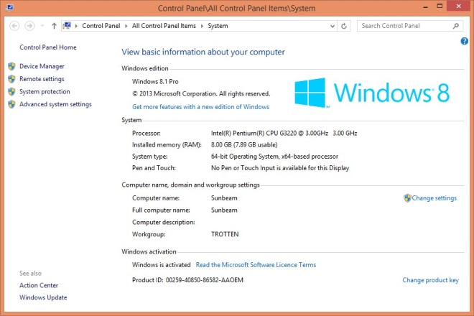
Purchased from Computer UK 01252 733873 January 2015
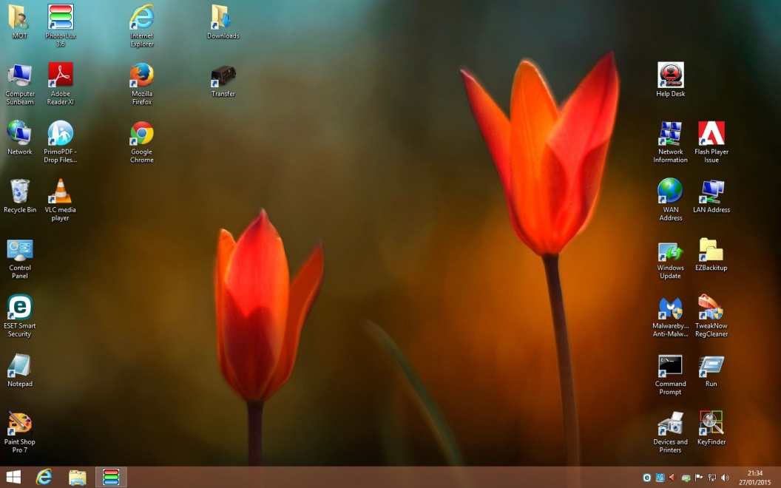

Snom Label

Emily
868548
Mike
868548
Belinda
Recovery
Tony
Workshop
Guy
MOT
Area 14

