Prepared by: David Bradley
Document: rogerbenham.docx

Technology Setup at 2 MPH
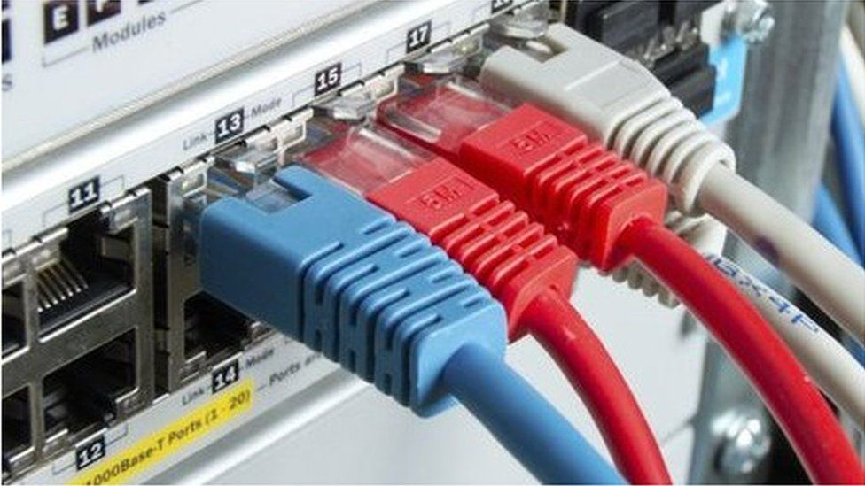
Cloudscape Connect - 0116 274 7360 - FTTP Broadband Service
Router Make: ZYXEL VNG8623-TSOB V5.50 (ABPM.5)C0
Router Address: 192.168.1.1:8443
WAN Address: https://92.62.0.97:8443
Router Userid: admin
Router Password: ArchieBishop2137?
Client DHCP Range: 192.168.1.2 ~ 192.168.1.251
Broadband Username: VFP1780043@cloudscape.uk
Broadband Password: gu101fh
Broadband Service: 220/30 Mbps

Access URL: https://www.cloudscapeconnect.com/myaccount/
Account Number: 00009461
Username: Bishop9461A
Password: A9461Bishop
Email Contact: archie.bishop@gmx.com

Hardware SSID Password
Router 2.4G WiFi abufb2022 56031065
Router 5G WiFi abufb20225g 56031065
Devolo AP 413 Kitchen devolo-413 FFMXKDUPRNFWKQEV
Devolo AP 566 Hallway devolo-566 QARBVOWTESRTXNBP

Summary of monthly financial commitment with VAT included:
Broadband: £43.80 Broadband @ 220/30 Mbps
01252712485 Phone Line Rental £15:00
01252712485 Standard Voice Mail £1.73
Total: £60.53

One-off charges: Zyxel FTTP Router 25 February 2022 £54.00

Short Codes available from phones plugged into the ZYXEL VNG8623 router
These Speed Dial Numbers are setup in the router on this web page in the router configuration: VoIP >>> Call Rule

#01 1MH - Jim Rice - 07594340509
#02 2MH - Archie Bishop - 01252279323
#03 8WG - Sharyn Fitzpatrick-Nash - 01252279121
#04 4WG - David Bradley - 01252758960
#05 10WG - Peter Clappison - 01252727443
#06 Oliver Penfold [Gardner] - 07747749270
#07 Cloudscape Connect - 01162747360
#08 Voipfone Help Desk - 02070435555
#09 MPHEM Office - 30208619*200
#10 Swing Open the MH Gates - 07430525930

Voipfone Credentials
URL: https://my.voipfone.co.uk/#!/account/account/email-addresses+auth
Login: anne.bishop787@gmail.com
Password: Archie2610!!
Memorable Word: Evelyn
Account: 30230489

Item | Quantity | Cost | Total
Renewal of UK Geographic Number 01252279033 | 1 | £3.000 | £3.000
Renewal of UK Geographic Number 01252712485 | 1 | £3.000 | £3.000
Renewal of Virtual PBX Call Group | 1 | £1.000 | £1.000
Renewal of Virtual PBX Extension(s) | 3 | £1.500 | £4.500
VAT @ 20% |  |  | £2.30
Total |  |  | £13.80

Security Console codes available when engaged in a conversation
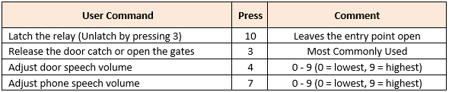

Seen on the Network 15/11/2022
DHCP | Host Name | MAC Address | Logon | Password | SSID | Password
192.168.1.1 | Router | 50:E0:39:71:D4:50 | admin | ArchieBishop2137? | abufb2022 | 56031065
192.168.1.120 | Unknown | 4e:84:ec:e2:4c:f2
192.168.1.123 | devolo-566 | b8:be:f4:9e:fd:ed | ----- None ----- |  | devolo-566 | FFMXKDUPRNFWKQEV
192.168.1.128 | Unknown | 4e:01:0c:f0:b2:f6
192.168.1.14 | batman | 8c:8c:aa:46:a2:e0
192.168.1.156 | Archies-Air | f0:18:98:87:7d:90
192.168.1.166 | Unknown | b2:d6:b2:ba:fb:de
192.168.1.180 | Unknown | 4a:42:1a:70:2f:90
192.168.1.19 | HPC254A | c8:d3:ff:ca:25:4a
192.168.1.202 | Dining Room | d4:a3:3d:67:64:31
192.168.1.215 | S850A-GO | 7c:2f:80:eb:90:27
192.168.1.28 | Unknown | 56:06:b2:b6:f1:20
192.168.1.76 | devolo-413 | b8:be:f4:9e:fa:f0 | ----- None ----- |  | devolo-413

Gigaset S850A GO
VoIP Settings in Router
SIP Account tab:
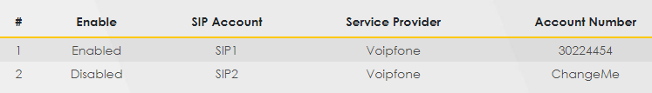
SIP Service Provider tab:
Phone Device tab:
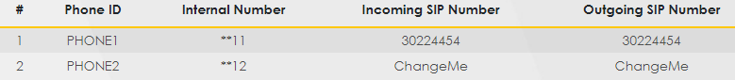
Region tab:
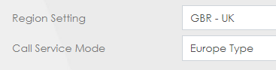
Call Rules:
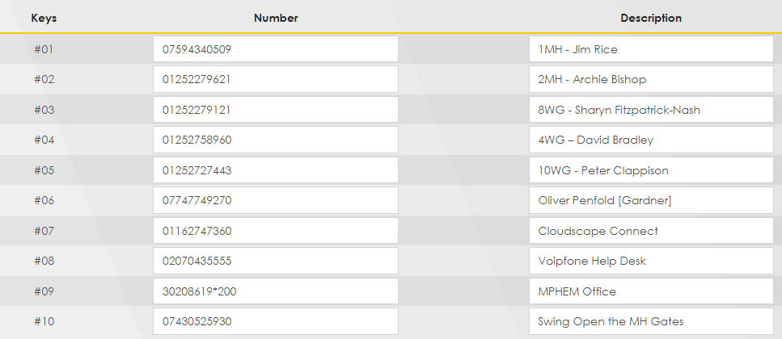
VoIP Status as at 14/10/22 at 19:43
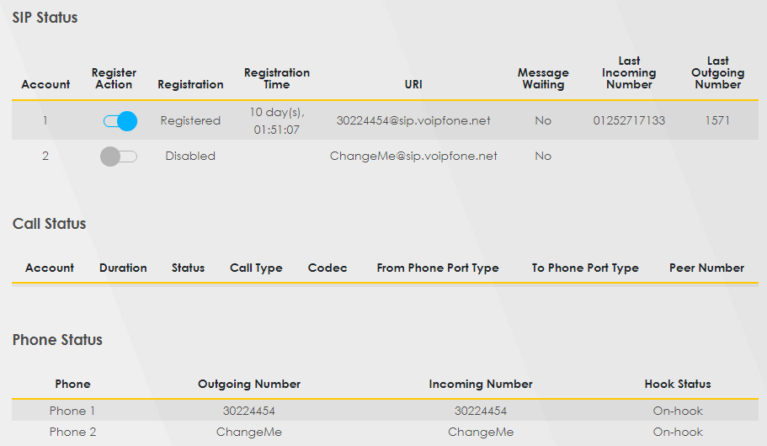

User Account
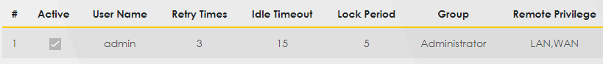

Remote Management
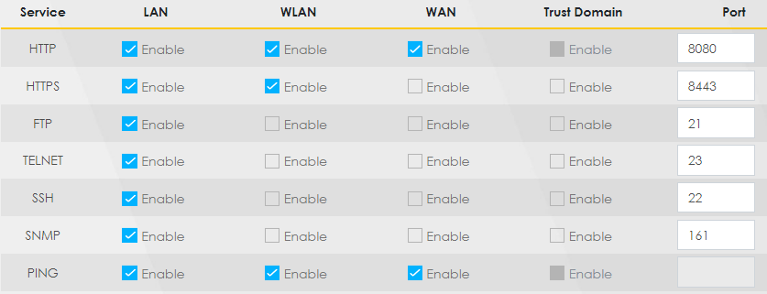

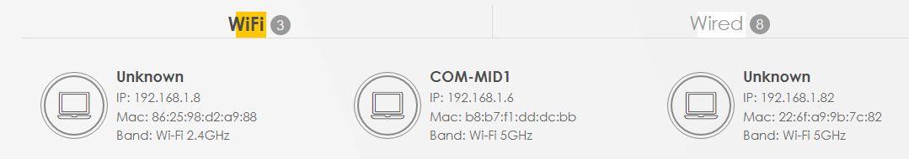

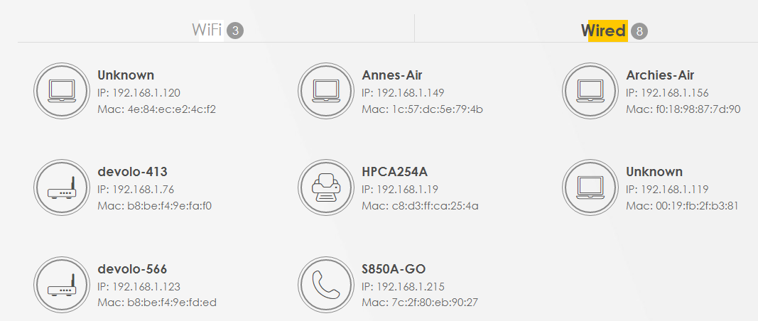

Time
