Audrey Knight - Computer and Telephone Setup
Notification email: hollyhouseknight@btinternet.com
Digital Voice Number: 01252 712 022 Live Date: 19th March 2025
Mobile Number: 07880 990 906

Observations

- Page 3 brings together an insight of the total monthly costs for the services contracted with Voipfone, Cloudscape and SKY TV. The information gathered together may not be comprehensive because there appears to be an insurance policy for damage to the Sky hardware on loan. The premium is said to be £9.99 per month. Not sure if Audrey has been paying the said monthly premium.
- Email accounts currently live and their future.
- hollyhouseknight@btinternet.com
This account is liable to be cut-off without notice unless an expensive monthly retention fee is paid. While the email account continues to be working using an Outlook client, watch closely for any emails from BT/EE saying the service is about to be closed down and take appropriate action.
- audrey@cldmail.co.uk
This email account was setup because group mailings from MPHEM were not being received into her BT email account. This is no longer the case. Email account should be closed down and advise Mike Clark to revise the Estate Telephone Directory accordingly.

- audrey@trolleybus.net
A temporary account setup to administer the switchover from BT to Cloudscape. Once the task is completed it will be mothballed. The domain name trolleybus.net is registered to David Bradley so there is no chance for the email address being lost.
- audrey@knightshome.uk
This is a working email account ready to be the prime email account. Cloudscape is the registrar and hosting provider of this email account who we trust. It has already been configured into Outlook.
- Added wireless phones around the apartment on 22nd March 2026 using Gigaset Base Station S850A-GO.
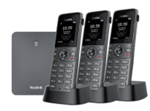
- Subscription TV services configured into each Tv. Conversion to streaming requires an Ethernet cable to be run from the router to the kitchen services cupboard.
- The total cost per month of technology installed in the apartment seems to add up to £165.39 plus another £14.13 for the TV licence. This is without considering mobile phone costs.

Monthly Commitment with Voipfone
Service went live 12th March 2025 – Rolling monthly contract
Not under contract with any/all services and able to be cancelled immediately.
Option available to ring Audrey’s mobile and desktop phone to ring simultaneously.
Call Deposit remaining on 25 January 2026, £6.23
Item | Price
Renewal of UK Geographical Number 01252 712 022 | £3.00
Renewal Virtual PBX Call Group | £1.00
Renewal of Virtual PBX Extensions - Qty 2 at £2.00 | £4.00
Net | £8.00
VAT at 20% | £1.60
Total | £9.60

Monthly Commitment with Cloudscape
Service went live on 14th March 2025 – 12-month contract
Yearly fee for the registration of the domain name: £6.00 inc. VAT (Paid)
Item | Price
Broadband - 220/30 | £28.50
Hosting of 5GB Mailbox for audrey@knightshome.net | £1.50
Net | £30.00
VAT at 20% | £6.00
Total | £36.00

Monthly Commitment with SKY TV from April (Discounts applied)
Service went live on 20th March 2025. Contract period thought to be 24 months.
Item | Price
Sky Signature | £31.50
Multiscreen | £10.00
Ultimate TV Pack | £4.50
Ultra HD | £4.00
Sky HD | £6.00
Sky Sports Complete Including Sky Sports+ | £19.00
Sky Cinema | £8.00
TNT Sports | £25.00
Sky Sports HD | £3.00
Net | £111.00
VAT Paid | £0.00
Total | £111.00

Voipfone - 150 or 020 7043 5555 - Digital Voice Service [VoIP]
Registered email address: audrey@trolleybus.net

Access URL: https://my.voipfone.co.uk/#!/dashboard+auth
Account Number: 30243070
Password: CrystalPalace654*
Memberable Word: gibson
Hint: At number 6
Extensions: *200 Password: 227651 Softphone
*201 Password: 920159 Wireless Base Station
Live Number: 01252 712 022
Free Number: 056 0368 4306 Used in the security consoles

Temporary email account for administration convenience during setup
Access URL: https://sxb1plzcpnl453518.prod.sxb1.secureserver.net:2096/
Email address: audrey@trolleybus.net
Password: 5vn4w8wyamdvikwq

Making Outgoing Calls
You have a Digital Voice service from Voipfone that utilising your broadband connection to a server located probably in London supporting voice traffic. BT were kicked into touch for their incompetence in resolving connectivity issues created by them.
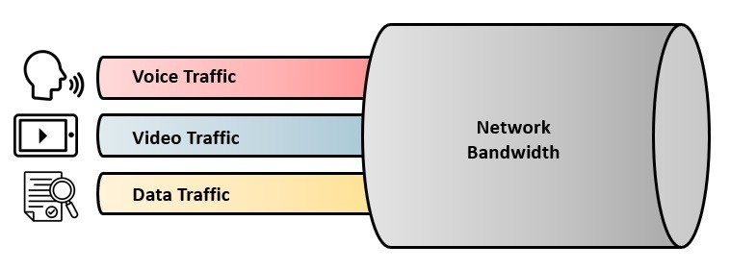
The quality of voice traffic can be affected by the volume of traffic on your internet connection while the call is in progress. However, your choice of a Bandwidth of 220/30 Mbps should not experience this problem.
You use the phone in much the same way for outgoing calls as you always have done but there are subtle differences, like the need to use the area code every time you call a subscriber on the public telephone network and the fact that call waiting is active. Many features previously chargeable by other telephone providers are free when using Voipfone, like advanced voicemail.

Mobile Phone Use – Extension 200

The mobile phone has to be connected to the internet to make or receive calls by either service.
As a general rule of thumb, all outgoing calls to UK numbers should use the Vodafone service because in the main there will be no call charge. Select the service via by pressing on the green phone icon. In most cases the call will be free. If the call is to an overseas number, then use the Voipfone service instead as it will be substantially cheaper. Avoid calling numbers starting with 09.

If the number you want starts with a 1, 3 or # then use the Voipfone service where those calls are free, as would calls to another Voipfone subscriber with a number starting 01, 02, or 03. Avoid calling 07 numbers using Voipfone. The cost of any proposed call using Voipfone can be determined by visiting this site: Voipfone - Call Cost Calculator.

When abroad, use the Voipfone service to call the UK, dialling the number as you would in the UK>

Wireless Phone Use – Extension 201
All calls from any one of the wireless phones, will use the Voipfone service. When in use, an incoming call will ring the other remaining three wireless phones, assuming DND is not set on any individual handset.

Extension to extension dialling
Irrespective of the mobile phone’s geographical location, extension to extension dialling is available.

System Design
The first digit you dial, when using the Voipfone service, routes the call accordingly:
Prefix | Action
0 | To another subscriber on the public telephone network  If that subscriber happens to be a Voipfone subscriber, the call is free
1 | A short code for various services provided by Voipfone, mostly FOC
2 | Connects to another extension number on your local network, FOC
3 | Connects to another subscriber on the Voipfone platform, FOC
9 | Emergency Services
# | Special features and services available to you
* | Commands on your local network

Known Short Codes Used by Service Selected
A softphone has been added to Audrey’s mobile phone 07880 990 906. For all UK calls it is recommended to use the Vodafone service as the majority of calls will normally be free.

When using the wireless phones all outgoing calls will use the Voipfone service where the call rate to 01/02/03 numbers is 1.2 ppm and to 07 number (mobiles) is 8.4 ppm where the cost can be significant for long duration calls. Start such calls using your mobile.

 Vodafone |  Voipfone
999 Emergency Services  112 Emergency Services  101 Police Non-Emergency Number  111 NHS Non-Emergency Number  105 Power Cut Information Line  121 Voicemail  100 Customer Care Line  Activate forward calls to voicemail:  1226 when busy  1228 when not picked up  1211 when busy or not picked up  1213 Deactivate forward all calls | 999 Emergency Services  112 Emergency Services  101 Police Non-Emergency Number  111 NHS Non-Emergency Number  105 Power Cut Information Line  116 999 Missing children helpline  116 111 NSPCC ChildLine  116 123 Samaritans  119 COVID-19 Help Line  123 Gives Day, Date and Time  141 Withhold your number (Not Recommended)  1470 Un-withhold your number  150 Voipfone Customer Services  Your account number is: 30243070  Memorable word: “gibson”  152 Echo test (Quality Call Check)  154 Call Credit Information  155 Should confirm connection OK to Voipfone  159 Report a Banking Scam  See https://stopscamsuk.org.uk/159  1471 Plays back the last incoming number  1571 Voicemail for the extension you are using  1573 Voicemail for Group messages  1995 Music on Hold  ## Transfer the Call  Example: ##01252758123  #0 Starts and stops call recording  These codes only work if phone socket used on router  #01 1WG - Lyla – 01252 724 884  #02 2WG - Richard – 01252 935 434  #03 3WG - Carole – 01252 266 827  #04 4WG - David Bradley – 01252 758 960  #05 Swing Open the WG Gates – 07860 565 543  #06 6WG - Stephen – 01252 279 986  #07 7WG - Terry – 01252 279 331  #08 8WG - Sharyn – 07812 555 746  #09 9WG - Denise – 01252 723 000  #10 10WG – Peter – 01252 727 443  Indicates System Wide Short Codes  Indicates Short Codes created in the router

Cloudscape Connect 0116 274 7360
Access URL: https://www.cloudscapeconnect.com/myaccount/
Account Number: 00009799
Username: AKnight9799
Password: Petal418Tango
Broadband: FTTP 220:30
Identification: Audrey-Knight

Bank Details: Sort-Code: 20-49-17 Account Nr: 13425525
Router Information
Service went live on 14th March, 2025
Router Make: ZYXEL VNG8623-TSOB V5.50 (ABPM.5)C0
Router Address (LAN): 192.168.5.1
Router Address (WAN): https://92.62.1.166:8443 Correct on 25 January 2026
Userid: admin
Password: 8=yQEBMP
Client DHCP Range: 192.168.5.50 ~ 192.168.5.199
Broadband Username: VFP2706622@cloudscape.uk
Broadband Password: gu101fa
Connection Type: PPPoE

Gigaset Base Station S850A-GO
Three wireless phones were installed on 22nd March 2025
URL: 192.168.5.53 IP address is sticky.
Password: 1111

WiFi Setup
Router location in Office - WAN: 92.62.1.166 LAN: 192.168.5.1
Mesh setup, thus credentials for each service the same
2.4 GHz 5 GHz
SSID: Audrey Audrey
Password: Pensioner2025* Pensioner2025*
Mode: WPA3-SAE/WPA2-PSK WPA3-SAE/WPA2-PSK
Channel: (Auto) 8 (Auto) 56
Router Mail Alert (Through provisioning account: 9799)
Captures messages from Router
Router Name: KNIGHT-TEMP
email address: knight-temp@cldmail.co.uk
Password: Route6542020
Server: smtp.cldmail.co.uk
Port: 465 (use SSL)

Router Configuration – To be added
New backup made as the WAN address was changed by Cloudscape on 17th March 2025.
Connected devices seen on the network on 22nd March 2025
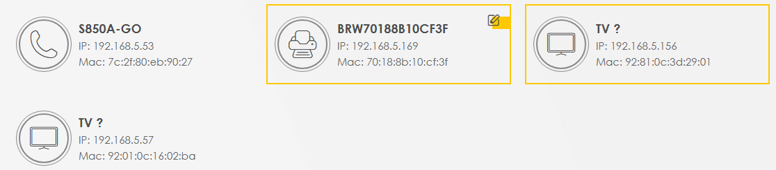
Two devices are thought to be TVs.

Diary of Significant Events

Quite a long time ago I set up an email account of audrey@cldmail.co.uk but I am now advised that this email account has not received any emails for perhaps a month or so. With access to quite a number of Cloudscape accounts, I cannot recall which one I used so as to investigate the matter further. I have a gut feeling that it was set up on a Cloudscape account that has since been closed down. Can you please advise which account was used.

From: CloudScape <info@cloudscapeconnect.co.uk>
Sent: 10 March 2025 11:47
Subject: audrey@cldmail.co.uk
It was set up on Mike Clarkes account. We have not closed it from our side.

From: David Bradley [WG4] <david@wg4.uk>
Sent: Wednesday, March 12, 2025 4:07 PM
Subject: Change of telephone number
Audrey has left BT in favour of Cloudscape/Voipfone for her broadband and digital voice services. As a consequence, would you please change the number in the security consoles for the WG Gate and the Foyer Door to apartments 2-5.The new number is 056 0368 4306.

With regards to Audrey’s email address of audrey@cldmail.co.uk it appears that Mike Clark is the administrator of this account. Would he kindly relinquish this control and pass it back to Cloudscape so that Audrey may be the administrator.

Email request to change a number in the console units rejected. Have to put in a maintenance request!

From: Mike Clark <mc@mphem.co.uk>
Sent: 12 March 2025 17:03
I have no connection whatsoever with Audrey's email account. I wouldn't even know how to arrange being an administrator.

Advanced payments made to Cloudscape:
12/03/2025 Connection Fee £60.00
13/03/2025 Ordered Router £60.00 Delivered 18th March 2025

12/03/2025 Call Deposit of £5 made to Voipfone.

On 13/03/2025 09:19, Voipfone Administration wrote:
You can ignore that email, you have already paid the outstanding fees for the services that are now on this account with the admin fees that were added so there is nothing outstanding.

On 13/03/2025 10:19, Voipfone Porting Department wrote:
Your porting request for number 01252712022 has been accepted and due
to go ahead on 19/03/2025.

On 14/03/2025, MPHEM put the number 056 0368 4306 into the two security consols, WG Gate and The Foyer Doors to apartments #2-#5; a test showed that Audrey’s mobile rang and it would have also rung the wireless/desktop phone(s) if installed.

From: David Bradley <david@cyberpictures.net>
Sent: 17 March 2025 06:24
Openreach has moved very swiftly in moving the FTTP service over from BT to Cloudscape even before the router has arrived! Not a problem as an unloved router of mine is temporarily being used.

The digital voice number has been successfully ported over to Voipfone and is due to go live on Wednesday.

She will ultimately loose her BT email address and the plan is to use your paid for service using a domain name that is available for Cloudscape to be the registrar. A separate email on this will follow today. It is a .uk domain name.

As a stop gap measure, we wish to use the email address of audrey@cldmail.co.uk which was working OK in her Outlook until recently. For reasons that are unclear, that email address is controlled by Mike Clark who denies that he knows anything about that. Can you possibly sort this matter out and move that email account over to Audrey’s account with you?

From: CloudScape <info@cloudscapeconnect.co.uk>
Sent: 17 March 2025 09:55
I cannot just move an email that you added to Mikes account without his consent due to data protection issues. I will contact him to see if he will give authorisation for me to move it over to Audrey.
17/03/2025. A fault was found with the ultrafast broadband service necessitating a change of WAN address.

On 19/03/2025 the first payment of £3.60 is payable for 01252 712 022 and it becomes the primary number on that day. Renewal of 01252 279 205 will be declined on 11/04/2025.

On 20/03/2025 a cancellation request for the temporary number made. Also, confirmation received from Voipfone that our porting request for phone number 01252712022 has been completed and the number is now active. Emergency services registration made.
Voice 01252279205 11/04/2025 Cancelled

Speed Test Result on date shown
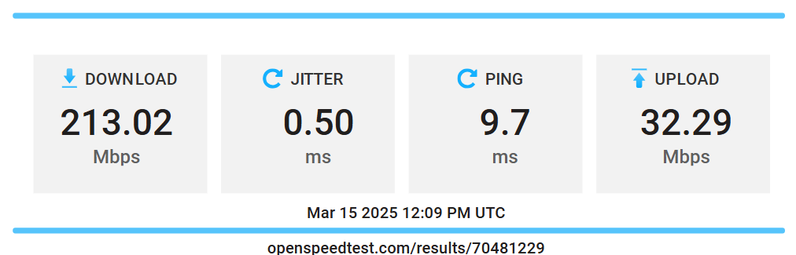

Recovery of the email account audrey@cldmail.co.uk from Mike Clark
The email account audrey@cldmail.co.uk is now under Audrey’s control. Unfortunately, the act of deleting the account by Mike Clark and its recreation under Audrey’s account, has resulted in a clean sheet with all historical and unread emails lost forever. Cloudscape was involved to force Mike Clark to relinquish control of the account. The prick deleted the account rather than allowing Cloudscape just to move it to her account, which would have brought across all the emails stored.

Emails are now arriving in this account as seen via webmail.

This email account is now pointless in view of other options available.

Access URL: https://webmail.cldmail.co.uk

Configuration Information for Outlook
Inbound Server (POP3):
Server: mail.cldmail.co.uk
Port: 995 use SSL
Username: audrey@cldmail.co.uk
Password: CrystalPalace654*
Outbound Server (SMTP):
The outbound mail server requires authentication.
Server: smtp.cldmail.co.uk
Port: 465 use SSL or SSL/TLS
Username: audrey@cldmail.co.uk
Password: CrystalPalace654*

Email account audrey@knightshome.uk
£5+VAT for the first year with optional renewal in subsequent years

Webmail Access URL: https://mail.hostedemail.com

Configuration Information for Outlook
Inbound Server (IMAP):
Server: mail.hostedemail.com
Port: 993 with SSL/TLS
Username: audrey@knightshome.uk
Password: Tut9BDh57!5QCvW
Outbound Server (SMTP):
The outbound mail server requires authentication.
Server: smtp.cldmail.co.uk
Port: 465 with SSL/TLS
Username: audrey@knightshome.uk
Password: Tut9BDh57!5QCvW

