Work Sheet to go over to Fixed IP
Currently the DrayTek router is a device hanging off the Virgin router to allow remote configuration to take place. To access this device use WAN address:
http:// 213.107.197.87:8088/ However, being a dynamically obtained, it changes frequently.
Userid: admin with Password: elstead2008 is used for both the DrayTek and Virgin routers
To access the Virgin router remotely use: http://213.107.197.87:8080/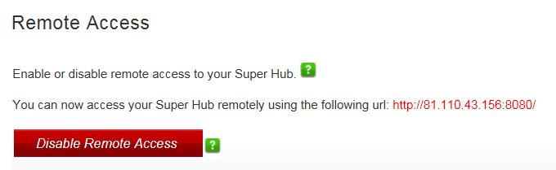
Not that the port number appears to un-selectable.
Being a live system the following devices are up and running hanging off the Virgin router: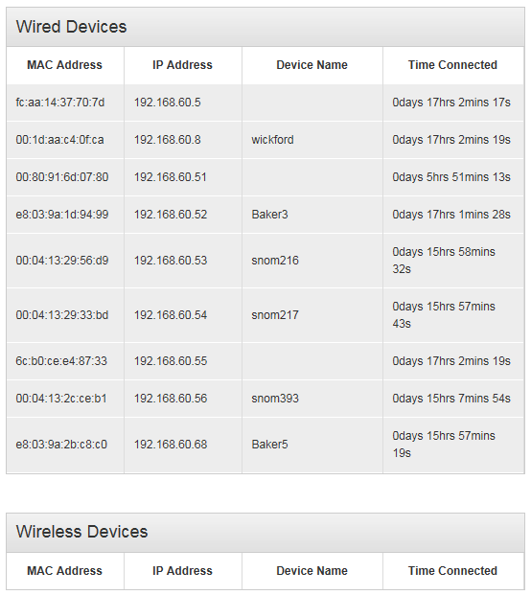Of particular note are:
192.168.60.5 – Fixed IP used as a document store which everyone maps a drive to.
192.168.60.8 – Fixed IP to provide temporary access to the DrayTek unit to configure it.
192.168.60.51 – Network printer. Not being on site I was unable to give it a fixed IP address so I have bound IP to MAC.I haven’t worked out why device 192.168.60.55 appears !! I guess it is the network switch.
- Ring Virgin to activate the fixed IP addresses.
- Required settings in Virgin Modem:
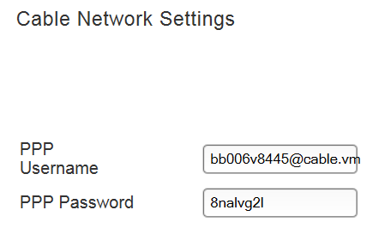
PPP is Password as shown.
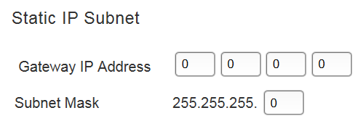
When fixed IP is switched on there is some doubt if we need to enter here:
213.105.209.217 with 248
- Home page states:
You are currently in Router Mode.
To change to Modem Mode, go to the Super Hub Settings section.
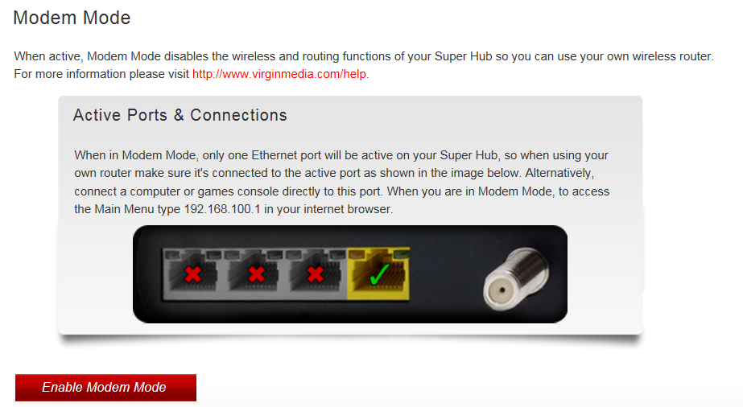
a) Install Ethernet cable between the green ticked socket on the Virgin router to the WAN socket on the DrayTek unit.
b) Enable Modem Mode?

Current DrayTek Settings
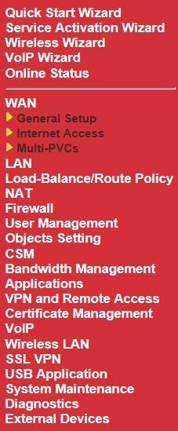

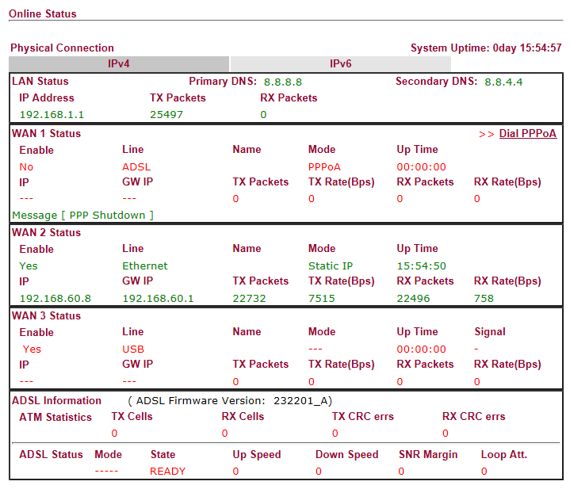Image 1
The WAN 2 Status is a temporary state to enable remote configuration of router.
Entries will be different when the Virgin router is converted to modem mode.
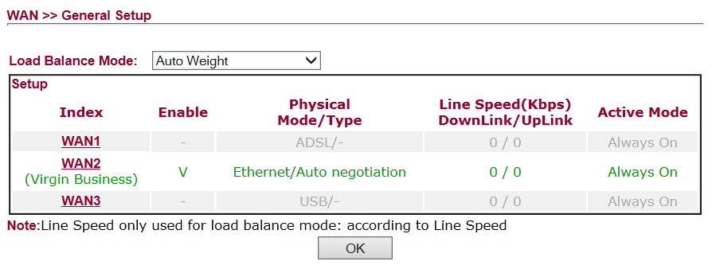Image 2

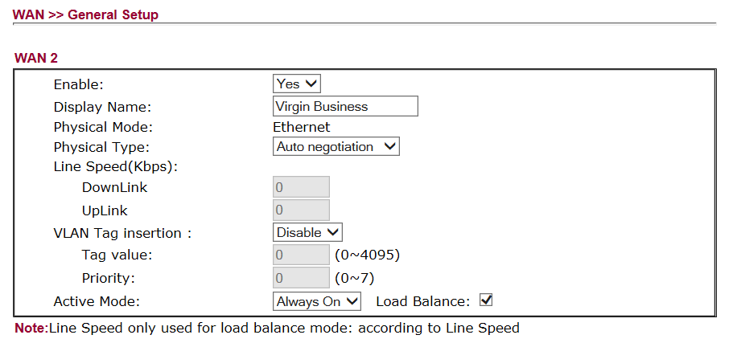Image 3
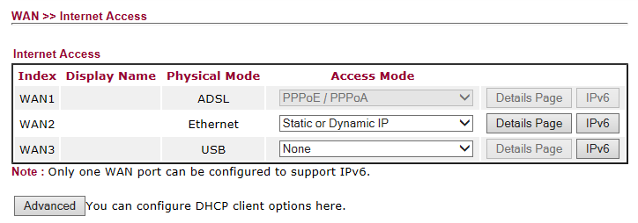Image 4
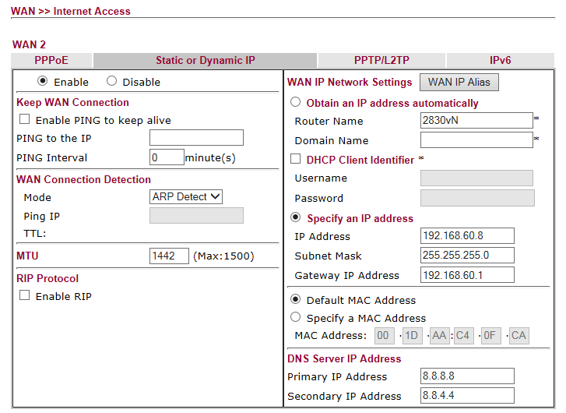Image 5
IP Address: Change 192.168.60.8 to 213.105.209.218
Subnet Mask: Change 255.255.255.0 to 255.255.255.248
Gateway IP Address Change 192.168.60.1 to 213.105.209.217
MTU Size: 1500?

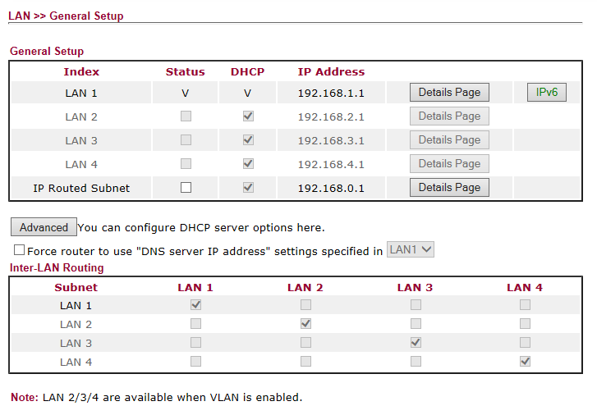Image 6
LAN IP Address needs changing

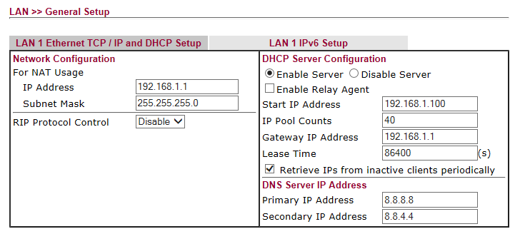
Image 7
IP Address: Change 192.168.1.1 to 192.168.60.1
Subnet Mask: 255.255.255.0
Start IP address: Change 192.168.1.100 to 192.168.60.50
Pool Size: Change 40 to 50
Gateway IP Address Change 192.168.1.1 to 192.168.60.1

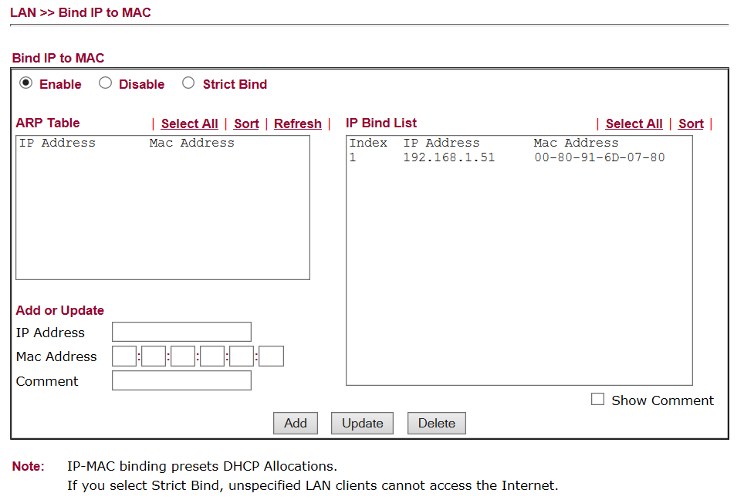Image 8
Change 192.168.1.51 to 192.168.60.51
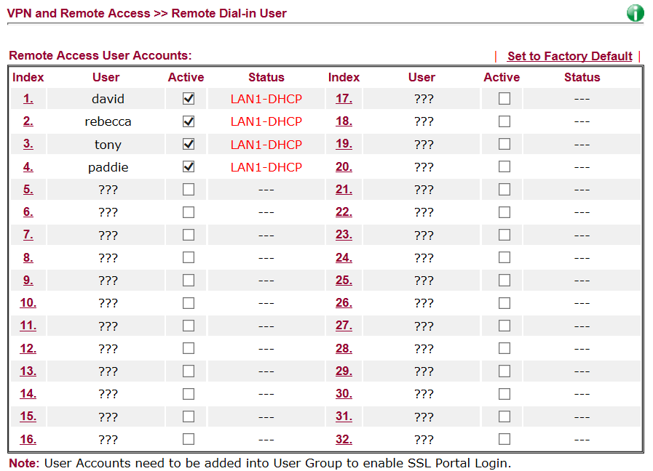 Image 9
Password for all accounts currently set to elstead2008
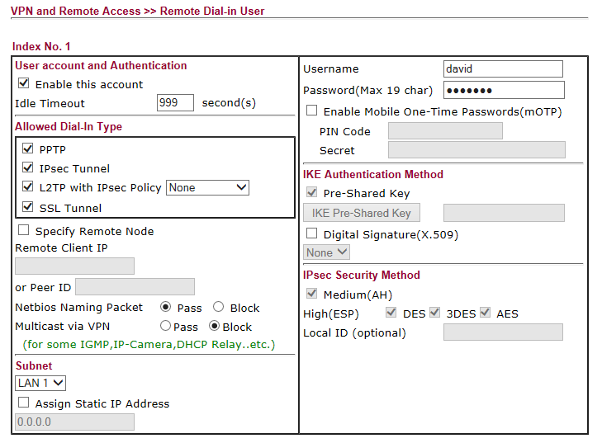Image 10
Perhaps I should only select PPTP ??
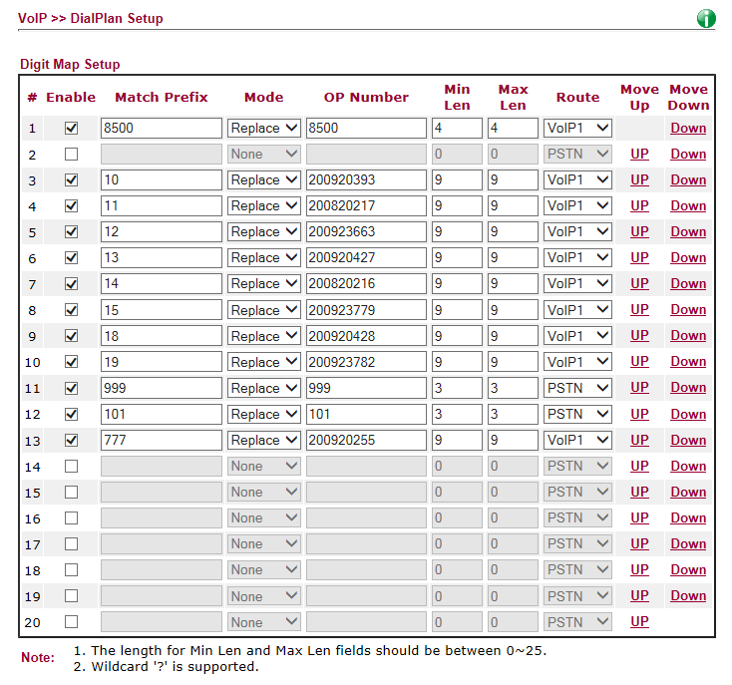
Image 11
All OK here
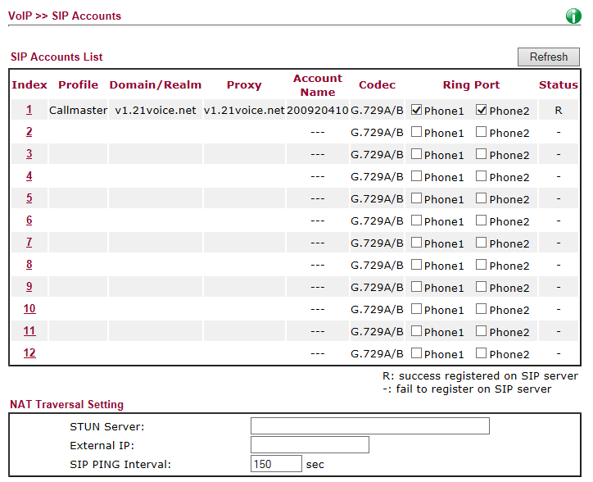
Image 12

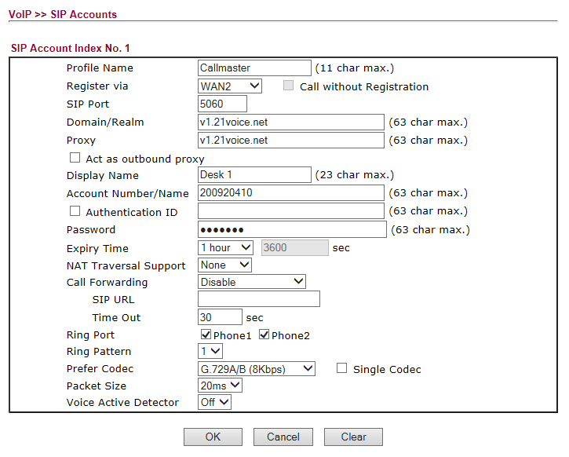Image 13

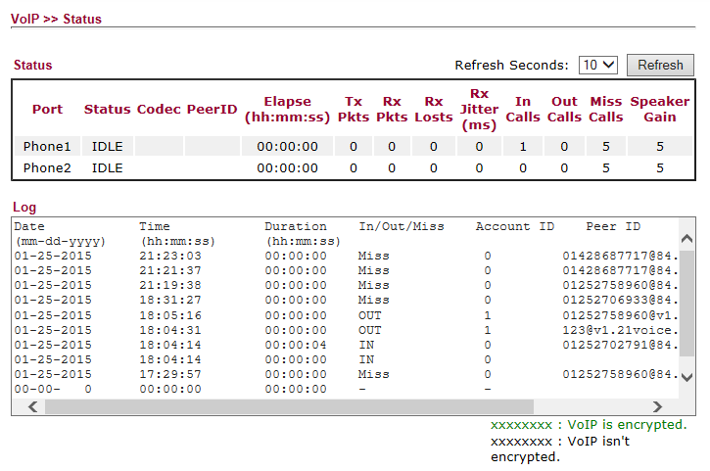Image 14
Why do some calls made have zero duration logged?

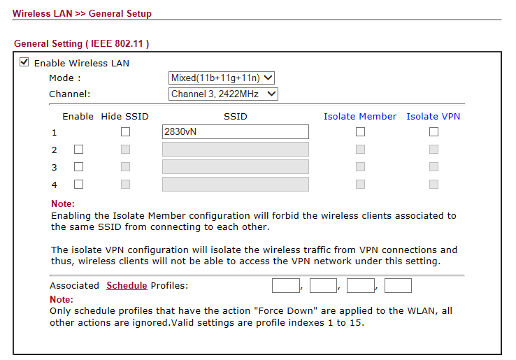Image 15
Final entries to be made here of SSIDs
Wiseman-Wingate
WW-Guest

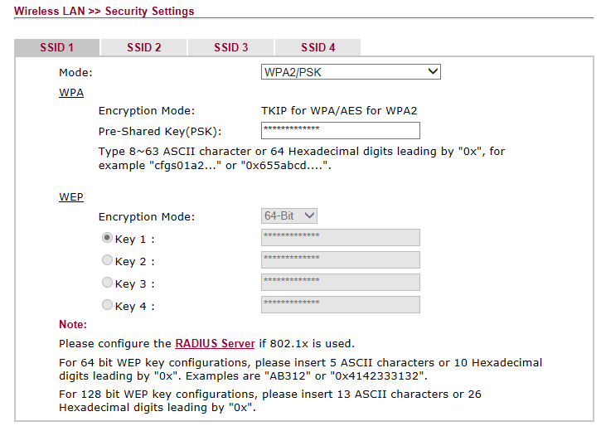Image 16

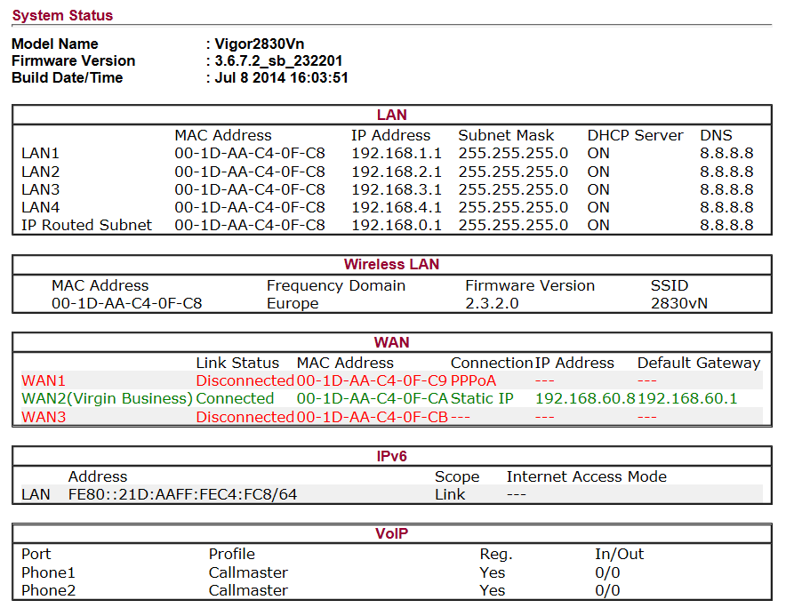Image 17
The WAN information reflects the current status which will change.

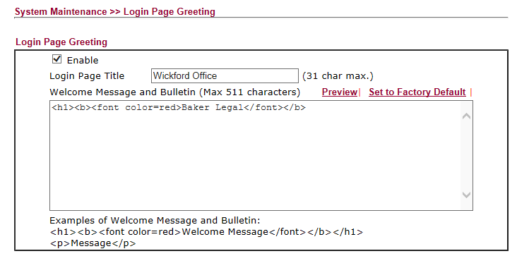
Image 18

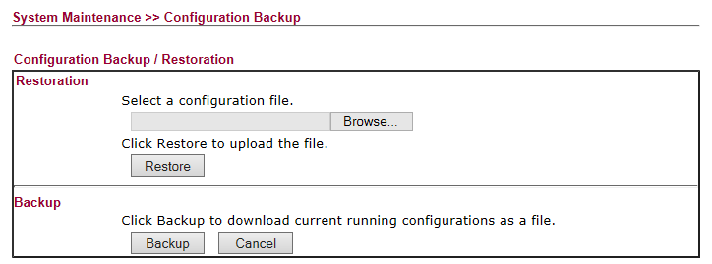Image 19
Back up made
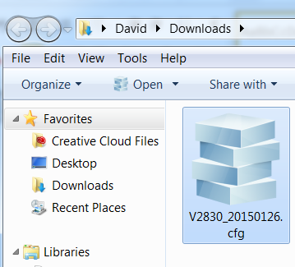
Image 20
Result

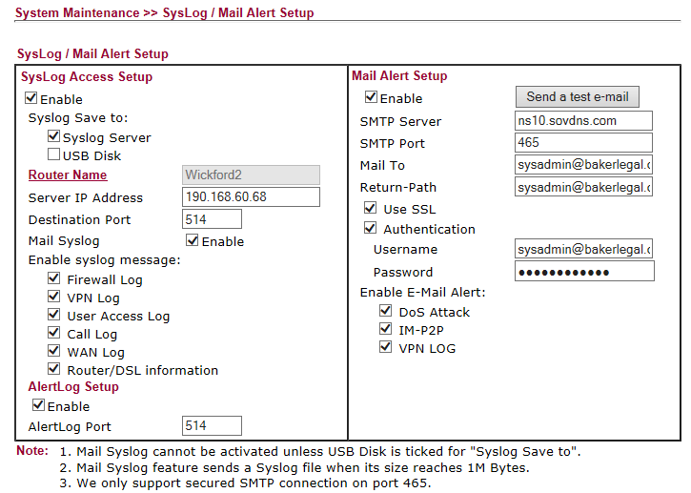Image 21
Image 22
Seems to work
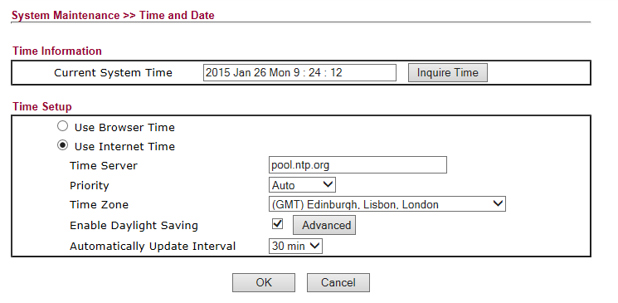Image 23

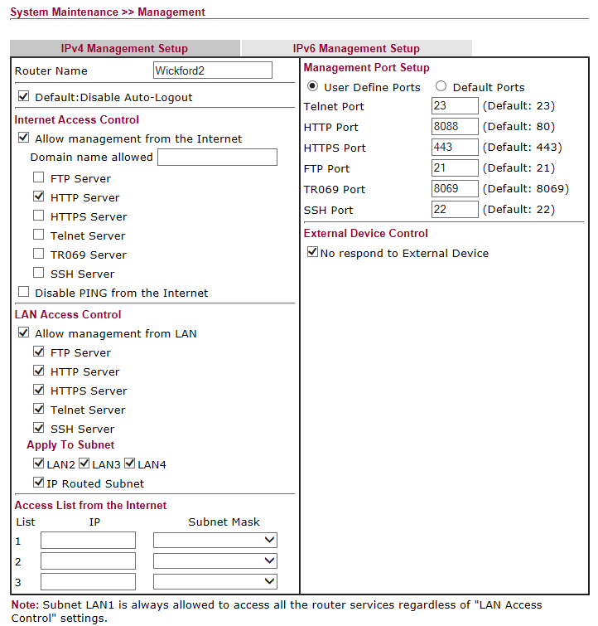Image 24
Note the use of port 8088

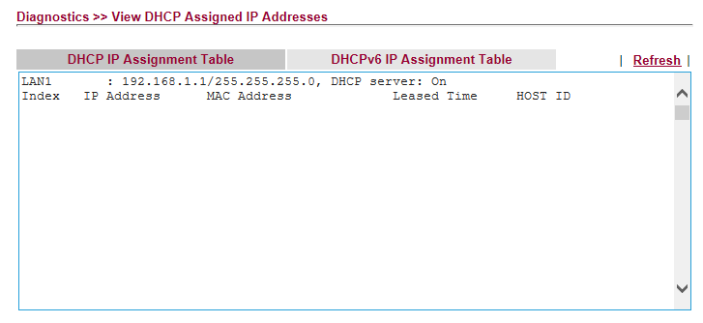Image 25
Nothing connect yet.
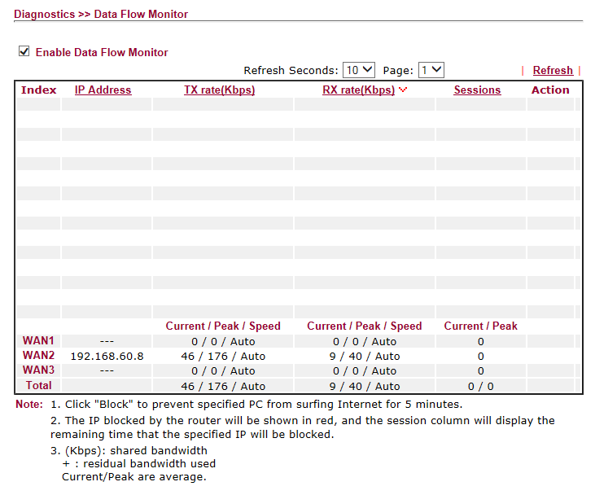Image 26

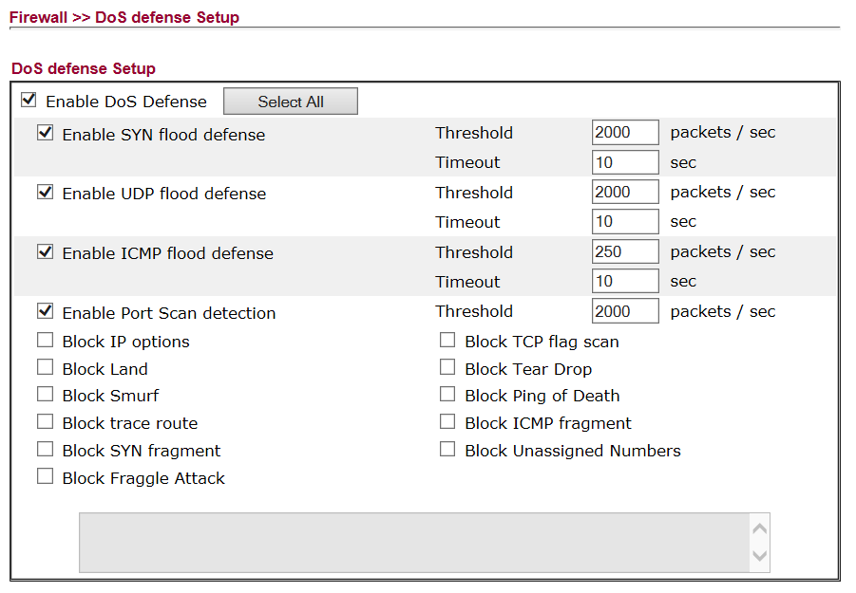 Image 27
Further fine tuning to follow.

First we contact Virgin to activate the fixed IP addresses in the range 213.105.209.216 to 223 – Immediately Internet access will be lost.
So I logon onto the Virgin router and head for the Advanced Settings >> Cable Network Settings to ensure my username and password are present. Then onto Static IP Subnet to enter an IP address of 213.105.209.218 with the Subnet Mask of 255.255.255.248
The Virgin router reboots. So we login again to enable Modem Mode and I guess the Virgin Router will reboot once more.
Then I propose to daisy chain from the Ethernet socket closest to the coaxial connection to the WAN2 port of my Vigor 2830vN.
Next, I connect my laptop to a LAN port of the Vigor router and use ipconfig to discover the IP Gateway address, which I am expecting to be the default of 192.168.1.1, to enable me to logon onto the Vigor.
Logon to the Vigor and head for WAN >> General Setup where WAN2 can be selected. Here we make sure that WAN 2 is enabled and we enter a display Name of Virgin Business.
Moving onto WAN >> Internet Access. For WAN2 we select the Access Mode of Static or Dynamic IP and go to the details page.
From the Tabs on the details page, select Static or Dynamic IP and enable the service. Not sure whether to change the MTU from 1442 to 1500 so will leave as is for now. On the other side of that page select Specify an IP address with:
IP Address: Change 192.168.60.8 >> 213.105.209.218
Subnet Mask: Change 255.255.255.0 >> 255.255.255.248
Gateway IP Address Change 192.168.60.1 >> 213.105.209.217
DNS settings to be 194.168.4.123 and 194.168.8.123
Following a reboot, I am hoping that we will have Internet access and other features of the Vigor can then be configured.
Should there be a need to logon onto the Virgin superhub what LAN address would I use? After all I may have to revert to Router Mode if I can't see the Internet from the Vigor router.

