BT FTTC provision:
Contact email address: info@mercury-free.co.uk
Order Number: BTMYR6131-2
holisticdental@btconnect.com Mercury55
Account number VP30391370
BB line: 01252 820003
Main number: 01252 820004
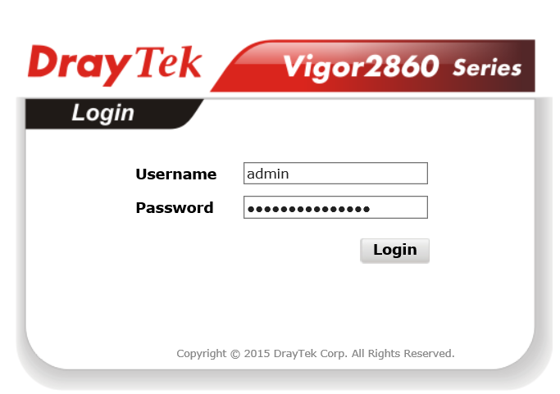
WAN IP: 81.148.114.154 [Friday, 27 May 2016]
Access: http://10.0.0.10:8080/
Draytek Username: admin Password: 5harttoothbrush
BT Userid: B349344@hg7.btclick.com Password: CApup170914
Model Name: Vigor2860n
Firmware Version: 3.8.2_VT1
Build Date/Time: Oct 29 2015 16:08:34
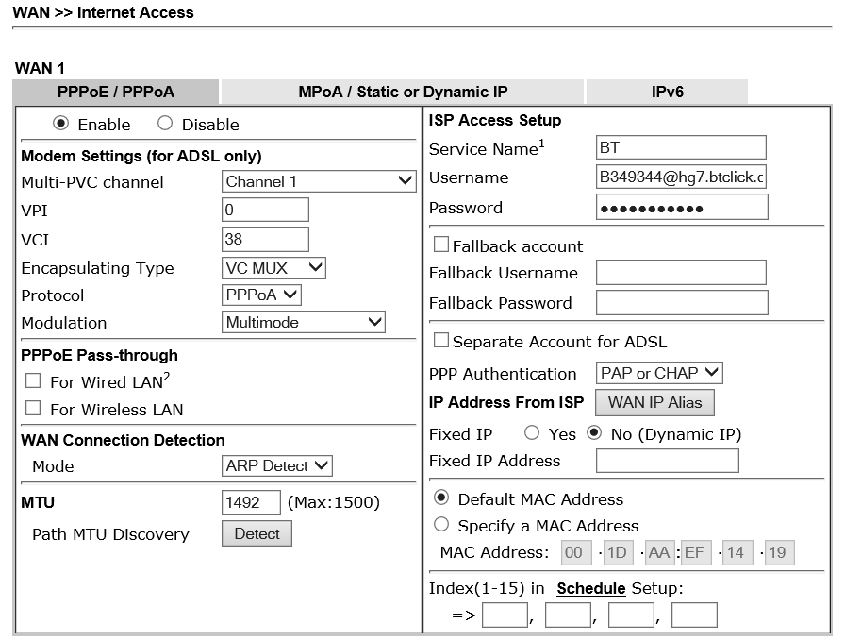
The above screen dump was created at 27/05/2016 22:24 where it can be seen that a Dynamic IP address was being called for and this was issued at approximately 7:30pm being 81.148.114.154 presumable replacing 81.135.175.91 at that time.
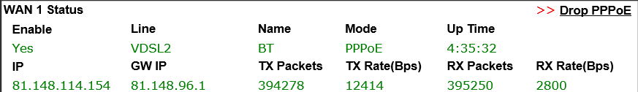
As BT have pointed out, the DrayTek configuration page should have stated a fixed IP address from the range 81.137.89.225 to 81.137.89.229 – This simple change can be carried out remotely but might fail in the process and so best done on site. It was assumed that GIANT were nipping in to your practice during the afternoon to carry out this simple task but clearly they have not done so.
You state there is a need to have VPN access to the practice over this bank holiday weekend and we are quite happy to resolve this issue for you without delay. Access to the practice would be best, but if needs must then the wireless signal from the router should reach out into the street and could therefor be picked picked up on a laptop.
We would use a single IP address of 81.137.89.225 from the range allocated by BT and following a router reboot should give Internet access on that WAN address; if it doesn’t then we would revert to the former setup. It would be preferred that GIANT carries out this work as there may be unforseen implications with some of your devices on the internal network which we would be unable to resolve, in theory there shouldn’t be but there is that risk.
It is just possible that the router could be remotely re-configured without problems and is worth a try before an exterior site visit. Let me know your thoughts.

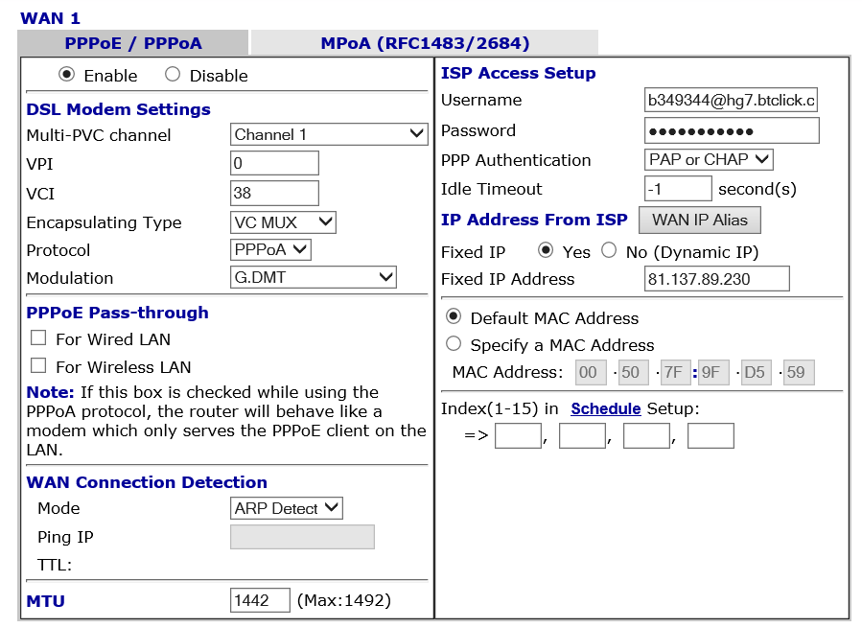
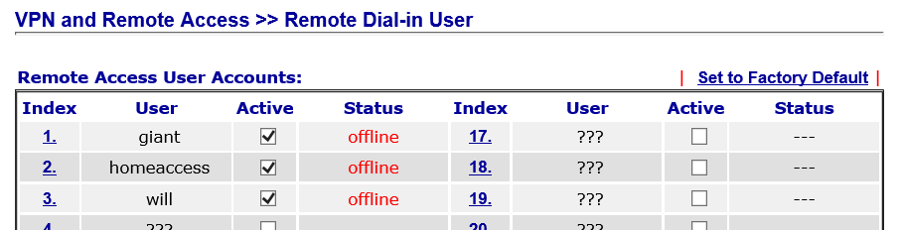
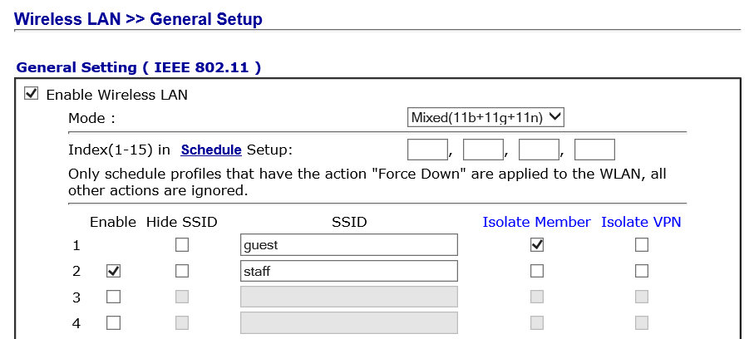
WiFi guest password: holisticdental WiFi staff password: To be determined
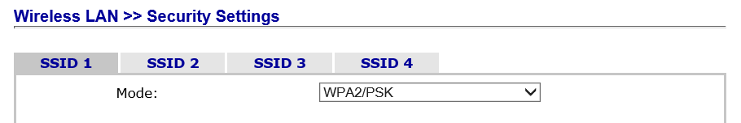
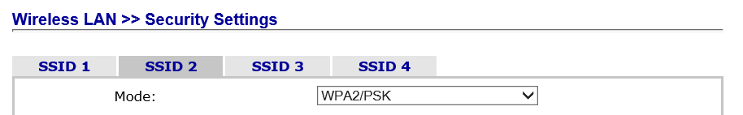
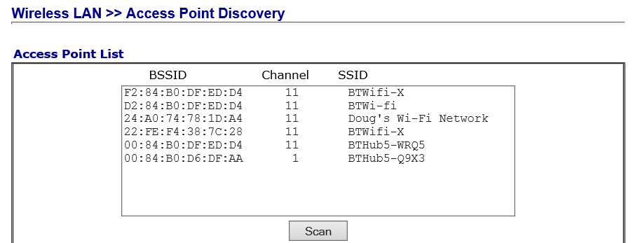
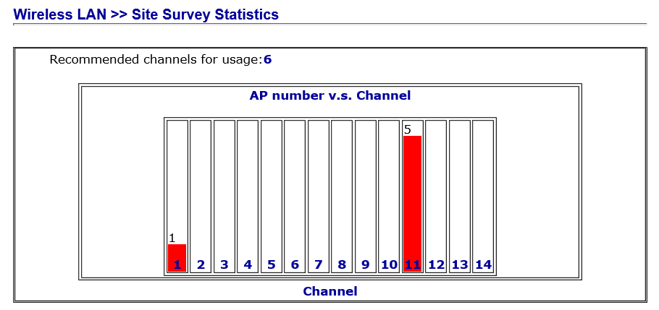

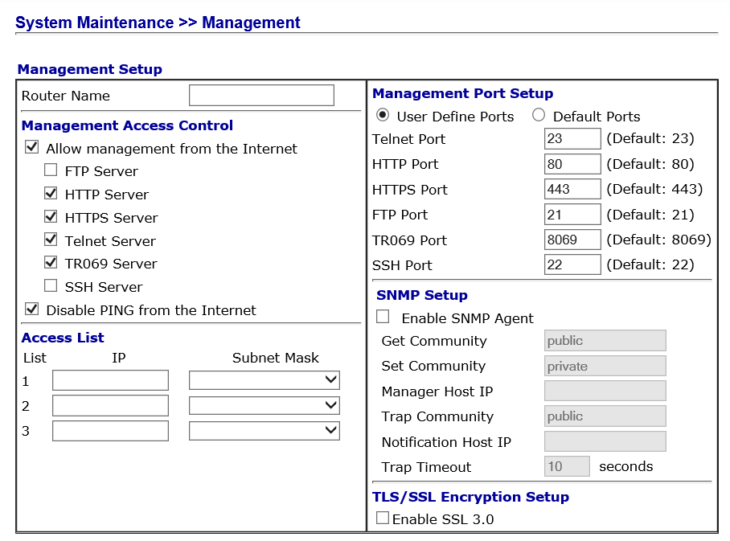
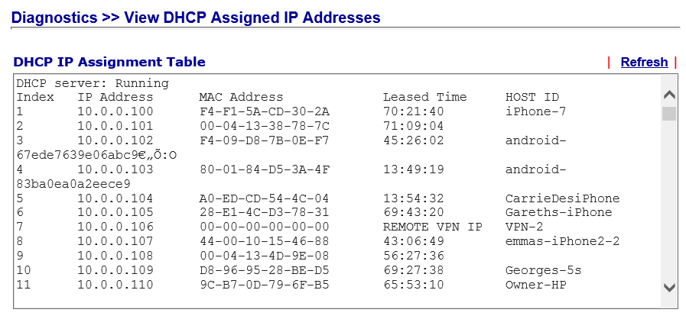

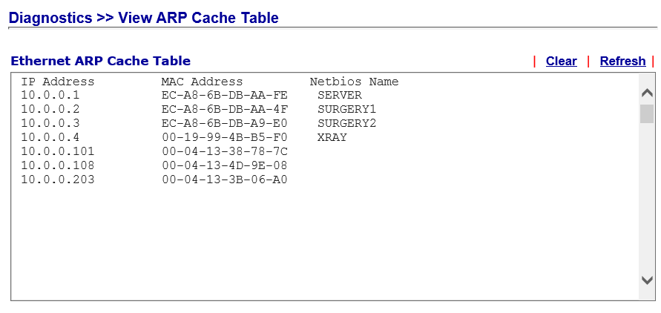

Running their own mail server in the Cloud

VoIP PHONES
200923867 uses DHCP with PC port in use
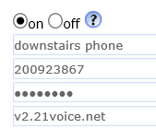
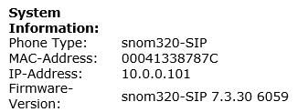

200923763 uses DHCP with PC port in use
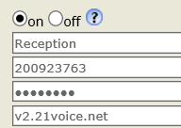
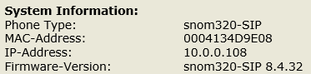

200923764 has a fixed IP with PC port in use
