Gordon Weston

Technology Setup at 3 MPH
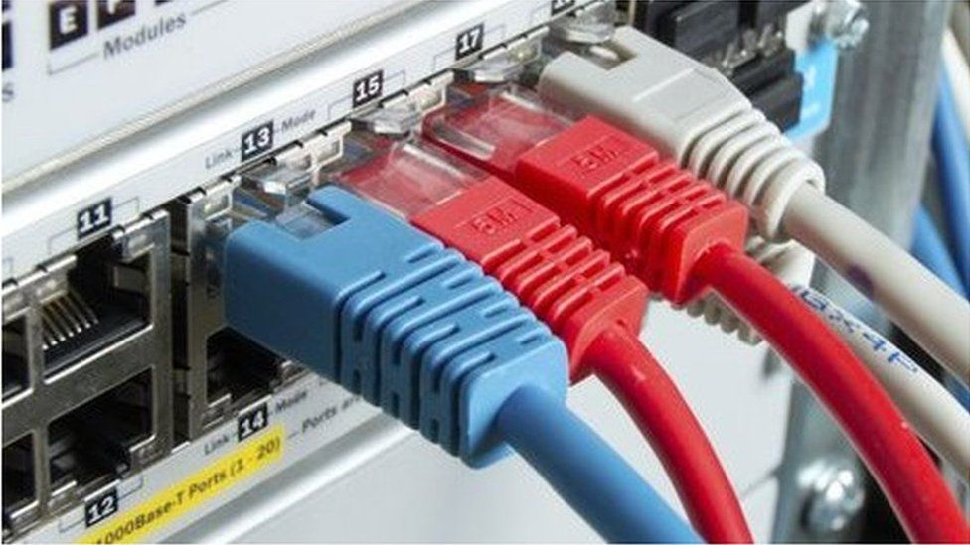
This page is blank

Technology Setup at 3MPH
Contact numbers: 01252 704111 – 07850 276688
Contact email: gw@westonmail.co.uk

Cloudscape Connect FTTP Broadband Service - 0116 274 7360 (Help Desk)
Router Make: ZYXEL VNG8623-TSOB V5.50 (ABPM.5)C0
Router Address: 192.168.103.1:8080
WAN Address: 92.62.0.141:8080
Router Userid: admin
Router Password: Elstead2008*
Client DHCP Range: 192.168.103.30 ~ 192.168.103.70
Broadband Username: VFP1881697@cloudscape.uk
Broadband Password: gu101fh
Broadband Tier Selected: 220/30 Mbps (Speed Test 210 Mbps obtained via WiFi)
Installation Date: 12th Dec 2022 (Connection Made)

SSID [2.5 GHz only]: Name: Penthouse Password: Route6302020*

Access URL: https://www.cloudscapeconnect.com/myaccount/
Account Number: 00009741
Username: Weston9741G
Password: Pen9742Letter

Cloudscape Connect email Service
Access URL: https://webmail.cldmail.co.uk/
email server: mail.cldmail.co.uk
email address/username: penthouse@cldmail.co.uk
Password: Route6542020
The mobile number 447836547472 has been registered with support. To raise support, w text 'help' followed by the message to 07786 209609 and an engineer will call you back. e.g.: help my internet is down

Voipfone Credentials - 150 or 020 7043 5555 (Help Desk)
Access URL: https://my.voipfone.co.uk/#!/dashboard
Registered email address: penthouse@cldmail.co.uk
Logon password: Route612^
Memorable word: Gordon Hint: Landlord
Account Number: 30233507
VoIP Password:

Voipfone supplied number: To be purchased when required
Voipfone free provisioning number: 056 0366 6971

Summary of financial commitment with FTTP [VAT included]
Broadband from Cloudscape: £xx.xx pm Broadband @ 220/30 Mbps
Services from Voipfone: £xx.xx pm Digital Voice facilities
Call Deposit not made: £0.00 Topped up when credit < £2:00

Configuration information for devices
Registrar: sip.voipfone.net
Account: 30233507*200 Password: 082216 Voipfone softphone
Account: 30233507*201 Password: 584558 Port 1 of Router for 01252 279 612
Voicemail delivery email address: penthouse@cldmail.co.uk
Personal Greeting not recorded
Previous Account: 30224761*201 owned by Tazmina Ellis removed from router
.

Making Outgoing Calls
You have a Digital Voice service from Voipfone by connecting your analogue telephone to Phone Port #1 of the router. Instead of being connected to the Farnham telephone exchange by an exclusive pair of copper wires, you are now utilising your broadband connection to a server located in London that supports voice traffic.
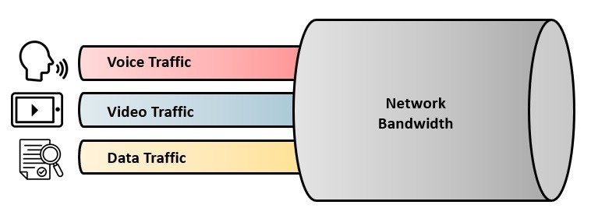
The quality of voice traffic can be affected by the volume of traffic on your internet connection while the call is in progress. However, your choice of a bandwidth of 220/30 Mbps should not experience this problem.
You use the phone in much the same way for outgoing calls as you always have done but there are subtle differences, like the need to use the area code every time you call a subscriber on the public telephone network and the fact that call waiting is active. Many features previously chargeable by other telephone providers are free when using Voipfone, like advanced voicemail.

The first digit you dial, routes the call accordingly:
Prefix | Action
0 | To another subscriber on the public telephone network  If that subscriber happens to be a Voipfone subscriber, the call is free
1 | A short code for various services provided by Voipfone, mostly FOC (See Page 5)
2 | Connects to another extension number on your local network, FOC
3 | Connects to another subscriber on the Voipfone platform, FOC
9 | Emergency Services
# | Special features and services available to you (See Page 5)
* | Commands on your local network (See Page 5)
Call Rates
These can be found at: https://www.voipfone.co.uk/prices

About Voicemail vs Answerphone
You can choose between using the answerphone facilities on your phone or the Voicemail service from Voipfone. The latter is to be recommended. A single extension number attracts a monthly fee of £1.80.

Netgear WN3000RPv3
penthouse@cldmail.co.uk
pickle2024

born: croydon
farther: William

penthouse1 wpa-psk
Route6542024*

Short Codes for Voipfone Users
Unless stated otherwise, all calls made using a short code are free

112 Emergency Services
999 Emergency Services
101 Police Non-Emergency Number
111 NHS Non-Emergency Number
105 Power Cut Information Line
116 999 Missing children helpline
116 111 NSPCC ChildLine
116 123 Samaritans
118 797 Connects to BT's Directory Enquiry services (Very expensive to use)
119 COVID-19 Help Line (Also used to make appointments)
123 Gives Day, Date and Time
141 Withhold your number (If you must – Not Recommended)
1470 Un-withhold your number
150 Voipfone Customer Services (Supply credentials as shown below).
Your account number is: 30224761 The memorable word is: “Gordon”
152 Echo test. Shows how good your connection to Voipfone is.
154 A recording of call credit left to use before top-up is necessary
155 Confirms that you have set up your phone correctly
159 Report a Banking Scam (See https://stopscamsuk.org.uk/159)
166 Voipfone Anti-Sales call tool (Optional monthly fee payable)
1280 Carrier pre-select disconnect from Voipfone (Only available to BT subscribers with pre-registration required)
1471 Plays back the last incoming number
1571 Voicemail for the extension you are using
1572 Voicemail for the Master Account (Used where your account does not have extension numbers)
1573 Voicemail for Group messages (Input the Group Number of Interest)
1995 Music on Hold (Listen to what is playing now)

** For business environments to pick up a call from another extension that is ringing (Usage Example: **205)
Also, codes **11 and **12 are router specific to switch to another port (Rare to Use)
## Transfer the call (Example: Dial ##01252758123 and then hang up - Call charges may apply)
#0 Starts and stops call recording (charged at 2.5p pm). Log into your account to listen to any messages left.
#1 Places call on hold. Use # to cancel. (This is NOT the same as DND)



Short Codes available from phones plugged into the ZYXEL VNG8623 router
These Speed Dial Numbers are setup in the router at: VoIP >>> Call Rule

#01 1MH - Jim Rice - 07594340509
#02 2MH - Annie Bishop - 01252279323
#03 8WG - Sharyn Fitzpatrick-Nash - 01252279121
#04 4WG - David Bradley - 01252758960
#05 10WG - Peter Clappison - 01252727443
#06 Oliver Penfold [Gardner] - 07747749270
#07 Cloudscape Connect - 01162747360
#08 Voipfone Help Desk - 02070435555
#09 MPHEM Office - 30208619*200
#10 Swing Open the MH Gates - 07430525930
Security Console codes available when engaged in a conversation

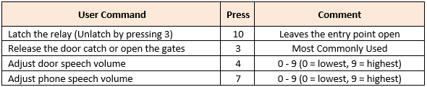

Settings in Gate Security Console as at 12/10/2022
MH Gates  07430 525 930 |  | Entry Code  5678 Enter |  |  | GU10 1FH
nnn  [Circuit] | Name | Appt | Primary  STN | Divert  STD / STE | Dial in Access  STR | Fob Issue  FOB
003 | Tazmina Ellis | 3MH | 05603 648 500 | See note below | . | .

Settings in Moor Park House Security Console as at 12/10/2022
MH Foyer  07430 527 654 |  |  | Entry Code  2121 Enter |  |  |  |  | GU10 1FH
nnn  [Circuit] | Name | Appt |  | Primary  STN | Divert  STD / STE |  | Dial in Access  STR |  | Fob Issue  FOB
003 | Tazmina Ellis | 3MH |  | 05603 648 500 | See note below |  | . |  | .

Note: The primary number rings simultaneously the house phone and Tazmina’s mobile. No need for a divert facility.

Voipfone setup
Installation URL: https://www.voipfone.co.uk/free.php?free=261740
Service | Details | Monthly  Fee
Voice | 01252 279231 | £3.00
Voice | 05603 648500 | £0.00
Extension 200 | Tazmina Mobile | £1.50
Extension 201 | Home Phone | £1.50
Extension 202 |  | £1.50
Extension Group | 1 | £1.00
 | Sum | £8.50
 | VAT | £1.70
 | Total | £10.20

VoIP Settings in Router

SIP Account tab:

SIP Service Provider tab:

Phone Device tab:

Region tab:
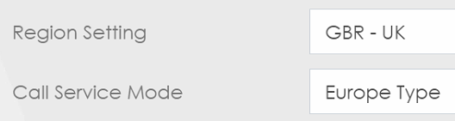

Call Rule:
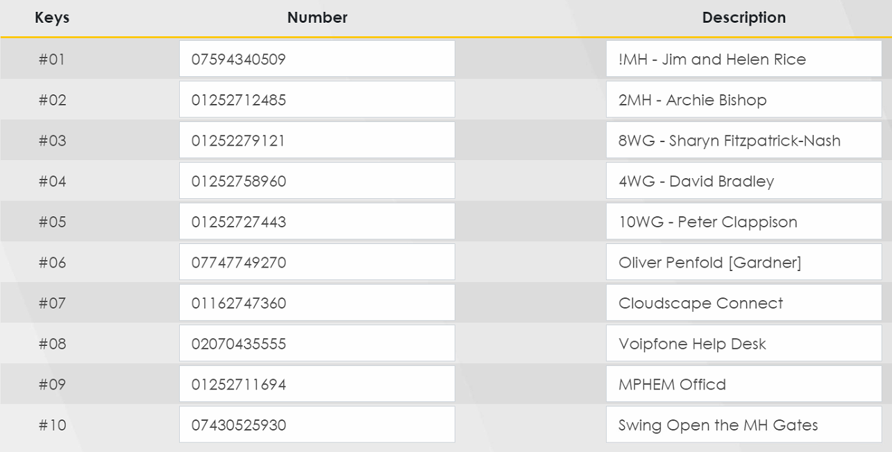

VoIP Status as at 14/12/22 at 11:23
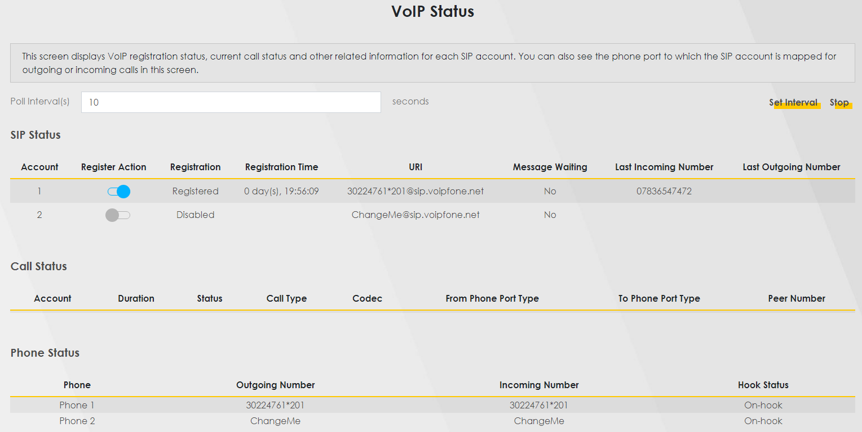

User Account

Remote Management
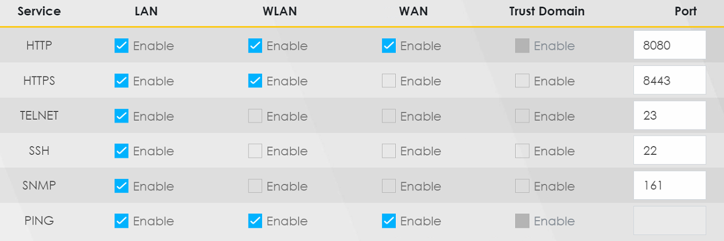

Time Setting
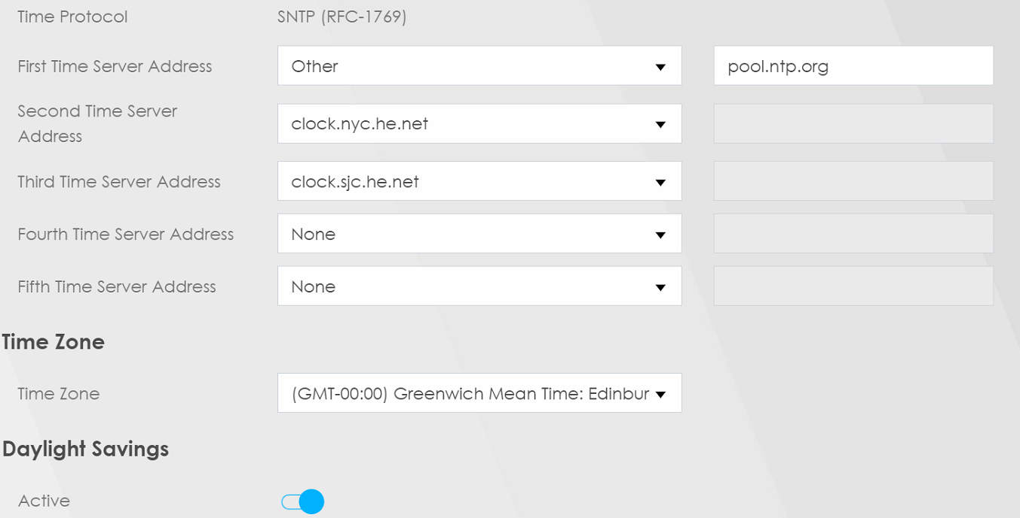

Lift Keys

This is the key needed to hold the lift doors open. £11.95 inc VAT each.
https://www.replacementkeys.co.uk/kaba-300-key.html?keycode=300

