Computer Installation and Telephone Services Fact Sheet
Company: JD Motors Version: Thursday, 20 September 2018
David Drew Limited t/a JD Motors, Registered in England & Wales Registration Number: 08229200
Registered Office: Unit 31, Base Point Business Centre, Winnall Valley Road, Winchester, Hampshire, SO23 0LD
Bank details: HSBC, Sort code: 402105 Account number: 51742973

Alton Address:
1 Rowan Industrial Park
Mill Lane
Alton
Hampshire
GU34 2NQ

Rushmoor Address:
Rushmoor Garage
Tilford Road
Rushmoor
Farnham
Surrey
GU10 2EP

VAT Number: GB413322794

Alton: 01420 544644
Alton [Not diverted]: 01420 544818
Alton Fax: 01420 448684 [Fax to Email - reception@jd-motors.co.uk **]
Alton Alarm: 01420 544654
Alton: Needed? 01420 89768
Vodafone Broadband: 01420 543937
SoConnect:

Rushmoor Rear Office: 01252 792103
Rushmoor Front Office: 01252 793608
Rushmoor Workshop: 01252 790940
Rushmoor Fax: 01252 758724 [Fax to Email – reception@jd-motors.co.uk **]

** reception@jd-motors.co.uk >>> Box Trapper circulation list

Web Page: http://www.jd-motors.co.uk and www.jdmotors.net

Connected Devices seen at Alton. Pool Table = 50

Business Devices
IP Address MAC Address HOST ID USER Logon Password
192.168.83.2 00-1D-AA-54-04-39 Router --- admin farnham2020
192.168.83.20 00-80-91-70-64-24 MFP11601437 --- admin 123456
192.168.83.34 04-F1-28-22-43-9F
192.168.83.37 54-E1-40-1C-74-4F 82170961 [Credit Card Machine Office]
192.168.83.43 30-05-5C-B3-5F-13 BRN30055CB35F13 [Tyre Bay Printer] route654
192.168.83.39 CC-2F-71-02-BA-11 Invicta
192.168.83.40 CC-9F-7A-22-40-2A
192.168.83.45 2C-30-33-62-C3-05 EX6000 AP --- david@jd-motors.co.uk route654
192.168.83.46 A0-C5-89-EB-14-EB Daf Georgie Georgie route654
192.168.83.47 CC-9F-7A-22-2F-40
192.168.83.48 48-2A-E3-09-B0-1D Humber Jasmine Jasmine recovery1
192.168.83.51 18-68-CB-8A-10-EA HIKVISION CCTV Required Required
192.168.83.52 54-E1-40-1D-2B-23 82236736 [Credit Card Machine Tyre Bay]
192.168.83.53 1C-1B-0D-E6-4B-99 Ford Dave Dave Drew buster1
-do- Tyre Bay Tyre Ba y tyrebay
192.168.83.58 A0-C5-89-CD-82-2D Albion Emma Emma recovery1
192.168.83.59 54-E1-AD-77-4D-88 Invicta Lewis Lewis Drew PiIN: 5446
192.168.83.61 50-E5-49-5B-C1-2D Bugatti Emma Emma buster1
192.168.83.62 54-7C-69-43-01-C8 SEP547C694301C8
192.168.83.64 9C-5C-8E-39-7A-97 Audi Sue Sue lucy
192.168.83.65 8C-89-A5-34-F5-A2 Porsche } Workshop Workshop spanner
-do- } Michelle Michelle Austin
192.168.83.68 AC-9E-17-A8-F9-A9 Daimler Michelle Michelle route654
192.168.83.72 08-62-66-C3-F4-F8 Bentley Sherrie Sherrie route630
192.168.83.71 40-8D-5C-C5-C2-CA MG Lewis Lewis buster544

Mobile Phones
192.168.83.35 40-9C-28-0A-CA-66 iPhone
192.168.83.36 4C-66-41-0B-DF-48 Galaxy-S6-edge
192.168.83.38 C0-D3-C0-E3-3A-6D Samsung-Galaxy-XCover-4
192.168.83.40 64-A5-C3-88-7B-1F MichellsiPhone1
192.168.83.41 A4-31-35-E9-73-27 iPhone
192.168.83.44 A8-5C-2C-29-61-48 Ians-iPhone
192.168.83.46 90-E7-C4-C7-CE-A6 android-98cbfe1dafc0ae41
192.168.83.47 BC-54-51-72-D0-92 SM-G390F
192.168.83.49 90-3C-92-F3-F3-96 iPhone
192.168.83.54 40-9C-28-12-23-BA Lees-iPhone
192.168.83.55 E8-50-8B-A8-88-5E Galaxy-S6-edge
192.168.83.57 AC-1F-74-29-2E-02 Reggies-iPhone
192.168.83.67 00-0C-E7-94-58-E1 android-b238a28310e0dbdd

ARP Table
192.168.83.71 40-8D-5C-C5-C2-CA MG LAN1 --- P1
192.168.83.72 08-62-66-C3-F4-F8 Bentley LAN1 --- P1
192.168.83.20 00-80-91-B1-06-1D MFP11601437 LAN1 --- P1
192.168.83.37 54-E1-40-1C-74-4F 82170961 LAN1 --- P5
192.168.83.40 64-A5-C3-88-7B-1F MichellsiPhone1 LAN1 --- S1
192.168.83.41 A4-31-35-E9-73-27 iPhone LAN1 --- P2
192.168.83.42 54-7C-69-49-1C-60 SEP547C69491C60 LAN1 --- P2
192.168.83.43 30-05-5C-B3-5F-13 BRN30055CB35F13 LAN1 --- P2
192.168.83.44 A8-5C-2C-29-61-48 Ians-iPhone LAN1 --- P2
192.168.83.45 2C-30-33-62-C3-05 EX6000 LAN1 --- P2
192.168.83.47 BC-54-51-72-D0-92 SM-G390F LAN1 --- S1
192.168.83.48 48-2A-E3-09-B0-1D Humber LAN1 --- P2
192.168.83.49 90-3C-92-F3-F3-96 iPhone LAN1 --- S1
192.168.83.51 18-68-CB-8A-10-EA LAN1 --- P3
192.168.83.52 54-E1-40-1D-2B-23 82236736 LAN1 --- P2
192.168.83.53 1C-1B-0D-E6-4B-99 Ford LAN1 --- P4
192.168.83.54 40-9C-28-12-23-BA Lees-iPhone LAN1 --- S1
192.168.83.55 E8-50-8B-A8-88-5E Galaxy-S6-edge LAN1 --- S1
192.168.83.57 AC-1F-74-29-2E-02 Reggies-iPhone LAN1 --- P2
192.168.83.59 54-E1-AD-77-4D-88 Invicta LAN1 --- P2
192.168.83.61 50-E5-49-5B-C1-2D Bugatti LAN1 --- P1
192.168.83.62 54-7C-69-48-CB-D6 SEP547C6948CBD6 LAN1 --- P2
192.168.83.64 9C-5C-8E-39-7A-97 Audi LAN1 --- P1
192.168.83.65 8C-89-A5-34-F5-A2 Porsche LAN1 --- P2
192.168.83.67 00-0C-E7-94-58-E1 android-b238a28310e0dbdd LAN1 --- P2
192.168.83.68 AC-9E-17-A8-F9-A9 Daimler LAN1 --- P1

Previously Seen
192.168.83.xx B0-C0-90-63-87-A9
192.168.83.xx 00-23-A7-24-BA-6A
192.168.83.xx 94-DE-80-0D-B6-08 Ferrari GM Server Back Office route654
192.168.83.xx 4C-BB-58-01-64-FA Robin General User gu@jd-motors.co.uk alton2014
192.168.83.xx 00-1B-9E-20-C6-F9 Lotus Spare JD route654
192.168.83.xx E0-CE-C3-4D-32-35 DHBservices
192.168.83.xx 00-1F-3B-5A-99-93 c-PC
192.168.34.xx 90-A4-DE-AA-3D-4C PLBOSCHPC
192.168.34.xx 30-CD-A7-90-73-AC SEC30CDA79073AC
192.168.34.xx 90-8D-6C-10-F9-AB JDs-iPad
192.168.83.xx 1C-DE-A7-66-18-28 SEP1CDEA7661828 [Adams VoIP Phone]
192.168.83.xx 94-DE-80-C8-21-6E Cooper Dave Dave buster1
192.168.83.xx 40-B0-34-51-1D-47 Scammel Sherrie JD Motors route654
192.168.83.xx 6C-F0-49-2B-D7-A7 LEXUS2 Off Line Sue lucy
192.168.83.xx 2C-6E-85-2B-9E-C7 Renault Lewis Drew buster544
192.168.83.xx F8-59-71-34-47-34 Hummer Adam stuartroad
192.168.83.xx 74-D4-35-9B-9A-19 Wolseley Adam Reception alton2014
192.168.83.xx AC-2B-6E-6A-06-E9 DESKTOP-VN31JBB
192.168.83.xx 24-FD-52-C5-8B-51 Maserati Sue Sue lucy
192.168.83.xx 30-52-CB-ED-B3-AC Jenson Staff JD Motors route654
192.168.83.xx 90-2B-34-8B-A1-20 Landrover } Ian Ian no2pc
-do- } Megan Megan Rowe

Connected Devices seen at Rushmoor. Pool Table = 50
LAN1: 192.168.20.1/255.255.255.0, DHCP server: On
IP Address MAC Address HOST ID USER Logon Password
192.168.20.1 00-1D-AA-AC-44-18 Router --- admin elstead2008
192.168.20.102 00-23-63-24-C8-E8 CCTV [FIXED IP]
192.168.20.103 00-40-EF-F9-F7-06 T2EM
192.168.20.104 74-D4-35-5B-E3-7C Morgan Front Desk Front Desk tessa
192.168.20.106 00-25-36-66-19-57 MB441-661957
192.168.20.108 00-10-5C-E1-06-C7 Viva Workshop
192.168.20.109 80-56-F2-B0-F7-A5 mac
192.168.20.113 FC-AA-14-37-22-5A Morris MOT mot computeruk
192.168.20.10x AC-22-0B-0D-84-E8 Maserati Sue sue lucy

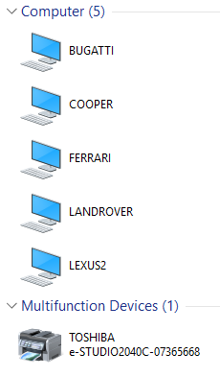

Tosh Network Printer at Alton

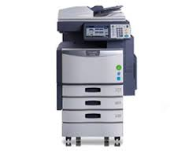
Userid: admin
Password: 123456
Name: MFP07365668
Copier Model: TOSHIBA e-STUDIO2040C
Serial Number: CJI119236
MAC Address: 00:80:91:70:64:24
Static IP Address: 192.168.83.20
Driver: Available in ‘Add a Printer’
Service Phone Number: 08450 500400 [Probably]

OKI Network Printer at Rushmoor

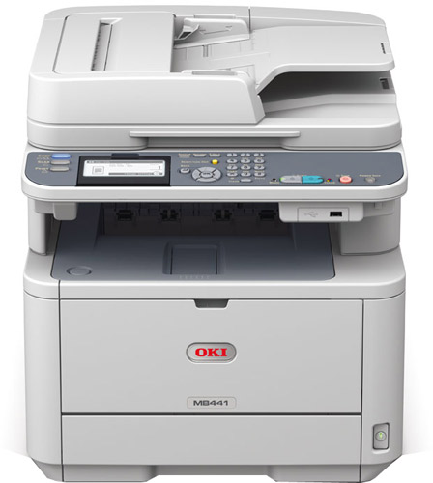

Price: £193.20 inc VAT [Less £30 Cashback + Free 3 Year Warranty]
Web interface Userid: root
Password: elstead2008
Device Name: OKI-MB441-661957
Copier Model: OKI-MB441
Serial Number: AK35040099
MAC Address: 00:25:36:66:19:57
IP Address [bound to MAC]: 192.168.20.106
Web Port: 80
Purchased: 9th January 2014
Supplied by: http://www.printerland.co.uk/
Phone Number: 0800 840 1992
Technical support issues: 01784 274318
Product Registration Number: 161467631
Manual: http://www.manualslib.com/manual/410310/Oki-Mb441mfp.html?page=2#manual

Queries regarding cashback claim: 020 7659 1135
Email: oki.enquiries@sales-promotions.com
* All VAT registered companies are liable for a reduction of input VAT (1/6 of cashback value) *
Microsoft Outlook 2010 Professional Plus
Purchased from www.software4students.co.uk

Order Numbers:
Placed by email Order # Activation Code
Andrew Bell bellboy1280@hotmail.co.uk 1017241 6G729-JDG6Y-QG6H8-VV4WV-YJBMW
Emma Drew emma.drew@hotmail.com 1017215 RCH8V-H6H6K-8P88T-QYX78-6XW8M

Log onto the website and view your "order history" in the "my account" section.
Microsoft Office 2010 Professional Plus
http://e5.onthehub.com/d.ashx?s=yimgrqqosc
http://e5.onthehub.com/d.ashx?s=8wyowcov0b

Email Setup:
If connected to TalkTalk
Laptops: SMTP: smtp-auth.gotadsl.co.uk jdm@gotadsl.co.uk dhov5bol
Desktops: SMTP: smtp.talktalkbusiness.net
DNS: 208.67.222.222 and 208.67.220.220

If connect to Zen
SMTP: mailhost.zen.co.uk
Authentication email address: zen254365@zen.co.uk Password: dUHwk8a2
Use Port: 587 with TLS

Universal
SMTP: mail.jd-motors.co.uk
Use Port: 465 with SSL

EMAIL ACCOUNTS

Email Address Password Installed on this device
adam.bradley@jd-motors.co.uk Wolseley and Hummer
admin@jd-motors.co.uk 69zyc27uhtyd
ali@jd-motors.co.uk hw9w4yid27oc
back.office@jd-motors.co.uk
brn30055cb35f13@jd-motors.co.uk i2d3z6ogxi8t
charlie@jd-motors.co.uk 2497vrrxhrp5 Using webmail.jd-motors.co.uk
controlroom@jd-motors.co.uk 97y6aynh8318 Jenson [Laptop 10 Home]
dave.drew@jd-motors.co.uk m4kb7qmvuj2t
david.harvey@jd-motors.co.uk od0qhpzf9s8w
david@jd-motors.co.uk route654 Woodland4
dummy@jd-motors.co.uk route654
emma.drew@jd-motors.co.uk 8qwqmharem70 Bugatti
front.office@jd-motors.co.uk mm5zsgx5a0l3 Wolseley
georgie@jd-motors.co.uk gxz9nfmf99ww Landrover / Daf
gu@jd-motors.co.uk alton2014 Robin
ian.hall@jd-motors.co.uk 9oi4qd2xc2ci
ian.madden@jd-motors.co.uk 5etq6e5swsc8 Landrover
iain.mcarthur@jd-motors.co.uk px0dt4e2r3mv
jasmine@jd-motors.co.uk wdmit40vmjtb
john.drew@jd-motors.co.uk 2ey5qytk5p0n
lee@jd-motors.co.uk 8vbqacif2d4x
lewis.drew@jd-motors.co.uk 89aicr3iwa25
lexus@jd-motors.co.uk b9bw74f8unz9 Lexus
lotus@jd-motors.co.uk 6xui4r90rmif Lotus
megan@jd-motors.co.uk onpcggs9zfcq Landrover
mike@jd-motors.co.uk bk8oegr955np
newsletter@jd-motors.co.uk 6x65afbvvxs1 Mailing List
michael@jd-motors.co.uk qkmx2cg2i65k
michelle.ingram@jd-motors.co.uk p50exu2a3ev8 Daimler
nick.summers@jd-motors.co.uk i83zdyrpdvk4
peter.chalcraft@jd-motors.co.uk g80xcmmwxcr9 Mobile Phone
police@jd-motors.co.uk zbbeac6wl2rs
private@jd-motors.co.uk [openallhours] Ford
renault@jd-motors.co.uk uhziqofy8oo9 Renault
rushmoor@jd-motors.co.uk 02wbumfn88b9 Bedford
reception@jd-motors.co.uk route654
sherrie.drew@jd-motors.co.uk 31m7h6qzekxh
steve.casey@jd-motors.co.uk sdn81tow11uu
steve.mayhead@jd-motors.co.uk 5at02d4g9hk0 Mobile Phone
susan.summers@jd-motors.co.uk c8qsb3p8xk2i Maserati
sysadmin@jdrecovery.team y7vqskq04fxjgeey
syslog@jd-motors.co.uk route654
tyre.bay@jd-motors.co.uk v2uf2f4u83rr Ford
tracking@jd-motors.co.uk
wayne.hibberd@jd-motors.co.uk 85z6i6afipzd
wayne.novak@jd-motors.co.uk 6qg68g7qe6pe
workshop@jd-motors.co.uk 70ken0rt3ior Porsche

Box Trapper on reception@jd-motors.co.uk forwarding cleaned emails to:
michelle.ingram@jd-motors.co.uk adam.bradley@jd-motors.co.uk
susan.summers@jd-motors.co.uk admin@jd-motors.co.uk
tyre.bay@jd-motors.co.uk rushmoor@jd-motors.co.uk
david@jd-motors.co.uk john.drew@jd-motors.co.uk
emma.drew@jd-motors.co.uk lexus@jd-motors.co.uk
lotus@jd-motors.co.uk gu@jd-motors.co.uk

Other Accounts with Box Trapper Enabled
emma.drew@jd-motors.co.uk

Alias/Forwarding
reception@jd-motors.co.uk >>> Box Trapper circulation list
accounts@jd-motors.co.uk >>> adam.bradley@jd-motors.co.uk
accounts@jd-motors.co.uk >>> emma.drew@jd-motors.co.uk
accounts@jd-motors.co.uk >>> lewis.drew@jd-motors.co.uk
accounts@jd-motors.co.uk >>> susan.summers@jd-motors.co.uk
emma@jd-motors.co.uk >>> emma.drew@jd-motors.co.uk
fax.service@jd-motors.co.uk >>> reception@jd-motors.co.uk
general.enquiries@jd-motors.co.uk >>> adam.bradley@jd-motors.co.uk
general.enquiries@jd-motors.co.uk >>> emma.drew@jd-motors.co.uk
general.enquiries@jd-motors.co.uk >>> lewis.drew@jd-motors.co.uk
general.enquiries@jd-motors.co.uk >>> megan@jd-motors.co.uk
general.enquiries@jd-motors.co.uk >>> michelle.ingram@jd-motors.co.uk
general.enquiries@jd-motors.co.uk >>> sherrie.drew@jd-motors.co.uk
general.enquiries@jd-motors.co.uk >>> susan.summers@jd-motors.co.uk
librarian@jd-motors.co.uk >>> david@jd-motors.co.uk
management@jd-motors.co.uk >>> adam.bradley@jd-motors.co.uk
management@jd-motors.co.uk >>> dave.drew@jd-motors.co.uk
management@jd-motors.co.uk >>> emma.drew@jd-motors.co.uk
management@jd-motors.co.uk >>> lewis.drew@jd-motors.co.uk
matt@jd-motors.co.uk >>> mike@mideng.co.uk
owner-info@jd-motors.co.uk >>> david@cyberpictures.net
owner-newsletter@jd-motors.co.uk >>> newsletter-owner@jd-motors.co.uk
recovery@jd-motors.co.uk >>> adam.bradley@jd-motors.co.uk
recovery@jd-motors.co.uk >>> emma.drew@jd-motors.co.uk
recovery@jd-motors.co.uk >>> lewis.drew@jd-motors.co.uk
recovery@jd-motors.co.uk >>> michelle.ingram@jd-motors.co.uk
recovery@jd-motors.co.uk >>> sherrie.drew@jd-motors.co.uk
service@jd-motors.co.uk >>> adam.bradley@jd-motors.co.uk
service@jd-motors.co.uk >>> lewis.drew@jd-motors.co.uk
service@jd-motors.co.uk >>> megan@jd-motors.co.uk
service@jd-motors.co.uk >>> michelle.ingram@jd-motors.co.uk
service@jd-motors.co.uk >>> susan.summers@jd-motors.co.uk
site@jd-motors.co.uk >>> dave.drew@jd-motors.co.uk
ss2@jd-motors.co.uk >>> susan.summers@jd-motors.co.uk
storage@jd-motors.co.uk >>> emma.drew@jd-motors.co.uk
storage@jd-motors.co.uk >>> lewis.drew@jd-motors.co.uk
storage@jd-motors.co.uk >>> michelle.ingram@jd-motors.co.uk
sue.summers@jd-motors.co.uk >>> susan.summers@jd-motors.co.uk
vosa@jd-motors.co.uk >>> adam.bradley@jd-motors.co.uk
vosa@jd-motors.co.uk >>> dave.drew@jd-motors.co.uk

Mailing List – Forwarding List for info@jd-motors.co.uk
Admin: http://jd-motors.co.uk/mailman/admin/info_jd-motors.co.uk/general Password: elstead
adam.bradley@jd-motors.co.uk ali@jd-motors.co.uk
charlie@jd-motors.co.uk chiefengineer@trolleybus.net
dave.drew@jd-motors.co.uk emma.drew@jd-motors.co.uk
gu@jd-motors.co.uk iain.mcarthur@jd-motors.co.uk
ian.hall@jd-motors.co.uk ian.madden@jd-motors.co.uk
john.drew@jd-motors.co.uk lee@jd-motors.co.uk
lewis.drew@jd-motors.co.uk michelle.ingram@jd-motors.co.uk
rushmoor@jd-motors.co.uk sherrie.drew@jd-motors.co.uk
steve.casey@jd-motors.co.uk wayne.hibberd@jd-motors.co.uk
wayne.novak@jd-motors.co.uk workshop@jd-motors.co.uk

Fax to email Service – Voipfone facility
Faxes sent to 01420 448684 or 01252 758724 are delivered as an attachment to
reception@jd-motors.co.uk with onward distribution as the Box Trapper listing above.

Pitney Bowes Account 30996222
Laura Jackson, Customer Relations
Tel: 01279 753 576
email: relationsccc@pb.com
Access account information www.pbmyaccount.co.uk

AutoRoute
MWRFX-HG2PG-W4X8Y-392YY-9QH9X

SAGE
Account: 60748725
Serial Number: E621749
Password:
Help Desk: 0845 11155555

Control Panel:
jd-motors.co.uk:2083
Login: davi1819 Password: 7218486356928$
APEX
RMS Settings – Installation Code: 916677
http://download.apex-rms.com
Jason Kemp - Customer Relationship Manager
Dundee House
Albion Place
Ramsgate
Kent
CT11 8HQ

Email: JKemp@apex-networks.com
Tel: 020 3195 6757 Fax: 0871 522 3151

ESET - Endpoint Security
Telephone Number: 01202 405 405
Administrator Licence No Password Expiry Date No.
david@jd-motors.co.uk EAV-55959751 dxenbpu8s3 24/08/20? 21
3RUK-XPFH-3NEP-EJWE-HH9M
URL: my.eset.com
Password: usN4BGr6SvaCqKm

y7vqskq04fxjgeey

Albion
Audi
Bentley
Bluebird
Bugatti
Cooper
DAF
Daimler
Ferrari
Ford
Humber
Hummer
Invicta
Jenson
Landrover
Maserati
McLaren
MG
Morgan
Morris
Porsche
Renault
Robin
Scammell
Vitesse
Viva
Wolseley

ALTON

192.168.83.15 6C-F0-49-2B-D7-A7 LEXUS2 Sue Sue lucy
192.168.83.36 50-E5-49-5B-C1-2D Bugatti Emma Emma buster1
192.168.83.42 90-2B-34-8B-A1-20 Landrover Ian Ian no2pc
-do- Megan Megan Rowe
192.168.83.43 94-DE-80-C8-21-6E Cooper Dave Dave buster1
192.168.83.51 4C-BB-58-01-64-FA Robin General User gu@jd-motors.co.uk alton2014
192.168.83.54 08-62-66-C3-F4-F8 Bentley Sherrie Sherrie route630
192.168.83.55 74-D4-35-9B-9A-19 Wolseley Adam Reception smile
192.168.83.56 AC-9E-17-A8-F9-A9 Daimler Michelle Michelle route654
192.168.83.57 40-8D-5C-C5-C2-CA MG GM2 Lewis route654
192.168.83.59 B4-6D-83-DC-A2-80 Audi Adam Adam elstead2008
192.168.83.65 8C-89-A5-34-F5-A2 Porsche } Workshop Workshop spanner
-do- } Michelle Michelle austin
192.168.83.73 DC-85-DE-EE-87-D9 Daimler …….. wired and WiFi
192.168.83.75 94-DE-80-0D-B6-08 Ferrari GM Server Back Office route654

RUSHMOOR

192.168.20.104 74-D4-35-5B-E3-7C Morgan Front Desk Front Desk tessa
192.168.20.108 00-10-5C-E1-06-C7 Viva Workshop
192.168.20.113 FC-AA-14-37-22-5A Morris MOT mot computeruk
192.168.20.10x AC-22-0B-0D-84-E8 Maserati Sue sue lucy

HAYLING

Bluebird
McLaren

DAVE DREW HOME

192.168.202.210 2C-6E-85-2B-9E-C7 21:30:06 Renault

SUE'S HOME

192.168.18.19 E0-66-78-BC-4C-9D 71:49:51 Vitesse
192.168.18.30 B8-86-87-68-BE-A2 67:40:35 LAPTOP-5J02H8L4

Garage Manager at Alton:
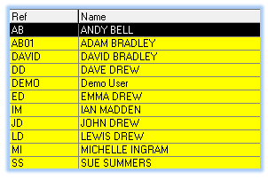

Alton CCTV
Add details

Scoot
Customer Support: 0800 160 1611.
email: info@scoot.co.uk
http://dashboard.scoot.co.uk/user/323996/messages/inbox/?business_id=CDDK949&hash=a306a55ace94eb9a70aac0d02c7bf655
This relates to the mobile device switch JavaScript used on the home page of the web site.

ELVIS
Help desk: 02380 674766 [John or Peter] email: frs@hampshire.pnn.police.uk
Registered IP address: 82.71.55.46
https://hantselvis.co.uk

Autotrader
Customer Services Tel: 0345 111 0003
Email: enquiries@autotrader.co.uk
Username: reception@jd-motors.co.uk
Password: minimiglia29
Address: 1 Rowan Industrial Park, Alton, GU34 2NQ
Telephone: 01420 544644
Confirmation given to:
https://accounts.autotrader.co.uk/Confirmation?ursacc=6B23351C-3587-4BEF-9834-81D9A899A28D
Managing Adverts Online
To amend, expire or rebook adverts use: http://trucks.autotrader.co.uk/manage-my-adverts

Autodata
Tel: 01628 688111
Help Desk email: customersupport@autodata-group.com
Access to Autodata Web Application: http://workshop.autodata-group.com
Username: reception-134591 [Used at Alton]
Account number: 80965
Account name: JD Motors
Password: alton123

Username: reception-134479 [Used at Rushmoor]
Account number: 80965
Account name: JD Motors
Password: BUsterdog1

Tyresoft
https://download.tyresoft.biz/app/system?license=TYR-29072016-FUL
Craig Fuller craig.fuller@fullertyres.co.uk
Fuller Tyres Ltd
01483755445
07545788131

Alton Workshop
A private wire, owned and maintained by JD Motors, links between the two buildings. The cabling is used for Ethernet over VDSL2 Bridge using VC-201A adaptors from Planet [www.planet.com.tw]. The basic setup is similar to this:
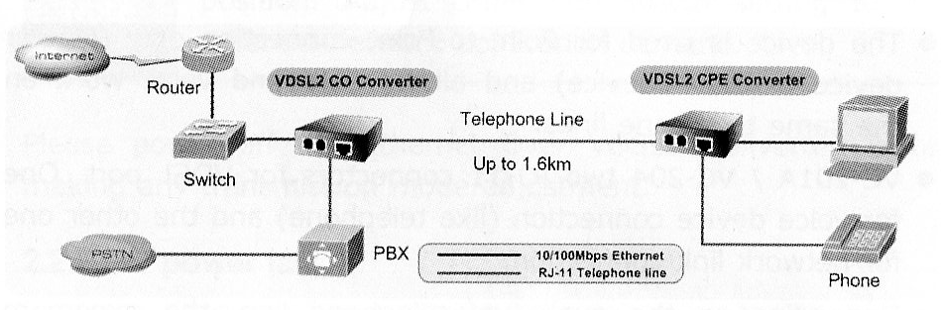
Office: 192.168.83.1 Workshop: 192.168.34.1

The Ethernet Bridge supports a connection between the two LANs and is multiplexed with a voice service to avoid cross talk. A wireless router is connected at the workshop end.

Telecom Services

Phone lines used for night service are covered by total care [costing £3.50] with a fee for call transfer [£1.20]. It is not known if the broadband lines are covered by total care.

It is thought that the Night Service lines return anonymous [or unknown] on phones with Caller Display. This could be a major issue as there is now a growing use of the “Anonymous Reject” facility and therefore you will be unable to connect with the caller.

Supplier contact for POTS Lines only:
Westmead House, Westmead, Farnborough, GU14 7LP
Tel: 01252 617116 Fax: 01252 626216
E-mail: Roma@businesscomms.co.uk Web: www.businesscomms.co.uk
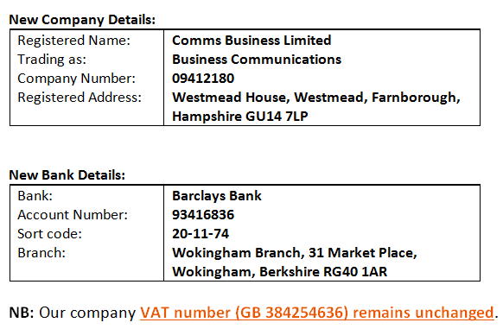

Alton Garage
Analogue Lines [No details known of the installed “Police Lines”]
- 01420 89768 Not Used.
- 01420 86370 Alarm system in the Workshop
- 01420 544654 Alarm system in the Admin Building

Voipfone [sip.voipfone.net] –
- Lewis Drew 30204994*200 01420 448393
- Snom360 Logon: trolleybus Password: route654 Security Key: 1618
- Comms Cabinet 30204994*201 01420 448388

DrayTEL Registration email addresses
8242201 emma.drew@jd-motors.co.uk Password: route654
All others numbers david@jd-motors.co.uk Password: ?

Telephone within the Comms Cabinet
It is sometime necessary for a support engineers to liaise with a help desk to resolve issues using. The telephone installed in the comms cabinet for this purpose. A conference call can be established with another staff member’s phone if required. The configuration of this phone automatically selects the service (Voipfone, Draytel or Vodafone) which has the lowest call charges.

If an engineer wishes to receive a call, the preferred number to use is 01420 448388.

Voipfone: 01420 448388 Identity 30204994*201 Password: 970382
This is the default service. Outgoing calls must be prefixed with the area code.

Draytel: 08455 570053 Identity 8242201 PAYG Service.
A PAYG service. There was an in-call credit of £1.93 on Wednesday, 3 May 2017.
Access URL: https://admin.draytel.org/login
Registered under emma.drew@jd-motors.co.uk Password: route654. [Facility to top-up credit].
Vodafone: 01420 543937 [Loop through service via the 2860 router]
This number is the voice element associated with the Vodafone VoIP service over broadband.
It is not possible to forward any calls to another number and therefore frequently rings with unsolicited calls. If you want to route outgoing calls via this service, prefix the number with #0. The call charges are unknown.

Short Codes
Called Party | Use Function Key or Dial | Free
David Bradley | 212 | ●
DrayTek Router Support | 800800 | ●
SoConnect | 71
Tsohost | 72
Vidahost | 150 | ●
Dave Drew | 3100
Georgie Bull | 3138
Lewis Drew
* Not available yet * | 20 | ●
Michelle Ingram | 3102
Mike Norgate | 3103
Service Desk | 3106
Sherrie Drew | 3104
Sue Summers | 3137
Workshop | 3105
MIDENG Area 14 | 01730 888152 | ●
MIDENG Recovery Control | 19 | ●
MIDENG Service Reception (Workshop) | 01730 888294 | ●
Listen to Voipfone messages left | 1571 | ●
Draytel Configuration Check | 902 | ●
Route outgoing call via Vodaphone | #0 followed by number
Route outgoing call via DrayTEL | #2 followed by number

Lewis snom360 label
David
448393
Mike
448393
Mike #2
Sue
Recovery
Georgie
Guy
Michelle
Belinda
Dave

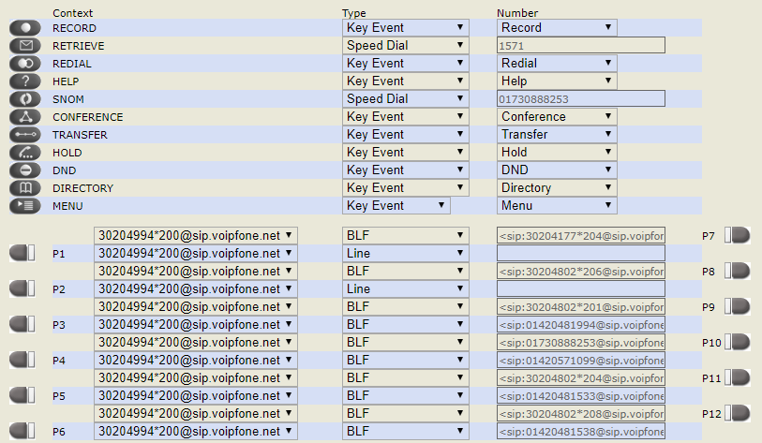
Router Configuration

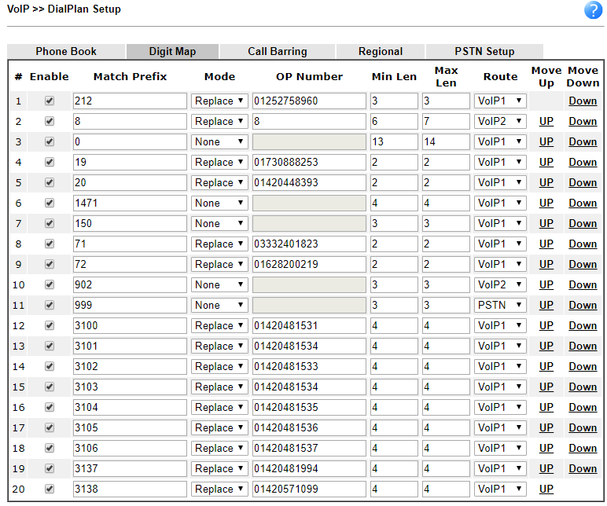

Alton Broadband Service
Cancellation Case Ref: 00066220
Service(s) will be cancelled as per the minimum notice period.
Zen Username/Service No: zen254365@zen
Date to be cancelled: 03/07/2017
ISP: Zen Help Desk: 01706 902009
8am - 8pm, Monday to Friday
9am - 5pm on Saturdays and Sundays

Customer Portal: http://portal.zen.co.uk/
Username: david@jd-motors.co.uk Password: route654
Line Number: 01420 89768
Zen ADSL login: zen254365 Password: dr7zsN5T
Network: 192.168.83.x

Static IP address: 82.71.55.46
Zen DNS Servers: 212.23.3.100 and 212.23.6.100 not used
Forced selection within router to use 8.8.8.8 and 8.8.4.4

Unlimited Broadband - monthly charge £17.83 + VAT
Care Level: Standard
Web Space Available
FTP Server ftp.zen.co.uk
FTP Username zen254365
FTP Password dUHwk8a2
Web Site Address http://www.zen254365.zen.co.uk
Web Space Quota 1024 MB

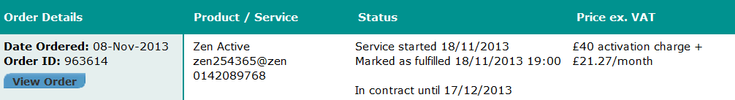
Prices do not include VAT
ADSL Username zen254365@zen ADSL Password dr7zsN5T
Main email: zen254365@zen.co.uk Password: dUHwk8a2 SMTP: mailhost.zen.co.uk Authentication: required Port: 587 with TLS

Assumed usage of 3GB per day - 200GB monthly quota per month should be fine.
If not £29.78 per month increases the quota to 500 GB.

Current ADSL service has a maximum download speed of 18400Kbps. Current line technology is WBMC.
Line rate data information:
Upstream Downstream Sync Rate BRAS Profile Interleave Sync Date
1231 18400 20856 TR101 Auto 20-Nov-2013 16:08

Vigor 2860vac - User Name: admin Password: elstead2008
Wireless SSID: JDM2860 Password: route654
Workgroup: ALTON

Research Activities on getting FTTC for
J D Motors, Unit 1-3 Rowan Industrial Estate Mill Lane Alton, GU34 2NQ

BT Line checker indicates no FTTC service available.
Source: https://www.dslchecker.bt.com/pls/adsl/ADSLChecker.TelephoneNumberOutput
Telephone Number 0142089768 on Exchange ALTON is served by Cabinet 31
Featured Products | Downstream Line Rate(Mbps) | Upstream Line Rate(Mbps) | Downstream Range(Mbps) | Availability Date
WBC ADSL 2+ | Up to 11 | -- | 6.5 to 15 | Available
Meanwhile a better service than BT predictions is being achieved. Our current maximum download speed is 77436Kbps.
Current line technology is WBMC. Line Rate Data as on date shown. Source: https://portal.zen.co.uk
Upstream | Downstream | Sync Rate | BRAS Profile | Interleave | Sync Date | Date
19999 | 77436 | 80001 | TR101 | Auto | 12-May-2014 02:33 | 12-May-2014 02:33

[See: https://www3.hants.gov.uk/broadband/broadband-signup.htm]

JD Motors Mill Lane address falls within the Hampshire Broadband programme to provide faster internet speeds since business along this road are unlikely to get superfast broadband through commercial investment. With the available combination of Government and local authority funding, the business community along Mill Lane area should be a priority recipient of high speed internet connectivity due to their contribution to the local economy. Our geographical footprint is surrounded by properties already able to subscribe to an FTTC service and is less than a mile from the enabled exchange, so is hardly a rural location.

Apparently local pressure helps in planning the delivery to unserved areas to secure investment in the network. Indeed as a business very much reliant on internet connectivity we have already registered our dismay from being excluded from any improvement to our current service.

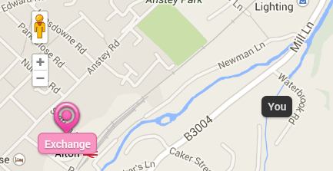

From: Kufel, Emanuela [mailto:Emanuela.Kufel@hants.gov.uk]
Sent: 29 May 2014 17:16
Subject: RE: FTTC in Mill Lane, Alton

Mill Lane isn’t currently included in the Superfast Broadband Programme; however the areas covered are based on the first part of the rollout bringing superfast broadband to 90% of Hampshire by 2015. The procurement to extend superfast broadband coverage to at least 95% by 2017 is due to be completed by the autumn of 2014. Your area will be considered for this part of the programme and we will be able to share more news in the autumn.

Within the programme we aim to reach as many premises as possible using the funding available. I understand that it is frustrating that your area isn’t currently covered and I hope that we will be able to find a solution in the autumn with possible self-funded alternatives if your area isn’t included.

We are also working on a new website with an updated mapping system that will enable us to share more accurate information.

Kind Regards,
Ema Kufel
Marketing Executive
Hampshire Superfast Broadband Programme
Culture, Communities and Business Services
Hampshire County Council
Email: emanuela.kufel@hants.gov.uk
Telephone: 01962 845002
From: colin.p.brooks@openreach.co.uk [mailto:colin.p.brooks@openreach.co.uk]
Sent: 16 April 2014 21:37
Cc: peter.r.cowen@bt.com
Subject: Draft Funded letter- Alton 31 34 & 36 Mill lane Industrial Estate 16042014

Please find gap fund as promised for the 3 cabs. All 3 cabs are very small in terms of number of Premises serviced (circa around 30 each). As an aside the commercial programme looked at cabs that were in excess of 250-300 individual customer as a starting point.

[The document was attached to this email is reproduced as Appendix #1 of this document].
Colin P Brooks
Sales & Customer Experience, NGA Development Solutions Manager
Openreach
Tel: 01977 596054
Mob: 07711 446493
email: Colin.P.Brooks@Openreach.co.uk
Web: www.openreach.co.uk

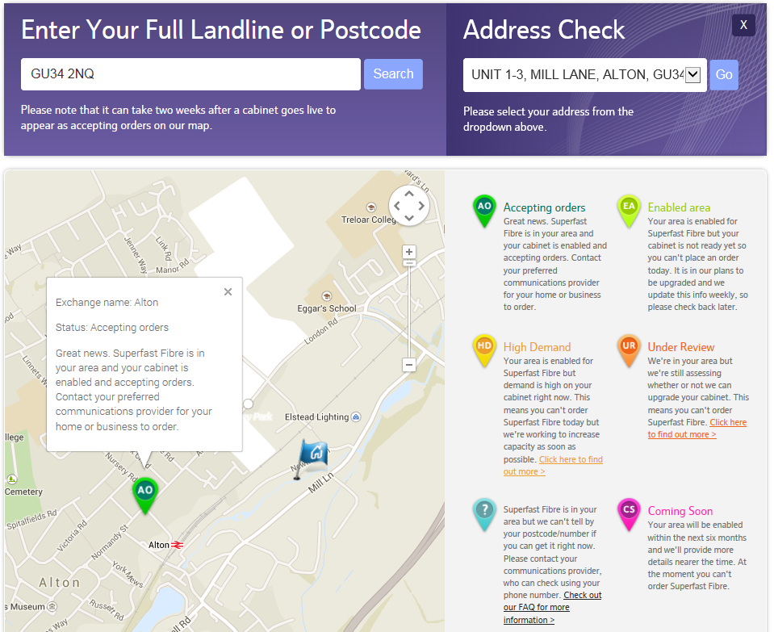

Bordon – GU [Sue Summers]
Analogue Lines
- 01420 473650 Business Line
supports the broadband service from TalkTalk
- 01420 476418 Domestic number

FTTC at 40/10 suggested
Telephone Number 01420473650 on Exchange BORDON is served by Cabinet 16
Featured Products | Downstream Line Rate(Mbps) |  | Upstream Line Rate(Mbps) |  | Downstream Range(Mbps) | Availability Date
 | High | Low | High | Low
FTTC Range A (Clean) | 32.8 | 23.8 | 7.5 | 5.9 | -- | Available
WBC ADSL 2+ | Up to 4 |  | -- |  | 2.5 to 6.5 | Available

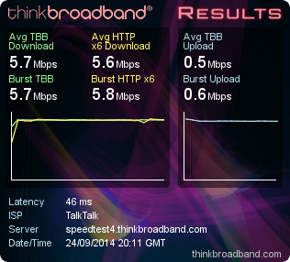
http://www.thinkbroadband.com/speedtest/results.html?id=141159299814535386084

Static IP: 213.208.109.147

Wireless
SSID: JDM-Bordon Password: route654
Shipley Close - GU34 2RW [Dave Drew]
Analogue Lines
- 01420 83250 Domestic Number
Supports 2*Sky.
- 01420 83609 Night Service Line
Supports the broadband service

Telephone Number 0142083609 on Exchange ALTON is served by Cabinet 4
Featured Products | Downstream Line Rate(Mbps) |  | Upstream Line Rate(Mbps) |  | Downstream Range(Mbps) | Availability Date
 | High | Low | High | Low
FTTC Range A (Clean) | 66.9 | 66.9 | 20 | 20 | -- | Available
FTTC Installation 2 December 2013
Zen username: zen255123@zen Connection password: mMmL9ML9
SMTP: mailhost.zen.co.uk Authentication: required Port: 587 with TLS
Network 202
Wireless SSID: JDMOTORS

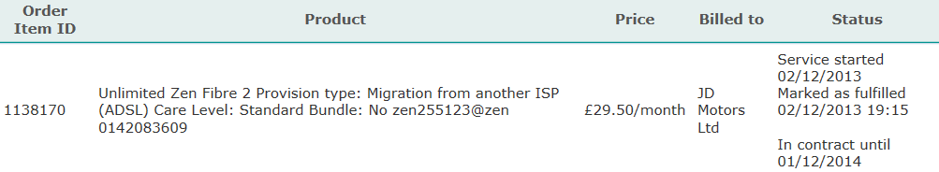

Hayling Island [John Drew]
Analogue Lines
- 02392 367986 Virgin Line [Is the number still live?]
- 02392 637401 Business Line
- 02392 462607 Domestic Number

FTTC at 80/20 installed in John’s Home
Telephone Number 02392637401 on Exchange HAYLING ISLAND is served by Cabinet 15
Featured Products | Downstream Line Rate(Mbps) |  | Upstream Line Rate(Mbps) |  | Downstream Range(Mbps) | Availability Date
 | High | Low | High | Low
FTTC Range A (Clean) | 80 | 80 | 20 | 20 | -- | Available
It is not known which line is used for BT Infinity, but using 02392637401 indicates that the FTTC cabinet is virtually in the front garden as 80/20 is available!

60-36-DD-7F-0B-8E Lancia John Fingerprint Logon

Rushmoor
Analogue Lines
- 01252 790940 Located in the workshop.
- 01252 792103 Back office phone
supports the broadband service from Zen
- 01252 793608 3 Lines [£23.30 for the extra lines]
Main advertised number and the number that is placed on night service
- 01252 793634 Front office – Phone / CC Machine / Redcare?
- 01252 717149 MOT Line
Can only be used for that purpose
- DrayTEL 8484874 !9,FpL(r

Broadband Service information
FTTC Service from Zen Old ADSL Service from TalkTalk
Name: 82-69-49-191.dsl.in-addr.zen.co.uk Name: jdmhq.gotadsl.co.uk
FTTC login: zen270161@zen ADSL login: jdmhq@gotadsl.co.uk
Password: 5dsmitxd Password: katie
Static IP address: 82.69.49.191 Static IP address: 81.6.247.206
Help Desk: 01706 902009 Help Desk: 0800 083 3003
8am - 8pm, Monday to Friday Account Number: 882 01286418
9am - 5pm on Saturdays and Sundays Bank: HSBC

Telephone Number 01252792103 on Exchange FRENSHAM is served by Cabinet 5
Featured Products | Downstream Line Rate(Mbps) |  | Upstream Line Rate(Mbps) |  | Downstream Range(Mbps) | Availability Date
 | High | Low | High | Low
FTTC Range A (Clean) | 18.4 | 12.6 | 1.2 | 0.8 | -- | Available
FTTC Range B (Impacted) | 15.5 | 7.2 | 1 | 0.6 | -- | Available
Requested MAC code 18 September 2014 – Reference number 13475722
MAC code is LATH4176973/MJ19M given to Zen [Date: 25-Sep-2014] – FTTC Installation [Date: 07/10/2014 08:00 - 13:00]

ZEN Fibre 1 product with download limit of 50 GB per month
Monthly charge: £20.75 excluding VAT Care Level: Standard Current Line technology: WBMC
Email notification given when usage reaches 50%, 75%, 90% and 100%
Line rental remains with www.businesscoms.co.uk

Zen Customer Portal: http://portal.zen.co.uk/ [Select broadband account zen270161@zen]
Username: david@jd-motors.co.uk
Password: route654

E-MAIL AND WEB SPACE
This is configured through the Customer Portal.

TECHINCAL DETAILS
Connection type: PPPoE Authentication type: CHAP
Fixed IP address: 82.69.49.191 (Subnet mask 255.255.255.255)
Primary DNS: 212.23.3.100 Secondary DNS: 212.23.6.100

Default email username: zen270161@zen.co.uk Default email password: FZRfju26
Default web space username: zen270161 Default web space password: FZRfju26
Router Information – Vigor 2830vN
User Name: admin Password: elstead2008
Wireless SSID [1]: JDMotors Password: route654
Wireless SSID [3]: ITSupport Password: WalledGarden
Workgroup: Rushmoor LAN: 192.168.20.x

Background Data
The FTTC cabinet is a mile away so connection speeds will be modest and certainly well below 40Mbps making a 40/10 Mbps service the first port of call. However download usage is 50 GB before surcharges kick in and these will be as shown in the table below:
1 GB - £1.27 2 GB - £2.54 5 GB - £6.34
10 GB - £12.68 20 GB - £25.36 50 GB - £63.40
Predictive usage is 25 GB to 40 GB per month, so should be OK. If this indicates to be unlikely then a switch to the unlimited package should be made for an extra £6.25 + VAT per month.
Download usage is reset on the first day of each calendar month.

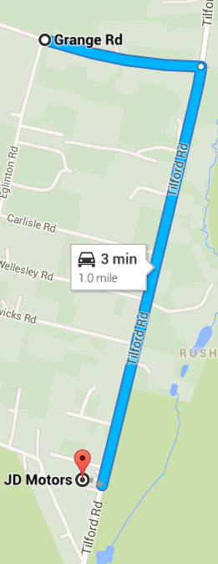  FRENSHAM Cabinet 5 is a mile away | 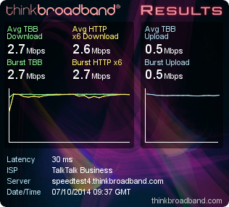  Speed test when using TalkTalk
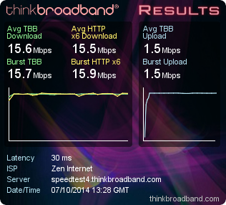
Speed test using Zen

Router Configuration Details – Alton
Access 192.168.83.2:8080 Userid: admin Password: elstead2008

Time Server: 192.43.244.18

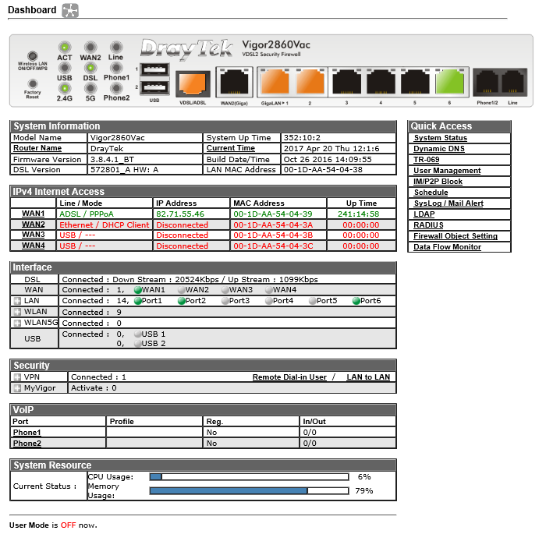

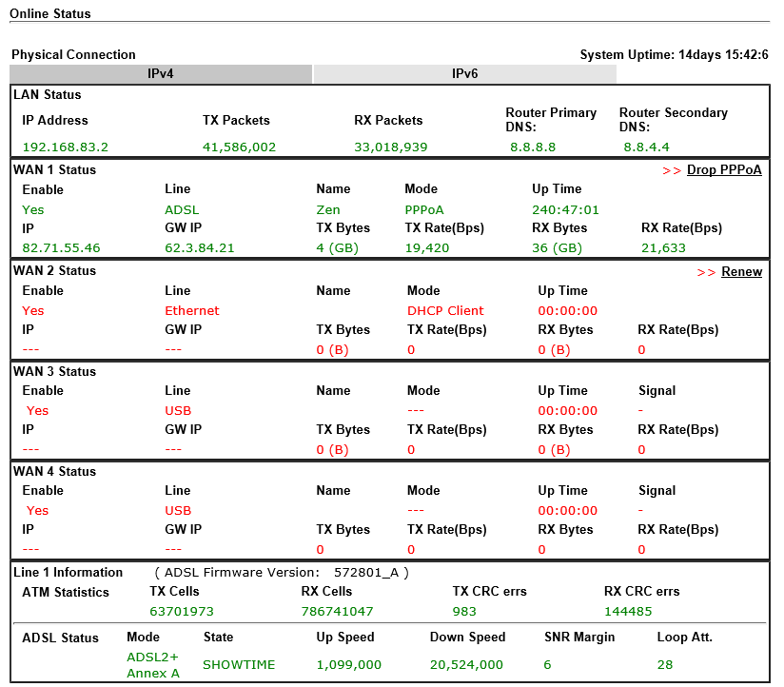

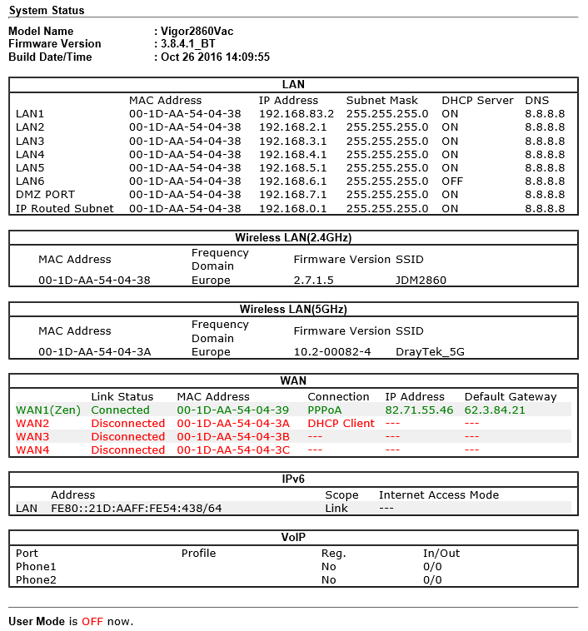

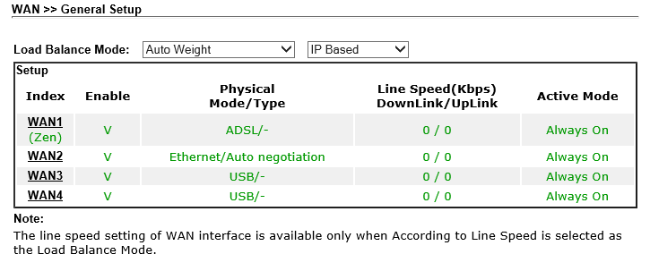
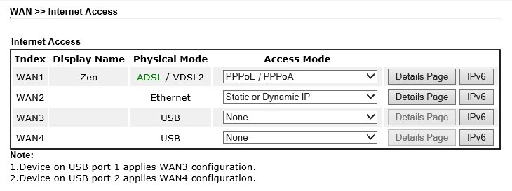

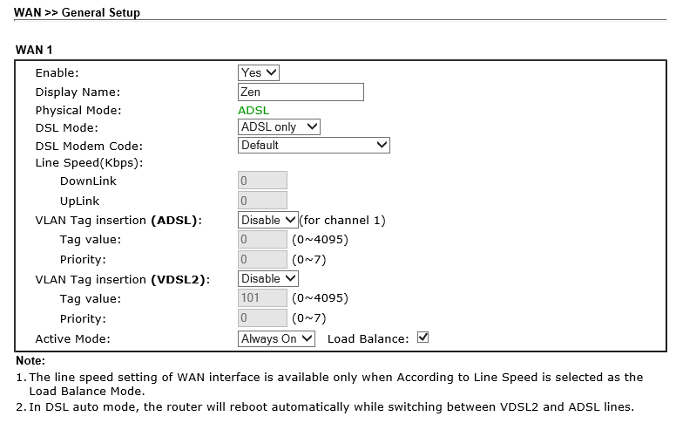

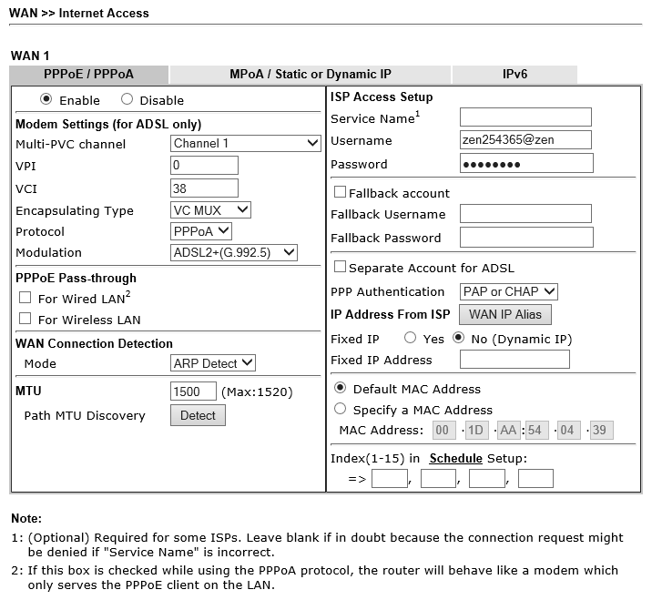
Zen Logon Password: dr7zsN5T

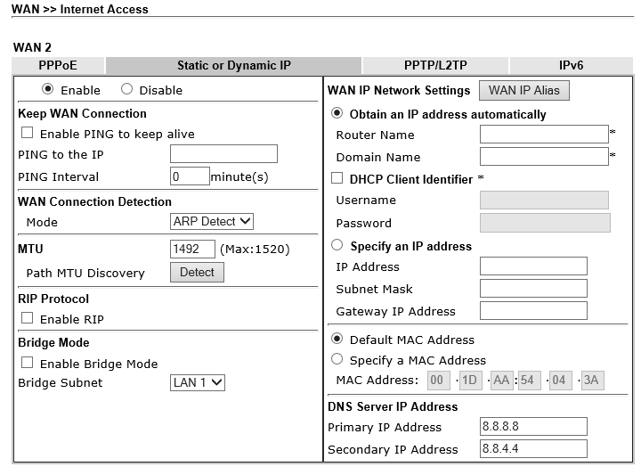

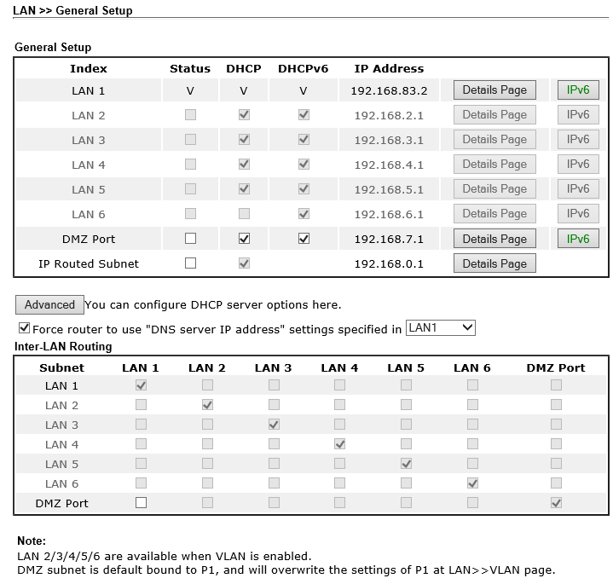

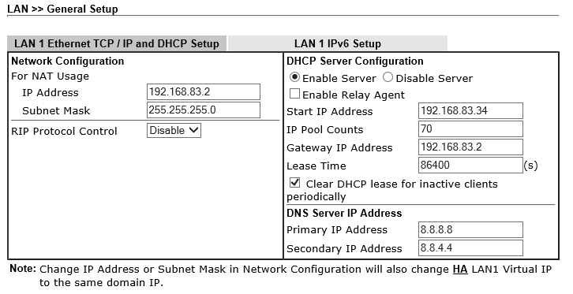

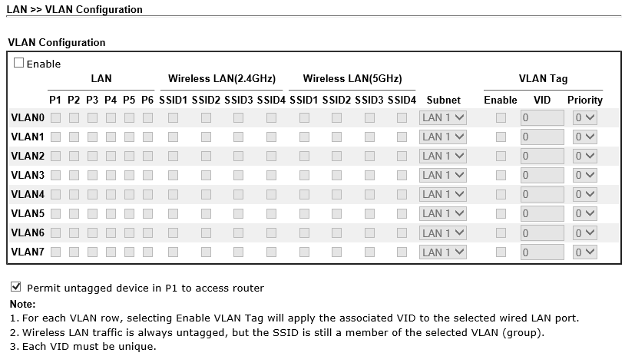

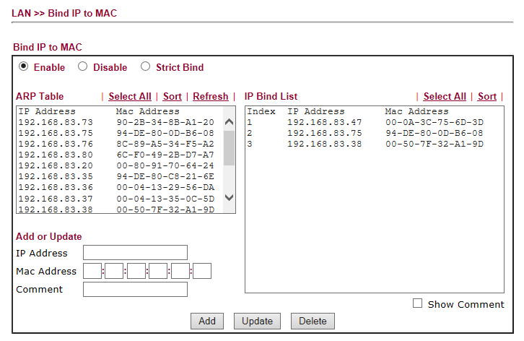
Binding for Ferrari [192.168.83.75] Workshop Router [192.168.83.38] and CCTV [192.168.83.47]
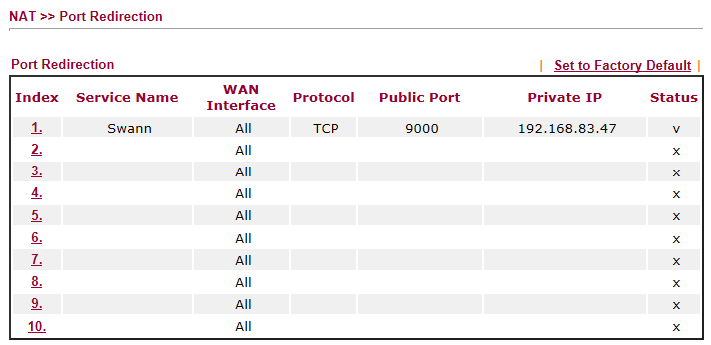

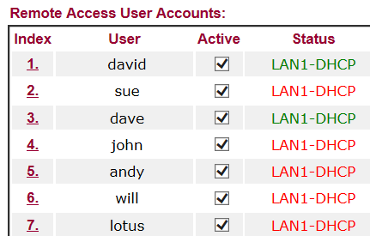

VPN Access:

VPN Account Name | Password | Normal IP Address
sue | bordon | 213.208.109.147 [Home]
dave | shipley | 82.71.12.19
john | hayling
will
cuk | caterham7
lotus | nowhere
david | elstead | 82.69.72.219
adam | palace
lewis | controller

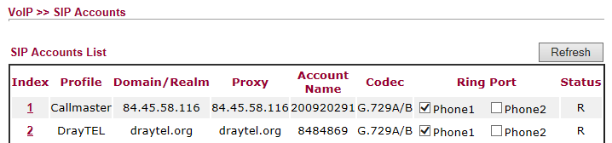

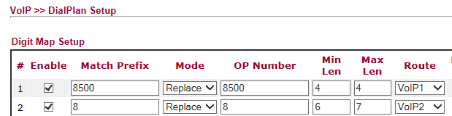
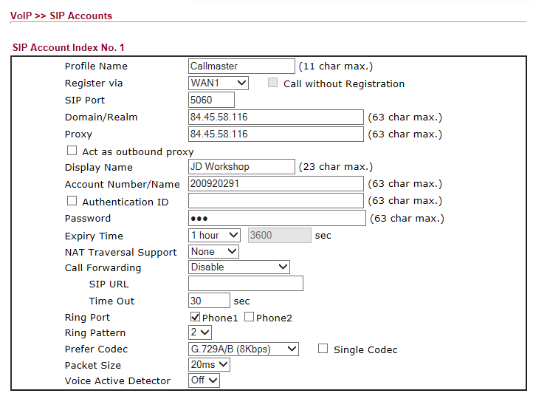

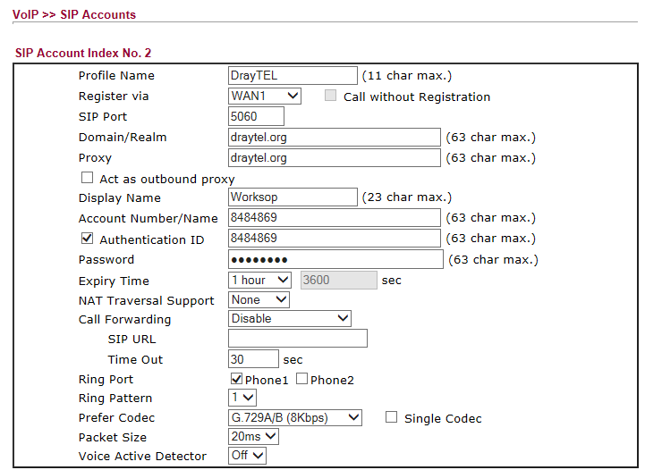

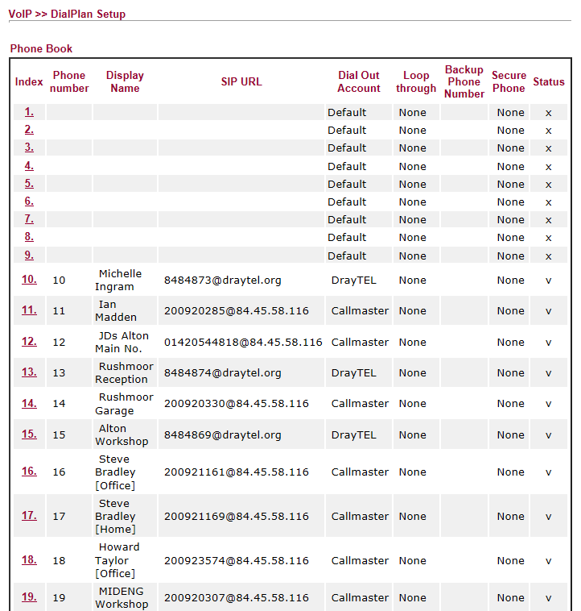
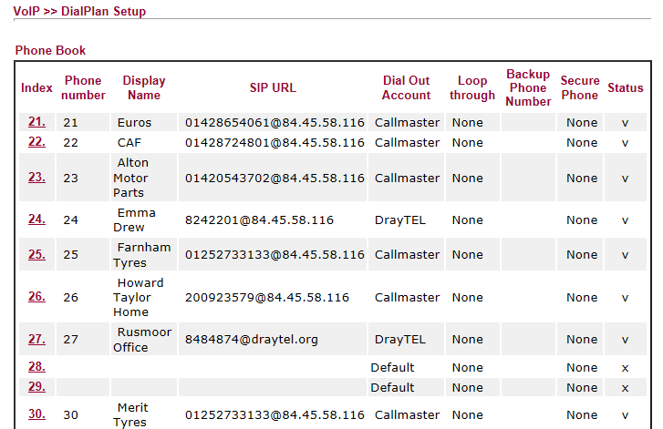
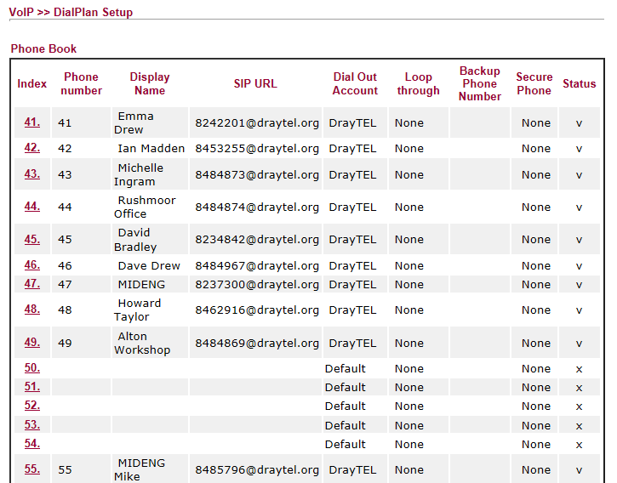

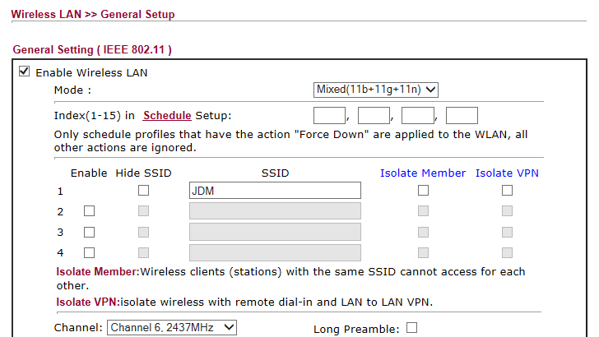

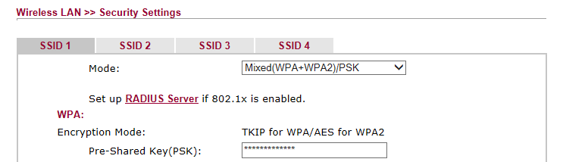

PSK: route654
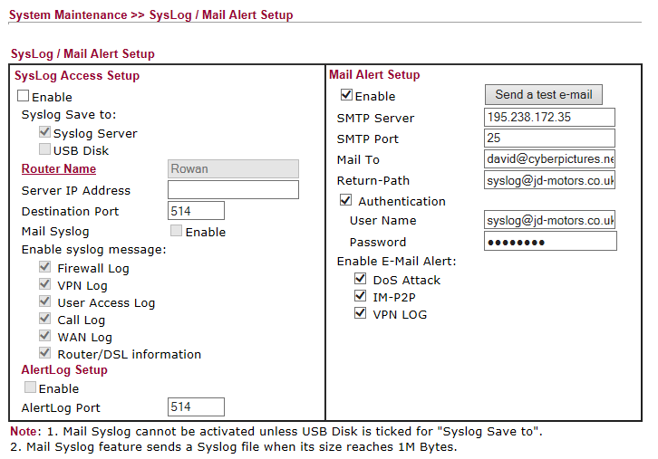

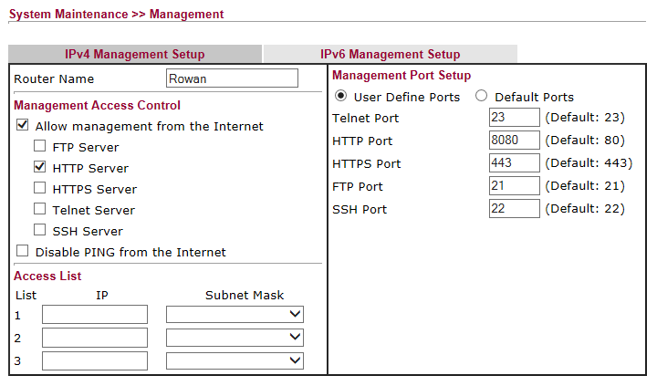

Alton Workshop Router
Access: 192.168.83.38 Userid: admin Password: elstead2008
Connection is over a VDSL2 bridge using a private wire between the two buildings
Supports Internet and VoIP from the Draytek 2830vN Router
Hardware: Planet VC-201A [www.planet.com.tw]

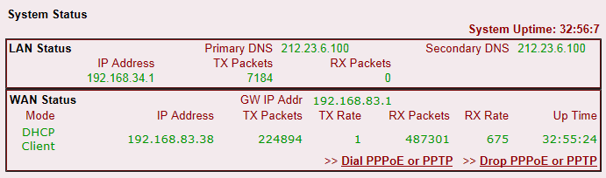

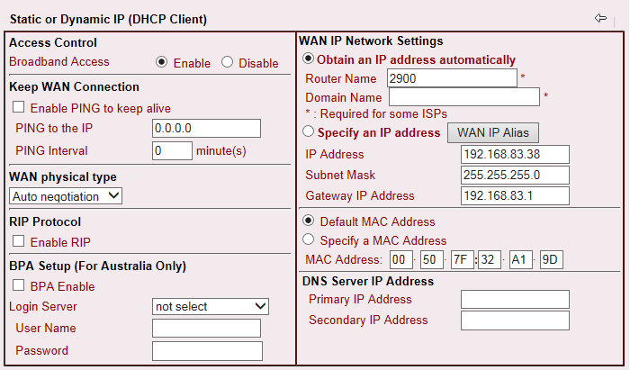

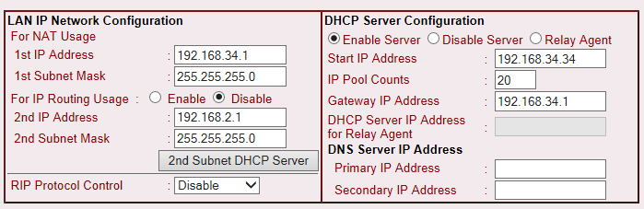

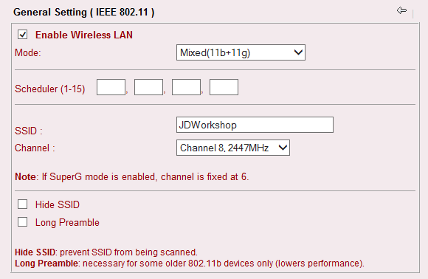

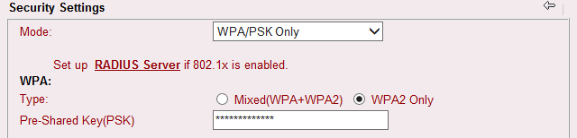

Historical Informatiom

Alton ELVIS Router
Access: http://213.208.108.34:8083/ Userid: admin Password: elstead2008
Broadband Login: jdm@gotadsl.co.uk Password: dhov5bol

Router Configuration Details at Rushmoor
Userid: admin Password: elstead2008

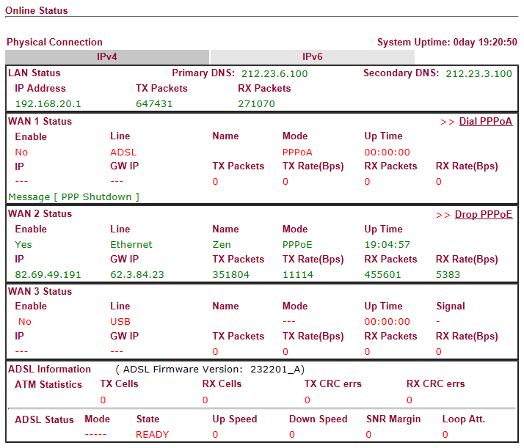

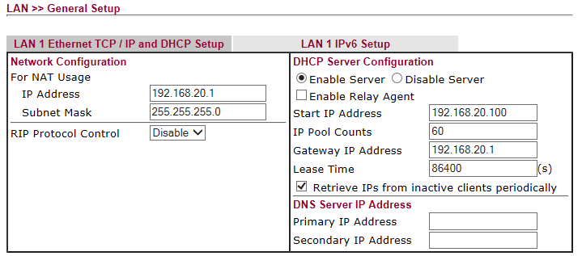
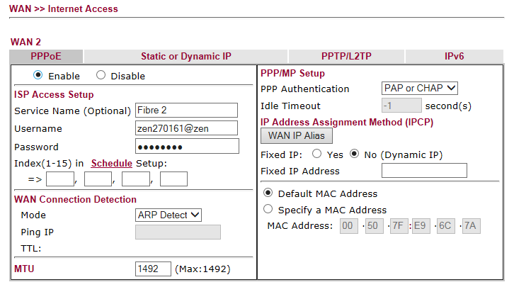

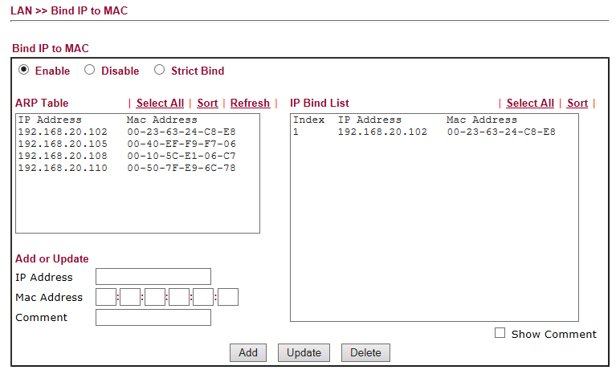

192.168.20.102 = CCTV
192.168.20.xxx = MFP

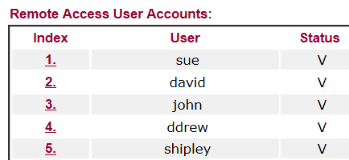

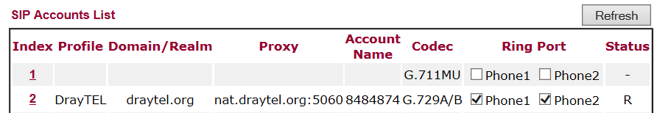

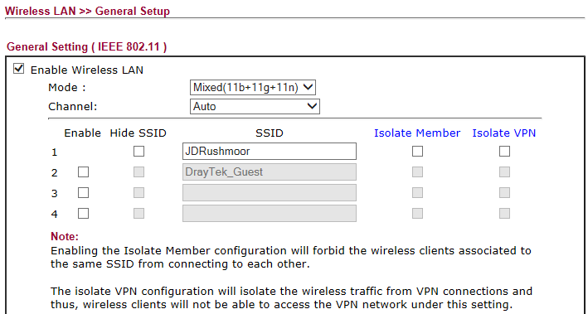

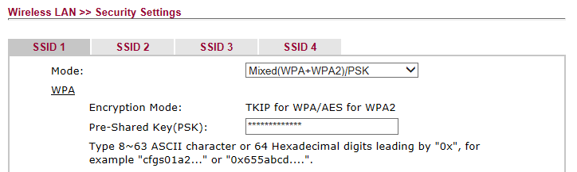

PSK = route654

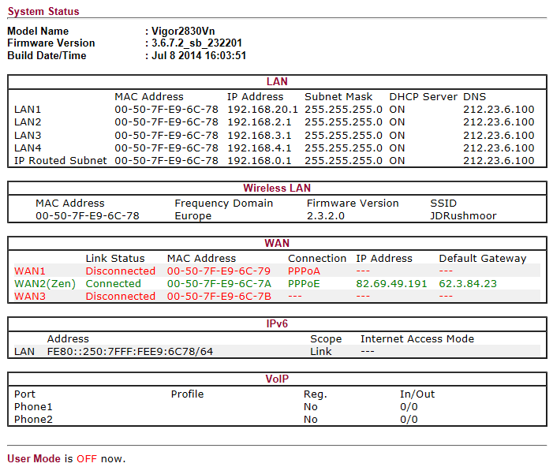

Computer Inventory

PLBOSCHPC – Laptop – Workshop
Windows 7 Ultimate Service Pack 1
Product Part No.: X15-37374
Product ID: 00426-OEM-8992662-00352
CD Key: DYFKK-XJ9CT-G2WRP-BFQ87-R66CF
Computer Name: PLBOSCHPC
Registered Owner: Robert Bosch GmbH
Registered Organization: Robert Bosch GmbH

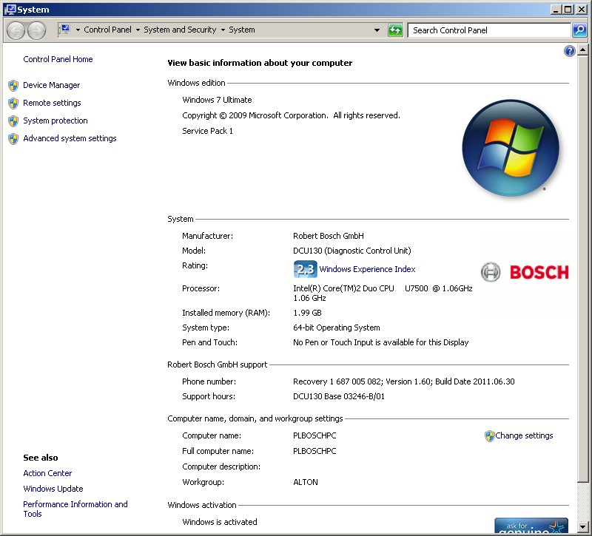

COOPER – Desktop – Dave Drew
Windows 7 Professional Service Pack 1
Product Part No.: X15-37362
Product ID: 00371-OEM-9045971-59277
CD Key: PQYY8-3728M-7K83T-2VQCV-JDDDH
Computer Name: COOPER
Registered Owner: Dave
Registered Organization:

Microsoft Office Single Image 2010
Product ID: 82503-033-1598282-11041
CD Key: V48VJ-94JJ3-MH8HX-HPTMY-P3RHW

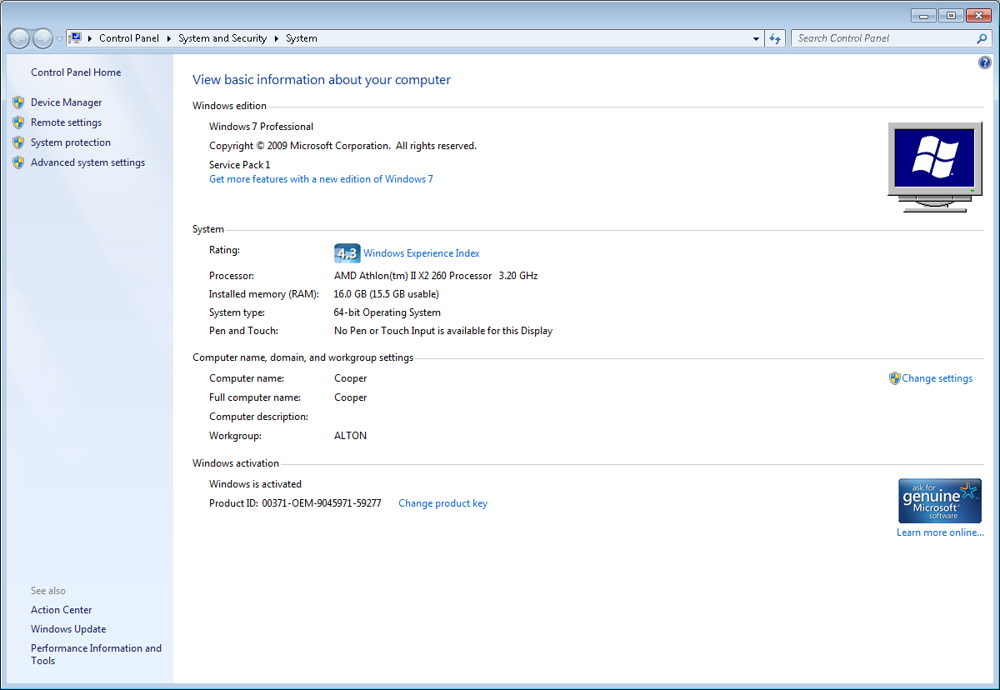

PORSCHE – Desktop – Michelle Ingram
Windows 7 Professional Service Pack 1
Product ID: 00371-OEM-9045316-11335
CD Key: JX98X-HD6FW-8QGTH-CFGVK-KW676
Computer Name: PORSCHE
Registered Owner: Mid Eng

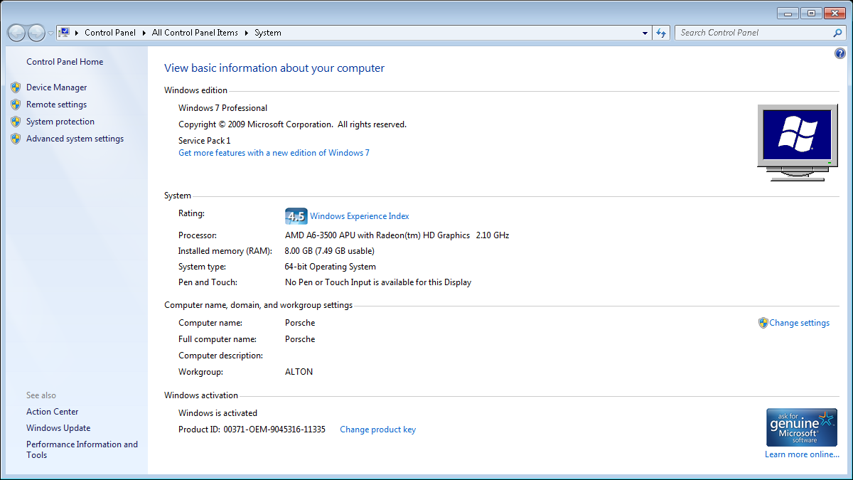



Bugatti – Desktop – Emma Drew
Windows 7 Professional Service Pack 1
Product ID: 00371-OEM-9045343-41380
CD Key: D237X-778RQ-9X93X-43TXT-4WCB8
Computer Name: BUGATTI
Registered Owner: User

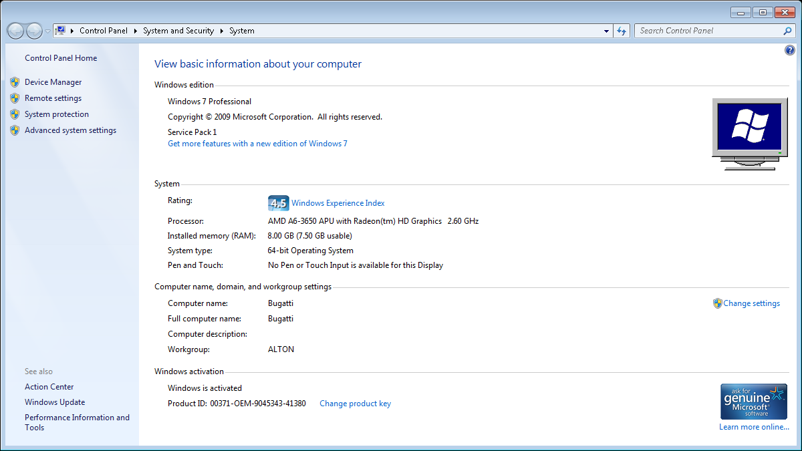

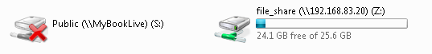

Lexus2 – Desktop – Sue Summers
Windows 7 Professional Service Pack 1
Product ID: 00371-OEM-9044443-44693
CD Key: 2QFH3-6CKK2-T9VT4-HFKM6-KDW3F
Computer Name: LEXUS2
Registered Owner: Sue

Microsoft Office Single Image 2010
Product ID: 82503-242-9975775-11336
CD Key: TJF47-9YKF3-G6DYM-DJDV6-HR9YY

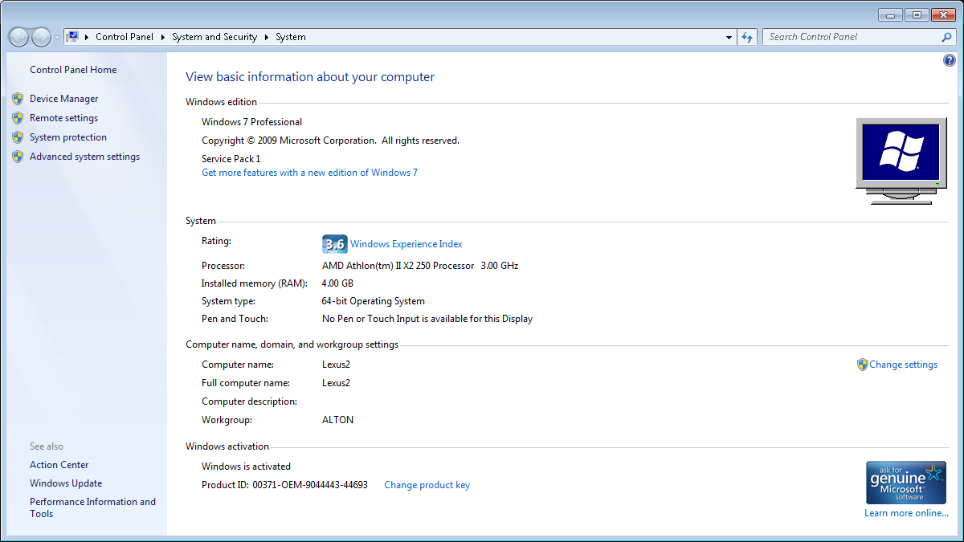



We have recently up dated our payroll to sage 50, and we also run sage 50 accounts. The thing is that the payroll is on my back computer in Alton and the Accounts is on my laptop with me, in order for me to send info to my laptop, Sage have said that the computers need to be networked together so a map can be linked? Does this make sense and is it very easy to do. If it is can you send me details or link in to do it?

Landrover – Desktop – Ian Madden
Windows 7 Professional Service Pack 1
Product Part No.: X15-37362
Product ID: 00371-OEM-9045566-83403
CD Key: GPTWX-6TKV2-MRB47-9YJXT-7M9XT
Computer Name: LANDROVER
Registered Owner: Ian
Registered Organization:

Microsoft Office Professional Plus 2010
Product ID: 82503-201-3688037-49797
CD Key: CXVQH-XRYKT-X7GD6-DCBT2-9JQBT

FERRARI – Desktop – Server
Windows 7 Professional Service Pack 1
Product Part No.: X15-37362
Product ID: 00371-OEM-9045566-96565
CD Key: C4YHD-MJT8G-66M7W-W46QV-37PCH
Computer Name: FERRARI
Registered Owner: Back Office
Registered Organization:

Maserati – Laptop – Sue Summers
Windows 8.1
Product Part No.: [8]X18-15
Product ID: 00179-60704-13133-AAOEM
CD Key: GGP7R-9NG8F-2Q7T9-X4YRV-2RYQ6
Computer Name: MASERATI
Registered Owner: Sue
Registered Organization:

Microsoft Office Single Image 2010
Product ID: 82503-033-1598282-11585
CD Key: V48VJ-94JJ3-MH8HX-HPTMY-P3RHW
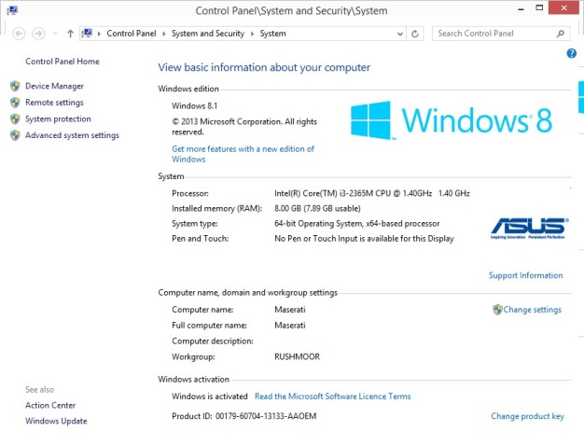
Date: Wednesday, 1 January 2014

Lotus – Desktop – Unallocated
Microsoft Windows XP Professional Service Pack 3
Product Part No.: A22-00001
Product ID: 76487-OEM-0066583-71777
CD Key: GC2YJ-R44YK-KYK8C-4XBK3-HDJ33
Computer Name: LOTUS
Registered Owner: JD
Registered Organization:

Microsoft Office Professional Plus 2007
Product ID: 89409-707-1230233-65271
CD Key: KXFDR-7PTMK-YKYHD-C8FWV-BBPVW

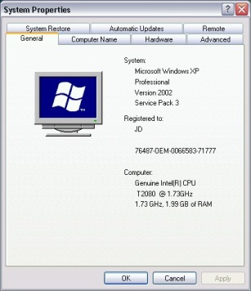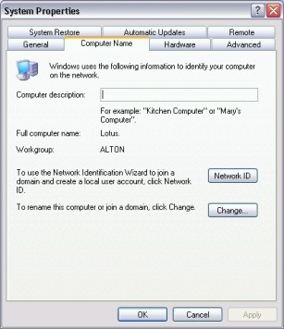

Date: Saturday, 11 January 2014

Morris – Desktop – NOT Station
Windows 8.1 Pro
Product Part No.:
[Blue]X18
Product ID: 00259-40854-36476-AAOEM match to CD Key data
CD Key: MCQN6-K4YGC-WFRKK-RW3X7-M4FW3
Computer Name: MORRIS
Registered Owner: MOT
Registered Organization:

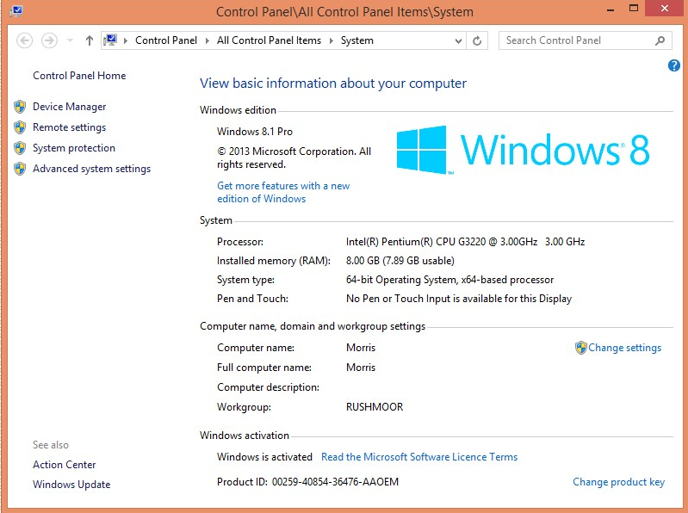

Password: computeruk

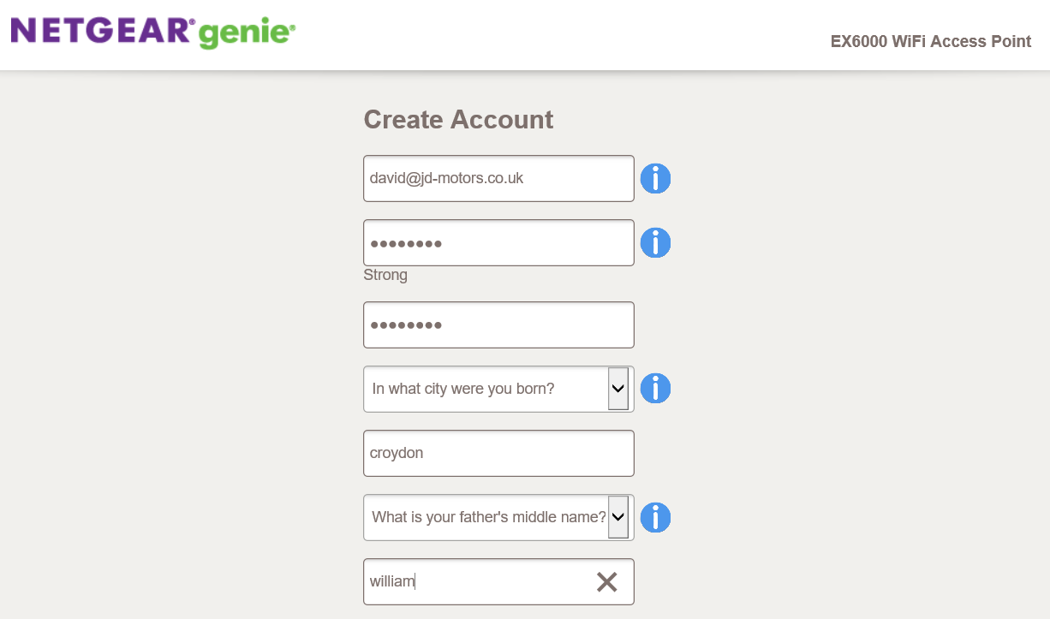

route654

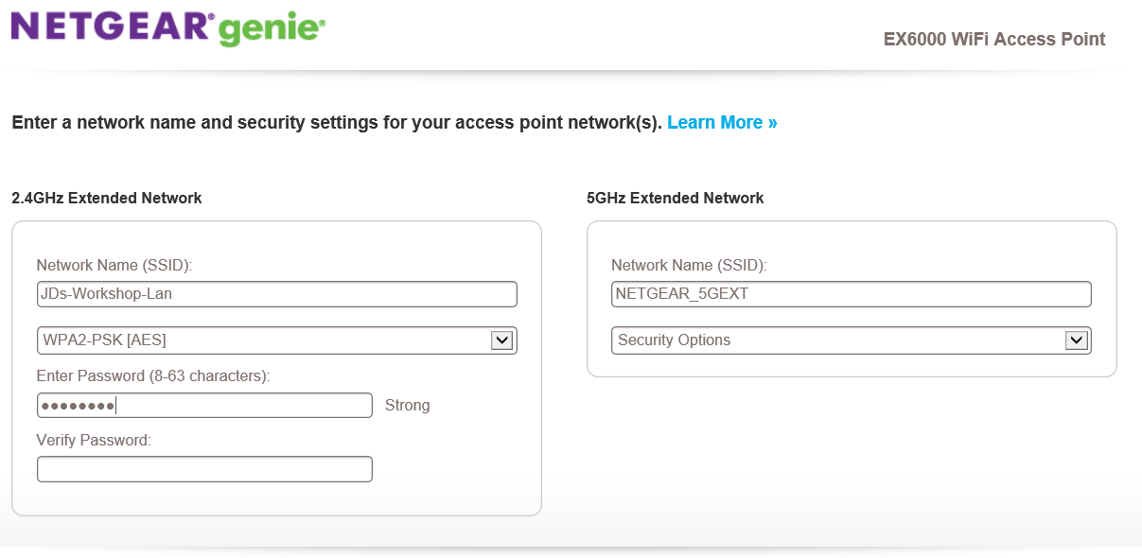

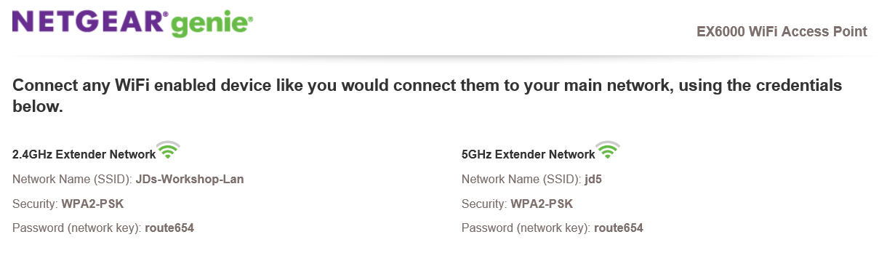

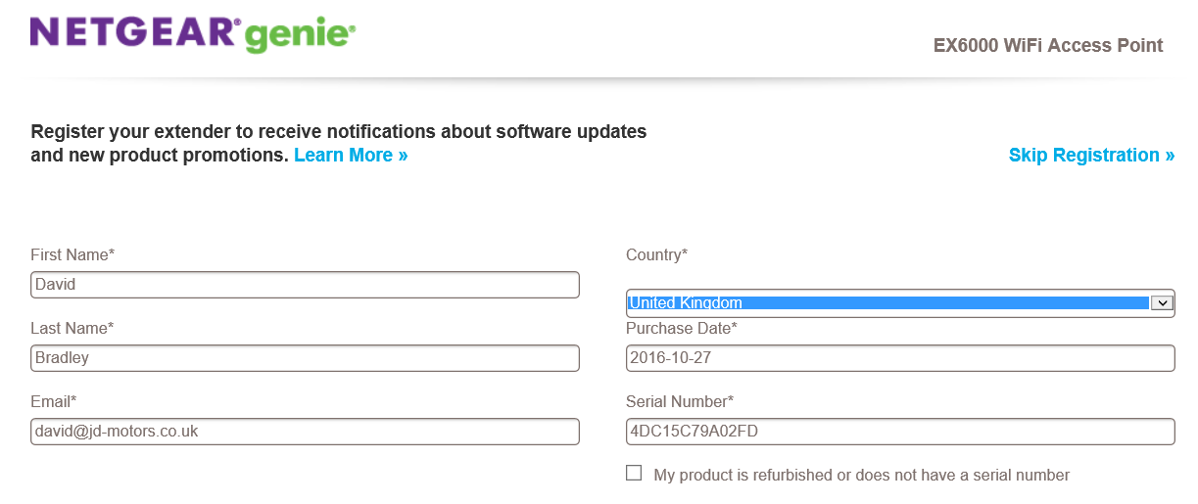

KiS
From: Ryan Kirby [mailto:ryan.kirby@mamsoft.co.uk]
Sent: Wednesday, August 26, 2015 9:34 AM
To: adam.bradley@jd-motors.co.uk; rushmoor@jd-motors.co.uk
Subject: Online MOT Booking - J D Motors, Rushmoor Garage, Tilford Road, GU10 2EP

I have attached user guides for the Online MOT Booking and the integration pack your web developer will need. Below is the unique token your developer also requires:

Unique token: a1ca9c3adf584370bf56fa0ef17b207e

The above Token is for J D Motors, Rushmoor Garage, Tilford Road, GU10 2EP

If you need any further assistance please contact the helpdesk on 01226 352 950

