Computer Installation and Telephone Services Fact Sheet
Company: JD Motors Version: Wednesday, 15 January 2014
David Drew Limited t/a JD Motors, Registered in England & Wales Registration Number: 08229200
Registered Office: Unit 31, Base Point Business Centre, Winnall Valley Road, Winchester, Hampshire, SO23 0LD

Alton Address:
1 Rowan Industrial Park
Mill Lane
Alton
Hampshire
GU34 2QG

Rushmoor Address:
Rushmoor Garage
Tilford Road
Rushmoor
Farnham
Surrey
GU10 2EP

VAT Number: GB413322794

Alton: 01420 544644
Alton [Not diverted]: 01420 544818
Alton Fax: 01420 448684 [Fax to Email] 01420 544654 [out of order]
Rushmoor Rear Office: 01252 792103
Rushmoor Front Office: 01252 793608
Rushmoor Workshop: 01252 790940
Rushmoor Fax: 01252 758724 [Fax to Email]

Web Page: http://www.jd-motors.co.uk

Connected Devices seen at Alton, main router 2830. Pool Table = 50
IP Address MAC Address HOST ID USER Logon Password
192.168.83.1 00-1D-AA-AC-44-18 Router --- admin elstead2008
192.168.83.20 00-80-91-70-64-24 Tosh Printer --- admin 123456
192.168.83.35 94-DE-80-C8-21-6E Cooper Dave Dave buster1
192.168.83.36 00-04-13-29-56-DA snom285 Ian --- ---
192.168.83.37 00-04-13-35-0C-5D snom292 Michelle --- ---
192.168.83.38 00-50-7F-32-A1-9D 2900 Workshop AP admin elstead2008
192.168.83.39 00-04-13-29-6A-B2 snom331 Emma --- ---
192.168.83.40 50-CC-F8-AB-95-E4
192.168.83.41 1C-99-4C-28-93-21 android-62acbbaf89185494
192.168.83.42 1C-99-4C-47-DA-92 android-e6ee896dde88f7f1
192.168.83.43 5C-0A-5B-50-0F-D0 android-512db89a0f638827
192.168.83.45 9C-04-EB-28-C1-82 Michellesphone2
192.168.83.46 34-23-BA-87-8D-C9 android-b25269fb6149d5ec
192.168.83.47 00-0A-3C-75-6D-3D CCTV
192.168.83.48 50-E5-49-5B-C1-2D Bugatti Emma Emma buster1
192.168.83.49 5C-F9-38-4C-96-DB adams-iPad
192.168.83.51 24-FD-52-BE-3A-D1 Coke Matt recovery1 Matt
192.168.83.52 00-88-65-A5-41-DE Emmas-phone
192.168.83.53 00-40-EF-F9-F0-E7 T2EM [Credit Card Machine]
192.168.83.54 F0-D1-A9-86-DE-2D iPhone
192.168.83.55 90-A4-DE-AA-3D-4C PLBOSCHPC
192.168.83.56 04-F7-E4-F3-57-F8 iPhone
192.168.83.57 A4-D1-D2-C2-E6-D5 mikes-iPad
192.168.83.58 1C-B0-94-38-DD-7C Android_359788041709954
192.168.83.59 00-1B-9E-20-C6-F9 Lotus Spare JD route654
192.168.83.73 90-2B-34-8B-A1-20 Landrover Ian Ian no2pc
192.168.83.75 94-DE-80-0D-B6-08 Ferrari GM Server Back Office route654
192.168.83.76 8C-89-A5-34-F5-A2 Porsche Michelle Michelle austin
192.168.83.80 6C-F0-49-2B-D7-A7 Lexus2 Sue Sue lucy

Connected Devices seen at Alton, workshop router 2900. Pool Table = 20
IP Address MAC Address HOST ID USER Logon Password
192.168.34.1 00-50-7F-32-A1-9C 2900 Router admin elstead2008
192.168.34.34 34-BB-1F-23-4D-06 BLACKBERRY-D4B9
192.168.34.35 5C-F9-38-4C-96-DB adams-iPad
192.168.34.36 E0-F5-C6-92-00-FB iPhone
192.168.34.37 90-A4-DE-AA-3D-4C PLBOSCHPC
192.168.34.38 F0-B4-79-9E-C4-F5 Beaus-iPod
192.168.34.42 00-0C-F1-BE-F4-63 AUSTIN Workshop Workshop autodata

Connected Devices seen at Rushmoor. Pool Table = 50
LAN1 : 192.168.20.1/255.255.255.0, DHCP server: On
IP Address MAC Address HOST ID USER Logon Password
192.168.83.1 00-1D-AA-AC-44-18 Router --- admin elstead2008
192.168.20.100 00-15-99-22-26-EF DEL0015992226EF
192.168.20.101 00-40-EF-F9-F7-06 T2EM
192.168.20.102 00-23-63-24-C8-E8 FIXED IP [Camera]
192.168.20.103 6C-3E-6D-4F-46-B7 Monkeys-iPhone
192.168.20.104 00-01-6C-DF-55-BC Bedford Front Desk
192.168.20.105 00-1D-4F-AD-02-FD monkey
192.168.20.106 E4-CE-8F-D3-A7-E4 Sues-iPhone
192.168.20.107 24-FD-52-C5-8B-51 Maserati sue sue lucy
192.168.20.108 00-10-5C-E1-06-C7 Viva Workshop
192.168.20.109 00-26-9E-00-2A-8E Polo sue sue lucy
192.168.20.110 AC-22-0B-0D-84-E8 Maserati sue sue lucy
192.168.20.114 B4-07-F9-63-4B-E0
192.168.20.115 00-25-36-66-19-57 MB441-661957
192.168.20.117 00-1B-9E-20-C6-F9 Lotus Anyone JD route654
192.168.20.118 34-23-BA-87-8D-C9 android-b25269fb6149d5ec

OKI Network Printer at Rushmoor

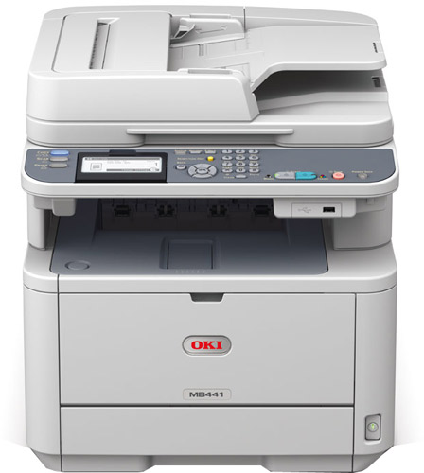

Price: £193.20 inc VAT [Less £30 Cashback + Free 3 Year Warranty]
Web interface Userid: root
Password: elstead2008
Device Name: OKI-MB441-661957
Copier Model: OKI-MB441
Serial Number: AK35040099
MAC Address: 00:25:36:66:19:57
IP Address [bound to MAC]: 192.168.20.115
Web Port: 80
Purchased: 9th January 2014
Supplied by: http://www.printerland.co.uk/
Phone Number: 0800 840 1992
Technical support issues: 01784 274318
Product Registration Number: 161467631
Manual: http://www.manualslib.com/manual/410310/Oki-Mb441mfp.html?page=2#manual

Queries regarding cashback claim: 020 7659 1135
Email: oki.enquiries@sales-promotions.com
* All VAT registered companies are liable for a reduction of input VAT (1/6 of cashback value) *
Alton – Broadband
Service: Zen Service: TalkTalk
Help Desk: 01706 902000 Help Desk: 0800 083 3003
8am - 8pm, Monday to Friday Account Number: 882 01286418
9am - 5pm on Saturdays and Sundays Bank: HSBC
Customer Portal: http://portal.zen.co.uk/
Username: david@jd-motors.co.uk
Password: route654
Line Number: 01420 89768 Line Number: 01420 544644 [882 01286418]
Network: 192.168.83.x Network: 192.168.83.x
Zen ADSL login: zen254365 TalkTalk ADSL login: jdm@gotadsl.co.uk
Password: dr7zsN5T Password: dhov5bol

Static IP address: 82.71.55.46 Static IP address: 213.208.108.34
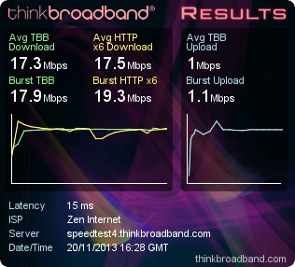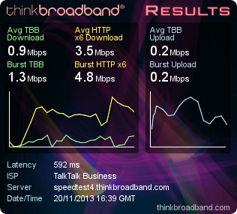

Vigor 2830vN - User Name: admin Password: elstead2008
Wireless SSID: jdmotors Password: route654
Workgroup: ALTON

Redcare was initially incompatible with ADSL, and the presence of Redcare on a line precluded an ADSL order. Around ten years ago, the equipment used for Redcare was tweaked to prevent DSL on the line from interfering with the Redcare signalling, with all new Redcare installations from July 2003 being ADSL compatible. BT SIN 284 section 3.2.1 states that all Redcare installations became ADSL compatible from February 2004. Therefore installing a broadband service on 01420 89768 is entirely feasible.

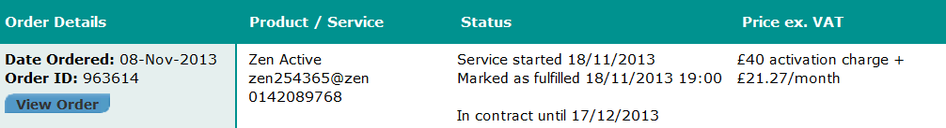
Prices do not include VAT
ADSL Username zen254365@zen ADSL Password dr7zsN5T
Main email: zen254365@zen.co.uk Password: dUHwk8a2 SMTP: mailhost.zen.co.uk Authentication: required Port: 587 with TLS

Assumed usage of 3 GB per day, so a 200 GB quota per month should be fine.
If not £29.78 per month increases the quota to 500 GB.

Current maximum download speed is 18400Kbps.
Current line technology is WBMC.

Line rate data
Upstream Downstream Sync Rate BRAS Profile Interleave Sync Date
1231 18400 20856 TR101 Auto 20-Nov-2013 16:08

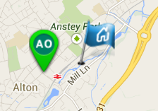

Internet Access
ADSL Username |  | zen254365@zen |  | ADSL Password |  | dr7zsN5T
BT Phone Number |  | 0142089768 |  | Installation address |  | Rowan Industrial Estate  Mill Lane  Alton  Hampshire  GU34 2QG
Web Space Settings
FTP Server | ftp.zen.co.uk |  | FTP Username |  | zen254365
FTP Password | dUHwk8a2 |  | Web Site Address |  | http://www.zen254365.zen.co.uk
Web Space Quota | 1024 MB

Email and News Settings
Email Address | zen254365@zen.co.uk | Email Username | zen254365
Email Password | dUHwk8a2 | POP-3 Server | mailhost.zen.co.uk
SMTP server | mailhost.zen.co.uk | News Server Address | news.zen.co.uk

DNS and IP Information
DNS Server | 212.23.3.100 | DNS Server | 212.23.6.100

Rushmoor - Broadband on 01252 792103 – Name jdmhq.gotadsl.co.uk
Network: 192.168.20.x
ADSL login: jdmhq@gotadsl.co.uk
Password: bruk4heh changed to katie
Static IP address: 81.6.247.206
Vigor 2830vN - User Name: admin Password: elstead2008
Wireless SSID:
Workgroup:

60-36-DD-7F-0B-8E Lancia John Fingerprint Logon

Microsoft Outlook 2010 Professional Plus
Purchased from www.software4students.co.uk

Order Numbers:
Placed by email Order # Activation Code
Andrew Bell bellboy1280@hotmail.co.uk 1017241 6G729-JDG6Y-QG6H8-VV4WV-YJBMW
Emma Drew emma.drew@hotmail.com 1017215 RCH8V-H6H6K-8P88T-QYX78-6XW8M

Log onto the website and view your "order history" in the "my account" section.
Microsoft Office 2010 Professional Plus
http://e5.onthehub.com/d.ashx?s=yimgrqqosc
http://e5.onthehub.com/d.ashx?s=8wyowcov0b

Email Setup:
POP3: www.jd-motors.co.uk

If connected to TalkTalk [e.g. at Rushmoor]
Laptops: SMTP: smtp-auth.gotadsl.co.uk jdm@gotadsl.co.uk dhov5bol
Desktops: SMTP: smtp.talktalkbusiness.net
DNS: 208.67.222.222 and 208.67.220.220

If connect to Zen [e.g. at Alton]
SMTP: mailhost.zen.co.uk
Authentication email address: zen254365@zen.co.uk Password: dUHwk8a2
Use Port: 587 with TLS

EMAIL ACCOUNTS
Email Address Password Installed on this device
adam.bradley@jd-motors.co.uk 28041989 Hand Held Device
admin@jd-motors.co.uk 37k9wmsi81kd
back.office@jd-motors.co.uk
dave.drew@jd-motors.co.uk pew29cyrdww8 Cooper
david@jd-motors.co.uk route654 Woodland4
emma.drew@jd-motors.co.uk 7rw02mcn675m Bugatti
ian.madden@jd-motors.co.uk 5etq6e5swsc8 Landrover
john.drew@jd-motors.co.uk 2ey5qytk5p0n
lexus@jd-motors.co.uk b9bw74f8unz9 Lexus
lotus@jd-motors.co.uk 6xui4r90rmif Lotus
michelle.ingram@jd-motors.co.uk p50exu2a3ev8 Porsche
nick.summers@jd-motors.co.uk
peter.chalcraft@jd-motors.co.uk g80xcmmwxcr9
rushmoor@jd-motors.co.uk Bedford
steve.mayhead@jd-motors.co.uk 5at02d4g9hk0 --
susan.summers@jd-motors.co.uk Lucy Maserati
syslog@jd-motors.co.uk route654
tracking@jd-motors.co.uk

Alias/Forwarding
emma@jd-motors.co.uk >>> emma.drew@jd-motors.co.uk
sue.summers@jd-motors.co.uk >>> susan.summers@jd-motors.co.uk
accounts@jd-motors.co.uk >>> susan.summers@jd-motors.co.uk
itsupport@jd-motors.co.uk >>> david@jd-motors.co.uk
librarian@jd-motors.co.uk >>> david@jd-motors.co.uk
owner-info@jd-motors.co.uk >>> david@jd-motors.co.uk
reception@jd-motors.co.uk >>> Box Trapper circulation list
webmaster@jd-motors.co.uk >>> david@jd-motors.co.uk

Box Trapper on reception@jd-motors.co.uk forwarding clean emails to:
michelle.ingram@jd-motors.co.uk adam.bradley@jd-motors.co.uk
susan.summers@jd-motors.co.uk admin@jd-motors.co.uk
ian.madden@jd-motors.co.uk rushmoor@jd-motors.co.uk
david@jd-motors.co.uk john.drew@jd-motors.co.uk
emma.drew@jd-motors.co.uk lexus@jd-motors.co.uk
lotus@jd-motors.co.uk

Fax to email Service - Callmaster facility
Faxes sent to 01420 448684 or 01252 758724 are delivered as an attachment to
reception@jd-motors.co.uk with onward distribution as the Box Trapper listing above.

Mailing List – Forwarding List for info@jd-motors.co.uk
Admin: http://jd-motors.co.uk/mailman/admin/info_jd-motors.co.uk/general Password: elstead
adam.bradley@jd-motors.co.uk chiefengineer@trolleybus.net
dave.drew@jd-motors.co.uk emma.drew@jd-motors.co.uk
ian.madden@jd-motors.co.uk john.drew@jd-motors.co.uk
michelle.ingram@jd-motors.co.uk rushmoor@jd-motors.co.uk
susan.summers@jd-motors.co.uk

ESET - Endpoint Security
Telephone Number: 0845 838 0832
Administrator Licence No Password Expiry Date No.
david@jd-motors.co.uk EAV-55959751 dxenbpu8s3 24/08/2013 16

Tosh Network Printer at Alton
Userid: admin
Password: 123456
Name: MFP07365668
Copier Model: TOSHIBA e-STUDIO2040C
Serial Number: CJI119236
MAC Address: 00:80:91:70:64:24
Service Phone Number: 08450 500400 ???
Static IP Address: 192.168.83.20
Driver: Now found in Windows7 after asking for an update

Pitney Bowes Account 30996222
Laura Jackson, Customer Relations
Tel: 01279 753 576
email: relationsccc@pb.com
Access account information www.pbmyaccount.co.uk ???

AutoRoute
MWRFX-HG2PG-W4X8Y-392YY-9QH9X

SAGE
Account: 60748725
Serial Number: E621749
Password:
Help Desk: 0845 11155555

Control Panel:
http://www.jd-motors.co.uk/cpanel
Login: davi1819 Password: kte4rew3bNhg

Garage Manager at Alton:
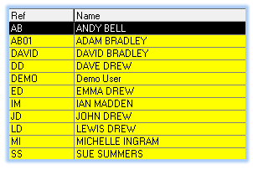

Alton CCTV
Add details

Scoot
Customer Support: 0800 160 1611.
email: info@scoot.co.uk
This relates to the mobile device switch JavaScript used on the home page of the web site.

ELVIS
Help desk: 02380 674766 [John or Peter] email: frs@hampshire.pnn.police.uk
Necessary to register the fixed IP address 213.208.108.34 but shortly changing to 82.71.55.46
This setting in Internet Explorer is normally set to Notepad it must be:
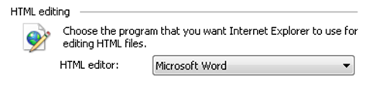
There are other essential settings which are detailed in a separate document.

Autodata
Username: JD Motors
Password: MIglia29
Telecommunication Services
Supplier contact: 01252 617116 - Roma

Most, if not all, of the telephone line rentals are paid by JD Motors which has thrown up some anomalies with features available on some of these lines that defy logic. Understandably the phone lines used for night service are covered by total care [costing £3.50] with a fee for call transfer [£1.20]. Some other analogue lines also have those facilities which seem a bit OTT.

It is thought that the Night Service lines return anonymous [or unknown] on phones with Caller Display. This could be a major issue as there is now a growing use of the “Anonymous Reject” facility and therefore you will be unable to connect with the caller.

Alton
ISDN 4 Channels [feeding the switch] 01252 544644 and 01252 544818
The switch provides extensions in the Admin Building as follows.
There is no DDI facility provided with only the ability to answer an incoming call on any extension.
A bypass number of 01420 544818 is provided when in night service mode.
[Listing the extension numbers would be a useful exercise notwithstanding the use of the buttons].

- Accounts Office
- Dave Drew
- Emma Drew
- Michelle Ingram
- Ian Madden
- Storage Area [No phone connected]
- ‘Lexus’ Room

Analogue Lines [No details known of the installed “Police Lines”]
- 01420 89768 Alarm system in the Admin Building
Broadband service from Zen on this line.
- 01420 86370 Alarm system in the Workshop
- 01420 544654 Physical fax machine disconnected
- 01420 83796 Redundant MOT line in the workshop.
No longer thought to be required
- 01420 549832 MOT Line
Can only be used for VOSA purposes

Callmaster VoIP [v1.21voice.net] – Business Service – Line Rental £10
- Ian Madden 200 92 0285 01420 448393 Mailbox:
- Workshop 200 92 0291 01420 448388 Mailbox: 9036

DrayTEL VoIP [draytel.org] – PAYG Service for POTS calls – No Line Rental
- Emma Drew 8242201 23127103 08455 570053
- Ian Madden 8453255 SE#=w1<i
- Michelle Ingram 8484873 }I1v5nNZ
- Workshop 8484869 2+5[tmAr
- Workshop2 8486316 xW$!W0%3
- 2830vN Line 2 8487825 [dE1&or<

DrayTEL Registration email addresses
8242201 emma.drew@jd-motors.co.uk Password: route654
All others numbers david@jd-motors.co.uk Password: ?

Alton Workshop
A private wire, owned and maintained by JD Motors, links between the two buildings. The cabling is used for Ethernet over VDSL2 Bridge using VC-201A adaptors from Planet [www.planet.com.tw]. The basic setup is similar to this:
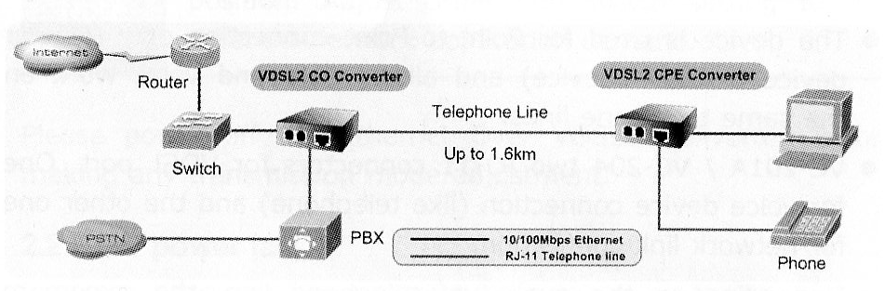
Office: 192.168.83.1 Workshop: 192.168.34.1

The Ethernet Bridge supports a connection between the two LANs and is multiplexed with a voice service to avoid cross talk. A wireless router is connected at the workshop end.

Telephone Services from Workshop phone
- VoIP: 01420 448388 [Identity 200920291 Mailbox: 9036 using 8500]
Outgoing POTS calls must use the area code even for ‘local’ calls. Calls to 2xxxxxxxx or 1xx numbers are routed over Callmaster’s VoIP service. Normally the short code is used.
- Draytel : 8484869
For outgoing calls, prefix number with #2. Normally the short code is used.
- POTS: 01420 89768 [Pass through PSTN service from 2830 router]
For outgoing calls, prefix number with #0. Area code not necessary for local calls.

Hayling Island [John Drew]
Analogue Lines
- 02392 367986 Virgin Line [Is the number still live?]
- 02392 637401 Business Line
- 02392 462607 Domestic Number

FTTC at 80/20 installed in John’s Home
Telephone Number 02392637401 on Exchange HAYLING ISLAND is served by Cabinet 15
Featured Products | Downstream Line Rate(Mbps) |  | Upstream Line Rate(Mbps) |  | Downstream Range(Mbps) | Availability Date
 | High | Low | High | Low
FTTC Range A (Clean) | 80 | 80 | 20 | 20 | -- | Available
It is not known which line is used for BT Infinity. but using 02392637401 indicates that the FTTC cabinet is virtually in the front garden if 80/20 is available!

Rushmoor
Analogue Lines
- 01252 790940 Located in the workshop.
- 01252 792103 Back office phone
supports the broadband service from TalkTalk
- 01252 793608 3 Lines [£23.30 for the extra lines]
Main advertised number and the number that is placed on night service
- 01252 793634 Front office – Phone / CC Machine / Redcare?
- 01252 717149 MOT Line
Can only be used for that purpose
- DrayTEL 8484874 !9,FpL(r

Telephone Number 01252792103 on Exchange FRENSHAM is served by Cabinet 5
Featured Products | Downstream Line Rate(Mbps) |  | Upstream Line Rate(Mbps) |  | Downstream Range(Mbps) | Availability Date
 | High | Low | High | Low
FTTC Range A (Clean) | 18.4 | 12.6 | 1.2 | 0.8 | -- | Available
FTTC Range B (Impacted) | 15.5 | 7.2 | 1 | 0.6 | -- | Available
WBC ADSL 2+ | Up to 2 |  | -- |  | 1 to 3.5 | Available

MAC code is LATH1726168/LL22M provided to Zen – FTTC Installation date awaited
Predictive speed: Down 12.6Mbps Up 0.8Mbps
Zen username: zen270161@zen Connection password: mot yet provided
SMTP: mailhost.zen.co.uk Authentication: required Port: 587 with TLS
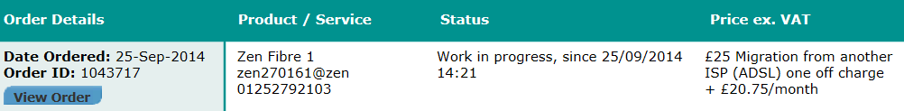

Bordon [Sue Summers]
Analogue Lines
- 01420 473650 Business Line
supports the broadband service from TalkTalk
- 01420 476418 Domestic number

FTTC at 40/10 available for Sue’s Home
Telephone Number 01420473650 on Exchange BORDON is served by Cabinet 16
Featured Products | Downstream Line Rate(Mbps) |  | Upstream Line Rate(Mbps) |  | Downstream Range(Mbps) | Availability Date
 | High | Low | High | Low
FTTC Range A (Clean) | 19.8 | 19.8 | 5 | 5 | -- | Available

Shipley Close - GU34 2RW [Dave Drew]
Analogue Lines
- 01420 83250 Domestic Number
Supports 2*Sky.
- 01420 83609 Night Service Line
Supports the broadband service
- DrayTEL 8484967
Not currently active in the router.

FTTC at 80/20 installed in Dave’s Home
Telephone Number 0142083609 on Exchange ALTON is served by Cabinet 4
Featured Products | Downstream Line Rate(Mbps) |  | Upstream Line Rate(Mbps) |  | Downstream Range(Mbps) | Availability Date
 | High | Low | High | Low
FTTC Range A (Clean) | 66.9 | 66.9 | 20 | 20 | -- | Available
MAC code is LATH1726168/LL22M provided to Zen – FTTC Installation 2 December 2013
Zen username: zen255123@zen Connection password: mMmL9ML9
SMTP: mailhost.zen.co.uk Authentication: required Port: 587 with TLS

Router Configuration Details – Alton
Access 192.168.83.1:8080 Userid: admin Password: elstead2008

Time Server: 192.43.244.18

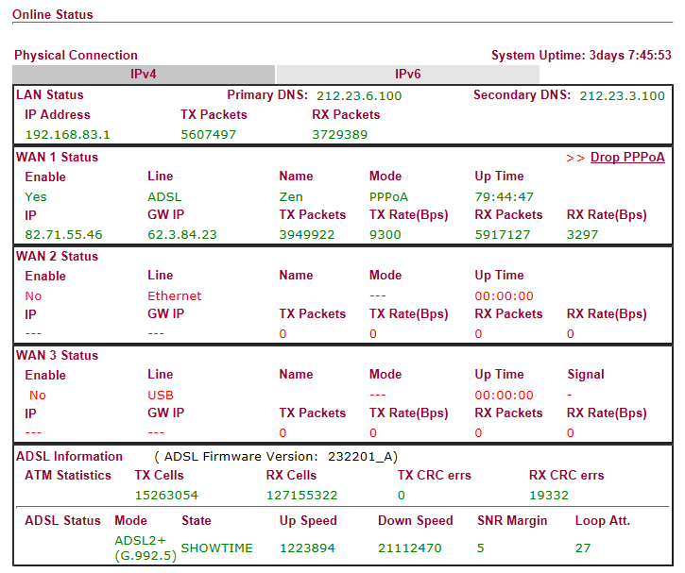

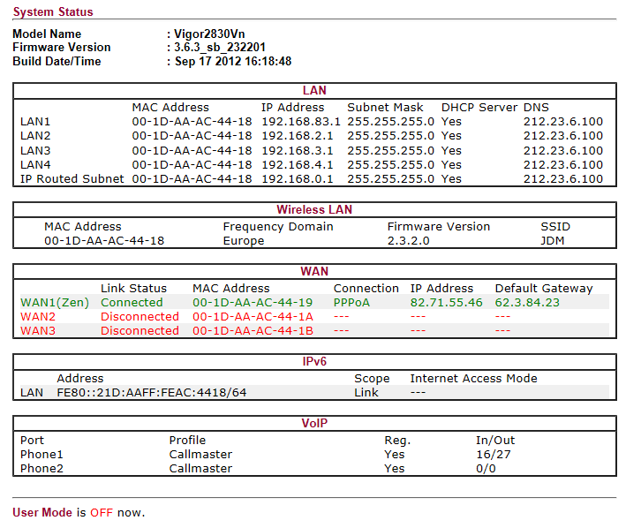

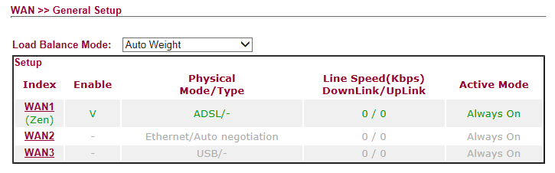
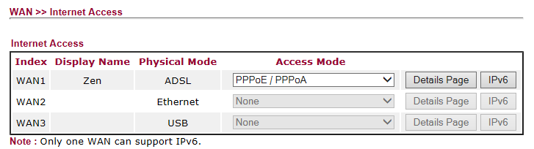
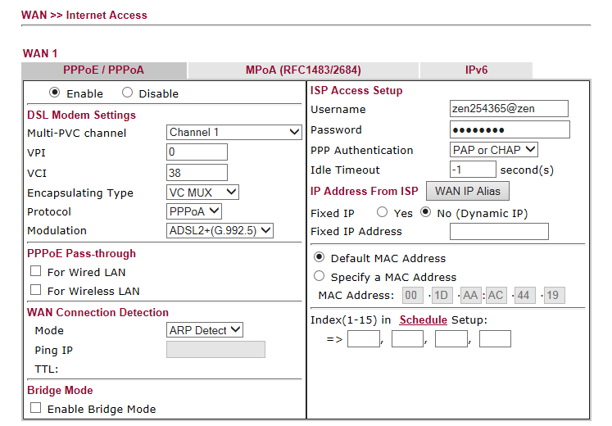
Zen Logon Password: dr7zsN5T

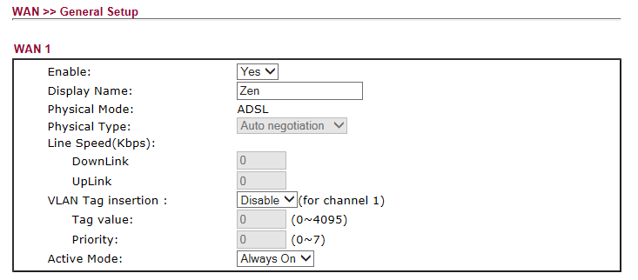

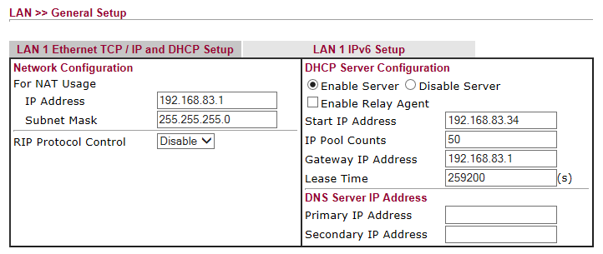
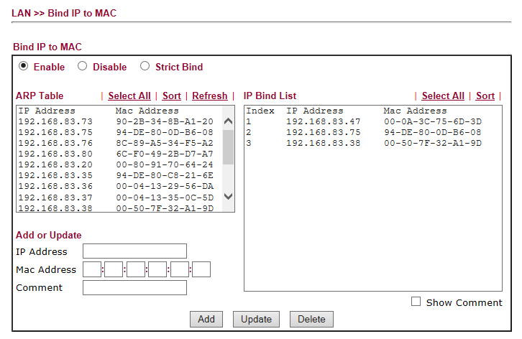
Binding for Ferrari [192.168.83.75] Workshop Router [192.168.83.38] and CCTV [192.168.83.47]
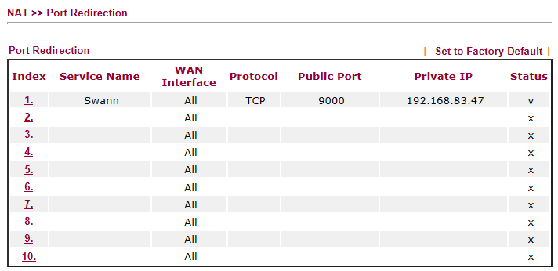

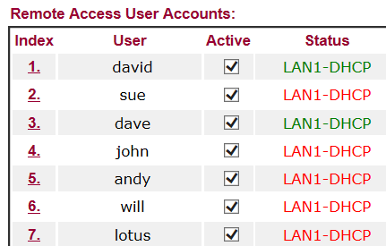

VPN Access:

VPN Account Name | Password | Normal IP Address
sue | bordon | 213.208.109.147 [Home]  81.6.247.206 [Rushmoor]
dave | shipley | 82.71.12.19
john | hayling
andy
will
cuk | caterham7
lotus | nowhere
david | elstead | 82.69.72.219

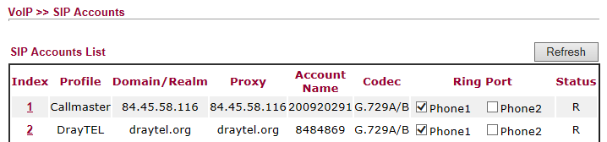

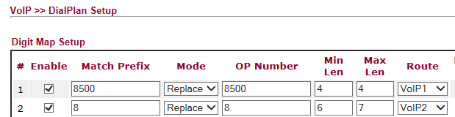
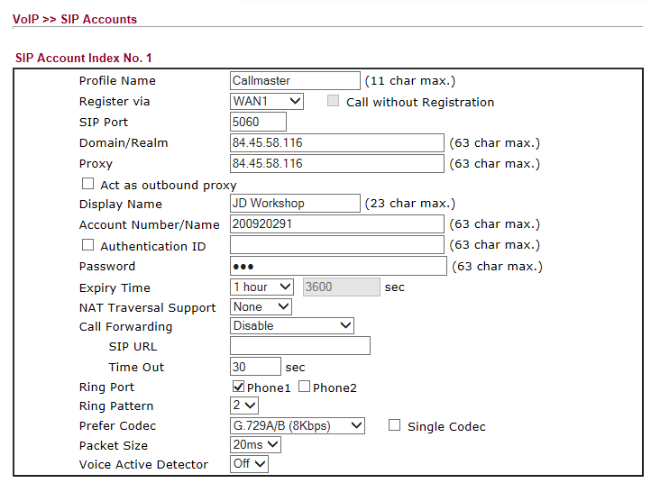

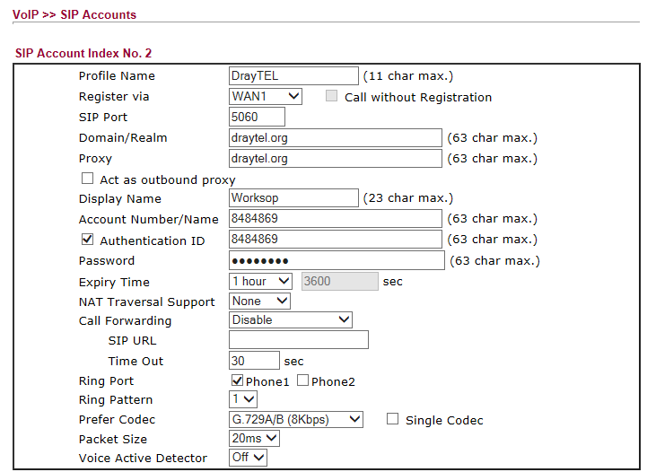

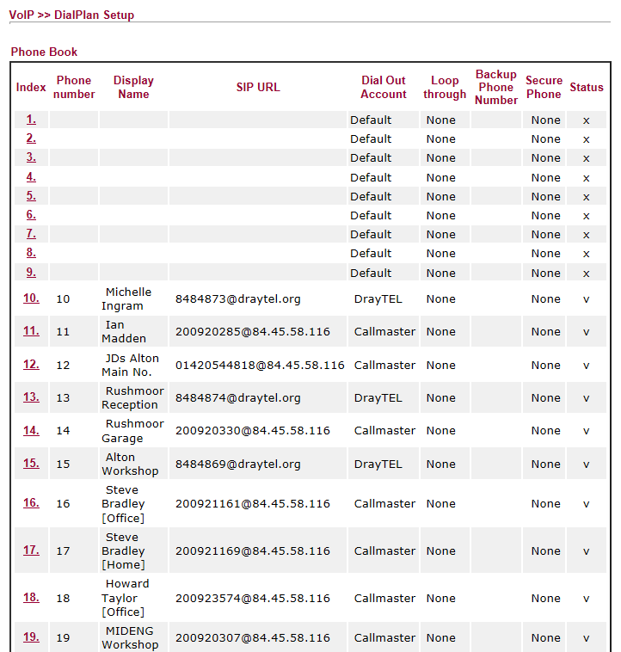
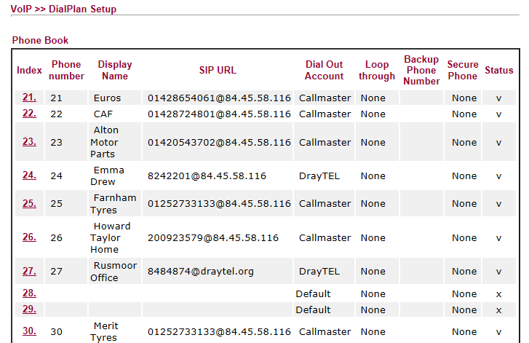
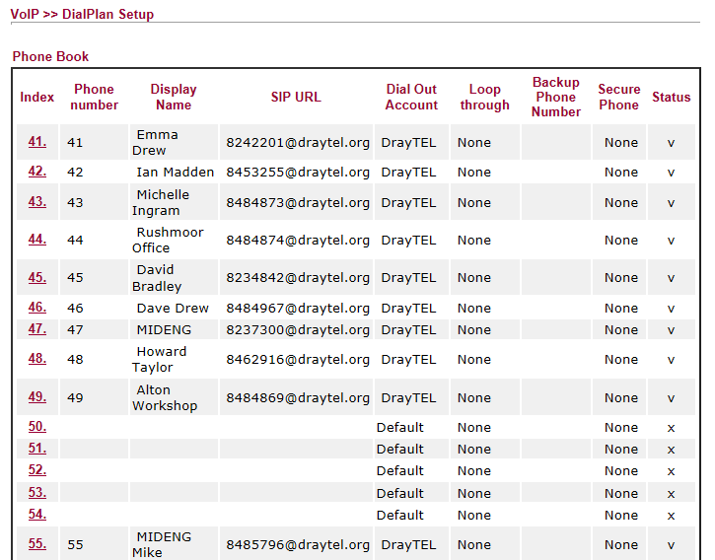

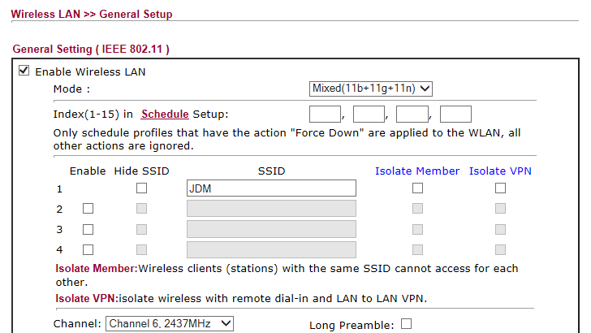

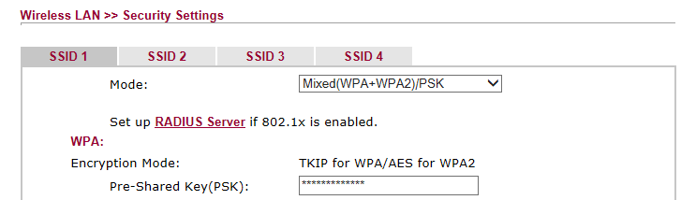

PSK: route654
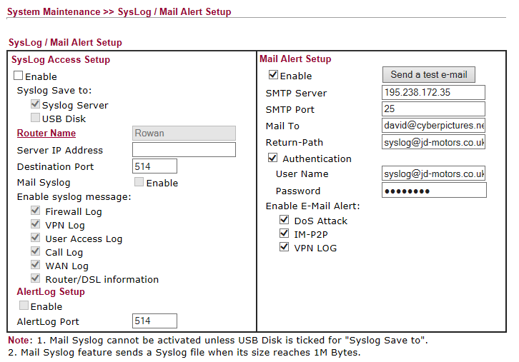

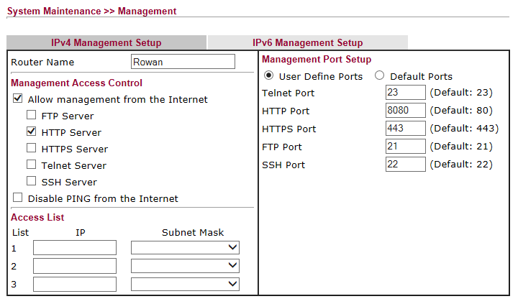

Alton Workshop Router
Access: 192.168.83.38 Userid: admin Password: elstead2008
Connection is over a VDSL2 bridge using a private wire between the two buildings
Supports Internet and VoIP from the Draytek 2830vN Router
Hardware: Planet VC-201A [www.planet.com.tw]

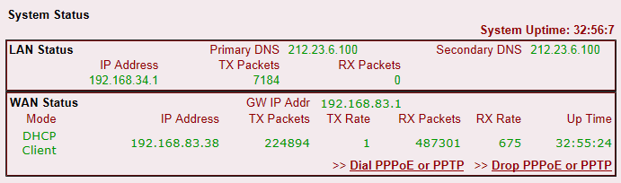

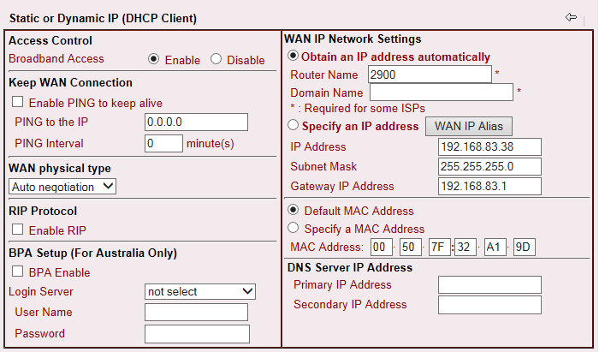

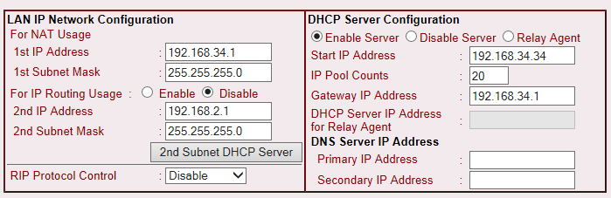

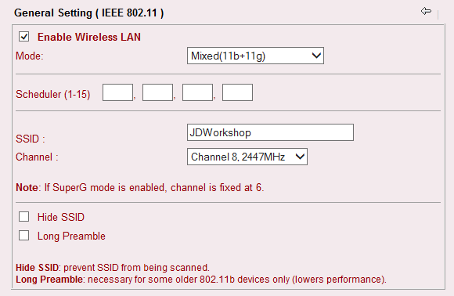

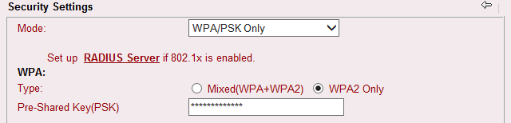

Historical Informatiom

Alton ELVIS Router
Access: http://213.208.108.34:8083/ Userid: admin Password: elstead2008
Broadband Login: jdm@gotadsl.co.uk Password: dhov5bol

Router Configuration Details at Rushmoor
Access: jdmhq.gotadsl.co.uk Userid: admin Password: elstead2008

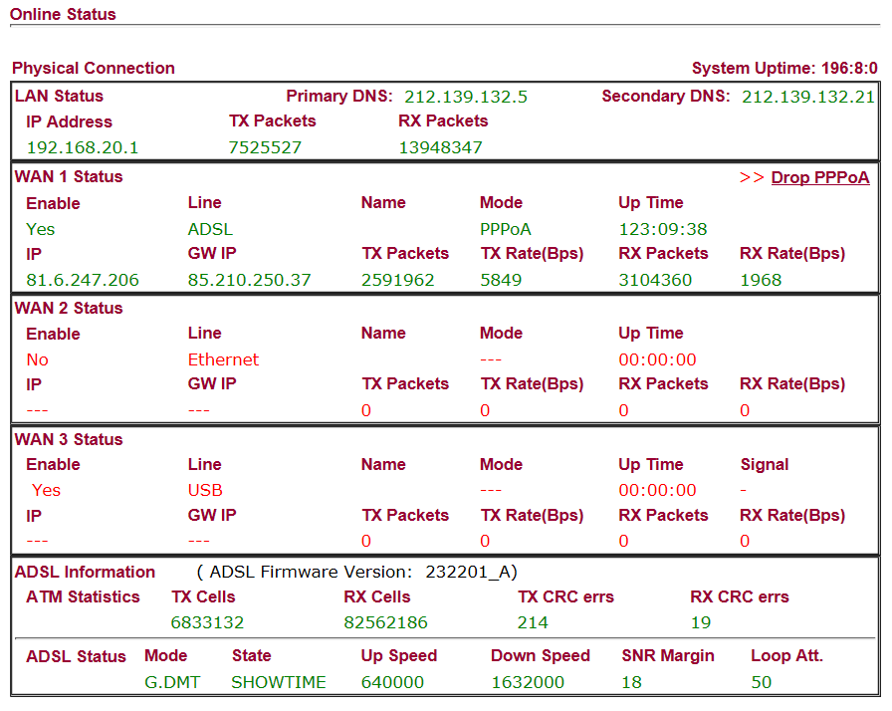

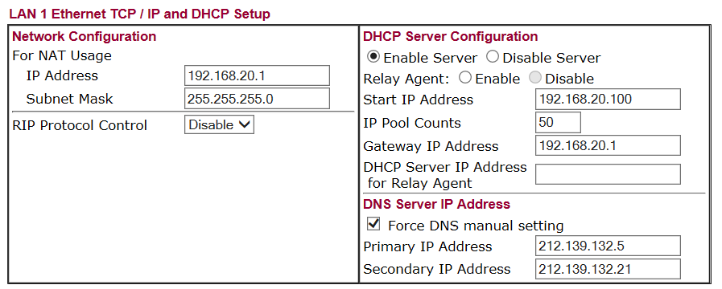
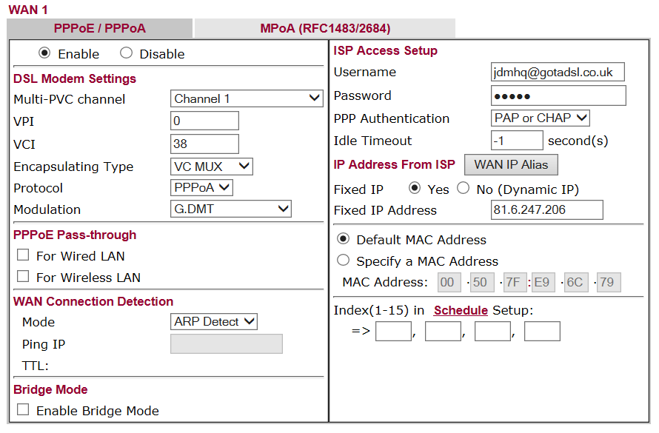

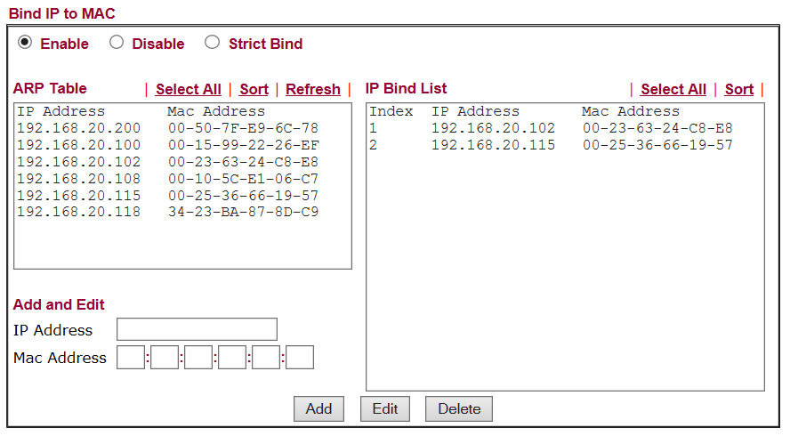

192.168.20.102 = CCTV
192.168.20.115 = MFP

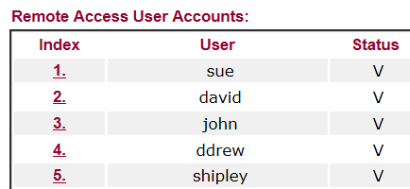

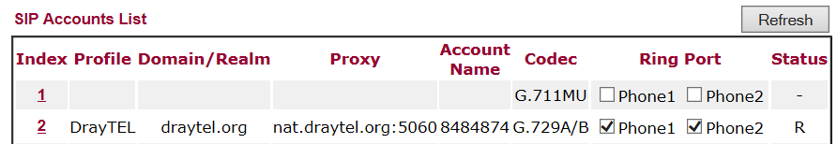

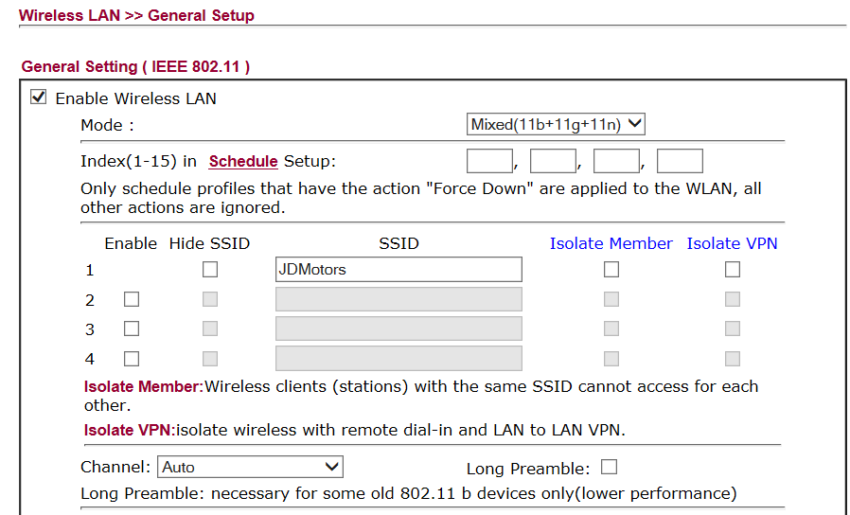

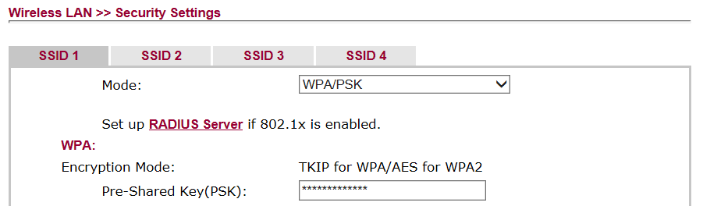
PSK = route654
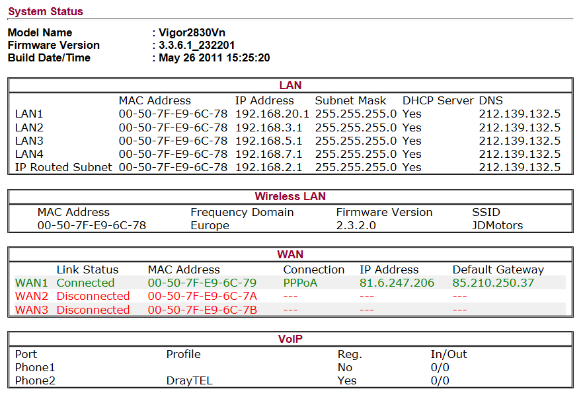
DOMAIN REGISTRATIONS:

Domain name Redirection facility with Compila
jd-recovery.co.uk

Registrant:
JD Motors

Trading as:
JD Motors

Registrant type:
UK Partnership

Registrant's address:
1 Rowan Industrial Estate
Mill Lane
Alton
Hampshire
GU34 2NQ
United Kingdom

Registrar:
Compila Limited [Tag = COMPILA]
URL: http://www.compila.com

Relevant dates:
Registered on: 25-May-2008
Expiry date: 25-May-2014
Last updated: 14-May-2012

Registration status:
Registered until expiry date.

Name servers:
ns.compila.com
ns2.sovdns.com
----------------------------------------------------------------------------------------
Domain name - Hosted with Compila
jd-motors.co.uk

Registrant:
J D Motors

Registrant type:
Unknown

Registrant's address:
Rushmoor Garage
Tilford Road
Rushmoor
Farnham
Surrey
GU10 2EP
United Kingdom

Registrar:
Compila Limited [Tag = COMPILA] URL: http://www.compila.com

Relevant dates:
Registered on: 15-Mar-2004
Expiry date: 15-Mar-2015
Last updated: 17-Feb-2013
Registration status: Registered until expiry date.

Name servers:
ns15.sovdns.com ns15sec.sovdns.com
Computer Inventory

PLBOSCHPC – Laptop – Workshop
Windows 7 Ultimate Service Pack 1
Product Part No.: X15-37374
Product ID: 00426-OEM-8992662-00352
CD Key: DYFKK-XJ9CT-G2WRP-BFQ87-R66CF
Computer Name: PLBOSCHPC
Registered Owner: Robert Bosch GmbH
Registered Organization: Robert Bosch GmbH

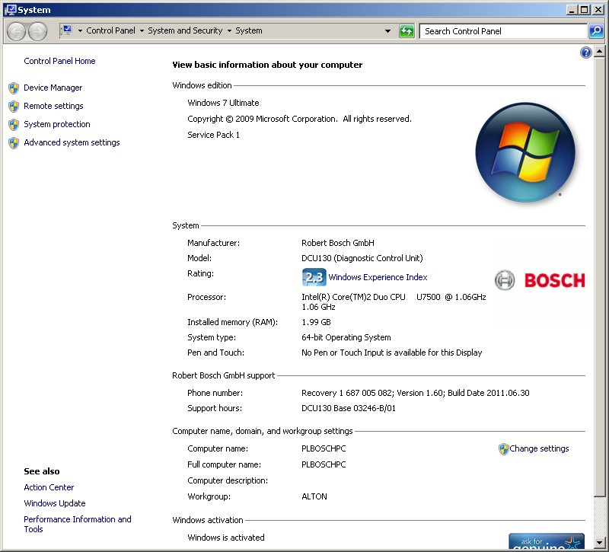

COOPER – Desktop – Dave Drew
Windows 7 Professional Service Pack 1
Product Part No.: X15-37362
Product ID: 00371-OEM-9045971-59277
CD Key: PQYY8-3728M-7K83T-2VQCV-JDDDH
Computer Name: COOPER
Registered Owner: Dave
Registered Organization:

Microsoft Office Single Image 2010
Product ID: 82503-033-1598282-11041
CD Key: V48VJ-94JJ3-MH8HX-HPTMY-P3RHW

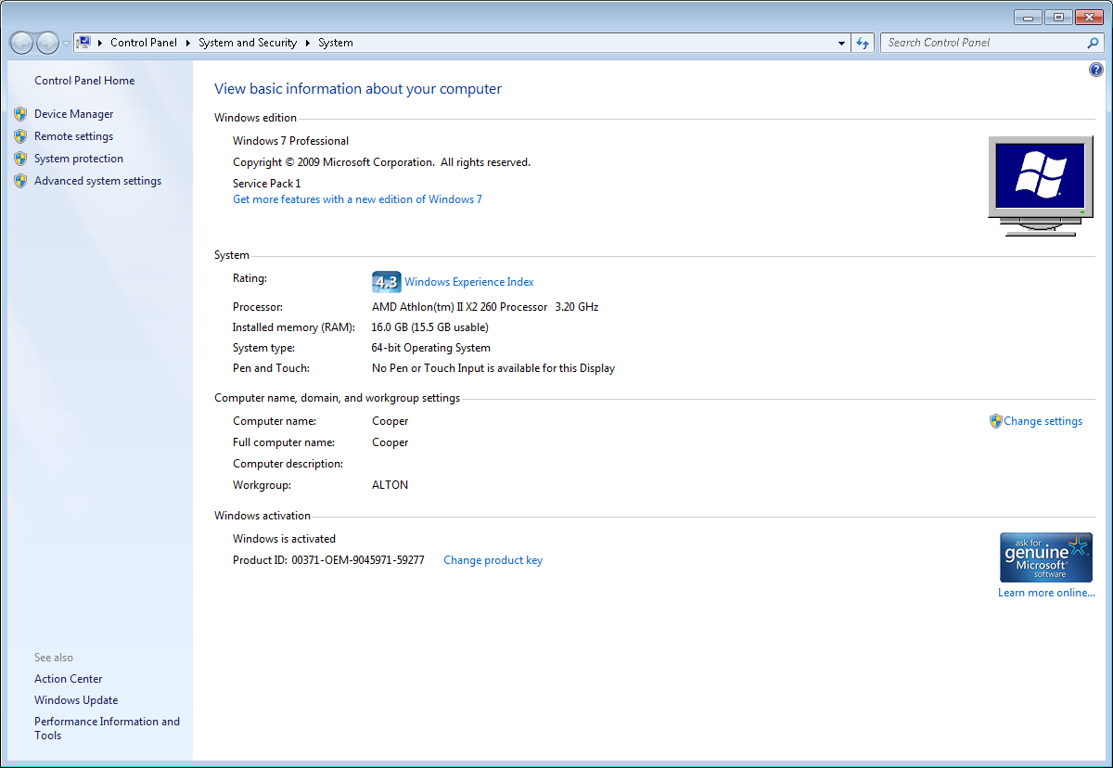

PORSCHE – Desktop – Michelle Ingram
Windows 7 Professional Service Pack 1
Product ID: 00371-OEM-9045316-11335
CD Key: JX98X-HD6FW-8QGTH-CFGVK-KW676
Computer Name: PORSCHE
Registered Owner: Mid Eng

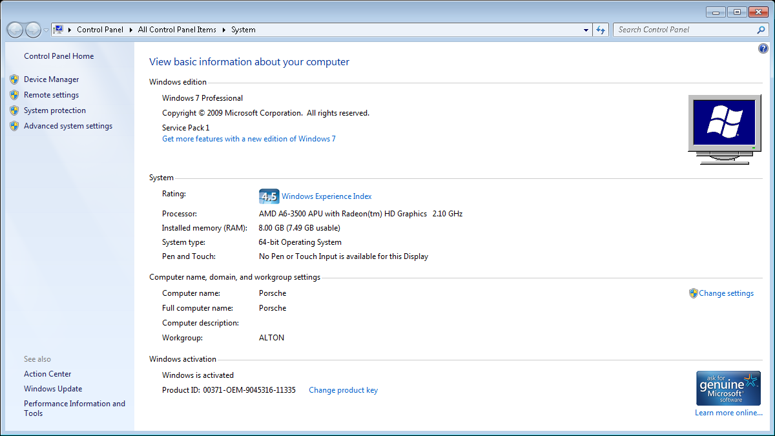



Bugatti – Desktop – Emma Drew
Windows 7 Professional Service Pack 1
Product ID: 00371-OEM-9045343-41380
CD Key: D237X-778RQ-9X93X-43TXT-4WCB8
Computer Name: BUGATTI
Registered Owner: User

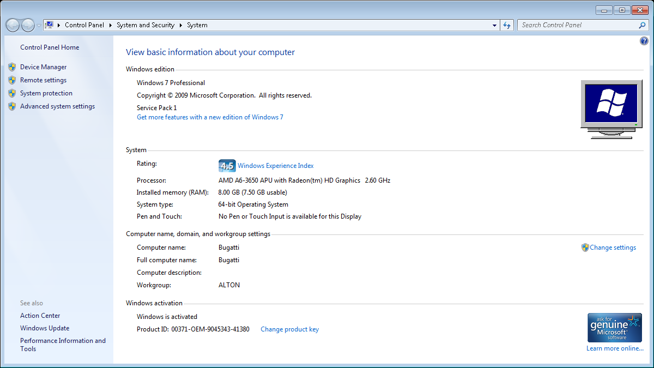

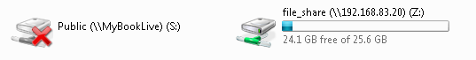

Lexus2 – Desktop – Sue Summers
Windows 7 Professional Service Pack 1
Product ID: 00371-OEM-9044443-44693
CD Key: 2QFH3-6CKK2-T9VT4-HFKM6-KDW3F
Computer Name: LEXUS2
Registered Owner: Sue

Microsoft Office Single Image 2010
Product ID: 82503-242-9975775-11336
CD Key: TJF47-9YKF3-G6DYM-DJDV6-HR9YY

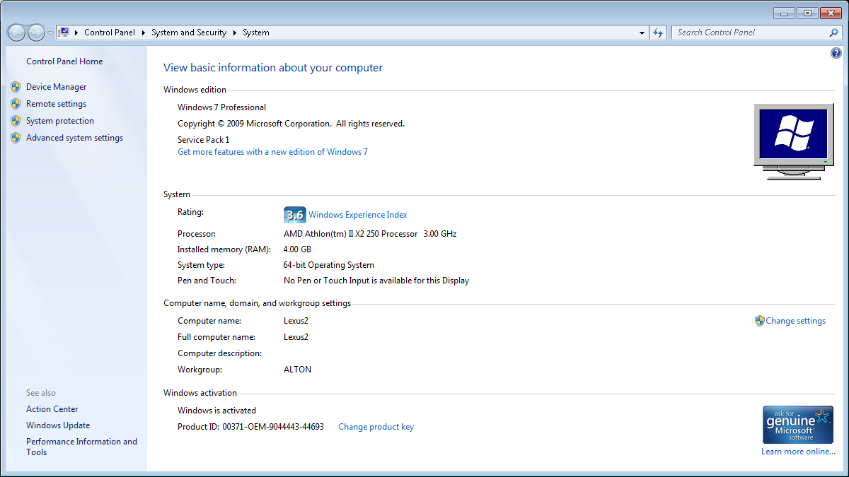



We have recently up dated our payroll to sage 50, and we also run sage 50 accounts. The thing is that the payroll is on my back computer in Alton and the Accounts is on my laptop with me, in order for me to send info to my laptop, Sage have said that the computers need to be networked together so a map can be linked? Does this make sense and is it very easy to do. If it is can you send me details or link in to do it?

Landrover – Desktop – Ian Madden
Windows 7 Professional Service Pack 1
Product Part No.: X15-37362
Product ID: 00371-OEM-9045566-83403
CD Key: GPTWX-6TKV2-MRB47-9YJXT-7M9XT
Computer Name: LANDROVER
Registered Owner: Ian
Registered Organization:

Microsoft Office Professional Plus 2010
Product ID: 82503-201-3688037-49797
CD Key: CXVQH-XRYKT-X7GD6-DCBT2-9JQBT

FERRARI – Desktop – Server
Windows 7 Professional Service Pack 1
Product Part No.: X15-37362
Product ID: 00371-OEM-9045566-96565
CD Key: C4YHD-MJT8G-66M7W-W46QV-37PCH
Computer Name: FERRARI
Registered Owner: Back Office
Registered Organization:

Maserati – Laptop – Sue Summers
Windows 8.1
Product Part No.: [8]X18-15
Product ID: 00179-60704-13133-AAOEM
CD Key: GGP7R-9NG8F-2Q7T9-X4YRV-2RYQ6
Computer Name: MASERATI
Registered Owner: Sue
Registered Organization:

Microsoft Office Single Image 2010
Product ID: 82503-033-1598282-11585
CD Key: V48VJ-94JJ3-MH8HX-HPTMY-P3RHW
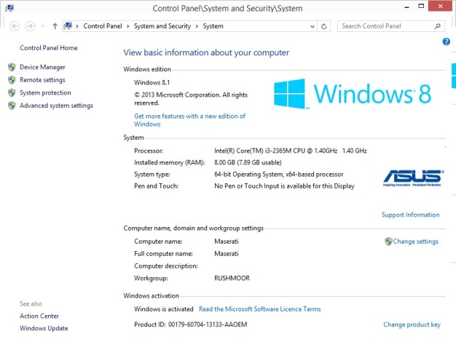
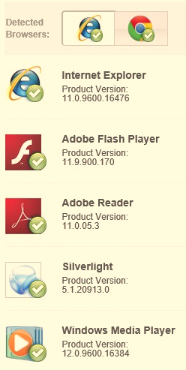 Date: Wednesday, 1 January 2014

Lotus – Desktop – Unallocated
Microsoft Windows XP Professional Service Pack 3
Product Part No.: A22-00001
Product ID: 76487-OEM-0066583-71777
CD Key: GC2YJ-R44YK-KYK8C-4XBK3-HDJ33
Computer Name: LOTUS
Registered Owner: JD
Registered Organization:

Microsoft Office Professional Plus 2007
Product ID: 89409-707-1230233-65271
CD Key: KXFDR-7PTMK-YKYHD-C8FWV-BBPVW

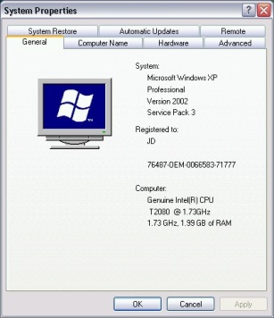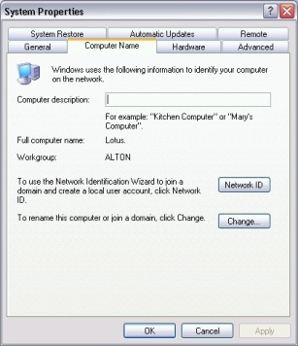

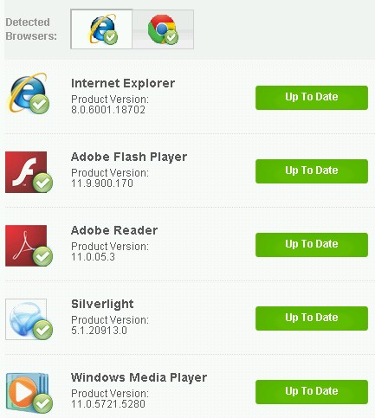 Date: Saturday, 11 January 2014
Overview of Zen Broadband Services
Each service retains the existing telephone voice provider
Zen Customer Portal: http://portal.zen.co.uk/
Username: david@jd-motors.co.uk Password: route654

Shipley Close – FTTC 80/20 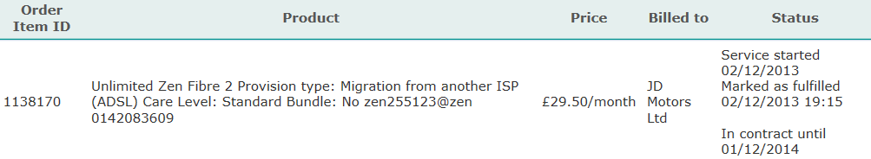

Alton Garage – ADSL Service

Rushmoor Garage – FTTC 40/10 – Order in progress
Sent: 19 September 2014 12:54 To: david@jd-motors.co.uk
TalkTalk Business account 01286418
Telephone number 01252792103
Your MAC code is: LATH4176973/MJ19M

Product Ordered from Zen is Fibre 1 without line rental so £4.25 surcharge payable. Ex-VAT.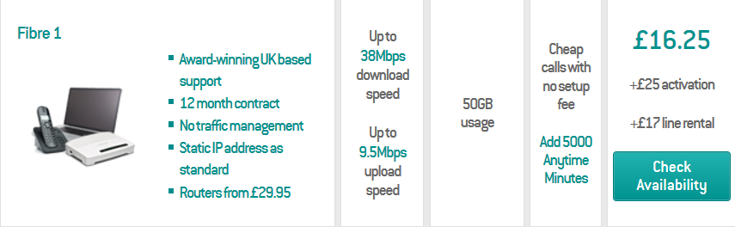
Predictive speed: Down 12.6Mbps Up 0.8Mbps
Zen Username: zen270161@zen
1st bill for installation at £25 + first payment for ongoing monthly payment of £16.25 + £4.25 excluding VAT

