Settings required for ELVIS on Windows7 64 bit
Help desk: 02380 674766 [John or Peter]
Internet Options: Advanced
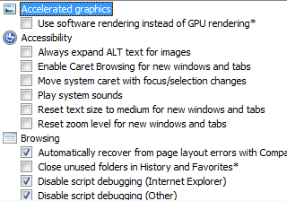
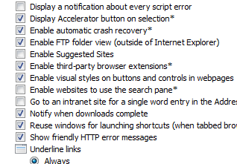
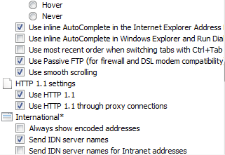
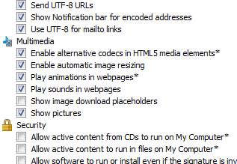
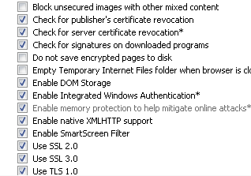
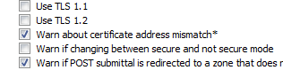

Internet Security >>> Trusted Sites >>> Sites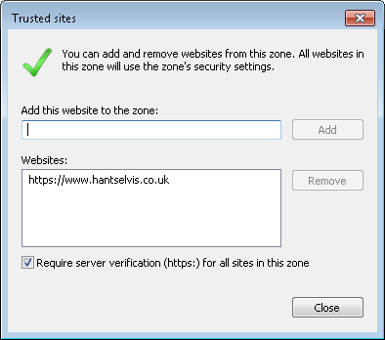
Logon using:
https://www.hantselvis.co.uk/main/start.asp?
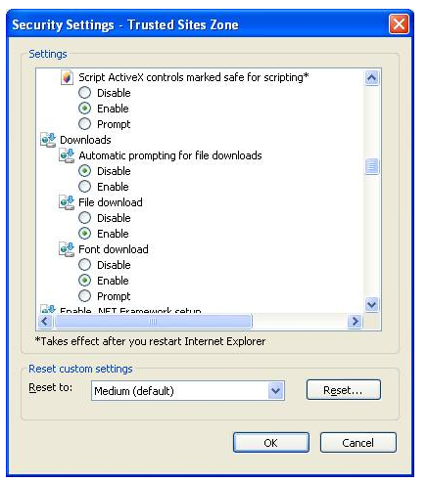
Internet Options >>> Programs >>> HTML Editing
