Lorton Agencies Computer Installation
Updated: Thursday, 20 August 2020 Contact: Leo Chapman

Business/Home Address:
34 Upper West Drive
South Ferring
West Sussex
BN12 5RH

Home: 01903 905002 #0
Mobile: 079 6639 1773

Gigaset: 213811458002

email: leo.chapman@lorage.co.uk
Web Page: http://www.lorage.co.uk
Categories: Specialist Electrical Estimating Services
cPanel: https://blazar.servers.prgn.misp.co.uk:2083/
Username: davi9994 Password: be6jp0kst5oq
ftp: --- Username: sysadmin@lorage.co.uk Password:

Lorton.Agency: Password: 8puib4n9w3vm

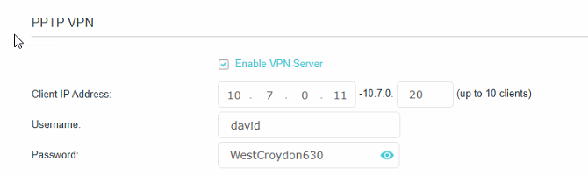

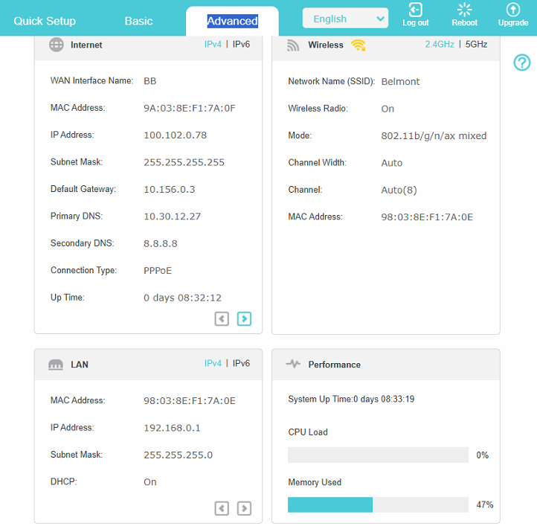

Webmail: https://mail.hostedemail.com
Userid: leo@volts.pro (Alias sysadmin@volts.pro)
password: gRcW!9q4HpLeYCc
hostname: mail.hostedemail.com

Registered On 2021-03-10 @ 14:14:47
Updated On 2023-03-21 @ 11:45:37
Expires On 2026-03-10 @ 14.14
Name Servers
dns1.4thenet.com
dns2.4thenet.com

Username: 005393
Password: rB9xhb2i
https://admin.briantbroadband.com/portal/login

Access Point in the Shed

https://www.youtube.com/watch?v=W6XU9_QEZEU

VoIP
Email: leo@volts.pro
Password: Route612!
Memorable Word: consulting
Hint: working out the price

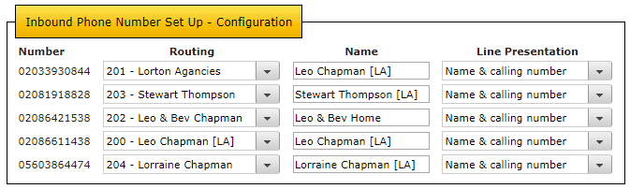

Gigaset http://192.168.134.142 Password: 1111 MAC: 00-21-04-0D-AF-A3
Personal info services configuration page: www.gigaset.net/myaccount
Username: 213811458002#9
Password: RT%KS1AL

SnomD375 http://192.168.134.154/ Userid: electric3 Password: A3S2Z2E4C5
Administrator Password: elstead2008 MAC: 00-04-13-91-2C-A3 Fixed IP

Snom360 http://192.168.134.134 Userid: electric3 Password: A3S2Z2E4C5
Administrator Password: 1618 MAC: 00-04-13-29-82-D7
To be shipped out to Stewart Thompson

CCTV
http://192.168.134.138:85/ Username: admin Password:

DrayTek AP902
http://192.168.134.135/home.asp Username: admin Password: elstead2008

System Status

Model | : VigorAP902
Device Name | : VigorAP902
Firmware Version | : 1.2.3.1
Build Date/Time | : r7791 Fri Nov 17 15:07:58 CST 2017
System Uptime | : 27d 14:22:05
Operation Mode | : AP

Backup

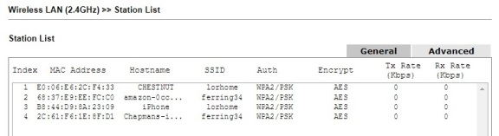

SSID: ferring34 Password: 30031945

Also connect on 902 ports the Gigaset unit and Power over Ethernet. Connected devices will show up the 2830 router’s DHCP listing.

ESET Smart Security Contact Number: 01202 405 405
4 computers until 19 July 2020
Username: EAV-32976939 Password: s5c3u3bhtt

Broadband Service from Cloudscape [From 29 December 2017]
Connection Fee Paid to:
Cloudscape Connect Ltd Leicester 07/12/17 £45.00
Card: DELTA Ending: 5578 Auth Code: 007835 ID: 585622140

Login: 01903905002@cloudscape.uk
Password: bn125rh
Static IP Address: 92.62.10.129
MTU: xxxx
Download Quota: Unlimited
LAN Start IP Address: 192.168.134.134 Pool Size: 60
Wireless SSID: Electric Password: route654 Security: WPA/PSK2 Channel: 9

MyAccount details:
URL: https://www.cloudscapeconnect.com/ [Use Customer Logon on left hand side of page]
Username: LChapman8334
Password: Mellow261Alert

Broadband Support during office hours: 0116 274 7360 -- 9am - 7pm Monday to Friday
Appears to be another number: 0345 688 7227
Accounts/General Queries: info@cloudscapeconnect.co.uk
Technical Support: support@cloudscapeconnect.com
Support Website: http://support.cloudscapeconnect.com/

Broadband Support out of Hours
SMS: Text the word "help" followed by a brief description of the problem to 07786 209609
An engineer will call you back. [The mobile phone number does not accept voice calls]
Email: support@cloudscapeconnect.co.uk
Support Website: http://support.cloudscapeconnect.com/

Entitled to five FREE pop3 email accounts which can be setup through the Customer Login pages
Service not really required
POP3: Not provided – [Normal cost £2.50 a month]
SMTP: smtp3.uk4dsl.co.uk [Only if connected to Cloudscape]

From: cloudscape
Received: Wed 06-Dec-17 14:22:20
Hi David,
Your quote includes Unlimited Data, not 100G.
(I was trying to indicate that if you signup on-line it will only offer 100G, but that does not apply to our quote.)
Regards
Kevin Peel

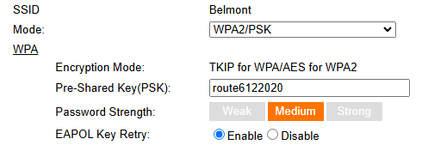

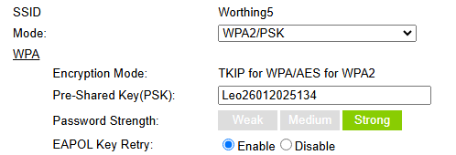

[LAN1: DHCP Server On IP Pool: 192.168.134.10 ~ 192.168.134.209]
Index IP Address MAC Address Leased Time HOST ID
1 192.168.134.10 1C-FE-2B-24-DD-88 23:23:33 amazon-e1d90405e
2 192.168.134.11 A4-0E-2B-2E-96-3D 12:56:32 Portal-F7F9CB0FDCD6
3 192.168.134.12 DC-CD-2F-99-DE-E2 17:43:55 EPSON99DEE2
4 192.168.134.13 FC-A6-67-91-01-F5 18:31:43
5 192.168.134.14 FA-59-B7-1A-D0-6E 17:34:58 iPhone
6 192.168.134.15 54-E0-19-62-E7-FC 13:09:33 54E01962E7FC-mysimplelin
7 192.168.134.16 Interface: 14 REMOTE VPN IP
8 192.168.134.17 7A-9E-72-64-F4-A7 18:02:32
9 192.168.134.18 96-D3-88-8F-9D-34 17:47:03 iPhone
10 192.168.134.19 3E-F7-D7-D4-75-69 23:55:12
11 192.168.134.21 84-C0-EF-84-03-36 21:32:37 Samsung
12 192.168.134.22 D8-5E-D3-FB-00-74 18:30:07 Lizard
13 192.168.134.23 C2-ED-8F-BC-A5-25 22:18:53 iPhone
14 192.168.134.24 64-D8-1B-07-E6-1D 12:04:35
15 192.168.134.26 D8-0D-17-01-26-AA 23:59:30 TL-WPA4220
16 192.168.134.28 68-37-E9-9C-FD-AE 0:54:55
17 192.168.134.100 00-1D-AA-3D-86-16 13:26:13
DrayTek: Vigor2830n Firmware Version: 3.6.3_sb_232201 Build Date/Time: Sep 17 2012 16:18:48
Router: http://192.168.134.1:8080 Userid: admin Password: elstead2008

Backup file of the router

Connected devices seen on Monday, 17 August 2020
DHCP Table
IP Address MAC Address HOST ID Userid Password
192.168.134.134 E0-06-E6-2C-F4-33 Chestnut
192.168.134.136 D8-0D-17-01-26-AA TL-WPA4220
192.168.134.137 68-37-E9-EE-FC-C0 amazon-0ccd497a3
192.168.134.138 FC-A6-67-91-01-F5 amazon-fda254800
192.168.134.139 00-1D-AA-3D-86-16 AP902
192.168.134.140 00-21-04-0D-AF-A3 C475IP
192.168.134.141 54-BD-79-1D-91-B2 Samsung
192.168.134.142 DC-D3-21-F1-38-FF
192.168.134.144 00-BB-3A-8B-CF-7A kindle-db65721ec
192.168.134.145 2C-61-F6-1E-8F-D1 LorrainesiPhone
192.168.134.147 B4-2E-99-CE-4A-B8 Lizard Owner £route654%
192.168.134.148 54-E0-19-15-B4-8E
192.168.134.149 E4-9A-DC-EE-F7-9F iPhone
192.168.134.151 40-BC-60-37-5A-4F iPhone

Previous Seen
IP Address MAC Address HOST ID Userid Password
192.168.134.xxx 00-25-B3-FD-19-52 HPFD1952 Make? Model? Printer?
192.168.134.xxx 5C-F9-38-1C-AB-C4 Leos-iPad
192.168.134.xxx 30-A9-DE-50-3D-9A DIXONS-JVC-TV
192.168.134.xxx F4-F5-D8-17-50-AE Chromecast
192.168.134.xxx 40-8D-5C-DE-46-FE Python leo route654

Fixed IP [Binding enabled but no entries]
IP Address MAC Address HOST ID Userid Password
192.168.134.154 00-04-13-91-2C-A3 30204778*200 electric3 A3S2Z2E4C5

ARP Table
IP Address MAC Address Netbios Name Interface
192.168.134.134 E0-06-E6-2C-F4-33 CHESTNUT LAN1
192.168.134.136 D8-0D-17-01-26-AA LAN1
192.168.134.137 68-37-E9-EE-FC-C0 LAN1
192.168.134.138 FC-A6-67-91-01-F5 LAN1
192.168.134.139 00-1D-AA-3D-86-16 LAN1
192.168.134.140 00-21-04-0D-AF-A3 LAN1
192.168.134.141 54-BD-79-1D-91-B2 LAN1
192.168.134.144 00-BB-3A-8B-CF-7A LAN1
192.168.134.145 2C-61-F6-1E-8F-D1 LAN1
192.168.134.147 B4-2E-99-CE-4A-B8 LIZARD LAN1
192.168.134.148 54-E0-19-15-B4-8E LAN1
192.168.134.149 E4-9A-DC-EE-F7-9F LAN1
192.168.134.151 40-BC-60-37-5A-4F LAN1
192.168.134.154 00-04-13-91-2C-A3 LAN1

Primary domain: lorton.agency
URL: lorton.agency/cpanel
cPanel login: ekn4voyoupdh
Password: s57vaNYp^Yws

info@lorton.agency fqv8bkcufzyhimui
leo@lorton.agency ixvjx2pnnw5z6ax3

Username: info@lorton.agency
Password: fqv8bkcufzyhimui
Incoming Server: sxb1plzcpnl487282.prod.sxb1.secureserver.net
IMAP Port: 993
Outgoing Server: sxb1plzcpnl487282.prod.sxb1.secureserver.net
SMTP Port: 465

IMAP and SMTP require authentication.

FTP
internal@lorton.agency &=hckt8+94)+a5pi

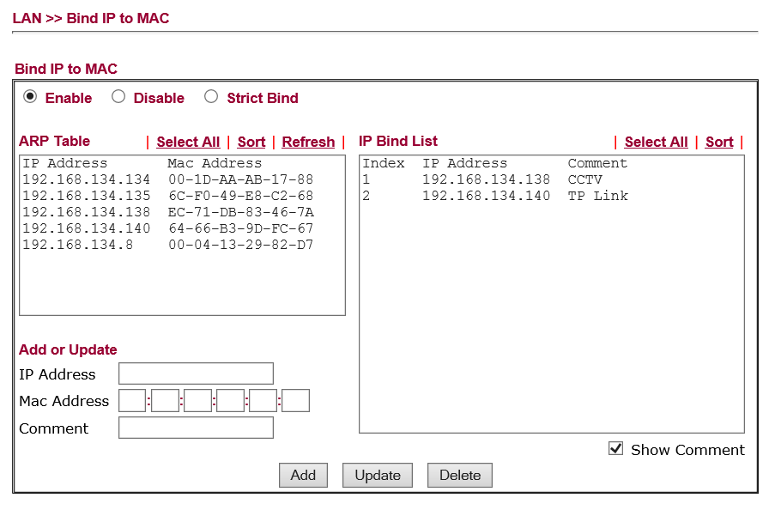

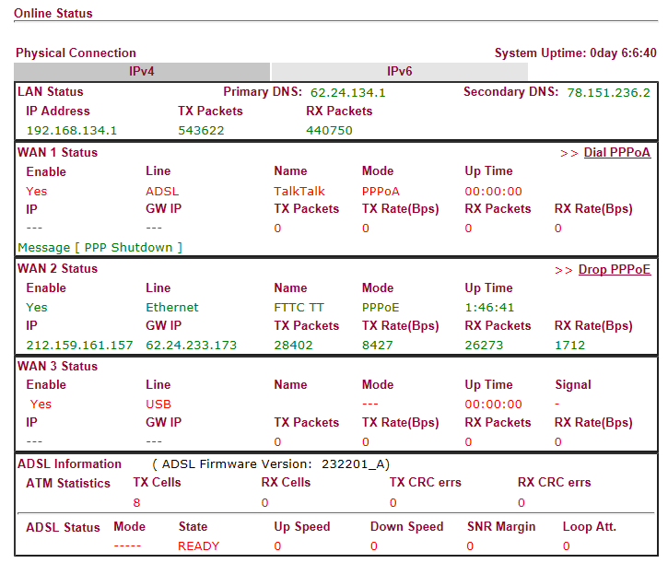
Workgroup: SUTTON

Control Panel
URL:
Username: davi9994
Password: be6jp0kst5oq

No idea what these numbers are for:
300345 230945

Email accounts
leo.chapman@lorage.co.uk erxhps8x79qf59u4
lorraine.chapman@lorage.co.uk sdzqhsx9c5se
messages@lorage.co.uk c*/zgR-?
landb@lorage.co.uk 9571542462
beverley.chapman@lorage.co.uk oz3wz47ypeu8
sysadmin@lorage.co.uk 98rg5gp0tw2i
david.mayall@lorage.co.uk 3qpb69fgetd9 safuycis3w94
richard.adams@lorage.co.uk 9p3rtrqk7xug >>> 5qav6yjs46ee >>> 9(wY}(mX7%D*
graham.travis@lorage.co.uk x91hkkqs1zpg
stewart.elliott@lorage.co.uk fx99aquqk2vg
stewart.thompson@lorage.co.uk 0o6knfpf7dy7

Forwarding
dave@lorage.co.uk >>> david.mayall@lorage.co.uk
info@lorage.co.uk >>> leo.chapman@lorage.co.uk
lwc@lorage.co.uk >>> lorraine.chapman@lorage.co.uk
ldc@lorage.co.uk >>> leo.chapman@lorage.co.uk
liam@lorage.co.uk >>> leo.chapman@lorage.co.uk

Typical email setup
Secure SSL/TLS Settings (Recommended)
Username: leo.chapman@lorage.co.uk
Password: QtZbDy7DVz
Incoming Server: mail.lorage.co.uk
IMAP Port: 993
Outgoing Server: mail.lorage.co.uk
SMTP Port: 465

IMAP, POP3, and SMTP require authentication.

Changes made 2 SEP 2020
leo.chapman@lorage.uk VtJzY3p1v3
leo.chapman@lorage.co.uk zhna4dj90zp0de55
messages@lorage.co.uk cey80v9uymnrs6uc

Casa5516

leo.chapman@lorage.uk QtZbDy7DVz
lorraine.chapman@lorage.uk FBa6jNF0ek
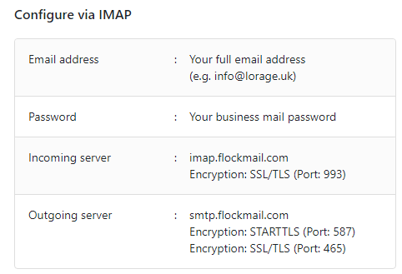

For installing our iOS app, you can refer to this link: https://apps.apple.com/app/flock-mail/id1435996267

For installing our Android app, you can refer to this link: https://play.google.com/store/apps/details?id=com.flockmail

Email information - Browser URL: webmail.cldmail.co.uk
Inbound Server (POP3):
Server: mail.cldmail.co.uk
Port: 993 (use SSL)

Outbound Server (SMTP):
The outbound mail server requires authentication.
Server: smtp.cldmail.co.uk
Port: 587 (SSL/TLS)

warren@cldmail.co.uk Route6542020

Email Account – lorage.uk
Outbound Server (SMTP):
The outbound mail server requires authentication.
Server: smtp.flockmail.com
Port: 465 (SSL/TLS)

messages@lorage.uk

Email account details for AP902
Outbound Server (SMTP):
The outbound mail server requires authentication.
Server: smtp.cldmail.co.uk
Port: 465 (use SSL or SSL/TLS)
Username: ap902@cldmail.co.uk
Password: Route6542020
Hollycroft
Password: 9PA41046S6387093N

Printer on Python
HP Photosmart 6520 series (Copy 1)
HPA4Office

Yousendit / Hightail
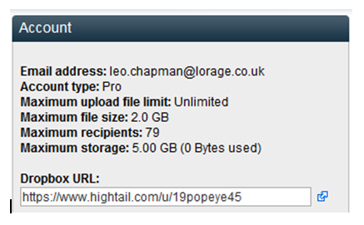
Login: https://www.hightail.com/login
Password: 19Popeye45

Setup for email client for


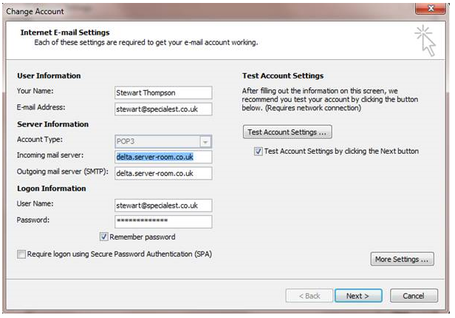
Where:
leo@specialest.co.uk rxiXeGFqHAJ
lorraine@specialest.co.uk eEhRJuYPML

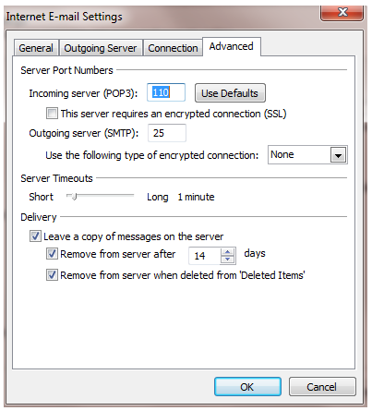

Email Footer:
This e-mail and attachments is/are confidential and may also be privileged. If you have received it in error, you are on notice of its status and please contact the sender. Unauthorised use, disclosure, copying or alteration of this message or its attachments is forbidden and to do so could be in breach of confidence. Views expressed in the e-mail are not necessarily the views of Specialest Limited

Mailing List
http://www.lorage.co.uk/mailman/admin/sgc_lorage.co.uk Password: elstead2008

Typical Setup for GMAIL in Outlook 2010
Refer to these instructions

http://www.lytebyte.com/2009/08/11/guide-to-setup-gmail-imap-in-outlook-2010/

http://www.lytebyte.com/2008/06/08/how-to-solve-when-two-copies-of-sent-mail-are-saved-while-using-gmail-and-outlook/

Call Fwd
8611438
David
8611438
House
Gary
Paul
331290
.
331290
.
Lorraine
Cut out the label and replace the existing one making sure the plastic cover is not lost!
Registrations

Domain name:
lorage.co.uk

Registrant:
Lorton Agencies Ltd

Registrant's address:
26 Avenue Road, Belmont
Sutton
Surrey
SM2 6JB
United Kingdom

Registrar:
Compila Limited [Tag = COMPILA]
URL: http://www.compila.com

Relevant dates:
Registered on: 08-Oct-2009
Expiry date: 08-Oct-2013
Last updated: 11-Nov-2011

Name servers:
ns12.sovdns.com
ns12sec.sovdns.com

Domain Name: lorton.agency
Domain ID: 41c16b27f5b04f79981ddd40d6ae5a2f-D
WHOIS Server: http://domains.meshdigital.com
Referral URL: http://www.domainbox.com
Updated Date: 2014-06-18T13:05:25Z
Creation Date: 2014-06-18T13:05:24Z
Registry Expiry Date: 2015-06-18T13:05:24Z
Sponsoring Registrar: Mesh Digital Limited
Sponsoring Registrar IANA ID: 1390
Domain Status: clientDeleteProhibited
Domain Status: clientTransferProhibited
Domain Status: clientUpdateProhibited
Registrant ID: mntb2343014403
Registrant Name: Leo Chapman
Registrant Organization: Lorton Agencies Ltd
Registrant Street: 34 Upper West Drive
Registrant City: Worthing
Registrant State/Province: Worthing
Registrant Postal Code: BN12 5RH
Registrant Country: GB
Registrant Phone: +44.1252758960
Registrant Phone Ext:
Registrant Fax:
Registrant Fax Ext:
Registrant Email:
Admin ID: mntb2343014403
Admin Name: Leo Chapman
Admin Organization: Lorton Agencies Ltd
Admin Street: 34 Upper West Drive
Admin City: Worthing
Admin State/Province: Worthing
Admin Postal Code: BN12 5RH
Admin Country: GB
Admin Phone: +44.1252758960
Admin Phone Ext:
Admin Fax:
Admin Fax Ext:
Admin Email:
Tech ID: mnt4c843014406
Tech Name: Webfusion Limited
Tech Organization:
Tech Street: 5 Roundwood Avenue
Tech City: Stockley Park
Tech State/Province: Uxbridge
Tech Postal Code: UB11 1FF
Tech Country: GB
Tech Phone: +44.3454502310
Tech Phone Ext:
Tech Fax:
Tech Fax Ext:
Tech Email:
Name Server: ns.123-reg.co.uk
Name Server: ns2.123-reg.co.uk
DNSSEC: unsigned
Typical Setup for email client on Lorage

Step-by-Step Setup Guide
- Log in to your Router:
  - Open a web browser and go to your router's IP address, such as tplinkwifi.net.
  - Log in using your router's password or TP-Link ID.
- Navigate to VPN Settings:
  - Go to the Advanced settings menu.
  - Find and click on the VPN Client tab.
- Enable the VPN Client:
  - Enable the VPN Client function.
  - Save the settings to apply the changes.
- Add a VPN Server Profile:
  - Click Add or Import to create a new VPN profile.
  - If using a service like NordVPN or ExpressVPN, download the OpenVPN configuration file for the desired server location.
  - Select OpenVPN as the VPN type if given the choice.
  - Import: the configuration file or manually enter the server address, username, and password.
- Select Devices to Use the VPN:
  - In the device list section, choose the devices on your network that you want to route through the VPN connection.
- Enable the VPN Connection:
  - Enable: the slider for the newly created profile.
  - The router will attempt to establish a connection to the VPN server.
Important Considerations
- VPN Provider: The process requires configuration files or settings from your VPN service provider.
- Router Compatibility: Ensure your specific router model supports the VPN Client function.
- Device Assignment: By default, all devices on the network might use the VPN, or you might need to select specific devices to route traffic through the VPN.

Historical Information

Wireless Extender [192.168.1.243] Not used
Userid: admin Password: admin
ESSID: Sitecom665416 Password: sanlameer5

Broadband Service from TalkTalk Connected to: 01903905002
TalkTalk Help Desk: 0800 083 3003 Security Question answer: ?
Account Number 882 01417131
Registered Address: david@cyberpictures.net
Payment by Lloyds Direct Debit
DrayTek: Vigor2830n Firmware Version: 3.6.3_sb_232201 Build Date/Time: Sep 17 2012 16:18:48
Router: http://192.168.134.1:8080 Userid: admin Password: elstead2008
[Direct access of http://212.159.161.157:8080/ not achieved with IE10 but OK with Firefox]
LAN Start IP Address: 192.168.134.134 Pool Size: 60
Wireless SSID: Electric Password: route654 Security: WPA/PSK2 Channel: 9
Credentials for TalkTalk Connection:
Login: 01903905002@talktalkbusiness.net
Password: A3S2Z2E4C5
Static IP Address: 212.159.161.157

