The IP address of 64.226.73.75 is trying very hard to log into the MIDENG VoIP Router.
The password wasn't particularly strong so it is now:
36eq3b3qmkxo^&^D

FileZilla Setup
gafrdvxwncst
nDi7!YgZ2k!1
92.205.172.138

ftp
internal@mideng.co.uk
vo5msyp6w8o03a5v

Username: ap903@mideng.co.uk
Password: mm84p7zjcwn0zhvh
Outgoing Server: mail.mideng.co.uk
SMTP Port: 465
POP3 and SMTP require authentication.

Username: margret2763@mideng.co.uk
Password: jbh92wden9yxt6sr
Outgoing Server: mail.mideng.co.uk
SMTP Port: 465
POP3 and SMTP require authentication.

Username: stable2763@mideng.co.uk
Password: yympdrfyuz6nfokp
Outgoing Server: mail.mideng.co.uk
SMTP Port: 465
POP3 and SMTP require authentication.

Username: dormers@mideng.co.uk
Password: uscsfrf3osae0a4c
Outgoing Server: mail.mideng.co.uk
SMTP Port: 465
POP3 and SMTP require authentication.

Username: datarouter@mideng.co.uk
Password: owv8iv0n2hdjy0l7
Incoming Server: mail.mideng.co.uk
IMAP Port: 993
Outgoing Server: mail.mideng.co.uk
SMTP Port: 465
IMAP and SMTP require authentication.

Username: broxhead@mideng.co.uk
Password: jvhb5otcz9hp
Incoming Server: mail.mideng.co.uk
IMAP Port: 993
Outgoing Server: mail.mideng.co.uk
SMTP Port: 465
IMAP and SMTP require authentication.

Computer Installation and Telecommunication Services Data Sheet
Registration Number: 432447

Main Business Address:  Rumbolds Hill  Midhurst  GU29 9DD | Broxhead  Headley Wood Business Park  Broxhead Farm Road  Lindford  Bordon  GU35 0NY
Selham Base  Area 14  W L West & Sons Ltd  Selham  GU28 0PJ | Brian Morgan’s Home:  Dormers  72 Petersfield Road  Midhurst  GU29 9JR
Guy Morgan’s Home  21 Great Stable Road  Chichester  PO19 6FF | Mike Morgan’s Home:  8 St Margaret’s Way,  Midhurst  GU29 9FQ

Midhurst Garage: 01730 812162
Broadband Line #1 FTTC: 01730 858011 [Cloudscape] 92.62.0.113
Broadband Line #2 FTTC: 01730 813999 [Zen] 88.97.19.69

St Margaret’s Way [Mike] FTTC: 01730 816595 [Cloudscape]

Area 14 Line #1 FTTC, Alarm & Broadband: 01798 861602 [Cloudscape] 92.62.10.44
Area 14 Line #2 ADSL2+, Broadband: 01798 861829 [Zen] 82.69.83.201
Area 14 Line #3: ADSL2+, Broadband: 01798 860984 [Cloudscape] 92.62.0.46
Area 14 Training Room: 01730 888241 [Ext 224] [Voipfone]
Area 14 SOCO Bay and Barn 01730 888438 [Ext 218] [Voipfone]
Midhurst Car and Van Sales: 01730 888162 [Voipfone]
Brian Morgan: 01730 888062 [Voipfone] 01730 812380 [Home BT]

Mobile Numbers:
Guy Morgan: 07769 723651
Andy: 07795 678143 or 07860 381586
Mike Morgan 07860 591810
Brian Morgan 07766 774338

SSIDs for the Workshop
Name Password Network
MIDENG-WORKSHOP Cornflakes2020* 20
MIDENG-Guest rx2r9mre
MIDENG-Paddy paddy309
MIDENG-Mike HORSERACING 100

SSIDs for Recovery Control
Name Password Network
MIDENG-500 trolleybus2020* 100
MIDENG-Paddy Shreddies2020*
MIDENG-Admin route654 20

Details of Mike’s AP – Feed from Workshop Switch
2.4GHz Access Point Network - http://192.168.100.102/
Security: WPA2-PSK [AES]
Network Name (SSID): MIDENG-Mike
Password (network key): HORSERACING

Hardware Version: WN3000RPv3
Firmware Version: V1.0.2.24

Connection to Existing Network (2.4GHz)
Connection Type: Ethernet
Connection Status: Connected

Access Point Wireless Settings (2.4GHz)
Name (SSID): MIDENG-Mike
Channel: 5(p)+9(s)
Region: Europe
Wireless mode: Up to 300Mbps
Wireless AP: ON
Broadcast Name: ON
Wi-Fi Protected Setup: Configured

Login: david@wg4.uk
Password: Route612

Security Answers: Jean
Ada

Active and in use on Thursday, 26 September 2019
VoIPtalk subscribers prefix the DrayTEL number with 73

- Registered email account: david@mideng.co.uk Password: route654
- Registered email account: zen255936@zen.co.uk Password: route654
- Registered email account: david@mideng.co.uk Password: route654

User Number Password Installed POTS Registered
Mike [Office] 8495474 cz!tjU4d D375 1
Adam 8491776 5i3^mXs} VoIP Router 1
Mike [Home] 8488593 gUk[5DRc 2830 router 0845 557 8295 2
Guy [Office] 8488326 e,YOQpH0 D375 3
Em 8485796 H[0e0cCH 3

Historical Registrations

Mideng Admin [Office] 8485796 H[0e0cCH david@mideng.co.uk route654
Selham Office/Barn 8493257 Y1vW2)4) selham@mideng.co.uk elstead2008 router Port 1 0845 557 8836

Selham Classroom 8493558 L(j48y)L david@mideng.co.uk route654 router Port 2
Tony 8237300 84825637 david.bradley@mideng.co.uk route654
Training Room 8495705 VRoAvy%9 david@mideng.co.uk route654

SOCO 8495935 JLR.5-ba petersfield@mideng.co.uk elstead2008 0843 849 6842
Voipfone
Account Number: 30204802
Phone Password: 904290
Registered email address: emily@mideng.co.uk
Account Password: Recovery9*
Account verification: MIDENG

Garage Broadband Services

TalkTalk Connected to 01730858011 with 7-day business support
Account Number: 882 01292148
TalkTalk Help Desk: 0800 083 3003 Security Question answer: trolleybus

Router IP: http://192.168.100.1:8080/
Draytek 2860Vac Firmware Version: 3.8.8_BT Build Date/Time: May 18 2018 17:26:52
Username: admin Password: farnham2020
DHCP Server: Enabled. Start IP Address: 192.168.100.100 Pool Size: 98
Workgroup: MTS

Credentials for TalkTalk Connection
Login: 01730858011@talktalkbusiness.net
Password: D4E3Z6D3J2
Static IP Address: 212.159.144.127

TalkTalk Account Panel
Go to https://myaccount.talktalkbusiness.co.uk/login/?ReturnUrl=%2fHome%2f

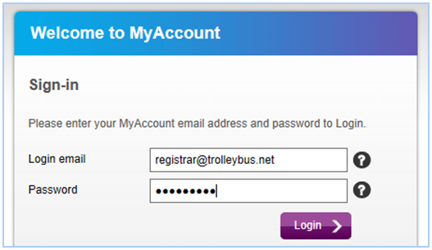
The password is: Route654 Security question: Where were you born? Answer: Croydon

Last known TalkTalk Line Rental and Broadband Service was £46.50 + VAT = £55.80
[£14.50 Line Rental + £32.00 for the Broadband = £46.50].
Does Include free minutes to 01/02/03 numbers. Primary use for the broadband service is for data traffic.

With VAT £38.40

Zen Line Rental 01730 816791 and Broadband Service = £48.50 + VAT = £58.20
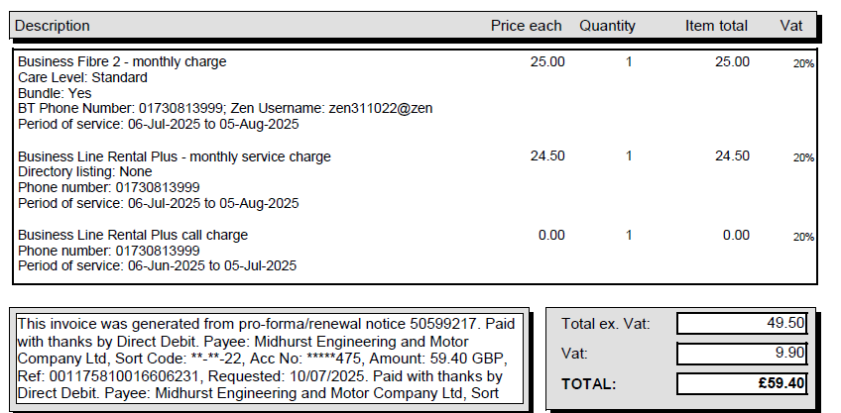
Zen
Connected to 01730
Customer Portal: http://portal.zen.co.uk/ Userid: mike@mideng.co.uk Password: route654
Help Desk: 01706 902000

Router IP: http://192.168.100.20:8080/
Draytek 2860Vac Firmware Version:
Username: admin Password: 36eq3b3qmkxo^&^
DHCP Server Disabled
Workgroup: MTS

Credentials for Zen Connection
Login: zen311022@zen
Password: fAaCLYq6
Static IP Address: 88.97.19.69

Extracted Thursday, October 27, 2016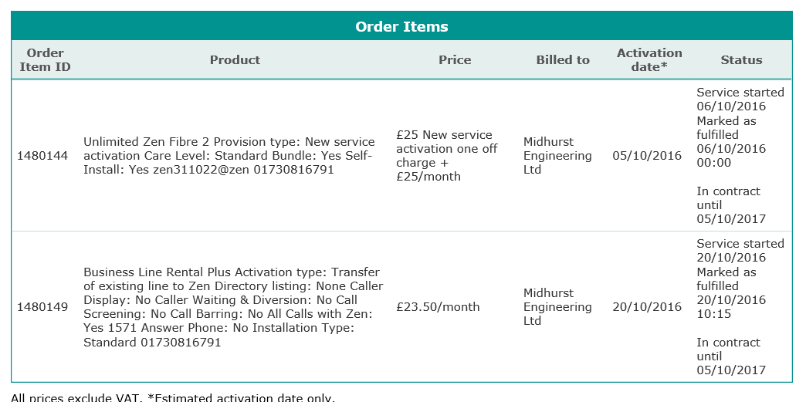

VAT on £48.50 is £9.70; Total monthly charge £58.20

Broadband Service from Cloudscape at Guy’s Home - Account Number: 882 01292148
TalkTalk Help Desk: 0800 083 3003
Security Question answer: trolleybus

Username: admin Password: elstead2008
DHCP Server Enabled. Start IP Address: 192.168.8.80 Pool Size: 30
Workgroup:
Static IP Address:

URL for “My Account”: https://supportcentre.talktalkbusiness.co.uk/home
My Account login: david@mideng.co.uk Password: L"p@K@*.A7S2T4_N
House Move order details RO-39191
Items | Monthly Total  exc VAT | One-Off Total  exc VAT | Total  exc VAT
Complete Fibre Business Broadband | £32.00 | £0.00 | £32.00
Total exc VAT | £32.00 | £0.00 | £32.00

Order summary
This is a copy of the details we hold on record for you.

+ Account Name: Midhurst Engineering and Motor company Ltd
+ Contact Name: David Bradley
+ Phone:
+ Mobile: 07836547472
+ Email:
mideng.co.uk
+ Activation Address:
+ Directory Listing:

Your order details
Complete Fibre Business Broadband £32.00 £0.00 £32.00 Extra £1 for fixed IP
Total exc VAT £32.00 £0.00 £32.00 £38.40 with VAT

Totals
+ Total Monthly Charges (exc VAT): £32.00
+ Total One Off Charges (exc VAT): £0.00
.
Estimated Line Speeds
The advertised download Speed for your TalkTalk package was up to 76Mbps and the advertised upload speed was up to 20Mbps.

As part of our mission to make broadband fairer for everyone, we're giving you a clearer look at the speeds you can expect. The speed we expect for your Fibre Business Broadband product, on the telephone number registered to 01730858062 is given below:

Your maximum Download Speed is: 75.44Mbps. However, typically your Download Speed should be between 71.41Mbps and 73.6Mbps.
Your Upload Speed should be between: 17.92Mbps and 18.86Mbps and shouldn’t fall below 5Mbps.

You are guaranteed a minimum download speed of 66.76Mbps. If you report your speed falling below the guaranteed minimum speed and we are unable to resolve the issue within 30 days, you have the right to cancel your contract without termination charges in line with the Ofcom Business Broadband Speeds Code of Practice.

Piwigo
http://mail.mideng.co.uk/piwigo
Administrative URL: http://mail.mideng.co.uk/piwigo/admin.php
Login: davi7174 Password: MNM9845kHGe

DHCP ADMIN LAN
IP Address MAC Host ID Logon Password User
192.168.100.111 58-03-FB-CD-60-A8 CCTV admin route654
192.168.100.129 40-8D-5C-C5-C4-23 Sunset Mideng recovery1 Wall mounted

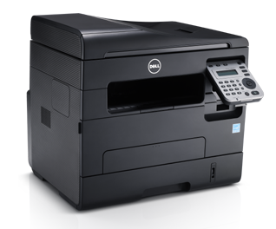
The Dell Printer: B1265dnf MFP
Model Name: B1265dnf Laser MFP
Host Name: DEL001599DC8553
Serial Number: 98BL7S1
Service Tag: 98BL7S1
IP Address: 192.168.100.30 (Fixed IP)
MAC Address: 00:15:99:DC:85:53
Location: MIDENG Recovery
Administrator: Mike Morgan
mike@mideng.co.uk
User ID: admin
Password: route654
The printer is hardwired by Ethernet cable

https://www.dell.com/support/home/en-uk/drivers/driversdetails?driverid=kpjnv&oscode=wt64a&productcode=dell-b1265dnf
Purchased from ? on ? Use the setup program on Ems PC in the installation folder
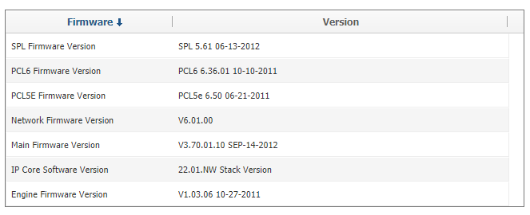
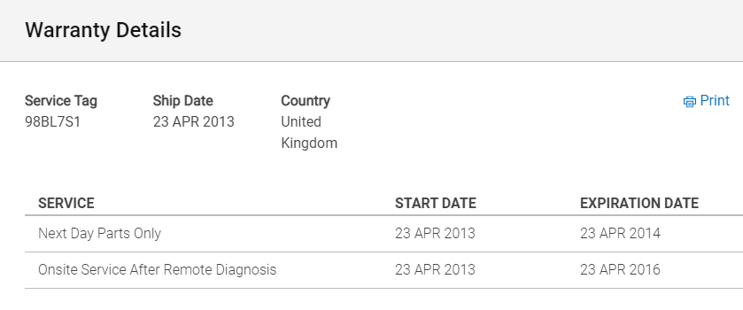
Toshiba Network Printer
https://www.manualslib.com/products/Toshiba-E-Studio-2010c-4159490.html

Userid: admin
Password: 123456
Name: MFP11601437
Copier Model: Toshiba - e-studio 2010AC
Serial Number: CNKK11361
MAC Address: 00-80-91-B1-06-1D
Former Static IP Address: 192.168.100.33
Driver:
Stored Scanned Documents: file_share

Algo Ringer and Broadcast Unit
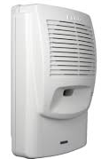
Support email: support@algosolutions.com
Web: www.algosolutions.com
IP Address: admin
Password: recovery3
Name: algo8180
MAC: 00:22:EE:02:6D:37
Static IP Address: 192.168.100.39

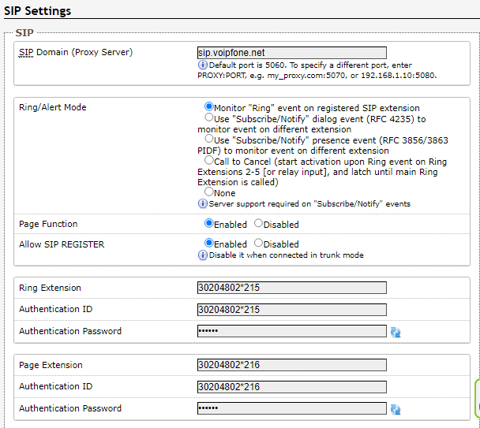

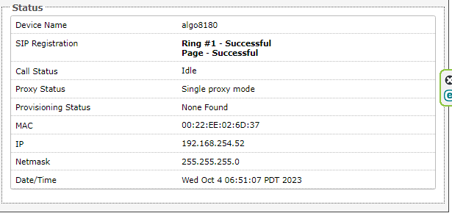

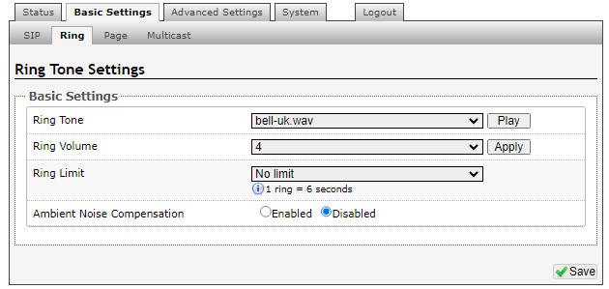

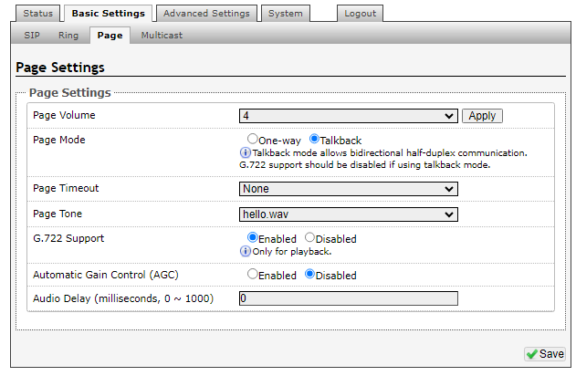
Number Plates
Supplier number is 2291.
Gareth Ball
RNPS Enforcement Officer
CAEG
DVLA Exeter | C/O HMRC Ground Floor | Longbrook House | New North Road | EXETER | EX4 4UD

Mail Client Setup for mideng.co.uk
Incoming Server: ceres.footholds.net IMAP Port: 993
Outgoing Server ceres.footholds.net SMTP Port: 465

Email Accounts
3140cw@mideng.co.uk | hansjrnf4gq9kr96
administration@mideng.co.uk
amabel@mideng.co.uk | n60y3ovdudakejdi
andrew@mideng.co.uk | as9grxbwz9xz7yh4
apollo@mideng.co.uk
archive@mideng.co.uk | n3604856whaw
area14@mideng.co.uk | wvnzcg6wx3oenbo1
brian@mideng.co.uk
carly.bayliss@mideng.co.uk | 2uh2fbbh0exqyvd2
cctv@mideng.co.uk
contracts@mideng.co.uk | cz5n492w7wtbvorf
daved@mideng.co.uk
davi7174
david@mideng.co.uk | WestCroydon630%
davidf@mideng.co.uk
dummy@mideng.co.uk | g6673s53mh64
drew@mideng.co.uk
emily@mideng.co.uk | QiZ}UbWqb2kM
george@mideng.co.uk
guy@mideng.co.uk | 8yyzmfzgstza
hayden@mideng.co.uk
historical@mideng.co.uk | 7Jc1(M,yEgr5
jackg@mideng.co.uk | xg48v4ds7oow4e5q
jordan@mideng.co.uk | um7j6e92fms7t0qg
julian@mideng.co.uk | sdjo6fn5vk4v
kieran@mideng.co.uk | tmjrh85xkhd4b9ps
lelo@mideng.co.uk | mh23kuux6niv
manager@mideng.co.uk | vqv818lvm2yk
marcus@mideng.co.uk | b5in2ui7xz5jwp0t
marilyn@mideng.co.uk | 8mphg2kim4yh
messages@mideng.co.uk
michaelf@mideng.co.uk
mike@mideng.co.uk | 36eq3b3qmkxo
mo@mideng.co.uk | mxf3
mot@mideng.co.uk | g89vcgfn06eu
ms@mideng.co.uk
north@mideng.co.uk | oh538fce7rki4828
paddy@mideng.co.uk | gv949nrjg8k2pkft
paulg@mideng.co.uk | 35mcovpkd4437nzb
pete@mideng.co.uk | 2kggsftx4qub9gu6
pics@mideng.co.uk | xb9nf4661k2y
pmc@mideng.co.uk
pool@mideng.co.uk
receptiondesk@mideng.co.uk
recovery@mideng.co.uk
router@mideng.co.uk | hkpew3owkn05w5zc
silver@mideng.co.uk | r05kw2qh0scmq4yg
steve@mideng.co.uk | unbnqq6g26vl
sunrise@mideng.co.uk | 5mex4tb70scf
susie@mideng.co.uk | cupf36bov74y
thyme@mideng.co.uk | 9i8rqe3bwi7a
tibi@mideng.co.uk
toshiba@mideng.co.uk
vosa@mideng.co.uk | 86bwoeiw9cn5
wayne@mideng.co.uk | psainj6sknzd
wayne.merridue@mideng.co.uk
workshop@mideng.co.uk | ubr3a6st9q2o

Mail Forwarding
andrew.pafford@mideng.co.uk to paddy@mideng.co.uk
bmg@mideng.co.uk to workshop@mideng.co.uk
bobby@mideng.co.uk to bobby.abernethy@mideng.co.uk
c19-bounces@mideng.co.uk to david@mideng.co.uk
c19-owner@mideng.co.uk to david@mideng.co.uk
carly@mideng.co.uk to carly.bayliss@mideng.co.uk
davidf@mideng.co.uk to davidfauset@gmail.com
david.bradley@mideng.co.uk to david@cyberpictures.net
dcb@mideng.co.uk to david@mideng.co.uk
directors@mideng.co.uk to guy@mideng.co.uk
dom@mideng.co.uk to chwedorczukdominik@gmail.com
general@mideng.co.uk to david@cyberpictures.net
general@mideng.co.uk to mike@mideng.co.uk
general@mideng.co.uk to paddy@mideng.co.uk
guy.morgan@mideng.co.uk to guy@mideng.co.uk
ian.harman@mideng.co.uk to ianandshirley@gmail.com
jackb@mideng.co.uk to scrumpyPS4@gmail.com
jackg@mideng.co.uk to gardner1611@icloud.com
julian@mideng.co.uk to workshop@mideng.co.uk
leo@mideng.co.uk to leloclark@hotmail.com
marcus@mideng.co.uk to visionlandscapesmgt@gmail.com
messages@mideng.co.uk to mike@mideng.co.uk
mike.morgan@mideng.co.uk to mike@mideng.co.uk
north@mideng.co.uk to stevekirwine@hotmail.co.uk
owner-c19@mideng.co.uk to c19-owner@mideng.co.uk
owner-closingmo@mideng.co.uk closingmo-owner@mideng.co.uk
owner-comp@mideng.co.uk to comp-owner@mideng.co.uk
owner-drivers@mideng.co.uk to drivers-owner@mideng.co.uk
owner-mideng@mideng.co.uk to mideng-owner@mideng.co.uk
owner-tesla@mideng.co.uk to david@mideng.co.uk
parking@mideng.co.uk to pics@mideng.co.uk
pete@mideng.co.uk to f.goodwin1@sky.com
pics@mideng.co.uk to emily@mideng.co.uk
pics@mideng.co.uk to marilyn@mideng.co.uk
pictures@mideng.co.uk to david@mideng.co.uk
selham@mideng.co.uk to area14@mideng.co.uk
selham@mideng.co.uk to mike@mideng.co.uk
selham@mideng.co.uk to paddy@mideng.co.uk
tesla-owner@mideng.co.uk to mike@mideng.co.uk
wayne@mideng.co.uk to waynehibberd1@gmail.com

Special email address tesla@mideng.co.uk. Password: 7e0vkv79xump.
Fundamentally ONLY these email accounts can post messages into this email account:
guy@mideng.co.uk roadsideadminemea@tesla.com
jordan@mideng.co.uk supplierportal@teslamotors.com
mike@mideng.co.uk erpapp@teslamotors.com
paddy@mideng.co.uk david@mideng.co.uk

TSOHOST server will distribute incoming messages addressed to tesla@mideng.co.uk to these email accounts:
guy@mideng.co.uk jordan@mideng.co.uk
mike@mideng.co.uk mo@mideng.co.uk
paddy@mideng.co.uk david@mideng.co.uk

Box Trapper used by receptiondesk@mideng.co.uk - On exit forwarded to:
workshop@mideng.co.uk guy@mideng.co.uk mike@mideng.co.uk
emily@mideng.co.uk david@mideng.co.uk marilyn@mideng.co.uk
carly.bayliss@mideng.co.uk

Emails exiting from Box Trapper for apollo@mideng.co.uk go to:
emily@mideng.co.uk mike@mideng.co.uk guy@mideng.co.uk

Emails exiting from Box Trapper for pmc@mideng.co.uk go to:
emily@mideng.co.uk mike@mideng.co.uk guy@mideng.co.uk
marilyn@mindeng.co.uk

Email Address: transport@cldmail.co.uk
Webmail Access: https://webmail.cldmail.co.uk
Inbound Server (IMAP):
Server: mail.cldmail.co.uk
Port: 993 (use SSL)
Username: transport@cldmail.co.uk
Password: WestCroydon630* <<< Was Route6542020*
Outbound Server (SMTP):
The outbound mail server requires authentication.
Server: smtp.cldmail.co.uk
Port: 465 (use SSL or SSL/TLS)
Username: transport@cldmail.co.uk
Password: Route6542020*
VoIP Details for Analogue Telephone Adapter
DrayTEL URL: www.draytel.org
Signup email address: petersfield@mideng.co.uk Password: elstead2008
Issued: DrayTEL Number: 8495935 Password: JLR.5-ba POTS Number: 08438 496842
[8.9ppm]

To use the [default] DrayTEL Service:
- Calls onto the public network are PAYG. Each call eats into the credit loaded.
- Calls to DrayTEL subscribers are free.
- There is a test number to check DrayTEL is working. Dial: 902
- No line rental.

To use the Voipfone service:
- Press # for the Voipfone dialling tone, followed by the subscriber’s number, e.g. 30204177*200
- Dial <area code><number> e.g. 01252758123 for telephone numbers on the public network.
Chargeable calls appear on the Voipfone account
- Numbers starting with 3 are internet calls and free
- Numbers starting with 1 are system wide three-digit short codes, e.g. 123.
- Dial 1571 to listen to voice mail messages. Logon 648 Password 648

Set up information for the Analogue Terminal Adapter:
Default dial plan: (*xx|[3469]11|0|00|[2-9]xxxxxx|1xxx[2-9]xxxxxxS0|xxxxxxxxxxxx.)
Custom dial plan required: (xxxxxxxxxxxx.|20xxxxxxxS0|1xxS0|5xxxxS0|0[45689]x.|*xx|8500S0|999S0)

Analogue phone codes that can used, normally setup via browser access from 192.168.100.11:
**** Enter Menu Gives access to menu options
100# Check DHCP Hear whether DHCP is enabled or disabled
101# Set DHCP Disable DHCP: 0 Enable DHCP: 1. Enter either option followed by #
110# Check IP address Hear the IP address of the unit [Currently fixed IP of 192.168.100.11]
73738# Factory RESET Clears user configuration from the Analogue Terminal Adapter
[Further calls not possible until unit is reconfigured]

Call Waiting using TalkTalk
Dial #0 then choose an option below.
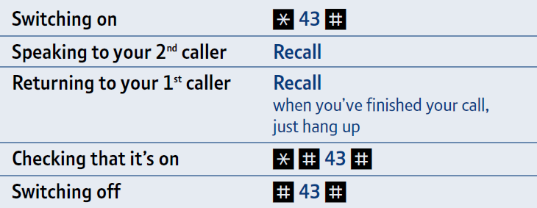
Call waiting will induce a blip tone with the current call in progress. Use the R button to toggle between callers. Alternatively ignore the 2nd incoming call and when ready call them back but remember that the 2nd caller may be withholding their number, so you won’t know who to call!

Voice Mail provided by TalkTalk
To retrieve your TalkTalk Voicemail messages: dial 1571

When you’ve listened to your message, you’ll hear the following options:
Delete your message: dial 3
Save your message: dial 2 [messages will be saved for 30 days]
Listen to your saved messages: dial 1
Call back those who leave you a message: dial 0
[You’ll be charged a 20p connection charge plus the regular rate of the call.

Full instructions are here:
http://help.talktalk.co.uk/guided-assist/using-your-home-phone-voicemail/listening-voicemail-messages/

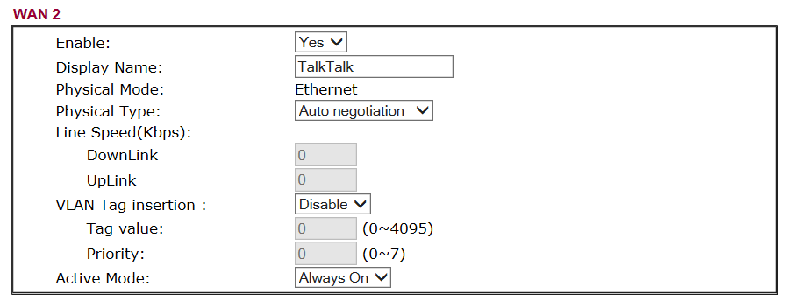
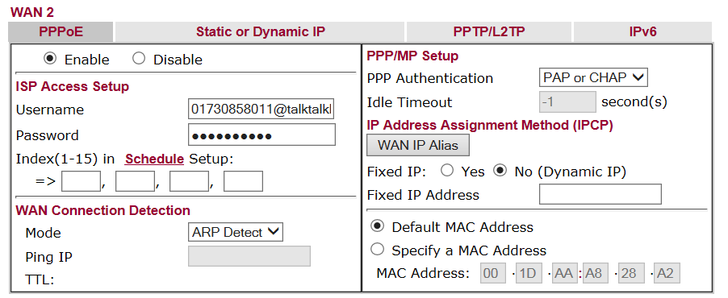
VoIP Setup Information

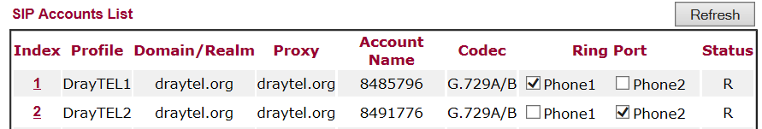

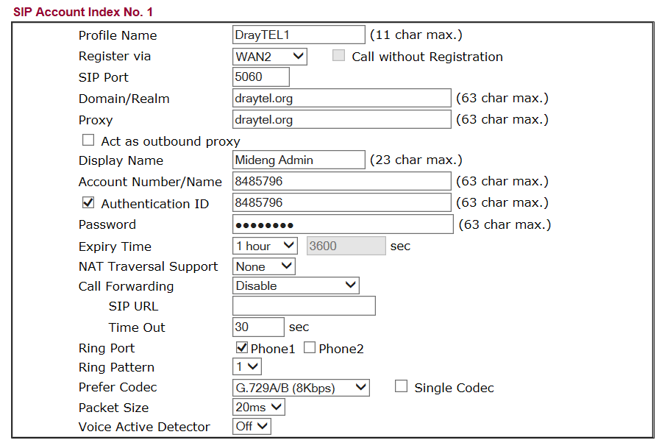

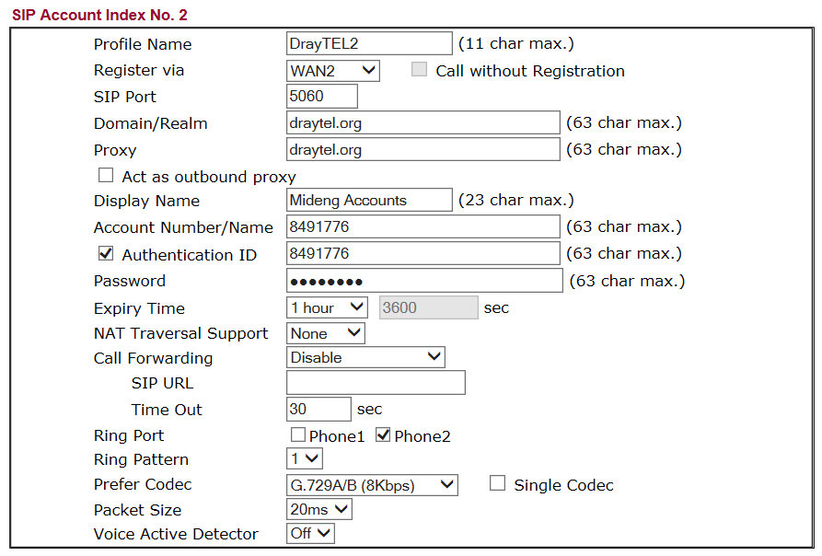
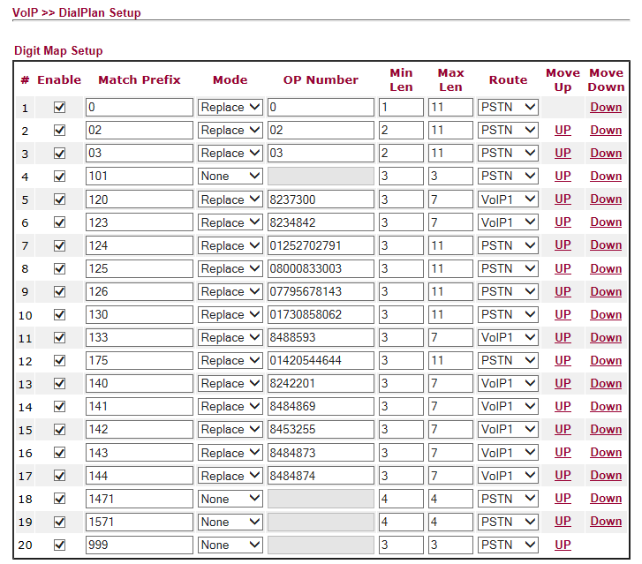

Your liGo Login Info David Bradley,
A new account has been created for you on liGo
Your login details are:
Email: david@mideng.co.uk
Password: a876d66b
Kind Regards,
liGo Electronics
Customer Services
website: www.ligo.co.uk

CCTV

Remote Access User Accounts
http://212.159.144.127/

david elstead2008
guy elstead2008
mike
brian
paddy
david elstead2008

Kyocera ECOSYS P2040dn

In Recovery Office
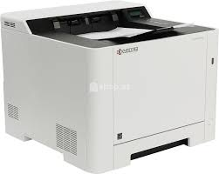
Static IP Address: 192.168.100.26
MAC Address: 00:17:C8:79:C7:38
Host Name: KM79C738
Userid: Admin
Password: farnham2020
Serial Number: VCY8Z44672
Printer Firmware Version: 2RX_3000.001.825
Network Firmware Version:
Installed Memory Size: 8 MB
Copier Model: Kyocera ECOSYS P2040dn £181.32 Cartridge: TK-1160 Black Toner Cartridge £82.50

Purchased from: Printerland, 6 Edward Court, Altrincham Business Park, Altrincham, Cheshire, WA14 5GL
Purchase Date Friday, 12 July 2019
Customer service team: 0800 995 1992 Order Confirmation SO585857
Free 3 Year On-site Warranty
Manual:
https://cdn.kyostatics.net/dlc/za/documentation/usermanual/og_ecosys_p2040dw7.-downloadcenteritem-Single-File.downloadcenteritem.tmp/OG_ECOSYSP2040dw_EN.pdf
Connecting DVR to an iPhone?
First you must install the MEye application from the App Store. Search for the developer of the software by entering “Sun Jian” in the search box. Find the MEye application and click install.

Run the MEye application and click the settings icon at the bottom of the screen, which looks like a Cog.
• Enter a Title by which the connection will be known.
• Enter the static Internet IP Address of your router [212.159.144.127].
• Enter the Port number 8080
• Enter the User ID for your DVR [See accounts list above]
• Enter the Password for your DVR.

Click the back icon at the top of the screen and connect to your DVR by clicking the Play icon at the bottom of the screen. Navigate between camera views by clicking on the camera number.

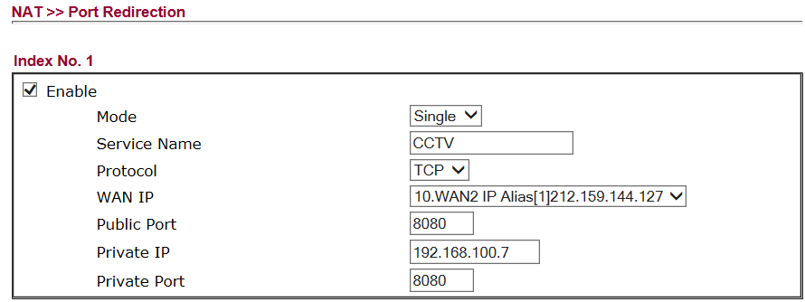

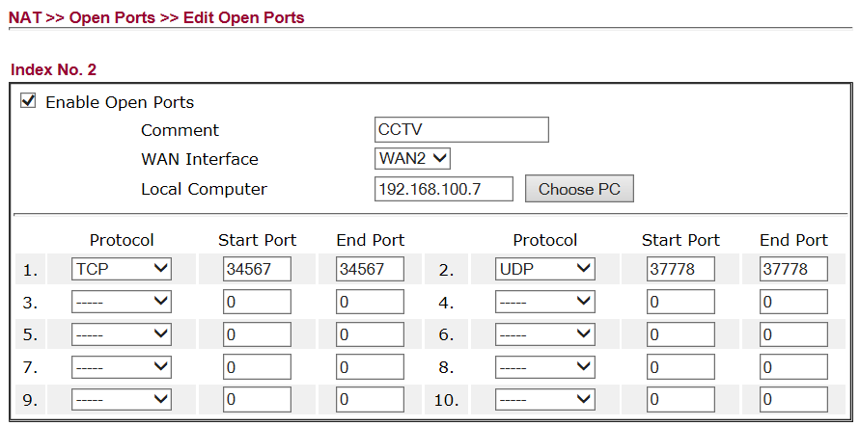

Configuration of Wireless Access Point in the Workshop
TalkTalk router configured as a Wireless Access Point - Signal reaches customer waiting area
192.168.100.xxx E8-08-8B-08-94-C5 HG533 router admin elstead2008 Workshop Access Point

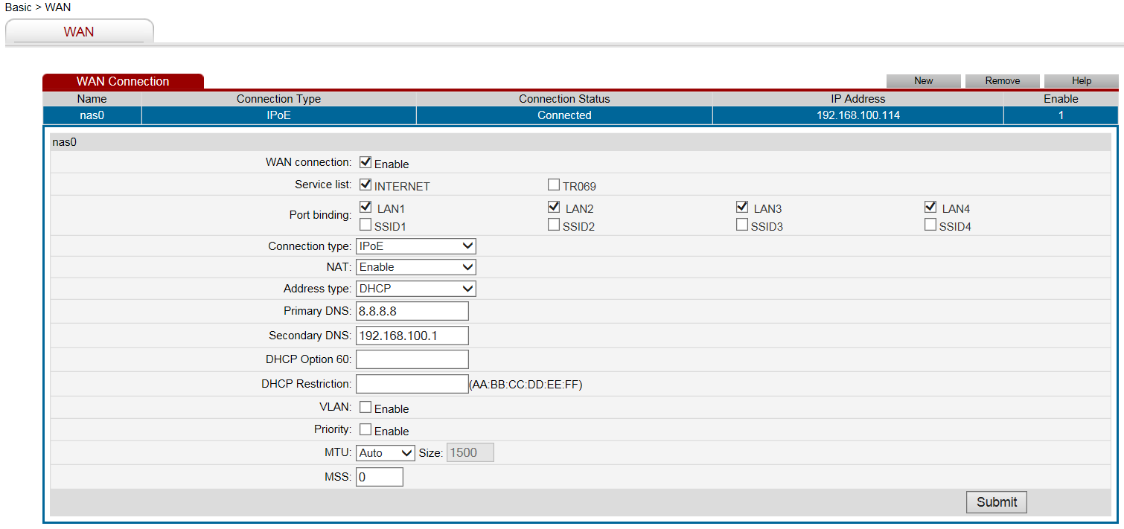

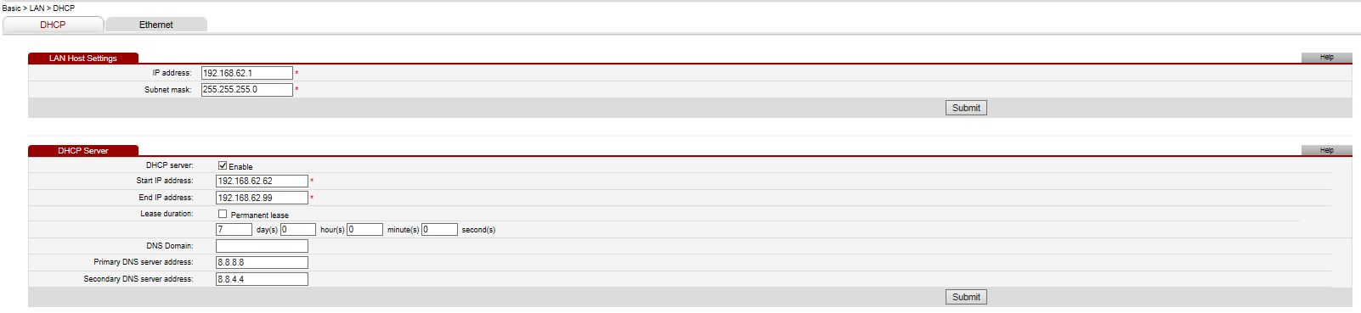

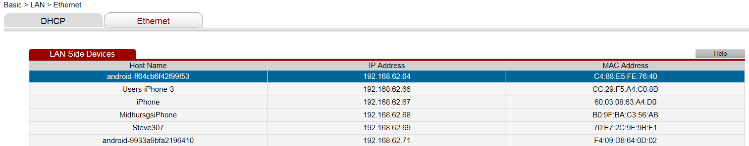

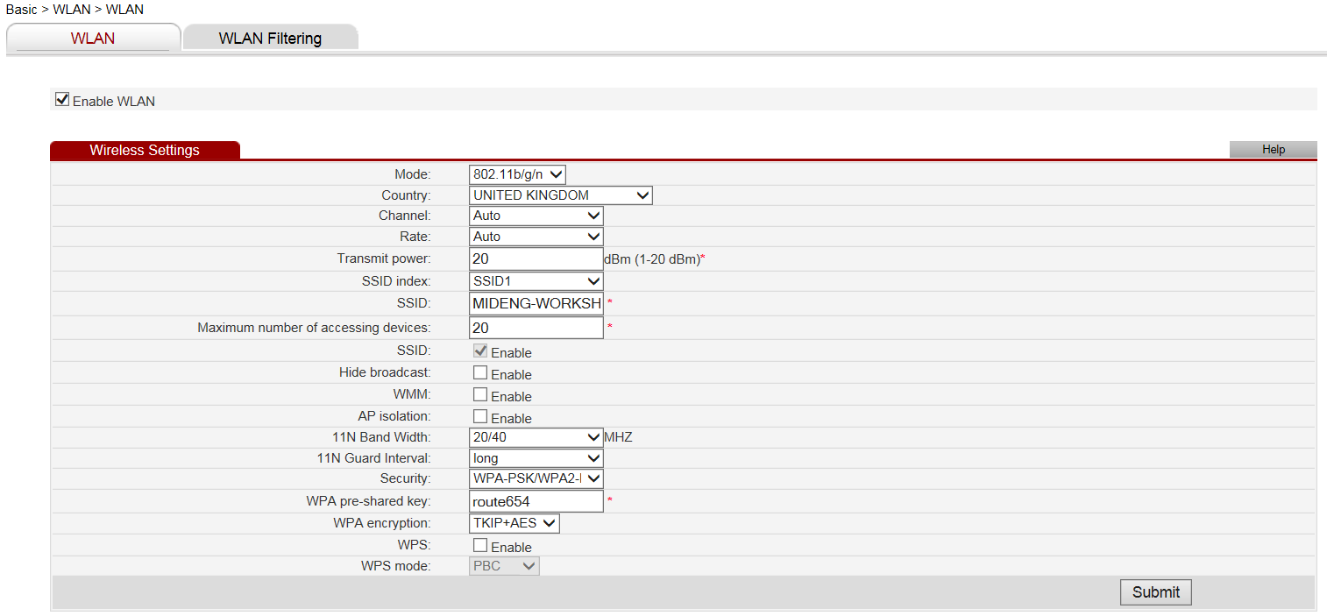

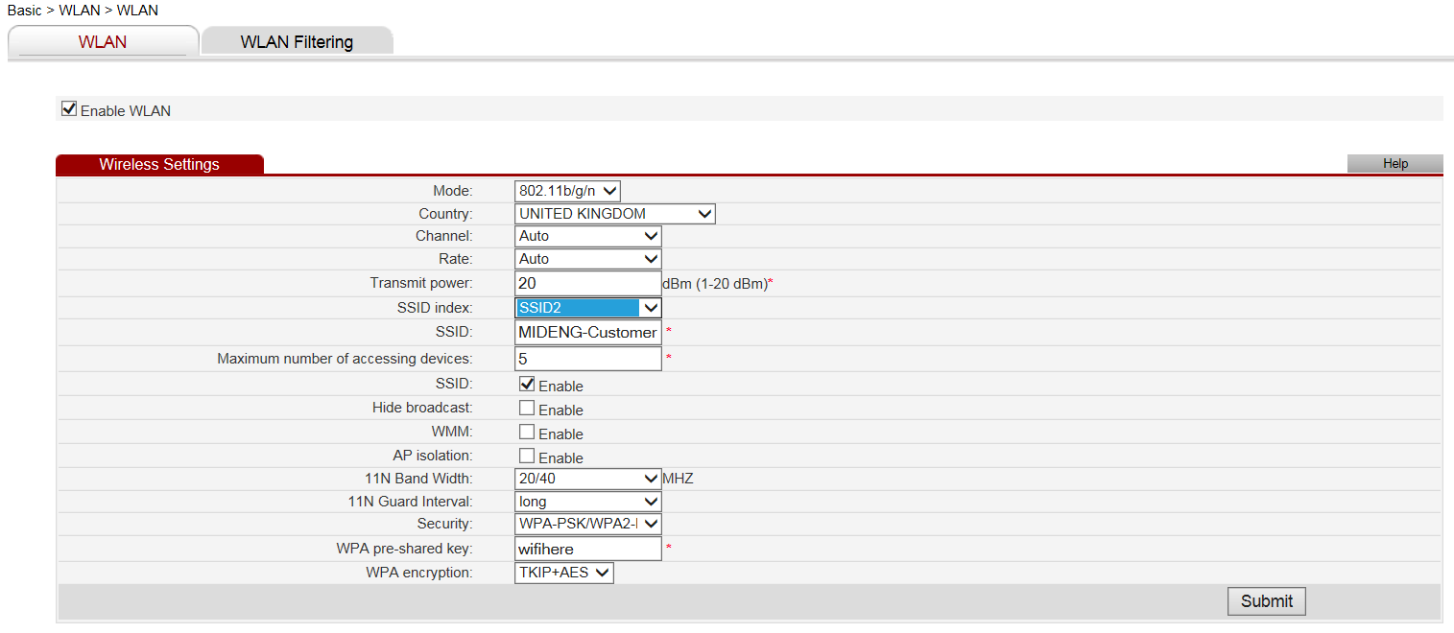
Domain Hosted by Vidahost
cPanel: https://ceres.footholds.net:2083/
Login: davi7174 Password: MNM9845kHGe

FTP and Piwigo access credentials need sorting out. Incorrect on Thursday, 11 January 2018

FTP access
https://ceres.footholds.net
Login: davi7174 Password: MNM9845kHGe
188.65.115.194
internal@midhurstcarandvansales.uk t88p4tgvvi3z8bq7

Piwigo
http://www.mideng.co.uk/piwigo
Administrative URL: http://www.mideng.co.uk/piwigo/admin.php
Login: davi7174 Password: MNM9845kHGe

ESET Endpoint on 15 computers until 6 April 202
Username: EAV-03080295 Password: nmp3rbswas
Licence Key: 9CNU-XTRW-UANJ-EE7T-X94F
Tele: 01202 405405

The link below to download ESET Endpoint security.
https://www.ESET.com/uk/business/endpoint-security/windows-security/#download
Make sure to enable Live grid and to allow detection of potential unwanted application.

ESET Licence Administrator
Thank you for registering your ESET License Administrator Security Admin account. This account has been activated under the email address david@mideng.co.uk
Licence Key: 9CNU-XTRW-UANJ-EE7T-X94F
URL: https://identity.eset.com/login/pwd?ReturnUrl=%2Fconnect%2Fauthorize%2Fcallback%3Fclient_id%3DEset.MyAccount%26redirect_uri%3Dhttps%253A%252F%252Feba.eset.com%252Fsignin-oidc%26response_type%3Dcode%2520id_token%26scope%3Dopenid%2520profile%2520eset_id%2520email%26response_mode%3Dform_post%26nonce%3D638570755604360344.ODVjMDRmNTMtNmY3NS00MjRiLWIyOGEtNTZkMjYyYTUzMjVhN2EzNzMyMzctOTZjYy00OTQ1LWE0YWEtNzNkZjUzOGY3OTAx%26state%3DCfDJ8LGxx_5fyU1Om0lyskMyX7Tzl1tWqv62QISxgg2fBAAXG127eKRbp5JyK4wyRiZnjsASLE2h1__qC_MHb4QrPSwWGWcHRZWFlRN4RJquG68k5AseXBAIQExRH71oAaFEEx9S-PJXkerPzbgtnhgbS2yIrcP7VZR0SnbiWgXQapkR8cQrv9hD8XQ1mTx183VP1mKS8qEv0cFU6cv2Wd3ekWKbJPODRVGHyG1hSR1EWUw9iclXkE-fW7tYprit7ufOIuxLiGgUgO0sqmWraJUcL4vDPbb24WFlupY3vVpHLQNuXGvFhIsNQ6LKTNNpCc9oow%26x-client-SKU%3DID_NETSTANDARD2_0%26x-client-ver%3D5.5.0.0
User: david@mideng.co.uk Administrator Password: Whitediamond2022
Changing Smart Security to Endpoint Security

- First, in order to remove ESET properly let’s disable SELF DEFENCE by going into the ESET application, press F5 to go into the advanced setup setting, locate the HIPS tab and disable the option called the enable self-defence so that it is not selected and has a black X on it and press OK to confirm.

- Kindly uninstall ESET from the system, in Control panel go to programs and applications and select the ESET application and select uninstall / remove or change and then remove.

- Once the uninstallation completed, please restart the computer before installing the new application.

- Then once the system restarted, kindly download the latest application from the link below:
https://www.ESET.com/uk/business/endpoint-security/windows-security/#download

- Please click on DOWNLOAD NOW to download the live installer as it will automatically install the best product for your system.

- Once downloaded, please install and submit your product license key to authenticate your licence.
Licence Key: 9CNU-XTRW-UANJ-EE7T-X94F
- Then please wait for the update to complete and make sure the application will run the first full scan, it will automatically start once the update has completed, please don’t cancel if you have the time to complete the scan, alternatively please make sure to run it as soon as you can.

Akzo Nobel Coatings Limited
Andy Bond
Colour IT Sales Support Specialist
Automotive & Aerospace Coatings EMEA
Tele: 01235 442189
Mobile: 07785 922801
email: andy.bond@akzonobel.com

Ann White
Regional Sales Manager
Automotive & Aerospace Coatings EMEA
Tele: 01235 862226
Mobile: 07770 645300
email: ann.white@akzonobel.com

136 Milton Park
Abingdon
Total Concept Paints Limited
Tele: 01243 532999
email: info@totalconceptpaints.co.uk

LESONAL
Program: Mixit2 / MX2000 / LCD2000
Version: 1.91:

Units 3-5 Matform Business Centre
Terminus Road
Chichester
West Sussex
PO19 8UL
www.totalconceptpaints.co.uk

Jim Chant 07825 852 646

OX14 4SB
www.akzonobel.com

Garage Manager
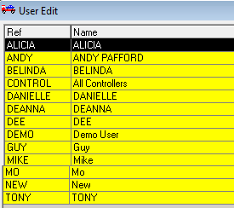
Extracted on: Monday, 8 December 2014
Help Desk open MON-FRI 09:00 to 17:300

The GMS file
If despatching required fill in the ‘Networking’ Section with the name of your computer.
The example is from Mike’s computer whose computer name is WHISKY

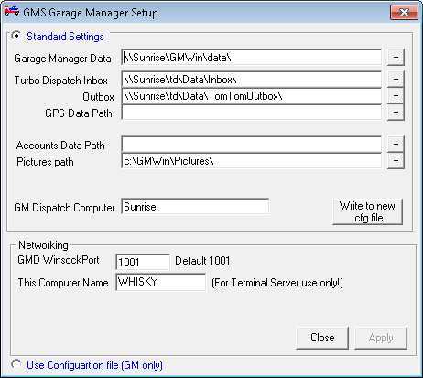
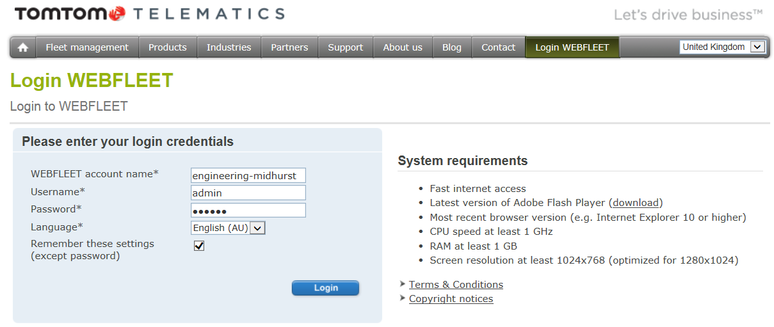

Access: https://webfleet.business.tomtom.com/swf/index.html Password: morgan
Web: http://business.tomtom.com/en_gb/products/webfleet/highlights/ Help Desk: 020 7255 9788

engineering-midhurst
Admin
morgan
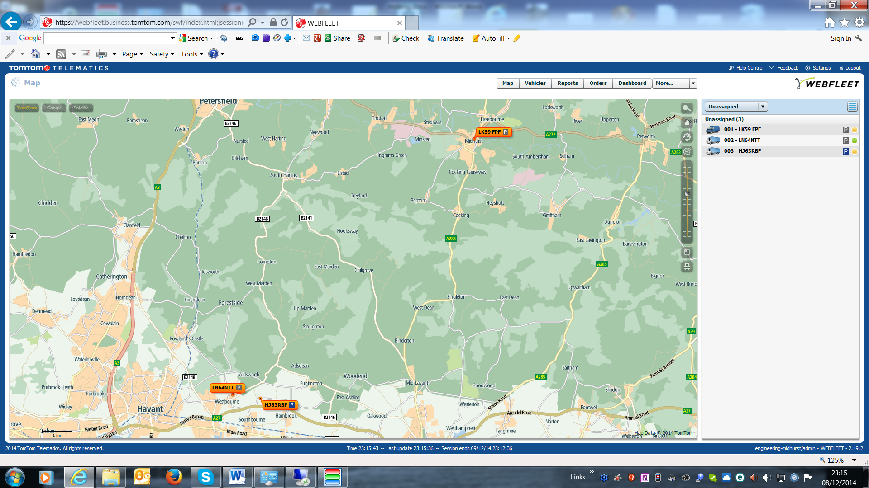
Guy

Apex Support Team [Auto Connect Client] TomTom Business Integration:
Account Number: 2999693 Lee Turley Mobile: 07990 680073 Tele: 01543 560073
Help Desk; 020 3195 6757 email: leeturley@connectfleet.co.uk
Web: www.apex-networks.com Web: www.ConnectFleet.co.uk
Install Code: 516570 Support: Business hours but normally available any time
Test Message: 2000003 Cost: £30 per month or £80 per quarter or £280 per annum

In Car Technology
3 Pelham Close
Whitehill
Hampshire
GU35 9DL

Sue Butt
01420 478053
info@incartech.net

http://www.incartechnology.co.uk/fleet-management/fleet-tracking-systems/

APEX
RMS Settings – Installation Code: 516570
http://download.apex-rms.com

Jason Kemp - Customer Relationship Manager
Dundee House
Albion Place
Ramsgate
Kent
CT11 8HQ

Fax: 0871 522 3151
Email: JKemp@apex-networks.com

Support: 0203 1956757
Out of Hours: 07920 780920
Email: support@apex-networks.com

Username Password Where is the 08080 used?:
Andy
Guy
Mike
Mo
Tony
Paddy
David password
KIS
The comprehensive and flexible Garage Management System for the Independent Motor Trade.

To find out more, to book a demo or arrange a free trial call 01865 383482 or email kisenquiries@unipartautoparts.com

https://issuu.com/unipartautoparts/docs/unipart-kis-brochure-web-version

http://www.kis-unipart.co.uk/

MyVigor Portal
This account enables us to register all of our Draytek products, activate service licenses and also to subscribe to newsletters keeping you informed of DrayTek product news and updates.
Activate my Account URL:
http://myvigor.draytek.com/mngt/Device/DeviceWeb.php?tid=963428&user=mideng&inv=nxs61v94gtid94yt&ticket=NhV+wNy3/yRjgqwDzL9YTJ3qP67DyutTLIwftB0bGZg=
Your account username is: mideng
Password: recovery3
The next step will be to either register your specific DrayTek product(s) or activate service licenses (such as GlobalView Web Content Filtering).
--
Your Sincerely
DrayTek Corp.
URL: http://myvigor.draytek.com
E-mail: webmaster@draytek.com
Service Line : +886-3-5972727

Telappliant
It does not cost anything to make a VoIPtalk account.
Because of the order total, we will need to raise the order, and send out the quote to you so we that we can have signed confirmation. We are not able to raise this order without an account to link it to.
Once this has been done, we will ring out to take payment.
If you require any further information please do not hesitate to contact us.
Customer Services (Tel) V.2 <customerservices@telappliant.com>

VoIPtalk
Access: http://www.voiptalk.org
VoIPtalk website login password.: 3DHXmz8q
Registered address: david@mideng.co.uk
VoIPtalk ID: 844319382
VoIPtalk Password: *Eds2008*
VoIP Domain/Registrar: voiptalk.org
Outbound Proxy: nat.voiptalk.org:5065
Retrieve VoIPtalk password at: https://www.voiptalk.org/products/password_forgotten.php .
Guide to using the service along with troubleshooting information at: http://www.voiptalk.org/products/voip-start
Visit http://twitter.com/voiptalkstatus for the latest VoIPtalk network status updates.

To test that the phone has been set up correctly, dial 902 and you should hear a confirmation message.

*Elstead2008*

901- Check your VoIPtalk credit balance
902 - Welcome message
903 - Check your User ID
904 - Echo Test (for latency checking)
905 - Audio Test. After the beep record your voice and receive it back to ensure two-way audio communication works properly
906 - Turns balance announcement when making calls on / off*
907 - Turns low credit announcement when making calls on / off*
908 - Check your current Caller ID display
9123 - UK Date & Time

73 - To dial a user on the DrayTEL network

* Dialling 906 will turn the balance announcement ON. This means that when you dial a number (before connecting) you will hear what your current balance is. To turn the balance announcement OFF, simply dial 906 again. The balance announcement is OFF by default.

The SIP Broker prefix for VoIPtalk is: *258

https://www.voiptalk.org/products/account.php

Just for your records, to get into the account:
URL: https://www.starlink.com/account
Username: david@mideng.co.uk
Password: Route6542023*

Currently Starlink uses Mike’s credit card for payment.

Registrations
VAT Number: GB 192 9300 54
Registration Number: 432447

Domain registered through Compila
Domain name:
mideng.co.uk
Registrant:
Midhurst Engineering & Motor Co.
Registrant type:
Unknown
Registrant's address:
Rumbolds Hill
Midhurst
West Sussex
GU29 9DD
United Kingdom
Data validation:
Nominet was able to match the registrant's name and address against a 3rd party data source on 10-Dec-2012
Registrar:
Paragon Internet Group Ltd t/a Compila Ltd [Tag = COMPILA]
URL: https://www.compila.com
Relevant dates:
Registered on: 03-May-2004
Expiry date: 03-May-2016
Last updated: 11-Apr-2015
Registration status:
Registered until expiry date.
Name servers:
ns15.sovdns.com
ns15sec.sovdns.com

Toughbook-Support
Tele: 08000 884 324 email: toughbooksupport@eu.panasonic.com Warranty until: 2nd June 2017
AutoRoute 2013
This was purchased from Microsoft requiring an account to be set up. Order #: 12623394148 Cost: £33.00
Account: paddy@mideng.co.uk Password: MidengTruck Security date of birth: 1.1.2014
http://www.microsoftstore.com/store/msuk/en_GB/pdp/productID.278710300?tduid=c0d659b59debe25e76e177c58a5ec8d9
Licence Key: WXQFT-YR6MX-7MT7D-2J39Q-JX9TP Single licence for 1 PC

External CD Drive
Software CD supplied for WinDVD Licence Key: YS10B22-7DY7UQG-LCU9FN2-MFT2ZN2

Vodafone SIM Card
Number: +447786247697

CCTV Account:
Userid: guy Password: morgan

Setup for CCTV in Internet Explorer

Internet Intranet
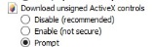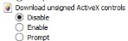

Mail Client Setup
Incoming POP3: 995 SSL
Outgoing: SMTP: 465 SSL
Server: ns15.sovdns.com

WEBFLEET and CCTV Display loaded
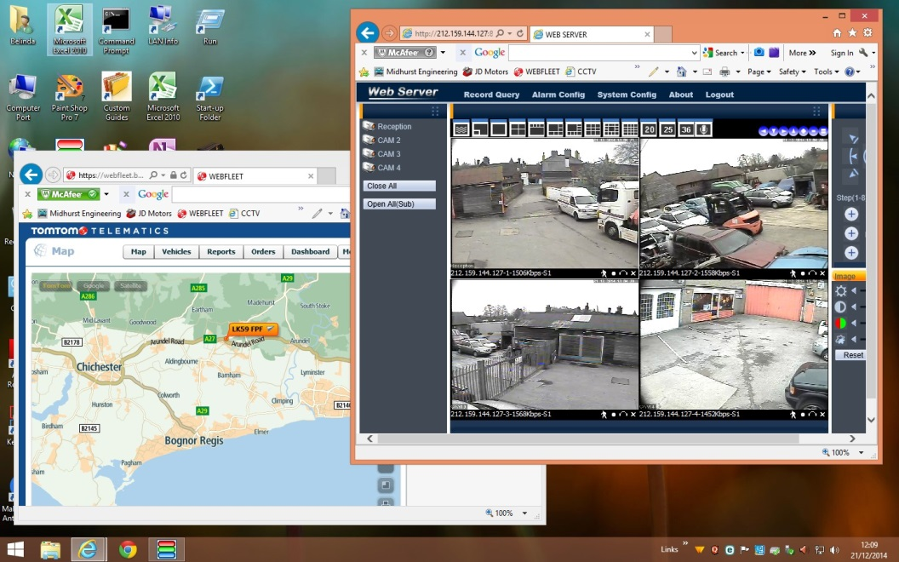

*** END OF ENTRIES FOR THE GARAGE ***
Guy Morgan Home
Hazel House, Cobden Road, Midhurst, West Sussex, GU29 9JW

Phone and Broadband Service from TalkTalk – Package: Office Broadband + Anytime calls + CLI
Connected to: 01730 858062 TalkTalk Help Desk: 0800 083 3003
Account Number: 882 01292148 - 24 month contract from 11th Feb 2013 @ £23.95 + £4.05
Account Password: trolleybus

Router Information
DrayTek Router 2860Vn [192.168.8.1] Firmware Version:
WAN Access: http://80.45.201.186:8080/ Logon: admin Password: elstead2008
LAN Start IP Address: 192.168.8.28 Pool Size: 50
SSID1: MIDENG-COBDEN Password: route654 Security: WPA/PSK2 Channel: 6
Login: 01730858062@talktalkbusiness.net Password: C3W4K7L7F2
Fixed IP Address: 80.45.201.186 Workgroup: ROSEMARY

Attached Devices
IP Address MAC Host ID Owner
192.168.8.80 84-AA-9C-22-93-FF 19:21:34 Sure Signal Device
192.168.8.81 E0-66-78-55-BF-19 20:37:26 Livis-ipad
192.168.8.82 A4-31-35-EC-22-B4 20:37:43 Olivias-iPhone
192.168.8.83 F8-16-54-17-DB-BC 23:55:04 Martini
192.168.8.85 A8-5C-2C-63-27-3F 20:37:57 Guys-iPhone

Help Desk:
Account Number: 229834079. My account mobile number: 07769723651
Charlotte Rose, Mobile & Data Manager T: 01302 552339 M: 07887868932
E: charlotte.rose@ninehundred.co.uk

VPN and Remote Access >> Remote Dial-in Users
User Password
david elstead

Remote Connection to the Garage
Seek out these icons on the Desktop:
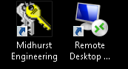

Only when remote from the Garage:
Click on Midhurst Engineering and wait for a VPN connection to be established

Once on the garage network, click on the Remote Desktop icon to bring up this:

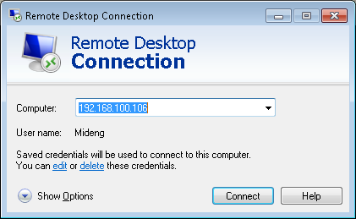

*** END OF ENTRIES FOR GUY’S HOME ***

Mike Morgan Home
8 St Margaret’s Way, Midhurst, GU29 9FQ

Phone and Broadband Service from Zen Package: 80/20
Connected to: 01730 816595 [No directory entry] Help Desk: 01706 902000
Default email username: zen255936@zen.co.uk Default email password: Xw94bK65
Static IP Address: 82.71.58.115 DNS: 212.23.3.100 Secondary DNS: 212.23.6.100
Customer Portal: http://portal.zen.co.uk/ Userid: mike@mideng,co.uk Password: route654
http://www.thinkbroadband.com/speedtest/results.html?id=1432926673531692155

Michelle Buckley
Customer Retentions Sales Executive
Zen Internet
Direct: 01706 902128 Fax: 01706 902127
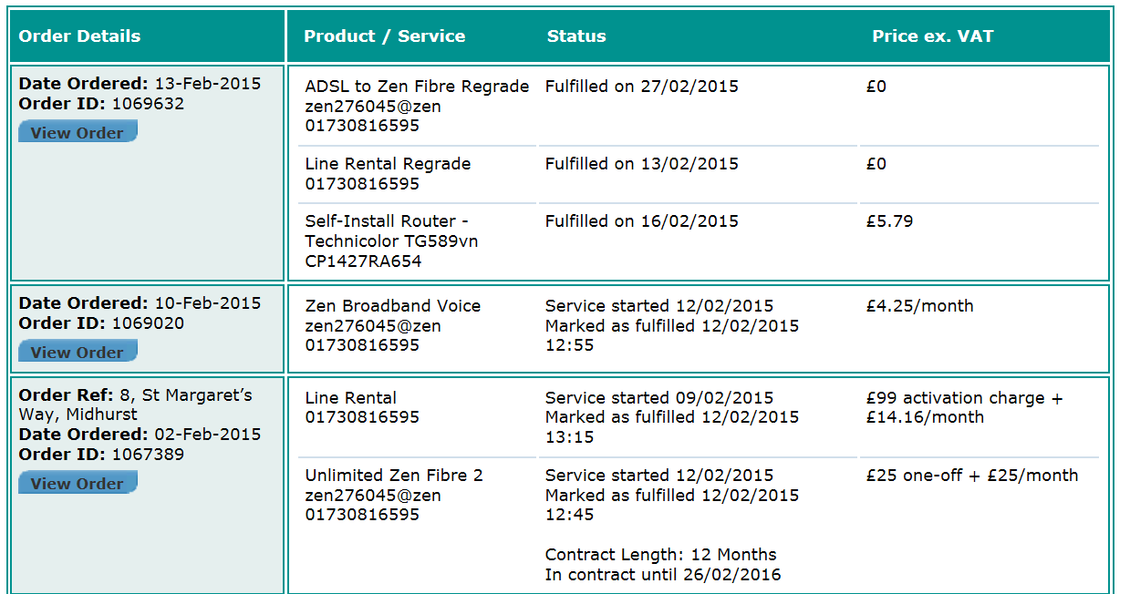
Connection password: 343spfyK

IP address information: 82.71.39.217
Subnet mask 255.255.255.255
Primary DNS: 212.23.3.100
Secondary DNS: 212.23.6.100

Default email username: zen276045@zen.co.uk
Default email password: 3fDnhPUs

Default web space username: zen276045
Default web space password: 3fDnhPUs

VoIP Username: 01730816595 Password: k6vFC5ii
Registrar Address: voip.zen.co.uk Proxy Address: voip.zen.co.uk

DrayTek Router
IP Address: 192.168.104.1 Logon ID: admin Password: elstead2008
Model Name: Vigor2830vN Firmware Version: 3.6.4.1_sb_232201
Build Date/Time: Jul 16 2013 11:03:01
WAN Username: zen255936@zen Password: NkWfXWqg
LAN Start IP Address: 192.168.104.104 Pool Size: 20
SSID: SMW Password: route612 Security: WPA/PSK2 Channel: 6
SSID: Guest: Password: Security: WPA/PSK2 Channel: 6
SSID ALA: Password: Security: WEP Channel: 6

Workgroup COBDEN

Connected Devices
IP Address MAC Address HOST ID USERID Password
192.168.104.1 00-1D-AA-B2-9D-F0 Router
192.168.104.104 34-57-60-67-26-B9 Sure Signal
192.168.104.105 00-19-FB-65-30-67 TV
192.168.104.106 E0-B5-2D-84-A5-44 Claudias-iPhone
192.168.104.107 74-E5-43-EE-9E-1A Vermouth Mike recovery2
192.168.104.108 18-E3-BC-E6-16-85 android-7a3847d033a30109
192.168.104.109 B4-AE-2B-2E-2B-27 DESKTOP-L0PF77C
192.168.104.110 74-E5-43-EE-9E-1A Vermouth
192.168.104.111 6C-96-CF-D4-72-EC Mikes-iPhone
192.168.104.112 48-6D-BB-32-86-AD POLAROID-TV
192.168.104.113 AC-B5-7D-8B-CC-E0 Alicja

VoIP Identities
Service Name Domain and Proxy Password POTS Number VoIP Number Test Number
Zen voip.zen.co.uk nNCUUbP9 01730 816595 -- 7130
DrayTEL draytel.org gUk[5DRc 0845 557 8295 8488593 902

DrayTEL registration email: zen255936@zen.co.uk Password: route654
Currently [3 SEP 14] with no credit on account

Current charges [19 May 2015] for Telephone service with FTTC
8 St Margaret’s Way, Midhurst, GU29 9FQ
Line Rental - monthly service charge: £14.16 + VAT = £16.99
Unlimited Zen Fibre 2 - monthly charge: £25.00 + VAT = £30.00
Zen Broadband Voice: £4.25 + VAT = £5.10
Total = £52.09

Notes on telephone service
If there is a fault on the exchange line you report it to Zen on 01706 902000 obviously using another telephone line. Your telephone number is 01730 816595.
Call rates on the landline shown below but use the 1000 free minutes via VoIP for 01/02/03/0870 numbers..
 | Daytime | Evening | Weekend
 | (7am - 7pm) | (7pm - 7am) | (Fri 7pm - Mon 7am)
UK Local and National Calls | 4.09 | 1.02 | 1.02
(01/02/03 numbers) | 4.09 | 1.02 | 1.02
0845 | 6.4 | 2.3 | 2.3
0870 | 4.09 | 1.53 | 1.53
O2 Mobile | 11.23 | 8.68 | 8.68
Orange Mobile | 14.3 | 8.68 | 8.68
Three Mobile | 14.81 | 8.68 | 8.68
T-Mobile | 11.23 | 10.21 | 8.68
Vodafone Mobile | 13.28 | 8.68 | 8.68
There are no set up, call connection or minimum call charges associated with calls made to any of the above call categories
Charges are Pence per Minute including VAT. Calls are billed by the second
The overall charge per bill and not each individual call is rounded to the nearest penny

The system is setup as shown in the diagram below.
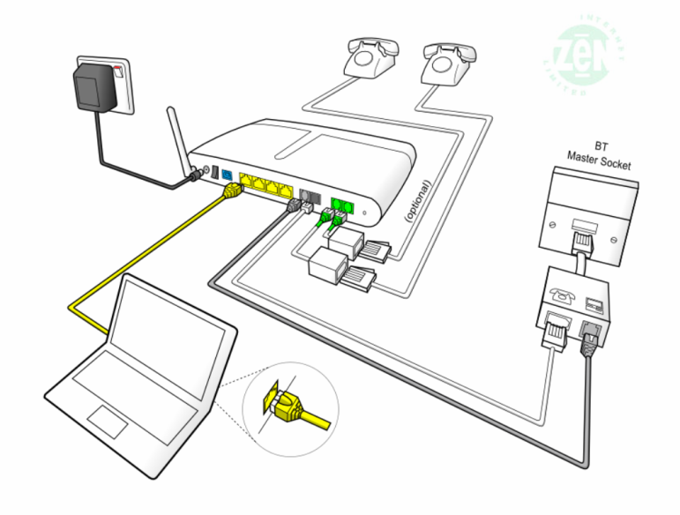

Calls are received via the landline on 01730 816595 or via the DrayTEL VoIP service using 0845 557 8295. However, another DrayTEL VoIP user could alternatively use 8488593@draytel.org [generally by just dialling the number].

The configuration of the router will default outgoing calls via the Zen VoIP service providing the number starts with a ‘0’. The initial, or complete, number shown in the dial plan, routes the call as shown.
Dial Plan

Entry | Service | CLI Display | Called | Called Party | Cost
[Area Code][Number] | Zen VoIP | 01730 816595 | As dialed | Any POTS Subscriber | Inclusive Minutes *
7 [Area Code][Number] | Zen VoIP | anonymous | 7 stripped off | Any POTS Subscriber | Inclusive Minutes *
123 | Draytel | 8488593 | 8234842 | David Bradley | Free
47 | Draytel | 8488593 | 8485796 | Mike Morgan [Office] | Free
49 | Draytel | 8488593 | 8237300 | MIDENG Workshop | Free
2 | Zen VoIP | 01730 816595 | 01730 812162 | MIDENG Switchboard | Inclusive Minutes *
8xxxxxx | Draytel | 8488593 | As dialed | Any Draytel Subscriber | Free
777 | Zen VoIP | 01730 816595 | 777 | Zen Help Desk | Free
999 | Landline | 01730 816595 | Emergency Services | Police, Fire, Ambulance | Free
#0 [Area Code][Number] | Landline | 01730 816595 | As dialed | Any POTS Subscriber | As phone line table
7130 | Zen VoIP | 01730 816595 | 7130 | Zen VoIP System Check | Free
902 | DrayTEL | - | 902 | DrayTEL service test | Free
Inclusive minute’s means 1000 anytime minutes available each month to 01/02/03 numbers only. When quota is exhausted, or not part of the plan, calls are charged as shown in this table below.
The landline number is permanently withheld. To bypass this facility prefix calls with 1470 to enable your number to be released on a call-by-call basis. The default VoIP service displays the number, so prefix each call with 7 to withhold the number.

Zen VoIP Service
This service, at £5.10 a month [inc VAT], includes 1,000 inclusive minutes to UK landlines (01/02/03/0870 numbers) and reasonable call rates to international and mobile telephone numbers. The DrayTek router has been configured to make this your default phone service as soon as 0 is dialed. The telephone number for this line is also 01730 816595; basically calls are routed out via VoIP for lower call charges and no setup fee but incoming calls are routed over the landline. This is NOT a second line service.

Pricing Overview | Landlines | Mobiles
UK Pricing
UK Local and National Calls | 1,000 minutes included, | From 14.1ppm
(01/02/03/0870 numbers) | then 2.35ppm | From 14.1ppm
International Pricing
North America | From 2.35ppm | From 2.35ppm
South America | From 3.53ppm | From 14.1ppm
Europe | From 2.35ppm | From 5.88ppm
Asia | From 2.35ppm | From 2.35ppm
Africa | From 7.05ppm | From 9.4ppm
Oceania | From 2.35ppm | From 21.15ppm
A full list of VoIP call charges are at http://www.zen.co.uk/business/voice/voip.aspx?page=10157
0845 - 4.7ppm [Peak]; 1.175ppm [Off Peak]
0844 - 5.88ppm
0871 - 11.75ppm
DrayTEL VoIP Service
No rental charges but useful for free calls to other DrayTEL subscribers.
The telephone number for this line is 0845 557 8295.
Mike’s Laptop Vermouth – Logon Accounts
Mike recovery2 Working Account
Roger route654 Phantom Account **
User route654 works Account

** The ESET product requires a phantom account for anti-theft protection. The setup procedure used:
Email address: david@mideng.co.uk Password: route654 First kiss: Pauline
https://my.ESET.com/Default.aspx [Theft recovery]
https://my.ESET.com

Email accounts
mike@mideng.co.uk mxm5
morganind@hotmail.co.uk Dragon9

*** END OF ENTRIES FOR MIKE’S HOME ***

Area 14
Location: W L West & Sons Ltd, Selham, GU28 0PJ

General Overview
To provide an additional engineering facility using an existing structure on the W L West & Sons site at Selham with the addition of a Portakabin for administration activities.

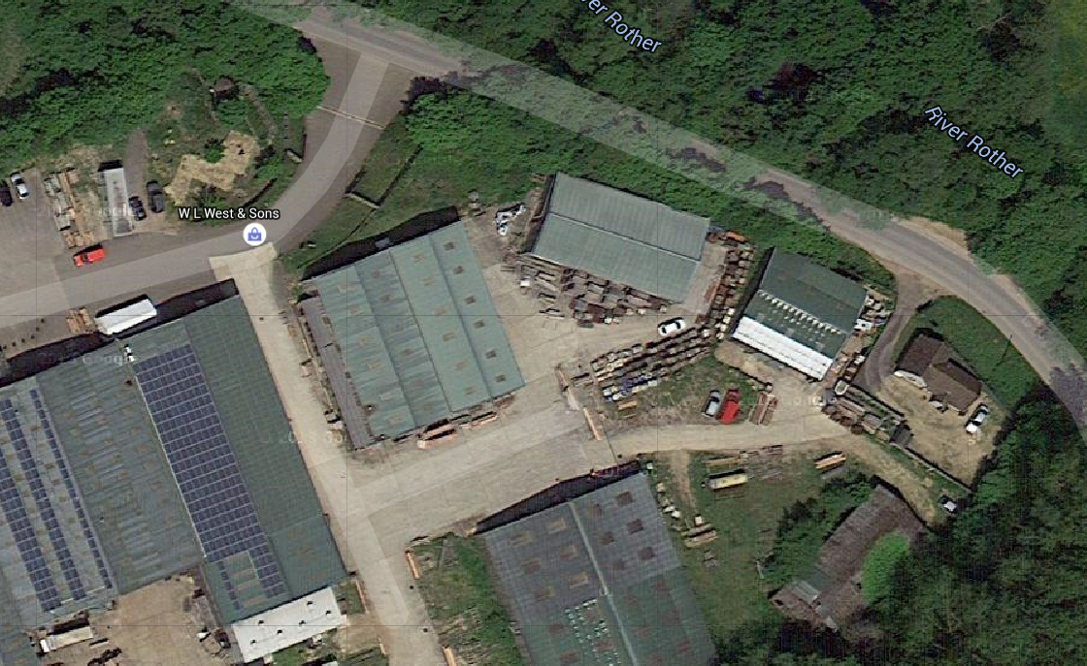

Accommodation Information
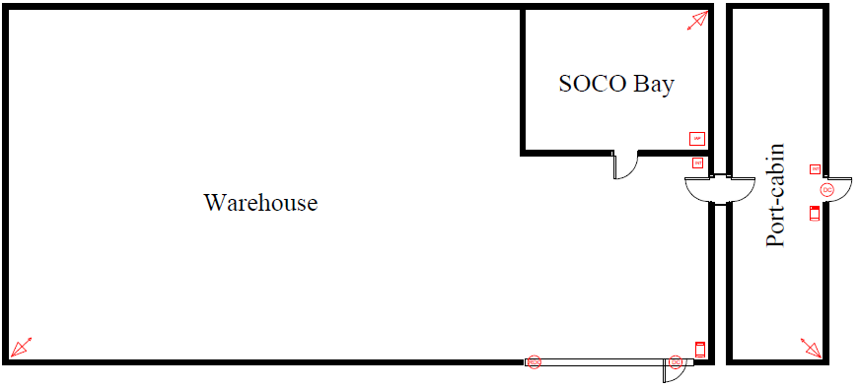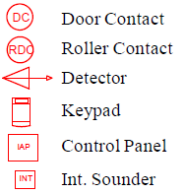

Broadband Services from Zen and Cloudscape

Common Router for both services
Model Name: Vigor2860Vn+
Firmware Version: 3.8.9.5_BT
Build Date/Time: May 3 2019 21:33:24

VPN for Cloudscape: 92.62.10.44 Login: david Password: *elstead2008*
VPN for Zen: 82.69.83.201 Login: david Password: *elstead2008*
Router: 192.168.14.1:8080 Logon: admin Password: *elstead2008*
LAN Start IP Address: 192.168.14.40 Pool Size: 200
LAN Start IP Address: 192.168.2.xx Pool Size: 10
SSID: MIDENG-SELHAM Password: route654 Security: WPA/PSK2 Channel: 1
DNS Servers Using 8.8.8.8 and 8.8.4.4

Zen on 01798 861829 – ADSL Service
Portal: https://portal.co.uk/ Account mike@mideng.co.uk Password: route654
Order Number: 1318083 Installation date: 1 DEC 2017
Product: Broadband Lite – HCA
Broadband Username: zen337223@zen
Broadband Password: 6RHgEmvk
Estimated download speed: 16 Speed estimate generated: 17/11/2017 15:15
Actual: 10 down and 1.22 up

Cloudscape on 01798 861602 – FTTC Service – Supports the CIA Intruder Alarm and CCTV

Broadband Username: 01798861602@cloudscape.uk
Broadband Password: gu280pj
Encapsulation PPPoE (PPP over Ethernet)
Encapsulation Type VC Mux
Modulation Auto/MultiMode*
TAG: Not used as via BT Modem

Bills are only available on line.at https://www.cloudscapeconnect.com/myaccount/
Then go to the tab ‘Billing’ to download desired invoices.

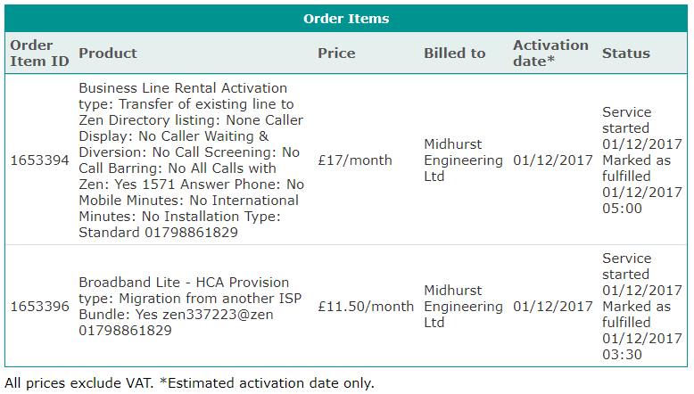

Cloudscape Line 3
Broadband Username: BAL3617973@cloudscape.si1
Broadband Password: gu299dd
Authentication Type: CHAP
Connection Type: PPPoA
VPI/VCI values: 0/38 (sometimes referred to as 0.38)
Encapsulation type: VC-MUX
IP: 92.62.0.46
SMTP Server: smtp3.uk4dsl.co.uk

Broadband Background Information
Lodsworth Exchange is 1485m away according to Sam Knows.

Telephone services in the portacabin come from roadside cabinet #2 in Lodsworth delivered to pole 18 in Selham.

Order placed with BT
Help Desk: 0800 800 152. Open Monday to Friday 8am to 6pm [excluding Bank Holidays]
Billing Enquiries: 0845 600 6156 08:00 - 18:00 Monday to Friday 08.00 - 13.00 Saturday
Installation address: Midhurst Engineering, Area 14 of W L West & Sons Ltd site, Selham, GU28 0PJ
Billing address: Midhurst Engineering, Rumbolds Hill, Midhurst, GU29 9DD

BT Business Account and BT Wi-fi username
Entering the system may require a response a security question. Mother’s maiden name: midhurst
01798 861829 Account: midhursteng2@btconnect.com Password: elstead2008
01798 861602 Account: midhursteng1@btconnect.com Password: recovery1

Name of Product/Service Minimum Period Quantity Total
Business Broadband Unlimited [£17] 24 Months 2 £34
Business Value PSTN phone line [£13] 24 Months 2 £26

Line Installation: £115 * 2 £230
Broadband Installation: £0
To make phone ring: 17070 and press 1 then hang up or 1475
The exchange line is looped through the router to enable calls to be routed through different telephone providers

Installation Orders with BT - Placed order 17 JUL 2015
Bill access: www.bt.com/billonline
Order number B0S000000015903405 - 01798 861602
Network Login Username:D839116@hg57.btclick.com Password: welcome1
Account Numbers: SD44864587 [Voice] and WM 4114 2114 [Broadband]
Voice facility completed: 11 AUG 2015 Broadband switched on: 20 AUG 2015
Name of Product/Service Minimum Period
Business Broadband Unlimited [£17] 24 Months
Business Value PSTN phone line [£13] 24 Months

Telephone Number: 01798861602 ??
BT.com login name: midhursteng1@btconnect.com
Date/Time: Thu Sep 10 10:20:36 BST 2015

Tele: 0800 169 8639 (8am–6pm Mon–Fri, closed weekends and Bank Holidays).
BT Account Number: SD 4486 4587
Order number B0S000000015903403 – STQ183SD - 01798 861829
Network Login Username: D839115@hg70.btclick.com Password: welcome1

Broadband Costs at Area 14 from 1 August 2018

Zen monthly charge on 10 July 2018 on 01798 861829
. Phone services: £11.50
. Broadband services: £17.00
. Average Usage charges: £0.06
. Fixed IP FOC
. Prompt Care Awaited
£28.56
. VAT at 20%: £5.71
Total per month: £34.27

Actual Service Provision: Down 10.07 Up 1.21
Estimated download speed: 16 Speed estimate generated: 17/11/2017 15:15
The exchange line is used for the physical fax machine. Only snom224 connected temporarily.
Call charges would normally be generated through fax machine usage

Cloudscape monthly charge on 1 August 2018 on 01798861602
. Phone services: £15.42 with Care Level 3
. FTTC Broadband services: £16.66
. Average Usage charges: £6.00
. Fixed IP FOC
. £32.08
. VAT at 20%: £6.41
Total per month: £38.50
Estimated download speed: 7 1.2

info@cloudscapeconnect.co.uk

BT account on 3 June 2018 on 01798 861602
. Phone services: £17.60
. Broadband services: £28.10 Now with Cloudscape
. Paper Bill Fee: £4.00
. Non-direct debit charge £10.00
. Average Usage charges: £0.91
£65.70
. VAT at 20%: £13.14
Total per month: £78.84

Fixed IP from a 3rd Party about £20,00

Zen - 01798861829
Portal: https://portal.zen.co.uk/ Account mike@mideng.co.uk Password: route654
Order Number: 1318083 Installation date: 1 DEC 2017
Product: Broadband Lite - HCA
Phone Number: 01798 861829
Estimated download speed: 16 Speed estimate generated: 17/11/2017 15:15
Actual: 10 down and 1.22 up

Broadband Username: zen337223@zen
Broadband Password: 6RHgEmvk
IP Address (Static): 82.69.83.201 (Subnet mask 255.255.255.255)
VPN: 82.69.83.201 Login: david Password: *elstead2008*
LAN Start IP Address: 192.168.14.30 Pool Size: 10
SSID: MIDENG-TBC Password: route654 Security: WPA/PSK2 Channel: 1
DNS Servers Using 8.8.8.8 and 8.8.4.4 ISP option 212.23.3.100 and 212.23.6.100
Encapsulation PPPoE (PPP over Ethernet) or PPPoA
Encapsulation Type VC Mux
Modulation Auto/MultiMode*
VPI/VCI 0/38
Authentication Type CHAP
SNR: 3
Loop: 44
Router: URL: 192.168.14.20:8080
Logon: admin Password: *elstead2008*
DHCP: ON
Model Name: Vigor2830Vn
Firmware Version 3.8.8.2_sb_232201
Build Date/Time: May 22 2018 14:24:30
DHCP TABLE
LAN1 : DHCP Server On IP Pool: 192.168.14.40 ~ 192.168.14.239
IP Address MAC Address HOST ID Logom Password PIN
192.168.14.40 40-61-86-4B-D9-27 Rum Selham recovery1

192.168.14.43 00-04-3A-FB-65-50 DVR
192.168.14.44 30-05-5C-72-F7-4D BRN30055C72F74D
192.168.14.45 6C-4D-73-8B-AB-0D jordans-iPhone
192.168.14.46 00-04-13-27-D4-7B 30204802224 trolleybus route654 1618
192.168.14.47 A4-4E-31-39-92-70 Tequila
192.168.14.48 3C-F7-A4-04-1F-4D SM-G390F
192.168.14.50 88-AE-07-BA-A3-A3 iPhone

LAN2 : DHCP Server On IP Pool: 192.168.2.10 ~ 192.168.2.19
IP Address MAC Address HOST ID Logom Password PIN
192.168.2.xx 00-22-EE-02-79-7A AlgoArea14 --- recovery3
192.168.2.10 00-04-13-29-8A-D0 30204802214 trolleybus route654 1618

Cloudscape - 01798 861602

Broadband Username: 01798861602@cloudscape.net
Broadband Password: gu280pj
WAN IP Address: Dynamic (Subnet mask 255.255.255.255)
VPN Access: Login: david Password: *elstead2008*
SSID: MIDENG-SELHAM-B Password: route654 Security: WPA/PSK2 Channel: 1

DNS Servers 8.8.8.8 and 8.8.4.4
Encapsulation PPPoE (PPP over Ethernet) or PPPoA
Encapsulation Type VC Mux
Modulation Auto/MultiMode*
Router URL: 192.168.14.20:8080
Logon: admin Password: elstead2008
DHCP: ON
Model Name: Vigor2860Vn+
Firmware Version: 3.8.8_BT
Build Date/Time: May 18 2018 17:26:52
Router Auto Re-boot: Every Monday at 5am [Applications >> Schedule]

82.69.83.201
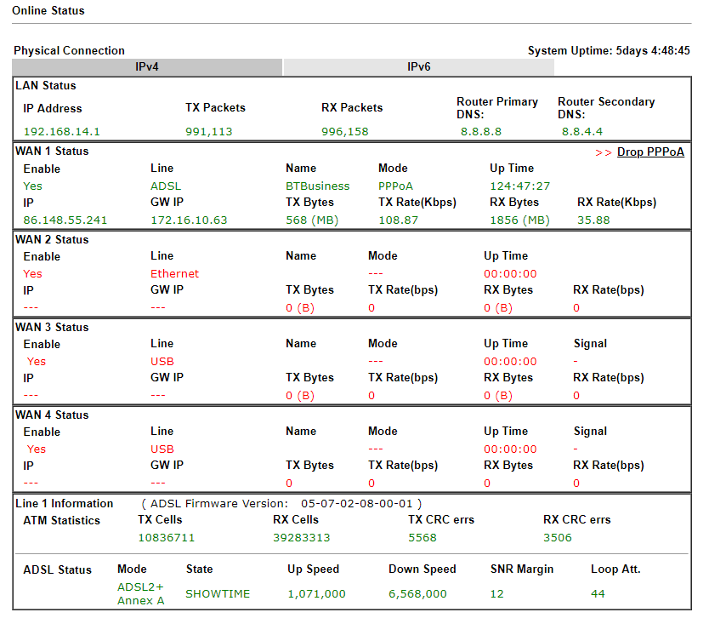

Dynamic DNS

Dynamic IP address from BT currently provided changes frequently.NO-IP is being used to gain access to the Draytek router. NO-IP keeps us notified of the current dynamic IP address.
£23 annual subscription paid – Renewal due 9 September 2017.
Access: https://www.noip.com/members/
Username: david@mideng.co.uk Password: recovery1 Security: Pets Name is pip

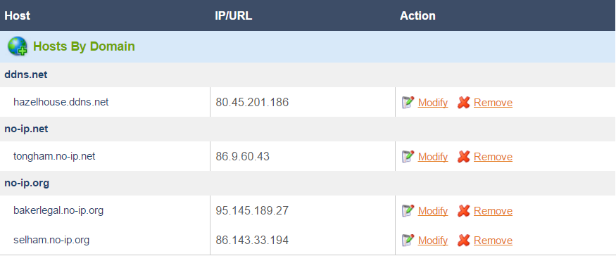

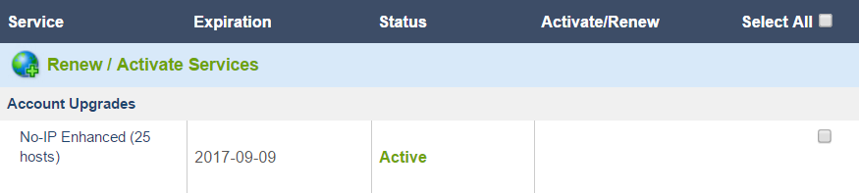

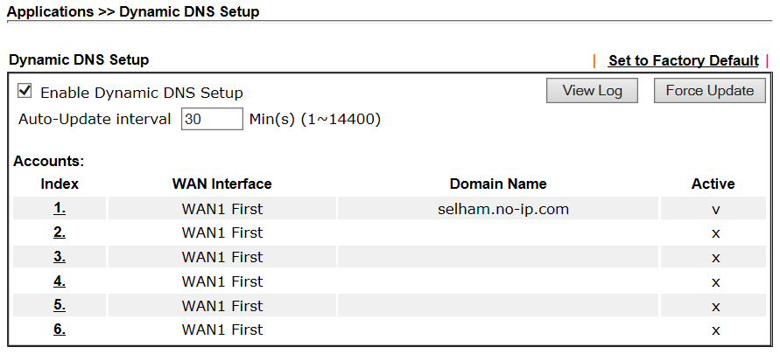

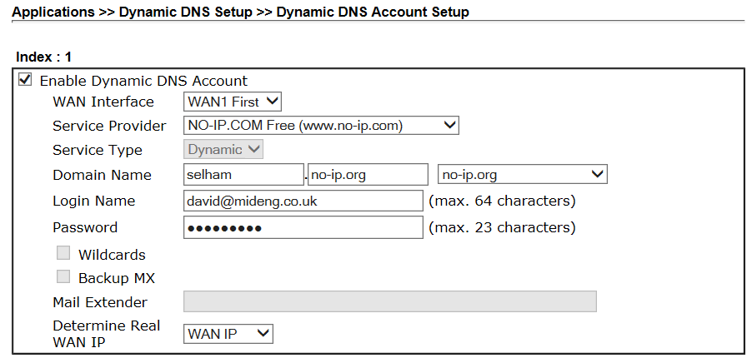

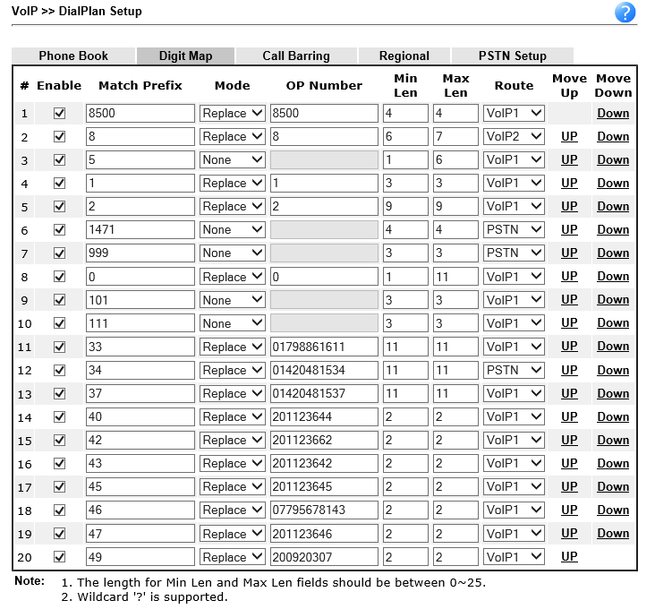
How to make phone calls from Area 14 as of Friday, 19 May 2017

- You must use the area code if calling a number on the public network, e.g. 01252 758123.
- Outgoing calls will show 01730 888152 on the called party’s phone.
- Abbreviated dialling codes have been setup for frequent destinations and are shown in the table below.
- A calling plan is in place giving free calls to 01/02/0800 numbers and any short code except for 101 and #0. Anything else is chargeable like 03, 0844 and 0845.
- Contact numbers can be stored in the wireless phone and redial is possible from the calls list.
- Using codes 4147, 4148 and 4149 will ring all phones in the area described.

Called Party | Use
David Bradley | 123
Voipfone [Will Hancock | 121
Listen to messages left | 8500 UID 23544 PW 23544
Last Caller’s number via BT | 1471
WL West’s Offices | 33
JDs Alton Office [Lewis] | 34
JDs Alton Workshop [Adam] | 37
MIDENG Mike [DDI] | 47
MIDENG Guy [DDI] | 45
MIDENG Belinda [DDI] | 43
MIDENG Emily [DDI] | 40
MIDENG Tony [DDI] | 49
MIDENG Workshop | 4147
MIDENG Bodyshop | 4148
MIDENG Recovery | 4149
MIDENG Petersfield Base | 42
MIDENG Paddy [Mobile] | 46
Draytel Subscriber | 8xxxxxx
Police, Fire, Ambulance | 999
Police [Non-emergency] | 101
Medical Emergency | 111
Route outgoing call via BT | #0 followed by number

Receiving Calls
- The preferred number to call Area 14 is 01730 888152. The wireless phone’s inbuilt calls list is populated with calls received on this number.
- An answerphone service kicks in after 40 seconds. Retrieve any messages left by dialling 8500 where the credentials are mailbox 23544 and password 23544
- A greeting message is in place for the answerphone facility. To listen to it dial 523544.
- Callers can use 01798 861602 instead but this choice will not show the telephone number of the caller although the last caller’s number can be obtained by dialling 1471.

Phone Faults
- Report faults with the phone service to David Bradley on 01252 758960.

BT Twin Set Cordless phones at Selham
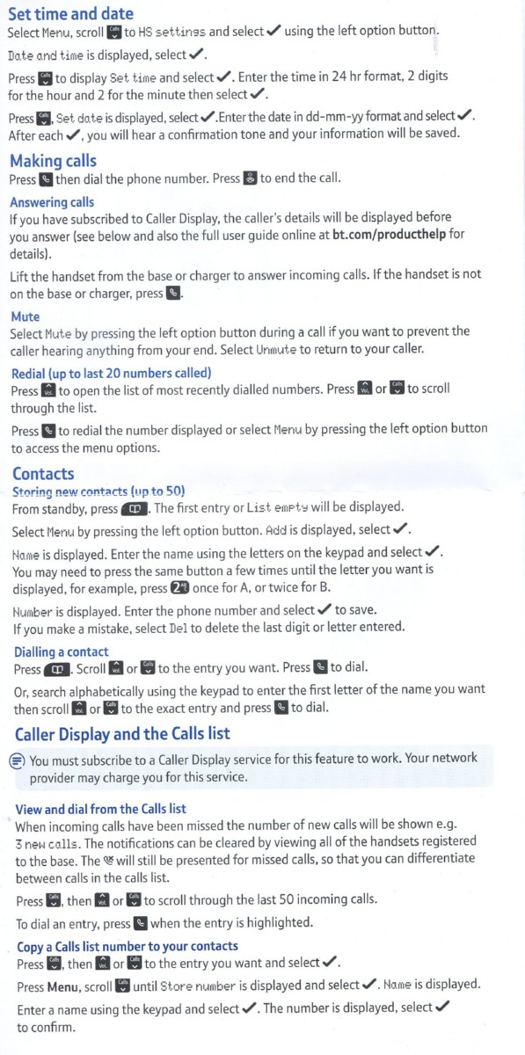
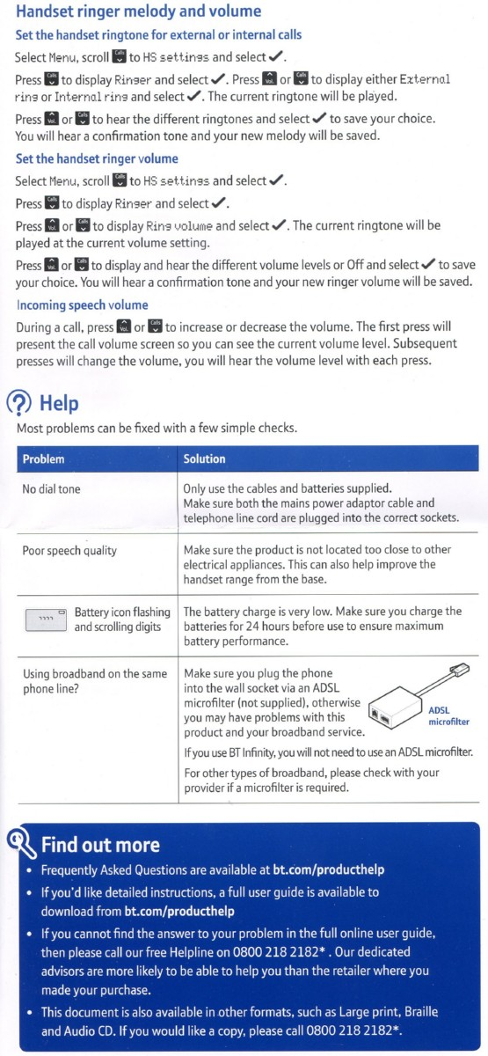

DrayTEL
Username: 8493257
Password: Y1vW2)4)
Domain: draytel.org
NAT Proxy (if required): nat.draytel.org
Signup details: selham@mideng.co.uk Password: elstead2008
Telephone number: 0845 557 8836

CCTV

LAN Web browser access: http://192.168.14.21
For remote access, establish a VPN connection first.
Web Address: selham.no-ip.org
Will only work with Internet Explorer
Camera Userid: admin Password not yet set

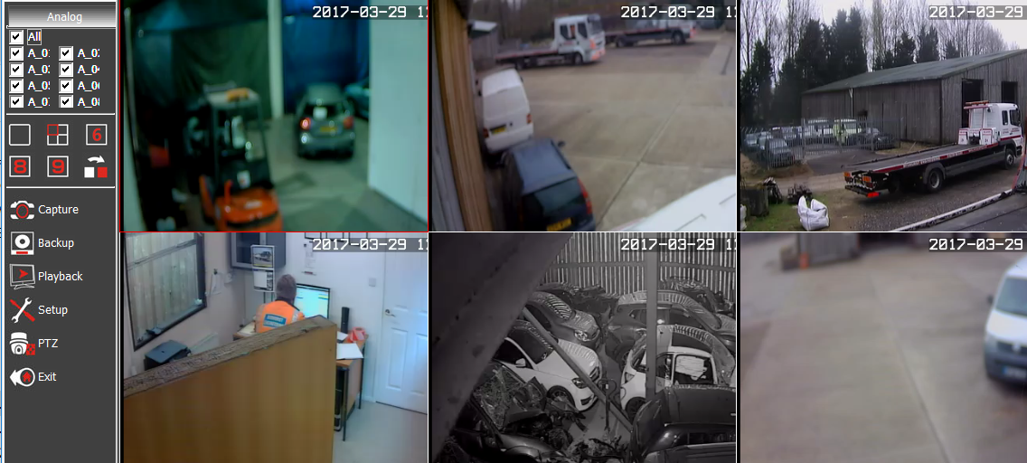

Workgroup: SELHAM
Brother Network Printer at Selham
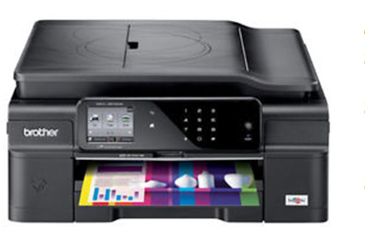
Userid: }
Password: } Facility not installed
Name: BRN30055C72F74D
Copier Model: MFC-J870DW
Serial Number: E71966A5F294095
MAC Address: 30-05-5C-72-F7-4D
Static IP Address: 192.168.14.44
Driver:
Firmware: L1409170826
Supplier: vikingdirect.com
Customer number: 5581412
Order number: GB018980274B
Purchased: 8 September 2005 Price: £100.19

Manuals
https://support.brother.com/g/b/manualtop.aspx?c=gb&lang=en&prod=mfcj870dw_us_eu_as

Viking
Username david@mideng.co.uk
Customer number 7136848

Google Account
Access: https://accounts.google.com/ServiceLogin?elo=1
Email: david@mideng.co.uk Password: WestCroydon630^
Verification link:
https://accounts.google.com/VEH?c=CMOd48fQqfT9DxDDs_Wwo4eCyVY&hl=en
Need this if I lose access to my account (for example, if you forget your username or password)

NO-IP
Account URL https://www.noip.com/login?ref_url=console
Userid: david@mideng.co.uk Password elstead

Samsung S24D300HS 24 inch LED HDMI Monitor - Black
Order #206-4068503-0637904 - Placed on June 14, 2016
Sold by Amazon EU S.a.r.L. £96.67

Access to GUI: http://192.168.14.17/general/index.html?pageid=1087


https://www.google.com/cloudprint#printers

https://www.google.com/cloudprint/learn/

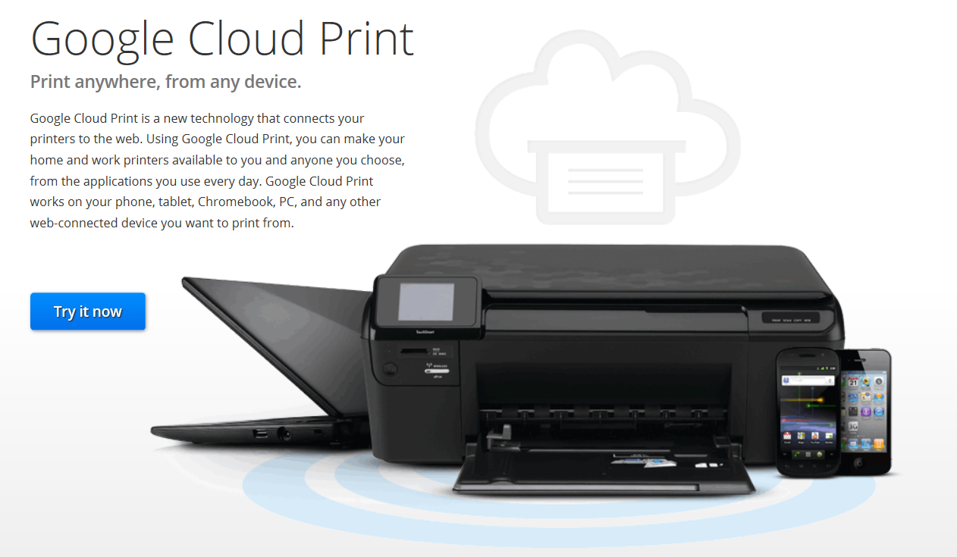

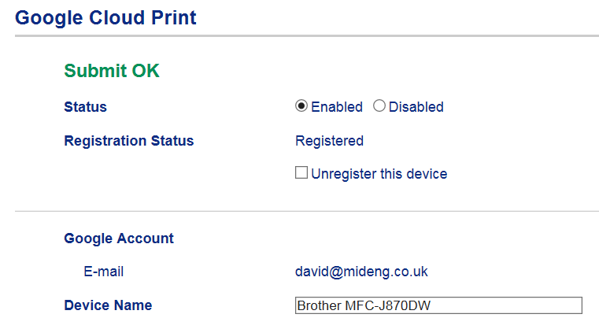

Brother Online Connections
It seems only to work if Google Chrome is used. Feature is unlikely to be used anyway.
https://connections.brother.com/
Email address: david@mideng.co.uk Password: Route612

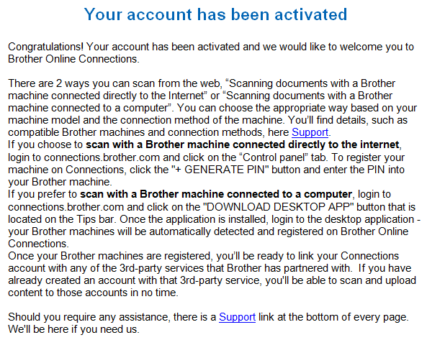

Not being on site to read the PIN off the printer could not proceed on 17th September 2015

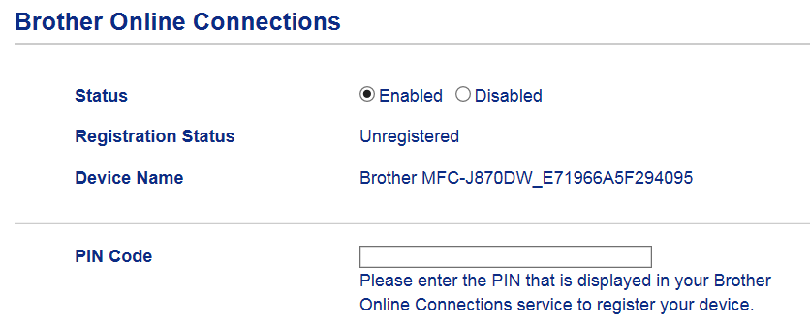

How to use google cloud print app for Android
See https://support.google.com/cloudprint/answer/3153824?hl=en

Google Cloud Print is an under-appreciated service that can send print jobs from virtually anywhere to a connected printer in any other location. Normally that involves tedious configuration on your network, but Cloud Print can do it in just a few minutes. It's really easy to set up, and there are a few things you can do to extend its support beyond the browser to make all your printing tasks a lot easier. Here's a look at what it can do, how you can set it up, and how to make it even better.

What You Can Do With Google Cloud Print

Google Cloud Print makes it possible to send any document or image to a printer from any location. For example, if you wanted to print out a letter at home while at work, you could use the service to send that letter to your home printer and have it waiting for you when you get back. Normally this kind of setup requires a tedious network configuration, but with Google Cloud Print you just click a few buttons and you're done. The service can also print web pages and other documents to PDF format and save them in your Google Docs account. This is can be especially handy if you're keeping your account synchronized with all your computers using a third-party service called InSync (more info here). Basically, if you want to print anything from any device to practically any location, Google Cloud Print can make that happen.
If you want to get started with Google Cloud Print, here's what you'll need:
- The Google Chrome web browser.
- A regular or internet-enabled printer. (Virtually any printer is fine, but the setup process varies depending on the type of printer you have.)
- An active, internet-connected computer that the printer is connected to if it is not an internet-enabled printer.
- A Google account. (If you don't have one, sign up for one here.)
Once you've got all of that ready to go, you can start setting it up.

How to Set Up Google Cloud Print
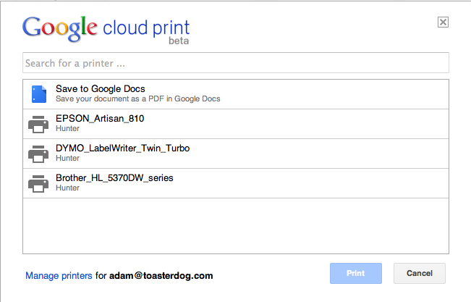
There are two ways to set up your printers with Google Cloud Print. A handful of newer printers have internet connectivity built in and so you can connect them to Google directly. This process varies by printer, so visit this page to learn if your printer is compatible and, if so, how to set it up. If you have a traditional printer that's connected to your computer, however, the setup process is always the same. Just follow these steps:
- First, make sure everything is in place. You'll need Google Chrome installed on your computer. Also, ensure that your printer is connected to your computer, it's currently on, and you can print from it normally. (Note: You'll only be able to send print jobs to this printer when it is connected to your computer, so it's best to set this up on a desktop machine where the printer will always remain connected and powered on.)
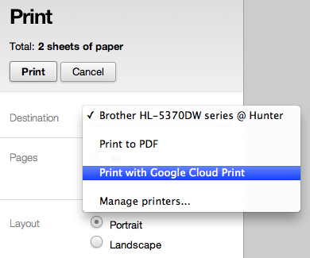
- Once you have everything in place, open up Google Chrome and click the wrench icon in the upper right corner, choose "Options" ("Preferences" on a Mac), and then click the "Under the Hood" tab. Alternatively, just click this link. Now scroll down to the Google Cloud Print section towards the bottom and click "Sign in to Google Cloud Print."
- In the resulting window, sign in with your Google Account. This will enable the Cloud Print Connector on your computer.
- When a new message appears with a button labeled "Finish printer registration," click it.
- You'll receive a confirmation if everything worked properly, and it'll offer a link called "Manage your printers." Click on it to verify all the printers on your computer are now listed.
To test out your new setup, try printing something from within Google Chrome (such as this web page). When the printing options appear, choose "Print with Google Cloud Print" from the Destination menu. Click the "Print" button and you'll be asked to choose one of your cloud printers. Pick the one you want and, assuming everything is working correctly, your printer should print out a document.

*** END OF ENTRIES FOR SELHAM FACILITY ***

Midhurst Car and Van Sales:
Tele: 01730 887556
VoIP: 201123513
Password: Mid31415
VMB: 10584 Local Access: 8500 Remote Access: 020 3468 5818
VMB email: messages@midhurstcarandvansales.uk

Vidahost
Control Panel: http://ns34.sovdns.com/cpanel
Username: davi1995
Password: 2sUuQoBi67

FTP Host Server: ftp.midhurstcarandvansales.uk
Username: davi1995
Password: 2sUuQoBi67

Email Information
mike@midhurstcarandvansales.uk 4q66fqqqax34
guy@midhurstcarandvansales.uk 9ee89452p9wy

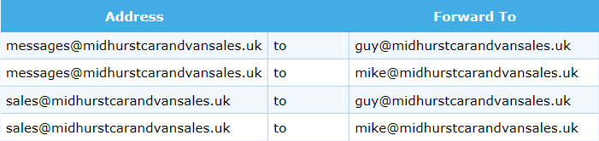

Primary
ns34.sovdns.com
195.238.172.21

Secondary
ns34sec.sovdns.com
195.238.172.22

Gigaset Unit
To configure personal info services (e.g. Weather, eBay, News) go to www.gigaset.net/myaccount
Username: 229388050024#9
Password: nxeAv72S

Appendix 1

MIDHURST ENG CO LTD, RUMBOLDS HILL, MIDHURST, GU29 9DD on Exchange MIDHURST is served by Cabinet 11
Featured Products | Downstream Line Rate(Mbps) |  | Upstream Line Rate(Mbps) |  | Downstream Range(Mbps) | Availability Date
 | High | Low | High | Low
FTTC Range A (Clean) | 80 | 79.5 | 20 | 19.9 | -- | Available
FTTC Range B (Impacted) | 80 | 70.2 | 20 | 17.9 | -- | Available
Monthly Charges:
Complete Fibre Business Broadband: £25.50
Complete Line Rental: £14.50
Total: £40.00
The fibre product, on the line registered to 01730858011 has an estimated downstream speed of 38 Mbps and an estimated upstream speed of 10 Mbps. Actually achieved:
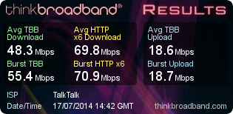
The Complete Fibre Business Broadband package is advertised on this page http://www.talktalk.co.uk/business/product/fibre where this extract was taken from:

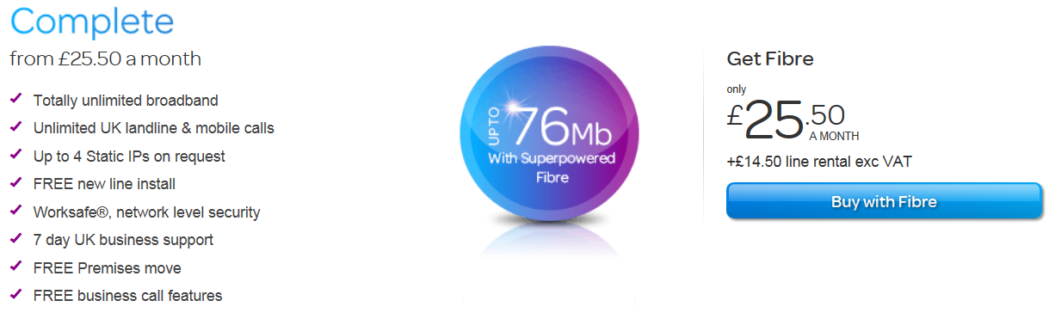

TalkTalk Business logon details for insertion in the DrayTek router.
DSL Username: 01730858011@talktalkbusiness.net
DSL Password: D4E3Z6D3J2 Subnet Mask: 255.255.255.0
Appendix 2
Brian Morgan Home Computer

Userid: Brian
Password: recovery0 [that’s a zero on the end]

CCTV.
Userid: brian
Password: morgan
Access is through Internet Explorer and on the Favourites Bar there is an item called “WEB SERVER”. Click on that to get to the logon screen.

The router has an IP address of 192.168.1.254 – Logon credentials are:
Username: admin
Password: W4H6KR6T

The PC has a fixed IP address of 192.168.1.46 and therefore remote access should be possible using the current WAN address of http://109.152.196.246:1939 but unfortunately needs tweaking for it to work, perhaps a reboot of the PC and router is needed.

Appendix 3
Auto Data

http://www.autodata-online.net/online/Chapters/UI/ModelIdentification.aspx
Username: OWLAADLR0
Password: LRDxwge178
Click here to log in to the online product.
This planned change is part of the upgrade to a new Autodata later in 2015. This will not just be an update, but a completely new online application, designed around real workshop needs to access information faster, easier and with more interactivity.

email: uksubsciptions@autodata-group.com
Tele: 01628 688 111

From: registration@autodata.ltd.uk [mailto:registration@autodata.ltd.uk]
Sent: 23 December 2014 16:12
To: belinda@mideng.co.uk
Subject: Thank you for purchasing an Autodata-Online subscription.

 | Thank you for using Autodata-Online.
 | Please log in using the link below.
 | We have supplied you with a temporary username and password, you will be able to change these
 | once you have logged in and filled out the registration form.
 | https://www.autodata-online.net/Online/Login/AutodataLogon.aspx
 | Administrator Login
 | Username: | belinda1
 | Password: | tony2
 | Login
 | Username: | tony001
 | Password: | belinda2

Update Monday, 6 August 2018
Password change for Tony:
Userid: belinda-240314 Password: recovery1

EURO CAR PARTS

The web address is:
http://web2.carparts-cat.com/default.aspx?11=24&10=BCBF8FAE712DE81EE040A8C01E3E0355024099&14=99&12=1003

But it needs the password manager of Internet Explorer which is unreadable.
The default browser is now Chrome, so the replacement icon for EURO CAR PARTS on the desktop forces Internet Explorer to open up for that web address. The credentials will be blank so hoover over the userid and select mcoop which will populate the password and away you go.

Contact Information:
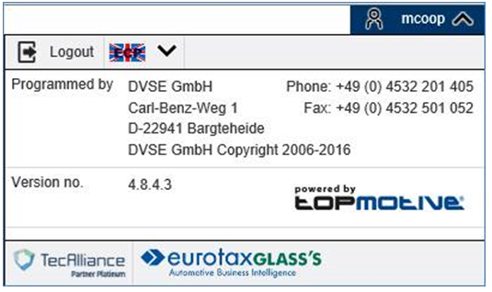

There doesn’t seem to be any option to reset the password.

Appendix 4

What are the settings for my TalkTalk Business e-mail account?

If you are using a TalkTalk Business e-mail address (@talktalkbusiness.net) then the settings that your e-mail client will require are listed below.
Incoming:
Server Name: pop3.talktalkbusiness.net
Connection Type: POP3 or IMAP4
Port: 110 for POP3
Authentication Type: Plaintext Password
SSL (Secure Socket Layer or Encryption): Disabled
SPA (Secure Password Authentication): Disabled (or clear text)
Username: Your E-mail address
Password: Your mailbox password
Outgoing:
Server name: smtp.talktalkbusiness.net
Connection Type: SMTP
Port: 25
SSL: Disabled
Authentication: Disabled
Please note that you will only be able to send mail through our outgoing server if you are using yourTalkTalk Business broadband (ADSL) connection. If you are using a connection provided by another supplier, including a 3G connection on your mobile, then you will need to use the outgoing server of that supplier instead.

Zen Enquiry Response
A preferred supplier but unfortunately they identified a number of issues in supplying telecommunication services to this site with their pricing reflecting issues identified.

From: Michelle Buckley [mailto:michelle.buckley@zeninternet.co.uk]
Sent: 07 July 2015 09:51
Subject: New phone and Broadband Service for MIDENG GU28 0PJ

I have spoken with my manager regarding supplying a new telephone line to a Portakabin on this site. Irrespective of how long the cabin will be on the site, Openreach treat this as a specialist installation, and the cost of the new line install would be £518.58 + VAT. Installation of broadband would be £40 + VAT.

With respect to the broadband, there is no date currently provided for Fibre, in fact the checker that I have used says it is not yet planned. As we both know, these estimations can change day by day. I would suggest placing an order for broadband and upgrading to Fibre as soon as it becomes available. Broadband speeds are estimated at 4 Mbps download.

Monthly Service Charges:
· Business Line Rental Premium - £17.49 + VAT
· Broadband Lite HCA 50 GB Usage - £11.50 + VAT

Putting this into a standard format for budgetary and comparison purposes:
Name of Product/Service Minimum Period Quantity Total
Business Broadband Lite HCA 50 GB Usage [£11.50] 12 Months 2 £23.00
Business Line Rental Premium [£17.49] 12 Months 2 £34.98
=====
Ongoing Monthly Rental with Zen £57.98

Line Installation: £518.58 * 2 £1037.16
Broadband Installation: £40.00 * 2 £80.00
Estimated Pole Cost: £300.00
=======
One-off Fees £1417.16

Business Line Rental Plus has 5000 inclusive anytime minutes to 01, 02, 03, 0845 and 0870 numbers, normally £23.50, but was not offered/available.

Using Zen would have cost in the first year [£57.98 * 12] £695.76 plus £1417.16 = £2112.92 plus the cost of any calls which cannot be estimated at this stage. However it would have been just a 12 month contract.

Zen provides a free IP address but this wouldn’t be needed anyway because aggregation supplies this feature.

From: Michelle Buckley [mailto:michelle.buckley@zeninternet.co.uk]
Sent: 17 July 2015 09:27
Subject: FW: New telephone and broadband service required

I see you are going with BT to provide the service as they are offering a cheaper installation charge. I am sorry that we were unable to be more competitive on this occasion, but hope that you will think about using Zen at any other sites that require Broadband.

Appendix 1

MOT testing service: web address changing

The website address for the MOT testing service will change from Friday 16 December 2016.

The change shouldn't affect most of you.

You should always access the service through www.gov.uk/mot-testing-service.

This makes sure that you see any urgent messages about service availability.

Download 'Use the MOT testing service poster' (PDF, 199KB) to display a reminder of where to sign in.

If you've bookmarked the direct link to the sign in screen within the service (http://mot-testing.i-env.net), update it with the GOV.UK address now.

Check your IT network allows access

Some large company networks stop you visiting certain website addresses.

Make sure that your IT team allows access to any website address that includes 'service.gov.uk' so you can access all government services.

SOCO Label
Emily
888241
Guy
888241
Mike
Jordan
Carly
Julian
Marilyn
Office
Broadcast
David

Emily’s phone label ext 203
Carly
812162
Ella
888492
Guy
Jordan
Julian
Marilyn
Mike
Area 14
Petersfield
Broadcast

Jordan phone label
Emily
812162
Mike
812162
Belinda
Sarah
Tony
Brian
Guy
Petersfield
Nick
Area 14

Brian Morgan Home phone label
Emily
888062
Mike
888062
Carly
Guy H
Workshop
David
Mike M
Guy O
Bordon
Area 14

Bordon Base

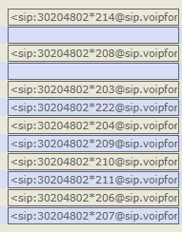
Emily
370070
Mike O
370070
Mike M
Guy H
Guy O
David
Carly
Workshop
Jordon
Area 14

Jordan phone label
Emily
812162
Mike
812162
Belinda
Sarah
Tony
Brian
Guy
Bordon
Nick
Area 14

Guy phone label
Emily
812162
Mike
812162
Belinda
888162
Tony
Brian
Sarah
Jordan
Nick
Area 14

Kieran label
Amabel
Area 14
Broxhead
Carly O
Carly W
Emily
Guy
Jordan
Marilyn
Mike
Wayne
Workshop

Carly phone label
15 Jan 2024
David
812162
Emily
812162
Guy
Marilyn
Mike
Wayne
Petersfield
Jordan
Julian
Area 14

URL: https://sputnik.servers.prgn.misp.co.uk:2083 or http://cpanel.midvehmapping.net
Username: davidb71
Password: qtan204BH2

Domain Name Registration
If you have requested a domain name registration during sign up, we will register this domain once your payment has been cleared. This can take upto 24 hours to process. No further action is required if this is the case.
If you have requested a domain name transfer, we'll send you a separate email with instructions.
If you have not registered or transferred in a domain, you will need to have your existing registrar change your existing domain's nameservers to the following. This can normally be done via an online control panel but, if you can't find the option, please phone or e-mail your domain registrar for assistance.
Nameserver 1: ns1.tsohost.co.uk
Nameserver 2: ns2.tsohost.co.uk
Nameserver 3: ns3.tsohost.co.uk
Please bear in mind that your domain name may not be visible on the internet for between 24 and 72 hours due to DNS propagation and caching. Until this time, you will not be able to access your new website or email however we have provided a temporary URL below from which you can view your website before your domain name is live.
New Account Info
Domain: midvehmapping.net
Username: davidb71
Password: qtan204BH2
Hosting Package: Startup cPanel Hosting
Server Hostname: sputnik.servers.prgn.misp.co.uk
Server IP: sputnik.servers.prgn.misp.co.uk
cPanel
cPanel is your interface for managing the website, its email settings, databases and much more. The login details are below. Please make a note of them but, if you do lose them, they can be viewed and reset through your Tsohost account.
URL: https://sputnik.servers.prgn.misp.co.uk:2083 or http://cpanel.midvehmapping.net
Username: davidb71
Password: qtan204BH2
Once your domain is set up and pointed to your Tsohost hosting, you can use midvehmapping.net/cpanel as a short cut to cPanel.
E-mail
Before you can start using e-mail, you need to log in to cPanel and set up your mailboxes. Once you have added a mailbox, you can access it via Webmail and through your desktop e-mail software or mobile device.
Webmail: https://sputnik.servers.prgn.misp.co.uk:2096 or https://midvehmapping.net/webmail once your domain is pointed
Username: The full e-mail address that you are trying to access
Password: The password you chose when adding the mailbox
To configure your desktop e-mail client or mobile device:
Incoming/outgoing server address: sputnik.servers.prgn.misp.co.uk
Username: The full e-mail address that you are trying to access
Password: The password you chose when adding the mailbox
SSL: On (recommended)
Outgoing server authentication: Enabled (same login details as above)
It is important to note that, if you have an externally registered domain and it is not yet set to our nameservers, you will not receive any email.
FTP (Uploading your site)
To connect with FTP, you will require the following details to configure your software.
Hostname: sputnik.servers.prgn.misp.co.uk
Username: davidb71
Password: qtan204BH2
Upload directory: public_html
If you don't have any FTP software, we recommend Filezilla from www.filezilla-project.org.
Softaculous (script auto installer)
The Softaculous option in cPanel will enable you to install content management systems such as Magento and Wordpress in just a couple of clicks. There's no need to worry about uploading, permissions or setting up databases.
Adding more domains to your hosting
If you have other domains that you want to add to your hosting, you can do this in two different ways. If you want the domain to show the same content as your main website, add it as a parked domain. If you want to set up a separate website, add it as an addon domain which will allow you to choose a directory for the new website's files to be stored. The domain will need to be registered first, either with Tsohost or with another domain registrar.
Thank you for using Tsohost. If you have any queries, please raise a support ticket at http://my.tsohost.com
Kind Regards,
Tsohost

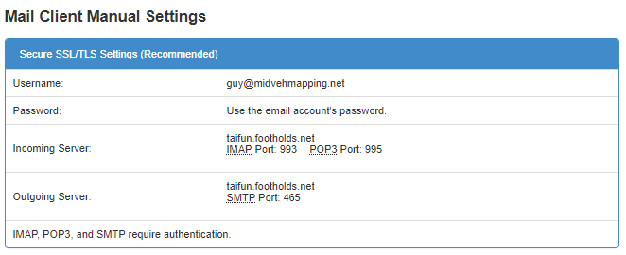

guy@midvehmapping.net rbpstq8nnc7t
emily@midvehmapping.net
paddy@midvehmapping.net c9uyivu6wwpw
north@midvehmapping.net
steve.kirwin@midvehmapping.net
david@midvehmapping.net 77n1bwhqmmga

A mailing list will be setup that will deliver messages to the above email accounts plus these email addresses:
guy.morgan307@hotmail.co.uk
mo@mideng.co.uk
stevekirwin@hotmail.co.uk
paddy@mideng.co.uk

It should be noted that only email address on the domain will receive posting using the generic access of broadcast@midvehmapping.net
From 21/06/2024
Broadcast Listing  amabel@mideng.co.uk  andrew@mideng.co.uk  area14@mideng.co.uk  brian@mideng.co.uk  carly.bayliss@mideng.co.uk  carlybayliss1982@outlook.com  daved@mideng.co.uk  davethemig@hotmail.co.uk  david@mideng.co.uk  davidf@mideng.co.uk  davidfauset@gmail.com  demko.t44@gmail.com  emily@mideng.co.uk  f.goodwin1@sky.com  gardner1611@icloud.com  george@mideng.co.uk  georgeloveridge512@gmail.com  goodwin71@sky.com  guy.morgan307@hotmail.co.uk  guy@mideng.co.uk  h-a-y@hotmail.co.uk  hayden@mideng.co.uk  indemily4@hotmail.co.uk  jack49101@gmail.com  jackg@mideng.co.uk  jordan@mideng.co.uk  jordanmorgann@hotmail.com  juliansouthey@gmail.com  kieran@mideng.co.uk  kierankcoombes@gmail.com  lelo@mideng.co.uk  leloclark@hotmail.com  marcustoone72@gmail.com  marilyn@mideng.co.uk  michael.foskett17@gmail.com  michaelf@mideng.co.uk  mike@mideng.co.uk  mptcasey@talktalk.net  north@mideng.co.uk  paddy@mideng.co.uk  paulg@mideng.co.uk  pete@mideng.co.uk  silver@mideng.co.uk  stevekirwin@hotmail.co.uk  stevemerry307@hotmail.co.uk  tibi@mideng.co.uk  workshop@mideng.co.uk | Drivers Listing  andrew@mideng.co.uk  area14@mideng.co.uk  daved@mideng.co.uk  david@mideng.co.uk  davidf@mideng.co.uk  davidfauset@gmail.com  demko.t44@gmail.com  gardner1611@icloud.com  georgeloveridge512@gmail.com  guy@mideng.co.uk  h-a-y@hotmail.co.uk  jack49101@gmail.com  jackg@mideng.co.uk  jordan@mideng.co.uk  jordanmorgann@hotmail.com  kierankcoombes@gmail.com  lelo@mideng.co.uk  leloclark@hotmail.com  michael.foskett17@gmail.com  mike@mideng.co.uk  paddy@mideng.co.uk  silver@mideng.co.uk  tibi@mideng.co.uk

Overview
Did you know that you can boost both the power and fuel economy of your car in about 30 minutes, simply by altering the settings on the engine control unit?
It’s a process called 'remapping'.

Car control
The engine control unit (ECU) is basically a computer that controls how the engine works, a bit like a brain. But the default settings – or maps – are not necessarily the best they could be, as manufacturers who sell their cars around the world have to take into account different climates, fuel qualities and laws when they program the software.

Car makers are also known deliberately to limit the performance of their cars through the ECU so they can release faster models at a later date, with just a few software changes and a much higher price tag.

Enhanced performance
Remapping is intended to make the most of your car by overwriting the ECU’s default settings with new software which can be programmed to enhance the car’s overall performance.
It usually takes between 30 minutes and an hour, and modern technology means it’s pretty straightforward.

Speed and power
If the remapping is successful, you should notice an immediate improvement in the speed and power of your car.

The engine will also be more responsive, so it will be easier to overtake, for example. You might also find that you don’t have to change gear as frequently, boosting the number of miles to the gallon.

Lifetime warranty
Damage to the engine is rare, but you should always choose a reputable firm to carry out the remapping – and preferably a firm that offers a lifetime warranty on the software.

Bear in mind, though, that some cars cannot be remapped, usually because they are too old. If your car was manufactured before 2000, you might have difficulty, but it all depends on the make and model of the vehicle.

Tell your insurer!
Remapping is a way of fundamentally changing your car, without actually changing your car, if you see what I mean, so do you need to tell your insurance company?
The short answer is, yes. Remapping is classed as a modification because your car has been altered, even though the alteration is not visible. And you must inform your insurer of any modifications you make to the car or you could invalidate your policy.

In other words, it would not pay out in the event of a claim. You could also get into more serious trouble for deliberately hiding relevant information, which is not too far away from insurance fraud.

Best deal
Some insurers refuse point blank to cover a modified or remapped car. Others are less squeamish, though they would usually charge an extra premium, sometimes in the form of a flat fee.

..you must inform your insurer of any modifications you make to the car or you could invalidate your policy.

http://www.autoexpress.co.uk/car-news/59931/engine-remapping-and-car-chipping-does-it-work
WANT MORE ECONOMY?
UNLOCK THE POWER OF YOUR VEHICLE?

ECU tuning has become the preferred option for engine modification. Whether you a driving enthusiast or everyday driver looking for more from your vehicle then an ECU remap is an excellent choice
By remapping the vehicles ECU, we can increase BHP, torque and fuel economy giving you the benefits available to the top of the range models within your class of vehicle. This process will considerably improve the driveability while retaining the reliability of the vehicle.
07769723651
DPF SPECIALISTS
REMAPPING EXPERTS
DIAGNOSTIC PROFESSIONALS

ECU tuning has become the preferred option for engine modification. Whether you a driving enthusiast or everyday driver looking for more from your vehicle then a ECU remap is an excellent choice
Here at we can assist you to make the best choice to meet your needs

ECU Remapping
DPF Cleaning
DPF Removal / Delete
EGR Removal / Delete
Speed Limiter Removal

Agents for Avon Tuning

