Computer Installation and Telecommunication Services Data Sheet
Updated: Saturday, 24 June 2017 Registration Number: 432447

Main Business Address:  Rumbolds Hill  Midhurst  GU29 9DD | Petersfield Depot  60 Winchester Road  Stroud  Petersfield  GU32 3PL
Selham Facility  Area 14  W L West & Sons Ltd  Selham  GU28 0PJ | Brian Morgan  Dormers  72 Petersfield Road  Midhurst  GU29
Guy Morgan’s Home:  Hazel House  Cobden Road  Midhurst  GU29 9JW | Mike Morgan’s Home:  8 St Margaret’s Way,  Midhurst  GU29 9FQ

Midhurst Garage: 01730 812162 [Callmaster]
Petersfield Base 01730 812163 [Callmaster]
Broadband Line #1 FTTC 01730 858011 [TalkTalk]
Broadband Line #2 FTTC + Physical Fax: 01730 816791 [Zen]
Disconnected 01730 716472 [Lakeside]
Disconnected 01730 815038 [Lakeside]

Credit Card Machines: Connected to the Internet now

Cobden Road [Guy] ADSL2: 01730 858062 [TalkTalk]
St Margaret’s Way [Mike] FTTC: 01730 816595 [Zen]

Area 14 Line #1 ADSL2+, Alarm & Broadband: 01798 861602 [BT]
Area 14 Line #2 ADSL2+, Fax & Unused Broadband: 01798 861829 [BT]
Area 14 Training Room: 08455 578836 [Draytel]

Petersfield Base: 01730 812163 [Callmaster via Roy’s Broadband]

Midhurst Car and Van Sales: 01730 887616 [Callmaster]

DrayTEL [Mike Home]: 8488593
DrayTEL [Mike Office]: 8485796
DrayTEL [Selham Facility]: 8493257
DrayTEL [Selham Training]: 8493558
DrayTEL [Mo]: 8491776
DrayTEL [Tony]: 8237300

Mobile Numbers:
Guy Morgan: 07769 723651
Paddy: 07795 678143 or 07860 381586
Mike Morgan 07860 591810
Brian Morgan 07766 774338
Zen Broadband Service - Connected to: 01730 816791 -
The Broadband Service from Zen is on a 12 Month contract. In contract until: 5th October 2017
Customer Portal: http://portal.zen.co.uk/ Userid: mike@mideng,co.uk Password: route654
Help Desk: 01706 902000
Router IP: http://192.168.100:20
Username: admin Password: elstead2008
DHCP Server Disabled
Workgroup: MTS
Static IP Address: 88.97.19.69

Credentials for Zen Connection
Login: zen311022@zen.co.uk
Password: fAaCLYq6
Static IP Address: 212.159.144.127

Extracted Thursday, October 27, 2016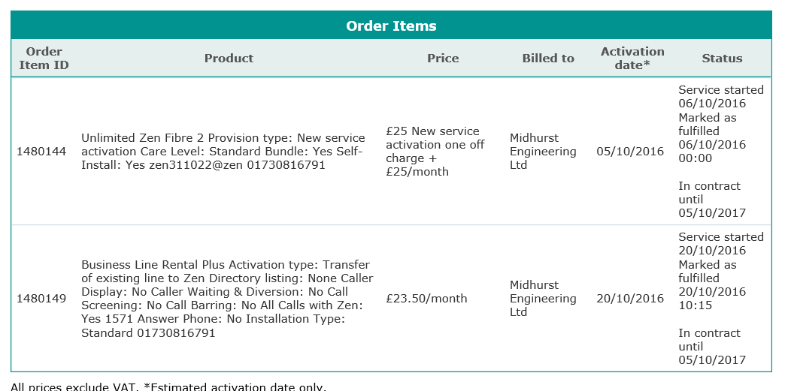

Mike paid the first months charges of £88.20 inc VAT on 27th September 2016 by credit card.
NTE5 shift move of master socket required into comms cabinet. It is planned to do this at the same time of decommissioning and removal of the PABX. Until moved, a filter is required.
Zen can move the socket for £130 ex VAT
Broadband Service from TalkTalk - Account Number: 882 01292148
TalkTalk Help Desk: 0800 083 3003 Security Question answer: trolleybus
Broadband Lines: Garage – 01730858011 Guy’s Home - 01730858062
Oddly enough in-contract till 10/10/18
Garage Router IP Address: http://192.168.100.1:8080/
Username: admin Password: elstead2008
DHCP Server Enabled. Start IP Address: 192.168.100.100 Pool Size: 98
Workgroup: MTS
Static IP Address: 212.159.144.127 for Garage
Static IP Address: 80.45.201.186 for Guy’s Home – Installation 26 June pm ref: so387101.[Put note on door]

URL for “My Account”: https://supportcentre.talktalkbusiness.co.uk/SCLoginhttps://supportcentre.talktalkbusiness.co.uk/SCLogin
My Account login: david@mideng.co.uk Password: Route654* [Case sensitive]

DrayTek: Vigor2830Vn Firmware Version: 3.6.3_sb_232201 Build Date/Time: Sep 17 2012 16:18:48
Router IP: http://192.168.100.1:8080
LAN Start IP Address: 192.168.100.100 Pool Size: 60
Workgroup: MTS
Static IP Address: 212.159.144.127

Credentials for TalkTalk Connection
Login: 01730858011@talktalkbusiness.net
Password: D4E3Z6D3J2
Static IP Address: 212.159.144.127
Wireless SSID: MIDENG-ADMIN Password: route654 Security: WPA/PSK2 Channel: 3

Call Recording
Belinda 201123642, Mike 201123646 and Em 201123644

To access the recordings got to: www.callmaster.co.uk
Or: http://v2.21voice.net/voip/login_input.htm

Click client login with these credentials:
Userid: mideng Password: recovery3 - Not working Saturday, 03 June 2017

Then select: Call Recordings

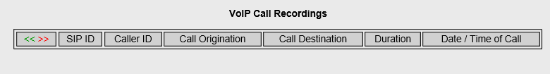

DHCP ADMIN LAN - Thursday, 29 December 2016

IP Address MAC Host ID Logon Password User
192.168.100.1 00-1D-AA-A8-28-A0 Router admin elstead2008 Not applicable
192.168.100.100 00-80-77-CB-F7-BE VIGOR100 admin access Brother Printer
192.168.100.101 54-E1-40-61-BF-7E 25563571 [Credit Card Machine]
192.168.100.102 10-DA-43-00-AE-10 Workshop Netgear --- recovery3 ---
192.168.100.103 54-E1-40-61-CA-83 25565135 [Credit Card Machine]
192.168.100.104 34-57-60-67-26-E9 Sure Signal Device
192.168.100.106 40-8D-5C-C5-C4-23 Sunset Mideng recovery1 Main Server
192.168.100.109 1C-6F-65-55-15-AB Brandy Nick goodwin Nick
192.168.100.112 1C-1B-0D-7A-08-45 Lemonade Belinda babybee Belinda
192.168.100.113 F8-16-54-17-DB-BC Martini Guy elstead2008 Guy
192.168.100.114 8C-89-A5-65-40-71 Guinness tony tony Tony
192.168.100.119 A4-4E-31-39-92-70 Tequila Paddy paddy309 In Paddy’s truck
192.168.100.120 FC-AA-14-3A-0B-9D Fosters VOSA goodcall MOT operative
192.168.100.122 FC-AA-14-3A-0B-92 Cognac Nick Goodwin Nick
192.168.100.125 8C-89-A5-65-3E-CD GingerBeer Sarah recovery1 Sarah
192.168.100.126 90-2B-34-20-68-AC Whisky Mike route654 Mike
192.168.100.127 24-FD-52-BE-3A-D1 } Coke Back Office recovery1 Not Allocated]
} Coke Sarah route654 Not Allocated

MOBILE DEVICES
IP Address MAC User
192.168.100.113 8C-84-04-5F-8C-CE android-2ecd9ae391f7543e MOT Tablet

6 192.168.100.105 40-33-1A-6C-03-B6 16:11:07 Mikes-iPhone
8 192.168.100.107 DC-66-72-AA-F7-1B 14:36:35 android-5b9db97db30012b2
9 192.168.100.108 A4-B8-05-5C-C2-CE 23:29:05 jordans-iPhone
11 192.168.100.110 AC-5F-3E-53-3D-9C 17:48:50 android-df85e20bcebfab9e
12 192.168.100.111 28-BE-03-BF-C4-1E 12:10:43 android-b22b9fcab2eeea84
16 192.168.100.115 74-C2-46-3C-83-73 17:09:28 kindle-b0e5cf241
17 192.168.100.116 88-AD-D2-74-92-98 12:57:59 android-1de24889e519104b
18 192.168.100.118 60-92-17-78-4F-72 14:24:37 julians-iPhone
21 192.168.100.121 44-00-10-AC-1B-99 22:10:44 Guys-iPhone
22 192.168.100.122 48-D7-05-7B-08-D0 21:56:06 Olivias-iPhone
24 192.168.100.124 44-D4-E0-CF-EE-D5 19:33:52 android-1563a48d7b8875b4
26 192.168.100.126 DC-66-72-AB-04-5D 17:28:59 android-bd25ff57282e7507
28 192.168.100.129 8C-84-04-5F-8C-CE 18:47:16 android-2ecd9ae391f7543e
29 192.168.100.130 DC-66-72-AB-04-C7 21:30:01 android-865aa2a083757217
30 192.168.100.134 DC-66-72-AB-0C-65 23:34:26 android-63457b9aec06a4df
31 192.168.100.135 DC-66-72-AA-F7-95 16:07:41 android-4261eb9a0353f9b3
32 192.168.100.136 DC-66-72-AB-0C-55 14:23:38 android-bcc4a80836c4fab3
33 192.168.100.138 DC-66-72-AB-04-A1 19:42:38 android-f31eaad1a0bb3c88

FIXED IPs
IP Address MAC Host ID Login Password Comment
192.168.100.7 CE-AF-48-5F-FE-04 CCTV --- --- Enter allocated credentials
192.168.100.16 F4-81-39-1E-2E-8A 1E2E8A000000 --- recovery3 Canon MG6400 Printer
192.168.100.17 7C-2F-80-C3-15-28 N300-IP --- 1111 VoIP Controller for Tony
192.168.100.20 00-1D-AA-A8-28-A0 2830 Router admin elstead2008 VoIP traffic gateway
192.168.100.25 1C-1B-0D-71-D5-F3 Bollinger accounts accounts Emily
192.168.100.27 10-DA-43-00-AB-44 JGS516PE --- recovery3 Recovery Room Switch
192.168.100.33 00-22-EE-02-79-7A AlgoBodyShop --- recovery3 Bell/Tannoy in Bodyshop
192.168.100.36 E8-08-8B-08-94-C5 HG533 router admin elstead2008 Workshop AP
192.168.100.37 30-B5-C2-DD-35-D5 BelindaPrintServer admin recovery HP P2035
192.168.100.38 EC-08-6B-C2-94-65 vosa-printserverr admin recovery HL-3140CW
192.168.100.39 00-22-EE-02-6D-37 Algo --- recovery3 Bell/Tannoy in Workshop
192.168.100.42 00-04-13-91-14-EC Belinda snom belinda warken }
192.168.100.44 00-04-13-91-14-FF Mo snom mo franks }
192.168.100.45 00-04-13-91-14-E3 Guy snom guy morgan } VoIP phones
192.168.100.46 00-04-13-91-14-E2 Mike snom mike morgan }
192.168.100.47 00-04-13-91-15-00 Sarah snom sarah hotston }
Petersfield 00-04-13-2C-3A-A0 Office 201123662 trolleybus route654 [1618] }

DHCP WORKSHOP LAN

Host Name | IP Address | MAC Address | Lease Duration
Steve307 | 192.168.62.4 | 70:E7:2C:9F:9B:F1 | Lease
shaun | 192.168.62.5 | B4:8B:19:6E:86:1F | Lease
iPhone | 192.168.62.12 | 70:E7:2C:AC:95:53 | Lease
android-1de24889e519104b | 192.168.62.13 | 88:AD:D2:74:92:98 | Lease

ARP TABLE
IP Address MAC Address Netbios Name Interface Port
192.168.100.100 00-80-77-CB-F7-BE VIGOR100 LAN1 --- P6
192.168.100.101 54-E1-40-61-BF-7E LAN1 --- P1
192.168.100.102 10-DA-43-00-AE-10 LAN1 --- P1
192.168.100.103 54-E1-40-61-CA-83 LAN1 --- P1
192.168.100.104 34-57-60-67-26-E9 LAN1 --- P1
192.168.100.106 40-8D-5C-C5-C4-23 SUNSET LAN1 --- P3
192.168.100.113 F8-16-54-17-DB-BC MARTINI LAN1 --- S1
192.168.100.126 DC-66-72-AB-04-5D LAN1 --- S1
192.168.100.128 90-2B-34-20-68-AC WHISKY LAN1 --- P1
192.168.100.135 DC-66-72-AA-F7-95 LAN1 --- S1
192.168.100.7 CE-AF-48-5F-FE-04 LAN1 --- P4
192.168.100.16 F4-81-39-1E-2E-8A 1E2E8A000000 LAN1 --- S1
192.168.100.17 7C-2F-80-C3-15-28 LAN1 --- P1
192.168.100.20 00-1D-AA-A8-28-A0 LAN1 --- P5
192.168.100.25 1C-1B-0D-71-D5-F3 BOLLINGER LAN1 --- P2
192.168.100.36 E8-08-8B-08-94-C5 LAN1 --- P1
192.168.100.37 30-B5-C2-DD-35-D5 BELINDAPRIN.. LAN1 --- P1
192.168.100.38 EC-08-6B-C2-94-65 VOSA-PRINTS.. LAN1 --- P1
192.168.100.39 00-22-EE-02-6D-37 LAN1 --- P1
192.168.100.42 00-04-13-91-14-EC LAN1 --- P1
192.168.100.44 00-04-13-91-14-FF LAN1 --- P1
192.168.100.45 00-04-13-91-14-E3 LAN1 --- P1
192.168.100.46 00-04-13-91-14-E2 LAN1 --- P1
192.168.100.47 00-04-13-91-15-00 LAN1 --- P1

Mail Client Setup for mideng.co.uk
Password: Use the email account’s password from details on page 5.
Incoming Server: brodie.footholds.net IMAP uses Port: 993
Outgoing Server brodie.footholds.net SMTP Port: 465

Memo Mailing List
Access: http://www.mideng.co.uk/mailman/admin/memo_mideng.co.uk
Password: elstead

Using memo@mideng.co.uk will send your email to:
administration@mideng.co.uk belinda@mideng.co.uk david@mideng.co.uk
guy@mideng.co.uk area14@mideng.co.uk mike@mideng.co.uk
mo@mideng.co.uk nick@mideng.co.uk tony.maccallum@mideng.co.uk
vosa@mideng.co.uk em@mideng.co.uk paddy@mideng.co.uk
recovery@mideng.co.uk brian@mideng.co.uk

Email accounts
administration@mideng.co.uk
apollo@mideng.co.uk
area14@mideng.co.uk 7u3v0698dmt0 [Rum at Selham]
belinda@mideng.co.uk 0etx63zi4xqo [Warken]
brian@mideng.co.uk ts6dckzc29xp [Morgan]
cctv@mideng.co.uk u4nto4aopgip
chris@mideng.co.uk 42doitfe4f7n [Pettrt]
david@mideng.co.uk 8t4p2ocf7wup [Bradley]
em@mideng.co.uk is6sp9f38ttz
general@mideng.co.uk
guy@mideng.co.uk 8yyzmfzgstza [Morgan]
jordan@mideng.co.uk 4ok5fn8y75rm [Morgan]
julian@mideng.co.uk pud98qfqdwtm [Southey]
lelo@mideng.co.uk mh23kuux6niv [Clark]
manager@mideng.co.uk vqv818lvm2yk
mike@mideng.co.uk mxm5 [Morgan]
mo@mideng.co.uk mxf3 [Franks]
mot@mideng.co.uk g89vcgfn06eu [MOT Tablet]
nick@mideng.co.uk n5fu7omeb5dc [Goodwin]
nobby@mideng.co.uk oq7dh3ep0cz6 [Randel]
office@mideng.co.uk di4w4525pd80
paddy@mideng.co.uk nk3zf3ir5xd4 [Pafford]
petersfield@mideng.co.uk b7trpoe663bo [Petersfield Base]
pmc@mideng.co.uk
printer@mideng.co.uk
receptiondesk@mideng.co.uk b9vkiccgo7wi [Used on Invoices etc]
recovery@mideng.co.uk 8218cx2eyrtq [Coke Laptop]
router@mideng.co.uk x4z09fzyuxvb [Router Use]
sarah@mideng.co.uk 15bvzocxdvny [Hotston]
steve@mideng.co.uk unbnqq6g26vl [Goddard]
sunrise@mideng.co.uk 5mex4tb70scf [Server]
susie@mideng.co.uk cupf36bov74y [Brian’s Wife]
sysadmin@mideng.co.uk uwyoi4w32p8r []
tony.maccallum@mideng.co.uk iw2g9p9mfwwn [Maccallum]
vosa@mideng.co.uk 86bwoeiw9cn5 [MOT Testing Station]
Mail Forwarding
andrew.pafford@mideng.co.uk to paddy@mideng.co.uk
andy@mideng.co.uk to mike@mideng.co.uk
david.bradley@mideng.co.uk to david@cyberpictures.net
dcb@mideng.co.uk to david@mideng.co.uk
emily@mideng.co.uk to em@mideng.co.uk
general@mideng.co.uk to belinda@mideng.co.uk
general@mideng.co.uk to david@cyberpictures.net
general@mideng.co.uk to guy@mideng.co.uk
general@mideng.co.uk to mike@mideng.co.uk
general@mideng.co.uk to mo@mideng.co.uk
general@mideng.co.uk to paddy@mideng.co.uk
general@mideng.co.uk to sarah@mideng.co.uk
guy.morgan@mideng.co.uk to guy@mideng.co.uk
info@mideng.co.uk to guy@mideng.co.uk
maureen.franks@mideng.co.uk to mo@mideng.co.uk
messages@mideng.co.uk to guy@mideng.co.uk
messages@mideng.co.uk to mike@mideng.co.uk
mike.morgan@mideng.co.uk to mike@mideng.co.uk
pics@mideng.co.uk to mike@mideng.co.uk
pics@mideng.co.uk to mo@mideng.co.uk
pics@mideng.co.uk to sarah@mideng.co.uk
pictures@mideng.co.uk to david@mideng.co.uk
reception@mideng.co.uk to receptiondesk@mideng.co.uk
selham@mideng.co.uk to area14@mideng.co.uk
selham@mideng.co.uk to mike@mideng.co.uk
selham@mideng.co.uk to paddy@mideng.co.uk
tony@mideng.co.uk to tony.maccallum@mideng.co.uk

About the email address pmc@mideng.co.uk.
Fundamentally ONLY these email accounts can post messages into this email account:
mike@mideng.co.uk pmc@mideng.co.uk
km@pmc247.com repairs@pmc247.com
as@pmc247.com rh@pmc247.com
bh@pmc247.com je@pmc247.com
bw@pmc247.com

Compila’s server will distribute incoming messages addressed to pmc@mideng.co.uk to these email accounts:
belinda@mideng.co.uk mo@mideng.co.uk mike@mideng.co.uk guy@mideng.co.uk
em@mideng.co.uk
To avoid the email box on the server reaching its quota limit of 250Mb, and therefore preventing further messages from being processed, stale messages are automatically deleted after 60 days.

VoIP Details for Analogue Telephone Adapter
DrayTEL URL: www.draytel.org
Signup email address: petersfield@mideng.co.uk Password: elstead2008
Issued: DrayTEL Number: 8495935 Password: JLR.5-ba POTS Number: 08438 496842
[8.9ppm]

To use the [default] DrayTEL Service:
- Calls onto the public network are PAYG. Each call eats into the credit loaded.
- Calls to DrayTEL subscribers are free.
- There is a test number to check DrayTEL is working. Dial: 902
- No line rental.

To use the Callmaster service:
- Press # for the Callmaster dialling tone, followed by the subscribers number, e.g. 200920255
- Dial <area code><number> e.g. 01252758123 for telephone numbers on the public network.
Chargeable calls appear on the Callmaster account
- Numbers starting with 20 are internet calls and free, e.g. 200921161
- Numbers starting with 1 are system wide three digit short codes, e.g. 123.
- Dial 8500 to listen to voice mail messages. Logon 648 Password 648
- £10 line rental. Call plan in place.
Set up information for the Analogue Terminal Adapter:
Default dial plan: (*xx|[3469]11|0|00|[2-9]xxxxxx|1xxx[2-9]xxxxxxS0|xxxxxxxxxxxx.)
Custom dial plan required: (xxxxxxxxxxxx.|20xxxxxxxS0|1xxS0|5xxxxS0|0[45689]x.|*xx|8500S0|999S0)

Analogue phone codes that can used, normally setup via browser access from 192.168.100.11:
**** Enter Menu Gives access to menu options
100# Check DHCP Hear whether DHCP is enabled or disabled
101# Set DHCP Disable DHCP: 0 Enable DHCP: 1. Enter either option followed by #
110# Check IP address Hear the IP address of the unit [Currently fixed IP of 192.168.100.11]
73738# Factory RESET Clears user configuration from the Analogue Terminal Adapter
[Further calls not possible until unit is reconfigured]

The White VoIP Phone [Feed from the 2860 Router] – Disconnected – Skip to page 17
Username: 8485796 - Password: H[0e0cCH Registration: david@mideng.co.uk

To call subscribers on the public network you must use the area code even for numbers on the Midhurst exchange [01730]. All calls to 01/02/03/0870/0845/07 numbers are free as is calling a VoIP number.

Simultaneously an exchange line call on 01730 858011 and a VoIP call can be made can be made.

Some dialling codes may take up to 15 seconds before the ringing tone is heard.

Code Person or Service Routing Number
101 Non-emergency police number TalkTalk 101
120 Mideng Workshop DrayTEL 8237300
123 David Bradley Office DrayTEL 8234842
124 David Bradley Home TalkTalk 01252 702791
125 TalkTalk Help Desk TalkTalk 0800 083 3003
126 Paddy Mobile TalkTalk 07795678143
130 Guy’s Home TalkTalk 01730 858062
133 Mike’s Home DrayTEL 8488593
175 JDs Alton General Number TalkTalk 01420 544644
140 JDs Service Reception
141 JDs Alton Workshop
142 JDs
143 JDs Michelle Ingram
144 JDs Adam Bradley
1471 Voice Mail Facility TalkTalk 1471
1571 Voice Mail Facility TalkTalk 1571
902 Check that VoIP is working DrayTEL 902
#0 Access TalkTalk directly Feature 01730 858011

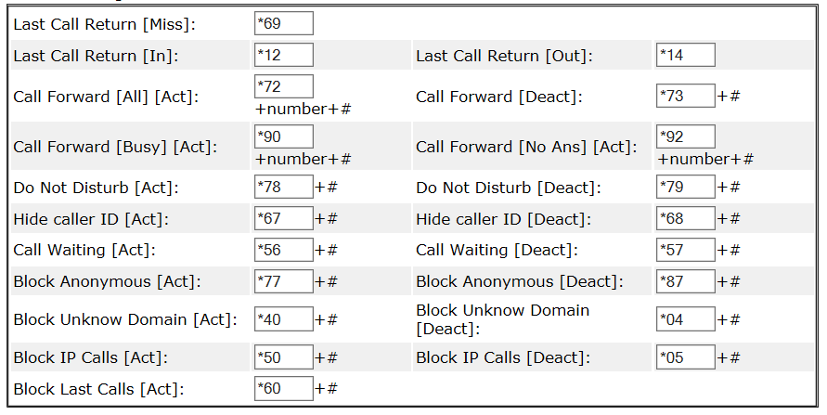
Example: *72+133+# to forward all calls to Mike’s home. Only short codes 120-143 can be used on call divert.
Technical Information
The exchange line 01730 858011 is looped through the router to provide access to subscribers of VoIP services. Configured at present is a service from DrayTEL with an allocated number of 8485796. To differentiate between making calls onto the public network or via VoIP normally means using the familiar area code as if you were using a mobile phone.

System wide short 3 and 4 digit codes can be used like 999, 104 and 1471 but some have been barred and others are not available if a fee for use was required. The dial tone heard is the default VoIP service, so to dial a DrayTEL subscriber, just dial their number. They all start with an 8, e.g. 8234842. Other VoIP service providers are accessed by prefixing their number with <*><gateway number><subscriber number>.

The exchange line supports a number of convenient features like call waiting, ring back, and call forwarding but to use any of these features it is necessary to obtain the exchange line dialling tone first by dialing #0, and then proceeding as shown within the gray panels below.

Call Diversion with TalkTalk
Dial #0 for the exchange line, wait for the dial tone and then use the sequence seen below depending on the action you want.
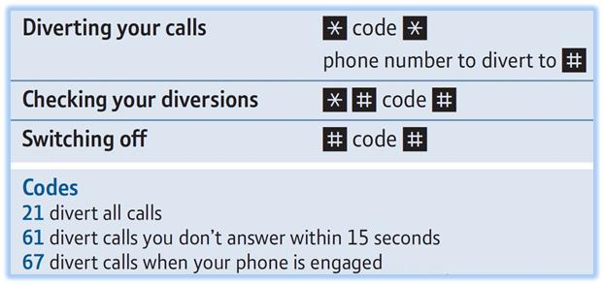
Example to setup call diversion to 01730 812162: Dial #0, wait for dial tone, then *61*01730812162#. The requested call diversion only takes place following 15 seconds of the phone ringing just in case you wish to take the call. The diversion remains in place until switched off.

Call Divert can be managed remotely by calling 0845 2232350, then follow voice instructions. PIN number required which by default is either 0000 or 1234 [this can be changed] and then any of the Call Divert codes can be used. Area codes must prefix all numbers e.g. 01730.

Ring Back using TalkTalk
Again dial #0 for the exchange line, wait for the dial tone and then use the sequence seen below depending on the action you want.
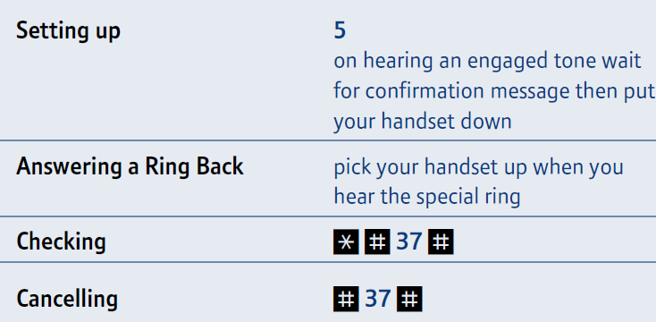
Example: Dial #0, wait for dial tone, then *#37# to check status.

Call Waiting using TalkTalk
Dial #0 then choose an option below.
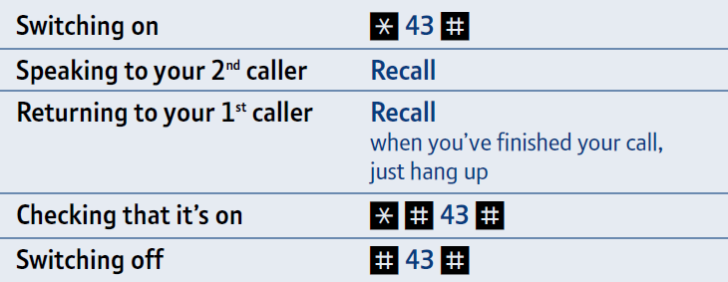
Call waiting will induce a blip tone with the current call in progress. Use the R button to toggle between callers. Alternatively ignore the 2nd incoming call and when ready call them back but remember that the 2nd caller may be withholding their number, so you won’t know who to call!

Voice Mail provided by TalkTalk
To retrieve your TalkTalk Voicemail messages: dial 1571

When you’ve listened to your message, you’ll hear the following options:
Delete your message: dial 3
Save your message: dial 2 [messages will be saved for 30 days]
Listen to your saved messages: dial 1
Call back those who leave you a message: dial 0
[You’ll be charged a 20p connection charge plus the regular rate of the call.

Full instructions are here:
http://help.talktalk.co.uk/guided-assist/using-your-home-phone-voicemail/listening-voicemail-messages/

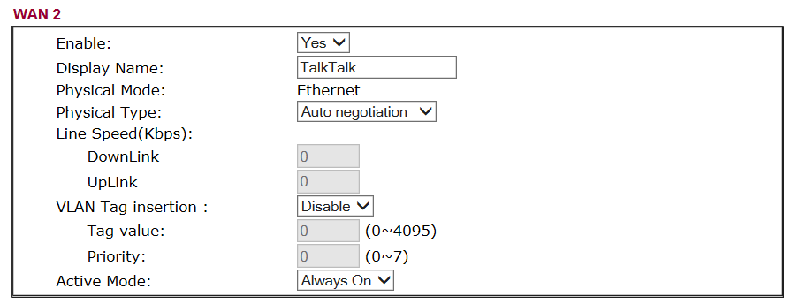
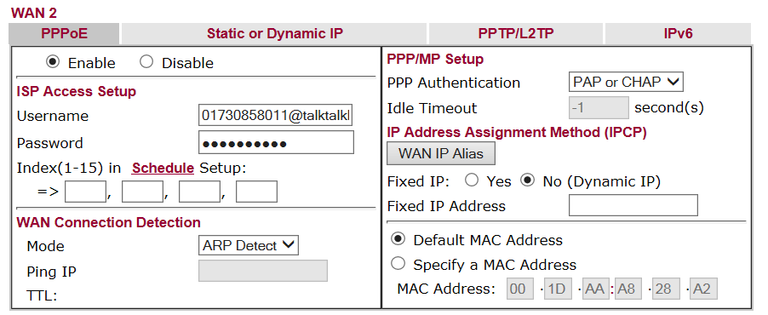
VoIP Setup Information

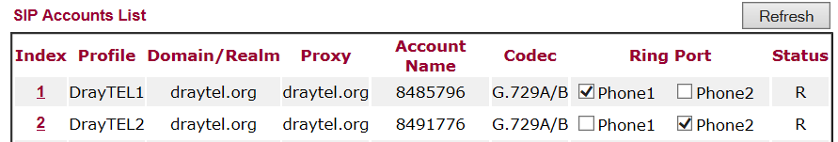

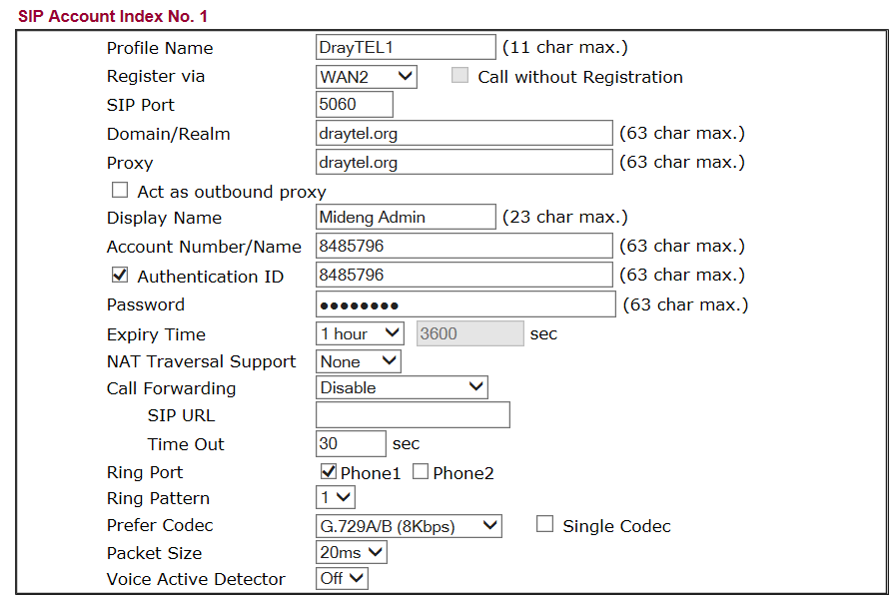

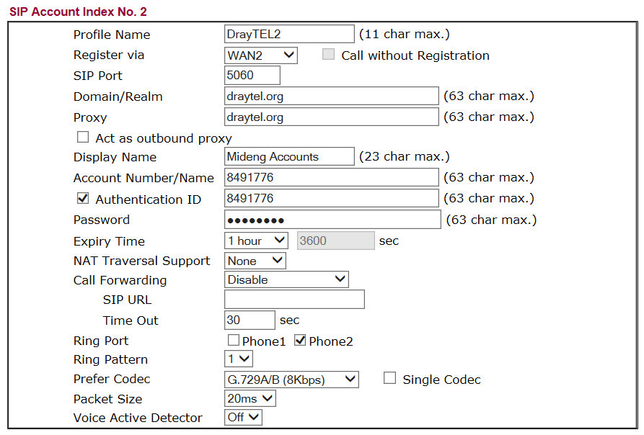
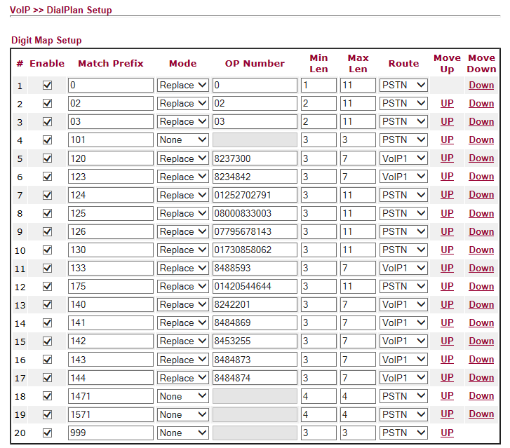

Your liGo Login Info David Bradley,
A new account has been created for you on liGo
Your login details are:
Email: david@mideng.co.uk
Password: a876d66b
Kind Regards,
liGo Electronics
Customer Services
website: www.ligo.co.uk

CCTV
The control unit has a fixed IP address of 192.168.100.7 The port number is 8080 [Do not change]

Web browser access when on the Local Area Network: http://192.168.100.7:8080/
Internet access uses: http://212.159.144.127:8080/

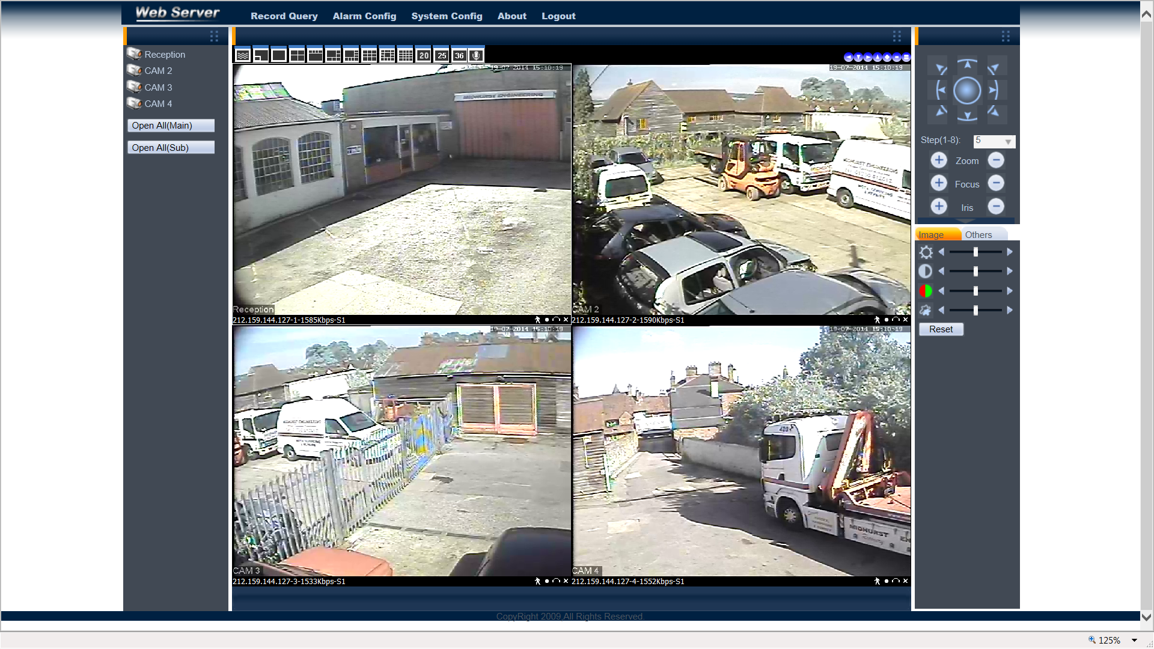

Accounts: [No information on what Repeat does]
Name Password Group Repeat
admin recovery1 admin Yes
mike morgan admin No
paddy ? admin No
david bradley admin No
Guest ? user Yes
guy morgan user No
brian morgan user Yes
VOSA goodcall user No
belinda warken user No

Remote Access User Accounts
http://212.159.144.127/

david elstead2008
guy elstead2008
mike
brian
paddy
belinda
sysadmin elstead2008

Brother Network Printer by Mo

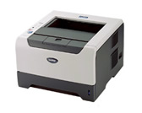
Static IP Address: 192.168.100.109
MAC Address: 00-80-77-CB-F7-BE
Name: VIGOR100
Userid: admin Password: access
Copier Model: HL-5250DN
Serial Number: M7J421540
Printer Firmware Version: 1.19
Network Firmware Version: 1.11
Memory Size: 32Mbytes

Connecting DVR to an iPhone?
First you must install the MEye application from the App Store. Search for the developer of the software by entering “Sun Jian” in the search box. Find the MEye application and click install.

Run the MEye application and click the settings icon at the bottom of the screen, which looks like a Cog.
• Enter a Title by which the connection will be known.
• Enter the static Internet IP Address of your router [212.159.144.127].
• Enter the Port number 8080
• Enter the User ID for your DVR [See accounts list above]
• Enter the Password for your DVR.

Click the back icon at the top of the screen and connect to your DVR by clicking the Play icon at the bottom of the screen. Navigate between camera views by clicking on the camera number.

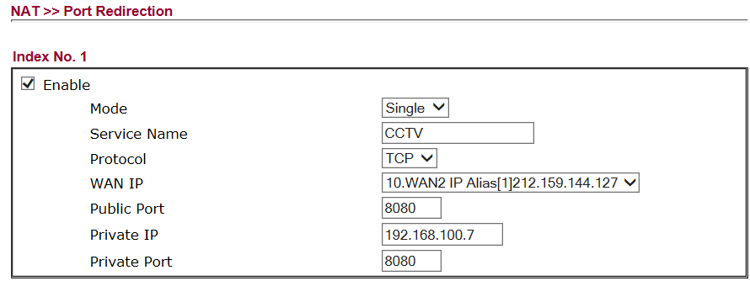

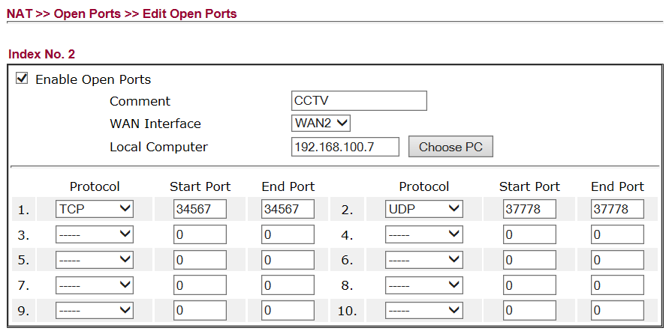

Configuration of Wireless Access Point in the Workshop
TalkTalk router configured as a Wireless Access Point - Signal reaches customer waiting area
192.168.100.xxx E8-08-8B-08-94-C5 HG533 router admin elstead2008 Workshop Access Point

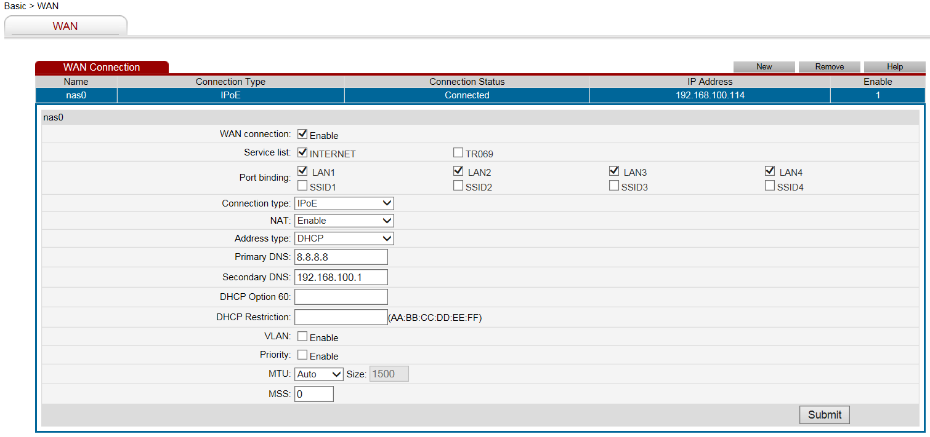

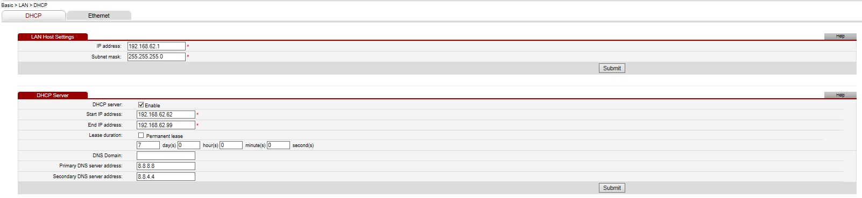

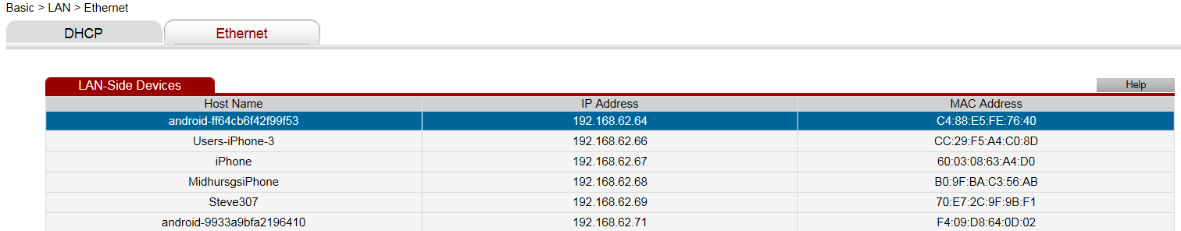

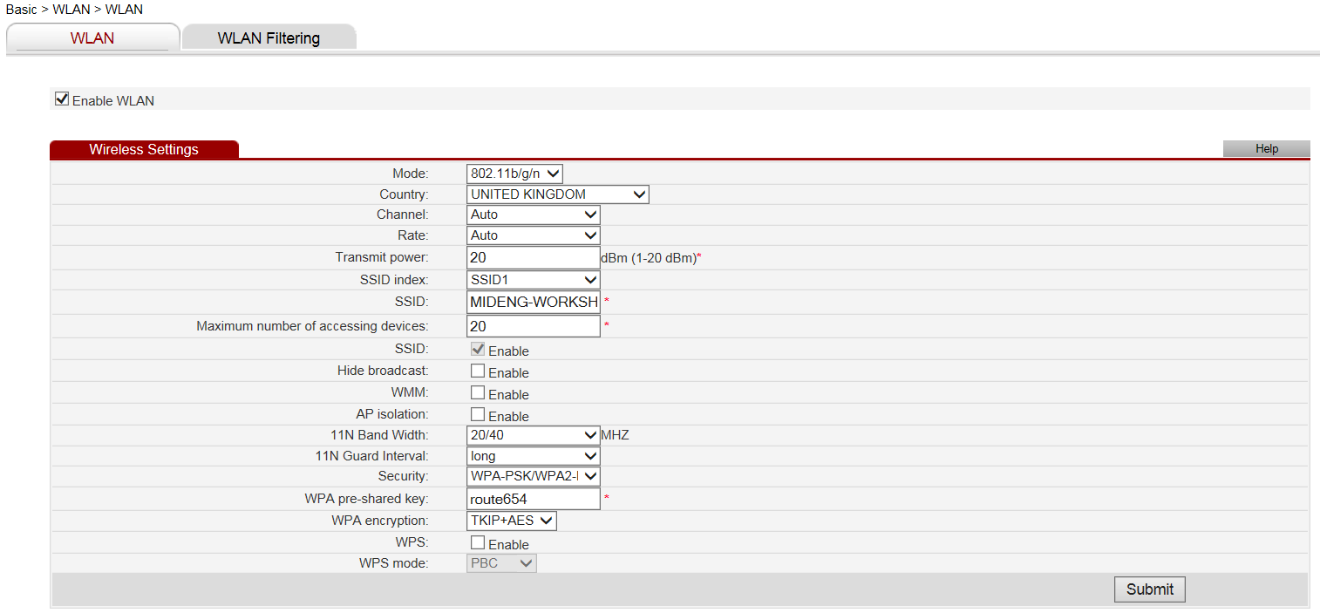

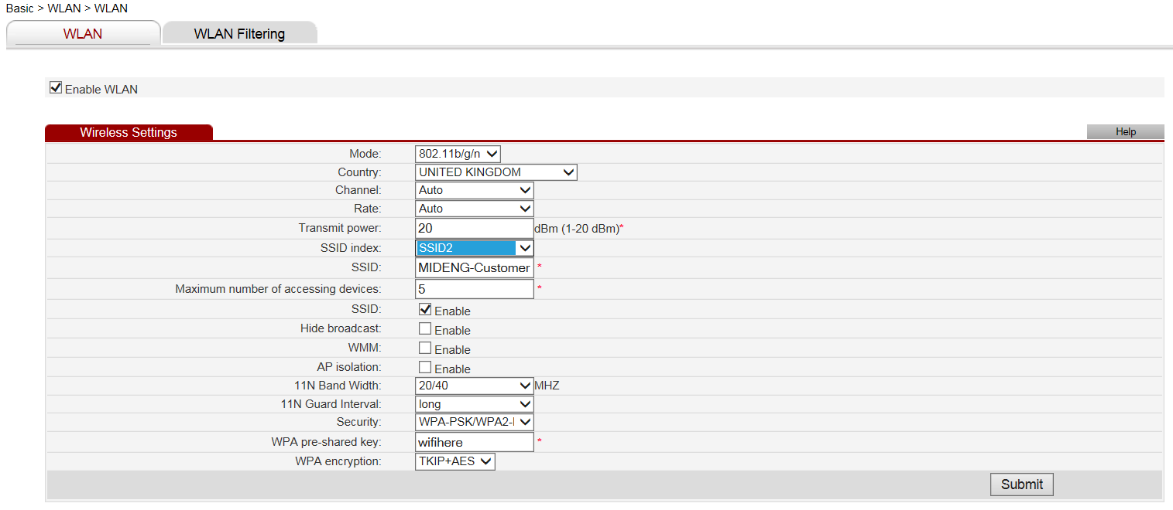
Domain Hosted by Compila
Control Panel: http://www.mideng.co.uk/cpanel
Login: davi7174 Password: MNM9845kHGe

FTP access
www.mideng.co.uk
Login: davi7174 Password: MNM9845kHGe

ESET Endpoint on 15 computers until 6 April 2019
Username: EAV-03080295 Password: nmp3rbswas
Licence Key: 9CNU-XTRW-UANJ-EE7T-X94F
Tele: 01202 548888

The link below to download ESET Endpoint security.
https://www.ESET.com/uk/business/endpoint-security/windows-security/#download
Make sure to enable Live grid and to allow detection of potential unwanted application.

1 192.168.100.25 1C-1B-0D-71-D5-F3 BOLLINGER [Replacing GANDT] Emily
2 192.168.100.105 1C-6F-65-55-15-AB BRANDY >>> [COGNAC in build] Nick
3 192.168.100.106 40-8D-5C-C5-C4-23 SUNSET Server
4 192.168.100.110 F8-16-54-17-DB-BC MARTINI Guy
5 192.168.100.114 8C-89-A5-65-40-71 GUINNESS Tony
6 192.168.100.117 FC-AA-14-3A-0B-92 LEMONADE [Replacing PORT] Belinda
7 192.168.100.120 FC-AA-14-3A-0B-9D FOSTERS VOSA
8 192.168.100.121 8C-84-04-5F-8C-CE android-2ecd9ae391f7543e Tablet
9 192.168.100.125 8C-89-A5-65-3E-CD GINGERBEER Sarah
. 192.168.100.127 FC-AA-14-3A-0B-92 COGNAC Nick
10 192.168.100.128 90-2B-34-20-68-AC WHISKY Mike
11 192.168.100.132 24-FD-52-BE-3A-D1 COKE [The Laptop] Not Allocated
12 192.168.28.35 74-E5-43-EE-9E-1A VERMOUTH Mike’s Laptop
13 192.168.14.27 40-61-86-4B-D9-27 RUM Area14
14 192.168.0.xxx Unknown BRIAN-PC Brian Home
15 192.168.100.xxx A4-4E-31-39-92-7 TEQUILA Paddy Truck

..

ESET Licence Administrator
Thank you for registering your ESET License Administrator Security Admin account. This account has been activated under the email address david@mideng.co.uk
Licence Key: 9CNU-XTRW-UANJ-EE7T-X94F
URL:
User: david@mideng.co.uk
Administrator Password: cbTRU8chtB

Changing Smart Security to Endpoint Security

- First, in order to remove ESET properly let’s disable SELF DEFENCE by going into the ESET application, press F5 to go into the advanced setup setting, locate the HIPS tab and disable the option called the enable self-defence so that it is not selected and has a black X on it and press OK to confirm.

- Kindly uninstall ESET from the system, in Control panel go to programs and applications and select the ESET application and select uninstall / remove or change and then remove.

- Once the uninstallation completed, please restart the computer before installing the new application.

- Then once the system restarted, kindly download the latest application from the link below:
https://www.ESET.com/uk/business/endpoint-security/windows-security/#download

- Please click on DOWNLOAD NOW to download the live installer as it will automatically install the best product for your system.

- Once downloaded, please install and submit your product license key to authenticate your licence.
Licence Key: 9CNU-XTRW-UANJ-EE7T-X94F
- Then please wait for the update to complete and make sure the application will run the first full scan, it will automatically start once the update has completed, please don’t cancel if you have the time to complete the scan, alternatively please make sure to run it as soon as you can.

AutoRoute 2011: MWRFX-HG2PG-W4X8Y-392YY-9QH9X
Re-use not possible

TalkTalk Account Panel
Go to https://myaccount.talktalkbusiness.co.uk/login/?ReturnUrl=%2fHome%2f

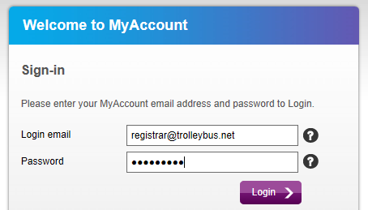
The password is: Route654 Security question: Where were you born? Answer: Croydon

Akzo Nobel Coatings Limited
Andy Bond
Colour IT Sales Support Specialist
Automotive & Aerospace Coatings EMEA
Tele: 01235 442189
Mobile: 07785 922801
email: andy.bond@akzonobel.com

Ann White
Regional Sales Manager
Automotive & Aerospace Coatings EMEA
Tele: 01235 862226
Mobile: 07770 645300
email: ann.white@akzonobel.com

136 Milton Park
Abingdon
Total Concept Paints Limited
Tele: 01243 532999
email: info@totalconceptpaints.co.uk

LESONAL
Program: Mixit2 / MX2000 / LCD2000
Version: 1.91:

Units 3-5 Matform Business Centre
Terminus Road
Chichester
West Sussex
PO19 8UL
www.totalconceptpaints.co.uk

OX14 4SB
www.akzonobel.com

Garage Manager
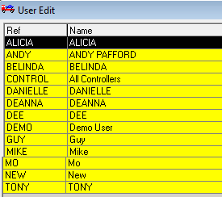
Extracted on: Monday, 8 December 2014
Help Desk open MON-FRI 09:00 to 17:300

The GMS file
If despatching required fill in the ‘Networking’ Section with the name of your computer.
The example is from Mike’s computer whose computer name is WHISKY

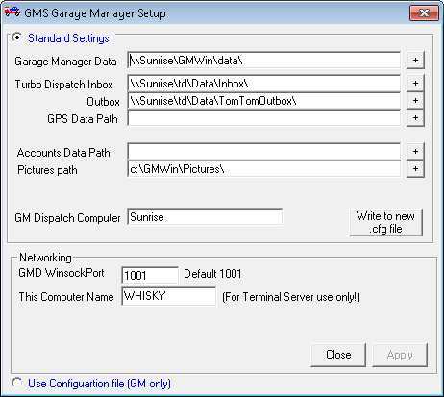
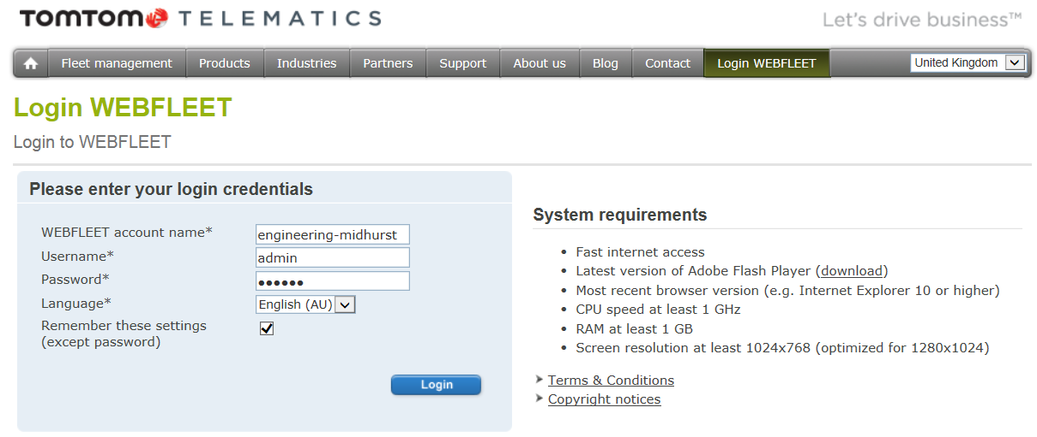

Access: https://webfleet.business.tomtom.com/swf/index.html Password: morgan
Web: http://business.tomtom.com/en_gb/products/webfleet/highlights/ Help Desk: 020 7255 9788

engineering-midhurst
Admin
morgan
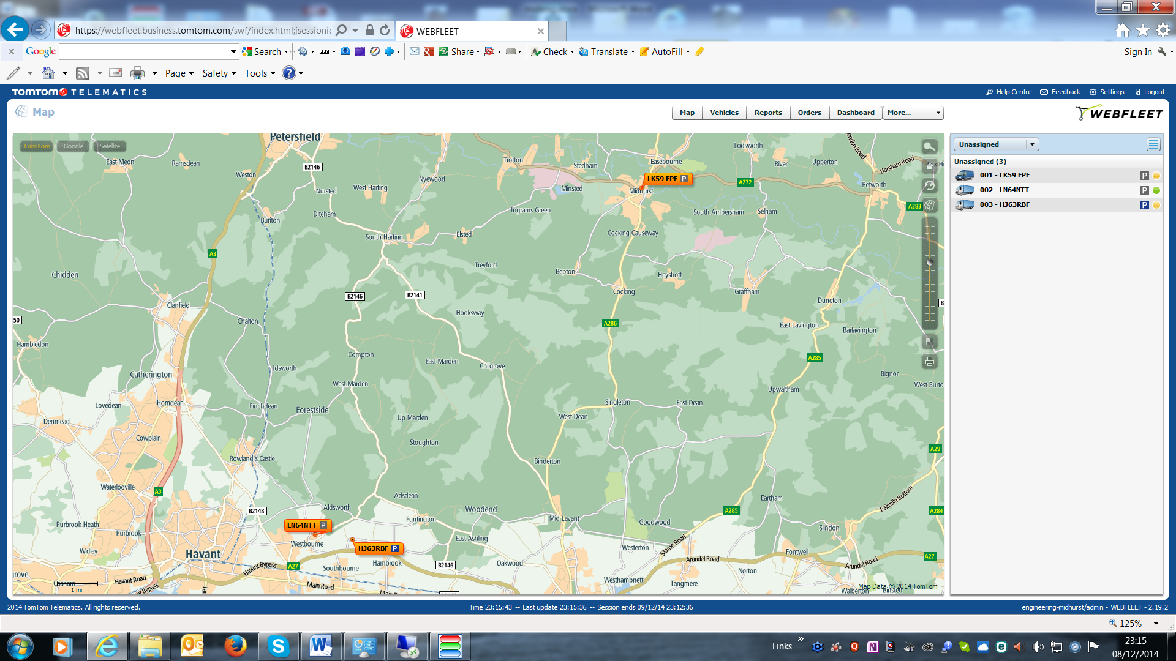
Guy

Apex Support Team [Auto Connect Client] TomTom Business Integration:
Account Number: 2999693 Lee Turley Mobile: 07990 680073 Tele: 01543 560073
Help Desk: 0845 521 2722 email: leeturley@connectfleet.co.uk
Web: www.apex-networks.com Web: www.ConnectFleet.co.uk
Install Code: 111958 Support: Business hours but normally available any time
Test Message: 2000003 Cost: £30 per month or £80 per quarter or £280 per annum

In Car Technology
3 Pelham Close
Whitehill
Hampshire
GU35 9DL

Sue Butt
01420 478053
info@incartech.net

http://www.incartechnology.co.uk/fleet-management/fleet-tracking-systems/

APEX
RMS Settings – Installation Code: 516570
http://download.apex-rms.com

Jason Kemp - Customer Relationship Manager
Dundee House
Albion Place
Ramsgate
Kent
CT11 8HQ

Fax: 0871 522 3151
Email: JKemp@apex-networks.com

Support: 0203 1956757
Out of Hours: 07920 780920
Email: support@apex-networks.com

Username Password Where is the 08080 used?:
Andy
Belinda
Guy
Mike
Mo
Tony
Paddy
Sarah
David password
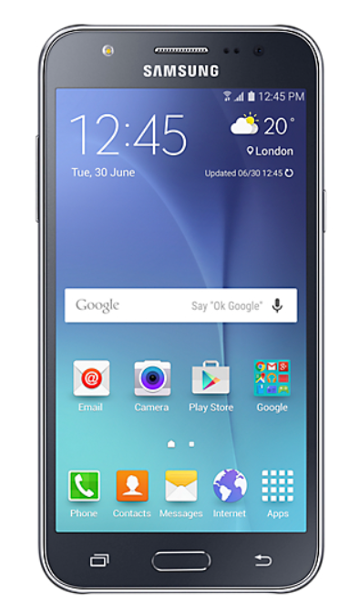
KIS
The comprehensive and flexible Garage Management System for the Independent Motor Trade.

To find out more, to book a demo or arrange a free trial call 01865 383482 or email kisenquiries@unipartautoparts.com

https://issuu.com/unipartautoparts/docs/unipart-kis-brochure-web-version

http://www.kis-unipart.co.uk/

MyVigor Portal
This account enables us to register all of our Draytek products, activate service licenses and also to subscribe to newsletters keeping you informed of DrayTek product news and updates.
Activate my Account URL:
http://myvigor.draytek.com/mngt/Device/DeviceWeb.php?tid=963428&user=mideng&inv=nxs61v94gtid94yt&ticket=NhV+wNy3/yRjgqwDzL9YTJ3qP67DyutTLIwftB0bGZg=
Your account username is: mideng
Password: recovery3
The next step will be to either register your specific DrayTek product(s) or activate service licenses (such as GlobalView Web Content Filtering).
--
Your Sincerely
DrayTek Corp.
URL: http://myvigor.draytek.com
E-mail: webmaster@draytek.com
Service Line : +886-3-5972727

Registrations
VAT Number: GB 192 9300 54
Registration Number: 432447

Domain registered through Compila
Domain name:
mideng.co.uk
Registrant:
Midhurst Engineering & Motor Co.
Registrant type:
Unknown
Registrant's address:
Rumbolds Hill
Midhurst
West Sussex
GU29 9DD
United Kingdom
Data validation:
Nominet was able to match the registrant's name and address against a 3rd party data source on 10-Dec-2012
Registrar:
Paragon Internet Group Ltd t/a Compila Ltd [Tag = COMPILA]
URL: https://www.compila.com
Relevant dates:
Registered on: 03-May-2004
Expiry date: 03-May-2016
Last updated: 11-Apr-2015
Registration status:
Registered until expiry date.
Name servers:
ns15.sovdns.com
ns15sec.sovdns.com

Detailed Information on each Computer

Coke – Laptop – Matt
MAC: 24-FD-52-BE-3A-D1
Windows 8.1
Product Part No.: [8]X18-15
Product ID: 00179-60704-52744-AAOEM match to CD Key data
CD Key: B3N6Q-72JYH-QW22P-P734G-72WYG
Computer Name: COKE
Registered Owner: Matt

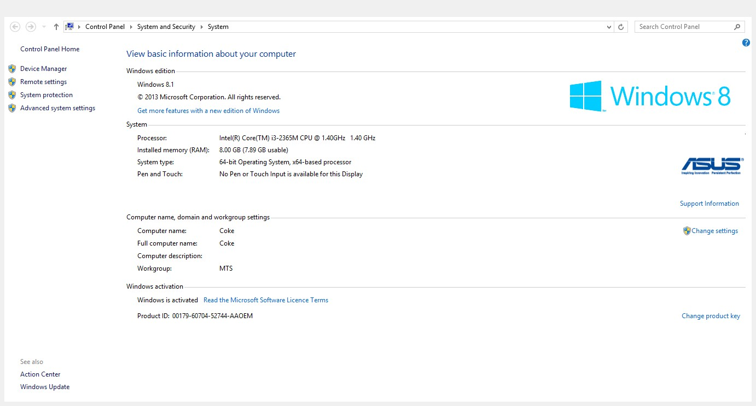

Whisky – Desktop – Mike
MAC: 90-2B-34-20-68-AC
Windows 7 Professional Service Pack 1
Product Part No.: X15-37362
Product ID: 00371-OEM-9045235-98143 match to CD Key data
CD Key: 6VWVK-MPVM8-BKD8Q-CWRJ8-3M8TD
Computer Name: WHISKY
Registered Owner: MidEng

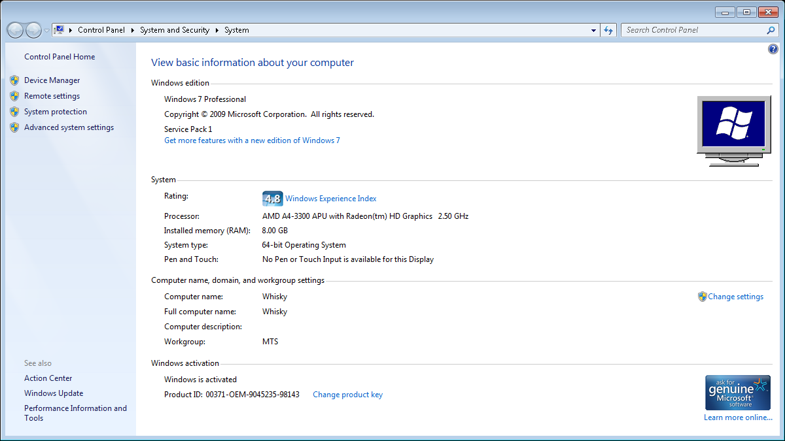

Tequila – Laptop - Paddy
Windows 7 Professional Service Pack 1
Product Part No.: X15-37377 Installed from 'OEM' media.
Product ID: 00371-OEM-8992671-00467 match to CD Key data
CD Key: 2RGBP-GKB4B-BGF4Y-8H6XF-WWPJD
Computer Name: TEQUILA Registered Owner: Paddy Registered Organization:

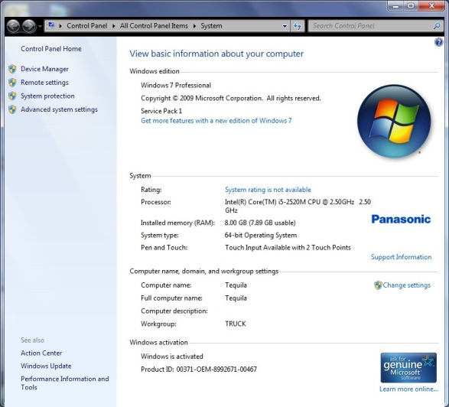
Detailed information on this laptop at http://tiny.cc/mideng-paddy A Vodafone SIM card installed – No details known

Supplier
Roughworld Tele: 01403 289 150 email: info@roughworld.co.uk

Toughbook-Support
Tele: 08000 884 324 email: toughbooksupport@eu.panasonic.com Warranty until: 2nd June 2017
AutoRoute 2013
This was purchased from Microsoft requiring an account to be set up. Order #: 12623394148 Cost: £33.00
Account: paddy@mideng.co.uk Password: MidengTruck Security date of birth: 1.1.2014
http://www.microsoftstore.com/store/msuk/en_GB/pdp/productID.278710300?tduid=c0d659b59debe25e76e177c58a5ec8d9
Licence Key: WXQFT-YR6MX-7MT7D-2J39Q-JX9TP Single licence for 1 PC

External CD Drive
Software CD supplied for WinDVD Licence Key: YS10B22-7DY7UQG-LCU9FN2-MFT2ZN2

Vodafone SIM Card
Number: +447786247697

Stout – Laptop - Guy
Windows 7 Professional Service Pack 1
Product Part No.: X15-37377
Product ID: 00371-OEM-8992671-00015 match to CD Key data
CD Key: W2PMW-T7DBH-YHKRM-DXXF6-KP4KT
Computer Name: STOUT
Registered Owner: Midhurst Engineering

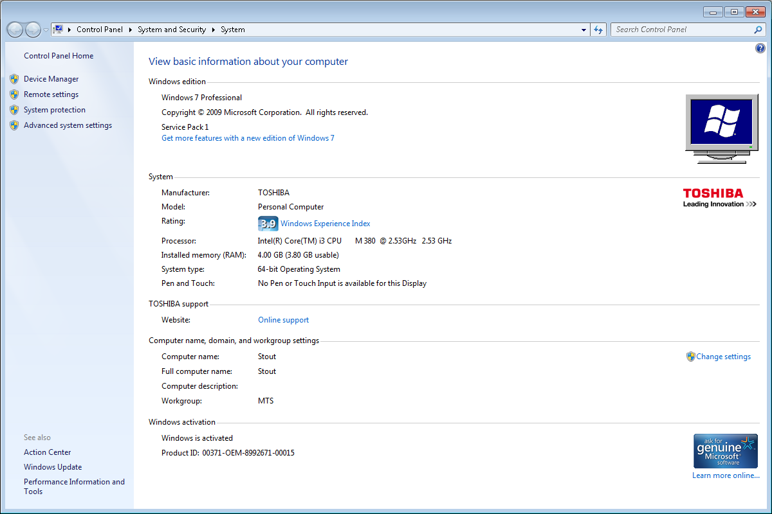
Laptop damaged with spilt water
Martini – Laptop – Guy
Windows 8.1 Pro
Product Part No.: [Blue]X18
Product ID: 00262-50075-66608-AAOEM match to CD Key data
CD Key: NXJQC-B6P7V-3GC7B-7HF8R-FCYD2
Computer Name: MARTINI
Registered Owner: Guy
Registered Organization:

Supplier
Computer UK Tele: 01252 733873 email: Julian Dacombe < julian.dacombe@gmail.com >

CCTV Account:
Userid: guy Password: morgan

Fosters – Desktop – MOT Testing Station
Windows 8.1 Pro
Product Part No.: [Blue]X18
Product ID: 00259-40846-85781-AAOEM match to CD Key data
CD Key: N293V-2QYQT-3YV38-92V8Y-TXWJ3
Computer Name: FOSTERS
Registered Owner: VOSA
Registered Organization:

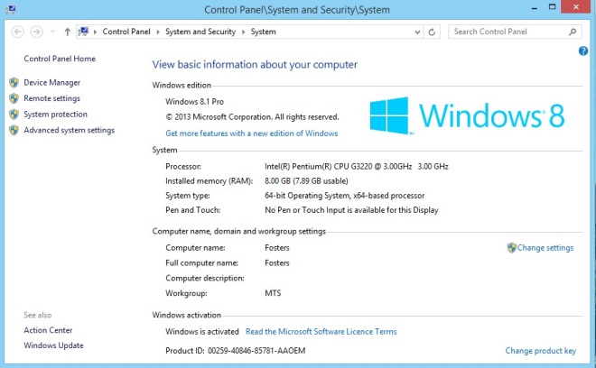

Supplier
Computer UK Tele: 01252 733873 email: Julian Dacombe < julian.dacombe@gmail.com >

CCTV Account:
Userid: VOSA Password: goodcall

Garage Manager:
This has not been uninstalled cleanly and requires MTTD to come in to sort it out. Establish a remote session at http://www.mttltd.com/
Error message in a screen dump on the desktop as image error.jpg - Telephone number: 01934 421320

Reading and Composing Documents:
The Microsoft suite of Office programs is not available on this PC. By default, WORD documents are opened in a WORD viewer which means you can't edited them. To compose a document use WordPad or Notepad.
GandT – Desktop – Mo Franks
Windows 7 Professional Service Pack 1
Product Part No.: X15-37362
Product ID: 00371-OEM-9044981-25715 match to CD Key data
CD Key: 2KCRC-XWPRJ-F4WKR-GFF66-7GXF8
Computer Name: GANDT
Registered Owner: User
Registered Organization:

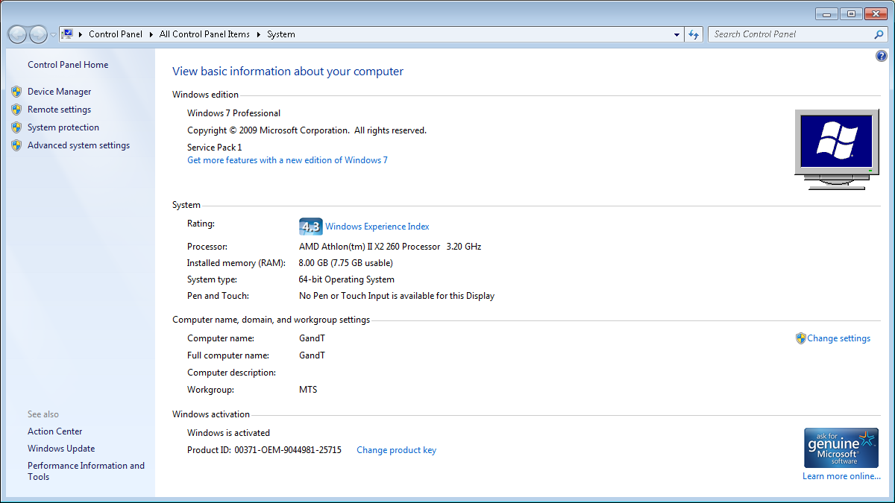

Sunrise – Desktop – Server
MAC: 40-61-86-4B-D9-27
Windows 7 Professional Service Pack 1
Product Part No.: X15-37362
Product ID: 00371-OEM-9044182-07853 match to CD Key data
CD Key: 82MQ7-682KW-C6P98-Q6DWC-7RK28
Computer Name: SUNRISE
Registered Owner: Mideng
Registered Organization:

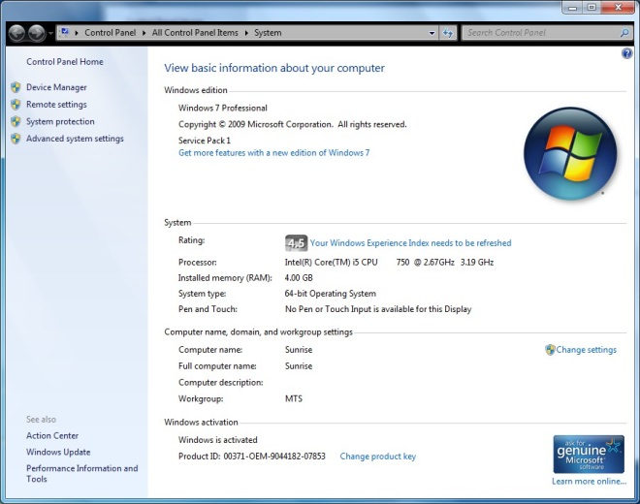

Purchased from Computer UK on 2nd July 2010 for £795 Hard disk reformatted on 16th December 2014
CORE i5 QUAD CORE 2.66 GHz 4 GB DDR3 RAM 320 GB HARD DRIVE
NVIDIA 512Mb GRAPHICS (DUAL OUTPUT) WINDOWS 7 PROFESSIONAL WIRELESS KEYBOARD & MOUSE SET
WALL MOUNT BRACKET FOR SCREEN 22" WIDE SCREEN
Brandy – Desktop – Nick
Windows 7 Professional Service Pack 1
Product Part No.: X15-37362
Product ID: 00371-OEM-9044335-41825 match to CD Key data
CD Key: PQKD3-3TQMF-W8CTR-K9PTY-DWPB3
Computer Name: BRANDY
Registered Owner: User
Registered Organization:

Microsoft Office Single Image 2010
Product ID: 82503-242-9975775-11352
CD Key: TJF47-9YKF3-G6DYM-DJDV6-HR9YY

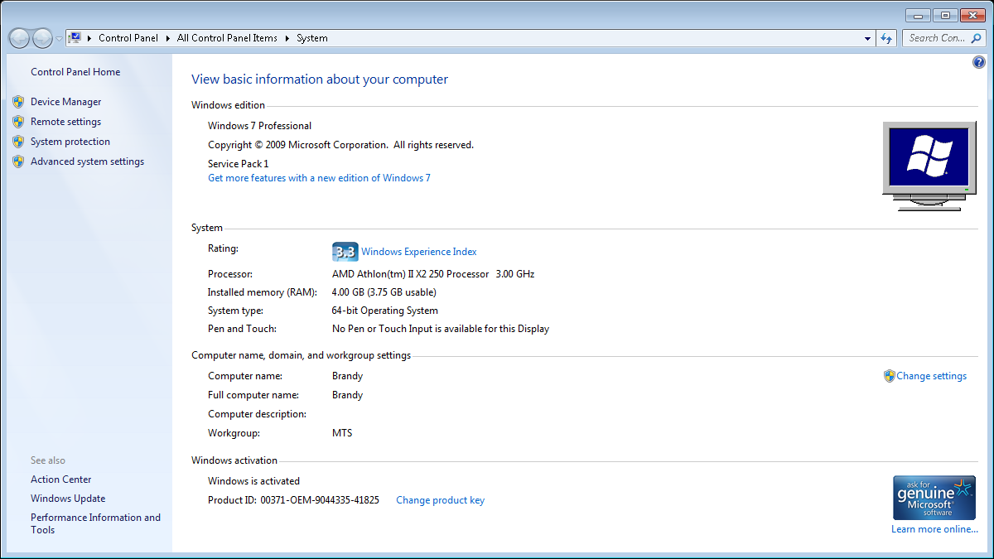

Guinness – Desktop – Tony
Windows 7 Professional Service Pack 1
Product Part No.: X15-37362
Product ID: 00371-OEM-9044981-25714 match to CD Key data
CD Key: Q2DW4-GG9K7-6C7KM-H6MPB-94K78
Computer Name: GUINNESS
Registered Owner: User
Registered Organization:

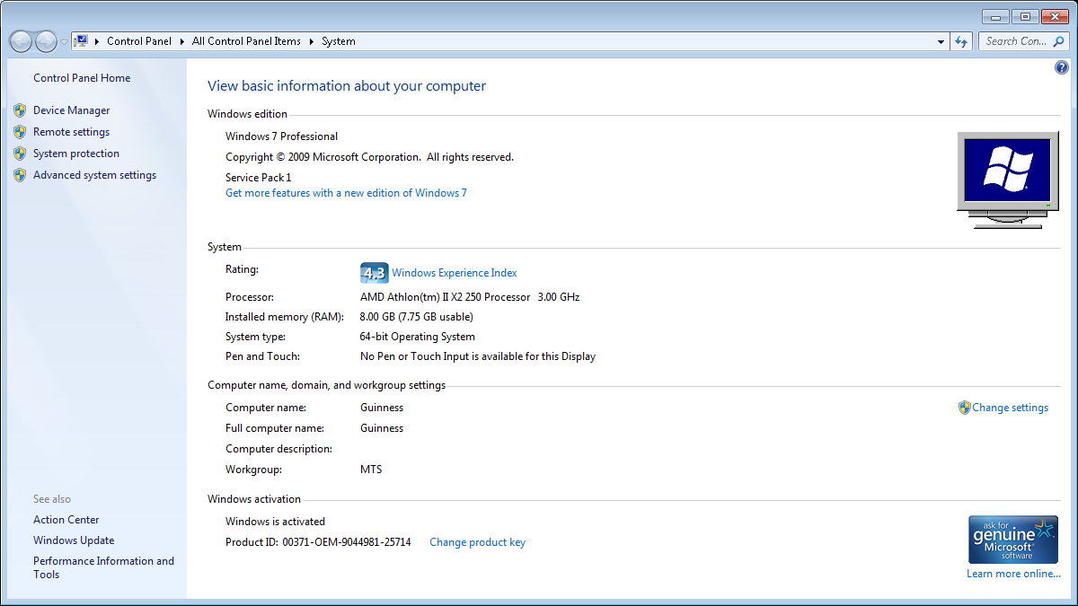

Port – Desktop – Belinda
Windows 8.1 Pro
Product Part No.: [Blue]X18
Product ID: 00259-40846-85781-AAOEM match to CD Key data
CD Key: N293V-2QYQT-3YV38-92V8Y-TXWJ3
Computer Name: PORT
Registered Owner: Belinda
Registered Organization:

Microsoft Office 2010: TJF47-9YKF3-G6DYM-DJDV6-HR9YY

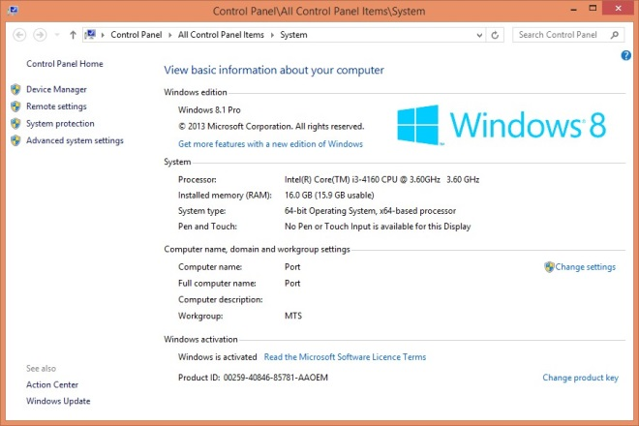

Supplier
Computer UK Tele: 01252 733873 email: Julian Dacombe < julian.dacombe@gmail.com >

Setup for CCTV in Internet Explorer

Internet Intranet
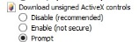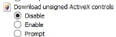

email Setup
belinda@mideng.co.uk 0etx63zi4xqo [Warken]
Mail Client Setup
Incoming POP3: 995 SSL
Outgoing: SMTP: 465 SSL
Server: ns15.sovdns.com

WEBFLEET and CCTV Display loaded
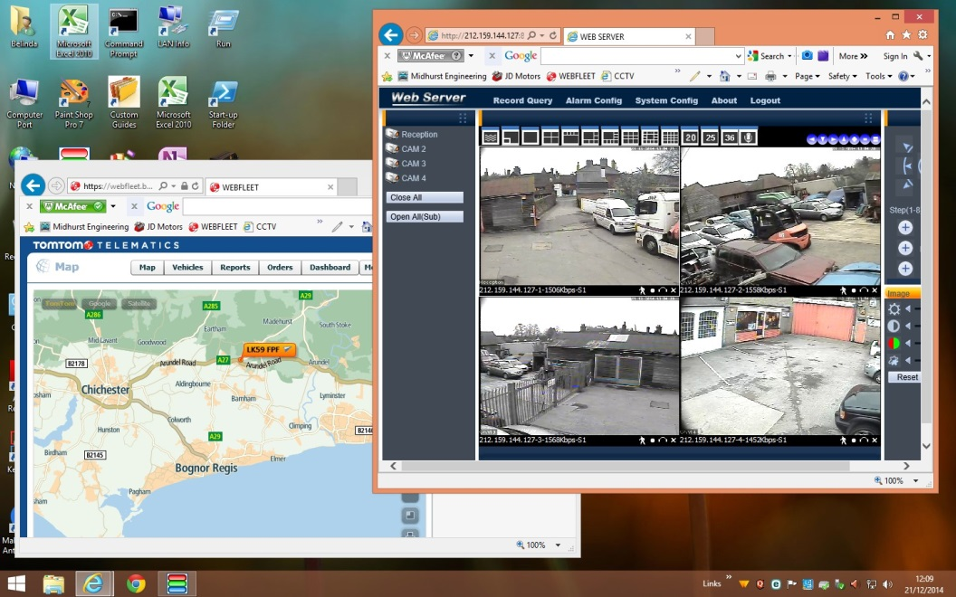

*** END OF ENTRIES FOR THE GARAGE ***
Guy Morgan Home
Hazel House, Cobden Road, Midhurst, West Sussex, GU29 9JW

Phone and Broadband Service from TalkTalk – Package: Office Broadband + Anytime calls + CLI
Connected to: 01730 858062 TalkTalk Help Desk: 0800 083 3003
Account Number: 882 01292148 - 24 month contract from 11th Feb 2013 @ £23.95 + £4.05
Account Password: trolleybus

Router Information

DrayTek Router 2860Vnn [192.168.8.1] Firmware Version:
WAN Access: http://80.45.201.186:8080/ Logon: admin Password: elstead2008
LAN Start IP Address: 192.168.8.28 Pool Size: 50
SSID1: MIDENG-COBDEN Password: route654 Security: WPA/PSK2 Channel: 6

Login: 01730858062@talktalkbusiness.net Password: C3W4K7L7F2
Fixed IP Address: 80.45.201.186 Workgroup: ROSEMARY

VPN and Remote Access >> Remote Dial-in Users
User Password
david elstead

Attached Devices
IP Address MAC Host ID Owner
192.168.28.28 50-67-F0-79-C8-61 Sure Signal Device
192.168.28.29 B0-9F-BA-C3-56-AB MidhursgsiPhone
192.168.28.31 B0-9F-BA-CE-FD-29 jordans-iPhone
192.168.28.32 60-D9-C7-0F-88-49 nicks-iPhone
192.168.28.33 6C-AD-F8-69-2A-75 Chromecast
192.168.28.34 78-DD-08-E2-DD-CC jack-VAIO
192.168.28.35 74-E5-43-EE-9E-1A
192.168.28.36 7C-ED-8D-BE-8B-A2
192.168.28.37 C8-E0-EB-93-1E-C4 CharlotesiPhone
192.168.28.38 E4-8B-7F-F1-90-71 iPhone
192.168.28.39 54-72-4F-08-46-8B jacks-iPhone-3

192.168.28.xx 68-A3-C4-40-3D-37 Stout Guy Morgan
192.168.28.xx A4-4E-31-39-92-70 Tequila

Sure Signal
MODEL 9361 HOMECELL V2-V PART NUMBER 3JR09110 ABBA
SERIAL NUMBER 40114201599 MAC: 50-67-F0-79-C8-61

Help Desk:
Account Number: 229834079. My account mobile number: 07769723651
Charlotte Rose, Mobile & Data Manager T: 01302 552339 M: 07887868932
E: charlotte.rose@ninehundred.co.uk

Registration Logon Details: mike@mideng.co.uk Password: recovery1 Credentials failed
Registration: flatbeds7 Password: hazel7 Registration email: david@cyberpictures.net

Remote Connection to the Garage

Seek out these icons on the Desktop:
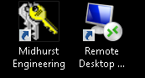

Only when remote from the Garage:
Click on Midhurst Engineering and wait for a VPN connection to be established

Once on the garage network, click on the Remote Desktop icon to bring up this:

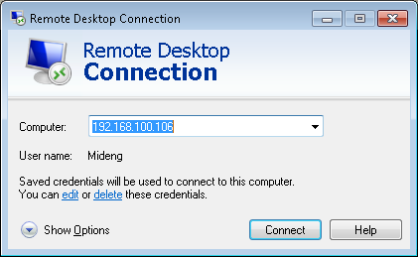

Choose a computer to connect to:
192.168.100.106 connects to Sunrise [the server]
192.168.100.125 connects to Mo’s computer
Any other entries seen should not be used

You will need to know the password to the PC you wish to connect to.

The Internet Explorer Favorites Bar has three entries of particular interest:
- WEBFLEET to see the location of the recovery vehicles
- LAN CCTV – Works when in the office
- WAN CCTV – For use ONLY from home [Shortcut will be added when the laptop is at home. Do not use WAN CCTV when in the office as it will cause the laptop to crash.
*** END OF ENTRIES FOR GUY’S HOME ***
Mike Morgan Home
8 St Margaret’s Way, Midhurst, GU29 9FQ

Phone and Broadband Service from Zen Package: 80/20
Contract Length: 12 Months In contract until 26/02/2016
Connected to: 01730 816595 [No directory entry] Help Desk: 01706 902000
Default email username: zen255936@zen.co.uk Default email password: Xw94bK65
Static IP Address: 82.71.58.115 DNS: 212.23.3.100 Secondary DNS: 212.23.6.100
Customer Portal: http://portal.zen.co.uk/ Userid: mike@mideng,co.uk Password: route654
http://www.thinkbroadband.com/speedtest/results.html?id=1432926673531692155

Michelle Buckley
Customer Retentions Sales Executive
Zen Internet
Direct: 01706 902128 Fax: 01706 902127
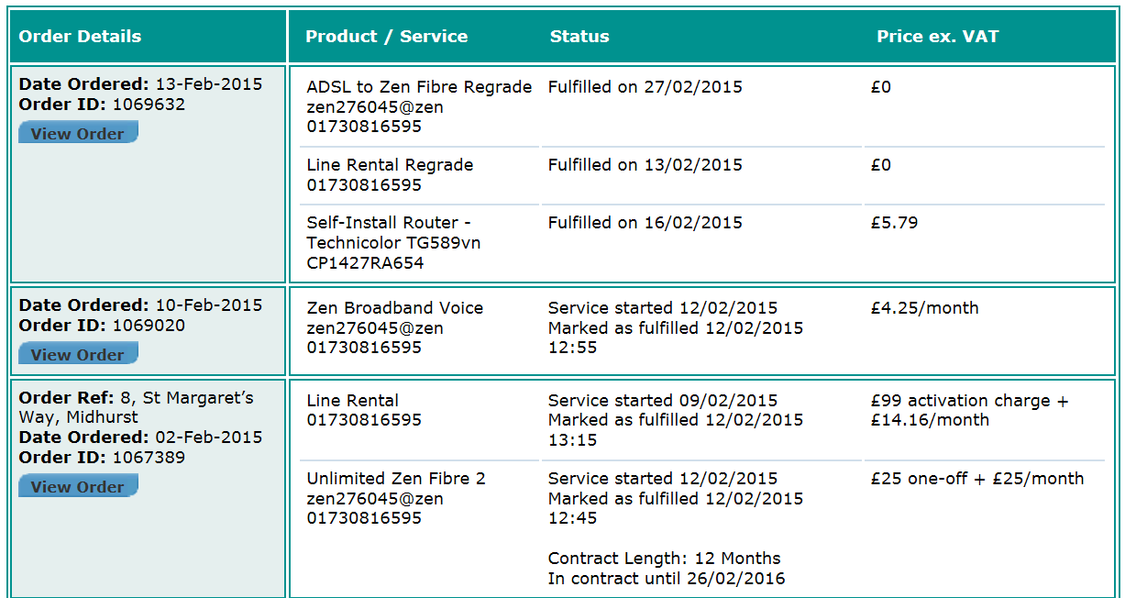
Connection password: 343spfyK

IP address information: 82.71.39.217
Subnet mask 255.255.255.255
Primary DNS: 212.23.3.100
Secondary DNS: 212.23.6.100

Default email username: zen276045@zen.co.uk
Default email password: 3fDnhPUs

Default web space username: zen276045
Default web space password: 3fDnhPUs

VoIP Username: 01730816595
Password: k6vFC5ii
Registrar Address: voip.zen.co.uk
Registrar Port: 5060
Proxy Address: voip.zen.co.uk
Proxy Port: 5060

Firewall Settings:
You will need to allow access to the following IP ranges through your firewall, if you have one:
212.23.7.226
212.23.7.227
212.23.7.228
62.3.88.0/28
62.3.88.16/28

The following port ranges should be allowed through your firewall:
5060 and 20,000->30,000

DrayTek Router
IP Address: 192.168.104.1 Logon ID: admin Password: elstead2008
Model Name: Vigor2830vN Firmware Version: 3.6.4.1_sb_232201
Build Date/Time: Jul 16 2013 11:03:01
WAN Username: zen255936@zen Password: NkWfXWqg
LAN Start IP Address: 192.168.104.104 Pool Size: 20
SSID: SMW Password: route612 Security: WPA/PSK2 Channel: 6
SSID: Guest: Password: Security: WPA/PSK2 Channel: 6
SSID ALA: Password: Security: WEP Channel: 6

Workgroup COBDEN

Connected Devices
IP Address MAC Address HOST ID USERID Password
192.168.104.1 00-1D-AA-B2-9D-F0 Router
192.168.104.104 34-57-60-67-26-B9 Sure Signal
192.168.104.105 00-19-FB-65-30-67 TV
192.168.104.106 E0-B5-2D-84-A5-44 Claudias-iPhone
192.168.104.107 74-E5-43-EE-9E-1A Vermouth Mike recovery2

VoIP Identities
Service Name Domain and Proxy Password POTS Number VoIP Number Test Number
Zen voip.zen.co.uk nNCUUbP9 01730 816595 -- 7130
DrayTEL draytel.org gUk[5DRc 0845 557 8295 8488593 902

DrayTEL registration email: zen255936@zen.co.uk Password: route654
Currently [3 SEP 14] with no credit on account

Current charges [19 May 2015] for Telephone service with FTTC
8 St Margaret’s Way, Midhurst, GU29 9FQ
Line Rental - monthly service charge: £14.16 + VAT = £16.99
Unlimited Zen Fibre 2 - monthly charge: £25.00 + VAT = £30.00
Zen Broadband Voice: £4.25 + VAT = £5.10
Total = £52.09
Installation charge was: £70.80
Notes on telephone service
If there is a fault on the exchange line you report it to Zen on 01706 902000 obviously using another telephone line. Your telephone number is 01730 816595.
Call rates on the landline shown below but use the 1000 free minutes via VoIP for 01/02/03/0870 numbers..
 | Daytime | Evening | Weekend
 | (7am - 7pm) | (7pm - 7am) | (Fri 7pm - Mon 7am)
UK Local and National Calls | 4.09 | 1.02 | 1.02
(01/02/03 numbers) | 4.09 | 1.02 | 1.02
0845 | 6.4 | 2.3 | 2.3
0870 | 4.09 | 1.53 | 1.53
O2 Mobile | 11.23 | 8.68 | 8.68
Orange Mobile | 14.3 | 8.68 | 8.68
Three Mobile | 14.81 | 8.68 | 8.68
T-Mobile | 11.23 | 10.21 | 8.68
Vodafone Mobile | 13.28 | 8.68 | 8.68
There are no set up, call connection or minimum call charges associated with calls made to any of the above call categories
Charges are Pence per Minute including VAT. Calls are billed by the second
The overall charge per bill and not each individual call is rounded to the nearest penny

The system is setup as shown in the diagram below.
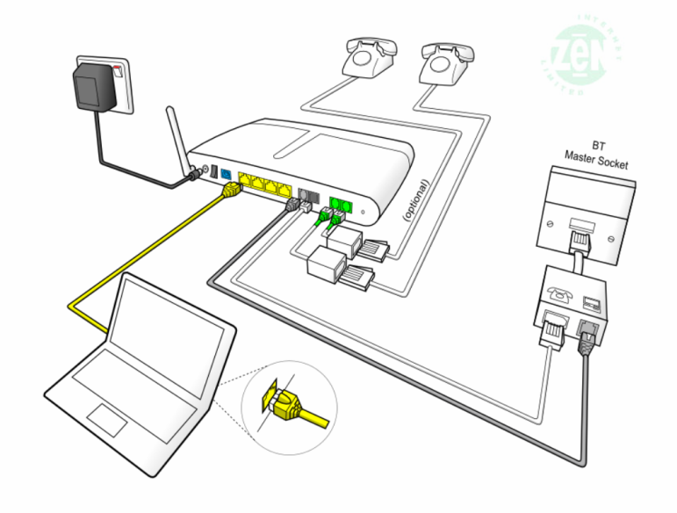

Calls are received via the landline on 01730 816595 or via the DrayTEL VoIP service using 0845 557 8295. However another DrayTEL VoIP user could alternatively use 8488593@draytel.org [generally by just dialling the number].

The configuration of the router will default outgoing calls via the Zen VoIP service providing the number starts with a ‘0’. The initial, or complete, number shown in the dial plan, routes the call as shown.
Dial Plan

Entry | Service | CLI Display | Called | Called Party | Cost
[Area Code][Number] | Zen VoIP | 01730 816595 | As dialed | Any POTS Subscriber | Inclusive Minutes *
7 [Area Code][Number] | Zen VoIP | anonymous | 7 stripped off | Any POTS Subscriber | Inclusive Minutes *
123 | Draytel | 8488593 | 8234842 | David Bradley | Free
47 | Draytel | 8488593 | 8485796 | Mike Morgan [Office] | Free
49 | Draytel | 8488593 | 8237300 | MIDENG Workshop | Free
2 | Zen VoIP | 01730 816595 | 01730 812162 | MIDENG Switchboard | Inclusive Minutes *
8xxxxxx | Draytel | 8488593 | As dialed | Any Draytel Subscriber | Free
777 | Zen VoIP | 01730 816595 | 777 | Zen Help Desk | Free
999 | Landline | 01730 816595 | Emergency Services | Police, Fire, Ambulance | Free
#0 [Area Code][Number] | Landline | 01730 816595 | As dialed | Any POTS Subscriber | As phone line table
7130 | Zen VoIP | 01730 816595 | 7130 | Zen VoIP System Check | Free
902 | DrayTEL | - | 902 | DrayTEL service test | Free
Inclusive minutes means 1000 anytime minutes available each month to 01/02/03 numbers only. When quota is exhausted, or not part of the plan, calls are charged as shown in this table below.
The landline number is permanently withheld. To bypass this facility prefix calls with 1470 to enable your number to be released on a call-by-call basis. The default VoIP service displays the number, so prefix each call with 7 to withhold the number.

Zen VoIP Service
This service, at £5.10 a month [inc VAT], includes 1,000 inclusive minutes to UK landlines (01/02/03/0870 numbers) and reasonable call rates to international and mobile telephone numbers. The DrayTek router has been configured to make this your default phone service as soon as 0 is dialed. The telephone number for this line is also 01730 816595; basically calls are routed out via VoIP for lower call charges and no setup fee but incoming calls are routed over the landline. This is NOT a second line service.

Pricing Overview | Landlines | Mobiles
UK Pricing
UK Local and National Calls | 1,000 minutes included, | From 14.1ppm
(01/02/03/0870 numbers) | then 2.35ppm | From 14.1ppm
International Pricing
North America | From 2.35ppm | From 2.35ppm
South America | From 3.53ppm | From 14.1ppm
Europe | From 2.35ppm | From 5.88ppm
Asia | From 2.35ppm | From 2.35ppm
Africa | From 7.05ppm | From 9.4ppm
Oceania | From 2.35ppm | From 21.15ppm
A full list of VoIP call charges are at http://www.zen.co.uk/business/voice/voip.aspx?page=10157
0845 - 4.7ppm [Peak]; 1.175ppm [Off Peak]
0844 - 5.88ppm
0871 - 11.75ppm
DrayTEL VoIP Service
No rental charges but useful for free calls to other DrayTEL subscribers.
The telephone number for this line is 0845 557 8295.
Mike’s Laptop Vermouth – Logon Accounts
Mike recovery2 Working Account
Roger route654 Phantom Account **
User route654 Dummy Account

** The ESET product requires a phantom account for anti-theft protection. The setup procedure used:
Email address: david@mideng.co.uk Password: route654 First kiss: Pauline
https://my.ESET.com/Default.aspx [Theft recovery]
https://my.ESET.com

Email accounts
mike@mideng.co.uk mxm5
morganind@hotmail.co.uk Dragon9

*** END OF ENTRIES FOR MIKE’S HOME ***

Area 14
Location: W L West & Sons Ltd, Selham, GU28 0PJ

Generally Overview
To provide an additional engineering facility using an existing structure on the W L West & Sons site at Selham with the addition of a Portakabin for administration activities.

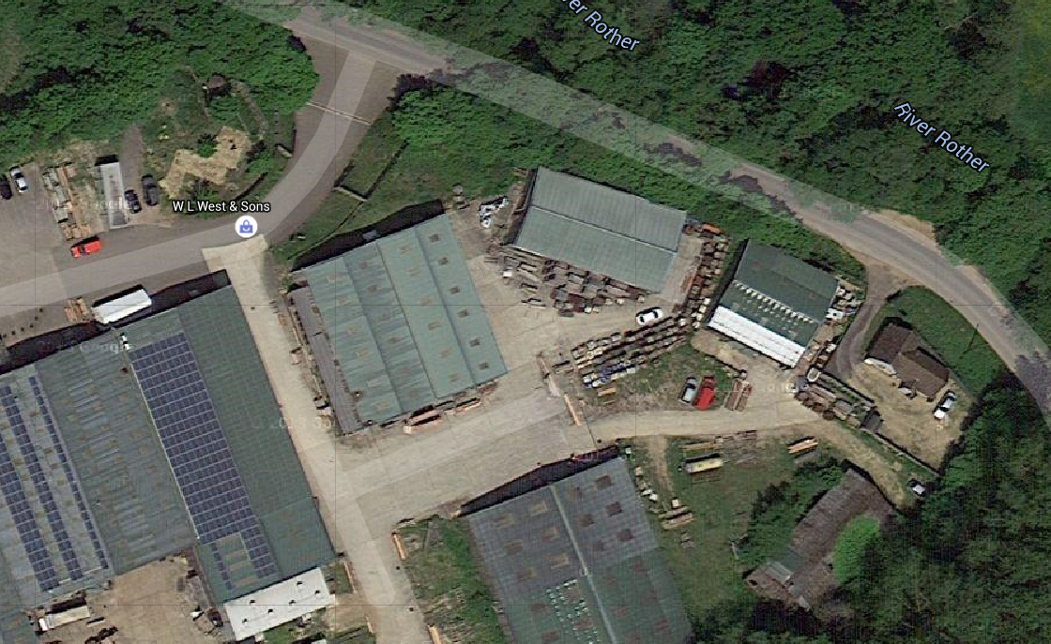

Accommodation Information
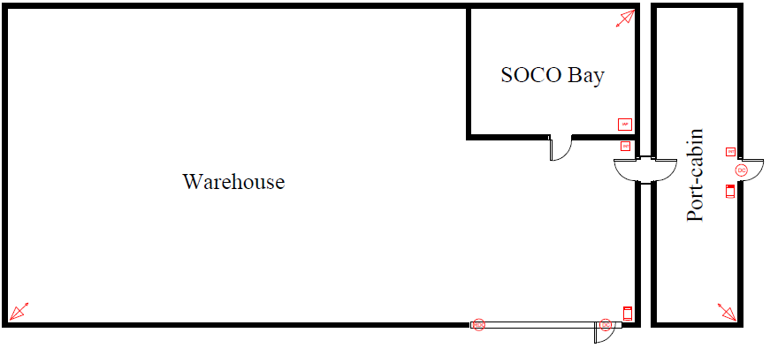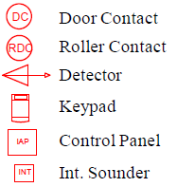

Broadband Options on this site

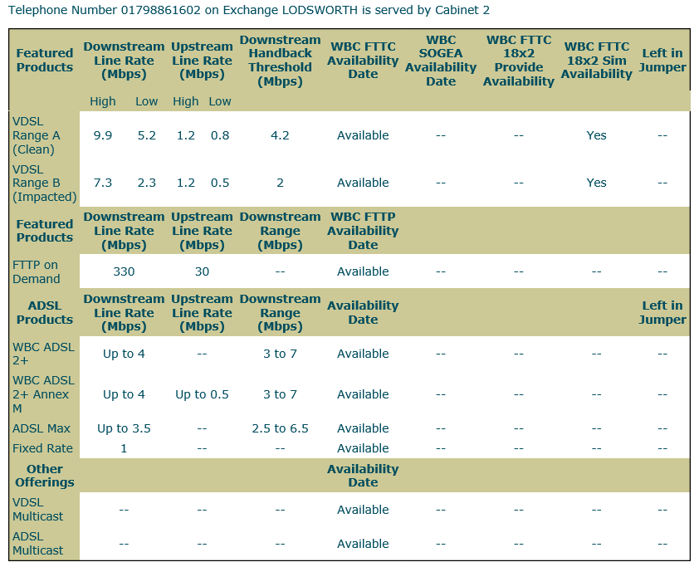
Lodsworth Exchange is 1485m away according to Sam Knows.

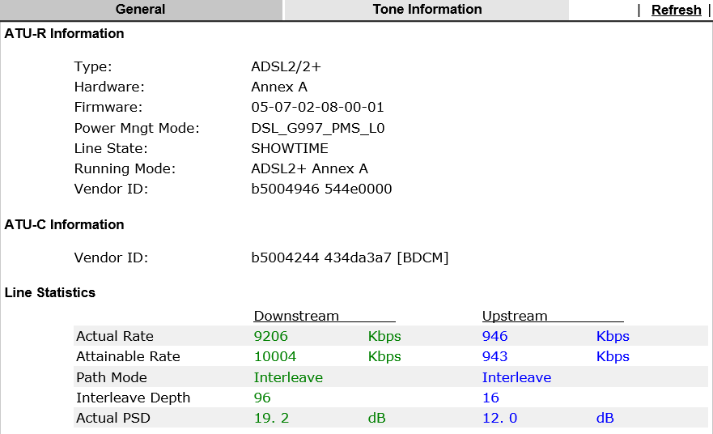

Telephone services in the portakabin come from roadside cabinet #2 in Lodsworth delivered to pole 18 in Selham. FTTC is available, but with hardly any uplift in speed due to the distance to cabinet. Upgrading from ADSL to FTTC with BT is allowed while ‘in contract’ without exit penalty, but a new contract period will kick in.

The rural location of MIDENGs development with our order for a telecommunication services, has highlighted BT limited resources in Selham area with the nearest pole [#18] only able to initially provide a single exchange line against the two ordered.

Order placed with BT
Help Desk: 0800 800 152. Open Monday to Friday 8am to 6pm [excluding Bank Holidays]
Billing Enquiries: 0845 600 6156 08:00 - 18:00 Monday to Friday 08.00 - 13.00 Saturday
Installation address: Midhurst Engineering, Area 14 of W L West & Sons Ltd site, Selham, GU28 0PJ
Billing address: Midhurst Engineering, Rumbolds Hill, Midhurst, GU29 9DD

BT Business Account and BT Wi-fi username
Full access all features not yet possible because an account number is required from the first bill!!
Entering the system may require a response a security question. Mother’s maiden name: midhurst
01798 861829 Account: midhursteng2@btconnect.com Password: elstead2008
01798 861602 Account: midhursteng1@btconnect.com Password: recovery1
[Previous password: nje0717164516]

Name of Product/Service Minimum Period Quantity Total
Business Broadband Unlimited [£17] 24 Months 2 £34
Business Value PSTN phone line [£13] 24 Months 2 £26
Business Call Essentials Plan & Call Package [£10] 24 Months 2 £20
===
Ongoing Rental with BT £80

Line Installation: £115 * 2 £230
Broadband Installation: £0
===
One-off Fees £230

Accounts are rendered quarterly so each should be £240 plus the cost of calls which are not to 01/02/03 numbers

The Broadband Service
BT will cost in the first year [£80 * 12] £960 plus £230 = £1190 with no call charges and no cap on internet usage. However it is a 24 month contract and there is a known price rise which will come into effect on 20th September 2015. Actual figure unknown but thought to be £2.50 adding £30 to first year costs. All prices exclude VAT. This is around a £600 saving against using Zen but with all the frustrations that is always present in dealing with BT.

On reaching the end of your Minimum Period:
- BT will continue to provide the benefits of BT Business Call Essentials with the exception of the Inclusive minutes, which will no longer apply. [Consider migrating to Zen then]
- There’s no new Minimum Period.
If a further 24 month contract is entered into, then inclusive minutes would be reinstated.

To make phone ring: 17070 and press 1 then hang up or 1475

VoIP setup
The exchange line is looped through the router to enable calls to be routed through different telephone providers
Installation Orders with BT - Placed order 17 JUL 2015
Tele: 0800 169 8639 (8am–6pm Mon–Fri, closed weekends and Bank Holidays).
Web Access to track orders: https://www.bt.com/business/youraccount
BT Account Number: SD 4486 4587

Order number B0S000000015903403 – STQ183SD - 01798 861829
Network Login Username: D839115@hg70.btclick.com Password: welcome1
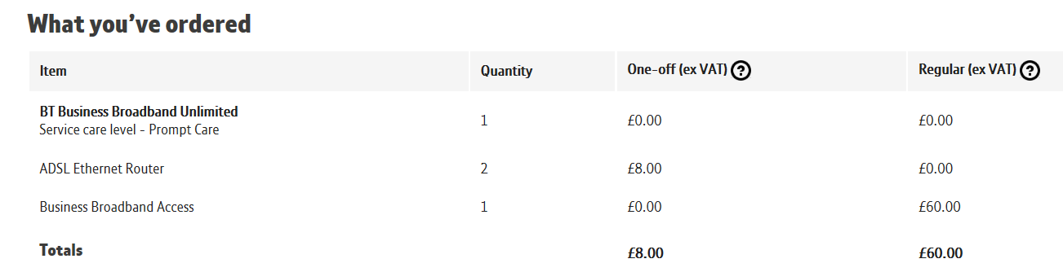

Order number B0S000000015903405 - 01798 861602
Network Login Username:D839116@hg57.btclick.com Password: welcome1
Account Numbers: SD44864587 [Voice] and WM 4114 2114 [Broadband]
Voice facility completed: 11 AUG 2015 Broadband switched on: 20 AUG 2015

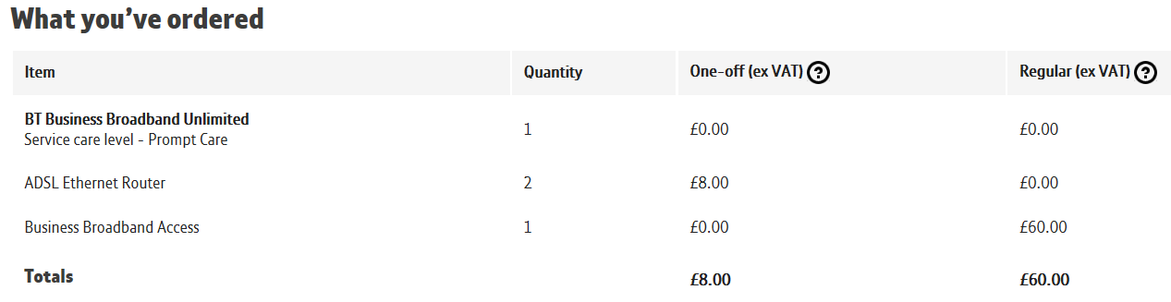

Telephone Number: 01798861602
BT.com login name: midhursteng1@btconnect.com
Date/Time: Thu Sep 10 10:20:36 BST 2015

Your BT Business Billing Account has been set up so you can manage your billing and payments online.
All future bills for the account above will be available at www.bt.com/billonline.
Draytek Router Configuration [405 Order] - Connected to 01798 861602
IP Address: 192.168.14.1 Logon ID: admin Password: elstead2008
Model Name: Firmware Version:
WAN Username: D839116@hg57.btclick.com Password: welcome1
LAN Start IP Address: 192.168.14.14 Pool Size: 50
SSID: MIDENG-SELHAM Password: route654 Security: WPA/PSK2 Channel: 1

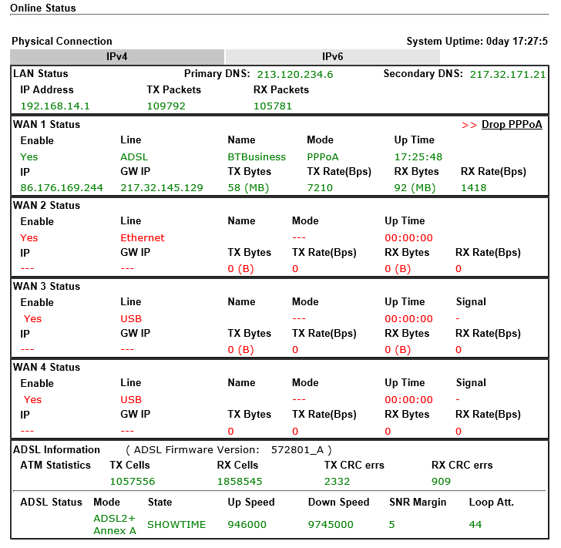

Dynamic DNS

Dynamic IP address from BT currently provided changes frequently.NO-IP is being used to gain access to the Draytek router. NO-IP keeps us notified of the current dynamic IP address.
£23 annual subscription paid – Renewal due 9 September 2017.
Access: https://www.noip.com/members/
Username: david@mideng.co.uk Password: recovery1 Security: Pets Name is pip

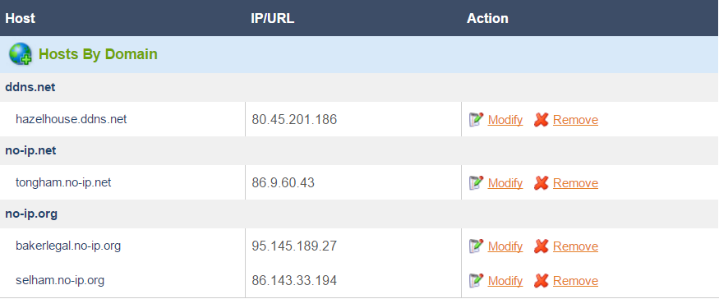

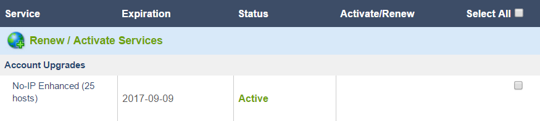

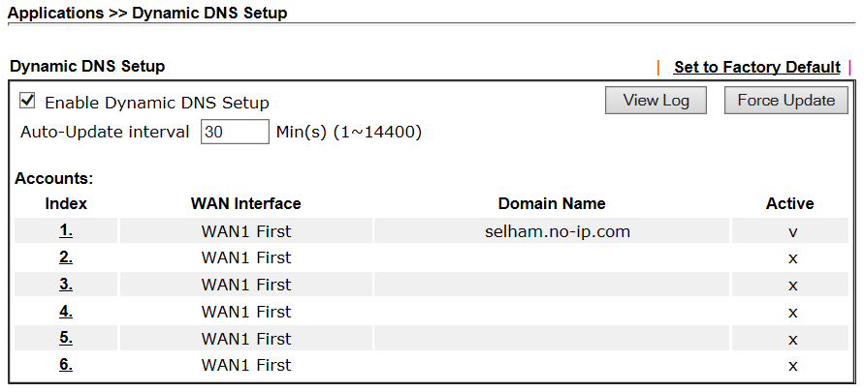

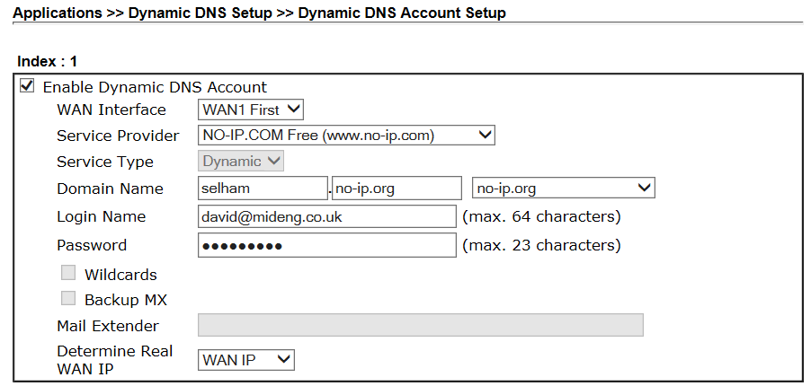
Uses on the network on Friday, 19 May 2017

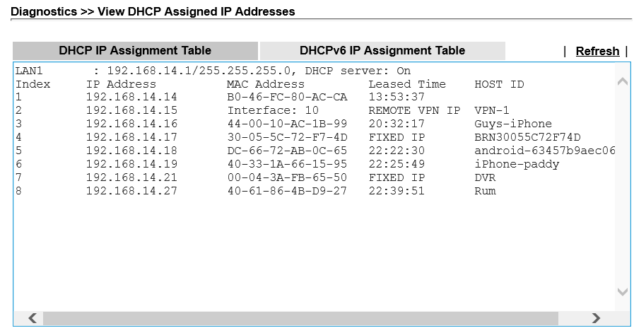
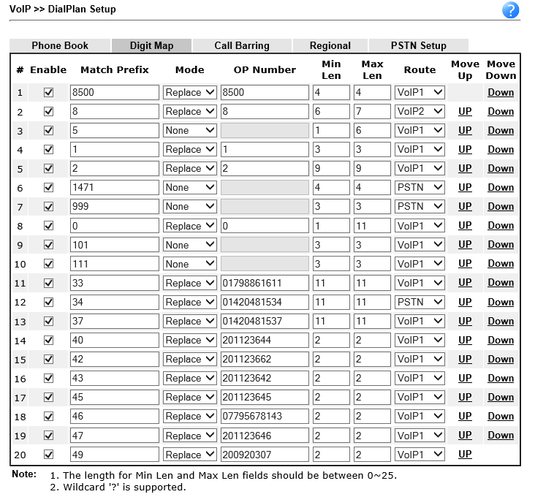
How to make phone calls from Area 14 as of Friday, 19 May 2017

- You must use the area code if calling a number on the public network, e.g. 01252 758123.
- Outgoing calls will show 01730 888152 on the called party’s phone.
- Abbreviated dialling codes have been setup for frequent destinations and are shown in the table below.
- A calling plan is in place giving free calls to 01/02/0800 numbers and any short code except for 101 and #0. Anything else is chargeable like 03, 0844 and 0845.
- Contact numbers can be stored in the wireless phone and redial is possible from the calls list.
- Using codes 4147, 4148 and 4149 will ring all phones in the area described.

Called Party | Use
David Bradley | 123
Callmaster [Will Hancock | 121
Listen to messages left | 8500 UID 23544 PW 23544
Last Caller’s number via BT | 1471
WL West’s Offices | 33
JDs Alton Office [Lewis] | 34
JDs Alton Workshop [Adam] | 37
MIDENG Mike [DDI] | 47
MIDENG Guy [DDI] | 45
MIDENG Belinda [DDI] | 43
MIDENG Emily [DDI] | 40
MIDENG Tony [DDI] | 49
MIDENG Workshop | 4147
MIDENG Bodyshop | 4148
MIDENG Recovery | 4149
MIDENG Petersfield Base | 42
MIDENG Paddy [Mobile] | 46
Draytel Subscriber | 8xxxxxx
Police, Fire, Ambulance | 999
Police [Non-emergency] | 101
Medical Emergency | 111
Route outgoing call via BT | #0 followed by number

Receiving Calls
- The preferred number to call Area 14 is 01730 888152. The wireless phone’s inbuilt calls list is populated with calls received on this number.
- An answerphone service kicks in after 40 seconds. Retrieve any messages left by dialling 8500 where the credentials are mailbox 23544 and password 23544
- A greeting message is in place for the answerphone facility. To listen to it dial 523544.
- Callers can use 01798 861602 instead but this choice will not show the telephone number of the caller although the last caller’s number can be obtained by dialling 1471.

Phone Faults
- Report faults with the phone service to David Bradley on 01252 758960.

BT Twin Set Cordless phones at Selham
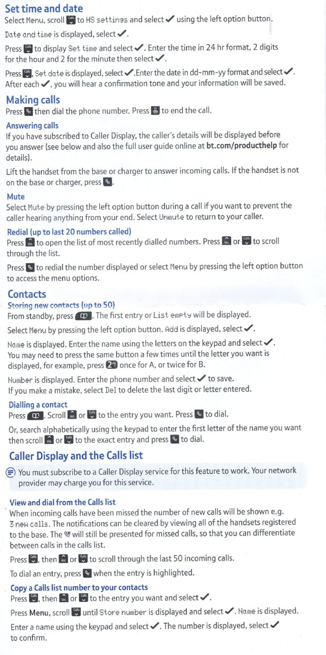
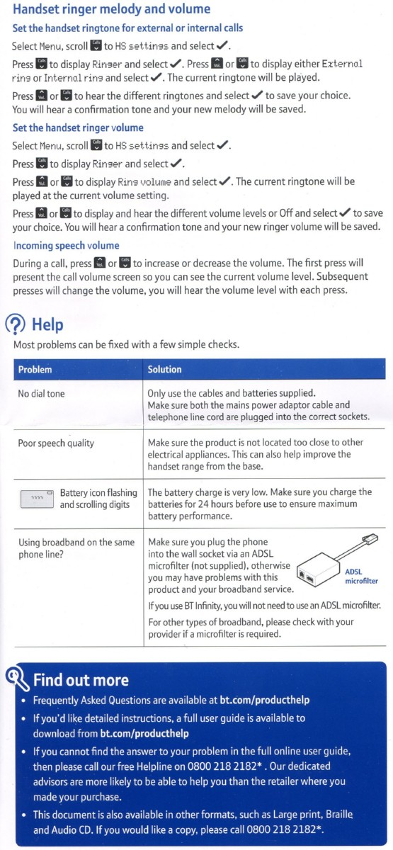
BT Router Configuration – [403 Order] - 01798 861829
IP Address: 192.168.1.254 Logon ID: admin Password: elstead2008
Model Name: Firmware Version:
WAN Username: D839115@hg70.btclick.com Password: welcome1
LAN Start IP Address: 192.168.1.2 Pool Size:
SSID: MIDENG-SELHAM-B Password: route654 Security: WPA/PSK2 Channel: 1

DrayTEL
Username: 8493257
Password: Y1vW2)4)
Domain: draytel.org
NAT Proxy (if required): nat.draytel.org
Signup details: selham@mideng.co.uk Password: elstead2008
Telephone number: 0845 557 8836

Callmaster
Username: 201123544
Telephone number: 01730 888152
Password: mid31415
Mailbox: 23544 Delivery email: selham@mideng.co.uk

CCTV
LAN Web browser access: http://192.168.14.21
For remote access, establish a VPN connection first.
Web Address: selham.no-ip.org
Camera Userid: admin Password not yet set

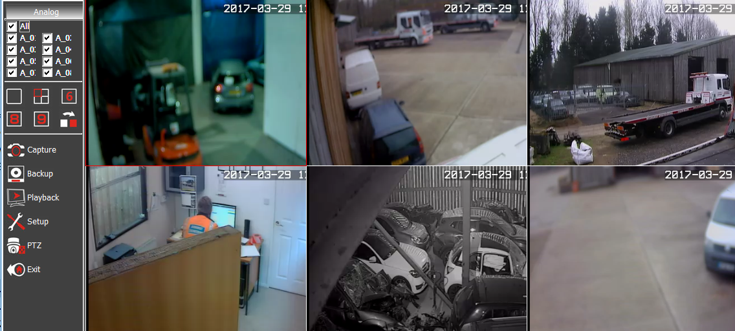

Sure Signal
Registered email address: david@mideng.co.uk
Web access: http://vodafone.co.uk/myaccount
Goto: Home > Account No.565902041 > Manage Services >Sure Signal
Username: mideng Password: recovery1
Secret Question: What was your favourite TV show? Answer: one foot in the grave
Registered Postcode: GU28 0PJ
Serial number 42151632454
Sure Signal Name: Good Call
MAC: B0-46-FC-80-AC-CA
Registered main mobile number: 07836547472
DOB: 6 OCT 1939

Sure Signal Registered User as at Friday, 13 November 2015
David Bradley 07836547472
Guy Morgan 07769723651
Paddy Pafford 07795678143
Stephen Cottle 07787488190
Lelo Driver 07795678142
Lelo2 Driver 07824166997

Workgroup: SELHAM

Brother Network Printer at Selham
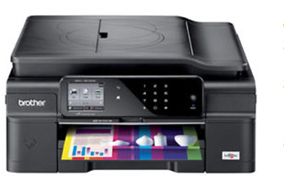
Userid: }
Password: } Facility not configured
Name: BRN30055C72F74D
Copier Model: MFC-J870DW
Serial Number: E71966A5F294095
MAC Address: 30-05-5C-72-F7-4D
Static IP Address: 192.168.14.17
Fax Number: 01798 861829
Firmware: L1409170826
Supplier: vikingdirect.com
Customer number: 5581412
Order number: GB018980274B
Purchased: 8 September 2015 Price: £100.19

Google Account
Access: https://accounts.google.com/ServiceLogin?elo=1
Email: david@mideng.co.uk Password: route612
Verification link:
https://accounts.google.com/VEH?c=CMOd48fQqfT9DxDDs_Wwo4eCyVY&hl=en
Need this if I lose access to my account (for example, if you forget your username or password)

On Wednesday, 8 June 2016.I was able to logon using david.bradley@mideng.co.uk with the password of route654 – Not sure if this connects me to the same area as the credentials shown above.

NO-IP
Account URL https://www.noip.com/login?ref_url=console
Userid: david@mideng.co.uk Password elstead

Samsung S24D300HS 24 inch LED HDMI Monitor - Black
Order #206-4068503-0637904 - Placed on June 14, 2016
Sold by Amazon EU S.a.r.L. £96.67
Access to GUI: http://192.168.14.17/general/index.html?pageid=1087


https://www.google.com/cloudprint#printers

https://www.google.com/cloudprint/learn/

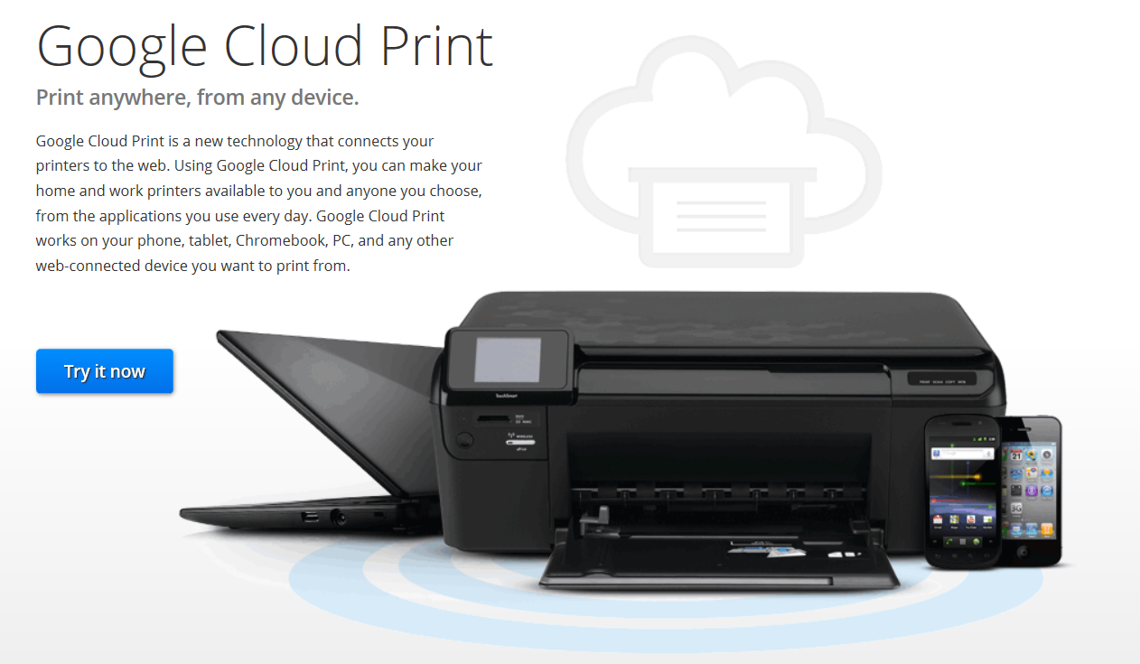

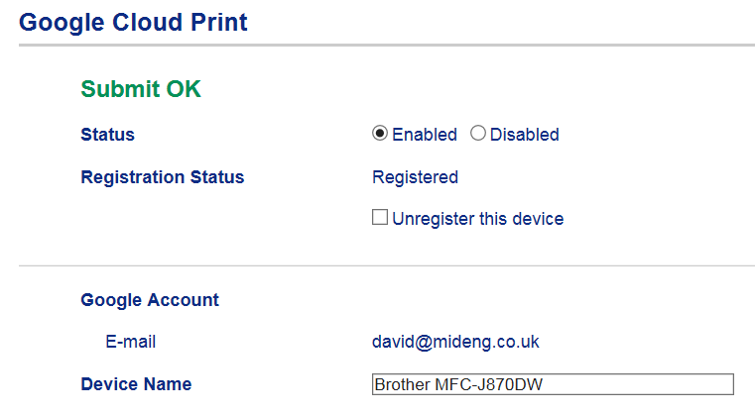

Brother Online Connections
It seems only to work if Google Chrome is used. Feature is unlikely to be used anyway.
https://connections.brother.com/
Email address: david@mideng.co.uk Password: Route612

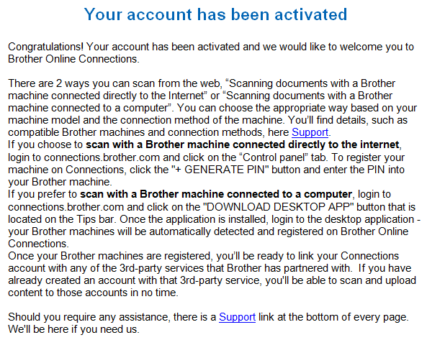

Not being on site to read the PIN off the printer could not proceed on 17th September 2015

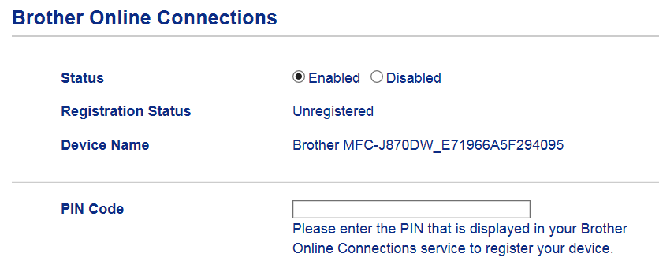

How to use google cloud print app for Android
See https://support.google.com/cloudprint/answer/3153824?hl=en

Google Cloud Print is an under-appreciated service that can send print jobs from virtually anywhere to a connected printer in any other location. Normally that involves tedious configuration on your network, but Cloud Print can do it in just a few minutes. It's really easy to set up, and there are a few things you can do to extend its support beyond the browser to make all your printing tasks a lot easier. Here's a look at what it can do, how you can set it up, and how to make it even better.

What You Can Do With Google Cloud Print

Google Cloud Print makes it possible to send any document or image to a printer from any location. For example, if you wanted to print out a letter at home while at work, you could use the service to send that letter to your home printer and have it waiting for you when you get back. Normally this kind of setup requires a tedious network configuration, but with Google Cloud Print you just click a few buttons and you're done. The service can also print web pages and other documents to PDF format and save them in your Google Docs account. This is can be especially handy if you're keeping your account synchronized with all your computers using a third-party service called InSync (more info here). Basically, if you want to print anything from any device to practically any location, Google Cloud Print can make that happen.
If you want to get started with Google Cloud Print, here's what you'll need:
- The Google Chrome web browser.
- A regular or internet-enabled printer. (Virtually any printer is fine, but the setup process varies depending on the type of printer you have.)
- An active, internet-connected computer that the printer is connected to if it is not an internet-enabled printer.
- A Google account. (If you don't have one, sign up for one here.)
Once you've got all of that ready to go, you can start setting it up.

How to Set Up Google Cloud Print
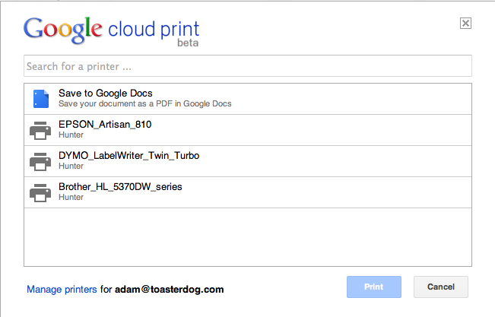
There are two ways to set up your printers with Google Cloud Print. A handful of newer printers have internet connectivity built in and so you can connect them to Google directly. This process varies by printer, so visit this page to learn if your printer is compatible and, if so, how to set it up. If you have a traditional printer that's connected to your computer, however, the setup process is always the same. Just follow these steps:
- First, make sure everything is in place. You'll need Google Chrome installed on your computer. Also, ensure that your printer is connected to your computer, it's currently on, and you can print from it normally. (Note: You'll only be able to send print jobs to this printer when it is connected to your computer, so it's best to set this up on a desktop machine where the printer will always remain connected and powered on.)
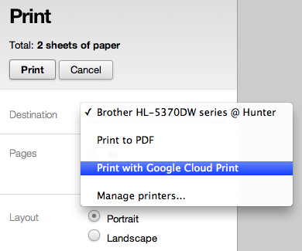
- Once you have everything in place, open up Google Chrome and click the wrench icon in the upper right corner, choose "Options" ("Preferences" on a Mac), and then click the "Under the Hood" tab. Alternatively, just click this link. Now scroll down to the Google Cloud Print section towards the bottom and click "Sign in to Google Cloud Print."
- In the resulting window, sign in with your Google Account. This will enable the Cloud Print Connector on your computer.
- When a new message appears with a button labeled "Finish printer registration," click it.
- You'll receive a confirmation if everything worked properly, and it'll offer a link called "Manage your printers." Click on it to verify all the printers on your computer are now listed.
To test out your new setup, try printing something from within Google Chrome (such as this web page). When the printing options appear, choose "Print with Google Cloud Print" from the Destination menu. Click the "Print" button and you'll be asked to choose one of your cloud printers. Pick the one you want and, assuming everything is working correctly, your printer should print out a document.

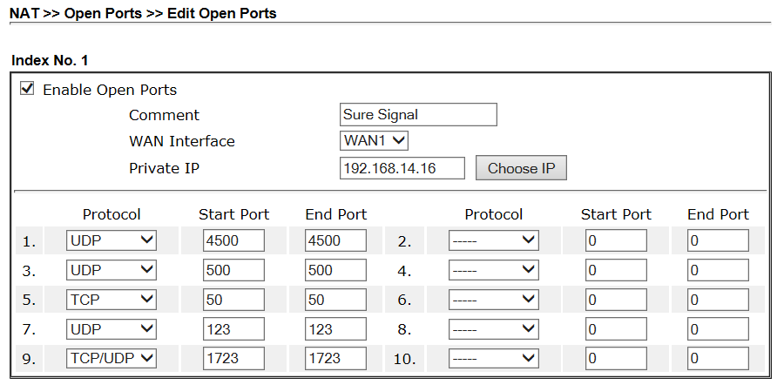

Visual Indication on Sure Signal Device
The unit is useable only while white lights are showing.
If an error message is showing, check that tracert to 212.183.133.177 resolves.
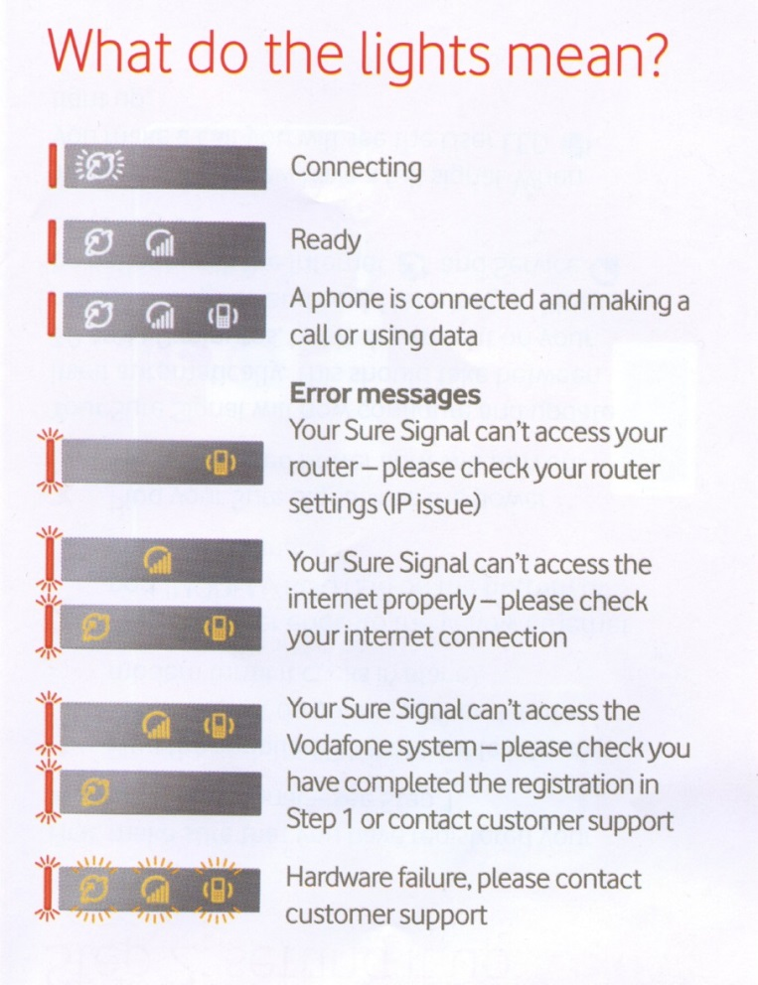

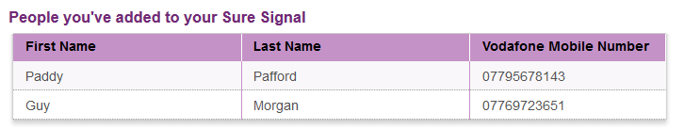
To add new numbers go to http://vodafone.co.uk/suresignal
Unable to add 07857638922 Jordan Morgan because he is on O2 [13 AUG 15]

The Aggregated Service

BT recommended the bonding service Sharedband http://uk.store.sharedband.com/index.php?package=Professional&refer=&packageID=39&stage=2
MIDENG are free to use any other supplier for the bonded broadband service but Sharedband looks fine. This adds to the connection costs and there is a monthly fee payable as well.

This innovative service allows multiple ADSL connections to be bonded. As these can be from any ISP, the service is essentially available to any broadband user. With Sharedband’s Professional package, two lines can be bonded for a total monthly subscription of £20 + VAT. It seems the Professional option meets MIDENGs requirements.

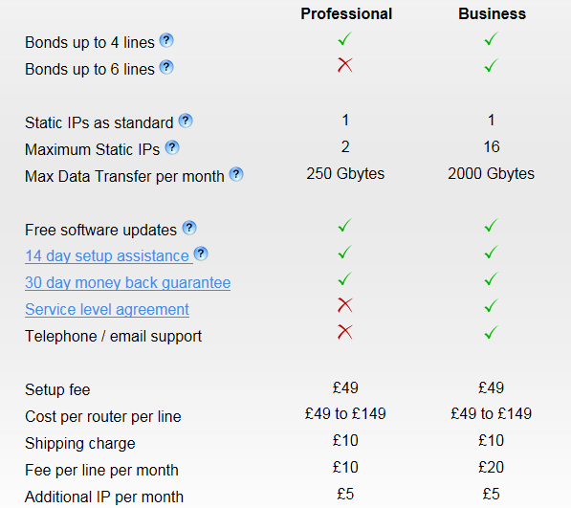

Research indicates it all goes together like this: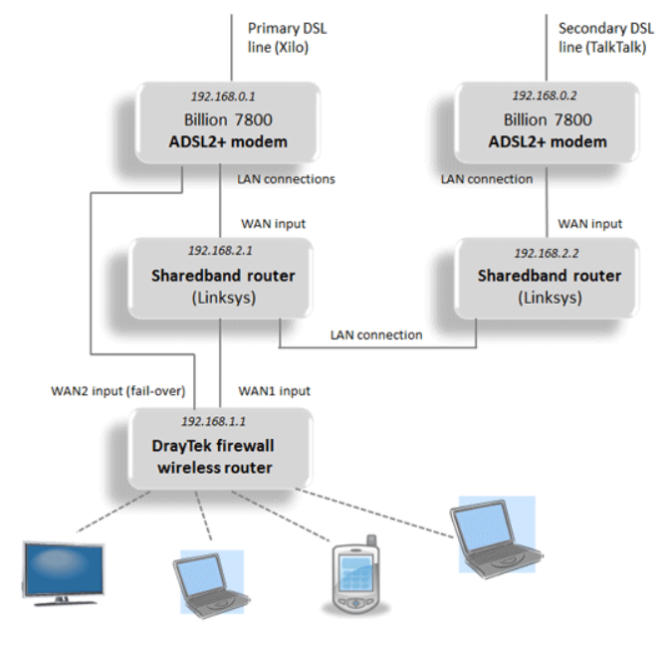
So apart from the aggregation monthly fee, there are additional hardware costs of two Billion ADSL2 modems and two Sharedband routers on top of the required Draytek router. This is an ongoing exercise to determine hardware costs but it could be like this:
2 * ADSL2+ modems @ £45 each £90
2 * Sharedband routers @ £150 each £300
1 * Draytek router @ £250 £250
====
£640

Plus ongoing monthly rental 2 * £10 £20
Ex VAT pricing

All this hardware means that a communication cabinet was necessary to include a patch panel, unmanaged switch, cable tidy, shelves and two power strips.

From BT
midhursteng1@btconnect.com
Your temporary password is: nje0717164516

Login to your BT Business Account
https://secure.business.bt.com/Hub/?TYPE=33554433&REALMOID=06-74628036-ccc7-110a-b564-843bdb4e0cb3&GUID=&SMAUTHREASON=0&METHOD=GET&SMAGENTNAME=$SM$jLaM4wRxiMajy5tOZCgVkme4mYjT0c8U0voO8n96UVuCrC%2b%2fec59QKMsQnSdb7n7&TARGET=$SM$HTTP%3a%2f%2fsecure%2ebusiness%2ebt%2ecom%2faccount%2fLoginRedirect%2easpx%3flegacyurl%3dhttp%3a%2f%2fwww%2ebt%2ecom%2fcmp%2fpublic%2fhub%2edo%3fs_cid%3dbtb_selfcare_BE001_BusEssentials_LogInbutton

https://secure.business.bt.com/Hub?s_cid=btb_FURL_business/youraccount

Reference number: BTUB2286

This is what we're going to order for you.
Please check all the details to make sure we’ve got it right.
If not, tell us what you'd like to change by chatting on line at www.bt.com/business/orderstatuschat
or call 0800 800 152. We are open Monday to Friday 8am to 6pm (excluding Bank Holidays).

Your Details

Email address: david@cyberpictures.net
Company/Trading name:MIDHURST ENGINEERING & MOTOR CO LTD T/A MIDHURST ENGINEERING & MOTOR CO LTD

We’ll confirm your installation or delivery address, as well as your billing address, when we send you your order confirmation.

Right, here’s what we’re doing for you –

Name of Product/Service Minimum Period* Quantity
BT Business Broadband Unlimited 24 Months 2
BT Business Value PSTN phone line 24 Months 2
BT Business Call Essentials Plan & Call Package 24 Months 2

Your order number is BOS 15903403
You ordered BT Business Broadband Unlimited

Your broadband
We'll get your new service up and running on 01798861829 by midnight on 03/08/2015.
We've got a few line checks to do first, so this date might change. (We'll let you know if it does.)
Your broadband service will go in at the same time as your new telephone line.
So if the date for installing your telephone line changes, the date for having your broadband ready will also change.
Note: your phone number might change, depending on your provider. So it's a good idea to wait until the number is working before publicising it.
Your phone line can support a maximum broadband speed of about 4 Mbps.

Your username(s)
Your network login username is D839115@hg70.btclick.com
BT Business account and BT Wi-fi username: midhursteng1@btconnect.com

You'll need your username (above) and password (in our next email). NOT YET RECEIVED 19/7/15

Your broadband comes with unlimited wi-fi access at BT Wi-fi (was BT Openzone) hotspots.
You'll need your username (above) and password (in our next email).

Bibliography on Sharedband ADSL bonding
http://www.increasebroadbandspeed.co.uk/review-sharedband-ADSL-bonding

Check out the videos starting at: https://www.youtube.com/watch?v=pYyCgcpn4zU
In particular: https://www.youtube.com/watch?v=OPAzo8j9Dns

Very useful technical guide: http://www.increasebroadbandspeed.co.uk/review-sharedband-page-3
Also read: http://www.increasebroadbandspeed.co.uk/follow-up-sharedband-review

Leased Line option
Prohibitively expensive and on the back burner for now..

*** END OF ENTRIES FOR SELHAM FACILITY ***

Midhurst Car and Van Sales:
Tele: 01730 887616
VoIP: 201123513
Password: Mid31415
VMB: 10584 Local Access: 8500 Remote Access: 020 3468 5818
VMB email: messages@midhurstcarandvansales.uk

Compila
Control Panel: http://ns34.sovdns.com/cpanel
Username: davi1995
Password: 2sUuQoBi67

FTP Host Server: ftp.midhurstcarandvansales.uk
Username: davi1995
Password: 2sUuQoBi67

Email Information
mike@midhurstcarandvansales.uk 4q66fqqqax34
guy@midhurstcarandvansales.uk 9ee89452p9wy

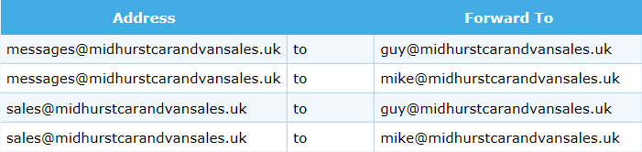

Primary
ns34.sovdns.com
195.238.172.21

Secondary
ns34sec.sovdns.com
195.238.172.22

Gigaset Unit
To configure personal info services (e.g. Weather, eBay, News) go to www.gigaset.net/myaccount
Username: 229388050024#9
Password: nxeAv72S

Appendix 1

MIDHURST ENG CO LTD, RUMBOLDS HILL, MIDHURST, GU29 9DD on Exchange MIDHURST is served by Cabinet 11
Featured Products | Downstream Line Rate(Mbps) |  | Upstream Line Rate(Mbps) |  | Downstream Range(Mbps) | Availability Date
 | High | Low | High | Low
FTTC Range A (Clean) | 80 | 79.5 | 20 | 19.9 | -- | Available
FTTC Range B (Impacted) | 80 | 70.2 | 20 | 17.9 | -- | Available
Monthly Charges:
Complete Fibre Business Broadband: £25.50
Complete Line Rental: £14.50
Total: £40.00
The fibre product, on the line registered to 01730858011 has an estimated downstream speed of 38 Mbps and an estimated upstream speed of 10 Mbps. Actually achieved:
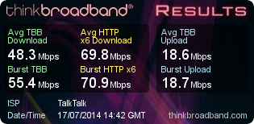
The Complete Fibre Business Broadband package is advertised on this page http://www.talktalk.co.uk/business/product/fibre where this extract was taken from:

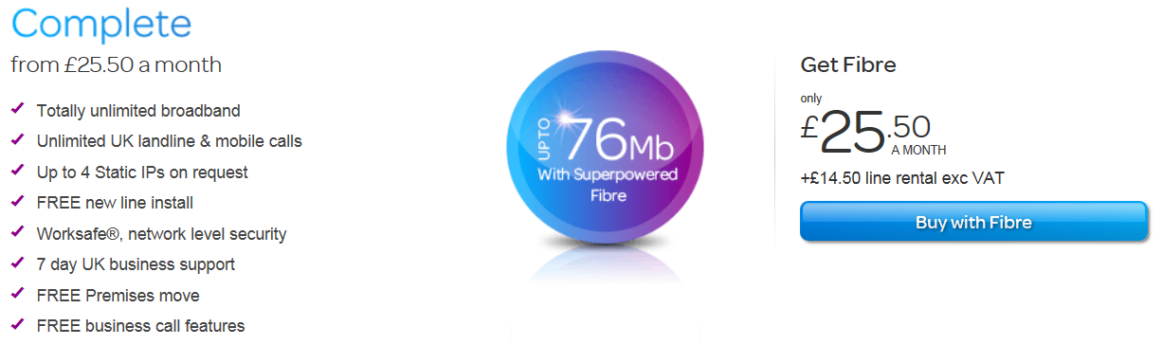

TalkTalk Business logon details for insertion in the DrayTek router.
DSL Username: 01730858011@talktalkbusiness.net
DSL Password: D4E3Z6D3J2 Subnet Mask: 255.255.255.0
Appendix 2
Brian Morgan Home Computer

Userid: Brian
Password: recovery0 [that’s a zero on the end]

CCTV.
Userid: brian
Password: morgan
Access is through Internet Explorer and on the Favourites Bar there is an item called “WEB SERVER”. Click on that to get to the logon screen.

The router has an IP address of 192.168.1.254 – Logon credentials are:
Username: admin
Password: W4H6KR6T

The PC has a fixed IP address of 192.168.1.46 and therefore remote access should be possible using the current WAN address of http://109.152.196.246:1939 but unfortunately needs tweaking for it to work, perhaps a reboot of the PC and router is needed.

Appendix 3
Auto Data

http://www.autodata-online.net/online/Chapters/UI/ModelIdentification.aspx
Username: OWLAADLR0
Password: LRDxwge178
Click here to log in to the online product.
This planned change is part of the upgrade to a new Autodata later in 2015. This will not just be an update, but a completely new online application, designed around real workshop needs to access information faster, easier and with more interactivity.

email: uksubsciptions@autodata-group.com
Tele: 01628 688 111

From: registration@autodata.ltd.uk [mailto:registration@autodata.ltd.uk]
Sent: 23 December 2014 16:12
To: belinda@mideng.co.uk
Subject: Thank you for purchasing an Autodata-Online subscription.

 | Thank you for using Autodata-Online.
 | Please log in using the link below.
 | We have supplied you with a temporary username and password, you will be able to change these
 | once you have logged in and filled out the registration form.
 | https://www.autodata-online.net/Online/Login/AutodataLogon.aspx
 | Administrator Login
 | Username: | belinda1
 | Password: | tony2
 | Login
 | Username: | tony001
 | Password: | belinda2

Appendix 4

What are the settings for my TalkTalk Business e-mail account?

If you are using a TalkTalk Business e-mail address (@talktalkbusiness.net) then the settings that your e-mail client will require are listed below.
Incoming:
Server Name: pop3.talktalkbusiness.net
Connection Type: POP3 or IMAP4
Port: 110 for POP3
Authentication Type: Plaintext Password
SSL (Secure Socket Layer or Encryption): Disabled
SPA (Secure Password Authentication): Disabled (or clear text)
Username: Your E-mail address
Password: Your mailbox password
Outgoing:
Server name: smtp.talktalkbusiness.net
Connection Type: SMTP
Port: 25
SSL: Disabled
Authentication: Disabled
Please note that you will only be able to send mail through our outgoing server if you are using yourTalkTalk Business broadband (ADSL) connection. If you are using a connection provided by another supplier, including a 3G connection on your mobile, then you will need to use the outgoing server of that supplier instead.

Appendix 5
Service enquiries for SelhaM

Kijoma Enquiry
Kijoma broadband, Coldwaltham, Pulborough, West Sussex
www.kijoma.net 01798 888001

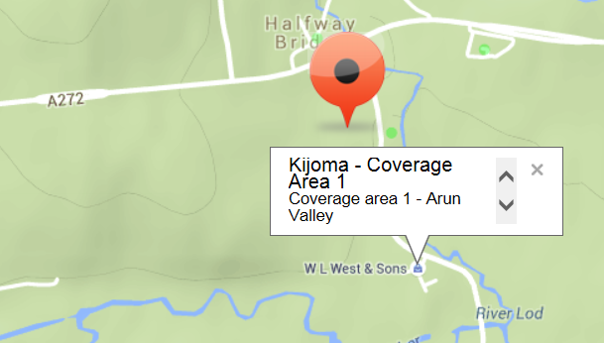
Kijoma is a wireless [not WiFi] broadband provider, who specialise in providing high speed broadband services overlaid with VoIP if required. They are not restricted by the ancient infrastructure of phone lines and their limitations. Kijoma is backed by 20 years+ of professional Radio network and system design, not many if any Wireless ISP's have this level of background in military and commercial solution provision and this is what makes them unique.

The downside to Kijoma is that it is a small company who do not have teams of call centre hens there to answer queries with generic responses. They receive a lot of enquiries from all over the country every day; as a result do have to sort them into a priority list. A response to any enquiry may take days or weeks and some may not get a response for months!

To answer all the enquiries received by Kijoma would require obviously require additional staff whose cost apparently impinges on their ability to maintain investment in the goal of them being the fastest Wireless ISP in the country and to also support their existing customer base on a priority basis.

The Kijoma service would probably be ideal for MIDENG but contact with the company has not been successful for the reasons given above with MIDENG having no other option than to subscribe to an inferior ADSL Max service. There would undoubtedly be substantial savings against a bonded ADSL.

Kijoma coverage mapping suggests they could provide a service of around 20 Mbps which would be fine for MIDENG at Selham.

Zen Enquiry Response
A preferred supplier but unfortunately they identified a number of issues in supplying telecommunication services to this site with their pricing reflecting issues identified.

From: Michelle Buckley [mailto:michelle.buckley@zeninternet.co.uk]
Sent: 07 July 2015 09:51
Subject: New phone and Broadband Service for MIDENG GU28 0PJ

I have spoken with my manager regarding supplying a new telephone line to a Portakabin on this site. Irrespective of how long the cabin will be on the site, Openreach treat this as a specialist installation, and the cost of the new line install would be £518.58 + VAT. Installation of broadband would be £40 + VAT.

With respect to the broadband, there is no date currently provided for Fibre, in fact the checker that I have used says it is not yet planned. As we both know, these estimations can change day by day. I would suggest placing an order for broadband and upgrading to Fibre as soon as it becomes available. Broadband speeds are estimated at 4 Mbps download.

Monthly Service Charges:
· Business Line Rental Premium - £17.49 + VAT
· Broadband Lite HCA 50 GB Usage - £11.50 + VAT

Putting this into a standard format for budgetary and comparison purposes:
Name of Product/Service Minimum Period Quantity Total
Business Broadband Lite HCA 50 GB Usage [£11.50] 12 Months 2 £23.00
Business Line Rental Premium [£17.49] 12 Months 2 £34.98
=====
Ongoing Monthly Rental with Zen £57.98

Line Installation: £518.58 * 2 £1037.16
Broadband Installation: £40.00 * 2 £80.00
Estimated Pole Cost: £300.00
=======
One-off Fees £1417.16

Business Line Rental Plus has 5000 inclusive anytime minutes to 01, 02, 03, 0845 and 0870 numbers, normally £23.50, but was not offered/available.

Using Zen would have cost in the first year [£57.98 * 12] £695.76 plus £1417.16 = £2112.92 plus the cost of any calls which cannot be estimated at this stage. However it would have been just a 12 month contract.

Zen provides a free IP address but this wouldn’t be needed anyway because aggregation supplies this feature.

From: Michelle Buckley [mailto:michelle.buckley@zeninternet.co.uk]
Sent: 17 July 2015 09:27
Subject: FW: New telephone and broadband service required

I see you are going with BT to provide the service as they are offering a cheaper installation charge. I am sorry that we were unable to be more competitive on this occasion, but hope that you will think about using Zen at any other sites that require Broadband.

Appendix 1

MOT testing service: web address changing

The website address for the MOT testing service will change from Friday 16 December 2016.

The change shouldn't affect most of you.

You should always access the service through www.gov.uk/mot-testing-service.

This makes sure that you see any urgent messages about service availability.

Download 'Use the MOT testing service poster' (PDF, 199KB) to display a reminder of where to sign in.

If you've bookmarked the direct link to the sign in screen within the service (http://mot-testing.i-env.net), update it with the GOV.UK address now.

Check your IT network allows access

Some large company networks stop you visiting certain website addresses.

Make sure that your IT team allows access to any website address that includes 'service.gov.uk' so you can access all government services.

