Computer Installation and Telecommunication Services Data Sheet
Updated: Friday, 20 February 2015 Registration Number: 432447

Main Business Address:  Rumbolds Hill  Midhurst  GU29 9DD | Petersfield Depot  60 Winchester Road  Stroud  Petersfield  GU32 3PL
Guy Morgan’s Home:  Hazel House  Cobden Road  Midhurst  GU29 9JW | Mike Morgan’s Home:  8 St Margaret’s Way,  Midhurst,  GU29 9FQ

Garage: 01730 812162 [ISDN Switch – 2 Channels]
Mobile: 07769 723651
Other: 01730 710749
Fax: 01730 816791 [Physical Machine]
Credit Card Machines: 01730 815038 [Parallel extension in the workshop]
Broadband Line: 01730 858011 [TalkTalk Internet Service and White Phone]
Cobden Road [Guy]: 01730 858062 [TalkTalk Internet Service]
St Margaret’s Way [Mike]: 01730 816595 [Zen Internet Service]

DrayTEL [Mike Home]: 8488593
DrayTEL [Mike Office]: 8485796
DrayTEL [Mo]: 8491776
DrayTEL [Tony]: 8237300
Callmaster [Tony]: 200920307 [Voice mail box: 648] 01730 888109

Web Page: http://www.mideng.co.uk

Mail Client Setup
Incoming POP3: 995 Incoming IMAP: 993
Outgoing: SMTP: 465 Server: ns15.sovdns.com

Memo Mailing List
Access: http://www.mideng.co.uk/mailman/admin/memo_mideng.co.uk
Password: elstead
Usage: memo@mideng.co.uk

Subscribers:
administration@mideng.co.uk belinda@mideng.co.uk david@mideng.co.uk
guy@mideng.co.uk matt.ayling@mideng.co.uk mike@mideng.co.uk
mo@mideng.co.uk nick@mideng.co.uk tony.maccallum@mideng.co.uk
vosa@mideng.co.uk
Email accounts
administration@mideng.co.uk
apollo@mideng.co.uk
belinda@mideng.co.uk 0etx63zi4xqo [Warken]
brian@mideng.co.uk
cctv@mideng.co.uk u4nto4aopgip
david@mideng.co.uk 8t4p2ocf7wup [Bradley]
general@mideng.co.uk
guy@mideng.co.uk 8yyzmfzgstza [Morgan]
matt.ayling@mideng.co.uk 6dr48uuisteg [Ayling]
mike@mideng.co.uk mxm5 [Morgan]
mo@mideng.co.uk mxf3 [Franks]
nick@mideng.co.uk n5fu7omeb5dc [Goodwin]
paddy@mideng.co.uk nk3zf3ir5xd4 [Pafford]
pmc@mideng.co.uk
printer@mideng.co.uk
router@mideng.co.uk 8syt8nuo50ft [Router Use]
sunrise@mideng.co.uk 5mex4tb70scf [Server]
tony.maccallum@mideng.co.uk iw2g9p9mfwwn [Maccallum]
vosa@mideng.co.uk 86bwoeiw9cn5 [MOT Testing Station]

Mail Forwarding
andrew.pafford@mideng.co.uk to paddy@mideng.co.uk
andy@mideng.co.uk to mike@mideng.co.uk
dcb@mideng.co.uk to david@mideng.co.uk
guy.morgan@mideng.co.uk to guy@mideng.co.uk
info@mideng.co.uk to guy@mideng.co.uk
mathew.ayling@mideng.co.uk to matt.ayling@mideng.co.uk
matt@mideng.co.uk to matt.ayling@mideng.co.uk
maureen.franks@mideng.co.uk to mo@mideng.co.uk
messages@mideng.co.uk to mike@mideng.co.uk
mike.morgan@mideng.co.uk to mike@mideng.co.uk
pictures@mideng.co.uk to david@mideng.co.uk
receptiondesk@mideng.co.uk to mike@mideng.co.uk
tony@mideng.co.uk to tony.maccallum@mideng.co.uk

About the email address pmc@mideng.co.uk.
Fundamentally ONLY these email accounts can post messages into this email account:
mike@mideng.co.uk
pmc@mideng.co.uk
km@pmc247.com
repairs@pmc247.com
as@pmc247.com
rh@pmc247.com
bh@pmc247.com
je@pmc247.com
bw@pmc247.com

Compila’s server will distribute incoming messages addressed to pnc@mideng.co.uk to these email accounts:
belinda@mideng.co.uk mo@mideng.co.uk mike@mideng.co.uk guy@mideng.co.uk
paddy@mideng.co.uk
To avoid the email box on the server reaching its quota limit of 250Mb, and therefore preventing further messages from being processed, stale messages are automatically deleted after 60 days.
Broadband Service from TalkTalk - Connected to: 01730 858011 – Account Number: 882 01292148
TalkTalk Help Desk: 0800 083 3003 Security Question answer: trolleybus
URL for “My Account”: https://myaccount.talktalkbusiness.co.uk/Login/
My Account login: registrar@trolleybus.net Password: Route654 [Case sensitive]
Conditions: http://response.talktalkbusiness.co.uk/business_update
DrayTek: Vigor2830Vn Firmware Version: 3.6.3_sb_232201 Build Date/Time: Sep 17 2012 16:18:48
Router IP: 192.168.100.1
LAN Start IP Address: 192.168.100.100 Pool Size: 60
Workgroup: MTS
Fixed IP: 212.159.144.127

Credentials for TalkTalk Connection
Login: 01730858011@talktalkbusiness.net
Password: D4E3Z6D3J2
Static IP Address: 212.159.144.127

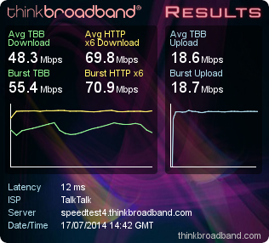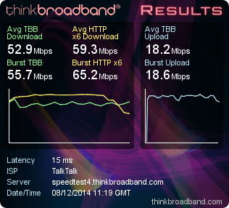
69.75 Mbps 59.26 Mbps

Wireless SSID: MidengAdmin Password: route654 Security: WPA/PSK2 Channel: 6

DEVICES ON THE NETWORK EXCLUDING MOBILE PHONES

LAN1 : 192.168.100.1/255.255.255.0, DHCP server: On
IP Address MAC Host ID Logon Password User
192.168.100.1 00-1D-AA-A8-28-A0 Router admin elstead2008 Not applicable
192.168.100.5 E8-05-6D-FE-E3-DE Nortel BCM ? ? ?
192.168.100.7 CE-AF-48-5F-FE-04 CCTV admin recovery1 Not applicable
192.168.100.11 00-0E-08-BC-85-43 ATA307 - - VoIP for Tony
192.168.100.100 00-80-77-CB-F7-BE VIGOR100 admin access Brother Printer by Mo
192.168.100.101 A4-4E-31-39-92-70 Tequila Paddy paddy309 Paddy
192.168.100.104 E0-66-78-55-BF-19 iPad
192.168.100.106 40-61-86-4B-D9-27 Sunrise Mideng recovery1
192.168.100.108 68-A3-C4-40-3D-37 Stout Midhurst Engineering elstead2008 Guy
192.168.100.110 B0-9F-BA-C3-56-AB MidhursgsiPhone
192.168.100.111 8C-89-A5-65-40-71 Guinness tony tony Tony
192.168.100.112 F8-16-54-17-DB-BC Martini Guy elstead2008 Guy
192.168.100.113 24-FD-52-BE-3A-D1 Coke Matt recovery1 Matt
192.168.100.114 E8-08-8B-08-94-C5 HG533 router admin elstead2008 Workshop Access Point
192.168.100.115 FC-AA-14-3A-0B-92 Port Belinda babybee Belinda
192.168.100.102 1C-6F-65-55-15-AB Brandy Nick Goodwin Nick
192.168.100.118 18-0C-AC-F3-44-5E F3445E000000 ** Canon MX450 series ** Matt/Guy
192.168.100.119 FC-AA-14-3A-0B-9D Fosters VOSA goodcall MOT operative
192.168.100.125 8C-89-A5-65-3E-CD GandT Mo franks Mo
192.168.100.128 90-2B-34-20-68-AC Whisky Mike route654 Mike

Mobile Devices
192.168.100.102 8C-00-6D-17-DA-68 kezlous-iPhone
192.168.100.104 20-62-74-AE-B6-2C Windows-Phone
192.168.100.105 60-03-08-75-44-71 iPhone
192.168.100.107 B0-9F-BA-CE-FD-29 jordans-iPhone
192.168.100.108 C4-88-E5-FE-76-40 android-ff64cb6f42f99f53
192.168.100.109 84-38-38-8A-72-30 android-d5c1a590d17d7df3
192.168.100.110 B0-9F-BA-C3-56-AB MidhursgsiPhone
192.168.100.114 E8-08-8B-08-94-C5
192.168.100.116 94-EB-CD-24-E7-23 north
192.168.100.119 20-A9-9B-25-76-95 Windows-Phone
192.168.100.120 84-38-38-8A-72-30 android-d5c1a590d17d7df3
192.168.100.121 F4-09-D8-64-0D-02 android-9933a9bfa2196410àµ-„¥D
192.168.100.122 F4-09-D8-64-0D-02 android-9933a9bfa2196410
192.168.100.123 98-F0-AB-3E-10-2C Callums-iPhone

Workshop Wireless Access point [192.168.100.114]
Advanced > Status > LAN > Ethernet
Host Name IP Address MAC Address
jordans-iPhone 192.168.62.62 B0:9F:BA:CE:FD:29
Stefens-iPhone 192.168.62.64 0C:30:21:D3:98:56
Users-iPhone 192.168.62.65 E0:F5:C6:A2:79:67
iPhone 192.168.62.66 08:70:45:60:09:22
north 192.168.62.67 94:EB:CD:24:E7:23
android-d5c1a590d17d7df3 192.168.62.68 84:38:38:8A:72:30

VoIP Details for Tony’s Analogue Telephone Adapter with POTS wireless phone connected
Callmaster Identity: 200920307 Password: jona POTS Number: 01730 888109
DrayTEL Number: 8237300 Password: 84825637 Signup email address unknown

To use the default Callmaster service:
- Dial <area code><number> e.g. 01252758123 for telephone numbers on the public network.
Chargeable calls appear on the Callmaster account
- Numbers starting with 20 are internet calls and free, e.g. 200921161
- Numbers starting with 1 are system wide three digit short codes, e.g. 123.
- Dial 8500 to listen to voice mail messages. Logon 648 Password 648
- £10 line rental with 01/02/03 numbers costing 1.2ppm and mobiles 14.7 ppm.
To use the DrayTEL Service:
- Press # for the DrayTEL dialling tone, followed by the subscribers number, e.g. 8234842
- Calls onto the public network are PAYG which has not been loaded with any credit.
Service primary for incoming calls to your number 8237300 [URI: 8237300@draytel.org]
- There is a test number to check DrayTEL is working. Dial: 902 [after entering #]
- No line rental.
- Calls to DrayTEL subscribers are free.

Set up information for the Analogue Terminal Adapter:
Default dial plan: (*xx|[3469]11|0|00|[2-9]xxxxxx|1xxx[2-9]xxxxxxS0|xxxxxxxxxxxx.)
Custom dial plan required: (xxxxxxxxxxxx.|20xxxxxxxS0|1xxS0|5xxxxS0|0[45689]x.|*xx|8500S0|999S0)

Analogue phone codes that can used, normally setup via browser access from 192.168.100.11 :
**** Enter Menu Gives access to menu options
100# Check DHCP Hear whether DHCP is enabled or disabled
101# Set DHCP Disable DHCP: 0 Enable DHCP: 1. Enter either option followed by #
110# Check IP address Hear the IP address of the unit [Currently fixed IP of 192.168.100.11]
73738# Factory Reset Clears user configuration from the Analogue Terminal Adapter
[Further calls not possible until unit is reconfigured]

The White and Black VoIP Phones
White: DrayTEL1: Username: 8485796 - Password: H[0e0cCH Registration: david@mideng.co.uk
Black: DrayTEL2: Username: 8491776 - Password: 5i3^mXs} Registration: david@mideng.co.uk

Calls to 01730 858011 will ring both phones. Whichever instrument picks up the call, the conversation cannot be heard on the other phone.

To call subscribers on the public network you must use the area code even for numbers on the Midhurst exchange [01730]. All calls to 01/02/03/0870/0845/07 numbers are free as is calling a VoIP number.

Simultaneously an exchange line call on 01730 858011 and a VoIP call can be made can be made. Use of the ‘R’ button is restricted to incoming calls on the exchange line.

Some dialling codes may take up to 15 seconds before the ringing tone is heard.

Code Person or Service Routing Number
101 Non-emergency police number TalkTalk 101
120 Mideng Workshop DrayTEL 8237300
123 David Bradley Office DrayTEL 8234842
124 David Bradley Home TalkTalk 01252 702791
125 TalkTalk Help Desk TalkTalk 0800 083 3003
126 Paddy Mobile TalkTalk 07795678143
130 Guy’s Home TalkTalk 01730 858062
133 Mike’s Home DrayTEL 8488593
175 JDs Alton General Number TalkTalk 01420 544644
140 JDs Service Reception DrayTEL 8242201
141 JDs Alton Workshop DrayTEL 8484869
142 JDs Ian Madden DrayTEL 8453255
143 JDs Michelle Ingram DrayTEL 8484873
144 JDs Adam Bradley DrayTEL 8242201
1471 Voice Mail Facility TalkTalk 1471
1571 Voice Mail Facility TalkTalk 1571
902 Check that VoIP is working DrayTEL 902
#0 Access TalkTalk directly Feature 01730 858011

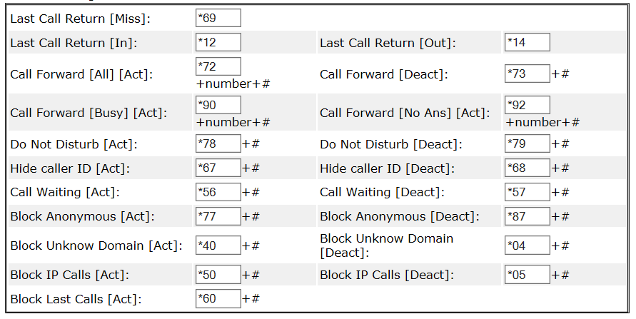
Example: *72+133+# to forward all calls to Mike’s home. Only short codes 120-143 can be used on call divert.
Technical Information
The exchange line 01730 858011 is looped through the router to provide access to subscribers of VoIP services. Configured at present is a service from DrayTEL with an allocated number of 8485796. To differentiate between making calls onto the public network or via VoIP normally means using the familiar area code as if you were using a mobile phone.

System wide short 3 and 4 digit codes can be used like 999, 104 and 1471 but some have been barred and others are not available if a fee for use was required. The dial tone heard is the default VoIP service, so to dial a DrayTEL subscriber, just dial their number. They all start with an 8, e.g. 8234842. Other VoIP service providers are accessed by prefixing their number with <*><gateway number><subscriber number>.

The exchange line supports a number of convenient features like call waiting, ring back, and call forwarding but to use any of these features it is necessary to obtain the exchange line dialling tone first by dialing #0, and then proceeding as shown within the gray panels below.

Call Diversion with TalkTalk
Dial #0 for the exchange line, wait for the dial tone and then use the sequence seen below depending on the action you want.
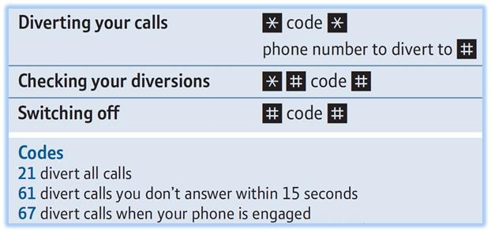
Example to setup call diversion to 01730 812162: Dial #0, wait for dial tone, then *61*01730812162#. The requested call diversion only takes place following 15 seconds of the phone ringing just in case you wish to take the call. The diversion remains in place until switched off.

Call Divert can be managed remotely by calling 0845 2232350, then follow voice instructions. PIN number required which by default is either 0000 or 1234 [this can be changed] and then any of the Call Divert codes can be used. Area codes must prefix all numbers e.g. 01730.

Ring Back using TalkTalk
Again dial #0 for the exchange line, wait for the dial tone and then use the sequence seen below depending on the action you want.
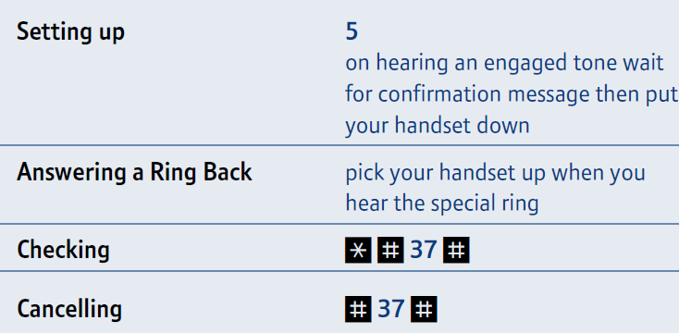
Example: Dial #0, wait for dial tone, then *#37# to check status.

Call Waiting using TalkTalk
Dial #0 then choose an option below.
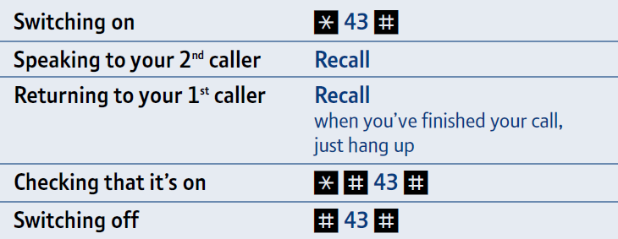
Call waiting will induce a blip tone with the current call in progress. Use the R button to toggle between callers. Alternatively ignore the 2nd incoming call and when ready call them back but remember that the 2nd caller may be withholding their number, so you won’t know who to call!

Voice Mail provided by TalkTalk
Dial #0 and if the dial tone stutters then dial 1571 to pick up messages
Full instructions are here:http://m.help.talktalk.co.uk/how-do-i-listen-voicemail-home-phone

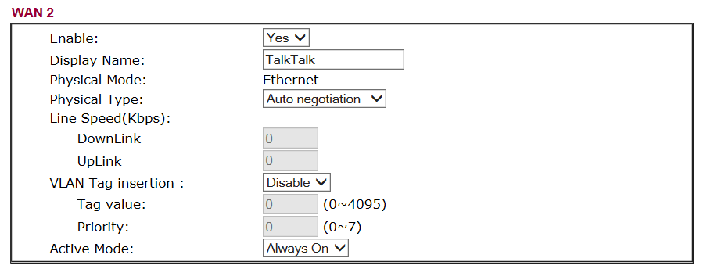
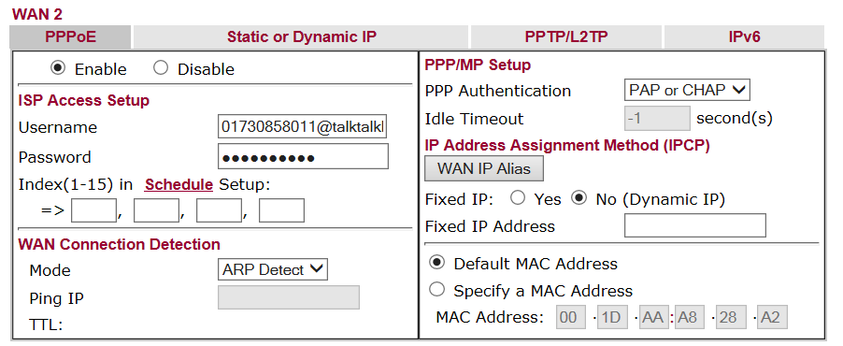
VoIP Setup Information

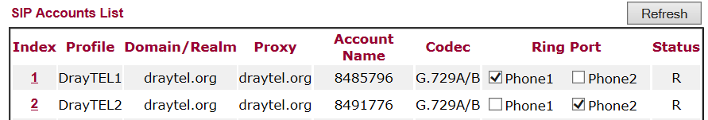

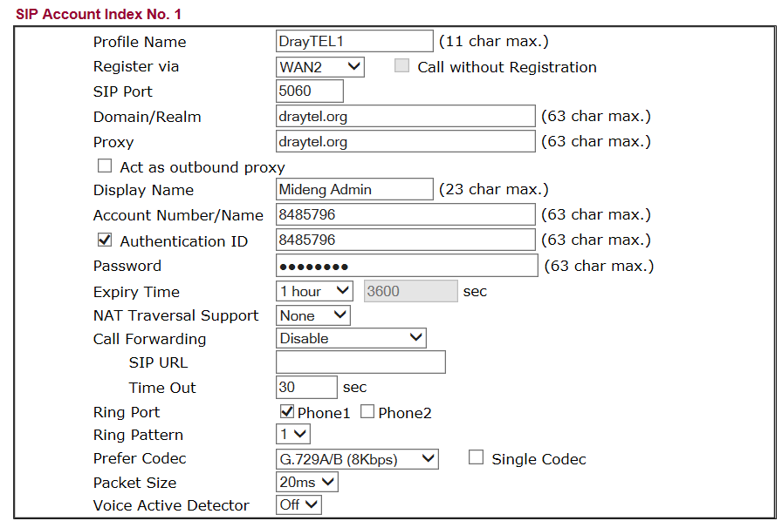

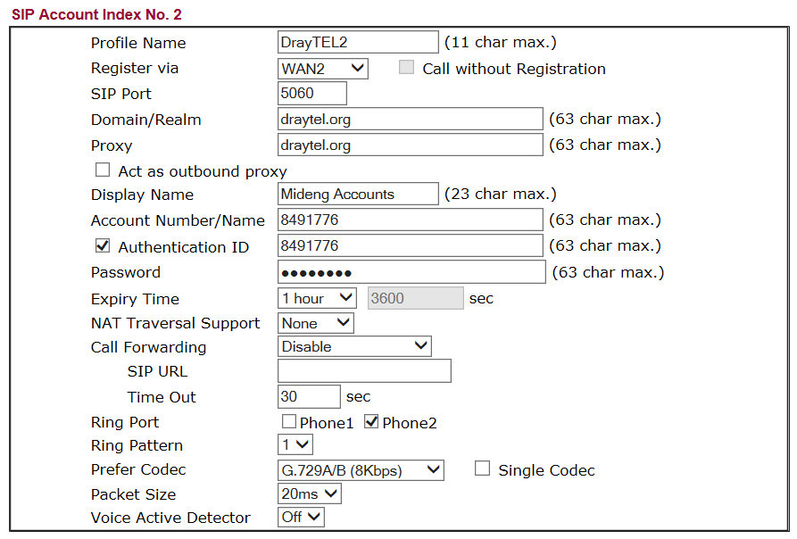
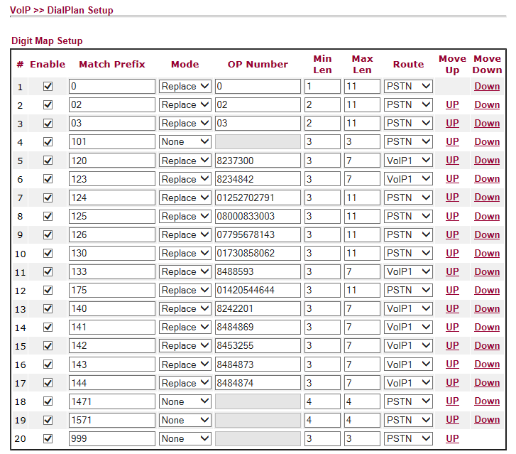

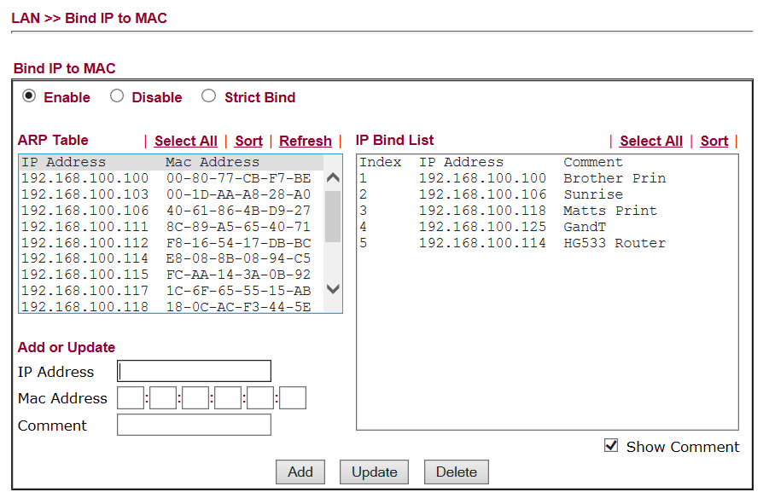

CCTV
The control unit has a fixed IP address of 192.168.100.7 The port number is 8080 [Do not change]

Web browser access when on the Local Area Network: http://192.168.00.7:8080/
Internet access uses: http://212.159.144.127:8080/

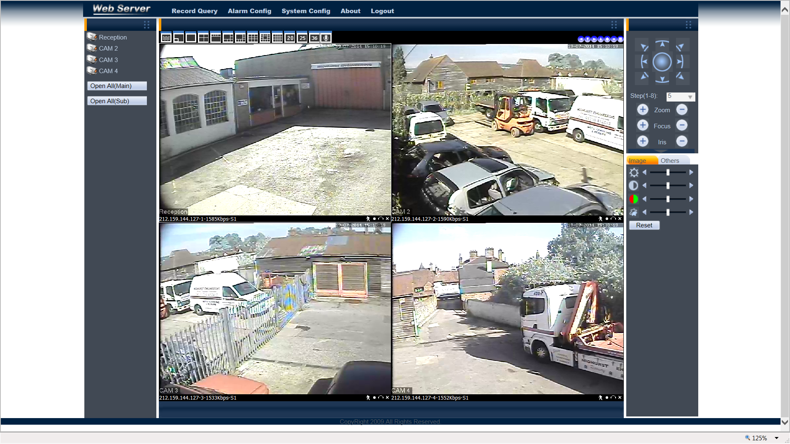

Accounts: [No information on what Repeat does]
Name Password Group Repeat
admin recovery1 admin Yes
mike morgan admin No
paddy ? admin No
david bradley admin No
Guest ? user Yes
guy morgan user No
brian morgan user Yes
VOSA goodcall user No
belinda warken user No

Remote Access User Accounts
http://212.159.144.127/

david elstead2008
guy elstead2008
mike
brian
paddy
belinda
sysadmin elstead2008

Connecting DVR to an iPhone?
First you must install the MEye application from the App Store. Search for the developer of the software by entering “Sun Jian” in the search box. Find the MEye application and click install.

Run the MEye application and click the settings icon at the bottom of the screen, which looks like a Cog.
• Enter a Title by which the connection will be known.
• Enter the static Internet IP Address of your router [212.159.144.127].
• Enter the Port number 8080
• Enter the User ID for your DVR [See accounts list above]
• Enter the Password for your DVR.

Click the back icon at the top of the screen and connect to your DVR by clicking the Play icon at the bottom of the screen. Navigate between camera views by clicking on the camera number.

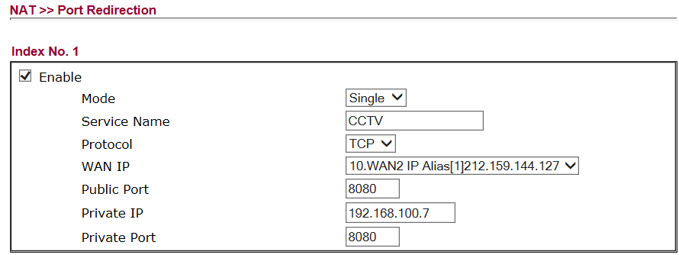

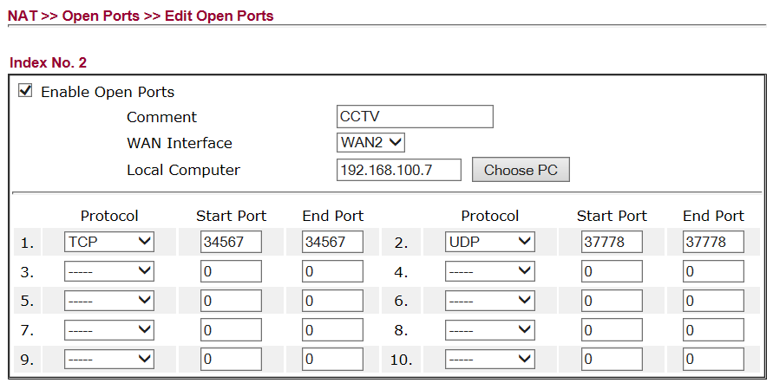

Configuration of Wireless Access Point in the Workshop
TalkTalk router configured as a Wireless Access Point - Signal reaches customer waiting area
192.168.100.114 E8-08-8B-08-94-C5 HG533 router admin elstead2008 Workshop Access Point

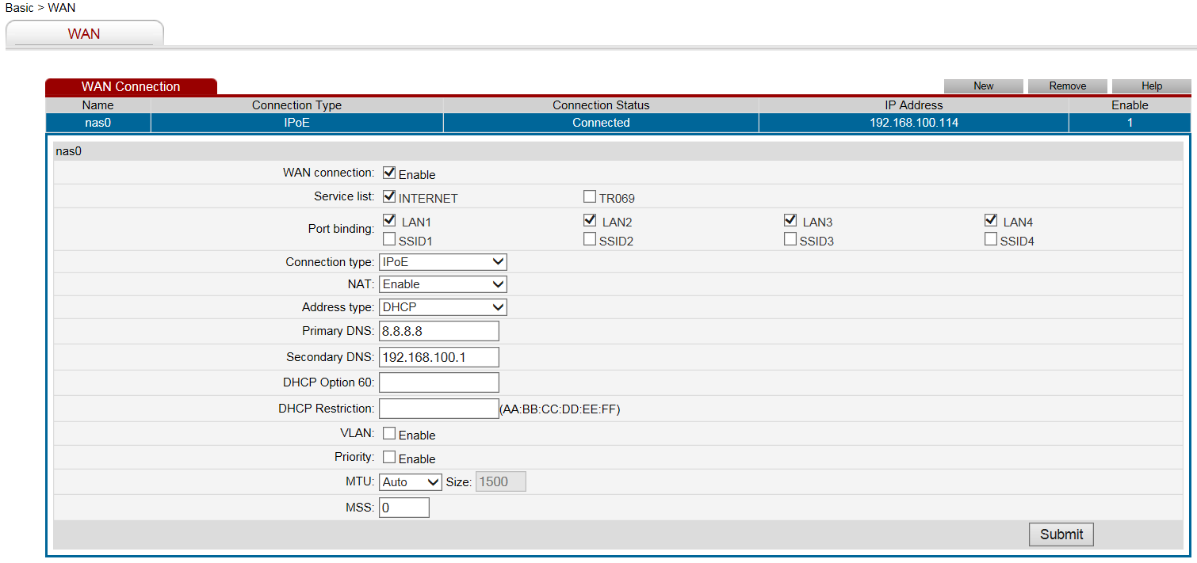

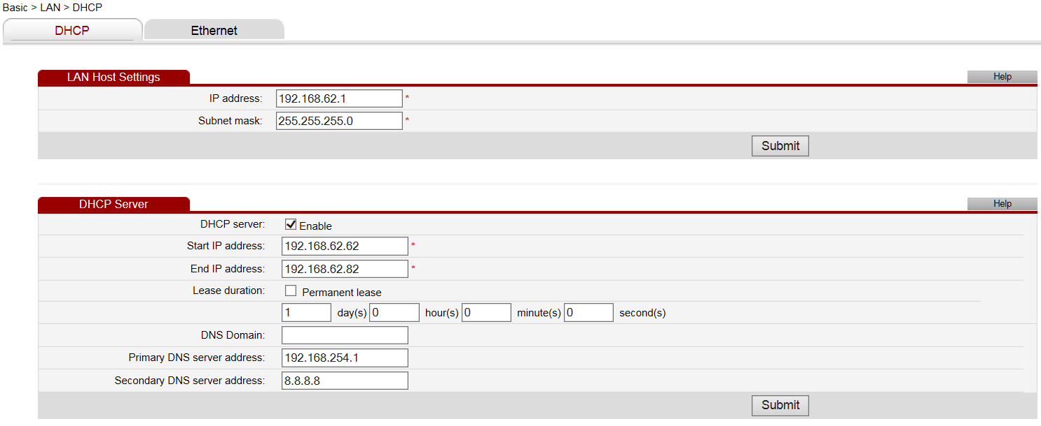

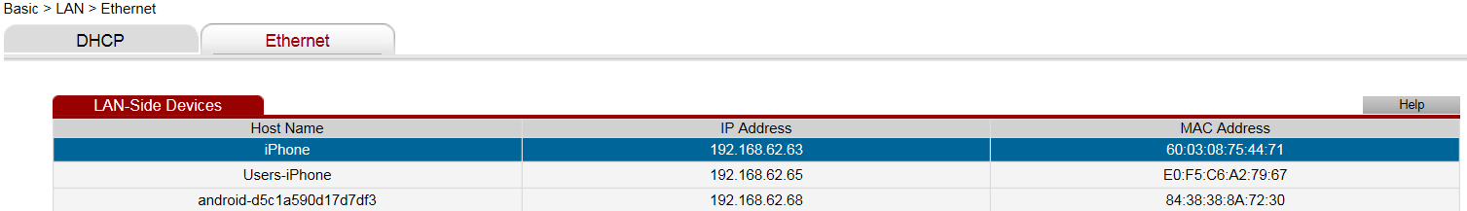

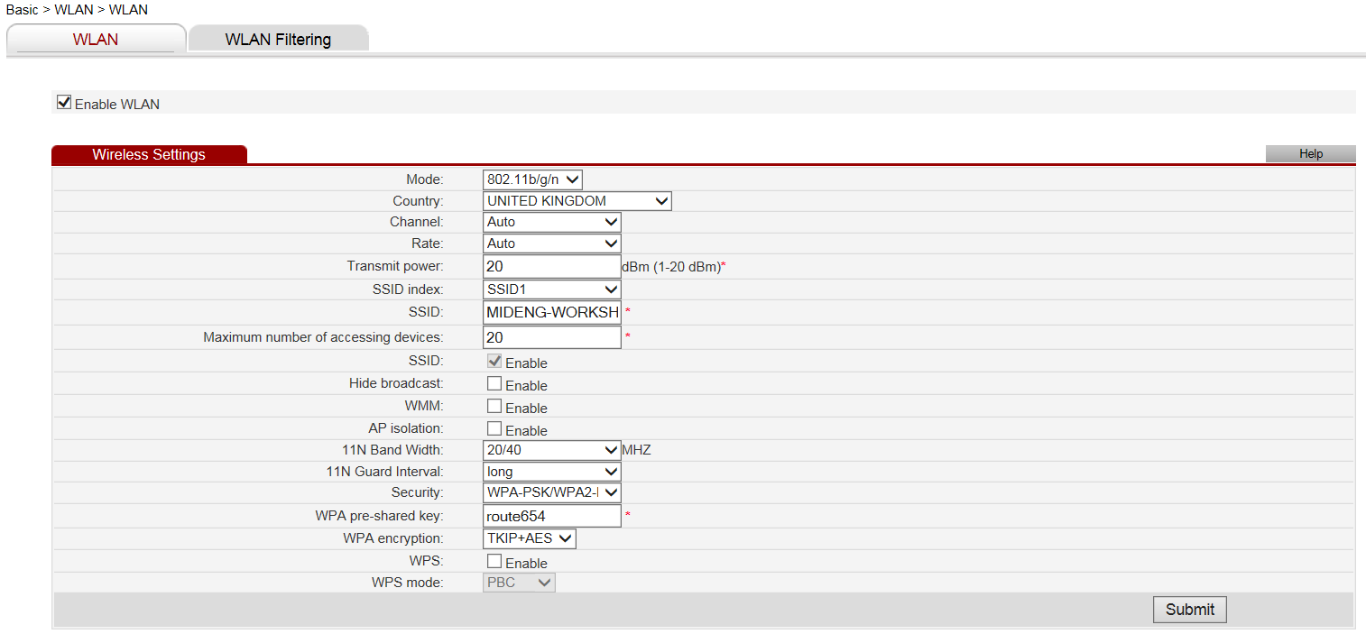

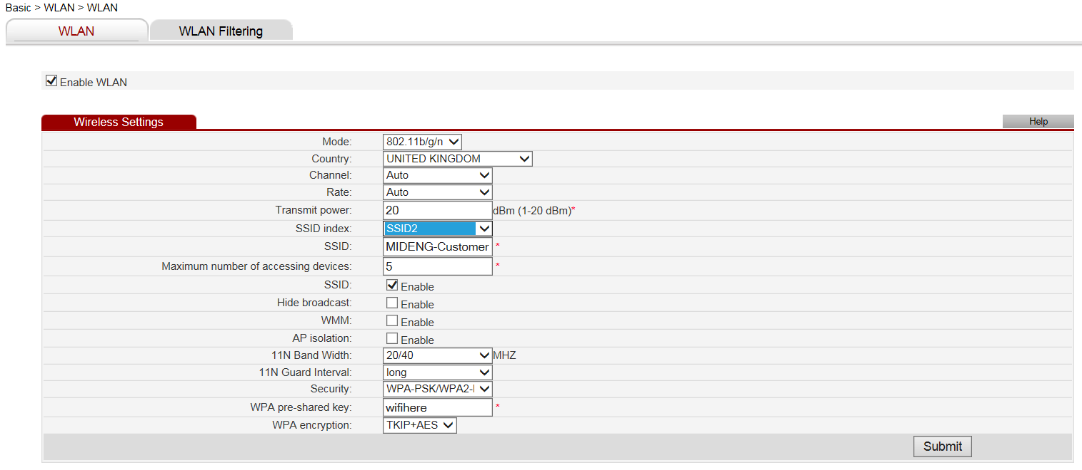
Domain Hosted by Compila
Control Panel: http://www.mideng.co.uk/cpanel
Login: davi7174 Password: MNM9845kHGe

FTP access
www.mideng.co.uk
Login: davi7174 Password: MNM9845kHGe

ESET Smart Security on 10 computers until 6 April 201?
Username: EAV-03080295 Password: nmp3rbswas

AutoRoute 2011: MWRFX-HG2PG-W4X8Y-392YY-9QH9X
Re-use not possible

TalkTalk Account Panel
Go to https://myaccount.talktalkbusiness.co.uk/login/?ReturnUrl=%2fHome%2f
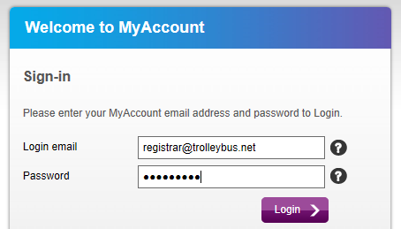
The password is: Route654 Security question: Where were you born? Answer: Croydon

Akzo Nobel Coatings Limited
Andy Bond
Colour IT Sales Support Specialist
Automotive & Aerospace Coatings EMEA
Tele: 01235 442189
Mobile: 07785 922801
email: andy.bond@akzonobel.com

Ann White
Regional Sales Manager
Automotive & Aerospace Coatings EMEA
Tele: 01235 862226
Mobile: 07770 645300
email: ann.white@akzonobel.com

136 Milton Park
Abingdon
Total Concept Paints Limited
Tele: 01243 532999
email: info@totalconceptpaints.co.uk

LESONAL
Program: Mixit2 / MX2000 / LCD2000
Version: 1.91:

Units 3-5 Matform Business Centre
Terminus Road
Chichester
West Sussex
PO19 8UL
www.totalconceptpaints.co.uk

OX14 4SB
www.akzonobel.com

Garage Manager
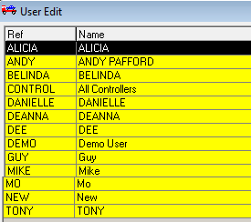
Extracted on: Monday, 8 December 2014
Help Desk open MON-FRI 09:00 to 17:300

The GMS file
If despatching required fill in the ‘Networking’ Section with the name of your computer.
The example is from Mike’s computer whose computer name is WHISKY

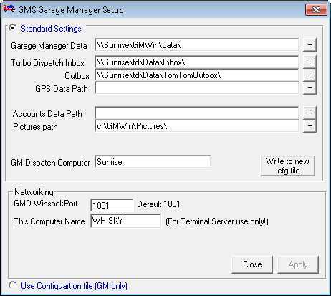
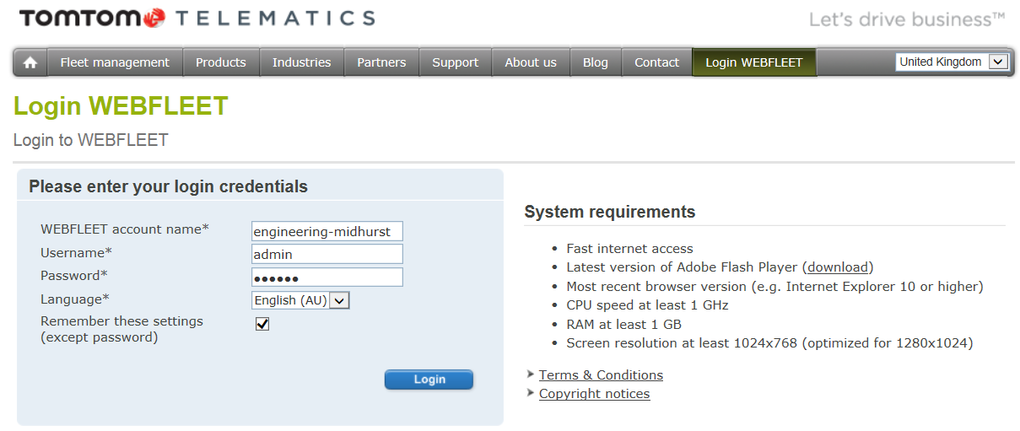

Access: https://webfleet.business.tomtom.com/swf/index.html Password: morgan
Web: http://business.tomtom.com/en_gb/products/webfleet/highlights/ Help Desk: 020 7255 9788
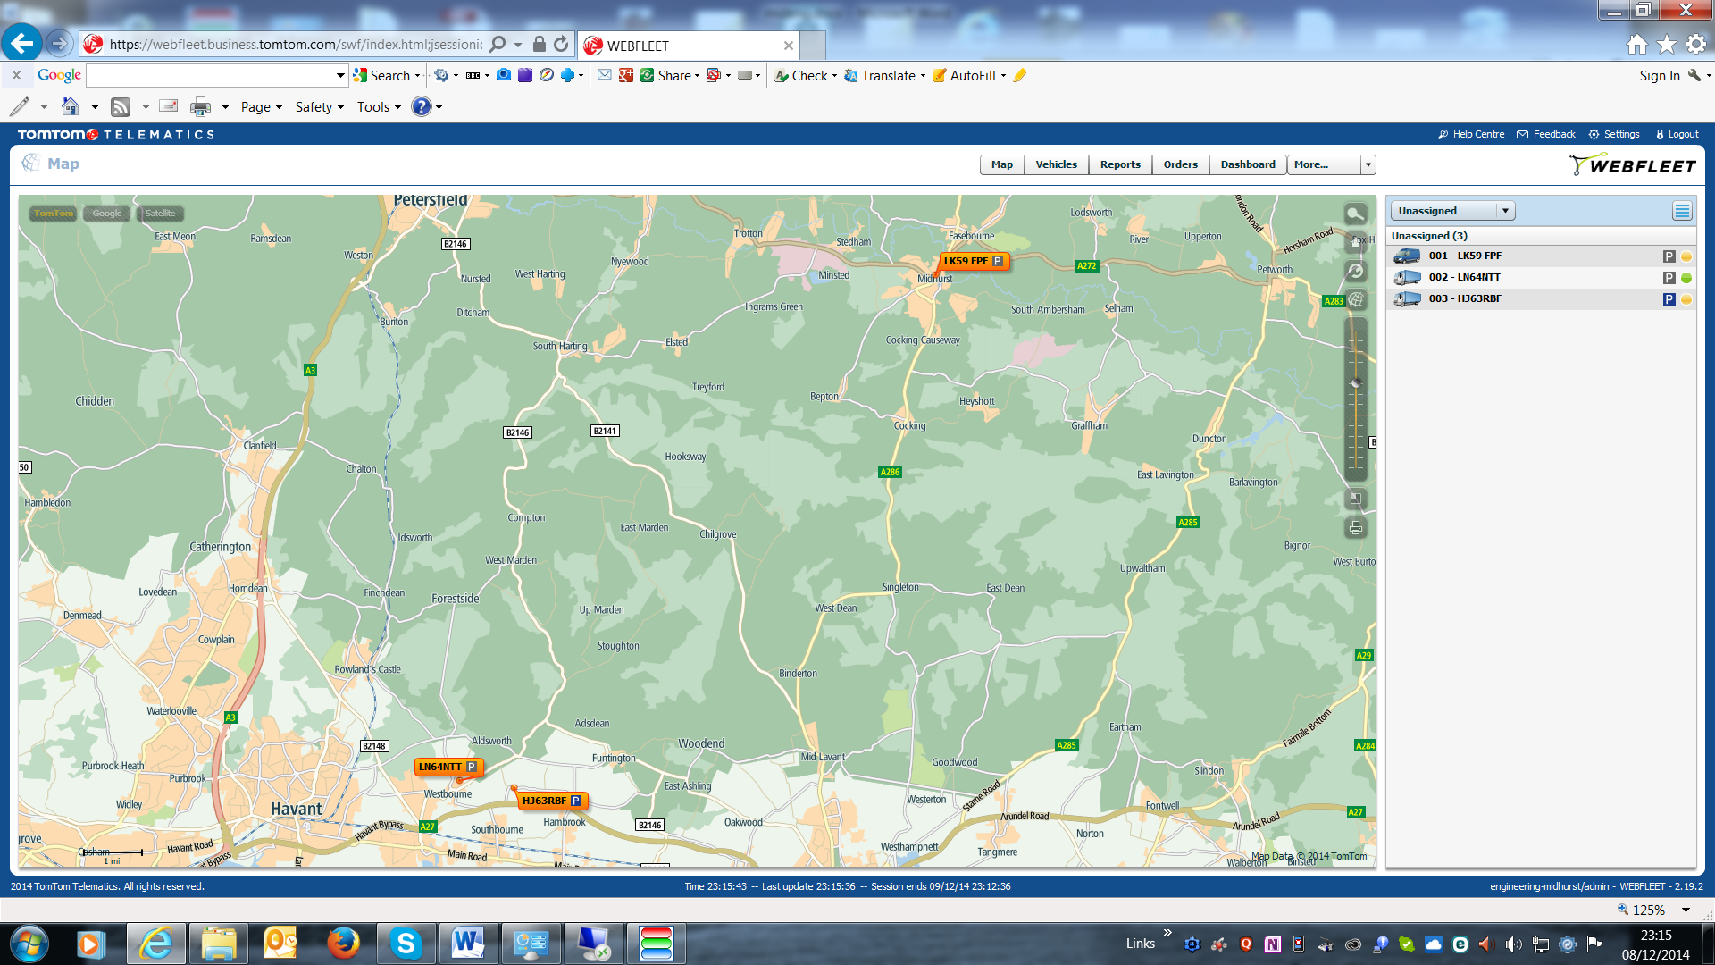
Guy

Apex Support Team [Auto Connect Client] TomTom Business Integration:
Account Number: 2999693 Lee Turley Mobile: 07990 680073 Tele: 01543 560073
Help Desk: 0845 521 2722 email: leeturley@connectfleet.co.uk
Web: www.apex-networks.com Web: www.ConnectFleet.co.uk
Install Code: 111958 Support: Business hours but normally available any time
Test Message: 2000003 Cost: £30 per month or £80 per quarter or £280 per annum
In Car Technology

3 Pelham Close
Whitehill
Hampshire
GU35 9DL

Sue Butt
01420 478053
info@incartech.net

http://www.incartechnology.co.uk/fleet-management/fleet-tracking-systems/

Registrations
VAT Number: GB 192 9300 54
Registration Number: 432447

Domain registered through Compila
Domain name:
mideng.co.uk

Registrant:
Midhurst Engineering & Motor Co.

Registrant type:
Unknown

Registrant's address:
Rumbolds Hill
Midhurst
West Sussex
GU29 9DD
United Kingdom

Registrar:
Compila Limited [Tag = COMPILA]
URL: http://www.compila.com

Relevant dates:
Registered on: 03-May-2004
Expiry date: 03-May-2015
Last updated: 01-May-2013

Registration status:
Registered until expiry date.

Name servers:
ns15.sovdns.com
ns15sec.sovdns.com

Detailed Information on each Computer

Coke – Laptop – Matt
MAC: 24-FD-52-BE-3A-D1
Windows 8.1
Product Part No.: [8]X18-15
Product ID: 00179-60704-52744-AAOEM match to CD Key data
CD Key: B3N6Q-72JYH-QW22P-P734G-72WYG
Computer Name: COKE
Registered Owner: Matt

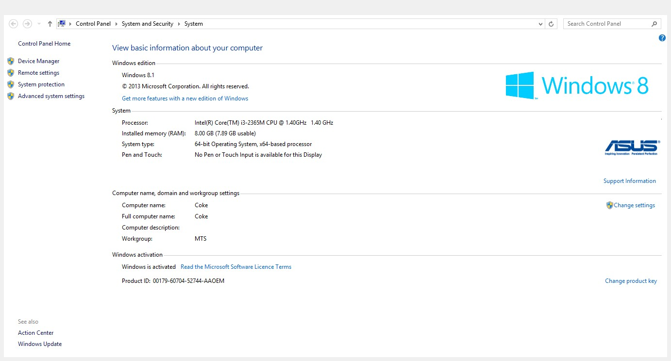

Whisky – Desktop – Mike
MAC: 90-2B-34-20-68-AC
Windows 7 Professional Service Pack 1
Product Part No.: X15-37362
Product ID: 00371-OEM-9045235-98143 match to CD Key data
CD Key: 6VWVK-MPVM8-BKD8Q-CWRJ8-3M8TD
Computer Name: WHISKY
Registered Owner: MidEng

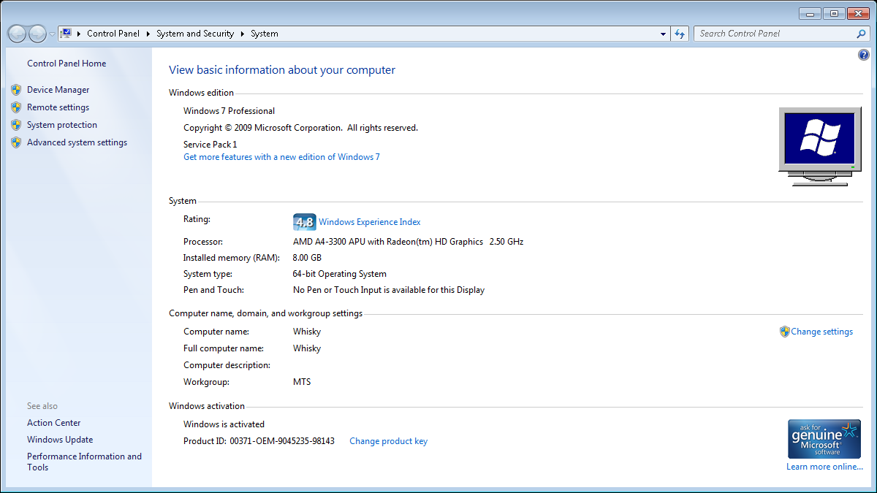

Tequila – Laptop - Paddy
Windows 7 Professional Service Pack 1
Product Part No.: X15-37377 Installed from 'OEM' media.
Product ID: 00371-OEM-8992671-00467 match to CD Key data
CD Key: 2RGBP-GKB4B-BGF4Y-8H6XF-WWPJD
Computer Name: TEQUILA Registered Owner: Paddy Registered Organization:

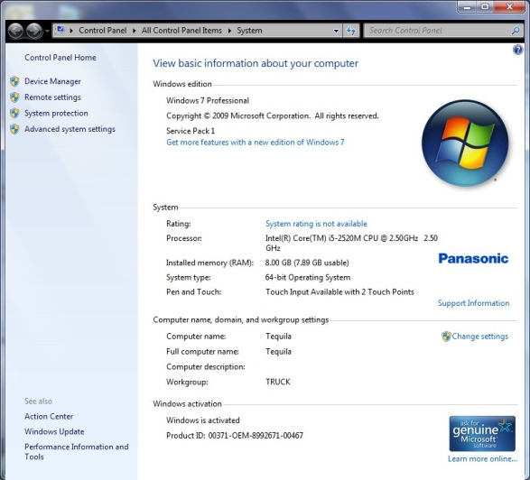
Detailed information on this laptop at http://tiny.cc/mideng-paddy A Vodafone SIM card installed – No details known

Supplier
Roughworld Tele: 01403 289 150 email: info@roughworld.co.uk

Toughbook-Support
Tele: 08000 884 324 email: toughbooksupport@eu.panasonic.com Warranty until: 2nd June 2017
AutoRoute 2013
This was purchased from Microsoft requiring an account to be set up. Order #: 12623394148 Cost: £33.00
Account: paddy@mideng.co.uk Password: MidengTruck Security date of birth: 1.1.2014
http://www.microsoftstore.com/store/msuk/en_GB/pdp/productID.278710300?tduid=c0d659b59debe25e76e177c58a5ec8d9
Licence Key: WXQFT-YR6MX-7MT7D-2J39Q-JX9TP Single licence for 1 PC

External CD Drive
Software CD supplied for WinDVD Licence Key: YS10B22-7DY7UQG-LCU9FN2-MFT2ZN2

Vodafone SIM Card
Number: +447786247697

Stout – Laptop - Guy
Windows 7 Professional Service Pack 1
Product Part No.: X15-37377
Product ID: 00371-OEM-8992671-00015 match to CD Key data
CD Key: W2PMW-T7DBH-YHKRM-DXXF6-KP4KT
Computer Name: STOUT
Registered Owner: Midhurst Engineering

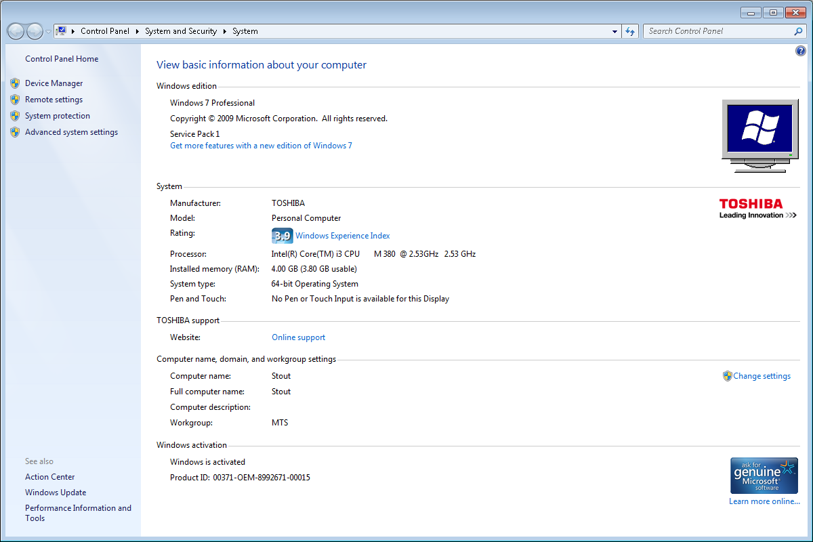
Laptop damaged with spilt water
Martini – Laptop – Guy
Windows 8.1 Pro
Product Part No.: [Blue]X18
Product ID: 00262-50075-66608-AAOEM match to CD Key data
CD Key: NXJQC-B6P7V-3GC7B-7HF8R-FCYD2
Computer Name: MARTINI
Registered Owner: Guy
Registered Organization:

Supplier
Computer UK Tele: 01252 733873 email: Julian Dacombe < julian.dacombe@gmail.com >

CCTV Account:
Userid: guy Password: morgan

Mail Client Setup
Incoming POP3: 995 Incoming IMAP: 993
Outgoing: SMTP: 465 Server: ns15.sovdns.com
guy@mideng.co.uk 8z3bkb7acf9i
Fosters – Desktop – MOT Testing Station
Windows 8.1 Pro
Product Part No.: [Blue]X18
Product ID: 00259-40846-85781-AAOEM match to CD Key data
CD Key: N293V-2QYQT-3YV38-92V8Y-TXWJ3
Computer Name: FOSTERS
Registered Owner: VOSA
Registered Organization:

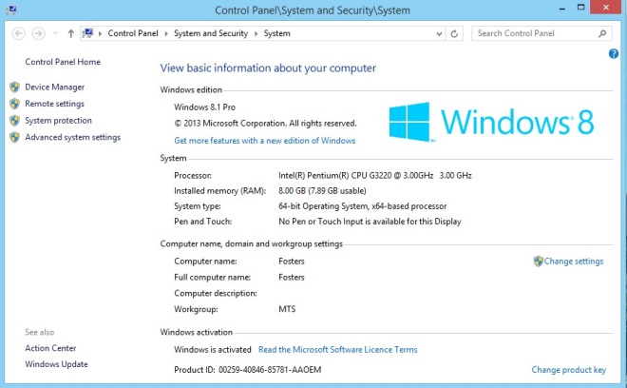

Supplier
Computer UK Tele: 01252 733873 email: Julian Dacombe < julian.dacombe@gmail.com >

CCTV Account:
Userid: VOSA Password: goodcall

Garage Manager:
This has not been uninstalled cleanly and requires MTTD to come in to sort it out. Establish a remote session at http://www.mttltd.com/
Error message in a screen dump on the desktop as image error.jpg - Telephone number: 01934 421320

Reading and Composing Documents:
The Microsoft suite of Office programs is not available on this PC. By default, WORD documents are opened in a WORD viewer which means you can't edited them. To compose a document use WordPad or Notepad.
GandT – Desktop – Mo Franks
Windows 7 Professional Service Pack 1
Product Part No.: X15-37362
Product ID: 00371-OEM-9044981-25715 match to CD Key data
CD Key: 2KCRC-XWPRJ-F4WKR-GFF66-7GXF8
Computer Name: GANDT
Registered Owner: User
Registered Organization:

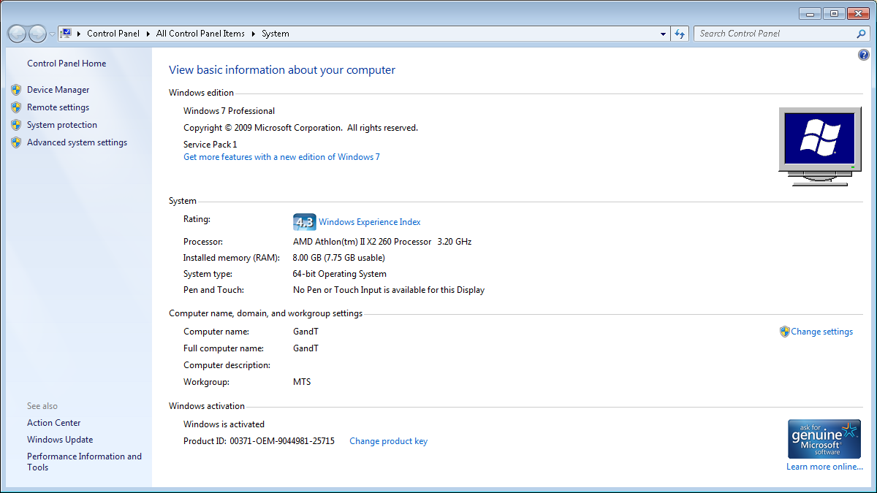

Sunrise – Desktop – Server
MAC: 40-61-86-4B-D9-27
Windows 7 Professional Service Pack 1
Product Part No.: X15-37362
Product ID: 00371-OEM-9044182-07853 match to CD Key data
CD Key: 82MQ7-682KW-C6P98-Q6DWC-7RK28
Computer Name: SUNRISE
Registered Owner: Mideng
Registered Organization:

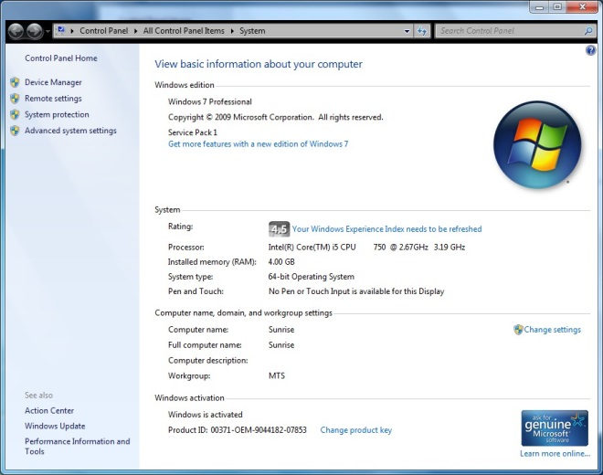

Purchased from Computer UK on 2nd July 2010 for £795 Hard disk reformatted on 16th December 2014
CORE i5 QUAD CORE 2.66 GHz 4 GB DDR3 RAM 320 GB HARD DRIVE
NVIDIA 512Mb GRAPHICS (DUAL OUTPUT) WINDOWS 7 PROFESSIONAL WIRELESS KEYBOARD & MOUSE SET
WALL MOUNT BRACKET FOR SCREEN 22" WIDE SCREEN
Brandy – Desktop – Nick
Windows 7 Professional Service Pack 1
Product Part No.: X15-37362
Product ID: 00371-OEM-9044335-41825 match to CD Key data
CD Key: PQKD3-3TQMF-W8CTR-K9PTY-DWPB3
Computer Name: BRANDY
Registered Owner: User
Registered Organization:

Microsoft Office Single Image 2010
Product ID: 82503-242-9975775-11352
CD Key: TJF47-9YKF3-G6DYM-DJDV6-HR9YY

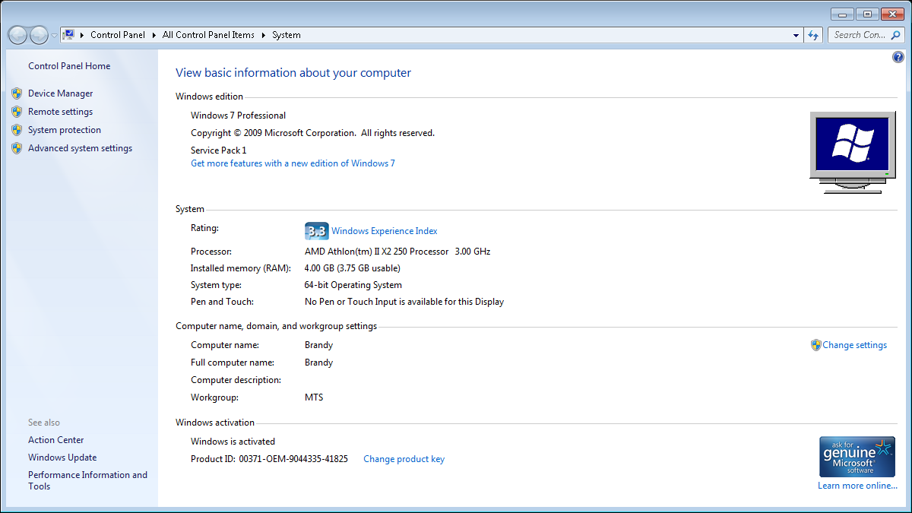

Guinness – Desktop – Tony
Windows 7 Professional Service Pack 1
Product Part No.: X15-37362
Product ID: 00371-OEM-9044981-25714 match to CD Key data
CD Key: Q2DW4-GG9K7-6C7KM-H6MPB-94K78
Computer Name: GUINNESS
Registered Owner: User
Registered Organization:

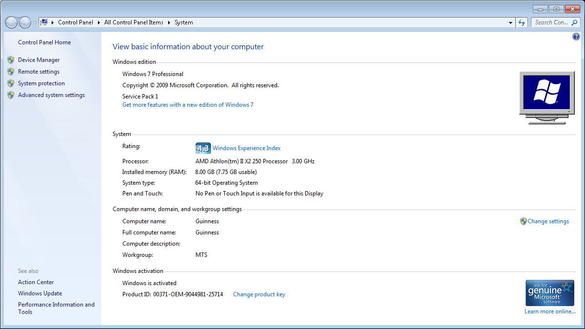

Port – Desktop – Belinda
Windows 8.1 Pro
Product Part No.: [Blue]X18
Product ID: 00259-40846-85781-AAOEM match to CD Key data
CD Key: N293V-2QYQT-3YV38-92V8Y-TXWJ3
Computer Name: PORT
Registered Owner: Belinda
Registered Organization:

Microsoft Office 2010: TJF47-9YKF3-G6DYM-DJDV6-HR9YY

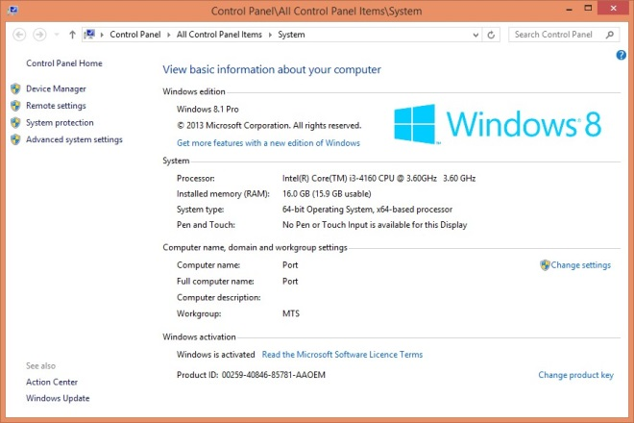

Supplier
Computer UK Tele: 01252 733873 email: Julian Dacombe < julian.dacombe@gmail.com >

Setup for CCTV in Internet Explorer

Internet Intranet
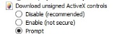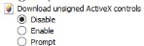

email Setup
belinda@mideng.co.uk 0etx63zi4xqo [Warken]
Mail Client Setup
Incoming POP3: 995 SSL
Outgoing: SMTP: 465 SSL
Server: ns15.sovdns.com

WEBFLEET and CCTV Display loaded
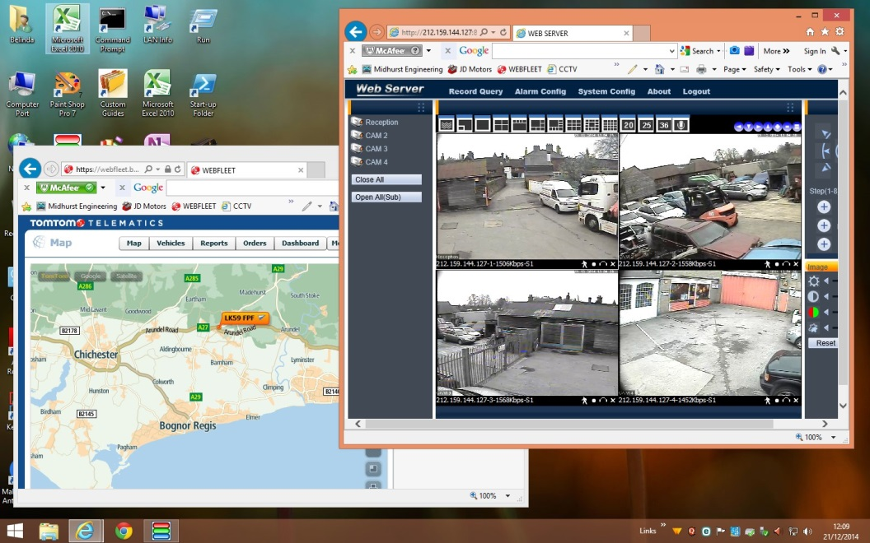

*** END OF ENTRIES FOR THE GARAGE ***
Guy Morgan Home
Hazel House, Cobden Road, Midhurst, West Sussex, GU29 9SA

Phone and Broadband Service from TalkTalk – Package: Office Broadband + Anytime calls + CLI
Connected to: 01730 858062 TalkTalk Help Desk: 0800 083 3003
Account Number: 882 01292148 - 24 month contract from 11th Feb 2013 @ £23.95 + £4.05
Account Password: trolleybus

Router Information

DrayTek Router 2600n [Ex AVE UK Office] - 192.168.28.1:8080
WAN Access: http://80.45.201.186:8080/ Logon: admin Password: *elstead2008*
Model Name: Vigor2820n Firmware Version: 3.3.7.
ADSL Firmware Version : 232201_A Hardware: Annex A
LAN Start IP Address: 192.168.28.28 Pool Size: 50
SSID1: MIDENG-GUY Password: route654 Security: WPA/PSK2 Channel: 6
SSID2: GarageGuest Password: route630 Security: WPA/PSK2 Channel: 6
Modulation: ADSL2+

Login: 01730858062@talktalkbusiness.net Password: C3W4K7L7F2
Fixed IP Address: 80.45.201.186 Workgroup: ROSEMARY

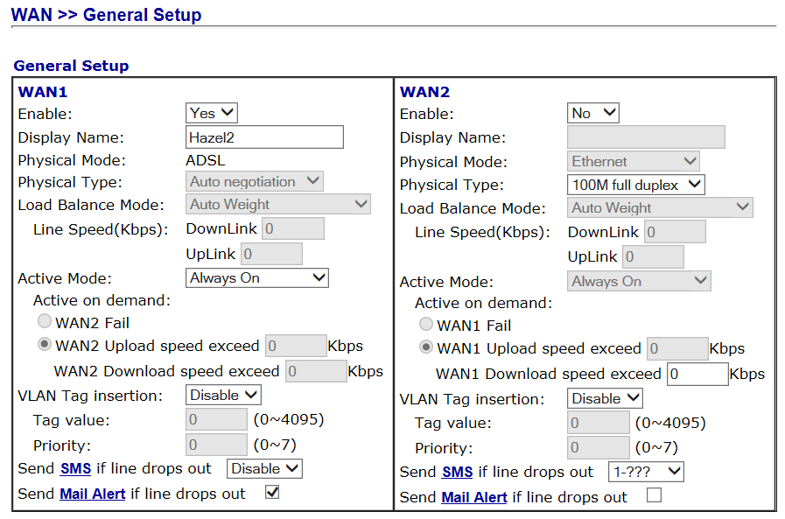

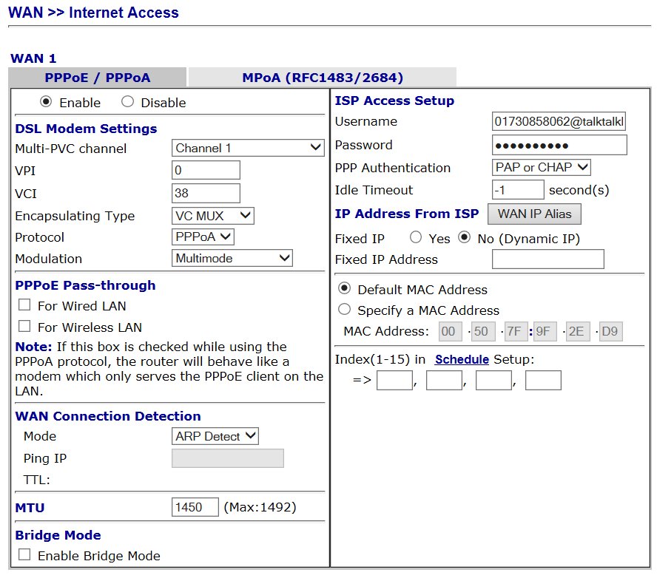

VPN and Remote Access >> Remote Dial-in Users
User Password
david elstead
guy hazelhouse

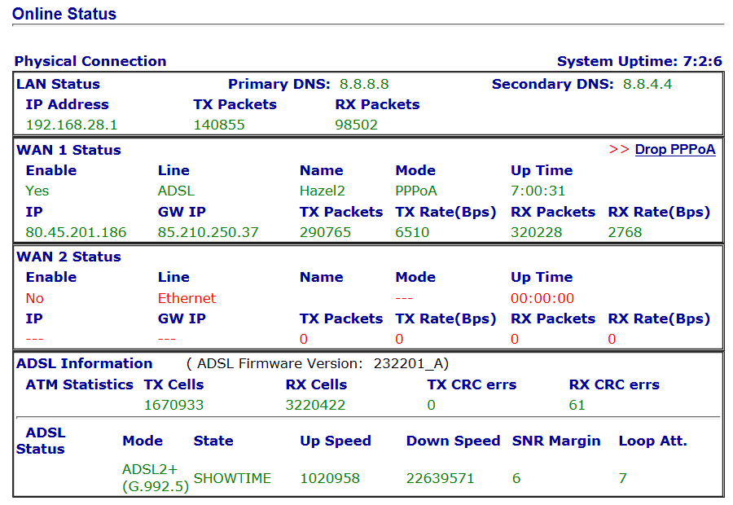

Attached Devices

IP Address MAC Host ID Owner
192.168.28.28 50-67-F0-79-C8-61 Sure Signal Device
192.168.28.29 B0-9F-BA-C3-56-AB MidhursgsiPhone
192.168.28.31 B0-9F-BA-CE-FD-29 jordans-iPhone
192.168.28.32 60-D9-C7-0F-88-49 nicks-iPhone
192.168.28.33 6C-AD-F8-69-2A-75 Chromecast
192.168.28.34 78-DD-08-E2-DD-CC jack-VAIO
192.168.28.35 74-E5-43-EE-9E-1A Vermouth
192.168.28.36 7C-ED-8D-BE-8B-A2
192.168.28.37 C8-E0-EB-93-1E-C4 CharlotesiPhone
192.168.28.38 E4-8B-7F-F1-90-71 iPhone
192.168.28.39 54-72-4F-08-46-8B jacks-iPhone-3

192.168.28.xx 68-A3-C4-40-3D-37 Stout Guy Morgan
192.168.28.xx A4-4E-31-39-92-70 Tequila

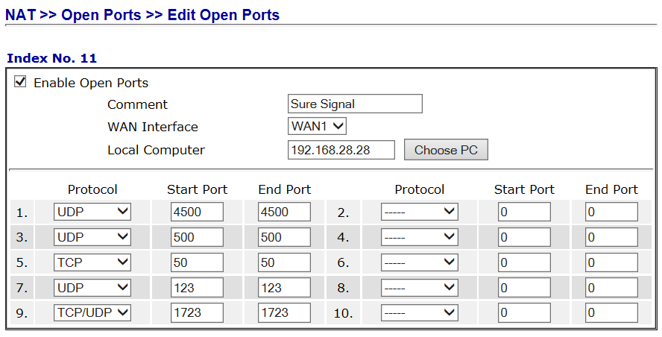

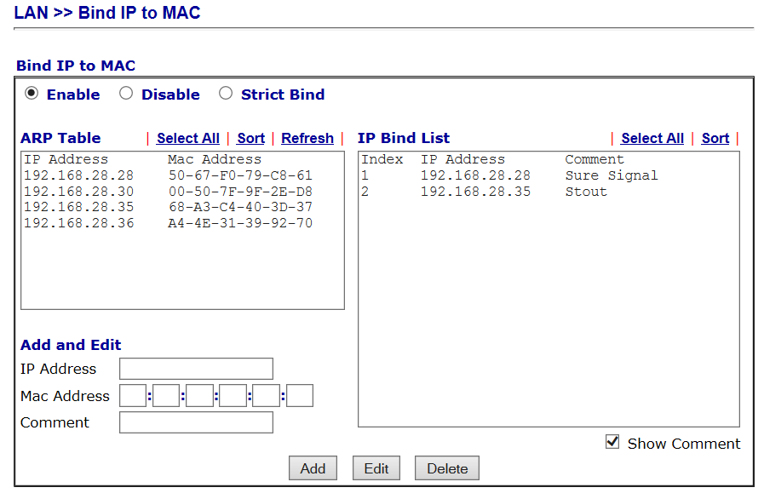
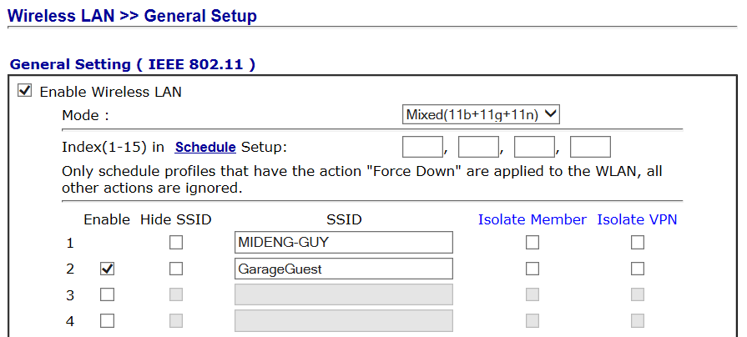

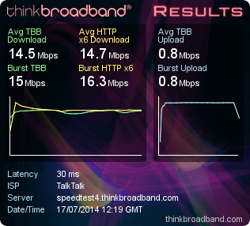

14.72 Mbps

Sure Signal
MODEL 9361 HOMECELL V2-V PART NUMBER 3JR09110 ABBA
SERIAL NUMBER 40114201599 MAC: 50-67-F0-79-C8-61

Help Desk:
Account Number: 229834079 My account mobile number: 07769723651
Emma Haughey, Mobile & Data Manager T: 01302 552339 M: 07747 876687
E: emma.haughey@ninehundred.co.uk

Registration Logon Details: mike@mideng.co.uk Password: recovery1 Credentials failed
Registration: flatbeds7 Password: hazel7 Registration email: david@cyberpictures.net
Remote Connection to the Garage

Seek out these icons on the Desktop:


Only when remote from the Garage:
Click on Midhurst Engineering and wait for a VPN connection to be established

Once on the garage network, click on the Remote Desktop icon to bring up this:

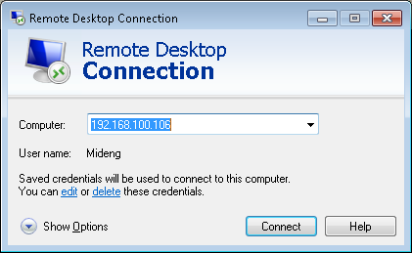

Choose a computer to connect to:
192.168.100.106 connects to Sunrise [the server]
192.168.100.125 connects to Mo’s computer
Any other entries seen should not be used

You will need to know the password to the PC you wish to connect to.

The Internet Explorer Favorites Bar has three entries of particular interest:
- WEBFLEET to see the location of the recovery vehicles
- LAN CCTV – Works when in the office
- WAN CCTV – For use ONLY from home [Shortcut will be added when the laptop is at home. Do not use WAN CCTV when in the office as it will cause the laptop to crash.
*** END OF ENTRIES FOR GUY’S HOME ***
Mike Morgan Home
8 St Margaret’s Way, Midhurst, GU29 9FQ

Zen Active order has successfully matched to your telephone line installation and has an activation date of Friday 13th February 2015.

Details for using this service are provided below:
Zen Order No: 1067389
Date order placed: 02-Feb-2015
Telephone number: 01730 816595
8 ST MARGARETS WAY MIDHURST GU29 9FQ

Zen username: zen276045@zen
Connection password: 343spfyK

IP address information: 82.71.39.217
Subnet mask 255.255.255.255
Primary DNS: 212.23.3.100
Secondary DNS: 212.23.6.100
Default email username: zen276045@zen.co.uk
Default email password: 3fDnhPUs

Default web space username: zen276045
Default web space password: 3fDnhPUs

Username: 01730816595
Password: k6vFC5ii
Registrar Address: voip.zen.co.uk
Registrar Port: 5060
Proxy Address: voip.zen.co.uk
Proxy Port: 5060

Firewall Settings:
You will need to allow access to the following IP ranges through your firewall, if you have one:
212.23.7.226
212.23.7.227
212.23.7.228
62.3.88.0/28
62.3.88.16/28

The following port ranges should be allowed through your firewall:
5060 and 20,000->30,000

Phone and Broadband Service from Zen Package: 80/20 No directory entry
Connected to: 01730 816315 to 01730 810624 Order No. 974165 Help Desk: 01706 902000
Default email username: zen255936@zen.co.uk Default email password: Xw94bK65
Static IP Address: 82.71.58.115 DNS: 212.23.3.100 Secondary DNS: 212.23.6.100
Customer Portal: http://portal.zen.co.uk/ Userid: mike@mideng,co.uk Password: route654

DrayTek Router
IP Address: 192.168.104.1 Logon ID: admin Password: elstead2008
Model Name: Vigor2830vN Firmware Version: 3.6.4.1_sb_232201
Build Date/Time: Jul 16 2013 11:03:01
WAN Username: zen255936@zen Password: NkWfXWqg
LAN Start IP Address: 192.168.104.104 Pool Size: 20
SSID: MIDENG-ANNEX Password: route654 Security: WPA/PSK2 Channel: Auto

Workgroup
COBDEN

VoIP Identities
Service Name Domain and Proxy Password POTS Number VoIP Number Test Number
Zen voip.zen.co.uk nNCUUbP9 01730816315 -- 7130
DrayTEL draytel.org gUk[5DRc 0845 557 8295 8488593 902

DrayTEL registration email: zen255936@zen.co.uk Password: route654
Currently [3 SEP 14] No credit on DrayTEL account

Enquiries made for new service
8 St Margaret’s Way, Midhurst, GU29 9FQ

From: Michelle Buckley [mailto:michelle.buckley@zeninternet.co.uk]
Sent: 01 December 2014 16:39
To: david@cyberpictures.net
I can confirm that:

- We can install a new line at your new address, 8, ST MARGARETS WAY, MIDHURST, GU29 9FQ at a reduced cost of £70.80
- We can simultaneously provide standard broadband on this line at no additional charge. As I mentioned, once the line is live, we will get an accurate confirmation if Fibre is available at this address. We can then place an order for Fibre if applicable.
- Our line rental charges for standard broadband services are priced as follows :
Line Rental Only - £13.80
Line Rental and Inclusive UK Landline and 0845 / 0870 numbers - £18.30

Should you require any further information or wish to take up this offer, please call me on 01706 902128.

Michelle Buckley
Customer Retentions Sales Executive
Zen Internet
Direct: 01706 902128
Fax: 01706 902127
Notes on above email:
To move over existing number costs £16 + VAT
Call package not required, continuing to use VoIP at £4.25 + VAT
Domestic rental quoted. Bussiness cost [excluding VAT]: Line Rental £17.00 + Broadband £25 + VoIP £4.25
FTTC is available at this address, just that BT records require updating

From: cloudscape
Received: Tue 02-Dec-14 21:55:17
Based on your partial phone number we should be able to offer:
FTTC 40/10 100G Data/month 1500 UK anytime minutes
Total: £39.50+VAT (£47.40)
Kevin Peel, Cloudscape Connect Ltd

Notes on above TTB message:
Unclear if this includes line rental but does indicated FTTC available at this address
Notes on telephone service
If there is a fault on the exchange line you report it to Zen on 01706 902000 obviously using another telephone line. Your telephone number is 01730 810624.
Call rates on the landline shown below but you have 1000 minutes free via VoIP for 01/02/03/0870.
 | Daytime | Evening | Weekend
 | (7am - 7pm) | (7pm - 7am) | (Fri 7pm - Mon 7am)
UK Local and National Calls | 4.09 | 1.02 | 1.02
(01/02/03 numbers) | 4.09 | 1.02 | 1.02
0845 | 6.4 | 2.3 | 2.3
0870 | 4.09 | 1.53 | 1.53
O2 Mobile | 11.23 | 8.68 | 8.68
Orange Mobile | 14.3 | 8.68 | 8.68
Three Mobile | 14.81 | 8.68 | 8.68
T-Mobile | 11.23 | 10.21 | 8.68
Vodafone Mobile | 13.28 | 8.68 | 8.68
There are no set up, call connection or minimum call charges associated with calls made to any of the above call categories
Charges are Pence per Minute including VAT
Calls are billed by the second
The overall charge per bill and not each individual call is rounded to the nearest penny

The system is setup as shown in the diagram below.
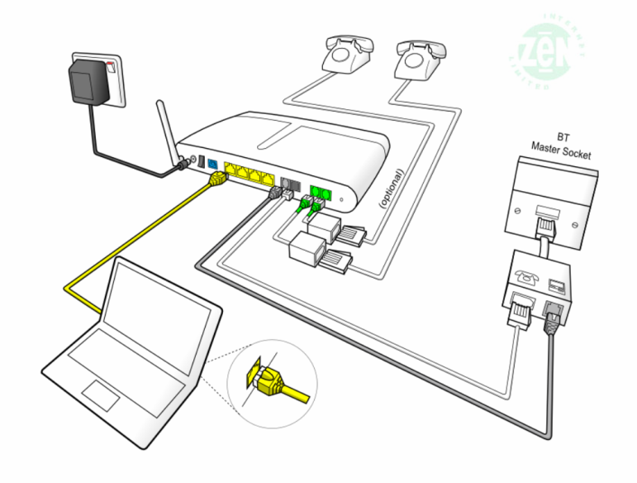

Calls are received via the landline on 01730 816315 or via the DrayTEL VoIP service using 0845 557 8295. However another DrayTEL VoIP user could alternatively use 8488593@draytel.org [generally by just dialling the number].

The configuration of the router will default outgoing calls via the Zen VoIP service providing the number starts with a ‘0’. The initial, or complete, number shown in the dial plan, routes the call as shown.
Dial Plan

Entry | Service | CLI Display | Called | Called Party | Cost
[Area Code][Number] | Zen VoIP | 01730 816315 | As dialed | Any POTS Subscriber | Inclusive Minutes *
7 [Area Code][Number] | Zen VoIP | anonymous | 7 stripped off | Any POTS Subscriber | Inclusive Minutes *
123 | Draytel | 8488593 | 8234842 | David Bradley | Free
42 | Draytel | 8488593 | 8453255 | JDs – Ian Madden | Free
47 | Draytel | 8488593 | 8485796 | Mike Morgan [Office] | Free
49 | Draytel | 8488593 | 8237300 | MIDENG Workshop | Free
2 | Zen VoIP | 01730 816315 | 01730 812162 | MIDENG Switchboard | Inclusive Minutes *
3 | Zen VoIP | 01730 816315 | 01730 858062 | Rosemary Courtyard | Inclusive Minutes *
8xxxxxx | Draytel | 8488593 | As dialed | Any Draytel Subscriber | Free
777 | Zen VoIP | 01730 816315 | 777 | Zen Help Desk | Free
999 | Landline | 01730 816315 | Emergency Services | Police, Fire, Ambulance | Free
#0 [Area Code][Number] | Landline | 01730 816315 | As dialed | Any POTS Subscriber | As phone line table
7130 | Zen VoIP | 01730 816315 | 7130 | Zen VoIP System Check | Free
902 | DrayTEL | - | 902 | DrayTEL service test | Free
Inclusive minutes mean 1000 anytime minutes available each month to 01/02/03 numbers only. When quota is exhausted, or not part of the plan, calls are charged as shown in this table below.
The landline number is permanently withheld. To bypass this facility prefix calls with 1470 to enable your number to be released on a call-by-call basis. The default VoIP service displays the number, so prefix each call with 7 to withhold the number.

Zen VoIP Service
This service, at £5.10 a month [inc VAT], includes 1,000 inclusive minutes to UK landlines (01/02/03/0870 numbers) and reasonable call rates to international and mobile telephone numbers. The DrayTek router has been configured to make this your default phone service as soon as 0 is dialed. The telephone number for this line is also 01730 816315; basically calls are routed out via VoIP for lower call charges but incoming calls are routed over the landline. This is NOT a second line service.

Pricing Overview | Landlines | Mobiles
UK Pricing
UK Local and National Calls | 1,000 minutes included, | From 14.1ppm
(01/02/03/0870 numbers) | then 2.35ppm | From 14.1ppm
International Pricing
North America | From 2.35ppm | From 2.35ppm
South America | From 3.53ppm | From 14.1ppm
Europe | From 2.35ppm | From 5.88ppm
Asia | From 2.35ppm | From 2.35ppm
Africa | From 7.05ppm | From 9.4ppm
Oceania | From 2.35ppm | From 21.15ppm
A full list of VoIP call charges are at http://www.zen.co.uk/business/voice/voip.aspx?page=10157
0845 - 4.7ppm [Peak]; 1.175ppm [Off Peak]
0844 - 5.88ppm
0871 - 11.75ppm
DrayTEL VoIP Service
No rental charges but useful for free calls to other DrayTEL subscribers.
The telephone number for this line is 0845 557 8295.
Mike’s Laptop Vermouth – Logon Accounts
Mike recovery2 Working Account
Roger route654 Phantom Account **
User route654 Dummy Account

** The ESET product requires a phantom account for anti-theft protection. The setup procedure used:
Email address: david@mideng.co.uk Password: route654 First kiss: Pauline
https://my.eset.com/Default.aspx [Theft recovery]
https://my.eset.com

Email accounts
mike@mideng.co.uk mxm5
morganind@hotmail.co.uk Dragon9

*** END OF ENTRIES FOR MIKE’S HOME ***
Appendix 1

MIDHURST ENG CO LTD, RUMBOLDS HILL, MIDHURST, GU29 9DD on Exchange MIDHURST is served by Cabinet 11
Featured Products | Downstream Line Rate(Mbps) |  | Upstream Line Rate(Mbps) |  | Downstream Range(Mbps) | Availability Date
 | High | Low | High | Low
FTTC Range A (Clean) | 80 | 79.5 | 20 | 19.9 | -- | Available
FTTC Range B (Impacted) | 80 | 70.2 | 20 | 17.9 | -- | Available
Monthly Charges:
Complete Fibre Business Broadband: £25.50
Complete Line Rental: £14.50
Total: £40.00
The fibre product, on the line registered to 01730858011 has an estimated downstream speed of 38 Mbps and an estimated upstream speed of 10 Mbps. Actually achieved:
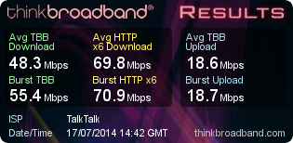
The Complete Fibre Business Broadband package is advertised on this page http://www.talktalk.co.uk/business/product/fibre where this extract was taken from:



TalkTalk Business logon details for insertion in the DrayTek router.
DSL Username: 01730858011@talktalkbusiness.net
DSL Password: D4E3Z6D3J2 Subnet Mask: 255.255.255.0
Appendix 2
Historical Information of services disconnected

Old Credentials for BT Connection
Login: mideng@gotadsl.co.uk
Password: bret3fug
Static IP Address: 81.6.244.185
DNS: 212.139.132.41 and 42

Existing Router Supplied by TalkTalk for Rosemary Courtyard
? - 192.168.1.254 - Firmware Version: ?
LAN Start IP Address: 192.168.1.? Pool Size: ?
Serial Number: cp1231vfd2m
SSID: TNCAP3DFB77 Password: D45751F4B1 PIN: 5320-3281

Appendix 3
Brian Morgan Home Computer

The work carried out by ESET on your Dad’s computer seems to have cured a lot of ills but has left the sound inoperative. A reboot solved that issue.

As mentioned to you it is absolutely essential to have a password associated with the logon account. I have therefore set one up as follows:
Userid: Brian
Password: recovery0 [that’s a zero on the end]
Having logon credentials should mean that un-attended remote access should be possible.

I have got CCTV working.
Userid: brian
Password: morgan
Access is through Internet Explorer and on the Favourites Bar there is an item called “WEB SERVER”. Click on that to get to the logon screen.

ESET has been activated using the Garage’s credentials.

I am of the opinion that the connection to your Dad’s home is FTTC but probably only on the 40/10 service but it is quite difficult to get precise information remotely.

The router has an IP address of 192.168.1.254 – Logon credentials are:
Username: admin
Password: W4H6KR6T

The PC has a fixed IP address of 192.168.1.46 and therefore remote access should be possible using the current WAN address of http://109.152.196.246:1939 but unfortunately needs tweaking for it to work, perhaps a reboot of the PC and router is needed.

The Qualys Browser Check, usable in Chrome, plugin reports that all programs are up-to-date.

Appendix 4
Auto Data

As stated in your last renewal we wanted to remind you that your Autodata CD will automatically stop working on 31st December. Of course, you will still have access to the current Autodata Online product.

http://www.autodata-online.net/online/Chapters/UI/ModelIdentification.aspx
Username: OWLAADLR0
Password: LRDxwge178
Click here to log in to the online product.
This planned change is part of the upgrade to a new Autodata later in 2015. This will not just be an update, but a completely new online application, designed around real workshop needs to access information faster, easier and with more interactivity.

email: uksubsciptions@autodata-group.com
Tele: 01628 688 111

From: registration@autodata.ltd.uk [mailto:registration@autodata.ltd.uk]
Sent: 23 December 2014 16:12
To: belinda@mideng.co.uk
Subject: Thank you for purchasing an Autodata-Online subscription.

 | Thank you for using Autodata-Online.
 | Please log in using the link below.
 | We have supplied you with a temporary username and password, you will be able to change these
 | once you have logged in and filled out the registration form.
 | https://www.autodata-online.net/Online/Login/AutodataLogon.aspx
 | Administrator Login
 | Username: | belinda1
 | Password: | tony2
 | Login
 | Username: | tony001
 | Password: | belinda2

Appendix 5

What are the settings for my TalkTalk Business e-mail account?

If you are using a TalkTalk Business e-mail address (@talktalkbusiness.net) then the settings that your e-mail client will require are listed below.
Incoming:
Server Name: pop3.talktalkbusiness.net
Connection Type: POP3 or IMAP4
Port: 110 for POP3
Authentication Type: Plaintext Password
SSL (Secure Socket Layer or Encryption): Disabled
SPA (Secure Password Authentication): Disabled (or clear text)
Username: Your E-mail address
Password: Your mailbox password
Outgoing:
Server name: smtp.talktalkbusiness.net
Connection Type: SMTP
Port: 25
SSL: Disabled
Authentication: Disabled
Please note that you will only be able to send mail through our outgoing server if you are using yourTalkTalk Business broadband (ADSL) connection. If you are using a connection provided by another supplier, including a 3G connection on your mobile, then you will need to use the outgoing server of that supplier instead.

