Computer Installation and Telecommunication Services Data Sheet
Mike Morgan’s Home

router@mideng.co.uk
16dg98mzz8e65q3v

8 St Margaret’s Way, Midhurst, GU29 9FQ

Phone and Broadband Service from Zen Package: 80/20 No directory entry
Report all faults to Zen by ringing 01706 902000 quoting your telephone number 01730 816595.
Contract Length: 12 Months In contract until 26/02/2016

Static IP Address: 82.71.58.115 DNS: 212.23.3.100 Secondary DNS: 212.23.6.100
Customer Portal: http://portal.zen.co.uk/ Userid: mike@mideng,co.uk Password: route654
Default email username: zen255936@zen.co.uk Default email password: Xw94bK65

DrayTek Router
IP Address: 192.168.104.1 Logon ID: admin Password: elstead2008
Model Name: Vigor2830vN Firmware Version: 3.6.4.1_sb_232201
Build Date/Time: Jul 16 2013 11:03:01
WAN Username: zen255936@zen Password: NkWfXWqg
LAN Start IP Address: 192.168.104.104 Pool Size: 20
SSID: MIDENG-SMW Password: route612 Security: WPA/PSK2 Channel: 6

Phone Service
All calls are routed through the router using this wiring plan: Currently there is no second phone used.
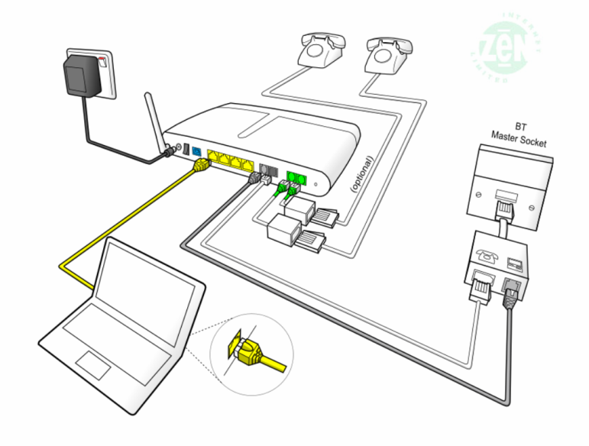
The most cost effective routing for outgoing calls is automatically selected by this Dial Plan:
Dialed | Service | CLI Display | Called | Called Party | Cost
[Area Code][Number] | Zen VoIP | 01730 816595 | As dialed | Any POTS Subscriber | Inclusive Minutes *
7 [Area Code][Number] | Zen VoIP | anonymous | 7 stripped off | Any POTS Subscriber | Inclusive Minutes *
123 | Draytel | 8488593 | 8234842 | David Bradley | Free
42 | Draytel | 8488593 | 8453255 | JDs – Ian Madden | Free
47 | Draytel | 8488593 | 8485796 | Mike Morgan [Office] | Free
49 | Draytel | 8488593 | 8237300 | MIDENG Workshop | Free
2 | Zen VoIP | 01730 816595 | 01730 812162 | MIDENG Switchboard | Inclusive Minutes *
3 | Zen VoIP | 01730 816595 | 01730 858062 | Rosemary Courtyard | Inclusive Minutes *
8xxxxxx | Draytel | 8488593 | As dialed | Any Draytel Subscriber | Free
777 | Zen VoIP | 01730 816595 | 777 | Zen Help Desk | Free
999 | Landline | 01730 816595 | Emergency Services | Police, Fire, Ambulance | Free
#0 [Area Code][Number] | Landline | 01730 816595 | As dialed | Any POTS Subscriber | As phone line table
7130 | Zen VoIP | 01730 816595 | 7130 | Zen Test Facility | Free
902 | DrayTEL | - | 902 | DrayTEL service test | Free
Calls routed through the Zen VoIP service are subject to these charges:
Pricing Overview | Landlines | Mobiles
UK Pricing
UK Local and National Calls | 1,000 minutes included, | From 14.1ppm
(01/02/03/0870 numbers) | then 2.35ppm | From 14.1ppm
International Pricing
North America | From 2.35ppm | From 2.35ppm
South America | From 3.53ppm | From 14.1ppm
Europe | From 2.35ppm | From 5.88ppm
Asia | From 2.35ppm | From 2.35ppm
Africa | From 7.05ppm | From 9.4ppm
Oceania | From 2.35ppm | From 21.15ppm
There are no set up, call connection or minimum call charges. Charges are Pence per Minute including VAT. Calls are billed by the second. The overall charge per bill and not each individual call is rounded to the nearest penny.
Inclusive minute’s means 1000 anytime minutes available each month to 01/02/03 numbers only. When quota is exhausted, or not part of the plan, calls are charged as shown in the table above.

A full list of VoIP call charges is at http://www.zen.co.uk/business/voice/voip.aspx?page=10157
Extracted from that listing are these call charges for four of the most common dialling codes used:
0845 - 4.7ppm [Peak]; 1.175ppm [Off Peak]
0844 - 5.88ppm
0871 - 11.75ppm
Mobile call charge:
If there is a need to route a call via the landline, prefix the call with #0 but these charges then apply:
 | Daytime | Evening | Weekend
 | (7am - 7pm) | (7pm - 7am) | (Fri 7pm - Mon 7am)
UK Local and National Calls | 4.09 | 1.02 | 1.02
(01/02/03 numbers) | 4.09 | 1.02 | 1.02
0845 | 6.4 | 2.3 | 2.3
0870 | 4.09 | 1.53 | 1.53
O2 Mobile | 11.23 | 8.68 | 8.68
Orange Mobile | 14.3 | 8.68 | 8.68
Three Mobile | 14.81 | 8.68 | 8.68
T-Mobile | 11.23 | 10.21 | 8.68
Vodafone Mobile | 13.28 | 8.68 | 8.68

Inclusive minutes means 1000 anytime minutes available each month to 01/02/03 numbers only. When quota is exhausted, or not part of the plan, calls are charged as shown in this table below.

The landline number is permanently withheld. To bypass this facility prefix calls with 1470 to enable your number to be released on a call-by-call basis. The default VoIP service displays the number, so prefix each call with 7 to withhold the number.

VoIP Identities
Service Name Domain and Proxy Password POTS Number VoIP Number Test Number
Zen voip.zen.co.uk nNCUUbP9 01730 816595 -- 7130
DrayTEL draytel.org gUk[5DRc 0845 557 8295 8488593 902

DrayTEL registration email: zen255936@zen.co.uk Password: route654
Currently [3 SEP 14] with no credit on account

Current charges [19 May 2015] for Telephone service
Call rates on the landline are shown below and only apply if the call is prefixed with 147 but use the 1000 free minutes via VoIP for 01/02/03/0870 numbers.

Calls are received on either 01730 816595 or 0845 557 8295.
DrayTEL VoIP users would normally use 8488593 which is routed over the internet and therefore free.

The configuration of the router will default outgoing calls via the Zen VoIP service providing the number starts with a ‘0’. The initial, or complete, number shown in the dial plan, routes the call as shown.

Dial Plan

Zen VoIP Service
This service, includes 1,000 inclusive minutes to UK landlines (01/02/03/0870 numbers) and reasonable call rates to international and mobile telephone numbers. The DrayTek router has been configured to make this your default phone service as soon as 0 is dialed. The telephone number for this line is 01730 816595; basically calls are routed out via VoIP for lower call charges and no setup fee but incoming calls are routed over the landline

DrayTEL VoIP Service
No rental charges but useful for free calls to other DrayTEL subscribers.
The telephone number for this line is 0845 557 8295.

Mike’s Laptop Vermouth – Logon Accounts
Mike recovery2 Working Account
Roger route654 Phantom Account **
User route654 Dummy Account

** The ESET product requires a phantom account for anti-theft protection. The setup procedure used:
Email address: david@mideng.co.uk Password: route654 First kiss: Pauline
https://my.eset.com/Default.aspx [Theft recovery]
https://my.eset.com

Email accounts
mike@mideng.co.uk mxm5
morganind@hotmail.co.uk Dragon9

Workgroup: COBDEN

Technical Information
Line Rental - monthly service charge: £14.16 + VAT = £16.99
Unlimited Zen Fibre 2 - monthly charge: £25.00 + VAT = £30.00
Zen Broadband Voice: £4.25 + VAT = £5.10
Total = £52.09
Installation charge was: £70.80

Michelle Buckley
Customer Retentions Sales Executive
Zen Internet
Direct: 01706 902128 Fax: 01706 902127

Technical Information
Zen Order No: 1067389
Date order placed: 02-Feb-2015
Telephone number: 01730 816595
8 ST MARGARETS WAY MIDHURST GU29 9FQ

Zen username: zen276045@zen
Connection password: 343spfyK

IP address information: 82.71.39.217
Subnet mask 255.255.255.255
Primary DNS: 212.23.3.100
Secondary DNS: 212.23.6.100
Default email username: zen276045@zen.co.uk
Default email password: 3fDnhPUs

Default web space username: zen276045
Default web space password: 3fDnhPUs

Username: 01730816595
Password: k6vFC5ii
Registrar Address: voip.zen.co.uk
Registrar Port: 5060
Proxy Address: voip.zen.co.uk
Proxy Port: 5060

Firewall Settings:
You will need to allow access to the following IP ranges through your firewall, if you have one:
212.23.7.226
212.23.7.227
212.23.7.228
62.3.88.0/28
62.3.88.16/28

The following port ranges should be allowed through your firewall:
5060 and 20,000->30,000

