Prepared by: David Bradley
Document: mikeclark.docx
Mike Clark – Technology Setup at 5CY
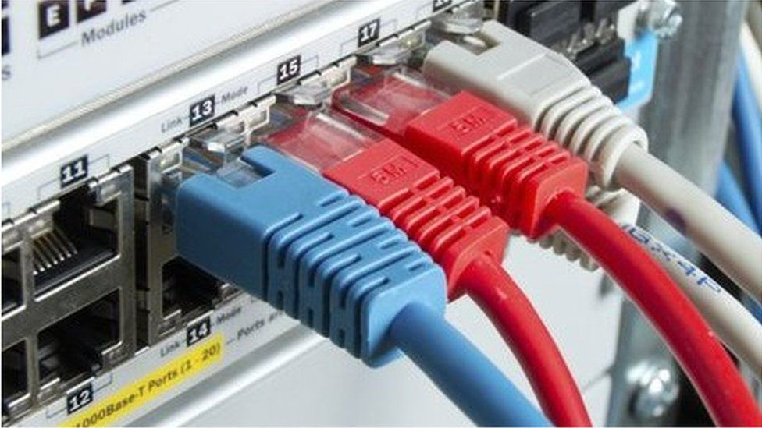
Mike Clark – Technology Setup at 5CY
Contact number: 07867 536 564 email: dr.mike.clark@btinternet.com
Service Installed on: 16th September 2022
Cloudscape Connect - 0116 274 7360 - FTTP Broadband Service
Router Make: ZYXEL VNG8623-TSOB V5.50 (ABPM.5)C0
Router Address: 192.168.15.1
Client DHCP Range: 192.168.15.15 Range: 15 to 64
Broadband Username: VFP1853930@cloudscape.uk
Broadband Password: gu101fe
WAN Address: 92.62.0.135

SSID [2.5 GHz]:
Name: MC5
Password: #trolleybus654

SSID [5 GHz]:
Name: MC55
Password: #trolleybus630

Account URL: https://www.cloudscapeconnect.com/myaccount/
Account Number: 00009535
Username: onedrmikeclark
Password: Groovycheese1!
Broadband Service: Presently FTTP 80/20 @ £31.80 pm

Cloudscape Connect email Service
https://webmail.cldmail.co.uk/
Server: mail.cldmail.co.uk Use SSL
email address/username: mike.clark@cldmail.co.uk [Alias: dr.mike.clark@cldmail.co.uk]
Password: #Pencil48Mine

Voipfone - 150 or 020 7043 5555 - Digital Voice Service [VoIP]
Registered email address: Mike.Clark@cldmail.co.uk
Account Number: 30224293 Password: Overlord1944*
Memorable Word: wartime Hint: Between 1939-1945

Extensions: 30224293*200 328095 Mobile
30224293*201 620980 Desktop Phone

Ported from BT: 01252 781 253
Voipfone provisioning: 05603 647 793

Voipfone Standing Charges per Month
Renewal of UK Geographic Number £3.00
Renewal of Virtual PBX Call Group £1.00
Renewal of Virtual PBX Extensions £3.00
Sum £7.00
VAT @ 20% £1.40
Total £8.40

Cloudscape Standing Charges per Month
Broadband FTTP 220/30 £36.50
VAT @ 20% £7.30
Total £43.80

BT email Service Fee per Month
To retain existing email address into Outlook £7.50
VAT @ 20% £1.50
Total £9.00

Monthly Commitment
£8.40 + £43.80 + £9.00 £61.20

Access to Router – ZYXEL DX3301-T0
Local URL: 192.168.15.1:8080
Remote URL: http://92.62.0.135:8080/login
Username: admin
Password: Route6542022*
Proceed to site ignoring warning messages
When the logon screen is locked, it takes 30 minutes to clear

Connected Devices on 18th September 2022
IPv4 Address MAC Address Host Name
192.168.15.18 94:9f:3e:19:97:d0
192.168.15.35 5c:aa:fd:52:b5:92
192.168.15.26 36:e5:73:90:c8:3b
System Wide Short Codes on the Voipfone Platform
Unless stated otherwise, all calls made using a short code are free

112 Emergency Services
999 Emergency Services
(See https://www.policeconduct.gov.uk/sites/default/files/Documents/research-learning/Silent_solution_guide.pdf)
101 Police Non-Emergency Number
111 NHS Mon-Emergency Number
105 Power Cut Information Line
116 999 Missing children helpline
116 111 NSPCC ChildLine
116 123 Samaritans
119 COVID-19 Help Line (Also used to make appointments)
123 Gives Day, Date and Time
141 Withhold your number (If you must – Not Recommended)
1470 Un-withhold your number
150 Voipfone Customer Services (Password protected service)
152 Echo test. Shows how good your connection to Voipfone is.
154 A recording of call credit left to use before top-up is necessary
155 Confirms that you have set up your phone correctly
159 Report a Banking Scam (See https://stopscamsuk.org.uk/159)
166 Voipfone Anti-Sales call tool (Optional monthly fee payable)
118 797 Connects to BT's Directory Enquiry services (Very expensive to use)
1280 Carrier pre-select disconnect from Voipfone (Only available to BT subscribers with pre-registration required)
1471 Plays back the last incoming number
1571 Voicemail for the extension you are using
1572 Voicemail for the Master Account (Used where your account does not have extension numbers)
1573 Voicemail for Group messages (Input the Group Number of Interest)
1995 Music on Hold (Listen to what is playing now)
## Transfer the call (Example ##01252758123 and hang up - Call charges may apply)
#0 Stops and starts call recording (Charged at 2.5 ppm)
** Generally used in business environments (Example **205 for call pickup from that extension)

Short Codes available via the Voipfone app or analogue phone connected to the ZYXEL VNG8623 router

200 Mobile Phone
201 Desktop/Wireless Phone

Short Codes available to phones plugged into your ZYXEL VNG8623 router
Speed Dial Numbers setup in the router on this page: VoIP >>> Call Rule

#01 1CY - Paul Scanlan & Nicole Scanlan - 01252 820381
#02 2CY - Sally Forrester - 01252 717133
#03 3CY - Peter Worthy - 07970 638187
#04 4CY - Roger & Jeni Benham - 01252 821811
#05 5CY - Mike Clark - 01252 781253
#06 6CY - Mark Page - 07999 223808
#07 7CY - Mary Langridge & Richard Langridge - 01252932670
#08 8CY - Camilla Curtis & Neil Curtis - 01252 711530
#09 9CY - Fred Wilkinson - 01252 715443
#10 Swing Open the MH Gates - 07430 525930

Gate Intercom Codes
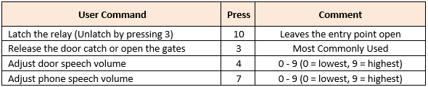
Setting in Gate Security Console as at 12/10/2022
MH Gates  07430 525 930 |  | Entry Code  5678 Enter |  |  | GU10 1FH [MH OC SH]  GU10 1FE [CY]
nnn  [Circuit] | Name | Appt | Primary  STN | Divert  STD / STE | Dial in Access  STR | Fob Issue  FOB
009 | Mike Clark | 5CY | 01252 781 253 | See Note below | 07867 536 564 | .
Note: The primary number rings simultaneously a group of numbers. No need for a divert facility.

Typical Voipfone configuration setup for an extension
Registrar: sip.voipfone.net
Voicemail delivery email address: dr.mike.clark@btinternet.com
Account: 30224293*200 Password: 328095
Forced CLI: 01252 279 231

Voicemail kicks in at 25 seconds
Greeting to be recorded

