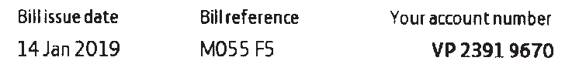
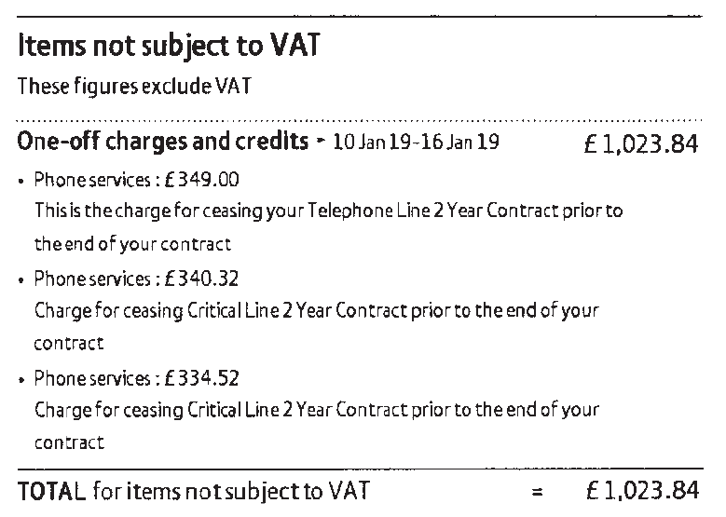

Lift Location | Cabin Number | Landline Number
The Walled Garden serving apartments #4 and #5  GU10 1FA | 11454904 | 01252 725864
The Walled Garden serving apartment #7  GU10 1FA | 11454906 | 01252 737734
The Walled Garden serving apartments #10 and #11  GU10 1FA | 11454905 | 01252 719138
1-3 Moor Park House, Moor Park House Way  GU10 1FH | TGB/0040 | 01252 721222

