Notes on the Gigaset Phone –- 01252 279323 –- Extension 202

These wireless phones accept calls from both his domestic line and via the Internet. Outgoing calls go out via the domestic line by default. To route an outgoing call via VoIP, dial the number and then hold the send button down and choose the Voipfone service from the GUI that is displayed.

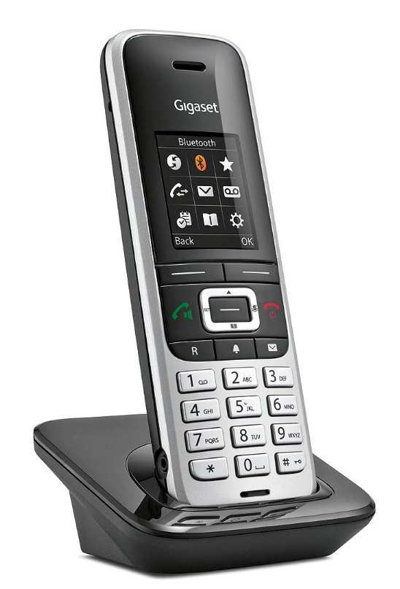
The ‘R’ key is used to access the advanced features of VoIP. The green key if briefly pressed while on a call turns the speaker on.
Access to the phone’s GUI is through its dynamic web address of 192.168.1.157 with the password 0000. Both these default settings will be changed as soon as possible.
The manual for this phone is here:
https://www.gigaset.com/en_en/cms/gigaset-phones-smartphones-and-smart-home-alarm-systems/service/support-detail/gigaset-s850a-go.html

If there is a need to sort out a Voipfone issue when I am not available, call
020 7043 5555 and quote Account Number 30208619 with Password 051.
Exchange Line: 01252 712485 VoIP Number: 01252 279323 Extension: 202

