Background Information on Maintenance Levels
A subscriber can opt to upgrade from the free default maintenance level to have a more rapid response in the event of a line fault. Upgrade prices vary across phone providers with Cloudscape tariff being:
Level 1 Free End of next working day + 1 working day, fix Monday to Friday.
Level 2 £2.50 End of next working day, fix Monday to Saturday.
Level 3 £6.50 Report AM fix PM. Report PM, fix next AM. Applies 24/7
Level 4 £7.50 Best efforts to fix within 6 hours.
For the moment MPHEM, have opted for Maintenance Level 2 for each lift, but this can be changed at any time. A line fault is reported to Cloudscape who alerts Openreach to the problem.
Openreach will handle the fault in accordance with the Maintenance Level select and pre-paid before the event. The ‘fix’ times will not occur if abnormal events prevail.
Lift Emergency Call Button
If the emergency call button does not work during testing in any lift, then call the appropriate cabin. Possible responses are and action to take is:
- A ringing tone that is never answered – Call Kone
- A fax style tone is heard – Call Kone.
- Silence – Call CloudScape who will alert Openreach as a line fault is probably the culprit
When operating normally, the status of the call is shown on the LED screen. Emergency lighting may come on but is not particularly bright. Voice calls are cleared down by the Call Centre, open 24/7..

Setup/Installation Fees
Until 4 January 2019 the exchange line service was provided by BT. Switching providers was free. The phone service in the office required the purchase TP-LINK AC250 RE200 Wi-Fi Access Point for approximately £25.00.
Lift Running Costs
CloudScape Line Rental with Maintenance Level 2 - £11.67 + 20% VAT Qty 4 £56.02
Voipfone Voice Rental - £3.00 + 20% VAT. (via Broadband) Qty 6 £21.00
Exchange Line Calls generated by each lift modem 5p a day * 4 * 30 Estimated £6.00
Exchange Line Calls from the Virtual PABX Estimated £20.00
£103.62

Lift Information
Information correct as at  4-Feb-19 18:07 | Cabin Number | Landline Number | Postcode and Entry System Codes provided for entrapment purposes
The Walled Garden serving apartments #4 and #5 | 11454904 | 01252 725864 | GU10 1FA –Gate Access Code 2612 Enter  Foyer Entrance Code: 4234 Enter
The Walled Garden serving apartment #7 | 11454906 | 01252 737734 | GU10 1FA – Gate Access Code 2612 Enter  Foyer Entrance Code: 4891 Enter Key pad operation.
The Walled Garden serving apartments #10 and #11 | 11454905 | 01252 719138 | GU10 1FA – Gate Access Code: 2612 Enter  Foyer Entrance (and rear door) Code: 2612 Enter
1-3 Moor Park House,  Moor Park House Way | TGB/0040 | 01252 721222 | GU10 1FH – Gate Access Code 5678 Enter  Foyer Entrance Code: 9519*

Annual Budget for 2019 was £2000 for WG and £750 for MH £2,700.00 Like for like comparison using Cloudscape £103.62 * 12 £1,243.44
Annual saving by switching suppliers £1,456.56
Bonus saving by not needing a separate exchange line for the new Office £240.00

Total Savings without early termination fees £1,696.56

VoIP Service
A hosted PABX service is used to provide a phone service for MPHEM using VoIP phones. This provides free calls between extensions with call charges from extensions 200 to 206 being deducted from a call deposit made to Cloudscape. A low threshold of call deposit triggers a top up taken from a Credit/Debit card on file. Threshold and top up amounts are of MPHEMs choice.
Each exchange line number with DDI costs £3.60 including VAT per month.
Total Purchases up to Wednesday, 9 January 2019 have been £26.44 for the following:
Invoice Number Purchased Date Cost
1012689315 05/01/2019 £12.00
1012678425 22/12/2018 £0.55
1012678424 22/12/2018 £1.11
1012667259 11/12/2018 £0.99
1012667218 11/12/2018 £1.99
1012662556 06/12/2018 £2.40
1012662555 06/12/2018 £2.40
1012662553 06/12/2018 £5.00
These costs have initially been paid by David Bradley with reimbursement now sought with ongoing costs to Cloudscape being made by Credit or Debit card. This arrangement needs to be setup.

Location | DDI / Divert | EXT No. | Monthly Cost | Notes
Carole McAuliffe | 01252 279655 | 200 | £3.60 | S850A GO with parallel extension to the Office
Norman Foster | 01252 279840 | 201 | £3.60 | Softphone
Archie Bishop | 01252 279323 | 202 | £3.60 | S850A GO
Roger Benham | 01252 279170 | 203 | £3.60 | Softphone
David Bradley | 05603 869268 | 204 | £1.20 | D375
Peter Clappison | Not Created | 206 | £3.60 | If required
Monthly Fixed Expenditure |  |  | £14.40
Estimated Monthly Call Deposit |  |  | £10.00
Total |  |  | £24.40

The setup is not complete but only minor effort is required to complete the job.

Call Costs using VoIP
There are no connection charges, with per second billing after the first minute.

Service Used | Pence per minute  (ex VAT) | Pence per minute  (inc VAT)
01, 02, 03 | 1p | 1.20p
0800 & 0808 | FREE | FREE
Internal and System Calls | FREE | FREE
O2, EE, Three, Virgin and Vodafone | 10p | 12p
Lyca and Others | 20p | 24p

The Lift Locations and Telephone Numbers
Regular exchange lines are used from Cloudscape
Lift Location | Landline Number | Cloudscape  Account Number | Notes
Serving #4 and #5 | 01252 725864 | 00051656 | GU10 1FA
Serving #7 | 01252 737734 | 00051656 | GU10 1FA.
Serving #10 and #11 | 01252 719138 | 00051656 | GU10 1FA
Moor Park House | 01252 721222 | 00051656 | GU10 1QP (Appledore) Incorrect
All numbers are ex-directory
BT Account number for The Walled Garden was: VP 2391 9670. The Manor House was TH 1692 2511

Operational Status as at Wednesday, 9 January 2019
There remains no service for the Emergency Call Button in the Manor House lift. Until a contract is in place with KONE it is not possible to request a repair. The Openreach DP box is in a most unsatisfactory state with the cover missing and therefore the DP number is unknown.
Calls received on 01252 279655 are being diverted to 01252 266 827 (Carole McAuliffe domestic number). Norman is organising a VoIP phone with two wireless handsets, one each for Carole and the office.

Kone Contract for the three lifts in the Walled Garden
Kone PLC currently have a contract for the 3 lifts in the WG, their contact details are:
View Point, Basing View, Basingstoke, RG21 4RG
Telephone: 01256 366972
Email: customercarecentreuk@kone.com
In the event of a fault with a lift requiring an engineer contact:
Kone Emergency Call Centre: 0800 652 0692:

Maintenance Contract Details
Between the Customer: Merlin Estates Ltd
and
KONE plc, Global House, Station Place. Chertsey, KT16 9HW
Project: LIS - Moor Park, FARNHAM (K1) - 11454904, 06 & 07
Date: 03.07.2017 Quotation No.: T-0001900139 v1

General contract agreements
Contract Start Date 01.06.2017 Contract Term 1 Year.
This has now expired; where is the latest version?
Invoiced Quarterly in Advance. Payment Terms: 30 Days Net
They have been paid their quarterly fee through to 28/2/19
Contract Price per annum excluding VAT £1,348.91

Cabin Serial  Number | Year of Manufacture | Annual Fee | Location
11454906 | 2012 | £446.93
11454904 | 2012 | £446.93 | #4 & #5
11454907 | 2011 | £455.05

Service | Option
Preventive Maintenance | KONE Modular Maintenance
KONE Customer Care Centre | Normal working hours  Calls taken outside of this time  maybe subject to an additional fee
Callout cover | All calls charged
Repair coverage | All parts chargeable
Planned maintenance service hours | KONE normal working hours
Call Out Response service | Not included
Breakdown service response time in working hours | 24 hours
Entrapment rescue service cost | Included (24/7)
Entrapment rescue response time | 1 Hour
Remote monitoring Service | Not Included
KONE Care Online | Desk Top Access included

Extracts from the Kone Contract
Planned maintenance service hours | You choose the time for scheduled maintenance  visits that best suits you
Breakdown service response time within  the agreed service hours | This service defines the response time for situations where your equipment breaks down completely, is not operating as it should, or requires the immediate attention of a KONE service technician. Response time is calculated from the moment the service request is confirmed by the KONE  Care Center until the moment a KONE service technician arrives at the site
Entrapment rescue service cost | KONE Entrapment Rescue Service ensures the quick and safe release of passengers trapped in elevators.
Entrapment rescue response time. | Generally within 1 hour. Emergency procedures ensure that entrapments situations are prioritized and technicians dispatched in the quickest possible manner
Contract management services | Contract Management Service allows you to include additional options into your contract to tailor it to your needs.
KONE Care Online | KONE Care Digital gives you instant access to a complete overview of all our performance, maintenance, breakdown, and repair data for all your equipment, making planning and budgeting easier. The content/functionality available is depending on the selected level.
Insurance Process Reminders | Not Printing
Preventive Maintenance | KONE Modular Based Maintenance helps to prevent problems before they appear. We maintain your equipment according to an individual plan based on factors like age and usage. This means that individual components and systems are serviced at the right time and according to all relevant regulations.
KONE Customer Care Centre | Our UK based Customer Care Centre deals with requests in a prompt and efficient manner. Customers and end-users can report any failures or faults and our staff will then dispatch a service technician to resolve your problem.
KONE Voice Link Service | An emergency two-way link between the elevator passengers and our Customer Care Center when the elevator’s alarm button is pushed.

Observations
- Fault with Emergency Call Button reported 7 January 2019 at 09:30. Kone Lift Engineer on site at 15:15. Lift wiring not connected into Openreach DP2718. Matter resolved. Service carried out as well. Copy of service log obtained, see image on next page. It would seem the phone service to the cabin has not been connected since July 2013. A five year period with line rental paid over those years.
- The auto-dialler calls 03308 084 988 daily at around 03:27 from two lifts and 08445768260 for the other. Complaint made about the use of an 0844 number which costs 8.4 ppm otherwise it would be 2.4 ppm. Call Duration is about 61 seconds. Ball with KONE to call back.
.
- I would have thought that the Emergency Call Button rings 0800 652 0692
- Not entirely sure what Remote Monitoring Service would provide as it is excluded within the contract for last year.
- Credentials sought for KONE Care.
I have emailed the below on to the portfolio manage to advise change of management and also to set you up with KONE Online. Your case reference is Kc-02061806.
Zoe Van Heusden
Customer Service Co-ordinator
KONE PLC
Worthdale House
Worth Bridge Road
Keighley
BD21 4YA
01535 687977 option 3
Van Heusden Zoe <Zoe.Waggett@kone.com>
.
- The telephone Master Socket for each lift is located in the lift shaft. Wiring is normally run directly into the Openreach DP box.
- The lift for apartment #7 uses a keypad to operate travel. Code thought to be 8888.

Lift Log Book Serving #4 and #5
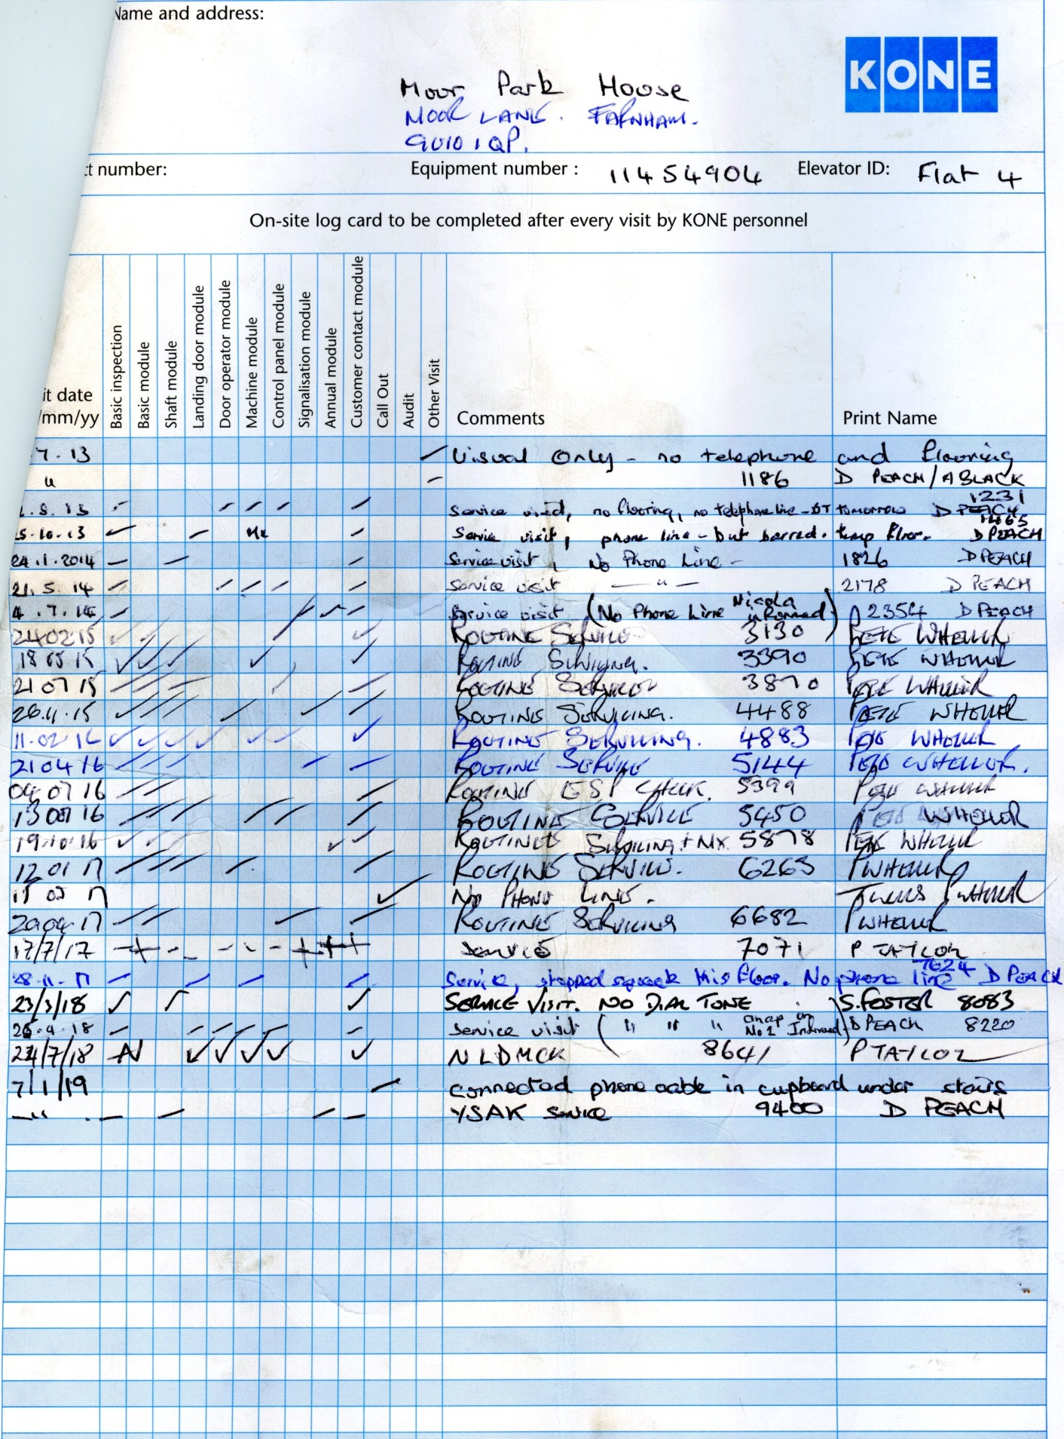
DP 2718 - Services Cupboard Apartments #2 to #5
