SQ/ RC.dc.170119

Mr Peter Clappison
Moor Park House Estate Management Ltd
Moor Park House
Moor Park House Way
Farnham
Surrey
GU10 1FH

17th January 2019

Dear Peter

Re: 3 Kone Passenger Lifts at Moor Park & 1 Nova Lift at The Walled Garden

Thank you for giving us the opportunity to quote for your lift maintenance at the above site, we have pleasure in quoting for the following;

To service the lifts with 4 visits per year per lift on our ‘A’ type contract;

For the sum of £240.00 Per Lift

To supply and fit a Memco Auto-dialler to each lift;

For the sum of £750.00 Per Lift

All prices quoted are exclusive of value added tax.

I trust our proposals are of interest to you and I look forward to hearing from you in the near future. In the meantime, should there be any points you would like to discuss, please do not hesitate to contact us.

Kind Regards

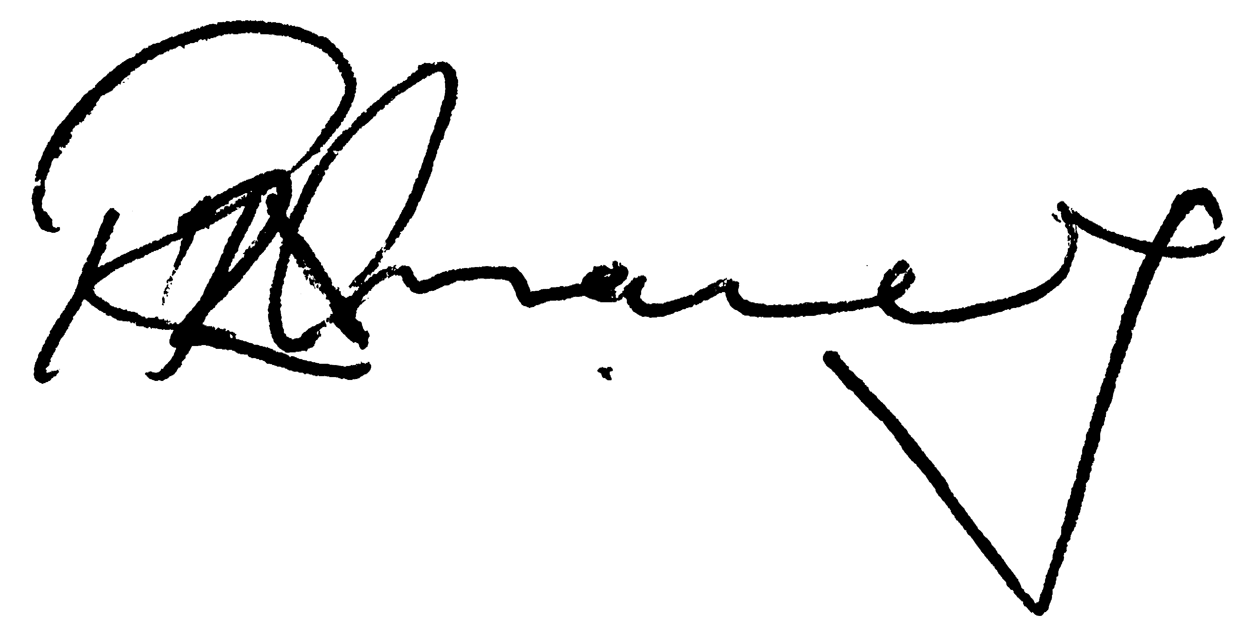
Richard Chaney
Director


