Pictorial of Office setup as at 25 May 2019

Start Dates
Voice service started on 20th May 2019 – 12 month contract.
Broadband service VDSL2 (FTTC), connected on 30th May 2019.

Router
An unused TalkTalk business router is employed, configured to operate on an VDSL service from Cloudscape. It should be noted that the logon information on the rear of the router is obsolete. Use the information shown below instead.
Model: HG633
Firmware installed: To be added
Using the latest firmware may destroy non-standard settings used by MPHEM
LAN Address: http://192.168.86.1
Logon: admin
Password: elstead2008
SSID: MPHEM-Office Password: eight2six Security: WPA/PSK2 Channel: Auto

Broadband Service from Cloudscape
Login: 01252711694@cloudscape.uk
Password: gu101fa
Static IP Address: 92.62.3.48 [Dynamically assigned]
MTU: 1492
Download Quota: Unlimited
LAN Start IP Address: 192.168.86.86 LAN End IP Address: 192.168.86.111

Phone Service

Incoming Calls in the Office
When a caller dials 01252 279655, the call will simultaneously ring the Office phone and Carole’s phone. Either phone can pick up the call. If the call is not picked up and a message is left, it can be retrieved by dialling 1573.

All other VoIP phones are reached by dialling their extension or DDI number.

Making Calls
Dial the number, which if it is on the public network will usually require the area code to be used, and press the green button.

Once connected, In-call Feature Codes shown below are available from Gigaset phones only.
- ## Used to transfer a call.
- #0 Starts and stops Call recording. Charged at 2.5ppm + normal call charge of 1.2ppm.
- #1 Places a call on hold. # will remove from hold. Do this if you don’t want the caller to hear your private conversations.
- ‘R’ Key Used to initiate a call transfer process and other facilities.
Other VoIP phones have dedicated buttons for these features.

Calls from any extension are charged to the MPHEM communal account.
Service Used | Pence per minute  (ex VAT) | Pence per minute  (inc VAT)
01, 02, 03 | 1p | 1.20p
0800 & 0808 | FREE | FREE
Internal and System Calls | FREE | FREE
O2, EE, Three, Virgin and Vodafone | 10p | 12p
Lyca and Others | 20p | 24p
There is no connection charge, with per second billing after the first minute.
.
Short Code Service Numbers available from all VoIP connected Phones
- 112 Emergency Services
- 999 Emergency Services
- 101 Non-emergency Police number
- 123 Gives date and time
- 141 Withhold your number
- 150 Voipfone help desk
- 152 Voipfone Echo test; shows how good your connection to Voipfone is.
- 154 Reads back your account minutes and balance.
- 155 Confirms that you have set up your phone correctly.
- 1470 un-withhold your number
- 1471 Plays back the last number that called you and allows you to ban the number if you have our call barring service.
- 1571 Voicemail for the extension you are using.
- 1573 Voicemail for 01252 279655.
- **1571ext - Direct Voicemail - Connect to the Voicemail of an Extension without having to call the extension and wait for it to ring out. Useful if you answer a call, and would like to transfer the caller directly to another users voicemail service thus avoiding having to take a message and pass it on. For example: **1571204 would connect to Extension 204 voicemail service directly to leave a message.

Estate Telephone Directory
 | Resident / Facility | Physical Line | MPHEM  Ext
 | MPHEM Office | 01252 279655 | 200
 | Carole McAuliffe | 01252 279121 | 206
 | David Bradley | 01252 758960 | 204
 | Peter Clappison | 01252 279840 | 205
 | Archie Bishop | 01252 279323 | 202
 | Roger Benham [Laptop] | 01252 279730 | 207
 | Roger Benham [Study] | 01252 279170 | 203
 | Aspire Accounting Ltd (John Gardiner) | 01252 723269 | 201

Printer – HP Office Jet Pro 6960
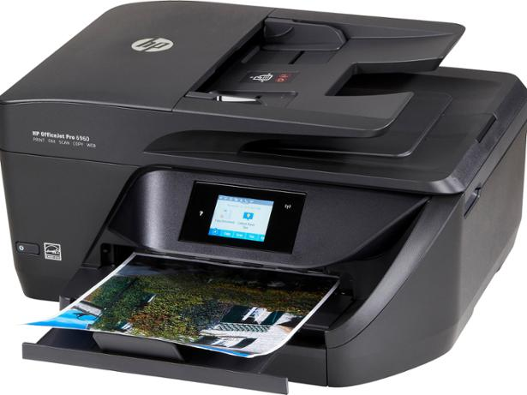
WiFi Direct Name: DIRECT-41-HP Office Jet Pro 6960
WiFi Direct Password: 12345678
URL for Embedded Web Server: http://192.168.223.1
Host Name: HPD9C83F
Copier Model: HP Office Jet Pro 6960
Serial Number: TH87A1N1QM
MAC Address: 30-05-5C-72-F7-4D
IP Address: 192.168.86.86
Fax Number: 01252 711694
Firmware: MCP2CN1847AR
Supplier: Currys/PC World
Purchased: 28 December 2018 Price: £69.99
Customer Support Agreement Cost: £16.99
Taken out by R Benham, 4CY Ref: 10904356627
Standard Guarantee Expiry Date: 28/12/2019 Instant Replacement Expiry Date: 27/12/2019
Printers email address: eifo877apy62@hpeprint.com

User Guide: http://h10032.www1.hp.com/ctg/Manual/c05135226
WiFi Direct: http://hp.com/go/wifidirectprinting

The Printer’s Scan Options
The printer can scan documents, photos, and other paper types, and send them to a variety of destinations, such as a computer or an email recipient. When scanning documents with the HP printer software, you can scan to a format that can be searched and edited. When scanning a borderless original, use the scanner glass and not the document feeder.

Scan to a computer
Before scanning to a computer, make sure you have already installed the HP recommended printer software. On Windows computers, the printer software must be running prior to scanning. You can use the HP printer software to scan documents into editable text. For more information, see Scanning documents as editable text.

To enable the scan to a computer feature (Windows)
- Open the HP printer software.
For more information, see Open the HP printer software (Windows).
- Go to the Scan section.
- Select Manage Scan to Computer.
- Click Enable.

To enable the scan to a computer feature (OS X)
- Open HP Utility.
NOTE: HP Utility is located in the HP folder in the Applications folder.
- Under Scan Settings, click Scan to Computer.
- Ensure that Enable Scan to Computer is selected.

To scan a document or photo to a file (Windows)
- Load your original print-side down on the scanner glass or print-side up in the document feeder.
- Open the HP printer software.
For more information, see Open the HP printer software (Windows).
- In the printer software, click Scan a Document or Photo.
- Select the type of scan you want and then click Scan.
- Choose “Save as PDF” to save the document (or photo) as a PDF file.
- Choose “Save as JPEG” to save the photo (or document) as an image file.
NOTE: The initial screen allows you to review and modify basic settings. Click the “More” link at the top right corner of the Scan dialog to review and modify detailed settings.
For more information, see Change scan settings (Windows).
If “Show Viewer after Scan” is selected, you can make adjustments to the scanned image in the preview screen.

To scan an original from HP printer software (OS X)
- Open HP Easy Scan. HP Easy Scan is located in the Applications folder.
- Click Scan.
- Choose the type of scan profile you want and follow the onscreen instructions.

Scan to email
The Scan-to-Email App is an application that allows you to quickly scan and email photos or documents to the specified recipients directly from the printer. You can set up your email addresses, log in to your accounts with the given PIN codes, and then scan and email your documents.

- Set up Scan to Email
- Enable Web Services on the printer.
- From Home screen, touch Apps, and then touch Scan-to-Email app.
- On the Welcome screen, touch Continue.
- Touch in the Email: box to enter your email address, and then touch Done.
- Touch Continue.
- A PIN will be sent to the email address you entered. Touch Continue.
- Touch the PIN to enter your PIN and then touch Done.
- Touch Store Email or Auto-login, depending upon how you want the printer to store your login information.
- Select your scan type by touching Photo or Document.
- For photos, select the scan settings, and touch Continue. For documents, continue with the next step.
- Verify the email information, and touch Continue.
- Touch Scan to Email.
- Touch OK when the scan completes, and then touch Yes to send another email, or No to finish.

- Scan a document or photo to email

- Load your original print-side down on the scanner glass or print-side up in the document feeder.
- From Home screen, touch Apps, and then touch Scan-to-Email app.
- On the control panel display, select the account that you want to use, and touch Continue.
(If you do not have an account, you will be prompted to enter your email address and receive a PIN).
- If prompted, enter the PIN.
- Select your scan type by touching Photo or Document.
- For photos, select the scan settings, and touch Continue. For documents, continue with the next step.
- To add or remove recipients, touch Modify Recipient(s), and when finished touch Done.
- Verify the email information and touch Continue.
- Touch Scan to Email.
- Touch OK when the scan completes, and then touch Yes to send another email, or No to finish.

From Home screen, touch Apps, and then touch Scan-to-Email app.
Select the account that you want to change, and touch Modify.
Select which setting you want to modify, and follow the onscreen prompts.

The Printer’s Fax Facility connected to 01252 711694
Outgoing faxes uses the Cloudscape network and cost 2ppm for 01/02/03 numbers.
Telephone line faults should be reported to Cloudscape using 0345 688 7227.
(Verify the fax is set up correctly by running the fax setup test from the printer control panel).

To send a standard fax from the printer control panel:
- Load an original print-side down on the scanner glass or print-side up in the document feeder.
- From the printer control panel display, touch Fax.
- Touch Send Now.
- Enter the fax number by using the keypad or by selecting from the phone book
- Touch Black or Colour
- Document is sent to the number of the fax machine entered.

To send a standard fax from the computer (Windows OS)
This feature requires the HP printer software installed on your computer.
- Open the document on your computer that you want to fax.
- On the File menu in your software application, click Print.
- From the Name list, select the printer that has “fax” in the name.
- To change settings, click the button that opens the Properties dialog box. Depending on your software application, this button might be called Properties, Options, Printer Setup, Printer or Preferences.
- After you have changed any settings, click OK.
- Click Print or OK.
- Enter the fax number and other information for the recipient and then click Send Fax. The printer sends the document to the number entered.
To send a standard fax from the computer (OS X):
- Open the document on your computer that you want to fax.
- From the File menu in your software, click Print.
- Select the printer that has “(Fax)” in the name.
- Enter a fax number or a name from your Contacts that has a fax number entry.
- When you have finished filling out the fax information, click Fax.

Receiving a fax
The printer automatically answers incoming calls and receives faxes after the number of rings that are specified by the ‘Rings to Answer’ setting where the default is 5.

Receiving faxes using HP Digital Fax
HP Digital Fax will automatically receive faxes and save them directly onto your computer. This saves paper and ink. Received faxes are saved as PDF files.
The files are named in the following format: <sender><date><time>.pdf
Only faxes in black-and-white will be sent to a computer. Colour faxes will be printed.
HP Digital Fax is conditional on:
- The destination folder of the computer must be available at all times.
- Faxes will not be saved if the computer is asleep or in hibernation mode.
- Paper must be loaded in the input tray.

To set up or modify HP Digital Fax (Windows)
- Open the HP printer software.
- Click Print, Scan & Fax and click Digital Fax Setup Wizard .
- Follow the onscreen instructions.

To set up or modify HP Digital Fax (OS X)
- Open HP Utility.
- Select the printer.
- Click Digital Fax Archive in the Fax Settings section.

Only for very brief periods has the printer been connected to the internet and consequentially it has not been possible to register it with HP nor has it been possible to take up this offer:

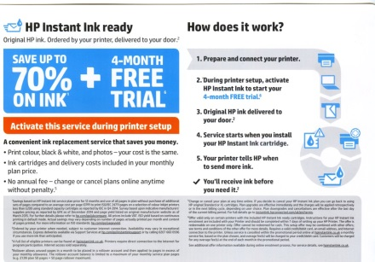

The small print enlarged:
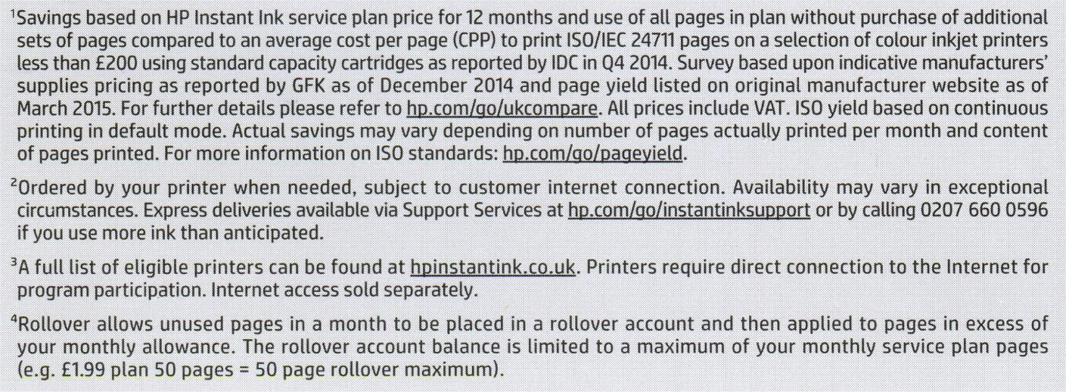
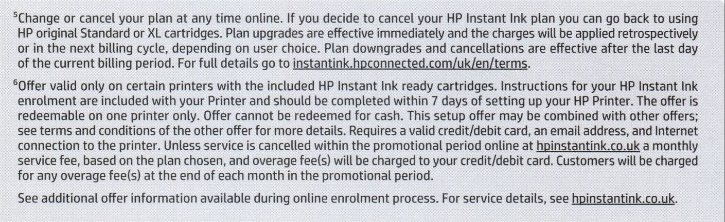
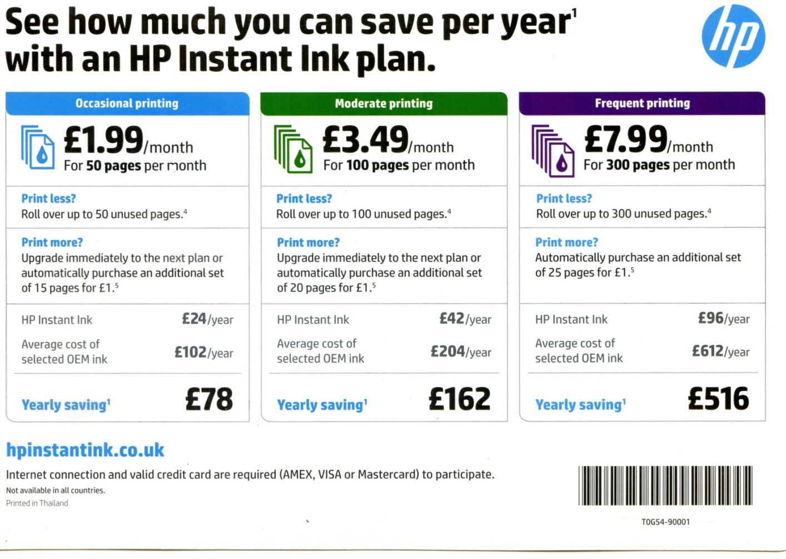
If this facility is to be taken up we shall have to wait until the printer is connected to the internet at the end of the month (May 2019).

Mobile Phone Signal
The Office is void of any mobile signal. It is possible to service Vodafone users by installing a Sure Signal Device but the hardware costs £110.

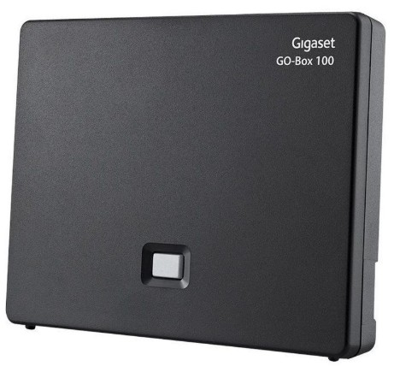
Gigaset S850A GO
The base unit GO-Box 100 is the transmitter that currently receives VoIP calls and from the exchange line 01252 711694, to two wireless handsets; one handset in the Office and the other located in Carole’s apartment. Handsets are able to operate up to 150 metres internally from the base unit reaching Carole’s apartment easily.

The handsets are not parallel extensions to one another, although it times it may appear that way. It is the hosted PABX that controls whether Carole’s handset receives calls when a caller rings the Office number.

From the 2nd June, the MPHEM VoIP service will be connected enabling the use of extension numbers shown the table below or to any number on the public network.
Name Exchange No. Extn Comment
MPHEM Office 01252 279655 200
Carole McAuliffe 01252 279121 206
David Bradley 01252 758960 204
Peter Clappison 01252 279840 205 Diverted to 01252 727443
Archie Bishop 01252 279323 202
Roger Benham 01252 279170 203
Roger Benham [2] 01252 279730 207 Experimental soft phone service
John Gardiner Not Provided 201 A short code to dial 01252 723269

It is possible to store frequent dialled numbers in each phone but in the meantime an Estate phone directory can be found at www.mphem.net/db.pdf.

Technical Information
Host Name: S850A-GO
Model: Siemens Gigaset S850 Go Professional VoIP Cordless Phone and Base unit
Additional Siemens Gigaset S850HX Handset
Serial Number: To be added
MAC Address: 58:9E:C6:01:63:BE
IP Address: 192.168.86.91
Firmware: 42.248 (422480000000 / V42.00)
Supplier: LiGo, 244 Seaward Street, Glasgow, G41 1NG. Telephone: 0333 259 7032
Purchased: 16th May 2019 by Roger Benham. Delivery Note Number LIG-19-1061567

Registered Handsets
Office: S850H Version: 114.74 Carole: S850HX Version: 114.74
Connecting to the Office Network
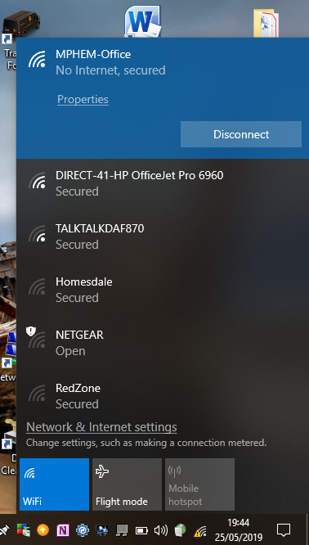
When located in the Office, search for the SSID MPHEM-Office which has the password of eight2six (Memory aid: Open 8 to 6 otherwise closed) and connect to that network.

Until the beginning of next month, such a connection will indicate there is no Internet service but access to the printer is possible.

Search for HP Office Jet Pro 6960 to print the desired file. It may be necessary to install an app or use the ‘add printer’ command on a Windows device first.

Eventually, it will be possible to remotely print to this device and also scan documents directly into your device or email them.

Also from around the 3rd June 2019, the printer can be used to receive and send faxes via exchange line 01252 711694.

Configuration of the Router
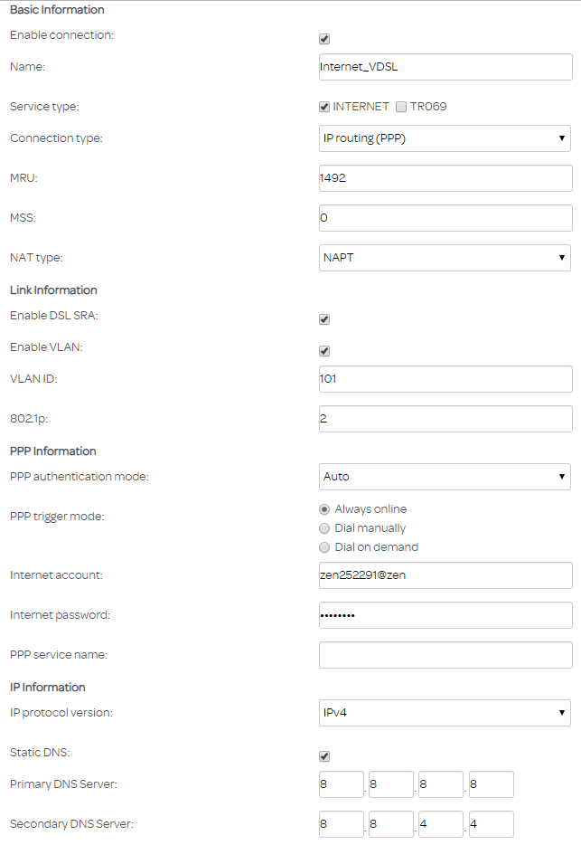

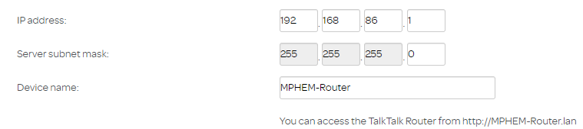

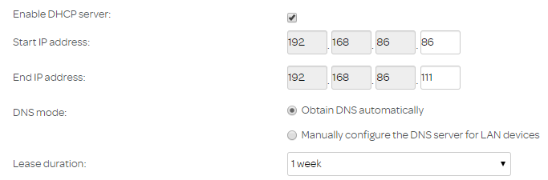

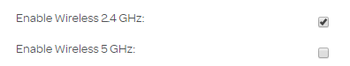

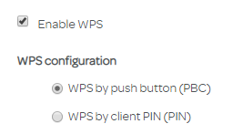

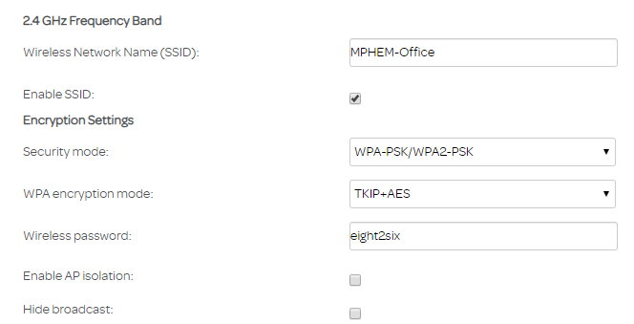

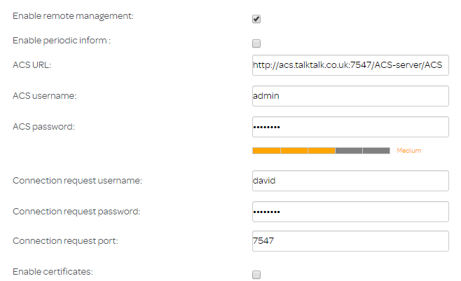
Testing the setup on another internet connection
DSL synchronization status: Up
Connection status: Showtime
WAN IP Address: 82.69.72.219
Primary DNS Server: 8.8.8.8
Secondary DNS Server: 8.8.4.4

Line Quality
Upstream line rate (kbit/s): 1007
Downstream line rate (kbit/s): 10479
Upstream noise safety coefficient (dB): 5.9
Downstream noise safety coefficient (dB): 3
Upstream interleave depth: 1
Downstream interleave depth: 13
Line standard: VDSL2
Upstream line attenuation (dB): 15.3
Downstream line attenuation (dB): 35.5

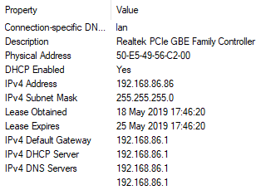

Configuration of the VoIP Base Unit
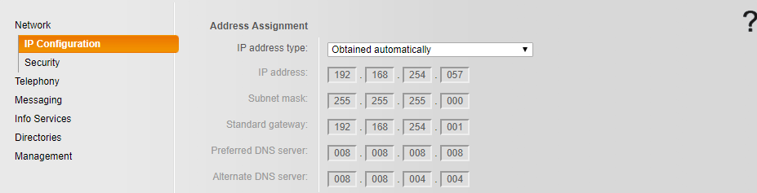
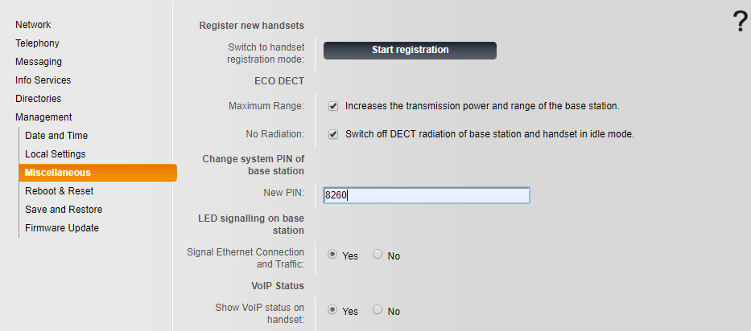
Information from the Hosted PABX that is needed
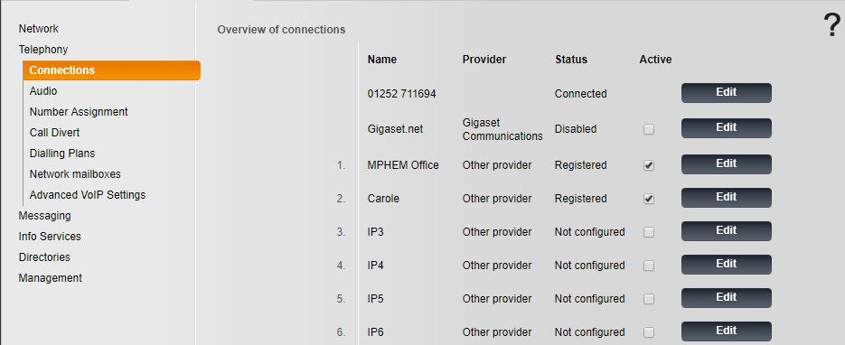
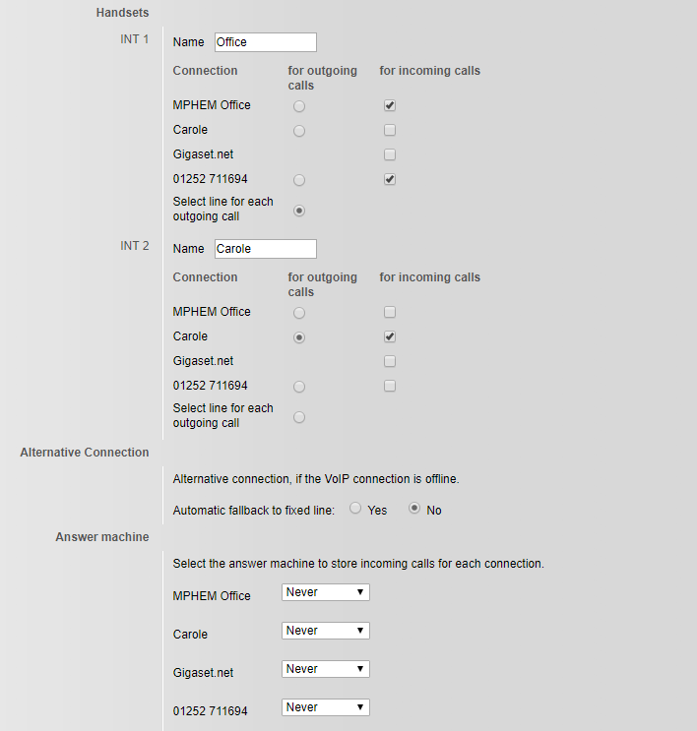
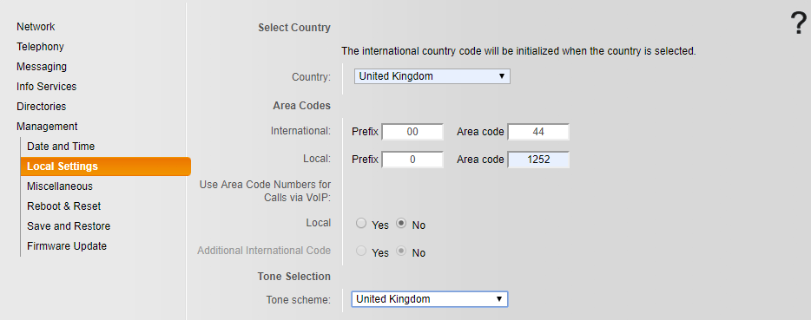

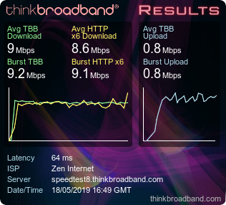

Comments
- Ultimately remote access to the MFP will available.
- Wireless connectivity to the MFP will be provided and ultimately remote access to the printer.
- There is no mobile signal in the office. Could possibly connect EE subscribers to the router and to have a Sure Signal Device for Vodafone subscribers.

