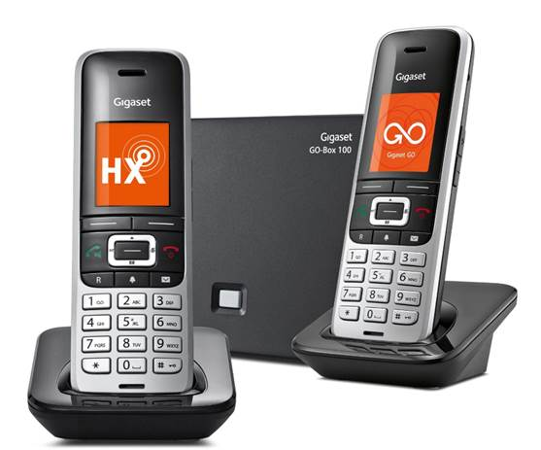
The recently installed telephone service in the Office currently provides a basic voice service using the telephone number:
01252 711694
The broadband service isn’t scheduled to be installed until 1st June at which point the number will changed to 01252 279 655 with all the benefits of VoIP.
Callers to 01252 279655 will still ring the Office phone and Carole’s apartment. VoIP extension numbers cannot be used from the Office phone until the broadband service is connected. A mini telephone directory of useful numbers is shown below.

 | Resident / Facility | Exchange Line | Location
 | MPHEM Office | 01252 711694 | Office
 | Peter and Lyla Alleman | 01252 724884 | 1WG
 | Richard Crowther and Fran Brett | 01252 935434 | 2WG
 | Chris and Carole McAuliffe | 01252 266827 | 3WG
 | David Bradley | 01252 714588 | 4WG
 | Audrey Knight | 01252 712022 | 5WG
 | David McAlpine and Haniel Barazowska | 01252 725280 | 6WG
 | Alex Thompson | 01252 734124 | 7WG
 | John and Sharyn Nash | 01483 538908 | 8WG
 | Denise and Anthony de Watteville | 01252 723000 | 9WG
 | Peter and Pamela Clappison | 01252 727443 | 10WG
 | David Goodwin and Fiona Gardiner | 01252 724465 | 11WG
 | Lea and Jo Westwood | 07887 955964 | 11WG
 | Brian Thurogood and Elvera McEwan | 01252 716331 | 12WG
 | Anita and Tony Richards | 01252 935624 | 13WG
 | Jim and Helen Rice | 01252 261795 | 1MH
 | Archie and Annie Bishop | 01252 712485 | 2MH
 | James and Tazmina Ellis | 01252 911746 | 3MH
 | David and Shirley Wardell | 01252 710491 | Chapel
 | Paul and Nicole Scanlan | 01252 710710 | 1CY
 | Sally Forrester | 01252 717133 | 2CY
 | Roger and Jeni Benham | 01252 821811 | 4CY
 | Rose McMonigall | 01252 202527 | 5CY
 | Mark Page | 07900 223808 | 6CY
 | Mary and Richard Langridge | 01252 932670 | 7CY
 | Andrew and Martine Torjussen |  | 8CY
 | Peter Youll | 01252 714706 | 8CY
 | Fred Wilkinson | 01252 715443 | 9CY
 | Aspire Accounting Ltd (John Gardiner) | 01252 723269 | Farnham

