Telephone and Broadband Service into the MHPEM Office

The plan was to use the phone line serving the lift for apartment #7 and adding a broadband service to it to provide a VoIP phone in the office, Unfortunately all attempts to find the master socket for this exchange line have come to nothing and if eventually found would undoubtedly be in the wrong place to attach a router with probably no power supply nearby.

The immediate action taken by me was to remove the broadband element from the order in progress, but apparently to do this can only be achieved by re-ordering the entire service request which sadly pushes back the installation date.

So it’s back to the drawing board to get a phone and broadband service into the office where the options seem to be limited to those that follow.

Option 1 – Using BT WiFi-with-FON
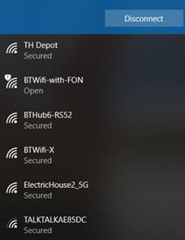

You connect into this service by selecting BT WiFi with FON as your wireless connection.

If you ignore the warning messages that appear, you can log onto the service by paying a fee or using credentials provided by BT.

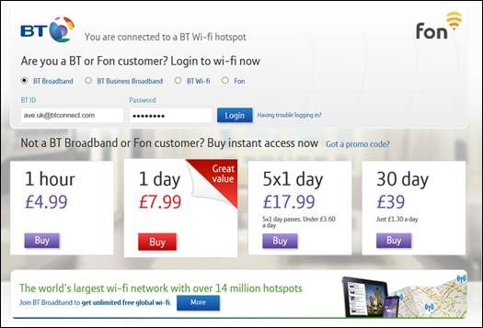

Your WAN credentials would be similar to this:

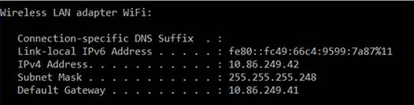

Maybe Audrey Knight, Lea Westwood, Peter & Lyla Alleman and Shirley Wardell are unaware that they have this facility and while it would be nice to use this service, the general security implications throw this concept into the long grass.

Option 2 – Simply get a new exchange line with broadband added
Even from Cloudscape that would cast £50 to install and an ongoing rental of £38 a month. Not an attractive proposition when the idea is to reduce costs.

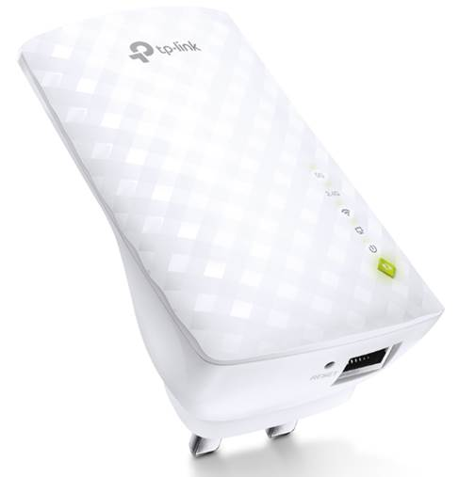
Option 3 – Hooking into a resident’s WiFi service
The AC750 Wi-Fi Range Extender RE200 receives a WiFi service from a nearby router with the Ethernet port allowing the Extender to function as a wireless adapter to connect wired devices.
We plug an IP phone into that single port and we are up and running with a working phone together with a wireless broadband service just for the cost of an adapter and having a minute effect on the source of supply.

The other side of the Office wall is apartment #6 and I have floated this concept with David McAlpine and Haniel Barazowska who are considering the matter. I hope some agreement can be reached.

Meanwhile the Office phone has had its internal directory populated with resident’s phone numbers that are to hand at present:
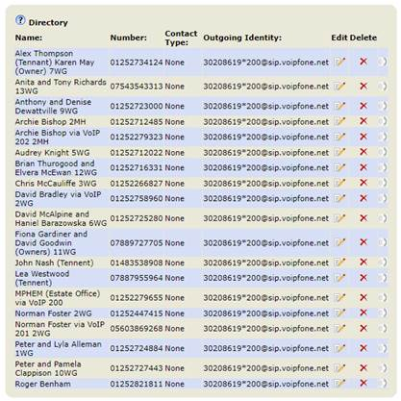

Hit the Directory Button and scroll down to the entry of interest. If that entry doesn’t fit the screen width, it scrolls across. Press the send button with an entry highlighted and the number will be dialled.
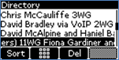
The normal idle state of the phone looks like this:
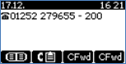

This visual will change when a call comes in and will match the number against an entry in the phone’s directory, if present. The number displayed maybe in an unusual format denoting the call is free.

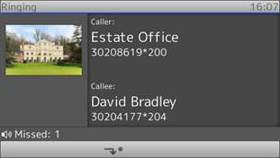

The IP phone has a speed dial facility which could be matched up with the apartment number in the Walled Garden.

It isn’t mandatory for any resident to have an IP phone but if they wanted a second line to avoid the clashing of a domestic call in progress at the same time the entry system was calling them, it would be a good solution. A VoIP phone would be required, ranging from £60 up to eye watering sums of money. The equivalent of line rental is £2.40 a month with call rates usually at 2ppm. There is no access charge or installation costs.
Anyone can experience the service for one month with a soft phone for a small fee of £10 + the cost of calls made.

