
Supplier of SIM cards for the Gate / Door Entry System
Kingfisher House
Northwood Park
Gatwick Road
Crawley
West Sussex
RH10 9XN

Tel: 01306 710120
Email: customerservice@telguard-telecom.co.uk
A/c No.: 1919 [30 day rolling account]

URL: https://login1.uk/portal.html
Login: office@mphem.net
Password: FT8KRRn2x

Payment collected by Direct Debit 7 days after the Invoice date
Account presented on the 1st of each month
Payments appear on the MPHEM Bank Account as TELG1919

Call rates: 6ppm + VAT = 7.2ppm
Line Rental: £3 + VAT = £3.60
Average monthly bill £39 including VAT
Refers to Telefónica UK Ltd (O2) SIM cards numbers shown below.
07430 525931 WG Gate
07430 526398 WG Main Foyer (Front)
07430 527525 WG 2-5 Foyer
07430 527482 WG 8-11 Foyer
07430 528086 WG 12-13 Foyer
07430 525930 MH Gate
07430 527654 MH Foyer
The MH Garages Gate is not part of the Charman Security Solutions system.

Supplier of Hosted VoIP Service

iNet Telecoms Ltd
Sovereign House
227 Marsh Wall
London
E14 9SD

Tel: 020 7043 5555 [150 from an MPHEM extension]
Email: info@voipfone.co.uk

URL: https://www.voipfone.co.uk/login.php?url=%2Faccount.php
Login: sysadmin@mphem.net
Password: 328051

Account No.: 30208619
Payments currently made by David Bradley since inception in December 2018 totalling £143.51 to date – Need to setup something on MPHEM soon. Current monthly bill £24 including VAT

Call Rates
Pence per minute
Including VAT
Landline - 01, 02, 03 | 1.20ppm
0800 & 0808 | FREE
Mobile | 12ppm
Between any Voipfone subscribers | FREE
Directory Enquiries (118707) | 145p per call plus  8.4ppm access charge

Anything else use https://www.voipfone.co.uk/prices_new.php#calc

Supplier of Landlines to the Lifts and Office

CloudScape Connect Ltd
Unit Q, Troon Way Business Centre
Humberstone Lane
Leicester
LE4 9HA

Tel: 0116 274 7360
Email: info@cloudscapeconnect.co.uk

URL: https://www.cloudscapeconnect.com/myaccount/
Login: Estate2019
Password: DqAC6NJNWUf6
Registered email address: david@cybrpictures.net
Registered mobile number: 07836 547472

Account No.: 00008676
Payment collected by Direct Debit on or around the 10th of each month
Appears on bank statement as <unknown>
Unknown from which bank account payments collected

Call rates: Landlines 2ppm; UK Mobiles 9ppm
Line Rental: £12.50 including VAT
Average monthly bill £63 including VAT

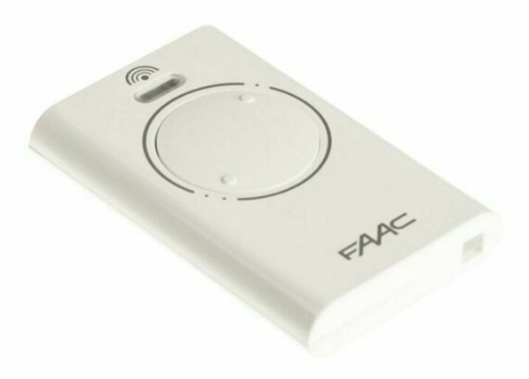

Gate Remote Control Transmitter Device

Using frequency 868MHz

These devices do not have to be registered into the Estate’s gate entry system. New and replacement units are available off the Internet. This unit at £14.55 appears to be similar to that used by many residents:
https://www.amazon.co.uk/Faac-868SLH-Remote-Control-Frequency-white/dp/B00BHFWR26
[Faac XT2 868SLH Remote Control Frequency 868 MHz - 2 Channels]
To bring the unit into operational status requires a “cloning” procedure using any other working Estate device as shown in this YouTube video: https://www.youtube.com/watch?v=JXOTXMyUP6M
Two separate systems exist for the MH and WG.

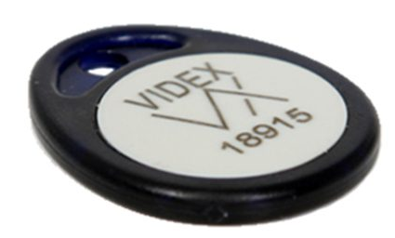
Videx 955T Proximity Fob

Proximity fob with a read range of 20mm. Built within tough ABS plastic casing. It is suitable for key rings due to its small size and style.
Diameter: 35 mm

Compatible with MPHEM proximity access control system and uses 32 bit code. All fobs are numbered for programming into the database.

It is available from many sources on the Internet for under £5 each.

See: https://www.rollingcenter.co.uk/products/videx-955-t-proximity-fob?sidecart=open

Fobs issued (or about to be) and their access rights:
Holder | Fob # | WG  Gate | WG  Main Foyer  (Front) | WG  Main Foyer  (Front) | WG  2-5  Foyer | WG  8-11  Foyer | WG  12-13  Foyer | MH  Gate | MH  Foyer
Anthony and Denise de Watteville | 06939 |  |  |  |   |  |   |   |  
Anthony and Denise de Watteville | 21386 |  |  |  |   |  |   |   |  
Archie and Annie Bishop | 63919 |  |  |  |  |  |  |  | 
Chris and Carole McAuliffe | 61359 |  |  |  |  |  |  |  | 
David Bradley | 45760 |  |  |  |  |  |  |  | 
Roger and Jeni Benham | 22171 |  |  |  |  |  |  |  | 
Jim and Helen Rice | 35441 |  |  |  |  |  |  |  | 
Peter and Pamela Clappison | 38806 |  |  |  |  |  |  |  | 
Oliver | 64128 |  |  |  |  |  |  |  | 
Not Issued | 42116 |  |  |  |  |  |  |  | 
Not Issued | 65337 |  |  |  |  |  |  |  | 

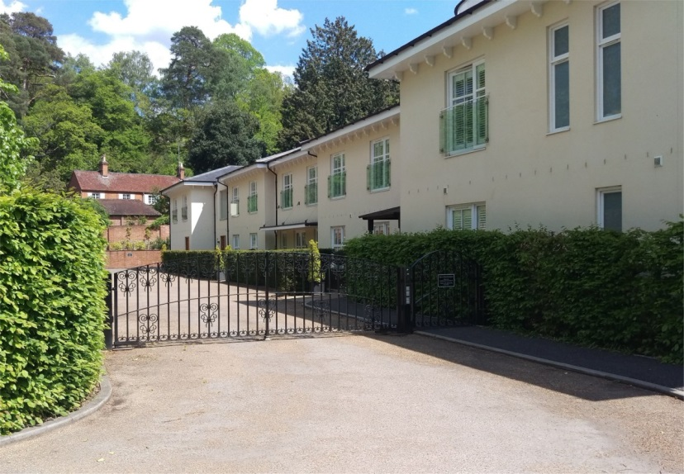
Access Codes to the Estate Gates and Foyer Doors
WG Gate | 2612
WG Main Foyer (Front) | 2612
WG Main Foyer (Rear) | 2612
WG 2-5 Foyer | 4234
WG 8-11 Foyer | 4891
WG 12-13 Foyer | 2612
MH Gate | 5678
MH Foyer | 9519
MH Garages Gate
WG Gate Access using a Mobile Phone

A mobile phone can be registered with MPHEM to control the opening of The Walled Garden gates. Using a registered phone, simply dial the gate number 07430 525931 and when it responds dial 3. Calling from a ¼ of a mile away and the gates will be fully open as you swing into The Walled Garden.

Current registered users are:
Posn | Apartment | Resident | Telephone No. | Active | User
7 | 5 | Audrey Knight | 07900 241 625 | 26 February 2019 | Son
2 | 4 | David Bradley | 07979 725 544 | 22 February 2018 | Daughter
3 | 4 | David Bradley | 07802 634 156 | 22 February 2018 | Son
5 | 4 | David Bradley | 07918 888 102 | 20 March 2018 | Son-in-Law
4 | - | Gary | 07875 281 397 | 23 February 2018 | Postman
1 | 2 | Norman Foster | 07787 313 765 | 22 February 2018 | Testing
6 | 2 | Sarah Foster | 07507 152 473 | 30 March 2018 | Daughter
Maintenance by Charman Security Solutions: Clive on 07774 701545
email: charmantelecom@yahoo.co.uk

Not used for Landlines or Broadband Services on the Estate

Currently in dispute for alleged early termination charges on three lines formerly serving the lifts in The Walled Garden. BT placed the “debt” into the hands of debt collectors who have added their charges. Attempts are being made to resolve this issue where we believe to have a strong case for the charges to be set aside.

There is an annotated exchange line in the services cupboard of apartments 2-5 which was intended to be used for the lift in that block. It was never connected and the Estate does not appear to be currently paying line rental for the service but may have done so in the past. It is noted that the number 01252 712716 has in the last few days (10MAY19) been allocated to another subscriber.

BT records show these lines had existed at one time or another:
Garden Flat
Top Floor
Original Purpose Unknown | 01252 726040
Original Purpose Unknown | 01252 739103
Where the numbers have been determined, they might not be used for voice traffic but instead for the TV distribution system. Perhaps one of the exchange lines is a feed for the MH Garages Gate.

